Section 4:
Professional and regulatory implementation

4.1 Department of Building and Housing (DBH)
At present the low-damage technologies discussed in this Report are not provided for in the Building Code as prescribed “acceptable solutions” or “verification methods”, and there are no New Zealand Standards that specifically provide for them. This means that their use is dependent on specific approvals given for each proposal in the building consent process, where they can be advanced as an alternative solution to meeting the performance requirements of the Building Code. While the Building Act allows the low-damage technologies to be used, the consent process is inevitably more expensive than for buildings of conventional design, and depends not only on detailed building consent applications that demonstrate the robustness of the technology, but also on a receptive and educated response from the individual building consent authority. The desirability of a more encouraging regulatory environment was an issue addressed in the hearing by Mr David Kelly and Mr Peter Thorby of DBH. This is a matter to which we will return in a later part of our Report, where it can form part of our overall discussion of the way in which the building consent process is designed and implemented.

4.2 Architects’ perspective
Aesthetics and architectural requirements are key factors contributing to the form of a structural system in a building.
Associate Professor Andrew Charleson from the School of Architecture at Victoria University of Wellington, and Trevor Watt, director of Athfield Architects in Christchurch, gave evidence to the Royal Commission on how the low-damage building technologies may affect current practice. Both agreed that the introduction of these types of structures into mainstream design and construction practices would have few significant architectural implications, as the forms of structure are very similar.
Base isolation was discussed as the technology that is most demanding on architectural features, as all entrances, services and other fittings that cross the seismic gap (or isolation plane) have to be specifically detailed to accommodate seismic movement. Associate Professor Charleson explained that one disadvantage of using new technologies is that they may require more maintenance. He considered that there should be regular checks on each use of the emerging technologies and gave the example of a base-isolated building where the whole system had been compromised because of a new addition to the building.
In the case of the PRESSS used for the Southern Cross Hospital Endoscopy building, both conventional reinforced concrete and PRESSS solutions were considered. It was Mr Haverland’s evidence that the use of the low-damage technology had no effect on architectural layout, with no reduction in the available floor area.
The Nelson Marlborough Institute of Technology (NMIT) building constructed using the latest timber Pres-Lam technology is shown in Figure 28. Mr Watt explained that aesthetics was an important component, and the architect wished to expose the structure and the damping devices. This is quite a different aesthetic, but in the Christchurch context, Mr Watt expected that a much wider range of building aesthetics would be used for new buildings.
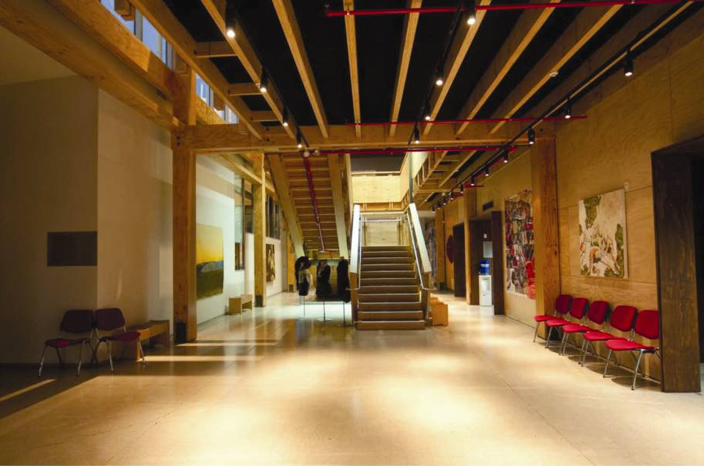
Figure 28: Architectural finish, NMIT building (source: Trevor Watt)
Damage caused by earthquakes also occurs to non-structural elements. Frequently these elements are included in the architect’s design. To prevent or limit the amount of secondary damage, engineers and architects should collaborate to minimise the potential distortion applied to non-structural elements. Particular attention must be paid to prevent the failure of non-structural elements blocking egress routes.

Section 5:
Cost considerations

Evidence presented to the Royal Commission demonstrated that low-damage technologies are comparable in cost to conventional construction. Professor Pampanin considered the costs to be similar to or only slightly higher than traditional methods. The extra costs would likely be offset by the improved performance of the building and other benefits such as a shorter construction time. The small number of examples that the Royal Commission has been able to consider has not enabled us to confirm Professor Pampanin’s views. However, on the evidence we heard, discussed above, it does appear that the increased cost of low-damage technologies ought not to be seen as prohibitive when compared with the possible benefits, especially for long-term owners.

5.1 Methods of controlling seismic response: base isolation
Ms Devine gave evidence to the Royal Commission on the business case for seismic isolation, and specifically the question of cost.
For new construction, Ms Devine stated that a general rule of thumb is that the inclusion of all aspects of seismic isolation will add no more than three per cent to the construction cost. A feature of base isolation is to trade off the increased initial cost for a decreased lifetime cost. The reduced accelerations achieved by isolation are the best way to protect contents and non-structural elements. A seismically isolated building has good potential to remain fully functional after an earthquake event, eliminating or minimising losses caused by downtime, lost production, lost data and lost building contents.
Base isolation can be used as a retrofit technique for existing buildings, but the variables inherent in modifying structures make it difficult to give a meaningful indication of cost.

5.2 Low-damage technologies
Evidence given at the hearings was in general agreement that the use of low-damage technologies, such as PRESSS or sliding friction dampers, results in only a small cost increase compared to conventional methods. The Southern Cross Hospital Endoscopy building and Nelson Marlborough Institute of Technology (NMIT) building, which use the PRESSS and Pres-Lam systems respectively, were found to be comparable in cost to conventional reinforced concrete and/or steel alternatives. The Te Puni Student Village, built using the latest steel technologies, had increased costs in the range of one to four per cent of the total construction cost.
Professor Pampanin advanced the following propositions on the relevant cost considerations for low-damage technologies:
1. Overall the cost is comparable to the use of their conventional counterparts.
2. The more they are developed and constructed, the more they can result in less expensive yet higher performance solutions.
3. The material costs are about the same as in conventional solutions (that is, post-tensioned costs are balanced by more efficient use of materials), with faster erection time.
4. In first applications, the novelty of the system and lack of comparison to previous cases may lead to a higher prediction of costs.

5.3 Other considerations
Mr Hare provided a breakdown of costs for a typical 6 to 15 storey office building from Rawlinson,15 the standard price guide used in the construction industry. The breakdown indicates that the structure represents typically only 21 per cent of the cost of the building, as shown in Figure 29. This means that if a low-damage technology requires, say, a five per cent increase in structure costs, that will only be a one per cent increase in the total cost.
Mr Hare made the point that if a building is so badly damaged that the structure is non-repairable it is a 100 per cent loss. But when looking at the building’s performance in a lower-level earthquake (for example, the September earthquake), which may leave the structural elements in a reasonable state, it is still necessary to consider the damaged state of the other 79 per cent of the building value.
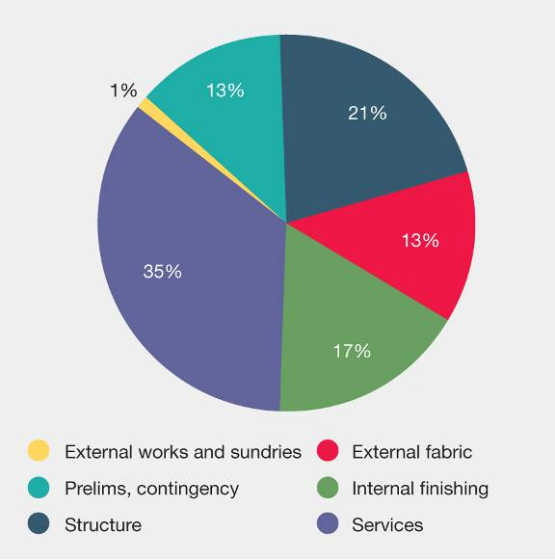
Figure 29: Rawlinson’s¹⁵ elemental cost of a typical 6 to 15 storey office building
Dr. Richard Sharpe gave evidence that “fix, fasten and forget” is a simple but effective way to lessen the non-structural and contents damage to a building. The September earthquake alone resulted in significant economic cost, with damage to partitions, ceilings, mechanical services and other non-structural elements requiring repair. Protecting the structural system from damage is only one aspect of damage mitigation.
Another interesting finding from examining Rawlinson15 is that the cost of an office building does not necessarily correlate to the seismicity of the region. Wellington and Auckland have similar building cost ranges, despite the difference in their hazard factors (0.4 and 0.13 respectively). This shows that there are significant other considerations driving the overall cost of buildings.

Section 6:
Discussion

The Royal Commission received submissions and heard evidence at hearings on the potential for alternative designs to reduce the social and economic costs arising from severe earthquakes.
The social and economic costs to Christchurch, Canterbury and New Zealand have been extreme and were unexpected by the public even for an event that created forces considerably greater than the design level. These costs include the time cost of business interruption.
It is relevant to consider the magnitude of these costs in the context of the rarity of the event. It is notable that the event that occurred on 4 September 2010 tested structures at around the design level. The structural damage to many well-designed modern buildings was not great. However, the possibility that alternative forms of structure could behave better in a major earthquake and sustain much less damage is attractive. Research into alternatives that perform safely with less damage in an extreme seismic event warrants support.
The various methods proposed and described in some detail above can be applied using conventional building materials and include a range of devices that absorb energy that would otherwise damage the building.
For low-damage structures, the initial capital cost was reported to the Royal Commission and examples of cost were provided. A modest increase of a few per cent was reported. Opinions were expressed that there is potential for the cost to fall as confidence grows in the techniques, and the prospect of rapid assembly of the structural frame saves construction time. In these respects, alternative technologies offer promise.
As research continues on low-damage buildings, matters have been identified that warrant attention. These include:
PRESSS and Pres-Lam structures:
• corrosion resistance of cables, particularly if exposed to moisture;
• stored energy in heavily stressed cables or rods if inadvertently released;
• need for additional redundancy if a cable failure occurs;
• ability to alter a building structure without losing its integrity; and
• desirability of redundancy of structural capacity.
Base-isolated structures:
• clearances around the structure to allow for movement;
• ensuring the space around the structure is not obstructed during the life of the building; and
• better understanding of ground conditions and the interaction between soils, foundations and building structure.
Devices:
• use of proven energy-dissipating devices; and
• standardisation of design practice for connections.
Building standards:
• development of standards that are incorporated into the building regulations;
• consideration of fire resistance for post-tensioned tendons;
• standardised methods of design; and
• familiarising building consent authorities, design organisations and constructors with low-damage techniques.
Communications:
• familiarising the public, owners and businesses with the potential of low-damage buildings; and
• commercial implications, funding and insurance are possible areas of interest.
Increasing the use of timber, a locally produced and plentiful material, has important economic advantages for New Zealand. Durability has been established through the use of preservatives. The manufacture of LVL and Glulam enables long lengths to be used with known material properties. An innovative application of treated timber piles (which are already widely used) uses a hole cored down the centre of the pile to allow jetting and subsequent introduction of cement grout to the pile base. The Royal Commission endorses these innovative developments.
The Royal Commission acknowledges the role these innovations can have and notes that there has already been considerable progress made at Canterbury and Auckland universities and in some design offices. Buildings that use low-damage technologies also offer prospects for ease of repair. Replacement of connections, energy-dissipating devices and localised elements of structure are ways in which buildings can be restored to full strength after a major earthquake. The potential for these benefits was apparent from presentations to the Commission.

Section 7:
Conclusions and recommendations

7.1 Conclusions
In considering the use of low-damage technologies as an alternative to current building methods, it is important that the lifetime costs be considered, including the capital cost, maintenance costs, the difference in performance in earthquakes and the resulting differences in repair costs and downtime of the building.
It is also important that all owners during the life of the building should be aware of the structural system. If an owner in the future wishes to modify a building, it is essential that they should understand the implications. Many low-damage buildings rely on different structural solutions than those of conventional buildings. Alterations may compromise the building’s behaviour in earthquakes. Examples of matters of concern have been highlighted in the discussion.
In selecting an appropriate low-damage technology, it is important to realise that these innovative techniques are in a relatively early stage of development. Some questions of a practical nature are being addressed as these methods become more widely adopted.
From the evidence we have received, we consider that there is a place for the use of new building techniques in the rebuild of Christchurch and in developments elsewhere. There will be many cases where their use is justified because of better structural performance not withstanding any increased costs that result.

7.2 Recommendations
Recommendations
We recommend that:
66. Research should continue into the development of low-damage technologies.
67. The Department of Building and Housing should work with researchers, engineering design specialists and industry product providers to ensure evidence-based information is easily available to designers and building consent authorities to enable low-damage technologies to proceed more readily through the building consent process as alternative solutions.
68. The Department of Building and Housing should work with researchers, engineering design specialists and industry product providers to progress, over time, the more developed low-damage technologies through to citation in the Building Code as acceptable solutions or verification methods. This may involve further development of existing cited Standards for materials, devices and methods of analysis.
69. The Department of Building and Housing should foster greater communication and knowledge of the development of these low-damage technologies among building owners, designers, building consent authorities and the public.
70. To prevent or limit the amount of secondary damage, engineers and architects should collaborate to minimise the potential distortion applied to non-structural elements. Particular attention must be paid to prevent the failure of non-structural elements blocking egress routes.

References

- Dhakal, R.P. (2011). Structural Design for Earthquake Resistance: Past, Present and Future. Christchurch, New Zealand: Canterbury Earthquakes Royal Commission.
- Buchanan, A., Bull, D., Dhakal, R. P., MacRae, G., Palermo, A. and Pampanin, S. (2011). Base Isolation and Damage-Resistant Technologies for Improved Seismic Performance of Buildings. Christchurch, New Zealand: Canterbury Earthquakes Royal Commission.
- California Office of Emergency Services. (1995). Vision 2000: Performance Based Seismic Engineering of Buildings. California, USA: Structural Engineers Association of California.
- AS/NZS 1170.0:2002. Structural Design Actions Part 0: General Principles. Standards Australia/Standards New Zealand.
- NZS 1170.5:2004. Structural Design Actions Part 5: Earthquake Actions. Standards
New Zealand.
- Hare, J., Oliver, S. and Galloway, B. (April, 2012). Performance Objectives for Low Damage Seismic Design of Buildings. Paper presented at the New Zealand Society of Earthquake Engineering Conference. Retrieved from http://www.nzsee.org.nz/db/2012/Handbook.pdf
- Preistley M. J. N., Calvi G. M. and Kowalsky M. J. (2007). Displacement-Based Seismic Design of Structures. Pavia, Italy: IUSS Press.
- Cubrinoviski, M. and McCahon, I. (2011). Foundations on Deep Alluvial Soils. Christchurch, New Zealand: Canterbury Earthquakes Royal Commission.
- Charleson, A. W. and Allaf, N. J. (April, 2012). Costs of Base-isolation and Earthquake Insurance in New Zealand. Paper presented at the New Zealand Society of Earthquake Engineering Conference. Retrieved from http://www.nzsee.org.nz/db/2012/Handbook.pdf
- Priestley, M. J. N., Sritharan S., Conley, J. R. and Pampanin, S. (1999). Preliminary
Results and Conclusions from the Press Five Storey Precast Concrete Test Building.
PCI Journal, 44(6).
- NZS 3101:2006. Concrete Structures Standard. Standards New Zealand.
- Amaris, A., Pampanin, S., Bull, D. and Carr, A. (2007). Development of a Non-tearing Floor Solution for Jointed Precast Frame Systems. Paper presented at the New Zealand Society of Earthquake Engineering Conference.
- Clifton, C., Bruneau, M., MacRae, G., Leon, R. and Fussell, A. (2011). Steel Building Damage from the Christchurch Earthquake Series of 2010 and 2011. Bulletin NZSEE, Volume 44(4).
- Buchanan, A., Carradine, D., Palermo, A. and Pampanin, S. (2011). Post-tensioned timber frame buildings. The Structural Engineer, 89(17).
- Rawlinsons Media Limited. (2010). Rawlinson New Zealand Construction Handbook (25th Edition.) Auckland, New Zealand: Author.

