3.3.4 Applications in timber buildings
3.3.4.1 Background
Many of the technologies discussed in preceding sections, such as the PRESSS technology, can be adapted into highly engineered wood structural systems.
The 1855 Wairarapa earthquake showed that timber buildings behaved well in earthquakes. Lessons from this led to the construction of the old Government Buildings (now functioning as the Law School of Victoria University) in 1876, a large timber structure with a facade textured to look like stone, as shown in Figure 24.
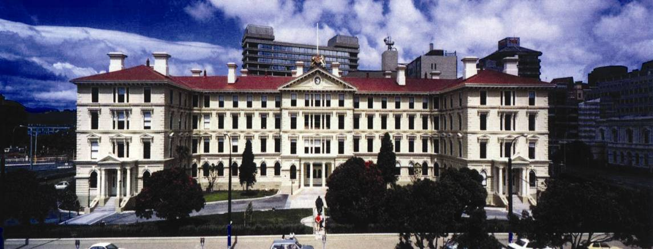
Figure 24: Old Government Buildings, Wellington (source: Andrew Buchanan)
An important difference between wood and steel or concrete is that wood is a highly inhomogeneous material, with different strength, stiffness and shrinking-swelling characteristics parallel or perpendicular to the direction of the grain. Professor Buchanan described wood as being like a bundle of drinking straws that transport water up the structure, with the highest strength in the direction parallel to the grain.
Timber is a lightweight, flexible (low elastic modulus) and brittle material. Professor Buchanan noted that the latest wood materials include plywood, laminated veneer lumber (LVL), Glulam (Glue Laminated) and cross laminated timber (CLT)). These engineered wood products lessen the inherent variability of wood by peeling or sawing it into layers and gluing them back together in alternating patterns. Since timber is brittle, it is combined with steel fasteners or connections to provide ductility and energy dissipation in an earthquake.
Since 2004, low-damage design has been implemented in timber structures. Particular attention has been paid to the hybrid connections, which combine post-tensioning bars with internal or external steel dissipaters. The structural concept described by Professor Buchanan is that seismic movements are accommodated through a controlled rocking mechanism between prefabricated elements. The structural elements are held together by long unbonded high-strength steel tendons. Energy dissipation is provided by the yielding of short lengths of replaceable mild steel or by energy-dissipation devices.
The rocking timber system has been named Pres-Lam and it covers both seismic resistant frames and walls. Professor Buchanan explained that the system has been designed and developed at the University of Canterbury14 with the support of the Structural Timber Innovation Company Ltd (STIC), a research consortium of the timber industry, universities and government. STIC is marketing Pres-Lam and other new timber technologies under the trade name EXPAN.
The development of multi-storey Pres-Lam timber buildings has been the focus of a major research programme at the University of Canterbury for the past five years, in association with The University of Auckland and the University of Technology, Sydney. Figure 25 shows testing on a two-thirds-scale multi-storey frame and wall building. After extensive testing with no significant structural damage, this test building was dismantled and re-erected as the head office of STIC on the University of Canterbury campus.
Professor Buchanan said that like most other materials, post-tensioned timber under high compressive stresses experiences some axial shortening caused by creep and relaxation, similar to concrete, in the direction parallel to the grain. The associated losses in post-tensioning are allowed for in design. Perpendicular to the grain the stiffness is much less and the creep and shrinkage are very much greater than along the grain. The poor properties perpendicular to the grain mean that columns in post-tensioned beam-column joints require special reinforcement.
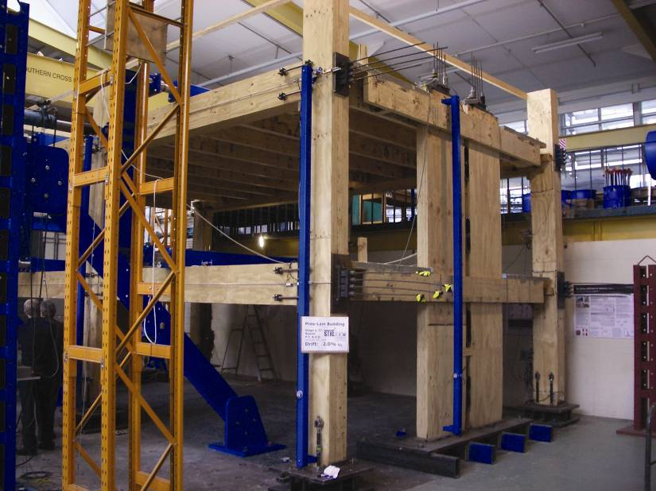
Figure 25: Multi-storey timber building tested at the University of Canterbury (source: Andrew Buchanan)
Multi-storey timber buildings are also being constructed in other parts of the world. Professor Buchanan described a seven-storey timber building that was prefabricated in Italy and then shipped to Japan, where it was tested on the largest shake-table in the world, as shown in Figure 26. This building is made of CLT wood panels. It is not post-tensioned, but the panels are well connected with metal fasteners and there was sufficient gravity load to ensure self-centring. Professor Buchanan said the building survived a number of very large earthquake motions with no significant structural damage, but the floor accelerations at the top of the building were high. He indicated that these accelerations could have been reduced if the building was designed for sufficient energy dissipation or ductility.
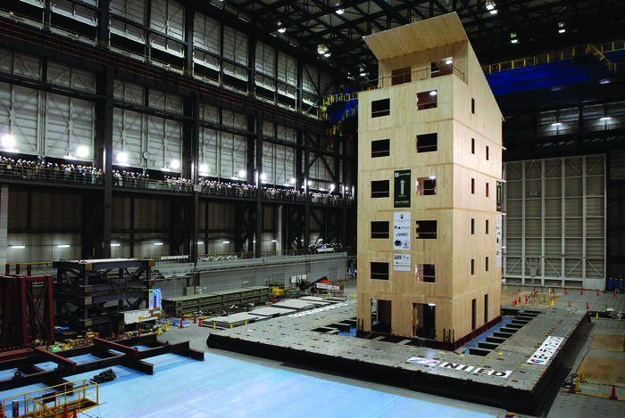
Figure 26: Shake-table testing of a seven-storey CLT building in Japan (source: National Research Council of Italy – Trees and Timber Institute (IVALSA))
Dr Pierre Quenneville from The University of Auckland gave evidence on the performance and details of steel slip-friction connections. The advantages and limitations are similar to those outlined in the discussion on supplemental damping devices, such as improved energy dissipation, self-centering ability and durability issues.
Mr Mark Batchelar, Principal of MLB Consulting Engineers, described further benefits of timber structures. He said that they usually have an inherent strength reserve and resilience, as deflection considerations typically govern the size of structural members rather than the strength requirements. The reduced weight of timber gives a reduced seismic demand and can lead to a significant reduction in foundation costs on poor soil sites compared to concrete buildings.
Mr Batchelar also described the concept of using hollow timber piles. The Royal Commission acknowledges the merits of this, which will need further development and testing in the Canterbury alluvial soils. It has practical advantages for use in foundations of light structures.
Professor Buchanan described timber as requiring unique consideration with regard to durability, decay and dimensional stability, all of which require it to be kept dry. Timber buildings also need special attention for fire safety and acoustics. Timber technologies are relatively new compared to the corresponding alternatives in steel and concrete, and there is a lot of work currently under way to ensure that the products are properly tested before they are widely adopted.
3.3.4.2 Practical example: Nelson Marlborough Institute of Technology (NMIT) building
The first ever practical application of the Pres-Lam technology was in the Nelson Marlborough Institute of Technology (NMIT) Arts and Media facility in Nelson. Mr Carl Devereux, Technical Director of Aurecon, provided evidence to the Royal Commission about this building. The NMIT building is divided into three blocks that were opened in January 2011 (Figure 27(a)). The three-storey block incorporates damage-mitigation technologies and has a footprint of 500m2.
This structure contains vertically post-tensioned coupled rocking timber walls, which resist lateral loads in both directions. These were prefabricated off-site and lifted into place to be connected at the foundations (Figure 27(b)). The walls are post-tensioned to the foundation through high-strength steel bars, with a cavity in the wall for the steel bar couplers. Steel U-shaped flexural plates link the pairs of structural walls together and provide dissipative capacity to the system. Mr Devereux said that, based on Aurecon’s current experience and knowledge, a building height of up to 10 storeys is achievable with this system.
All structural elements including the beams, columns, walls and floors are constructed of LVL, as shown in Figure 27(c). LVL is a sustainable building product that is grown and manufactured locally.
Through a cost analysis, Mr Devereux estimated the primary structure to be 33 per cent of the total capital cost. The steel and concrete structure options were also considered and cost around 30 to 40 per cent of the total capital cost. This showed that the cost of this new low-damage technology is comparable to conventional systems and therefore does not have a significant effect on the total capital cost.
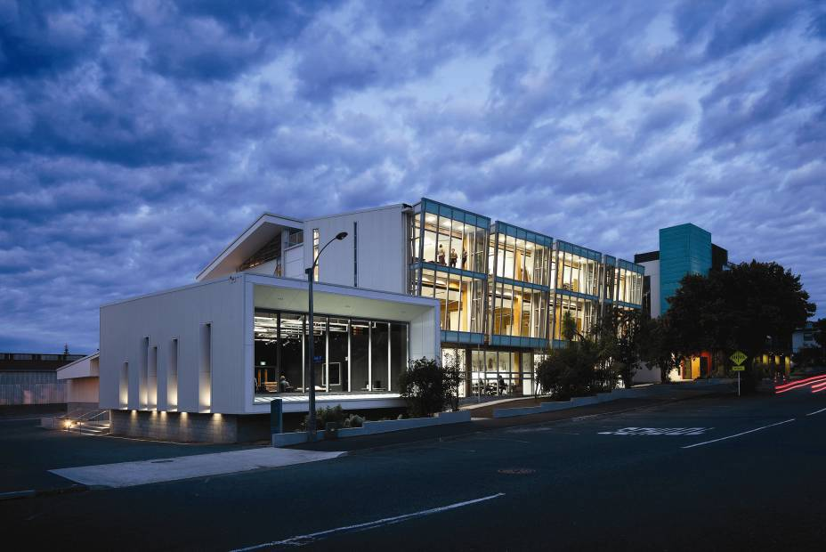
(a) Finished building
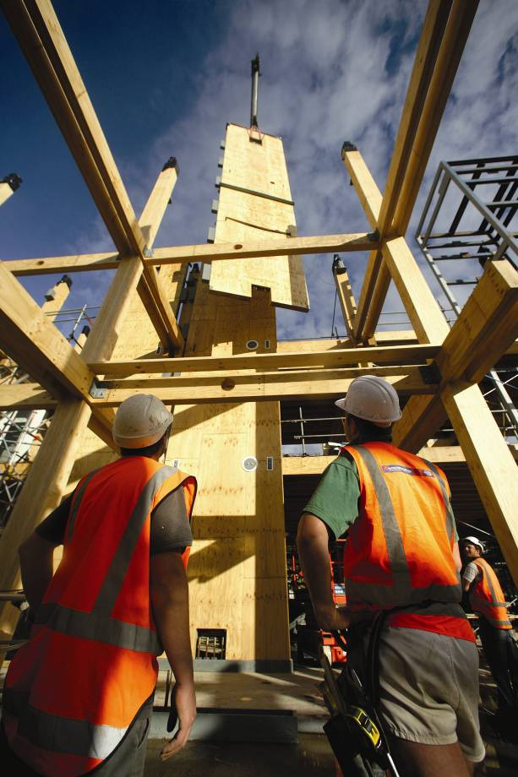
(b) Installation of prefabricated wall elements
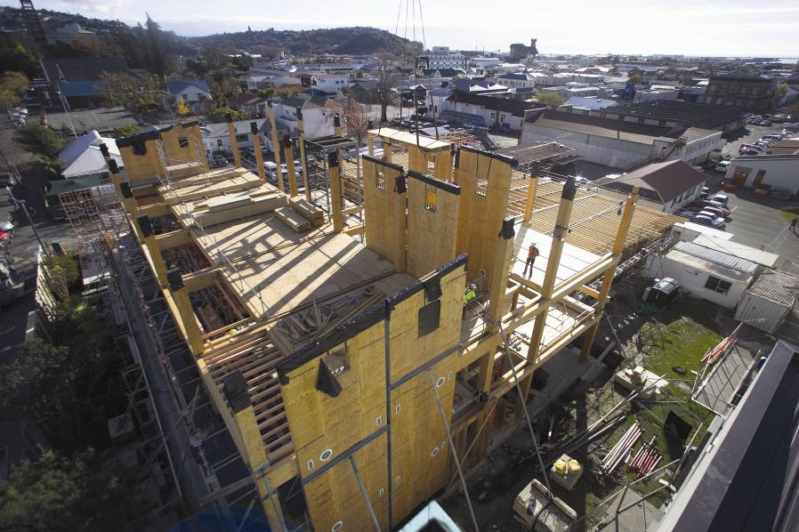
(c) During construction
Figure 27: Nelson Marlborough Institute of Technology (NMIT) building in Nelson (source: Carl Devereux)

