2. Southern Cross Hospital Endoscopy building
Mr Gary Haverland, Director of Structex Metro Ltd, described the key details of the second PRESSS building constructed in New Zealand. This is the Southern Cross Hospital Endoscopy building, shown in Figure 19(a), which was completed a month before the September earthquake and is located just north of the Christchurch CBD.
The four-storey building was designed as an Importance Level 3 structure that required piled foundations because of the site’s soft soils. The gross floor area was 2940m2. The cost was $2450 per m2.
This structure has both frames (Figure 19(b)) and coupled walls, which resist lateral forces in the two orthogonal directions. The unbonded post-tensioned walls are coupled by using U-shaped flexural plate dissipaters, details of which are shown in Figure 19(c).
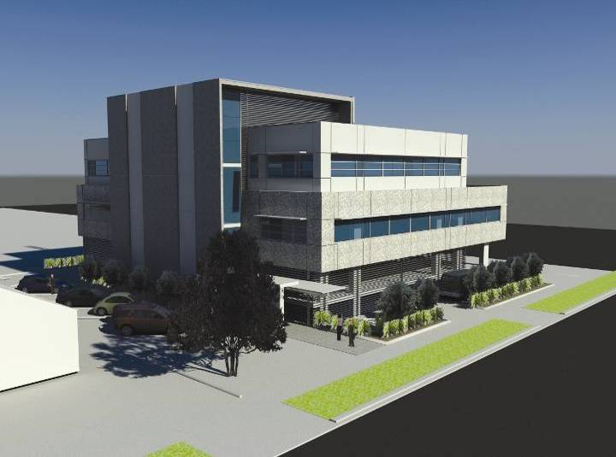
(a) Architect’s impression
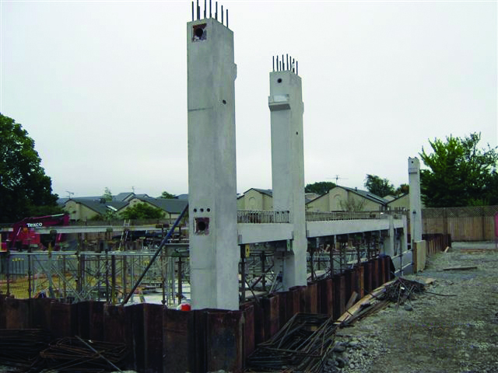
(b) PRESSS frame under construction
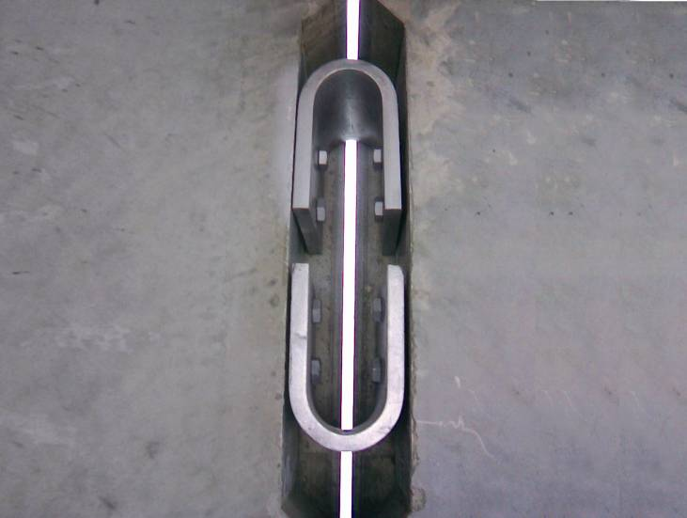
(c) U-shaped flexural plates between coupled walls
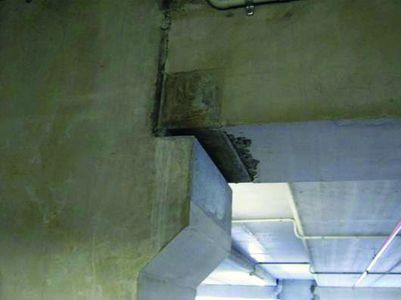
(d) Steel armoured beam-column joint
Figure 19: Southern Cross Hospital Endoscopy building (source: Gary Haverland)
Some advantages of using a PRESSS structure in this development were identified by Mr Haverland. These included:
1. There are no plastic hinges so there is little structural damage. The reduction in potential downtime was important for the client.
2. The building structure is self-centring, resulting in little residual lean after an earthquake.
3. Lower design seismic actions compared to a conventional reinforced concrete frame or wall building. This means less risk of damage to contents, lower wall reinforcement and foundation forces. This was important because of the expensive medical equipment in the building.
4. Less in situ concrete on site, meaning shorter construction time. Construction also used conventional building components.
Mr Haverland described the building as having satisfactorily passed the tests of the Canterbury earthquakes, with the seismic resisting structure (frame and walls) performing “extremely well”. The building suffered minor cosmetic damage to non-structural components, with some damage to services requiring repair. After minimal downtime, the building was made fully operational again.
Mr Haverland commented that steel armoured joints had performed well (see Figure 19(d)) and he recommended this approach to reduce spalling in future buildings.
An initial cost of a conventional building was estimated to be $7.2 million. The PRESSS building was constructed for $6.9 million but other problems encountered, including upgrading the boiler, running additional services and striking a well in the excavation for the lift pit, brought it back up to the initial budget of $7.2 million. The structural elements cost $2.17 million, around 30 per cent of the total building cost, which in Mr Haverland’s view is comparable to other conventional buildings.

3.3.3 Applications in steel buildings
3.3.3.1 Background
Multi-storey steel building construction has grown in prominence over the last 20 years. The lull before this time was reported by Clifton et al13 to be due to the 1970s labour disputes that adversely affected the steel industry, as well as the recession in the late 1980s.
The number of steel buildings in the Christchurch CBD is relatively low compared to concrete buildings. These steel buildings date from 1985 to 2010, and therefore were designed to modern seismic specifications. Professor Charles Clifton told the Royal Commission that these structural systems performed well, satisfying their life-safety objective, with some buildings also being able to be reoccupied after repairs.
3.3.3.2 Low-damage steel building technologies
Conventional lateral resisting systems used in steel buildings include the moment resisting frame (MRF), the eccentrically braced frame (EBF) and the concentrically braced frame (CBF). The new concepts used to reduce damage in structural steel incorporate these forms of lateral resisting systems. However, there is a focus on special detailing in regions where structural elements are expected to be damaged.
(a) Technologies in moment resisting frame structures
The sliding hinge joint has been tested and developed in New Zealand by Professors Charles Clifton and Gregory MacRae. This system has been used in five multi-storey buildings to date. It is only recommended for dry internal environments, as the long-term durability and maintenance of the sliding joints is a subject of ongoing research.
In a severe earthquake, the column sways back and forth and the beam rotates about its top flange, while the bottom components undergo controlled sliding. The friction force is derived from the clamped plates sliding relative to each other. This behaviour gives good energy absorption and suppresses damage in the column and beam. Figure 20 shows some of the key aspects of this concept.
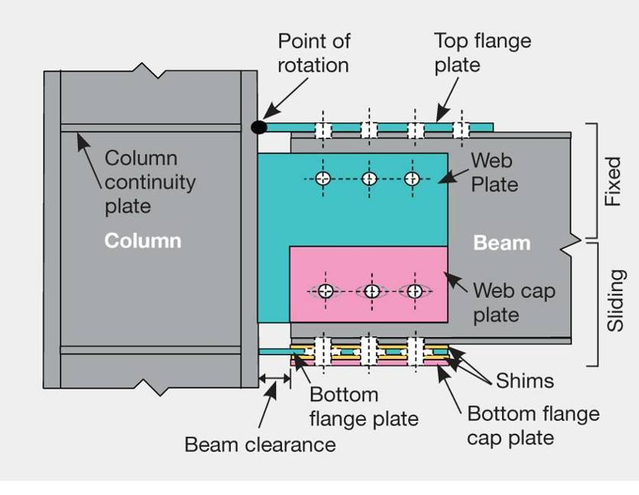
Figure 20: Sliding hinge joint detailing (source: Buchanan report)
Professor Clifton described further desirable characteristics of this system as follows:
1. Large deformations can be sustained using elongated boltholes and the clearance between the end of the beam and the column.
2. Strength and stiffness are decoupled. Since most member sizes are governed by stiffness, the lower strength of this connection is not disadvantageous as the friction connection has high stiffness.
3. Strength can be controlled by the number and size of friction grip bolts.
The system is still evolving, with different arrangements to reduce the localised bending in plates. To increase the ability of the connection to self-centre, a double- acting ring spring can be connected to the underside of the beam’s flange and to the column face.
Professor Clifton stated that the construction detailing is similar to conventional connections. Damage is suppressed in composite floors, beams and columns with damaged bolts being replaced or re-tightened after a major earthquake. He estimated that the cost would be one to five per cent greater than that of a conventional system.
Other devices applicable to steel moment frames include the high-force-to-volume (HF2V) dissipater, which could replace the sliding friction joints. Professor Clifton also described the flange-bolted joint, which he considered suitable only for low-seismicity regions such as Auckland.
Rocking structures have been adopted in steel structures, such as the uplifting columns used in the Te Puni Student Village (see page 29). Some issues to be considered when contemplating the use of rocking structures were referred to in the Buchanan report, including:
1. Vertical impacts on the foundation.
2. Horizontal accelerations resulting from impact. Some systems will have a rapid increase in stiffness when travelling at high velocity, which may produce uncomfortable shock in the building.
3. Vertical deformations on the side of the frame may result in large demands to the floor slab as the wall lifts up the floors.
Professor Clifton described another concept, the linked-column frame, which consists of two closely spaced columns with links between them acting as the primary lateral load resisting system. This is coupled with a linked gravity frame. The gravity frames are more flexible and are designed to remain elastic, helping the building to self-centre. A conceptual example from research carried out at the University of Portland, Oregon, is shown in Figure 21.
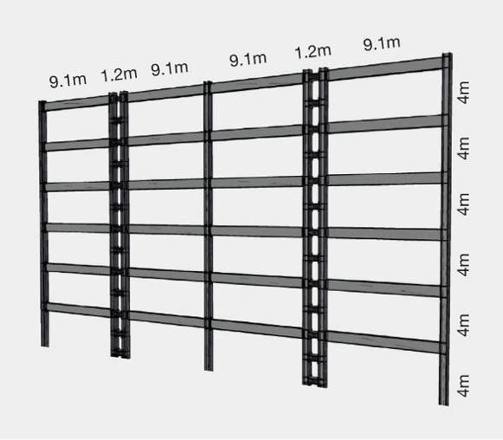
Figure 21: Linked-column frame (source: Charles Clifton)
The links in the frame are intended to yield and can be replaced after an earthquake. The system has a high level of redundancy, with frames remaining stable after removal of damaged links. These replaceable links can be bolted active links (similar to those used in EBFs) or could incorporate the sliding hinge joint. The technology is readily applicable to standard capacity design principles.
(b) Technologies in braced frame structures
Bolted replaceable active links
The bolted replaceable link described by Professor Clifton has an advantage over the conventional EBF of an easy link replacement. The performance of EBFs during the Christchurch earthquakes has shown that the floor slab may contribute to the strength of the links, reducing deformations and hence reducing damage. Investigations to quantify slab strength, stiffness and over-strength effects on the EBFs are currently under way at The University of Auckland. Figure 22 shows how this replaceable link may be constructed. This is still in development, with load tracking being an important consideration in the detailing of steel connections.
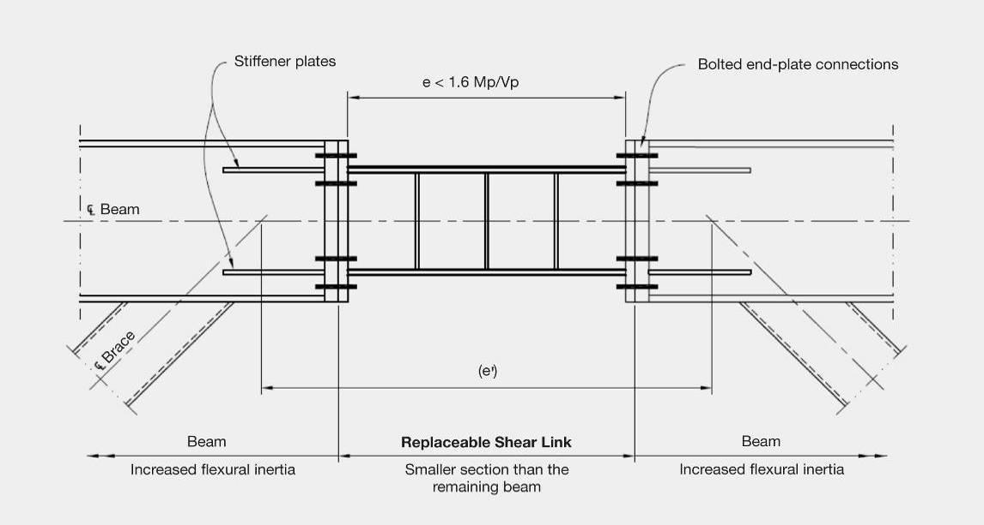
Figure 22: Bolted replaceable link in an eccentrically braced frame (EBF) (source: Buchanan report)
Concentrically braced frames
In concentrically braced frames, supplemental damping devices such as the buckling restrained brace and the friction sliding brace can be incorporated into conventional systems. In a conventional concentric frame, the braces yield in tension and buckle in compression, which leads to slackening in the system.
3.3.3.3 Practical example: Te Puni Student Village
Low-damage technologies were used in the Te Puni Student Village buildings after a request from Victoria University of Wellington to develop a design that would limit damage in a major earthquake. Mr Sean Gledhill, Technical Director of Aurecon, gave evidence to the Royal Commission on the practical application of low- damage steel devices in this development.
The project involved the construction of three 11-storey buildings (see Figure 23(a)). A conventional design was tendered in parallel with the low-damage design solution. Mr Gledhill said the drivers leading to the selection of the low-damage design were:
• provision of a facility to function as a disaster administration centre with nominal repair after a major earthquake;
• suitability to multi-storey steel buildings;
• speed and ease of construction (see Figure 23(b));
• sustainability for the future; and
• economy of mitigation of damage to primary structural members.
In collaboration with the latest research available from The University of Auckland and the Heavy Engineering Research Association (HERA), a lateral load resisting system of moment frames with sliding friction hinge joints (Figure 23(c)) was combined with concentrically braced rocking steel frames. The rocking motion from uplifting columns was controlled with Ringfeder springs and friction plates (Figure 23(d)). These details dissipate earthquake energy and suppress damage to structural components.
In terms of cost-effectiveness, Mr Gledhill said the low-damage technologies cost an additional one to four per cent of capital costs compared to the conventional design. He outlined some other costs incurred on the project, including the additional design effort and a more rigorous consenting process.
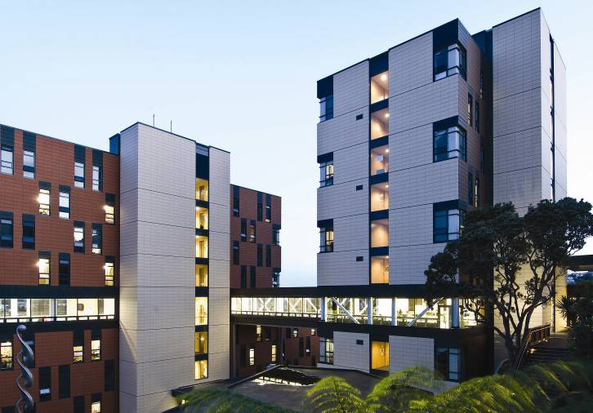
(a) Completed buildings
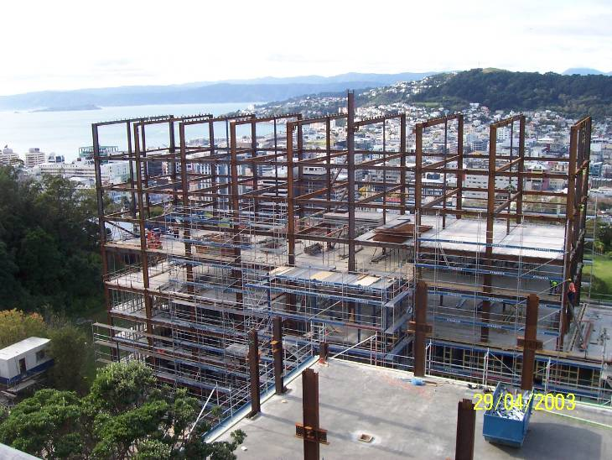
(b) Building under construction
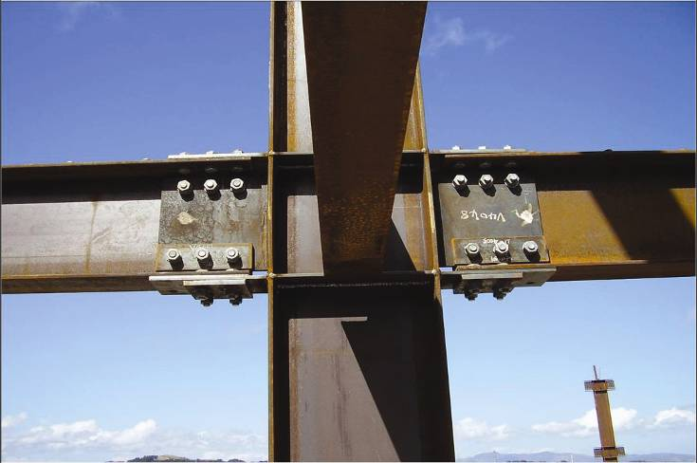
(c) Sliding hinge joints in a moment resisting frame
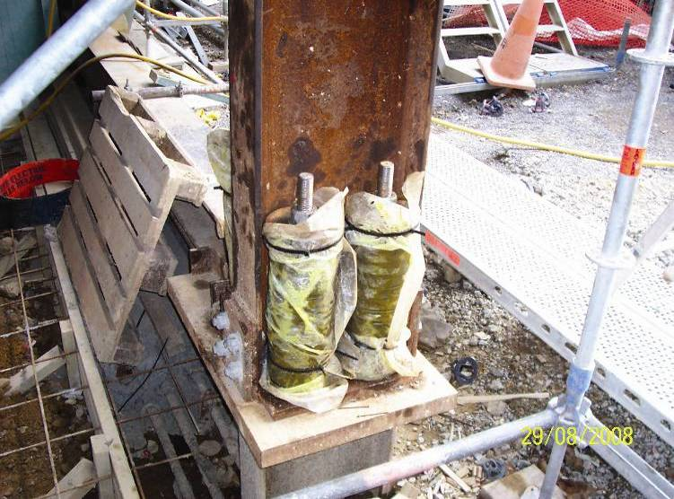
(d) Rocking column detail
Figure 23: Te Puni Student Village, Wellington (source: Sean Gledhill)

