3.3.2.2 Practical examples
1. Alan MacDiarmid building
The first multi-storey PRESSS building constructed in New Zealand was the Alan MacDiarmid building at Victoria University of Wellington (see Figure 18(a)), completed in 2009. Mr Alistair Cattanach, a director of Dunning Thornton Consultants Ltd who designed the building, has advised the Royal Commission about the project.
The project budget was $40 million (though a sixth of this cost was associated with structure required specifically for the laboratory). The building has two basement levels, which are conventionally constructed. Above this is a four-storey PRESSS building with an area of 6000m2 for teaching and research laboratories.
The structural system consists of post-tensioned seismic frames in one direction, and coupled post-tensioned walls in the other direction. This building features external replaceable supplemental dampers at the moment resisting frame joints (see Figure 18(b)) and slender steel coupling beams between rocking walls, which yield in flexure (see Figure 18(c)).
Key benefits demonstrated by this project include:
1. In a major earthquake, the rocking is initiated, which increases the system’s period of vibration. This reduces building accelerations and damage to sensitive equipment.
2. The ductile rocking joints suppress structural damage.
3. The rocking system is very stiff, with minimal displacements during small earthquakes.
4. Increased site safety, better quality assurance and speed of construction.
Challenges that needed to be confronted include:
1. Designing and detailing the floor and its connections to the walls and frames. This requires extensive work and expertise.
2. Anchorage zones for post-tensioned tendons take up space and affect building geometry.
3. Owing to constraints on lifting equipment, a sandwich wall system was used, but this system was quite complex.
4. A thorough review process was required. This included a peer review by Professor Pampanin and a scope review of concepts by Professor Priestley.
In 2009 the building was awarded the New Zealand Concrete Society Supreme Award in recognition of its innovation and advancement of concrete practice in design, construction and research.
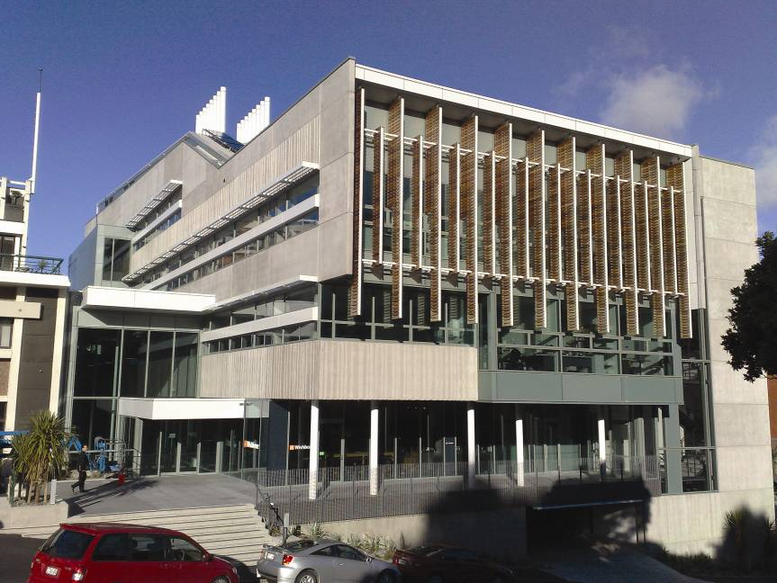
(a) Finished building
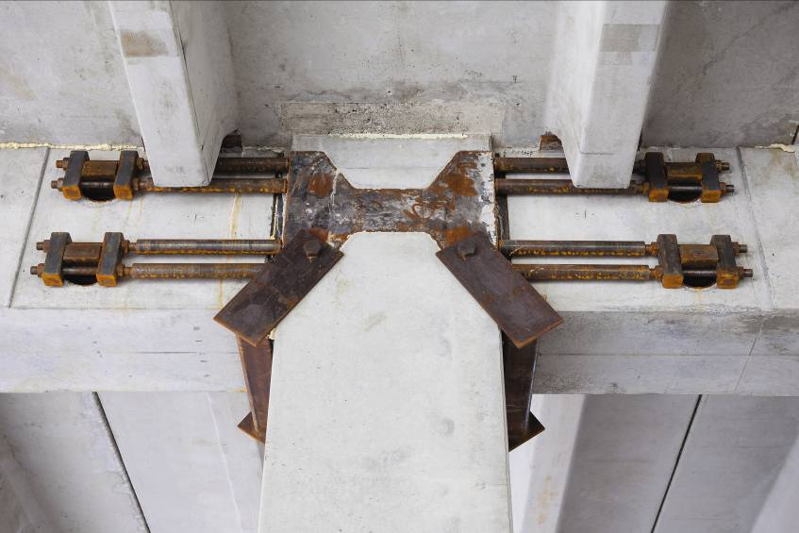
(b) Beam-column connection detail during construction
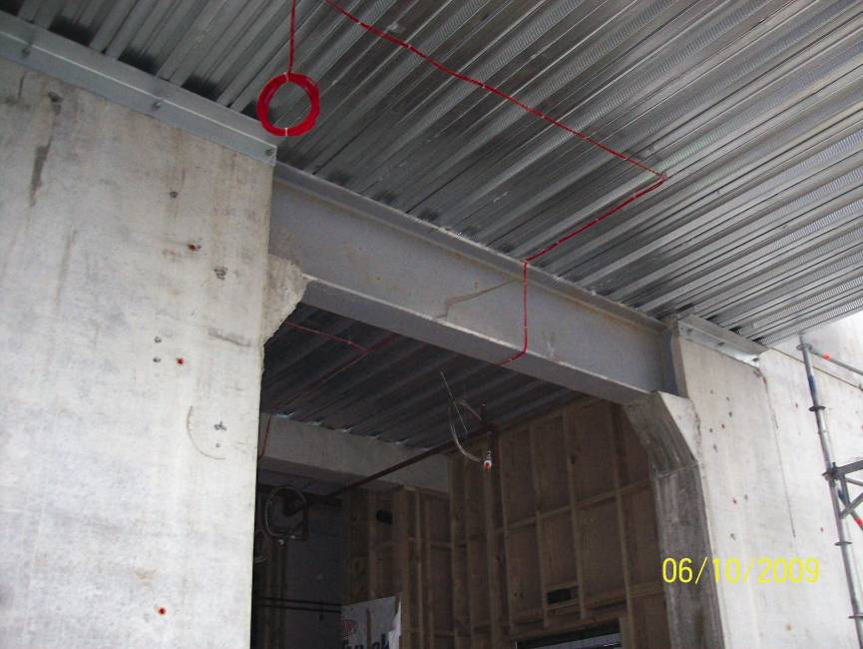
(c) Steel coupling beam
Figure 18: PRESSS technology in the Alan MacDiarmid building, Wellington (source: Alistair Cattanach)

