Section 3:
Low-damage building technologies

3.1 Introduction
Low-damage technologies are being developed that aim to achieve a better building performance by reducing damage in major earthquakes. At the hearing Professor Desmond Bull expressed the view that the engineering profession might have thought that the damage sustained in conventional capacity-designed buildings was repairable, but for various reasons this had not been the case following the February earthquake, with full demolition often considered preferable.
Professor Stefano Pampanin described the low-damage technologies as giving greater building resilience by providing damage reduction in the primary structural systems, with the potential to reduce damage to non-structural elements and building contents by damping, isolation or careful detailing. The minor damage inflicted by a design level event may be easily and economically repaired, with minimal disruption and minimal downtime for building users. For new buildings, the low-damage technologies have been developed specifically to be incorporated into the structure at a comparable cost to conventional systems using common construction practices. The low-damage concepts can also be applied to existing buildings by retrofit techniques, although this is a more difficult task.
The low-damage technologies are all inter-related and are not mutually exclusive. However, they can conveniently be described in two main categories:
1. Methods of controlling seismic response. Base isolation combined with supplemental damping, which is an energy-dissipation device, to control the response of a building by reducing accelerations and the building’s displacements.
2. Emerging forms of low-damage technology.
These come in various types. Many incorporate rocking mechanisms in conjunction with energy-dissipation devices, which act as ductile regions, absorbing energy without any significant structural damage. Most of these structural systems can be constructed from concrete, steel or timber.
Low-damage building technologies are sometimes referred to as “damage-resistant” technologies. This terminology should be used with care, as it is not possible to design and build structures that are damage-resistant under all earthquakes, as the term may suggest. In the context of the Buchanan report, “damage-resistant” means that there should be less damage than in existing construction as a result of a design level earthquake.
These low-damage technologies are at various stages of development. There has been a significant research effort into the development of low-damage design systems, such as Precast Seismic Structural Systems (PRESSS), steel friction dampers and rocking timber systems (Pres-Lam), with some buildings already completed. Mr John Hare, President of the Structural Engineering Society New Zealand Inc. (SESOC), expressed the view at the hearing that it is important that these systems genuinely deliver on their prescribed performance objectives and
do not introduce unknown future problems. A set of properties to determine the effectiveness of low-damage technologies has been proposed by Mr Hare.6 The properties of a low-damage system can be characterised and assessed under the following six categories:
1. Damage mitigation effectiveness.
2. Repairability.
3. Ability to self-centre.
4. Non-structural and contents damage.
5. Durability.
6. Affordability.
We consider that there is merit in this approach. We note also that conventional structural systems usually provide for secondary load paths, so that if one critical component fails, there is an in-built fail-safe mechanism. Low-damage technologies should also seek to satisfy this criterion.
The seismic analysis methods are an important component of the design. Professor Nigel Priestley gave evidence on the displacement-based design (DBD) of structures. He described the advantages of this emerging approach and methods for its application.7 Dr. Didier Pettinga described the practising engineer’s perspective and benefits of being able to use both DBD and force-based design (FBD) in different situations. A major advantage with FBD is the amount of software that has been written for its use. The Royal Commission can see the value in being able to use both approaches. The DBD has some potential advantages in the analysis of buildings where low-damage technologies are used. Both approaches have a range of assumptions and simplifications; therefore, a designer should carefully select a method or combination of methods to best model the real-life building behaviour.

3.2 Methods of controlling seismic response

3.2.1 Base isolation
3.2.1.1 The concept
The goal of base isolation involves separating the building from the ground so that violent earthquake motions are not transmitted directly into the structure. In simple terms, it is equivalent to adding a horizontal suspension system to the building. This adds flexibility at the level of the isolators, giving a stiff building a more gentle rolling motion during an earthquake. Base isolation is not a solution for all building types and in some cases can actually worsen effects. Expertise and careful consideration are required when using this technology.
The mechanism of base isolation is described schematically in Figure 3. In conventional construction, a building is rigidly connected or fixed to its foundations as shown in Figure 3(a). A perfectly isolated building, say, on frictionless rollers as in Figure 3(b), would remain stationary while the ground moved beneath it. A few fundamental problems with this, if it was achievable, are that the building would start to move under other external forces such as wind, and after an earthquake the building could end up some distance from where it started. In practice, devices are installed at an isolated plane, usually at the level of the foundations, to allow for controlled movement as in Figure 3(c).
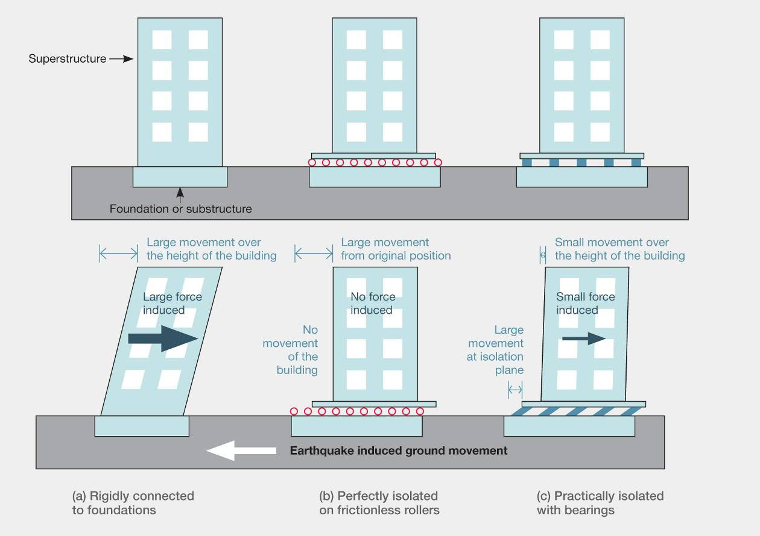Figure 3: The concept of base isolation
The modern form of base isolation is considered a mature technology and has been used in buildings since the late 1970s. The Royal Commission heard evidence from Mr Trevor Kelly, a technical director at Holmes Consulting Group, who is well familiar with this technique. He said that impediments to the adoption of base isolation arelack of awareness and understanding, misconceptions about its cost, an unsupportive regulatory framework and the perception that little is known about its performance in a real earthquake.
In fact, the performance of base-isolated structures has been tested and documented in a number of significant earthquakes in North America, Japan and New Zealand. An example is from the 1994 Northridge earthquake, where the base-isolated University of Southern California Hospital remained undamaged while other modern buildings in the same area had non-repairable damage.
Mr Kelly stated that after the 2011 Japan earthquake, a survey was carried out on the performance of buildings that incorporated some form of vibration control. The survey reported that around a third of those buildings suffered some form of damage “resulting from the dampers or moving parts not functioning properly”. The failure of some isolation devices is of interest, as these real-life events show up weaknesses (such as durability issues) not seen in laboratory tests, and possibly can be used to help refine current procedures.
3.2.1.2 Technical aspects
The primary benefit of base isolation is the decrease in base shear forces and floor accelerations. The extent of the benefit will depend on the dynamic characteristics of the building, the soil type, the magnitude of the earthquake and its proximity to the fault.
The most fundamental aspect is called the period shift. The flexibility of the isolators increases the period of response of the structure in a major earthquake, and this generally reduces the acceleration (as shown in Figure 4(a)). This is accompanied by an increase in displacement as seen in Figure 4(b). However, this displacement occurs primarily in the base isolation devices instead of in the building structure itself. This aspect can be thought of as the spring and gives a more gentle rolling motion.
The second key characteristic is damping. The damping is typically taken as five per cent for a non-isolated structure. With the higher (typically 25 per cent) damping in a base-isolated structure, there are two effects. First, it reduces the acceleration further, as shown in Figure 4(a); and second, it reduces the displacement, see Figure 4(b). This characteristic can be compared with the effect of shock absorbers in a motor vehicle. They reduce how much you bounce and also bring you back to rest much more quickly.
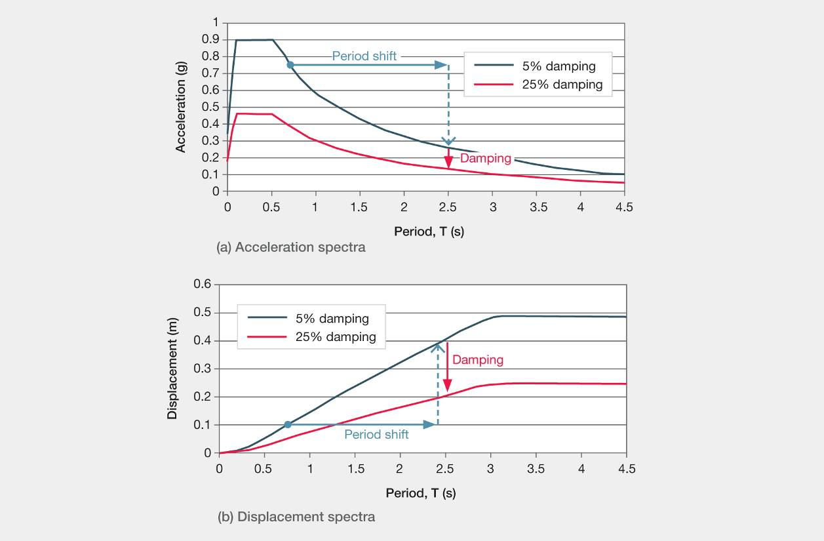Figure 4: Technical aspects of period shift and damping
Base isolation is not suitable for all soil types as soft soils transmit more earthquake energy in the long period range, which means isolation is less effective. The design spectra in NZS 1170.5 are classified into five different soil types. Stiff soil and rock sites have acceleration coefficients that decrease more rapidly in the longer-period ranges compared to design spectra for soft-soil sites. Therefore, the reduction in acceleration caused by period shift would be less for a soft-soil site than a stiff-soil site.
Another effect is the near-fault effect, where the epicentre of the earthquake is close to a building. A near-fault effect increases displacements and accelerations in the long-period range. It has a similar effect to the soft-soil effect, with increases in both acceleration and displacement. In NZS 1170.5 a near-fault effect applies to structures within 20km of a major fault and for any period greater than 1.5 seconds. Hence, most base-isolated structures in high-seismicity areas will be affected as they typically have a period greater than 1.5 seconds.
Another consequence of base isolation is rigidity under small and frequent service lateral loads such as wind and traffic vibrations. When designing a building to resist very large earthquakes, the stiffness of the isolator may be set quite high. It is therefore important to remember that in smaller earthquakes, the building will act similarly to a structure that is not isolated.
3.2.1.3 Types of base isolators
The bearings used to isolate buildings come in a range of different forms and are the subject of a number of patents. The defining characteristic is that the system decouples the building from the ground motion by interposing a low horizontal stiffness. New Zealander Dr. Bill Robinson developed the lead rubber bearing, one of the most common base isolators used in New Zealand.
The lead rubber bearing consists of alternating laminations of rubber layers and steel plates. These are bonded together to provide vertical rigidity and horizontal flexibility, with a lead plug to provide stiffness (against wind loads for example) and energy dissipation in major earthquakes. The vertical rigidity means that the building is not isolated from seismic vertical accelerations and the lead plug has the disadvantage of allowing high-frequency accelerations to pass through it.
Other types of isolators include the laminated friction rubber bearing, steel yielding isolator, spherical rubber bearing and friction pendulum bearing or sleeved pile. Mr Kelly recommended that in determining the appropriate bearing system to use, the manufacturer and designer should collaborate to meet the unique performance requirements of the building. We agree with that approach.
Ms Megan Devine, General Manager of Robinson Seismic Ltd, stated that seismic isolation devices required no maintenance during the life of the building. However, after an earthquake they should be inspected to ensure that bolts and load plates were still in place.
She went on to indicate that generally there would not be a need to replace seismic isolation devices unless the event was significantly in excess of their design specification. In this case, some isolators should be taken out for testing to check their performance. We agree with Ms Devine’s observations.
3.2.1.4 Suitability of base isolation
The technical aspects and considerations of period shift, damping, soil type and near fault can lead to parameters that determine whether a project is suitable for base isolation. Mr Kelly outlined these parameters as:
a) Building:
The first consideration is the building itself. Since the fundamental benefit of isolating a building is the period shift, buildings best suited for isolation will typically have a period of less than one second, as the effectiveness of base isolation declines in taller, longer-period structures. Rocking of tall, slender buildings can also lead to tension forces in bearings, which make them poor candidates for base isolation even if they are not already ruled out by period.
b) Site:
Firmer soils are more suitable for base isolation. As discussed earlier, softer soils make the base isolation less effective.
In Mexico City, seismic waves bounce across a large alluvial basin at a period of about 2–2.5 seconds, thus creating resonance in a building in that period range. Designers should be aware of the possibility of this effect and consideration will be important for developments in Christchurch. Response spectra from the 4 September 2010 and 22 February 2011 earthquakes show high displacements are induced in the period range of two to four seconds.8 There may be a number of reasons for the amplified response in this period range, including the response of 300–500 metre thickness of alluvial soils that are overlain by 20–30 metres of recent soft soils. These two layers may interact to amplify excitation in the two to four second range. In addition, there may be some amplification associated with basin effects.8
c) Space and installation:
With base isolation, the reduced force comes with increased displacements. Buildings therefore require clearance around their perimeter. This is typically in the order of 250–1000mm and may rule out closely spaced buildings owing to loss of potential floor area.
This clearance must be maintained for the full life of the building and may require periodic inspection to ensure it is not compromised. Any services, utilities and any other components between the ground and the building have to be specially detailed to allow for the design movement. Installation is also a challenge for existing buildings, as the building has to be supported while it is cut from its foundations and the bearings installed. Generally, only very important historic buildings will warrant this level of effort for a retrofit.
The natural candidates for base isolation have usually been:
• essential facilities such as hospitals that require continued functionality;
• historic structures and museums that have low available ductility, valuable contents and require preservation; and
• manufacturing facilities that have high-value contents and require continued functionality.
The stiffness and strength requirements are similar for base-isolated and normal ductile designed buildings, with the ductile detailing perhaps less onerous for base- isolated buildings.
Mr Kelly described a misconception that the reduction of inertial forces owing to base isolation will result in smaller structural members than in conventional buildings. This is not the case, owing to ductility. Base isolation reduces the forces typically by a factor of three to four. However, conventional buildings are also designed for similarly reduced forces in designing for ductility.
The key benefit is that base isolation reduces the amplitude of the horizontal ground motions transmitted into the structure. This makes it the leading technique to protect contents and non-structural elements, which are generally a high proportion of the total cost of a building. Accompanying this reduction in damage is the prospect of continued functionality immediately after the earthquake event.

3.2.2 Supplemental damping devices
Mr Hare observed that one of the dilemmas a designer faces at the conceptual stage is whether to design a stiff building with smaller lateral displacement and high accelerations, or a more flexible building with higher displacement to reduce floor accelerations. Reducing lateral displacements will result in less damage to non-structural components (that is, cladding) but the floor accelerations will be higher and the motion more violent for occupants and building contents. A flexible building will have the opposite effect. One way to improve both aspects is supplemental damping, which can reduce both acceleration and displacement.
Supplemental damping provides a mechanism for the dissipation of seismic energy in a controlled manner. Damping devices can be used in a range of applications and can be incorporated into new buildings or retrofitted. They can be placed at foundation level or elsewhere in the structure
at diagonal braces and at the rocking joints. Supplemental damping is generally used as part of base-isolation schemes, or alone in tall buildings that cannot effectively be base-isolated.
Professor Pampanin explained that cost-efficient, externally located supplemental dampers are being developed. These can, if required, be easily removed and replaced after an earthquake event. This type of structure allows for a modular system with replaceable sacrificial components that act as energy-dissipation devices at the rocking connection. Together, the rocking joint and the energy-dissipation device have a similar action to a plastic hinge. However, while a plastic hinge is very difficult to replace and repair after a major earthquake, it is a relatively simple matter to replace or repair an energy-dissipation device.
There are three broad categories of damper: viscous dampers, friction dampers and yielding dampers. These employ various mechanisms to convert earthquake energy into heat.
3.2.2.1 Viscous dampers
As explained in the Buchanan report, viscous dampers (also called fluid viscous dampers) function by the movement of the fluid or by the plastic extrusion of lead within a cylinder, as shown in Figure 5(a) and (b). The high-force-to-volume (HF2V) or lead-extrusion dissipater works by having a bulged shaft that passes through encased lead.
These devices can be used in diagonal braces or a rocking interface. Figure 5(c) shows dampers connected to a foundation and a rocking timber element.
A limitation is that some of these devices are expensive.
3.2.2.2 Friction dampers
Friction dampers are used with low-damage steel and timber structures, and can be used in moment resisting frames, diagonal braces or rocking walls. Usually two metal surfaces are clamped together with bolts in slotted holes. The main concern with this device is durability. Currently, it is only recommended for use in dry internal environments. Accelerated corrosion testing is under way at The University of Auckland.
3.2.2.3 Yielding dampers
Yielding dampers (also called hysteretic dampers) are typically made of ductile steel, which yields and deforms plastically. The buckling restraint brace (BRB) comprises a yielding steel core that is encased to prevent buckling when the brace goes into compression. The steel core is debonded from the surrounding material so that it can freely slide, as shown in Figure 6(a). This ensures the brace has a similar strength and stiffness in both tension and compression. Professor Charles Clifton said in evidence that the BRB can be used in new construction or as a retrofit to various structural systems. Proprietary BRBs are common in Japan and North America. In Professor Clifton’s view, the small New Zealand market and its distance from the main suppliers mean that these proprietary products are unsuitable for here. He believes a better option is to develop an equivalent BRB for use in New Zealand. A research project at The University of Auckland is finalising a design procedure for a BRB, as shown in Figure 6(b).
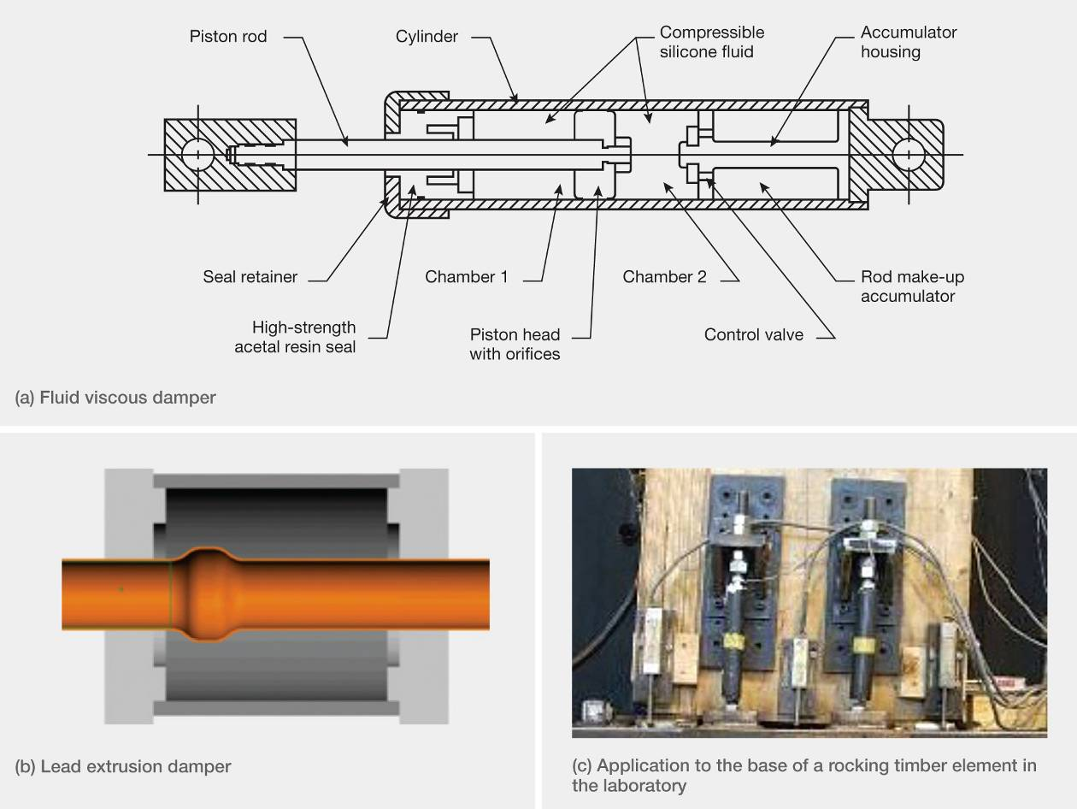Figure 5: Viscous dampers (source: Buchanan report)
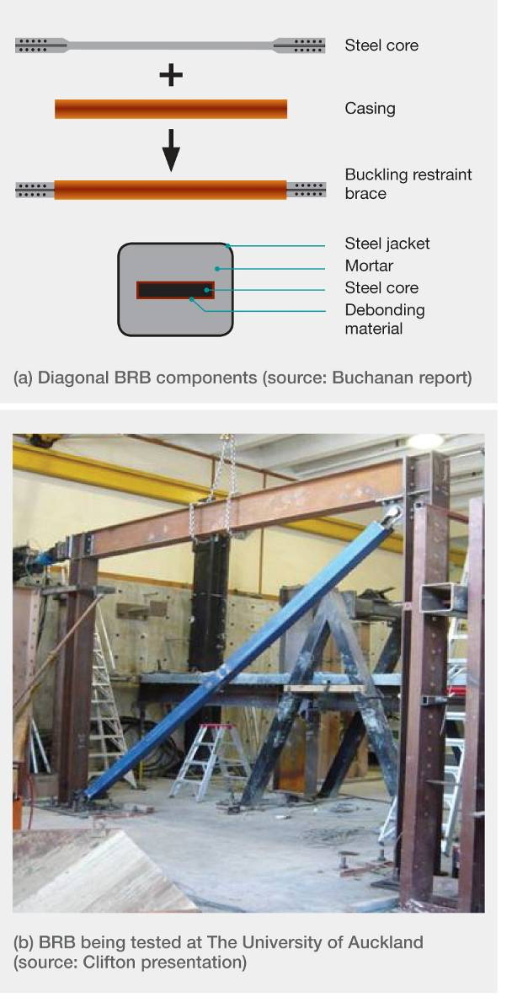
Figure 6: Buckling Restraint Brace (BRB)
Another form of hysteretic damping device, shown in Figure 7(a) and (b), can be placed between concrete or timber rocking walls. The U-shaped flexural plate (UFP) was developed by a New Zealand pioneer in this field, Dr. Ivan Skinner. It is a simple device that has been thoroughly tested in laboratories. The very good energy dissipation obtained with this device is shown in Figure 7(c).
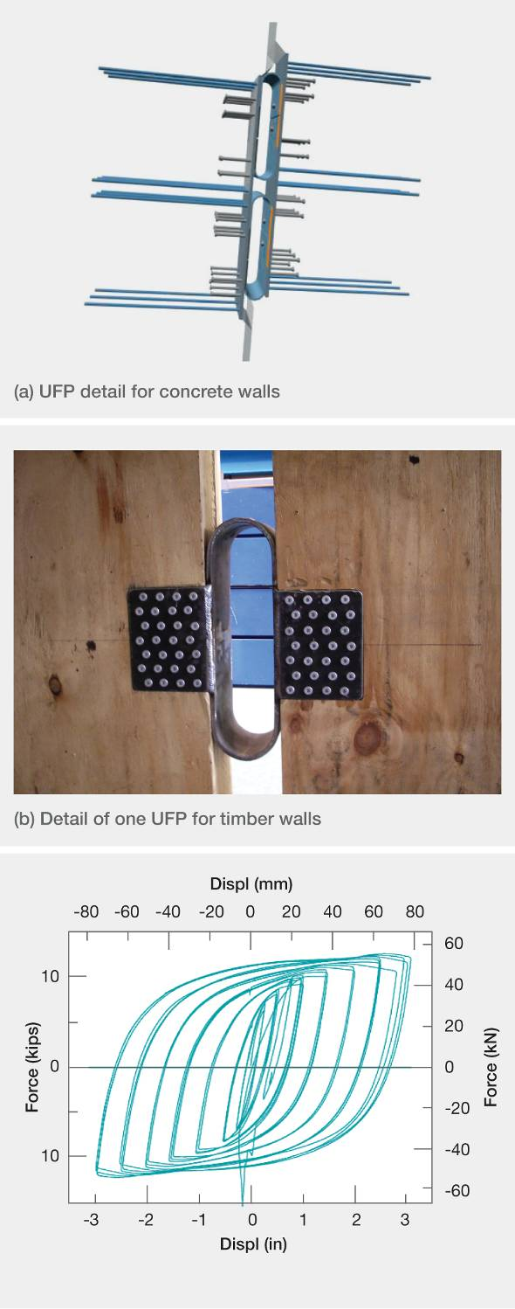
Figure 7: U-shaped flexural plate: typical details and characteristics (source: Buchanan report)
Further information about the different types of dampers and their application to different structural forms in concrete, steel and timber can be found in the Buchanan report.

3.2.3 Examples of base isolation and supplemental damping devices
The William Clayton building (Figure 8(a)), constructed in Wellington in the late 1970s, was the first base-isolated structure to use lead rubber bearings. Other buildings have followed, including the Museum of New Zealand Te Papa Tongarewa and Parliament Buildings (an example of a seismically retrofitted building) in Wellington, and various regional hospitals. The Christchurch Women’s Hospital is the only base-isolated building in the South Island. Lead rubber bearing systems have been extensively used for base isolation in Japan, China, California and elsewhere.
An example of a building incorporating supplemental damping devices with a novel method of base isolation is the Union House building, built in the 1980s on the Auckland waterfront (see Figure 8(b)). This structure dissipates seismic energy through flexural yielding of steel members located near its base. The building is isolated on long piles in sleeves that allow lateral movement. Ms Devine stated in evidence that there had been a seven per cent saving on the total construction cost ($6.6 million) thanks to a three months’ shorter construction time.
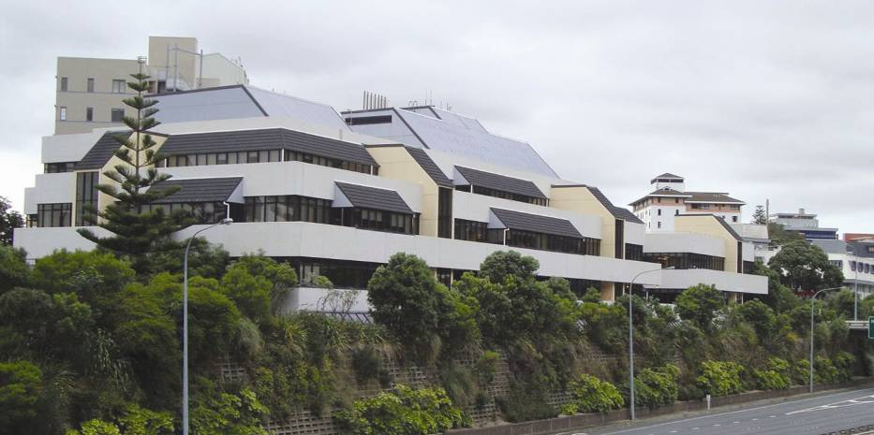
(a) William Clayton building, Wellington (source: Richard Sharpe)
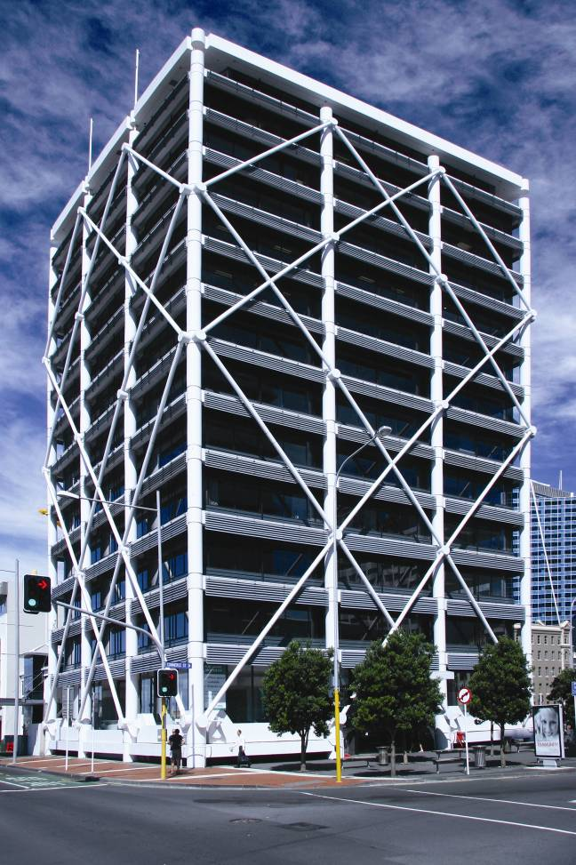
(b) Union House building, Auckland (source: Trevor Kelly)
Figure 8: Buildings incorporating methods to control seismic response

