Section 8:   
Discussion of representative sample issues

## 8.1 Introduction

### 8.1.1 General

In this section issues noted in our study of the representative sample of buildings are brought together to enable some overall observations to be made.

Structural design and material Standards are largely based on the results of structural testing, so it is desirable to relate the observed earthquake damage to the results of structural testing on individual structural elements. This aspect is discussed in section 8.1.2 of this Volume.

Before examining the observed performance of different structural elements in the Christchurch earthquakes the influence of strain ageing of steel, which can change the load-deflection characteristics of structural steel members and reinforcement, is briefly discussed in section 8.1.3 of this Volume. The method developed to assess the remaining strain capacity of steel in buildings is briefly outlined in section 8.1.4 of this Volume.

In subsequent sections the observed performance of individual structural elements is considered, together with the way in which these elements interact.

### 8.1.2 Comparison of observed behaviour and results of structural tests

In structural design a number of conservative assumptions are made. From an analysis of the proposed building, the design engineer determines the minimum required strength of the individual components to satisfy the ultimate and serviceability limit states. This is referred to in the New Zealand Standards as a design action. Generally the value will be conservative, as this analysis assumes the most adverse possible combination of actions. Having obtained a design action, such as the minimum flexural strength of a member, the design process then assures this minimum strength is achieved with a high level of certainty, given the variability of materials and workmanship, the reliability of design equations, etc. The design strength, which has to be equal to or greater than the design action, is taken as the nominal strength multiplied by a strength-reduction factor. The nominal strength is a theoretical value calculated assuming that the materials in the member have their lower characteristic strengths. Consequently, for example, if the minimum quantity of reinforcement is used in a reinforced concrete member, the strength of that member will on average be greater than the nominal strength in more than 95 per cent of cases. The strength-reduction factor for reinforced concrete members subjected to flexural and axial load is 0.85.

In practice the nominal strength nearly always exceeds the minimum required value. This arises as the reinforcement sizes are not infinitely variable, and for simplicity it is important to maintain similar reinforcement arrangements for similar members. A typical ratio of nominal strength to the minimum required would be 1.15:1.0.

The nominal strength is calculated assuming the material properties have their lower strength characteristic values. Replacing the lower characteristic strength by average material properties would increase the strength by a factor of about 1.15.

The strength-reduction of 0.85 for flexure in reinforcement is equivalent to a factor of safety of 1.18.

Allowing for all of the factors indicates that the average strength will be around 1.5 times the design action.

In the design of a ductile structure a structural ductility factor of around 5 is likely to have been used, which if based on the likely average strengths would reduce the structural ductility factor to 3.3. Allowing for the conservative combination of actions assumed in the analysis, the actual ratio of average member strengths to the corresponding actions induced by an earthquake with an intensity equal to the design-level earthquake is likely to correspond to the values associated with a structural ductility factor between 2.5 and 3.0. A number of other factors such as energy dissipation in soils, increased damping associated with non-structural elements, etc., may further reduce the inelastic demands in an earthquake compared with design values.

In any comparison between damage sustained in an earthquake and that observed in structural tests, it is essential to recognise the inherent conservatism of structural design. Given all the variables that may occur this conservatism is essential if the risk of failure is to be kept low as specified for the ultimate limit state in our design codes and Standards. On the basis of the discussion above one could expect that on average the damage observed in the February earthquake would correspond to that observed in individual components tested to displacement ductility factors of 3.0–4.5.

It is also important to note that most structural tests apply an appreciable number of inelastic load cycles of increasing magnitude, all of which increase the damage sustained by the test specimen. Owing to the short duration of the February earthquake, very few inelastic load cycles would have been applied to the structures before the maximum displacement was imposed.

### 8.1.3 Significance of strain ageing

Strain ageing develops in reinforcing and structural steel over a period of a few weeks after it has been strained into the inelastic range. The extent to which strain ageing develops depends on the chemical composition of the steel, the temperature and the level of strain to which it has been subjected. The chemical composition and source of manufacture have varied over the years, so no single set of figures can be given for the influence of strain ageing in existing buildings. In structures where strain levels are assessed as critical we recommend that samples of reinforcement be broken out of the structure and tested to check for possible adverse effects of strain ageing. The Royal Commission understands that some batches of reinforcement used in the past are considerably more sensitive to strain ageing than is the case with structural steel members and concrete reinforcement being used at present.

Strain ageing causes:

* an increase in the yield stress;
* an increase in the maximum stress (though in many cases this increase is small);
* a reduction in the ductility of the reinforcement; and
* a decrease in the transition temperature at which the reinforcement ceases to behave as a ductile material1.

Momtahan et al. (2009)2 found from tests on New Zealand-manufactured reinforcement obtained from Pacific Steel in 2008 that strain ageing increased with:

* the strain level in the reinforcement in their tests, which varied from two to 15 times the yield strain; and
* the time interval between when the strain was induced and when the reinforcement was retested to measure the effect of strain ageing, which ranged from three to 50 days.

At a strain level of 10 yield strains (about 1.6 per cent) in Grade 300 reinforcement after a period of 50 days the yield stress had increased by about 13 per cent. No significant increase in the ultimate stress or decrease in ductility was noted in these tests. However, different values may be expected for reinforcement used in earlier decades or obtained from overseas.

### 8.1.4 Assessment of strain levels induced in reinforcement

To assess the strain levels in reinforcement that had crossed cracks in concrete, Leeb hardness measurements (surface hardness) were made on reinforcement extracted from damaged buildings in Christchurch. Reinforcing bars were broken out of buildings and tested for their remaining strain capacity. Tests were conducted on some bars that had been strained into the inelastic range at cracks, and some bars that had not been strained into the yield range. The latter were tested to establish the original properties of the bars that had not been yielded.

Leeb hardness measurements are made by a machine that fires an impact body at the surface and records the details of its impact (Allington, 2011)3. This process is repeated along the bar at close centres, enabling variations in surface hardness to be measured, and variations are related to the strain level in the reinforcement. With this information it is possible to assess the length of bar that has been strained into the yield range, and the maximum strain levels sustained at different locations along the bar. One issue with these tests that needs clarification is the possible significance of the change in material properties of the reinforcement caused by previous strain ageing of yielded reinforcement.

Tests on a number of bars have indicated that high strain levels were sustained by some reinforcement that crossed cracks in concrete. This raised concern that the reinforcement might not have the capacity to sustain additional inelastic deformation in the event of a further significant earthquake. Critical conditions were identified in:

* walls with only one crack or widely spaced cracks apparent after an earthquake;
* the potential plastic hinge zones of beams where only a single crack appeared to have formed in potential plastic hinge zones close to the face of the columns; and
* wide cracks in some floors.

Single cracks in potential plastic hinge zones in beams were seen in a number of buildings that were assessed for the Royal Commission, including 90 Armagh Street, the Christchurch Central Police Station and 151 Worcester Street. Single or widely-spaced cracks were seen in the structural walls of the Gallery Apartments, the PGC and IRD buildings. Wide floor cracks were seen in many buildings and they were common in floors constructed with precast prestressed floor units such as hollow-core or double-tee units.

## 8.2 Performance of reinforced concrete buildings

### 8.2.1 Beams in ductile moment resisting frames

The formation of single cracks up to 5mm wide in potential plastic hinge zones in beams is of concern, as it appeared to indicate that high strains had been induced in the reinforcement, limiting the strain capacity available for further seismic resistance. The observed behaviour of the potential plastic hinges in the beams appeared to be different from that observed in laboratory tests of beams, where multiple cracks formed in a radial pattern in plastic hinge zones, and yielding extended along the member for a length of about one beam's depth. However, we suggest that a closer examination of the evidence might have lead to a different conclusion.

The mechanism of a plastic hinge zone is shown in Figure 137, which is based on a beam in a ductile frame as described by CCANZ (2008)4 with a clear span of 6450mm between columns. The beam depth is 900mm and it supports a floor that spans nearly 11m. The floor consists of 300mm hollow-core units spaced 750mm apart with timber infill and a 75mm concrete topping reinforced with 12mm Grade 300 bars in both directions. The ratio of bending moment to shear force at the column face corresponds to a length of 1.78m, as shown in Figure 137(b).

Under seismic actions a primary crack forms in the beam close to the face of the column. This crack reduces the tensile stresses in the concrete in the hatched area shown in Figure 137(c) for a distance of L1 along the beam. If the bending moment transferred across the primary crack is of sufficient magnitude a second primary crack may be initiated at a distance of between L1 and 2L1 from the first primary crack. The location of these cracks is independent of the bond characteristics of the reinforcement. As shown, the spacing of these cracks is generally about 1.5 times the distance from the extreme tension fibre to the neutral axis. However, if the bending moment increases sufficiently an additional primary crack may form between the more widely spaced primary cracks.

Secondary cracks may form between the primary cracks if the reinforcement crossing the crack can transfer sufficient tension force to exceed the direct tensile strength of the concrete surrounding the reinforcement (see commentary to NZS 3101:20065, section 5 for the difference between the direct and flexural tensile strengths of concrete). This critical area of concrete is shown hatched in Figure 137(d). Secondary cracks are generally spaced at about three times the distance of the centroid of the bars from the extreme tension fibre in the beam. However, stirrups tend to act as crack initiators so the spacing of the cracks is often equal to that of the stirrups.

In the beam shown in Figure 137 the stirrup spacing is 150mm, which indicates that a secondary crack may be expected to form 150mm from the primary crack. If a secondary crack forms during an earthquake it will afterwards close to a small width unless the reinforcement at this crack has yielded, in which case it will remain open. If the reinforcement does not yield, the crack will be difficult to see unless the concrete surface is examined closely with a magnifying glass.

In Figure 137 the secondary crack is located at a distance of 150mm from the primary crack. The bending moment at this secondary crack is 91.5 per cent of the bending moment at the primary crack. The tension force at the primary crack must increase by at least 1/0.915, or 9.3 per cent, to cause the reinforcement to yield at the secondary crack. Note that diagonal cracks and the associated tension lag in the reinforcement generally develop after extensive flexural cracks have formed.

Figure 137(a) shows the measured stress-strain response of a deformed 24mm Grade 300 bar (Matthews, 2004)6. The ratio of ultimate stress to yield stress in this bar was close to the maximum permissible value of 1.5 for Grade 300 reinforcement in the Steel Reinforcing Materials Standard, AS/NZS 4671:20017. The corresponding minimum ratio in the Standard is 1:15. In Figure 137(a) the stress-strain relationship in the strain hardening range has been scaled to correspond to the minimum ratio of peak stress to yield stress. While the test carried out by Matthews (2004)6 shows that strain hardening is initiated at a strain of close to 1.25 per cent, other tests (Allington, 2011)3 show initiation at strain levels above 2.5 per cent.

From the stress-strain relationships shown in Figure 1(a) it can be seen that to reach a strain-hardening level of 9.3 per cent requires strain levels of 1.8–4.0 per cent. Now assume that the reinforcement yields over a distance of around eight bar diameters and that the strain varies linearly between the crack and locations where the yield strain is reached. Then the width of the primary crack will be in the range of 1.8–5.2mm, which gives material strain levels of 15–33 per cent of the maximum design values given in NZS 3101:20065.

Once diagonal cracks form in the plastic hinge, the length over which the reinforcement yields is typically extended by 40 per cent of the beam depth, owing to tension lag. Generally, however, relatively high strains are induced in the reinforcement before this stage is reached, as discussed above.

Our conclusion is that numerous observations of plastic hinge zones with only one crack several millimetres wide do not contradict test results obtained from beam-column sub-assemblies. Relatively high strains need to be sustained at the critical section of a plastic hinge before yielding can spread along the beam. This process may be assisted for actions associated with aftershocks by moderate strain ageing of the highly strained reinforcement near the face of the column, or another critical section in a plastic hinge. The high localised strain in the longitudinal reinforcement close to the column face does not necessarily indicate a significant decrease in seismic capacity of the plastic hinge zone. Once strain hardening has taken place, yielding of the reinforcement extends along the beam. Then, as plastic hinge deformation further increases, the rate of increase of strain diminishes in the reinforcement close to the critical section.

One aspect of the behaviour of plastic hinges in beam and beam-column sub-assemblies requires further investigation. Generally in tests the loading sequence involves applying displacement cycles of gradually increasing magnitude until failure occurs. Each time the reinforcement yields and a crack opens up, the reinforcing bars are displaced relative to the concrete to enable them to span the crack. This movement reduces the bond resistance. Consequently, the distance along which yielding penetrates into the beam-column joint zone increases with each inelastic load cycle. In the February earthquake the major displacement cycles took place without the multiple small cycles that have been applied in structural tests. Consequently, the yield penetration of the bars into the beam-column joint zones of buildings in Christchurch is likely to have been appreciably less resulting in higher peak strains than was the case in laboratory tests.

Research is needed into the influence of different loading sequences on yield penetration of reinforcement into beam-column joints.

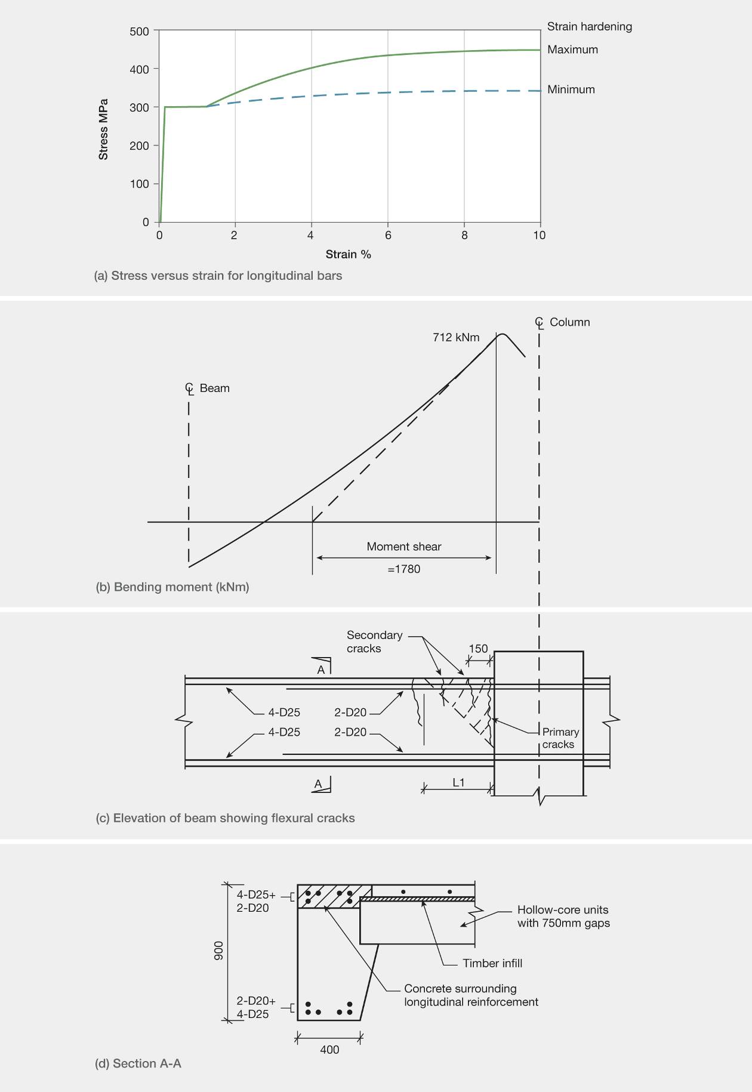

Figure 137: Crack formation in a beam

## 8.2.2 Structural walls

8.2.2.1 Crack control in lightly reinforced structural walls

In the Gallery Apartments building a single relatively fine crack was seen in one of the walls. On further investigation it was found that the reinforcement crossing this crack had failed in tension. This gave rise to concern that the strains arising in reinforcement crossing other cracks might be much higher than was anticipated from laboratory tests.

It is likely that the flexural crack in the wall was a primary crack induced by seismic actions exceeding the flexural cracking moment of the wall. As the wall was several metres in length any further primary crack would be several metres away from the first one. However, such a crack could only form if the bending moment that could be sustained at the section containing the first primary crack was of sufficient magnitude to enable the bending moment induced at the location of the second primary crack to exceed the flexural cracking moment. As indicated in the next paragraph, this is unlikely to have happened in the walls of the Gallery Apartments building (see section 6.5.1.1 of this Volume), because of the low proportions of longitudinal reinforcement in the walls.

Inspection of the drawings indicates that typically the proportion of longitudinal reinforcement in the walls was 0.17–0.22 per cent, which satisfied the minimum of 0.14 per cent for Grade 500 reinforcement in NZS 3101:19958. With 0.22 per cent longitudinal reinforcement stressed to 1.15 x 500MPa (where the factor 1.15 allows for strain hardening), the average tensile stress induced in the concrete is equal to 1.25MPa. As noted in our discussion of the Gallery Apartments building, the concrete compression strength in the walls was measured on two cores taken from the walls and assessed from a number of Schmidt Hammer tests. The assessed strength was of the order of 50MPa. Two further cores were taken from the wall and the direct tensile strength was assessed from split cylinder tests as 2.4 and 3.4MPa. The calculated average tensile strength given in NZS 3101:20065 (see commentary to section 5 of this Volume) is 4.1MPa, with upper and lower characteristic strengths of 2.8 and 5.4MPa. The clear indication from the assessed and measured tensile strengths of the concrete is that there was insufficient longitudinal reinforcement to initiate secondary cracks. Consequently yielding of reinforcement was confined to the immediate vicinity of the single crack, which induced high tensile strains in the reinforcement and may account for the observed failure of the reinforcement at the crack.

The minimum longitudinal reinforcement proportion given in the present NZS 3101:20065 is defined by the

expression , which allowing for strain

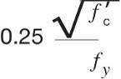

hardening gives an average tensile stress in 50MPa concrete of close to 2MPa. The minimum reinforcement content recommended in SESOC (2012)9 is

for which the corresponding average tensile stress is 3.2MPa. Cracking would probably develop at tensile stress levels below the average tensile strength, owing to stress concentrations close to the bars and eccentric actions in the wall. However, it is clear that current minimum design specifications are inadequate to ensure that cracking will spread over a number of secondary cracks, allowing ductile behaviour to develop. Research into crack control in walls is highly desirable. Increasing the minimum longitudinal (vertical) reinforcement has the disadvantage of increasing the strength of the walls and hence increasing the cost of the foundations.



There are two potential approaches that can be used to improve crack control, both of which have advantages and disadvantages:

1. A proportion of the longitudinal (vertical) reinforcement may be concentrated at the ends of the wall. This would ensure sufficient reinforcement in these zones to initiate secondary cracks in the immediate locality. A lower proportion of reinforcement is required between the zones of concentrated reinforcement, to ensure that the secondary cracks formed in the end zones can spread over the remainder of the wall. A further advantage of this reinforcement arrangement is increased strength for the serviceability limit state, as the strength increases more rapidly with displacement than is the case when reinforcement is uniformly distributed. However, concentrated reinforcement in the compression zone in walls with low axial load ratios

increases the potential for elongation of the wall, which may reduce the lateral resistance to sliding shear. Concentrated reinforcement may also increase interaction with other structural elements due to increased elongation of the walls.



2. At the critical section of a potential plastic hinge longitudinal reinforcement may be de-bonded for a length by wrapping the bars in a grease-impregnated tape. This will ensure that the bar yields over the de-bonded length and that a single wide crack can form under critical loading conditions. This has implications for shear transfer across the crack and may cause more of the shear force to be resisted by the compression zone of the wall, and loss of torsional resistance where the wall is part of a shear core. This was one of the potential failure mechanisms identified for the PGC building.

8.2.2.2 Shear core walls

In some buildings, such as the PGC and Bradley Nuttall House buildings, walls surrounding stairwells, lifts and sometimes toilets formed a rectangular core of walls (shear core) acting as a unit to provide lateral force resistance to the building. In the PGC building this core was subjected to both torsion and flexure. Bending action may have induced a primary tension crack that extended along the wall. An open crack of a few millimetres may then have resulted in a loss of shear transfer by aggregate interlock action, leading to a redistribution of torsional actions that initiated failure. The longitudinal reinforcement in the walls had a cover of 92mm, which created good bond conditions, so it is likely that in the PGC building the opening up of the crack led to tensile failure of the bars. The same outcome could have been achieved by a single wide crack forming where reinforcement was de-bonded. Consequently there are situations where de-bonding reinforcement might not achieve the desired outcome.

If sufficient shear stress caused by torsional moments acting on the shear core can be transferred across tension cracks by aggregate interlock, diagonal cracking may occur. In this event the shear stresses are resisted by diagonal compression forces in the concrete acting together with tension forces in both the horizontal and vertical wall reinforcement. However, when the flexural bending moment and its associated tension force increase, there is a decrease in the tension available to resist the longitudinal component of the tension force associated with the torsional moment. As a result the torsional resistance decreases as the flexural bending moment increases, and when the longitudinal reinforcement yields because of the flexural moment, torsional resistance is minimal. In assessing the potential seismic performance it is important to understand this interaction. The commentary to NZS 3101:20065 discusses it but the equations for the interaction of flexure and torsion are not included in the Standard.

We recommend that interaction equations for flexure and torsion be added to NZS 3101:20065 and that the significance of wide cracks in members as an influence on shear and torsion be identified in documents used to design or assess the potential seismic performance of buildings.

8.2.2.3 Walls under high axial loads

In the assessment of the HGC it was found that wall D5–6 failed, possibly by buckling. We noted that the criteria for buckling of a compression zone of a wall in NZS 3101:20065 were based on the assumption that the compression zone had been subjected to extensive yielding in tension during a previous half-cycle of loading. Prior tensile yielding of reinforcement in a compression zone reduces the buckling stability of the compression zone and hence the buckling stability of the wall. Consequently the stability criterion for walls subjected to low axial load ratios

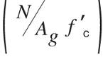

is well founded. However, buckling in walls subjected to moderate and high axial load ratios is not covered, as in these walls extensive tensile yielding of reinforcement may not occur.

We recommend that suitable equations be developed to define the minimum slenderness ratios for these walls, with allowance made for the axial load ratio and the lateral displacement imposed on a wall. Until this work has been carried out it is recommended that in a ductile detailing length where the axial load ratio exceeds 0.10 the ratio of clear height to thickness should be equal to or less than the smaller of the ratios given by current design criteria in NZS 3101:20065, or 10.

A number of unexpected failures occurred in structural walls, apparently caused by a combination of axial load, bi-axial bending moments and shear forces leading to buckling of reinforcement. This buckling was probably associated with compression being imposed on reinforcement after it had been subjected to tensile yielding in a previous half-cycle of loading.

It is noted that the axial force acting on a structural wall is difficult to determine with any degree of accuracy. When bending moments act on a wall, elongation occurs. The relative vertical movement is partially restrained by floors and other vertical structural members. In some cases, this restraint can result in additional high axial compression forces being imposed on a wall. In a large-scale structural test this action has been observed to increase very significantly the lateral load resistance of the wall10. In other situations this restraining action might reduce the ductility of the wall or change its load-deflection characteristics. It should be noted that current standard methods of analysis do not predict elongation, so axial loads determined by these methods can be significantly in error in terms of the critical axial forces acting on walls.

In design it has been standard practice to determine where compression zones form in walls subjected to their maximum design bending and axial loading. Confinement reinforcement in the compression zones is provided for this condition. Between these zones no confinement or restraint against bar buckling has been required. However, in a half-cycle of loading, high tensile strains may be induced in the vertical reinforcement in the mid-region between the confined regions of the wall. When the bending moment decreases and starts to reverse in direction, the reinforcement in the mid-region is subjected to compression by the axial load. As the crack is initially still open the vertical reinforcement has to yield back in compression before the crack can close to enable the concrete to act. Under these conditions the buckling resistance of vertical reinforcement is reduced.

In a number of cases, including the Westpac Tower building, crushing of concrete and buckling of the reinforcement occurred in walls outside the confined end zones. This problem is identified in the draft proposals9, and we support the suggestion made in the document in regard to the ductile detailing length, that:

• the full length of the compression zones associated with the ultimate limit state be confined, rather than the limited portion of the compression specified in   
NZS 3101:20065; and

• anti-buckling ties be added to restrain all the longitudinal (vertical) reinforcement in the wall between the confined zones.

8.2.2.4 Coupled structural walls

Since the mid-1970s coupled shear walls have been proportioned so that yielding is confined to the base of the walls and to the coupling beams. The over-strength actions in coupled walls, and in particular the axial forces induced in the individual walls, are calculated from the over-strengths of the coupling beams. However, one aspect of behaviour has been ignored in this process: the flexural and shear capacity of the coupling beams increases when axial compression is imposed on these members. With the formation of plastic hinges in the coupling beams, elongation occurs and pushes the walls apart. However, the walls are almost invariably tied into the floors, which will partially restrain this movement so that coupling beams are compressed and floors tensioned. This action may result in either a significant increase in the strength of the coupled shear wall or the development of a wide crack and failure of the reinforcement in the floors.

The IRD building (section 6.5.3) provides an example of where the interaction of a coupled shear wall with the floors is likely to have increased the strength of the walls. That increase may also have increased the forces acting on the foundations. If so, it may have contributed to the differential settlement of the piles under the shear core relative to the piles under the perimeter walls.

The potential influence of floor slabs on coupled shear walls needs to be identified and the significance of this action assessed in a research project.

### 8.2.3 Floors as diaphragms

8.2.3.1 Design actions for ground acceleration

The current Earthquake Actions Standard NZS 1170.5:200411 does not give a clear method of determining diaphragm forces in the floors of multi-storey buildings, but does provide equations to determine design accelerations of floors at different levels. These could be used to estimate the maximum inertial force acting on a floor, although they do not appear to allow for the likely increase in floor accelerations in parts of floors where significant torsional displacements occur. The commentary to NZS 1170.511 indicates that these equations can be applied to a wide range of structural and non-structural items attached to floors or other structural elements. However, nowhere does it suggest that these equations can be used to calculate the total forces due to inertia forces acting on the floors as a whole.

Floors acting as diaphragms are required to:

* transfer forces between lateral-force-resisting elements;
* resist self-strain forces such as those that arise from in-plane deformation of walls that have different strengths for lateral displacement in the forward and backward directions (see section 8.4); and
* transfer inertial forces caused by gravity loads on the floor to the lateral-force-resisting elements.

Drag bars are required in many buildings to tie diaphragms into lateral-force-resisting elements. This particular aspect of design appears to have been inadequately considered. Given the lack of treatment of this problem in the design Standards, this omission is not surprising.

The need to tie floor slabs into individual lateral-force-resisting elements depends on the position of the elements used to resist lateral force. For a shear core surrounded by floors the situation is generally not critical as the force can be resisted by lateral pressure between the floor slab and one or more of the walls of the shear core (as in the IRD building), or the indirect route of shear transfer between the walls and the floor may provide continuity reinforcement between the floor and the wall (as in the Bradley Nuttall building). The situation is more critical when lateral-force-resisting elements are on the perimeter of the building. In this situation beams need to be tied into walls and columns so the forces can be transferred, or drag bars may be required to pick up the necessary forces from the floor slabs.

All columns and walls need to be adequately tied into floors to provide restraint against buckling and ensure that they do not separate from the floor slab.

From observations of our representative sample of buildings we consider that structural engineers need additional guidance on how to assess the magnitude of membrane forces and design for membrane actions in floors.

8.2.3.2 Elongation of reinforced concrete beams

The Royal Commission examined a number of cases where elongation of reinforced concrete beams caused wide cracks to form in the floors. In one case (Clarendon Tower) the cracks were so wide that the floors were in danger of collapse through the precast floor units being pulled off their support ledges. Elsewhere cracks in the floors were wide enough to cause the mesh reinforcement to fail in tension (Craigs Investment building, Clarendon Tower, 151 Worcester Street) and again, in the case of the Clarendon some of the columns were separated from the floors. The development of wide cracks can reduce a floor’s ability to transmit diaphragm forces to walls and columns on its perimeter, and can result in failure of the reinforcement tying these elements to the floor.

The cast-in-situ concrete floors that we examined had behaved well. With these, elongation of beams generated a number of fine cracks that are not a concern in terms of seismic performance. Concrete slabs cast on metal trays formed from metal sheeting (Traydec, Hibond) appear to have performed well where they were used with steel beams. Their performance with reinforced concrete beams is likely to depend on the type of reinforcement used in the in situ concrete topping. The use of mesh reinforcement can result in the floors sustaining a brittle failure mode, so this is not suitable for resisting membrane forces, particularly where elongation induces wide cracks in the floor.

The situation where floors are built up using precast prestressed concrete units (double-tee and hollow-core) with in situ concrete topping differs from that where the floors are fully cast-in-situ. In the case of the precast units the prestressing prevents or restrains crack widths from opening in a direction normal to the span of the unit. As a result nearly all of the elongation in the plastic hinge closest to the support position of the precast units opens up a single crack between their ends and the structural element supporting them. Under sufficient elongation the reinforcement crossing the crack may fail in tension, particularly where non-ductile mesh has been used. The loss of support length for the precast units, caused by beam elongation and spalling of the concrete (behind the precast unit and from the front face of the support ledge) can endanger the stability   
of the floor supports unless an adequate ledge length has been provided to allow for these actions12.

8.2.3.3 Support of precast floor units

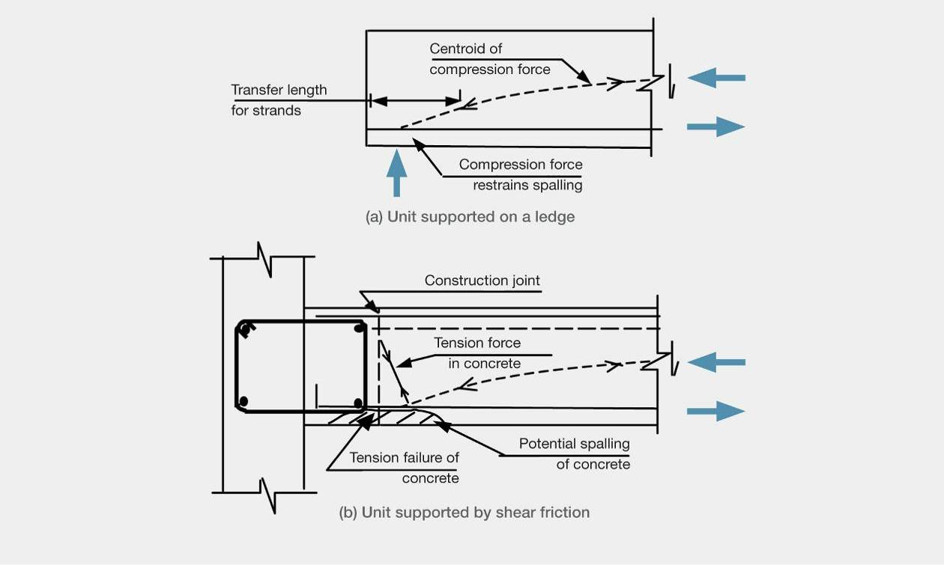

Figure 138: Support of precast floor units.

The usual arrangement is to support precast floor units on a ledge. With this arrangement the reaction from the support balances the transfer force from the pretension strands and the inclined compression force in the unit, as shown in Figure 138(a). The spalling of concrete below the strands in the transfer length is prevented by the compressive reaction from the supporting ledge.

In two structures (the IRD and Gallery Apartments buildings) some units were supported by shear friction between the back face of the unit and the face of the supporting structural element. One detail is shown in Figure 138(b). In this case there was no compression force from the support to suppress tension stresses in the transfer length, and consequently the spalling resistance was diminished in the concrete below the pretension strands.

A potential problem arises if sway of the structure causes relative rotation to develop between the precast unit and the supporting element. This rotation generates a prising action and any reinforcement near the bottom of the unit is likely to be either subjected to high yield strains or pulled out of the supporting element or precast unit. The crack width at the end face of the precast unit increases with the magnitude of rotation, and with this the capacity for shear transfer by aggregate interlock action decreases sharply. This decrease may be even more pronounced if the direction of sway reverses several times, as this increases the elongation caused by yielding of reinforcement on both sides of the member. With a wide crack, of a millimetre or two, aggregate interlock action is negligible and only dowel action remains. Dowel action in bars is generally limited by the tensile strength of the concrete at the level of the bars, and failure can be brittle. If the precast unit is mounted directly against the face of a wall, tension failure caused by dowel action is suppressed. True dowel action is limited, especially if the bars are simultaneously subjected to high axial tensile strains. In this situation, kinking of the bar to about 30° can occur and potentially prevent complete failure. However, this mechanism is associated with a vertical displacement in the order of the bar diameter13. Relying on this action is not recommended, as a few cycles of loading may result in a low-cycle fatigue failure.

8.2.3.4 Punching shear failure

In the Hotel Grand Chancellor (HGC) and Grant Thornton building at 47 Cathedral Square, punching shear failures were seen in floor slabs (Figure 139). The HGC punching shear may have been due to the shock loading associated with the collapse of the wall D5–6, or alternatively due to high vertical accelerations associated with vertical ground motion. Another possible cause was the bending moments transferred to the slab by column deformation associated with inter-storey drift.

To ensure safety of slabs against punching shear failure, the design of flat slabs should follow a capacity design approach to ensure they can resist the maximum bending moment that can be transferred to them by the columns. Punching shear failures due to these actions are brittle in character.

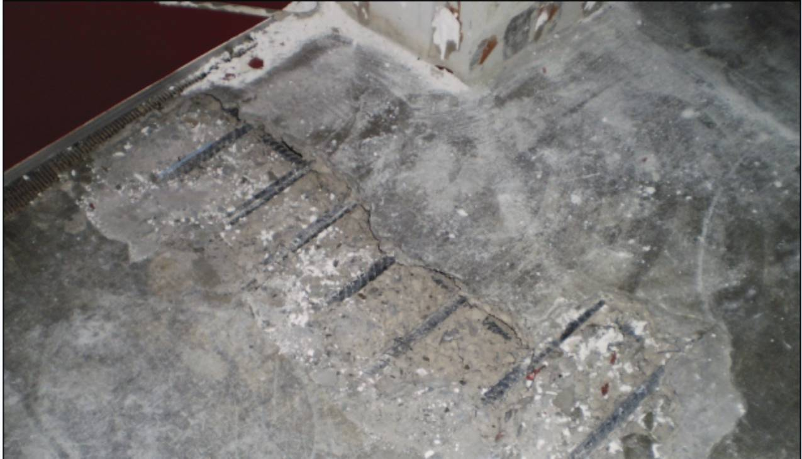

139: Punching shear failure: Grant Thornton building (source: Holmes Consulting Group Ltd)

## 8.3 Performance of structural steel buildings

The damage to low-rise structural steel industrial buildings was relatively minor14. Damage tended to be limited to bracing elements, which needed either to be replaced or re-tightened because they had yielded. In some cases the connection details between the bracing elements and the main structure needed repair.

Load tracking is important when designing structural steel and concrete structures alike. The example in Figure 14014 shows a case where load tracking was not used.

In an earthquake the lateral displacement of the building concerned caused the rectangular hollow section (RHS) brace, shown in Figure 140(a), to be loaded in tension or compression, with the forces being transferred into the column. When the brace was in tension, the transfer of forces through the weld caused the column flange to bend. The incompatibility of the flange displacement relative to the end of the RHS brace resulted in the stress distribution, shown in Figure 140(b). Concentrations of high-tension stress caused the weld to fracture. If a stiffener plate had been welded in the column it would have reduced flange bending and suppressed the weld failure.

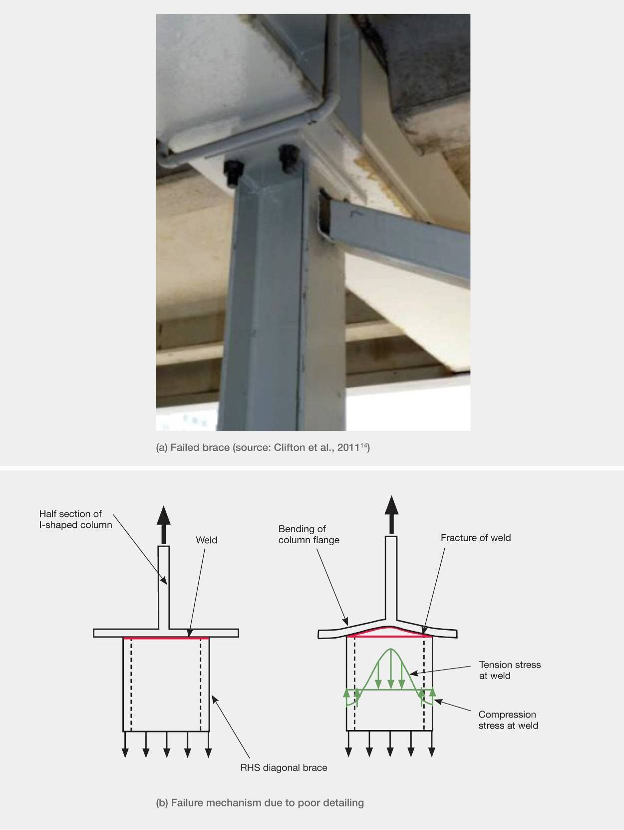

Figure 140: Failure of brace welded to a column (source: Clifton et al., 201114)

Figure 141 shows one of the two link fractures that occurred in a concrete parking building with eccentrically braced steel frames acting as the lateral load resisting elements. This structure had at least six eccentrically braced frames in each of its principal directions at each level. This significant redundancy gave a satisfactory seismic performance despite the fracture of two links. Clifton et al.,14 noted that the fractures might not have been discovered had they been hidden by non-structural finishes. The failed link in the Pacific Tower is an example of this happening, as it was not discovered in the initial inspections.

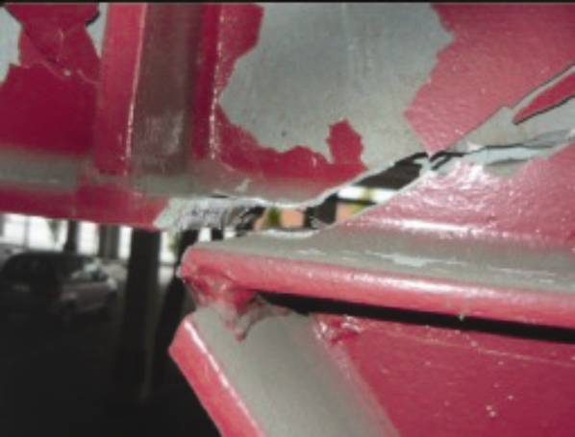

Figure 141: Example of a fractured EBF near the active link: car park building on the corner of St Asaph and Antigua Streets (source: Clifton et al., 201113)

A high standard of workmanship is especially important in structural elements containing highly stressed components. The active links are designed for high inelastic demands, so poor construction quality can lead to compromised load paths or material defects. The failure in Figure 141 was attributed to the offset of the diagonal brace flange from the stiffener plate. This offset meant that when the brace was loaded in tension, the axial tension load in the brace was fed into the web adjacent to the active link rather than directly into the stiffener. This led to the failure of the beam web outside the zone of the active link.

We note that local stress concentrations may be induced by inclusions or gaps in welding, or by localised spot-welding. These stress concentrations can act as fracture-initiation points when the steel is subjected to cyclic inelastic actions. An example of this may occur where shear studs have been welded to the top flanges of beams to obtain composite action between the beam and floor slab. If the studs are welded directly above the active link region, this may act as an initiation point for premature failure. Long welds generally heat the full steel section and cool more uniformly, so the stress is less concentrated.

Multi-storey steel buildings in the CBD generally performed well, with some fit for reoccupation after repairs. Christchurch has relatively few structural steel buildings and most of these have been designed and built during the last 20 years. Consequently they have been designed to recent Standards.

The Pacific Tower has been discussed in section 6.5.4 of this Volume. The fracturing of the active link in eccentrically braced frames (EBF) has also been observed in another building, as described above. Clifton et al.,14 note that these fractures are a particular concern as they are the first of their type to be recorded in EBFs worldwide.

Our major concern is with the behaviour of the active links and the lack of redundancy seen in some buildings that rely on EBFs for their seismic resistance. It appears possible to design such buildings to comply with relevant standards while still lacking redundancy. To prevent this, consideration should be given to amending NZS 3404:199715 to require some measure of redundancy to be designed into these buildings. This might be achieved by requiring the columns to have sufficient strength and stiffness so that they contribute to an alternative load path if a single active link fails in an EBF.

## 8.4 Application of basic concepts in seismic design

### 8.4.1 Ratcheting

Our investigation into the seismic performance of buildings in Christchurch has indicated that a number of designers have overlooked some fundamental concepts of structural design. Response spectra provide a basis for much of current practice in seismic design. However, response spectra are based on the assumption that the strength and stiffness of single degree of freedom oscillators are equal for displacements both forwards and backwards. In the HGC building this condition was not satisfied because the eastern-most bay was cantilevered off the remainder of the building, causing the structure to displace preferentially towards the east in the February earthquake. This situation, known as ratcheting, could have been simply avoided by redistributing the flexural reinforcement in the beams to equalise the strengths for both forward and backward displacements (see the discussion of the HGC building, section 3 of this Volume).

Ratcheting can also occur in structures that contain walls or columns that have different strengths forwards and backwards. A typical example of this occurs when T-shaped walls are built into buildings, as shown in Figure 142. Generally there will be less longitudinal (vertical) reinforcement in the flange than in the leg, meaning that when lateral seismic forces act on the wall it is weaker when the leg goes into tension and the flange goes into compression, than when the reverse is the case. In the example shown in Figure 142 the walls would tend to move apart, inducing tension in the region between the walls. If both walls were turned around so that the flanges were close to each other, they would tend to move together in an earthquake, potentially crushing or tending to crush the structure between them. This situation was seen by the NZSEE/EQC teams observing damage from the 27 February 2010 earthquake in Chile16.

Ratcheting can also occur in cantilevers and other transfer structures where gravity loads act in conjunction with vertical forces induced by vertical ground motion. Where this situation can arise, designers should ensure that under the combined gravity and seismic actions either the transfer structure remains elastic or the bending moments shake down into a stable configuration.

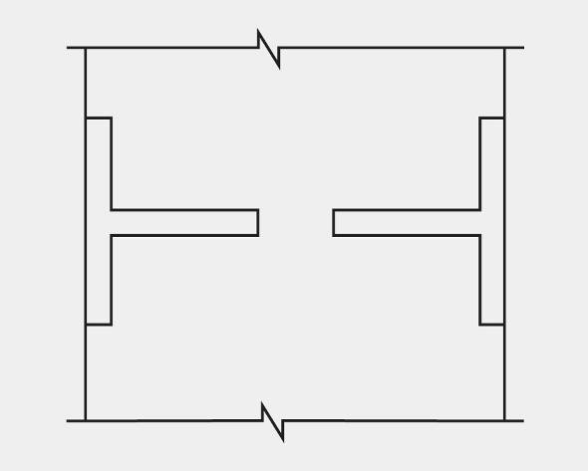

Figure 142: Two T-shaped walls in a building

### 8.4.2 The ‘what-if’ approach

Analyses for earthquake actions are invariably based on assumptions that cannot be validated before the analysis has been completed. The ‘what-if’ approach requires the designer to assess, review and check for significant potential sources of error. Two examples are given here of the failure to follow this approach.

With the Gallery Apartments, in the analytical model used to assess design actions the flexural stiffness of the walls was taken as 0.25 times the properties based on the gross sections as recommended in the Concrete Structures Standard, NZS 3101:19958. On this basis the fundamental periods of the building in the north–south and east–west directions were assessed as 3.4 and 3.9 seconds respectively. However, an inspection of the magnitudes of bending moments induced and the level of reinforcement required to resist these actions would have indicated that cracking would be limited to near the base of the wall. Furthermore, given the low reinforcement content, the ‘what-if’ approach would have shown that secondary cracking could not form; yielding would therefore be confined to one crack, meaning that ductile performance of the building could not be achieved. If this approach had been followed it would have revealed that the building should be re-analysed with increased wall stiffness values and designed (if the distribution of cracking was still limited) as a nominally ductile structure.

The PGC building was analysed at least twice using the inelastic time history method. The details used on the first occasion are not known. However, in the analysis for DBH, the shear core wall section properties were taken as 0.4 times the values based on gross section properties (the current Standard recommends 0.25). The origin of the 0.4 value is not known. Multiplying gross section properties by a factor of less than one is a common practice to allow for stiffness reduction caused by flexural cracking.

However, again if the predicted bending moments and axial forces had been assessed following the ‘what-if’ approach, it would have been evident that few cracks would have been expected to form and consequently the reduction in stiffness of the walls assumed in the analysis was not appropriate. It should have been clear that secondary cracks could not be expected to form and that virtually all the inelastic deformation would be concentrated at one crack, which could have indicated a potential brittle failure location.

### 8.4.3 Compatibility

In a number of buildings it was clear that no consideration had been given to compatibility of displacements of different structural elements. Floors were attached to walls that deflected independently of one another under lateral forces, applying incompatible displacements to the floors or beams connecting the walls (Gallery Apartments, Bedford Row Car park building) so that the differential deflections damaged the floors.

### 8.4.4 Flexural torsional interaction

Flexural torsional interaction was not considered in the analysis of the PGC building and it is not dealt with in the Concrete Structures Standard5, although it is discussed in the commentary to the Standard.

We recommended that torsional flexural interaction be introduced into the Concrete Structures Standard.

### 8.4.5 Irregularity in buildings

From the post-1960 buildings we have assessed, it is clear that the performance of the buildings in the Christchurch earthquakes was strongly influenced by their degree of irregularity and the magnitude of the eccentricity of the centre of mass from the centre of lateral stiffness and strength of each building. The latter factor is referred to as the ‘eccentricity’ of a given building in this Report.

The Christchurch Central Police Station and the CCC Civic Offices buildings are both regular structures with low eccentricity and both performed well in terms of the objectives of the design standards at the time when they were designed. The Forsyth Barr building was also regular, had a relatively low eccentricity and performed well except for the stairs. At the other extreme the PGC, HGC, Gallery Apartments and 151 Worcester Street buildings all were highly irregular with high eccentricities and all performed poorly. The Bradley Nuttall House building also had a high eccentricity and its performance was marginal.

In terms of regularity and eccentricity, the IRD building lay between the two groups described above and performed well except for the differential settlement of its foundations.

The major exception to this trend was the Clarendon Tower. This structure was relatively regular and the eccentricity was low. However, in this case the high level of elongation associated with the structural details used in the northern and southern external moment resisting frames resulted in a rapid stiffness degradation of the northern frame. This resulted in the building developing high eccentricity in the February and subsequent earthquakes (see section 6.3.5 in this Volume). The loss of stiffness would have had less effect on the torsional response of the building if the perimeter frames in the eastern and western walls had been of similar lateral stiffness to those in the northern and southern sides.

We recommend that the current method of allowing for irregularity and eccentricity in building design should be revised to allow more realistically for the adverse effects of these two factors.

### 8.4.6 Vertical seismic ground motion

Further research is required into the potential effects of vertical ground motion on buildings. A ratcheting action is possible in beams and slabs, caused by gravity load acting simultaneously with the vertical excitation. However, the high frequency of the vertical motion may limit this interaction. More research is required to determine possible adverse effects of vertical ground motion and to establish where high vertical ground motion is likely to occur.

### References:

1. Erasmus, L. A. and Pussegoda, L. N. (1977). Strain Age Embrittlement of Reinforcing Steels, New Zealand Engineering, 32(8), 178-183.

2. Momtahan, A., Dhakal, R.P. and Reider, A. (2009). Effects of strain ageing on New Zealand Reinforcing Steel Bars. Bulletin of the New Zealand Society for Earthquake Engineering, 42(2), September 2009, 179-186.

3. Allington, C. (2011). Materials Testing in Buildings of Interest. Christchurch, New Zealand: Canterbury Earthquakes Royal Commission.

4. Concrete and Cement Association of New Zealand (CCANZ). Examples of Concrete Structures Designed to New Zealand Standard 3101. 2008. Concrete and Cement Association of New Zealand: Wellington, New Zealand.

5. NZS 3101:Part 1:2006. Concrete Structures Standard, Part 1 – The Design of Concrete Structures. Standards New Zealand.

6. Matthews, J. (2004). Hollow-core Floor Performance Following a Severe Earthquake. (PhD thesis). Christchurch, University of Canterbury, New Zealand.

7. NZS 4671:2001. Steel Reinforcing Materials. Standards New Zealand.

8. NZS 3101: Part 1:1995. Concrete Structures Standard, Part 1 – The Design of Concrete Structures. Standards New Zealand.

9. Structural Engineering Society New Zealand Inc. (SESOC). (2012). Practice Note: Design Guidance for Design of Conventional Structural Systems Following the Canterbury Earthquakes. Draft 18 April 2012. Wellington, New Zealand: Structural Engineering Society New Zealand Inc.

10. Wight, J., K. (ed). 1985. Earthquake Effects on Reinforced Concrete Structures, American Concrete Institute, Special Publication, SP84.

11. NZS 1170.5:2004. Structural Design Actions, Part 5: Earthquake actions – New Zealand. Standards New Zealand.

12. Fenwick, R. C., Bull, D.K. and Moss, P. J. (2011). Design of Floors Containing Precast Units in Multi-storey Buildings. Structural Engineering Society New Zealand Inc. Journal 24(1).

13. Hawkins N. M. and Mitchell, D. (1979). Progressive Collapse of Plate Structures. American Concrete Institute Journal, 76(7), 775-808.

14. Clifton, C., Bruneau, M., MacRae, G., Leon, R., and Fussell, A. (2011). Steel Building Damage from the Christchurch Earthquake Series of 2010 and 2011, Bulletin of the New Zealand Society for Earthquake Engineering Inc. 44(4).

15. NZS 3404:Parts 1 and 2:1997. Steel Structures Standard. Standards New Zealand

16. Cowan, H., Beattie, G., Hill, K., Evans, N., McGhie, G., Gibson, G., Lawrence, G., Hamilton, J., Allan, P., Bryang, M., Davis, M., Hyland, C., Oyarzo-Veva, C., Quintana-Gallo, P. and Smith, P. (2011). The M8.8 Chile Earthquake, 27 February 2010. Bulletin of the New Zealand Society for Earthquake Engineering Inc. 44(3).