6.5.4 166 Gloucester Street: Pacific Tower building
Current status
Under repair.
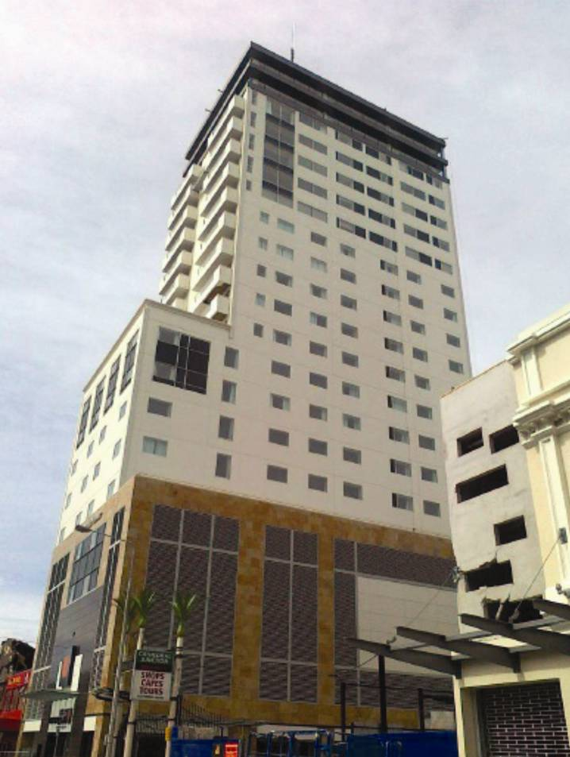
Figure 130: Pacific Tower building, looking south-east from Gloucester Street (source: Clifton et al.²⁷)
6.5.4.1 Introduction
The Pacific Tower building (formally the C1 Tower) was designed in 2006 and 2007, with four building consents issued by the CCC in those years for different stages of the development. Amendments to the consents were issued up until 2009, with a code compliance certificate issued in 2010. It is a 22-storey steel-framed building with precast concrete cladding panels (Figure 130).
6.5.4.2 Structure
Lateral load resistance is provided by eccentrically braced frames in both K and D configurations, as well as moment resisting frames. There are vertical irregularities in the configuration of the eccentrically braced frames and moment resisting frames that require the floors at levels 2, 6 and 11 to act as transfer diaphragms.
The floors and roof are typically built with a 150mm thick composite steel deck supported on composite steel beams. The topping is reinforced with 10mm diameter Grade 500 reinforcement spaced at 300mm centres in each direction, supplemented by additional reinforcement, known as drag bars, where necessary.
Reinforced concrete foundation beams are supported on a combination of bored concrete piles and steel screw piles (used primarily for tension loads). The ground floor is a reinforced concrete slab on grade.
The stairs and car stacker level ramp are detailed to slide to prevent overloading from inter-storey drift.
6.5.4.3 Performance and damage
A post-earthquake assessment and detailed engineering evaluation was carried out by CPG New Zealand Ltd. The performance and damage reported here has been taken from the CPG report.
The building was designed to NZS 1170.510 with a zone hazard factor, Z, of 0.22, as applied in Christchurch before the February earthquake. It was detailed as a limited ductile structure. Clifton et al27 and CPG stated that the design ductility, µ, was close to 1.5 (due to standardised section sizes and to the conservative approach of adding the gravity shear component to the earthquake shear when sizing the active links). The building’s calculated fundamental periods are 3.96 and 3.26 seconds in the north–south and east–west directions respectively. CPG noted that the performance of the building in the earthquake series showed that the structure was twice as stiff and strong as indicated by analytical models used in design.
CPG concluded that the building experienced earthquake shaking greater than the design-level earthquake for the recently revised seismic actions associated with a seismic hazard factor, Z, of 0.3. Given the satisfactory performance of the building in these earthquakes, CPG concluded that the building would meet the criterion for 100 per cent of new building standard (NBS) once structural repairs were completed.
The building generally suffered minor structural and non-structural damage but isolated areas of significant damage were also recorded. The residual deformation measurements suggest the building twisted slightly, although mostly in the upper levels. These offsets were not of concern to CPG as they were within the displacements allowed for during design and construction.
The CPG investigation involved visually inspecting at least one side of all eccentrically braced frame links and moment resisting frame potential plastic hinge regions for yielding and any significant permanent offsets or fractures.
A number of active links in the eccentrically braced frames showed evidence of the onset of yielding, with some permanent deformation. Yielding was indicated by diagonal Luders' lines and paint flaking. One active link fractured, as shown in Figure 131. This link was located on the north-western frame at the underside of level 6.
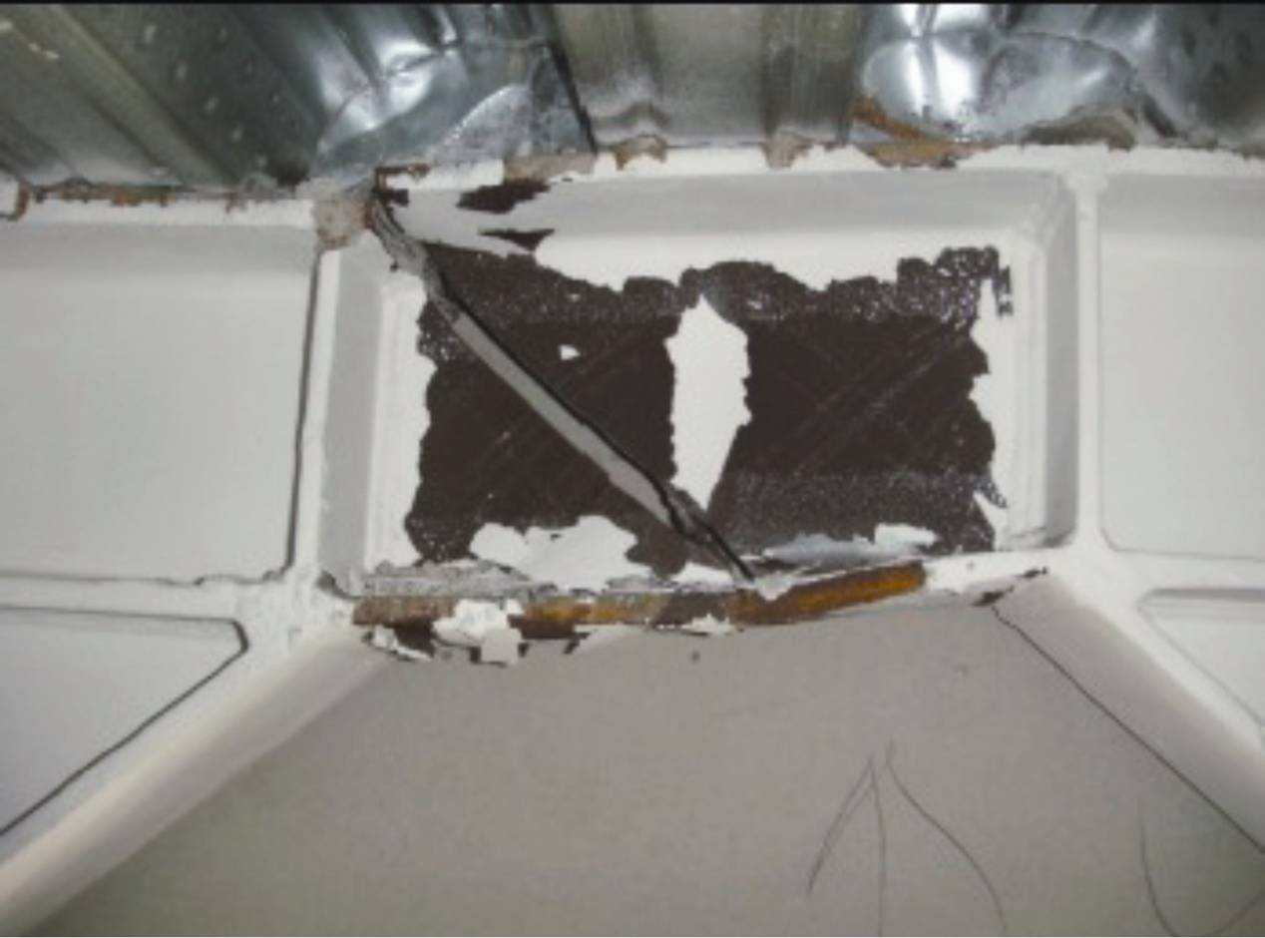
Figure 131: Fractured active link in the Pacific Tower (source: Clifton et al.27)
An assessment of damage accumulation by Professor Charles Clifton concluded the links had undergone 45 per cent damage (where 100 per cent damage means the link has fractured) and they would have sufficient capacity to resist a repeat of the Canterbury earthquake series or an Alpine Fault rupture without failure.
In its report, CPG stated that hardness testing of the lower links in this frame (without slabs attached) indicated strain hardening had occurred and that this would have resulted in a reduction of ductility capacity. While this has not been quantified in comparison to destructive testing of outside samples, it was CPG's opinion that it would be advisable to have these links replaced.
6.5.4.4 Conclusions
The performance of the Pacific Tower building appears to have been satisfactory. The level of redundancy in the building gives it a robust structure.
The Royal Commission has not carried out a detailed assessment of the Pacific Tower building but we consider that some aspects require further investigation. The concerns we have include:
- CPG reported that the structure was twice as stiff and twice as strong as the analytical models had indicated. This would have reduced the fundamental periods of vibration from 3.96–2.8 seconds in the north–south direction, and 3.26–2.3 seconds in the east–west direction. The February east–west ground motions showed amplification in the period between 2.7 and 4 seconds. For this ground motion, the reduction in period would have reduced the acceleration demand on the building, as shown in Figure 132. It is highly desirable that the source of this increased stiffness should be accounted for.
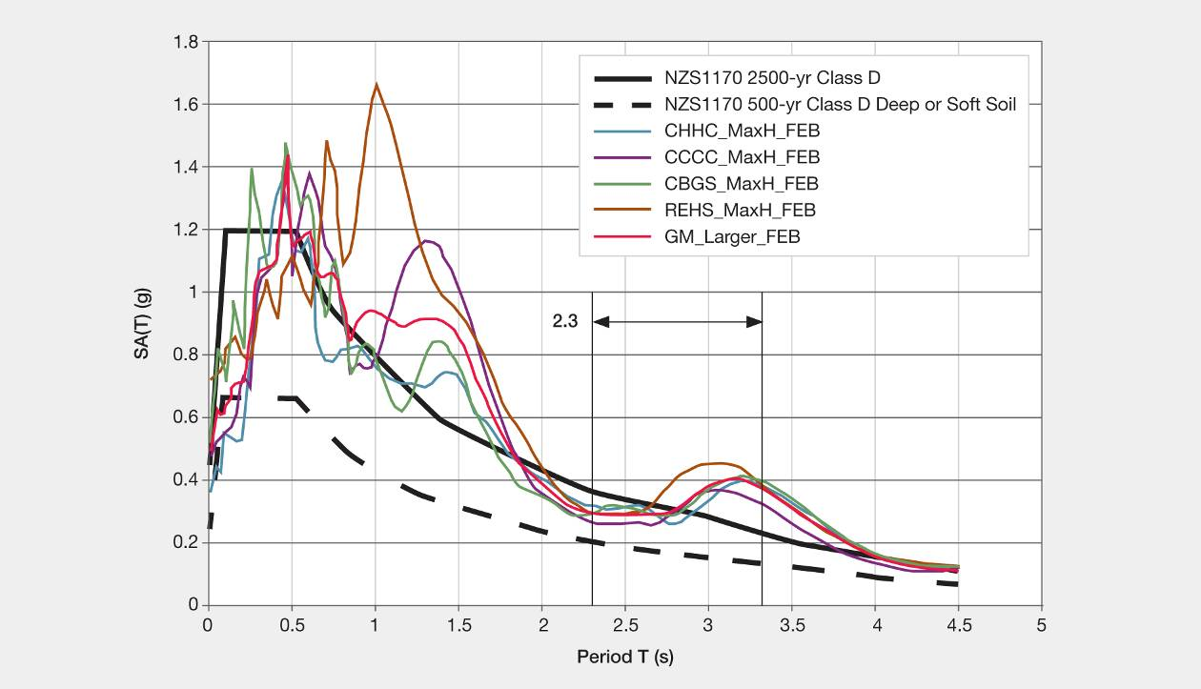
Figure 132: NZS 1170.5¹⁰ spectra and largest horizontal direction recorded from the CBD strong motion records (source: Clifton et al.²⁷)
2. The required level of ductility used for design, u, was stated as 1.5 in both the paper by Clifton et al27 and in the CPG report. Given the magnitude of the February earthquake, this would indicate the ductility demand would have been considerably less than 3, and even less than this if the building, in fact, was twice as stiff and twice as strong as indicated. This would imply that relatively small ductility demands would have been placed on the eccentrically braced frame active links. Hence, it was surprising that one failed and several sustained displacements well into the strain hardening range. It was important to note that building ductility was limited by the ductility of the active link and also to note that a relatively small increase in displacement ductility of the building can greatly increase the deformation ductility demand in the active link.
3. It was seen that some of the links had been strained well into the strain hardening range. These should be tested to see if there were any adverse impacts from both strain hardening and strain ageing. Strain levels of four per cent were in the range where strain ageing may be expected to have a significant influence on performance.
4. Owing to the mixed use of eccentrically braced frames and moment resisting frames in the building, the columns were considerably stronger and stiffer than would be required by NZS 3404:199728, or in a building where greater reliance was placed on eccentrically braced frames alone. This raised a question about the stability of a building if eccentrically braced frames were located in the boundary walls, with one braced bay in each wall. In this situation the loss of a single active link would be likely to result in a loss of torsional resistance, leading to a major overload of the remaining walls, which could lead to its collapse. The failure of the link in the Pacific Tower building highlights the need for a degree of structural redundancy in these buildings, which may be provided by requiring more robust columns.
5. The failure of the active link at what appeared to be a strain level well below the strain at which fracture may be expected to occur, highlights the need for very high quality detailing, construction and supervision of eccentrically braced frames.
6. We would encourage the steel industry to thoroughly assess the performance of eccentrically braced frames and demonstrate in tests that eccentrically braced frame units built under normal construction conditions, and tested under dynamic loading rates comparable with those induced in the February earthquake, do, in fact, have the level of reliability required by the Building Code.

