6.5.2 2 Riccarton Avenue: Christchurch Women’s Hospital building
Current status
Substantially undamaged and has remained in use.
Figure 125: View looking north-east (source: Holmes Consulting Group)
6.5.2.1 Introduction
The Christchurch Women’s Hospital building was designed in 2001 and 2002 and construction was completed in 2004 (see Figure 125). The building is also discussed briefly in section 3 of Volume 3 of this Report.
6.5.2.2 Building structure
The nine-storey building is the only base-isolated structure in the South Island and is positioned adjacent to the western end of the Parkside building complex, with a 550mm seismic gap between the two structures. The two buildings are connected via drop-in plates at each of the floors from lower ground floor to level 4.
The primary structure consists of precast prestressed floor ribs (spanning north–south) with a 100mm thick topping slab on timber infill planks. The floor is supported on precast beams (east–west) that span onto cast in situ interior and exterior columns. The lateral force resisting system in the north–south direction from the lower ground floor to the underside of level 3 is a dual system that uses reinforced concrete moment resisting frames at the ends of the building and eccentric K-braced frames forming the sides of the stair/service shafts. From level 3 to the roof, the reinforced concrete moment resisting frame forms the lateral force resisting system. The east–west direction lateral system consists of full height moment resisting frames on the northern and southern faces of the building. The entire building is supported (both for vertical gravity loads and lateral seismic shears) at the underside of the lower ground floor on lead rubber isolator bearings (see Figure 126). These are connected with a grid of stiff transfer beams.
The stair, lift and service shafts are framed with structural steel beams and posts and a composite steel deck and concrete topping forms the floors in these areas. The staircases are precast concrete seated on steel beams and tied into the floor topping slabs with reinforcement.
Above level 6 there are two mechanical/service floors covered by a structural steel portal frame and a lightweight roof system.
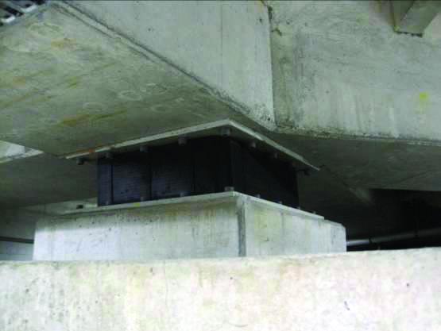
Figure 126: One of 40 lead rubber isolator bearings (source: University of Canterbury)
6.5.2.3 Building performance
HCG completed a full structural review of the Christchurch City Campus for the Canterbury District Health Board. The findings in this report are outlined as follows.
HCG observed little structural damage and there were few indications that ductile action had taken place in the concrete moment resisting frames or the steel braced frames above the isolated level. This is in keeping with the philosophy of a base isolation system, which concentrates the earthquake-induced deformations to the isolated level of the building.
Ground motions recorded at the Christchurch Hospital GeoNet site (CHHC spectra) had stronger horizontal ground motions in the September earthquake than in the February event, owing to the amplification of accelerations in the longer period range. Once the isolators yield they have a period of 2.5–3.0 seconds and a damping of 30 per cent and 22 per cent in a design-based earthquake (DBE – also referred to as ULS or ultimate limit state) and a maximum considered earthquake (MCE), respectively. The recorded acceleration response spectrum exceeded the original site-specific MCE design spectrum for the September record in the north–south direction. Of note is that the CHHC site is one of the four primary seismic measuring stations for Christchurch. It is located near this building on another part of the hospital site and the measured ground movements are, therefore, likely to be similar to those that affected this building.
HGC generally found that structural damage above the isolator level was limited to cracking of the floor slab and some stair landings. In places the cracking of the slabs was consistent with pre-existing shrinkage crack patterns but their extent and width may have increased as a result of earthquake movements. Some diagonal cracking was observed in the transfer beams supporting the elevator pit and spanning back to adjacent isolator bearings. Given that cracks were not extensively observed in other transfer beams, HGC thought it was possible that this cracking had occurred as a result of vertical acceleration of the liftshaft during the February earthquake. We note that bearings are stiff vertically to support gravity loads and, therefore, do not isolate seismic vertical accelerations. Mechanical equipment “excited” by vertical accelerations may also have caused flexing and damage to slabs and cantilevers.
From its evaluation of the structural drawings and observations at the site HGC did not consider that there were any critical structural weaknesses in the lateral force resisting system. However, it considered that the cracks in the precast ribs forming the lower ground floor were a significant weakness and required immediate attention. Another weakness identified was the detailing of the stairs at mid-landing. Based on the structural drawings, it appears that the preferred allowance for relative movement between the floor levels cannot be accommodated by the detailing used and will need to be remediated to ensure that no further damage occurs under large earthquake demands.
6.5.2.4: Conclusions
We conclude that:
1. The base isolation system for this building generally performed as expected and, to a large extent, limited the damage caused by horizontal accelerations.
2. Vertical accelerations are not usually damped by base isolation systems. In addition, high-frequency displacements can be transmitted through the lead core of the isolators. This might cause damage to sensitive equipment, or induce large vertical actions by accelerating heavy components such as liftshafts.

6.5.3 224 Cashel Street: IRD building
Current status
Still standing but proposed to be demolished.
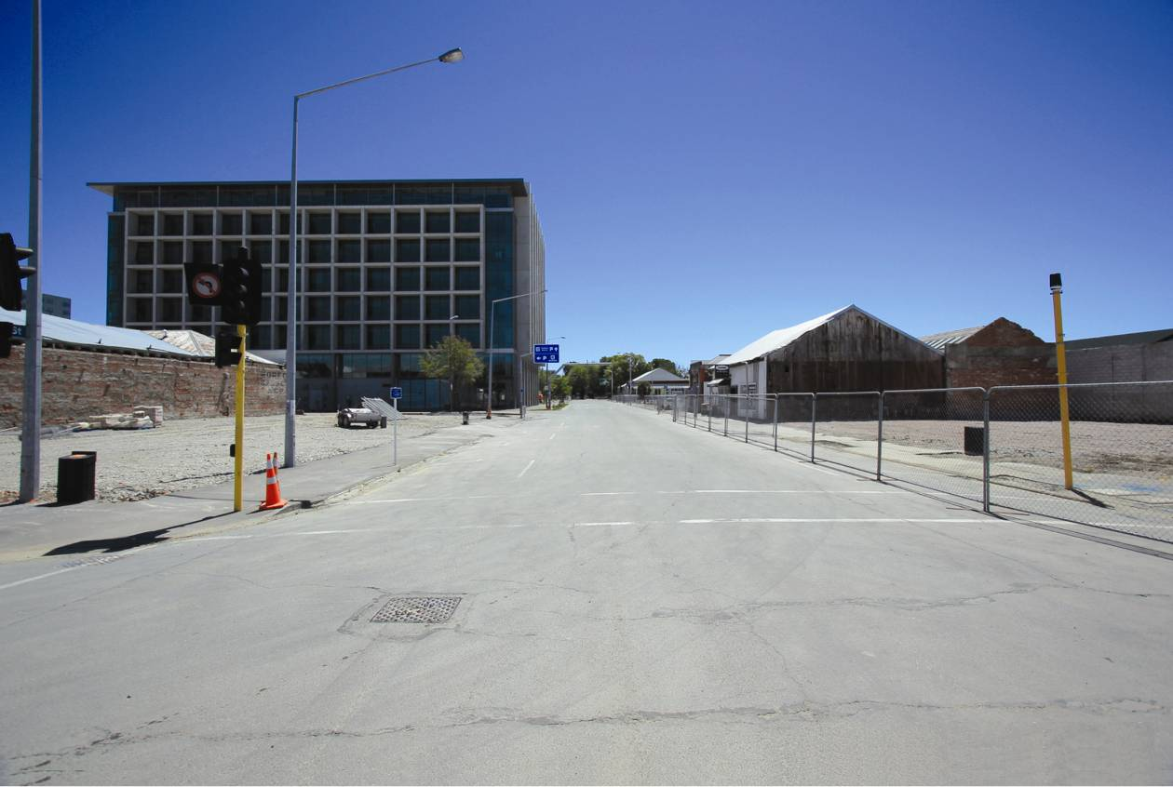
Figure 127: View of the IRD building from the corner of Cashel and Lichfield Streets (source: Becker Fraser Photos)
6.5.3.1 Introduction
The IRD building at 224 Cashel Street (Figure 127) was designed between 2004 and 2006 and issued with a building consent in four stages, receiving a code compliance certificate on 16 October 2007. It is a seven-storey office building with the Inland Revenue Department as the primary tenant and retail businesses on the ground floor. It is rectangular in shape, with overall dimensions of about 40m by 60m. It is relatively regular, with minimal eccentricities to the seismic structure.
6.5.3.2 Foundations and ground floor
The foundations are on 900m and 1200mm bored concrete piles founded in dense sands at depths of up to 12m below street level. The shear core is supported on two interconnected 2.5m deep reinforced concrete rafts supported by the piles, with the rafts being at the eastern and western ends of the shear core. Extensive ground investigations were carried out before the design was undertaken when the risk of liquefaction was considered.
The ground floor is a 100mm thick conventionally reinforced concrete slab.
6.5.3.3 Structure
A typical elevated floor plan is shown in Figure 128. The elevated floors are built from 300mm thick hollow core precast floor units with a 90mm thick in situ concrete topping. These floors are supported on precast concrete beams on the northern and southern sides of the building perimeter, the shear core walls and internal moment resisting frames on grid lines E and H between the eastern and western walls and the shear core. Throughout the structure extensive use is made of precast concrete in both the moment resisting frames and the shear core.
The roof is lightweight steel with structural steel roof framing.
Precast fin panels made of reinforced concrete are connected to the exterior of the eastern and western perimeter walls.
Exterior façade frames are attached to the moment resisting frames along lines B and L on the northern and southern walls of the building.
The primary lateral force resisting element is the central shear core, which is assisted in the east–west direction by the moment resisting frames in the northern and southern walls. The shear core comprises precast panels that are interconnected with in situ concrete. In the north–south direction, concrete panels are connected with diagonally reinforced coupling beams
to form coupled shear walls. In the transverse direction the walls are built up from hit and miss precast and in situ concrete.
The primary purpose of the internal moment resisting frames on lines E and H is to support the gravity loads.
The main stairs consist of precast flights and landings with an in situ topping to the landings. They are located within the shear core. No provision appeared to have been made for inter-storey drift but the stairs suffered no apparent damage in the earthquakes.
At the time of design, NZS 4203:199222 was the relevant verification method for the New Zealand Building Code, and NZS 1170.5:200410 was not cited (therefore needed to be considered as an alternative solution to the Building Code). Both Standards were considered as a part of the design, which indicates that the building should have complied with NZS 1170.510 at the time of the February earthquake.
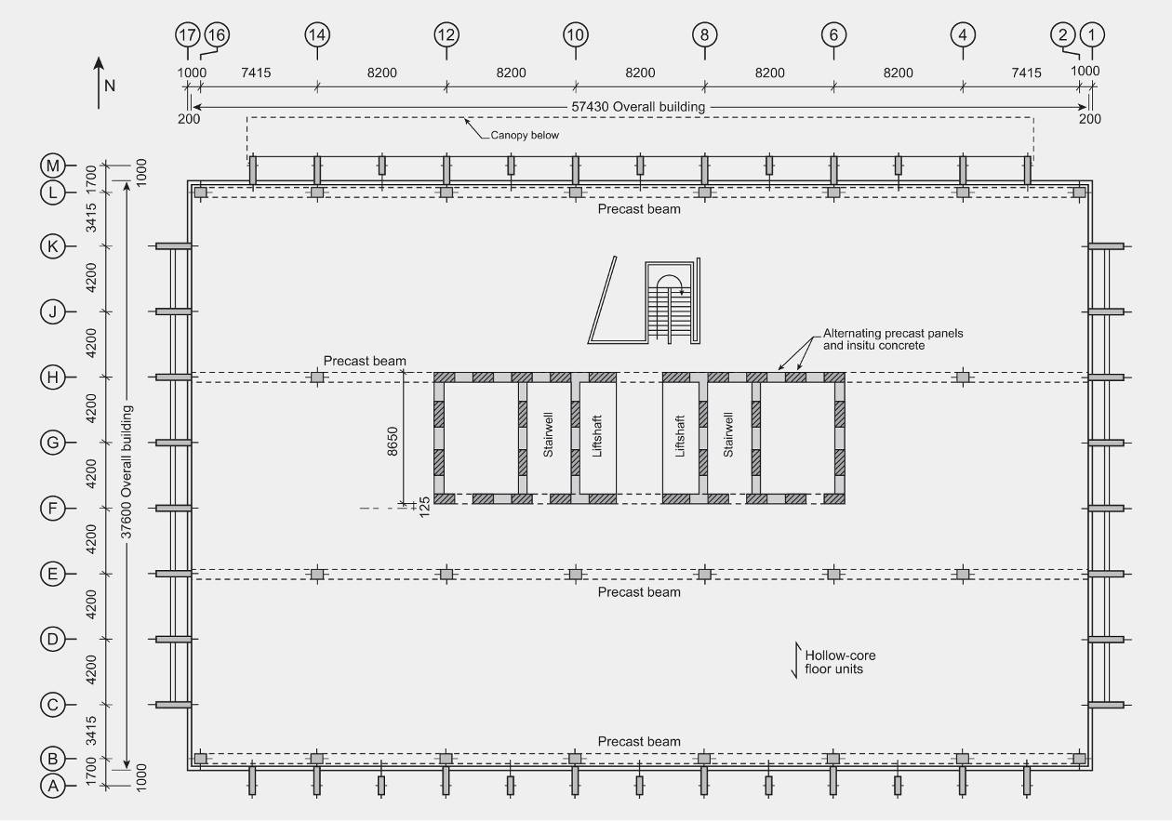
Figure 128: Typical upper floor
6.5.3.4 Building performance
The Royal Commission was assisted in the assessment of the performance of this building by a report prepared by Spencer Holmes Ltd.
6.5.3.4.1 General observations
We have no evidence to show there was any significant damage to the building as a result of the September and Boxing Day 2010 earthquakes or in the aftershocks associated with those events.
The effective initial fundamental period of the IRD building was assessed as between 0.8–0.9 seconds depending on direction of excitation. The February earthquake was particularly damaging to buildings with a period range of 0.5–1.5 seconds. This building was likely to have been subjected to shaking exceeding 1.5 times the intensity of design seismic actions for the ultimate limit state. From the structural drawings it is apparent that it was a robust structure and detailed
to comply with the Concrete Structures Standard, NZS 3101:199523.
Design Standards for reinforced concrete structures (NZS 3101:199523 and NZS 3101:200612) recommend that section properties should be based on gross section properties multiplied by a factor that allows for the reduction in stiffness due to flexural cracking. We assumed that the recommended section properties would have been used in the design. However, from the extent of flexural cracking observed in the concrete after the February earthquake, it was clear that this cracking was considerably less than that consistent with the recommended allowance for cracking. Consequently, the fundamental period was likely to be around 0.6 seconds rather than the value of about 0.8 seconds assumed in the design. The response spectra calculated from the recorded ground motions in the CBD indicate that a reduction in the initial fundamental period from 0.8 to 0.6 seconds would increase the seismic forces and reduce seismic displacements.
6.5.3.4.2 Foundations
In the geotechnical report on the foundation soils, it was recommended that the strength of foundation soils could be based on 0.8 times the average measured value for load combinations that included seismic forces.
The piles were founded in sands at a depth of about 12m. In the February earthquake differential settlement of 20–90mm occurred between the shear core and the perimeter frames. The greatest differential settlement was between the corner columns and the shear core. It was likely that this differential settlement was associated with:
• liquefaction reducing friction on the sides of the piles and the end bearing strength of the piles; and
• the different levels of gravity load and seismic forces acting on the different structural elements.
The seismic forces sustained by the shear core may have been underestimated and this may have contributed to the increase in the settlement of the shear core. This underestimation of design actions arises because current design practice does not allow adequately for the interaction of floor diaphragms with some structural wall systems. This issue is discussed later.
The foundations were designed to allow for the level of liquefaction expected in an Alpine Fault earthquake. However, the extent of liquefaction in the February earthquake exceeded that anticipated level.
6.5.3.4.3 Moment resisting frames
Seismic resisting moment resisting frames are located on the northern and southern sides of the building. They appear to have performed well in the February earthquake. Flexural cracks, which ranged from one to five millimetres, were observed in the beams at the faces of the columns. In one or more of the corners of the building it was noted that the crack width was greater at the top of the beam than at the bottom. This was consistent with the measured differential settlement of the shear core relative to the perimeter frames and the redistribution of gravity load bending moments caused by yielding of the reinforcement. A crack 5mm wide indicated that material strains of about one third of the maximum permitted in NZS 3101:200612 were sustained in the earthquake. It is likely that other secondary cracks opened up during the earthquake but largely closed again when the ground motion ceased, making it difficult to see them in subsequent inspections. The top flexural reinforcement in the beam consisted of three 25mm and two 20mm bars with a 600mm wide beam. This level and concentration of reinforcement should have been adequate to initiate secondary flexural cracks. However, unless the strains in the reinforcement at the column face were sufficient to induce appreciable strain hardening in the reinforcement, the increase in strength would not have caused yielding to occur at one or more of the secondary cracks. Without this yielding, it would be difficult to see the cracks, which were likely to be less than 0.05mm wide.
6.5.3.4.4 Floor diaphragms
The opening up of the cracks in the beams at the column faces was a clear indication that elongation had occurred in the beams. This movement was reflected in the floor slabs, which sustained some cracking at right angles to the beams and between the precast hollow-core floor units.
The floor diaphragms appeared to have performed adequately. A positive moment flexural crack was seen in the soffit of the hollow-core units close to a support in one floor. Such cracking has been shown to seriously reduce the strength of hollow-core floors. However, in this case there would be no loss of strength as the hollow-core unit was tied into the supporting beam by reinforcement with in situ concrete being placed in broken-out cells at the supports26.
On the northern and southern walls in the shear core (lines F and H) many of the hollow-core units were supported by TAC20 connectors anchored into the walls. The TAC20s were placed into broken-out cells in the hollow-core units that were later filled with in situ concrete (Figure 129). The connection performed adequately during the earthquake, but with this arrangement the support of the precast unit depends to a large extent on shear friction at the interface and to a lesser extent on potential dowel action of the reinforcement. The dowel action of the bars is limited (refer to NZS 3101:200612) and shear friction decreases with increasing crack width. As it was not possible to accurately predict the width of cracks that might be induced in severe earthquakes, we do not recommend that shear friction be relied on to support precast floors.
6.5.3.4.5 Shear core
The north and south shear core walls consisted of individual wall panels linked by diagonally reinforced coupling beams. Coupling beams have been extensively used in construction throughout the world. However, one aspect of their behaviour has received little attention. A diagonally reinforced coupling beam will elongate in a very similar manner to a reinforced concrete beam. Any such elongation was partially restrained by floor slabs which, in this case, extended round the shear core. This restraint applies axial forces to the coupling beams, increasing their strength. As a consequence, higher lateral forces may be resisted by the walls than was anticipated in the design. An assessment indicates a likely increase in the strength of the coupling beams of the order of 50 per cent compared with strengths assessed by current design practice. An increase in resistance of this order would have significantly increased the seismic forces applied to the foundations and might have contributed to the settlement of the foundations of the structural walls seen after the earthquake.
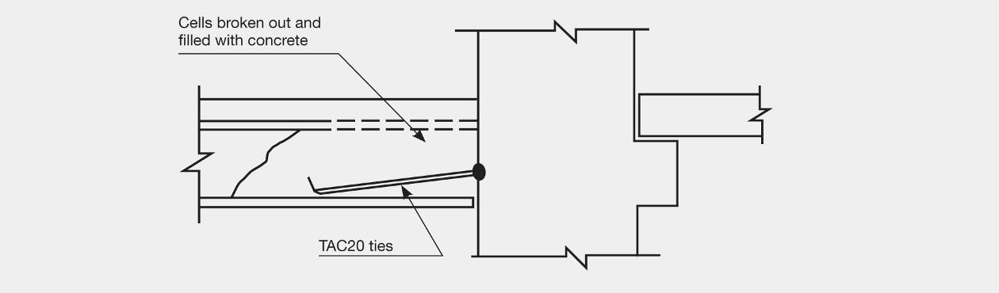
Figure 129: Support of hollow-core unit on shear core wall using TAC20 connector
6.5.3.4.6 Canopy
The canopy that spanned between the IRD building and the adjacent car park pavilion collapsed in the February earthquake. Given the intensity of the earthquake this was not surprising as the peak displacement between the two buildings would have been close to twice the value given by NZS 1170.510. The factor of 2 arises from the design displacement being less than the peak value owing to the use of the structural performance factor (Sp) and the calculated spectral displacements in the CBD being about 50 per cent greater than the values calculated from the design spectral values.
6.5.3.5 Conclusions
We conclude that:
1. Liquefaction on bored piles is likely to have reduced the strength of the soils, which may have contributed to the observed settlement of the building.
2. The recommended use of a strength-reduction value of 0.8 for the design of soil strengths for
over-strength actions was likely too high for granular soils.
3. The floors restrained the elongation of coupling beams in coupled structural walls. This restraint could increase the strength of coupling beams and impose higher seismic actions on the walls and foundations than would be calculated by standard design practice.
4. Cracking in beams in the moment resisting frames appeared to consist of single cracks at the column faces. However, it was likely that other cracks formed by the reinforcement did not yield and, consequently, closed. They would not have been apparent without the use of a crack microscope.
5. Reliance on the support of floor units by shear friction cannot be recommended.
6. Peak displacements induced in the February earthquake were significantly greater than indicated by standard design calculations.

