6.2.1.6 Conclusions
Only a few of the more significant aspects of damage are discussed here.
6.2.1.6.1 Spalling and buckling of reinforcement in shear walls
The walls were detailed for confinement and buckling restraint of bars below level 1. However, from the observed damage it appears that reinforcement yielded over a greater length than anticipated in the design. As there was damage to the seismic joint between the podium and tower it is likely that interaction between the two structures could have caused plastic hinging to occur at higher levels in the tower than would otherwise be anticipated (see Figure 80).
Current design requirements (NZS 3101:2006¹²) require ductile detailing to extend for a distance equal to the height of the shear core divided by six. Damage to the expansion gap of 25mm was not unexpected, for two reasons. First, the design standard of the time recommended the use of stiffer section properties for assessing design actions than is now the case, which would have led to predictions of lower lateral displacements than would be expected from current practice. Secondly, the design displacement was taken as 50 per cent of the peak displacement calculated on the basis of the equal displacement concept.
The buckling of the longitudinal reinforcement observed in the wall below level 3 highlights the importance of providing lateral restraint to longitudinal bars in the potential plastic hinge zones (ductile detailing lengths) of walls (refer to Figures 81–83). The extensive spalling of the cover concrete results in the loss of anchorage of the transverse reinforcement, which creates a potential problem that has not been addressed in the current design standards.
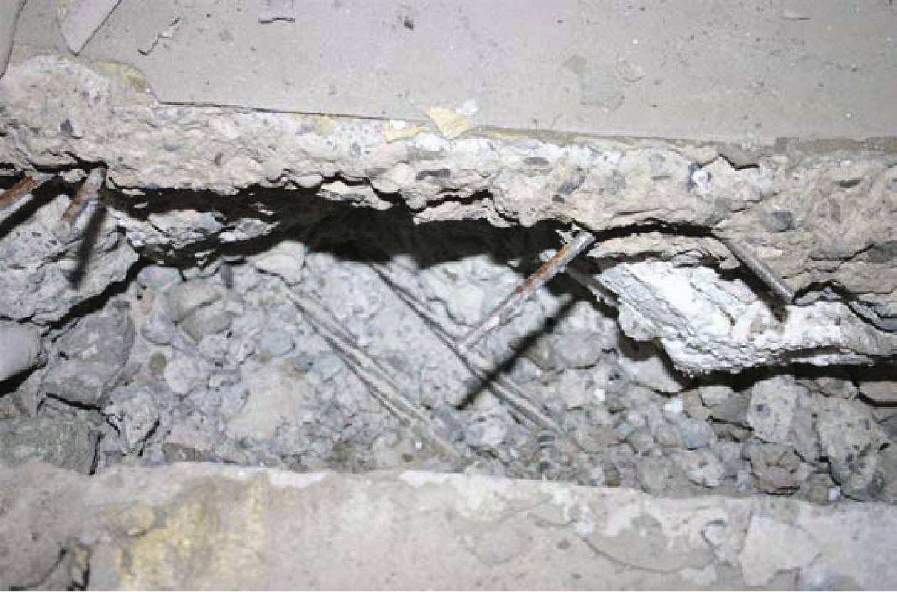
Figure 80: Damage to seismic joint (source: Spencer Holmes)
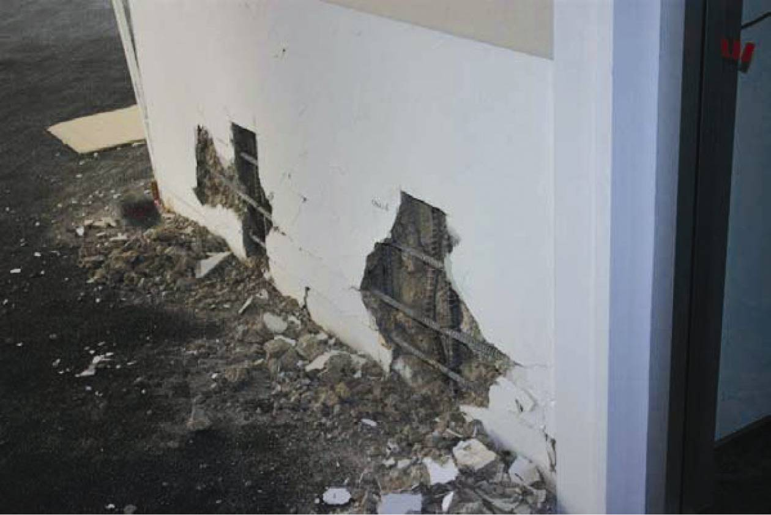
Figure 81: Spalling on shear wall (source: Spencer Holmes)
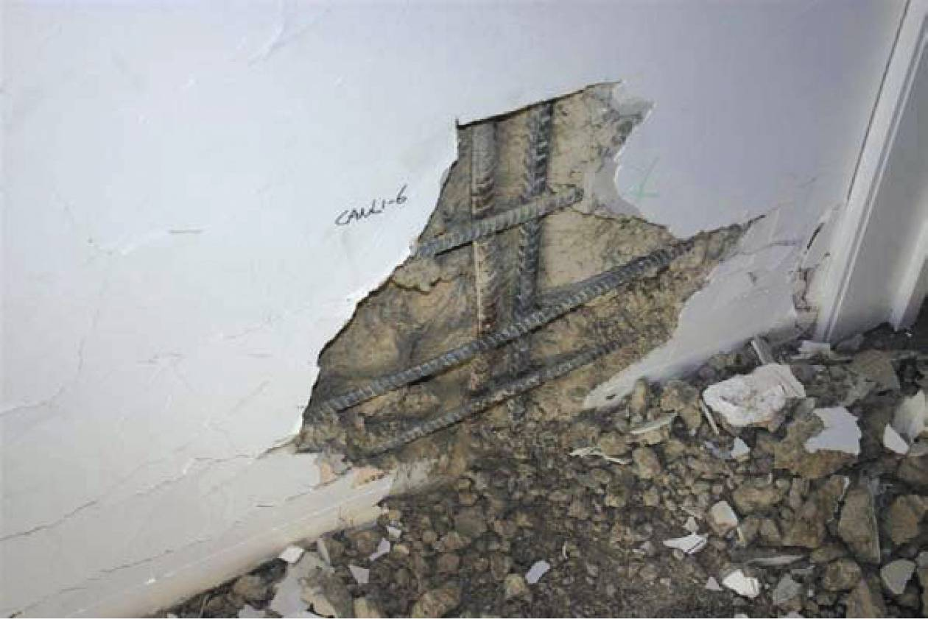
Figure 82: Buckling of vertical reinforcement level 1 (source: Spencer Holmes)
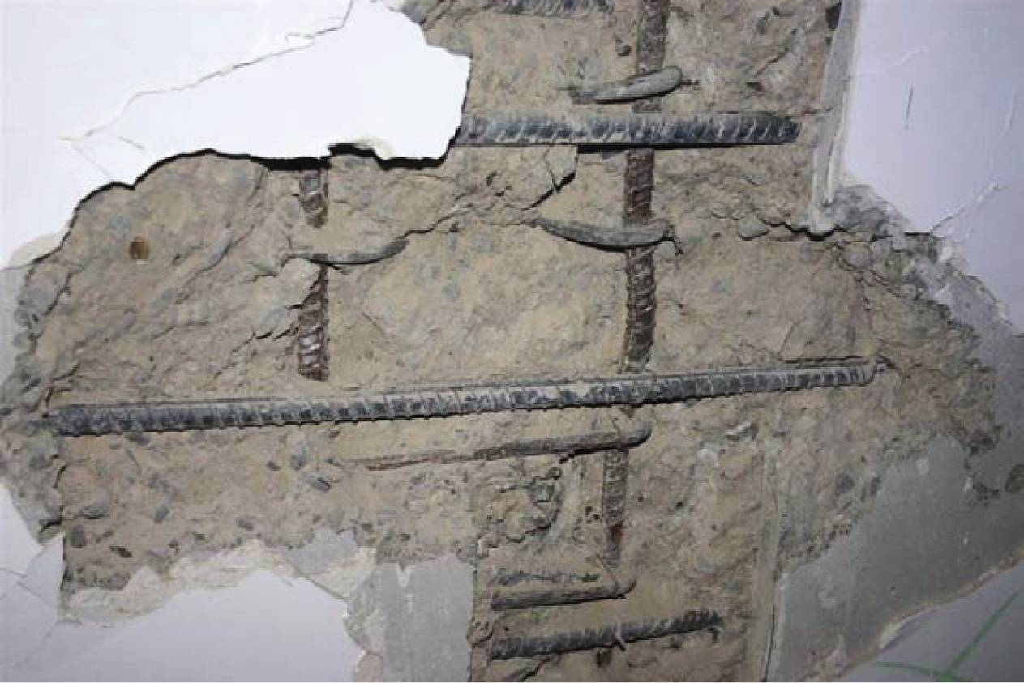
Figure 83: Buckling of reinforcement level 2 (source: Spencer Holmes)
6.2.1.6.2 Concrete spalling at junction of truss beams and columns
Extensive spalling of the cover concrete in the columns occurred adjacent to the junctions with the truss beams, which were embedded in the columns (refer to Figures 84 and 85). The detail was designed for gravity load transfer but the connection detail was not designed to allow for the relative rotation that could result from inter-storey drift. The relative rotation between the truss beams and the columns generates a prising action of the beam on the column, with the cover concrete outside the spiral spalling over an appreciable length. The extent of this spalling may have been increased as each truss beam was anchored onto a longitudinal bar in the column, which might have been pulled sideways by the prising action (see Figures 86 and 87).
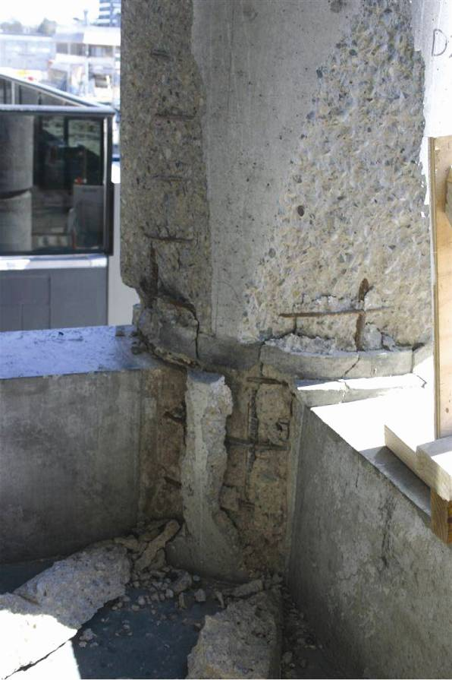
Figure 84: Spalling of circular external column (source: Spencer Holmes)
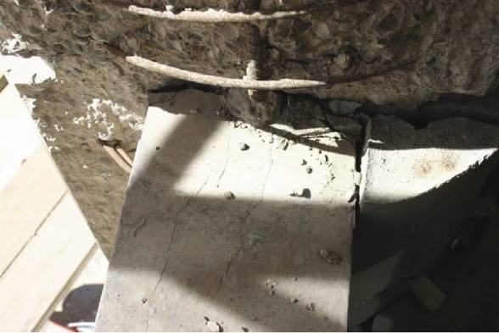
Figure 85: Spalling of circular external column at junction with precast truss (source: Spencer Holmes)
As mentioned above, the precast truss beams were anchored into the perimeter columns. However, during an inspection of the building it was noted that there was an outward movement of the columns relative to the floor, of the order of 25 to 30mm (see Figure 86).
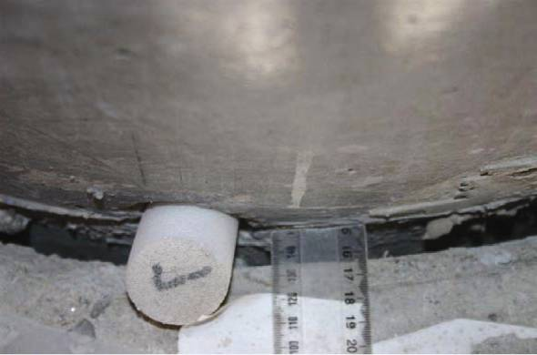
Figure 86: Tearing between precast truss and floor (source: Spencer Holmes)
The origin of this movement can be traced to elongation associated with the structure, as shown in Figure 87. The depth of the beam at the junction with the column is 900mm. A storey drift of two per cent would cause, on average, an elongation of 9mm at each column when the seismic motion ceased. Where the enclosed angle between the truss beams meeting at a column is 135°, the application of 9mm elongation from each bay corresponds to an outward displacement of 24mm, which is similar to the observed movement. Where the enclosed angle is 90° the corresponding movement is 13mm. The forces required to restrain the outward movement of the columns would be very high and it would not be practical to provide this restraint.
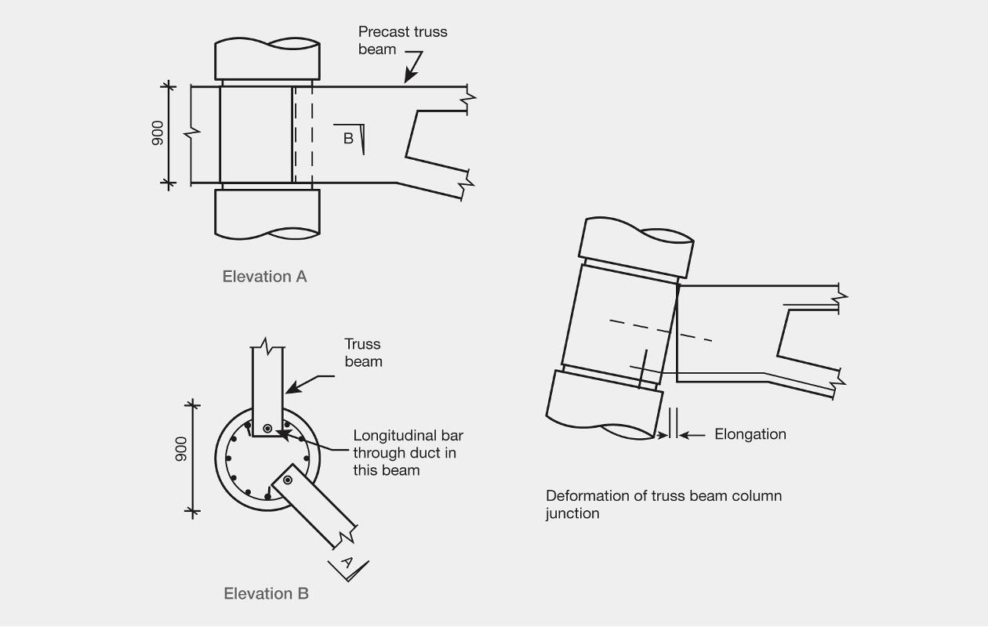
Figure 87: Junction of truss beam and a perimeter column
6.2.1.6.3 Incompatible deformation damage
The walls making up the shear core behaved as flexural members, causing the floors adjacent to the walls to rotate. The gravity load system consisting of the columns and truss beams tended to be displaced laterally without rotation. These two different patterns of deformation imposed rotation and twisting on the precast and in situ floor components. We consider that this source of incompatible deformation largely accounts for the observed damage to the floors.

