6.1.3 100 Kilmore Street: Christchurch Town Hall
Current status
Proposed to be repaired.
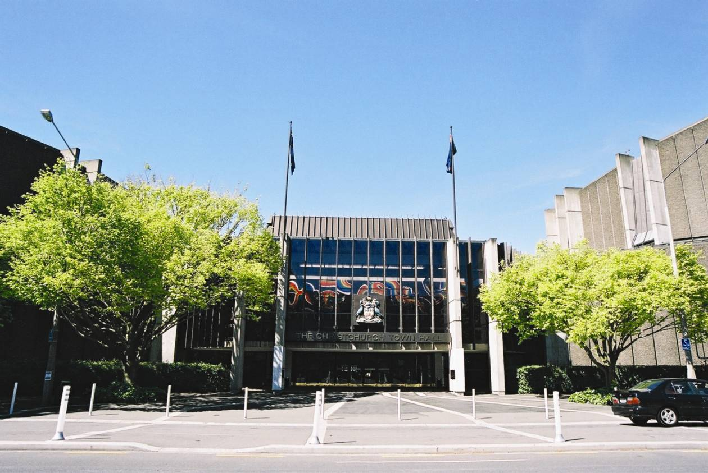
Figure 74: View of entrance to the Town Hall lobby looking south from Kilmore Street (source: CCC)
6.1.3.1 Introduction
The Christchurch Town Hall was designed and built between 1968 and 1972 (Figures 74 and 75). It is a T-shaped building comprising an auditorium, a theatre and three large conference rooms. At the southern end of the building is a restaurant with adjacent kitchen areas. For the general layout see Figure 76. The structure extends over three storeys, with a plan area of about 6500m². The Avon River is immediately adjacent to the southern side of the building.
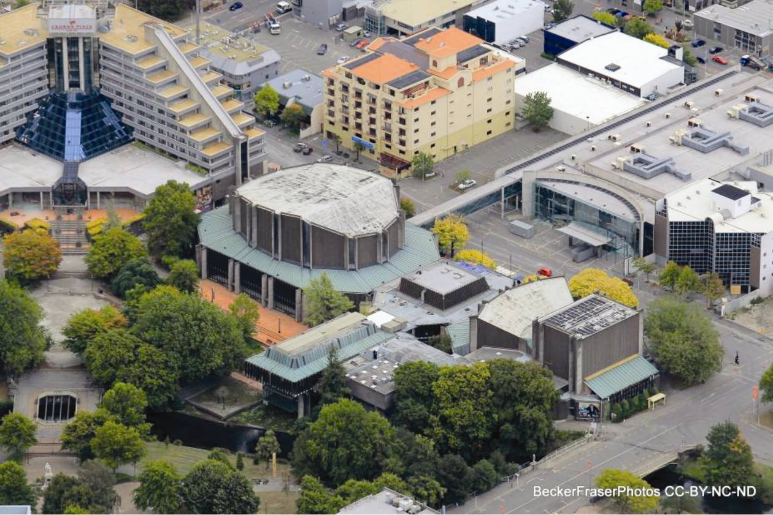
Figure 75: Aerial view looking north-west with Colombo Street in the foreground (source: Becker Fraser Photos)
6.1.3.2 Foundations
Generally, the Town Hall’s foundation system consists of shallow foundations such as strip or rectangular footings, although a relatively small extension added in 1976 was supported on deep foundations. In the auditorium, slender piers are supported by pad footings at both the interior oval and the exterior. Foundations for the slender piers at the interior oval are further connected to each other by strip footings under the reinforced concrete walls. At the exterior they are tied together by small beams cast on grade.
The theatre employs similar foundation elements, with slender piers supported by pad footings, reinforced concrete walls by strip footings and several small beams cast on grade interconnecting various elements. Slender piers to the lobby are also supported on pad footings with small grade beams. In addition several significant concrete ducts run under the slab on grade. One of these ducts continues to the restaurant, where slender piers are again supported on pad footings. More significant tie beams exist between pad footings in the north–south direction of the restaurant, with smaller grade beams running east–west.
The kitchen block rests on a reinforced concrete mat foundation that is thickened near its centres, where it supports an interior reinforced concrete wall. As noted above, in contrast to the original structure, the 1976 addition uses reinforced concrete piles rather than shallow foundations.
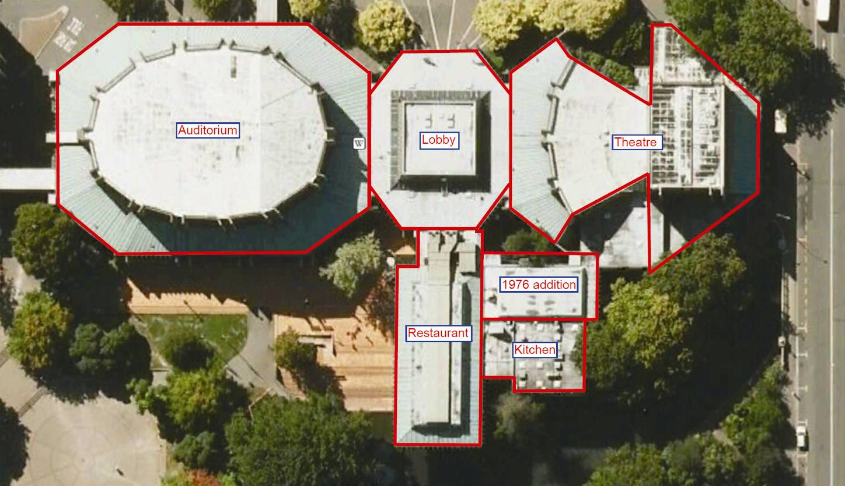
Figure 76: Aerial view showing the various uses
6.1.3.3 Superstructure
Reflecting the building occupancy and use, the lateral force resisting system varies between portions of the structure. Because the damage observed was primarily identified as being due to liquefaction and lateral spread, the superstructure is not discussed fully in this Report.
6.1.3.4 Building structural performance
The Royal Commission was helped in the assessment of this building by a report prepared by Rutherford and Chekene, consulting engineers, from California.
The Town Hall suffered significant damage during the Canterbury earthquake sequence, with the February event producing by far the greatest effects. Most of the superstructure damage appears to have been caused by widespread liquefaction and lateral spreading that resulted in differential settlement and building separation. Localised eruption of sand and the presence of sand and silt in the Town Hall’s basement are the most obvious evidence of liquefaction, while ground cracking near the Avon River suggests extensive lateral spreading. Foundation settlement varied from 70 to 460mm, but more typically between 200 and 350mm over most of the building. Lateral spread varied from no displacement at the northern side of the building (Kilmore Street) to as much as 350mm close to the Avon River bank. Available reconnaissance reports indicate that no foundation bearing capacity failures were observed. Several portions of the superstructure tilted either towards or away from the Avon River to accommodate the severe ground movement. Structural response due to ground shaking may also explain some superstructure cracking, although it is difficult to identify in the presence of such dramatic settlement damage.
6.1.3.5 Conclusions
The damage to the Town Hall is primarily due to liquefaction settlement and lateral spread of the ground. Given the large displacements caused by the ground damage, the building has performed well. It is a complex network of structures, and as the damage from shaking could not be clearly isolated from the ground failures, and the building was not built to current standards, there is little value in the Royal Commission commenting further on its superstructure.

6.2 1976 to 1984: Buildings designed to Loadings Code NZS 4203:1976¹

6.2.1 166 Cashel Street: Canterbury Centre/ Westpac Tower building
Current status
To be demolished.
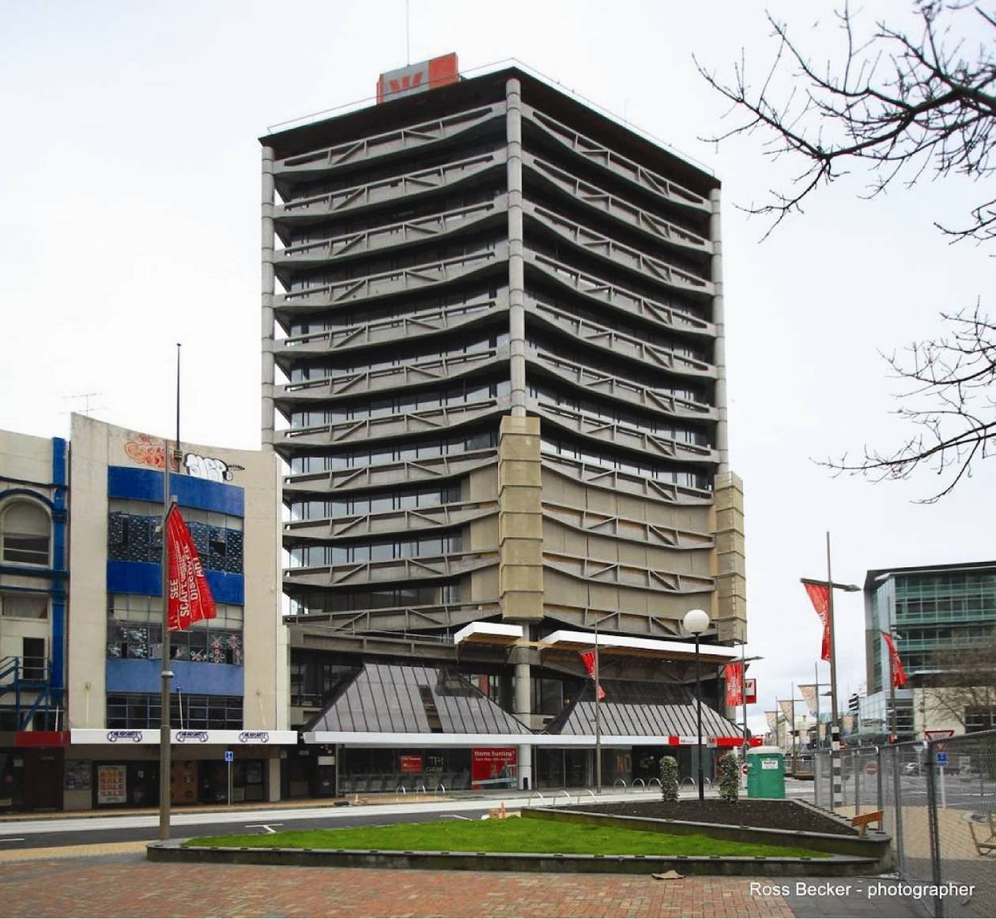
Figure 77: Westpac Tower, looking northwest (source: Ross Becker Photos)
6.2.1.1 Introduction
The Canterbury Centre/Westpac Tower (Figure 77) was designed in 1981 and a building permit was issued that year by the CCC. It was constructed over the next two years as the Canterbury Savings Bank building. The building is a 13-storey reinforced concrete building with a basement, and is interconnected through a seismic gap with a three-storey podium that also has a basement. The tower is of hexagonal form, with the tower orientation offset from the essentially rectangular form of the podium (see Figure 78). Only the performance of the tower is considered in this Report.
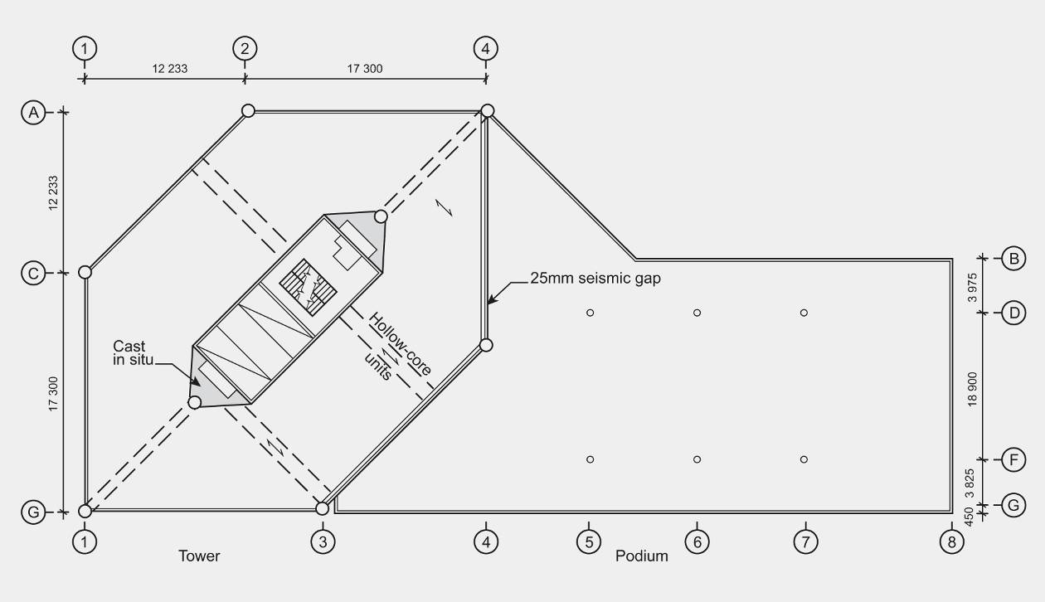
Figure 78: Plan on level 3 showing relationship of podium to tower
6.2.1.2 Foundations
There is no specific information on the geotechnical profile below the building, but the ground liquefied, with sand ejected through the basement floor. This is reported in a damage assessment carried out after the February earthquake but is not recorded in information available from the September earthquake.
The building is built on a raft-type foundation consisting of outrigger beams from the core to pick up the weight of the external columns to help resist overturning loads. The raft has possibly rotated up to 58mm, but from the information available the variations in level are too small to be conclusive. The indications are that the tower raft has settled by up to 70mm.
6.2.1.3 Gravity load system
The floors comprise precast hollow-core units with 50 to 65mm of in situ concrete topping, reinforced with hard drawn wire mesh. The hollow-core units were supported on the shear core walls, the two internal beams which span between the external columns at A4 and G1 and the internal columns (see Figure 78), and on the perimeter truss-shaped precast beams (see Figure 79). The support at the external beams is provided by a steel angle section that was anchored into the web of the beams. At each end of the shear core there is a region of in situ concrete floor that provided support to a few of the hollow-core units.
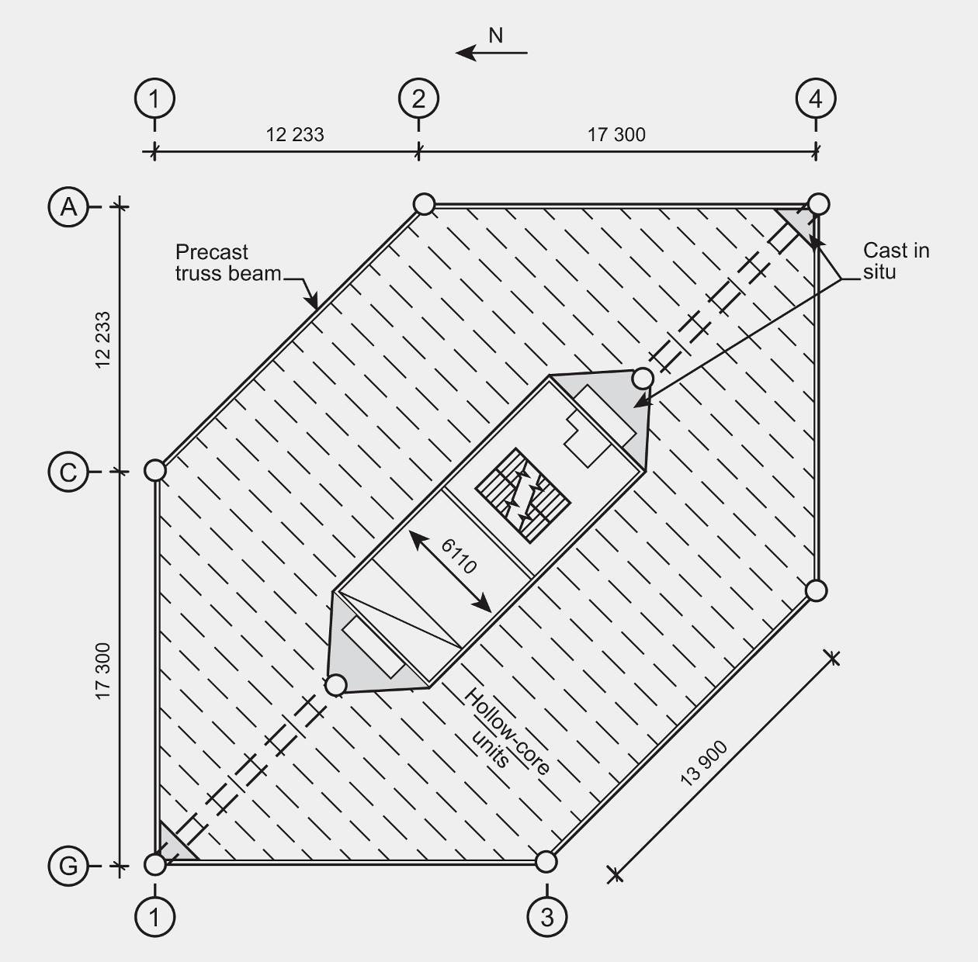
Figure 79: Plan on typical level in the tower
6.2.1.4 Seismic load system
The primary lateral force resisting system to the tower is provided by reinforced concrete ductile shear walls that form a shear core, which is located centrally within the hexagonal floor plate of the building. A perimeter frame consisting of six columns and the truss beams provides support for gravity loads. Their contribution to resisting seismic forces would have been minimal, owing to the flexibility of the columns and beams relative to the shear core.
A seismic gap of 25mm was provided between the podium and the tower.
The precast stairs are generally supported by structural steel legs cast into them and mortared into pockets at both ends. This detail provided little allowance for inter-storey drift but because the stairs were located within the shear core any shortening or lengthening of the stairs would have been small.
The Loadings Standard current when the building was designed was NZS 4203:1976¹. The design forces that were used would have been less than 75 per cent of the current requirements in 2010 (based on a Z value of 0.22). The design was carried out before publication of the first Concrete Structures Standard, NZS 3101:1982¹¹, which contained detailed information on design for ductility. However, the detailing on the drawings shows that many of the ductile detailing concepts that were being proposed at the time were employed. It should be noted that detailing requirements have been considerably improved over the last 30 years, but the structural design was clearly advanced for its time. There was some confinement in the walls, and the beams above doorways in the shear core were designed as diagonally reinforced coupling beams.
6.2.1.5 Performance of the building
The Royal Commission was assisted in the assessment of the performance of this building by a report prepared by Spencer Holmes Ltd.
As a result of the September earthquake the building suffered some damage, in particular:
• flexural and shear cracking of the lower shear walls and coupling beams;
• tearing of the floor slabs adjacent to the shear core walls;
• cracking of the floor slabs adjacent to the exterior beams;
• damage and spalling at seismic gaps;
• spalling of external columns (and minor rusting of reinforcing exposed); and
• destruction of level 13 non-structural cladding (glazing).
Damage assessed after the Boxing Day aftershock was reported as an overall summary to
that date:
1. For the tower, minor flexural and shear cracking of the core walls was observed throughout. Local buckling of the southern side of the core wall occurred at level 1, with significant cracking at this level.
2. Extensive spalling of cover concrete occurred on the exterior columns and significant damage was observed to the columns at the beam connections. Cracking and crushing extended to the core of the column section in these locations. Minor cracking of the precast truss beams occurred.
3. Failure of hollow-core flooring was observed at sliding seismic joint locations. Relative movement of the tower and podium caused failure of the sliding corbel seating for the level 2 bridge. Tearing of the floor topping was observed at some levels adjacent to the core as well as extensive pullout of cast-in inserts connecting the floor to the exterior beams.
4. Sliding connections for the podium roof were extensively damaged, with a residual displacement between the tower and podium. Non-structural cladding (glazing) at level 13 was badly damaged.
5. Liquefaction occurred at the site, with sand ejected throughout the basement slab. Possible differential settlement of the podium’s shallow foundations occurred, with minor rotation of the tower raft foundation implied from the verticality survey.
At the time of the February earthquake, the repairs of damage from the previous earthquakes were under way and overall damage from all events to that point was reported:
1. Moderate cracking of the shear core walls was observed throughout, particularly at the first floor level where local wall buckling occurred. Steel material testing indicated that the core wall reinforcing had lost up to 90 per cent of its strain capacity in this area. Extensive spalling and cracking of the external columns occurred, resulting in significant damage to the precast
truss beam seating.
2. Failure of hollow-core flooring units and the level 2 bridge occurred, resulting in local collapse hazards mitigated by temporary propping or cordoning. Tearing of the floor slab topping was observed in some isolated locations, as well as extensive pullout of the cast-in inserts connecting the floor to the exterior beams. The sliding connection for the podium roof failed and the top floor (level 13) glazing was completely destroyed.
3. Liquefaction occurred at the site, with sand ejected throughout the basement slab.
4. There were differential settlements of the podium’s shallow foundations of up to 70mm, with minor rotation of the tower raft foundation implied from the verticality survey. The verticality survey indicated relatively minor residual displacements.
5. In general the structural damage sustained was considered relatively extensive and substantial repairs or replacement would be required. As a result of the earthquakes the building’s capacity was reduced, although it was not considered to pose an immediate collapse hazard in a moderate earthquake.

