Section 4:
Forsyth Barr building

The Forsyth Barr building at 764 Colombo Street is on the south-eastern corner of Colombo and Armagh Streets in central Christchurch, a short distance from Cathedral Square. In the 22 February 2011 earthquake, the main access stairs in the building collapsed. All stairs collapsed below level 14 in one stairwell and below level 15 in the other. People were trapped in the floors above.
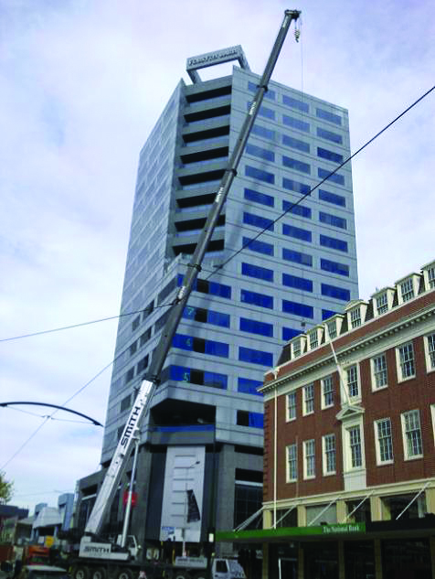
Figure 44: Post-February view from Victoria Square
The discussion below covers:
• the history of the Forsyth Barr building prior to the 4 September 2010 earthquake;
• the September earthquake, the performance of the building in that earthquake and the actions taken as a result;
• the February earthquake and the failure of the stairs; and
• lessons the Royal Commission considers should be learned from this failure.

It reflects information gathered from a variety of sources including:
• the Christchurch City Council (CCC) as the regulatory authority administering building controls in Christchurch;
• Colliers International Property Management Ltd (Colliers), building managers at the relevant times;
• the Beca Carter Hollings & Ferner Ltd investigation into the failure for the Department of Building and Housing (DBH) (the Beca report¹);
• DBH Expert Panel review of the Beca investigation (the Expert Panel report²);
• a review of the Beca and Expert Panel reports carried out on behalf of the Royal Commission by Mr William T. Holmes of Rutherford and Chekene; and
• evidence given and submissions made to the Royal Commission at a public hearing on 23 and 24 February 2012.
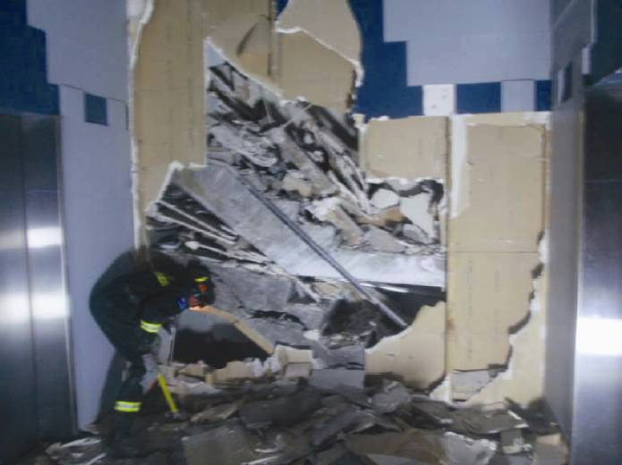
Figure 45: Fallen stair flights at the bottom of the stairwell

4.1 Original construction of the Forsyth Barr building
The Forsyth Barr building has 18 storeys and was designed in 1988 as a retail and office development. The developer was Paynter Developments Ltd and the building was sold on completion to Robt Jones (Canterbury) Ltd. It was originally called Robert Jones House.
The architectural design was carried out by Architecture Warren and Mahoney Ltd, with the final structural drawings prepared by Holmes Consulting Group Ltd (HCG). The contractor was Fletcher Construction Ltd.
A design certificate for the building was signed off on behalf of HCG by Mr R.A. Poole on 7 March 1998. The certification includes the following:
I have exercised reasonable control over the design processes for the works defined above which have been designed in accordance with sound and widely accepted engineering principles to support the loads specified in NZS 4203:1984.
I believe the stresses in the various materials of construction and force resisting elements of the structure including the foundation strata under the above loads are such as to ensure the safety and stability of the structure if the works are constructed in accordance with the above described drawings and specifications.
A building permit was issued by the CCC on 9 May 1988.
The building is founded on a shallow raft at a depth of around 2.5m below the ground floor level.
Both the Beca report and the Expert Panel report have concluded that there was no evidence that liquefaction or foundation failure played any role in the collapse of the stairs. The Royal Commission accepts those conclusions.
Lateral resilience of the building is provided by the frame action of the reinforced concrete beams and columns. For three storeys above the ground floor level, the floors extend beyond the footprint of the tower to form a podium on the south and east sides.
The building system for the tower is unusual in that it comprises two triangular portions that are reinforced concrete frames linked together by a precast concrete floor system. Figure 46 shows a typical floor plan and indicates some of the building features of original drawings. Figure 47 shows the lower floors and locates the tower in relation to the podium.
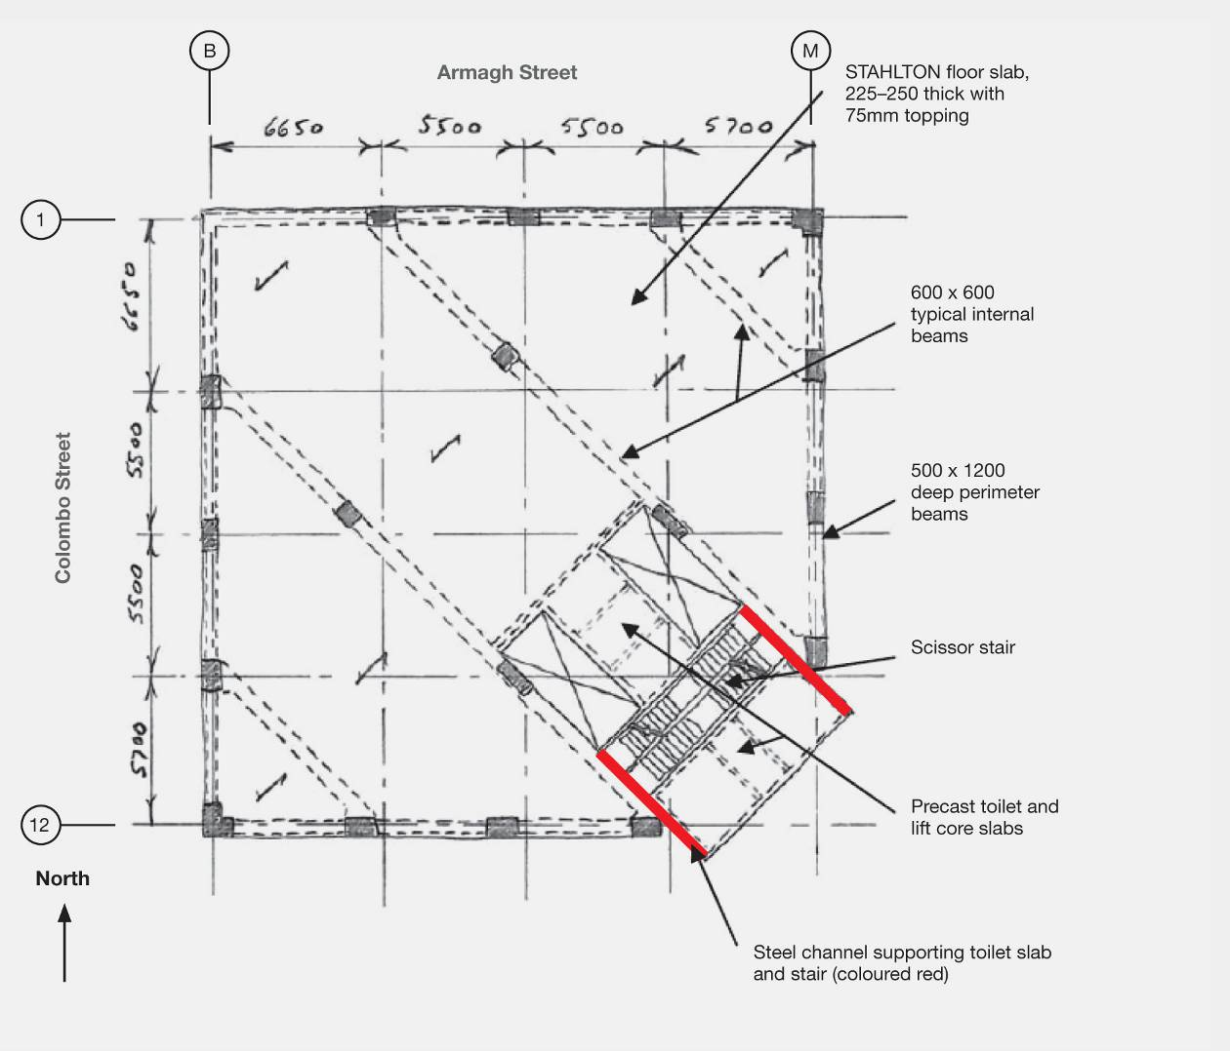
Figure 46: Typical plan above podium level (source: Beca report)
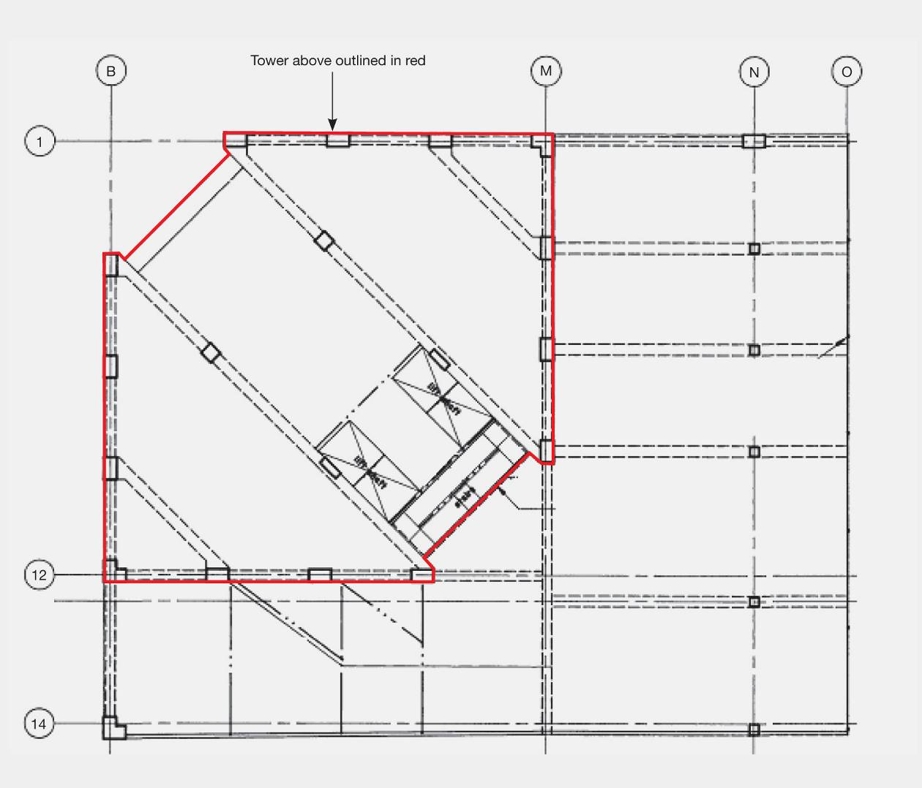
Figure 47: Lower levels showing podium (source: Modified from original construction drawings obtained from the
CCC file)
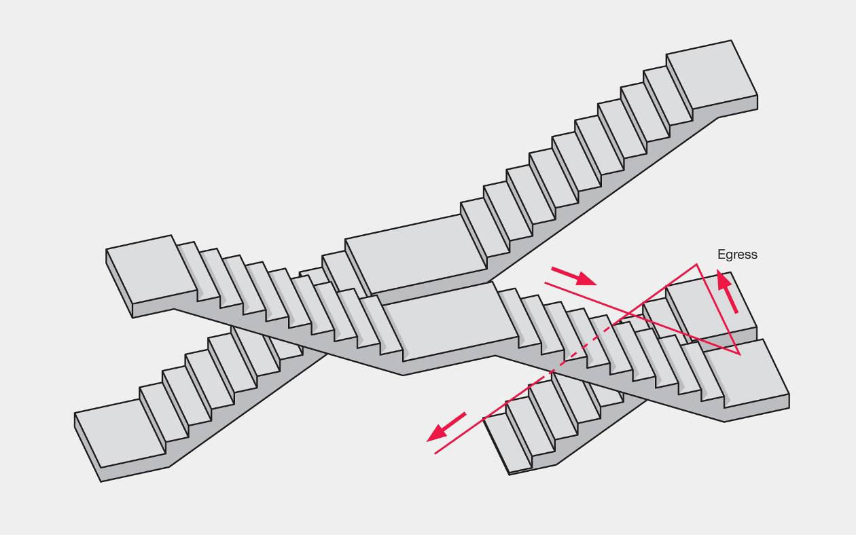
Figure 48: Example of scissor stairs (source: Beca report)
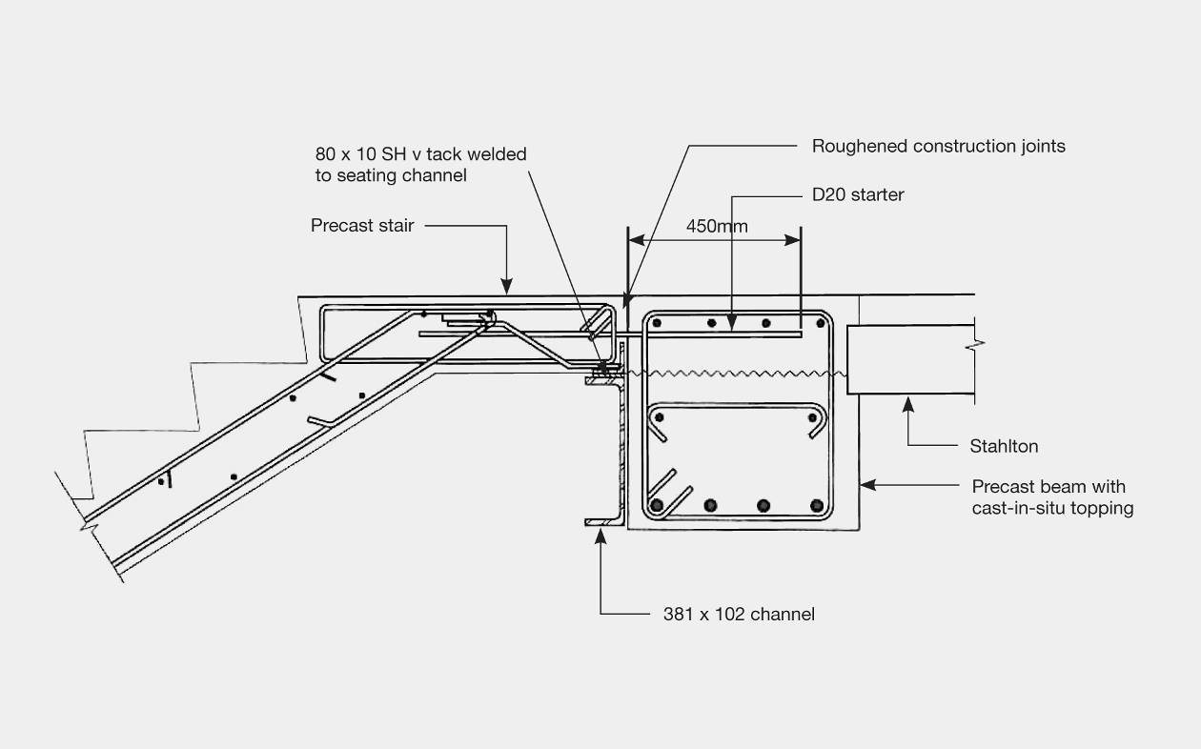
Figure 49: Detail at top of each stair flight (source: Beca report)
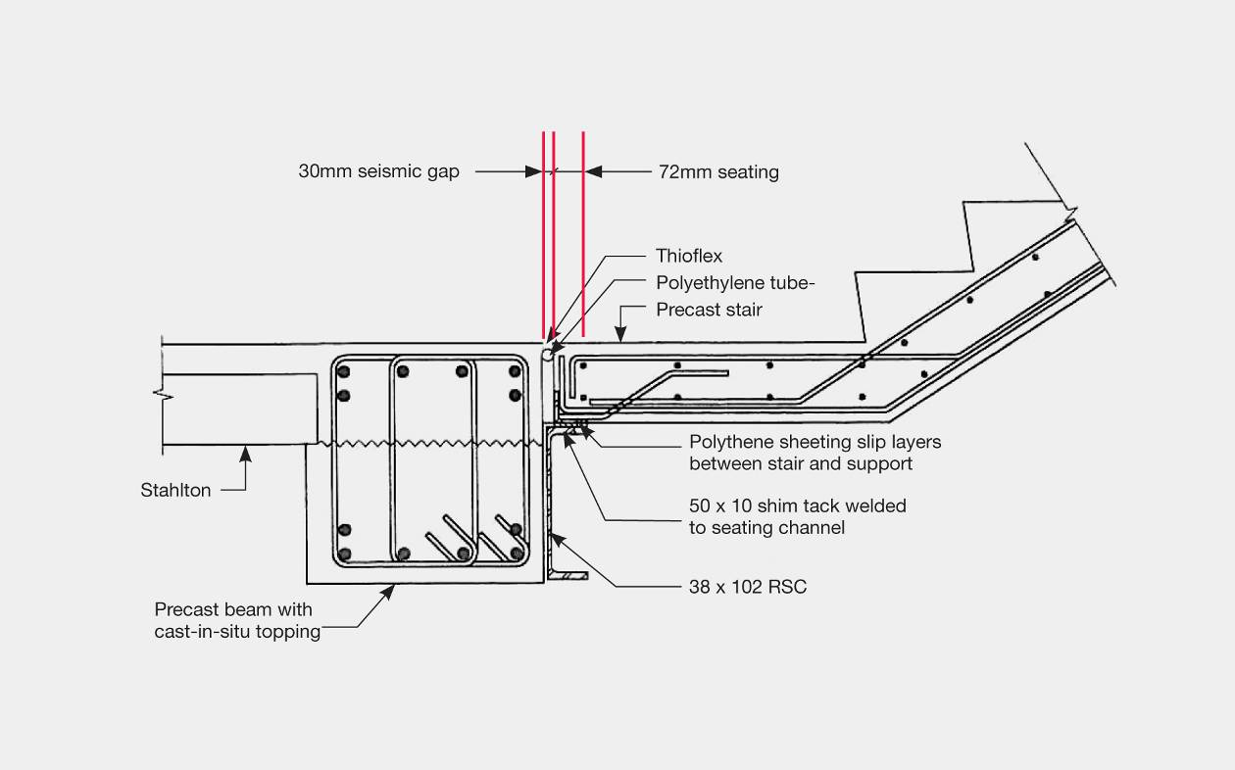
Figure 50: Detail at lower landing of stair flights (source: Beca report)
The stairs are orientated diagonally within the tower in a north-easterly to south-westerly direction. Figure 46 locates the position of the stairs, which are of the “scissor” type. In a scissor stair, two stairways are provided within a single shaft, separated by a light-weight partition in between and over the full height of the stairwell. Access is by winding up or down the stairwell, changing sides at each floor and passing under the flight of the other stair. Figure 48 shows the general arrangement. One of the risks associated with such a stair system is that if a flight collapses on one side of the shaft it may render both stairs impassable.
Most of the stair flights were precast concrete units, each cast as a single unit, not as separate flights, and connected by a cast-in-situ slab. Each flight was supported on a channel with a reinforcing bar cast into the supporting concrete beam at the upper landing, as seen in Figure 49.
At their lower landings, the stairs were seated on a steel channel with a horizontal gap specified as a 30mm seismic gap in Figure 50.
The steel channels also support the toilet slab, accessed off the landings (Figure 46, page 90).
There was evidence that during the course of construction, site instructions were given to the contractors about maintaining the seismic gap. However, Mr Paul Tonkin, site manager employed by Fletcher Construction Ltd during construction, gave evidence that he did not appreciate the critical importance of the seismic gap at that time.

4.2 Up until 4 September 2010
Between the time of the original construction of the Forsyth Barr building and 4 September 2010, numerous building permits, building consents, and exemptions from building consents were issued by the CCC. None of these approvals involved significant structural alterations of the building.
The building had a current building warrant of fitness at the time of both the 4 September 2010 and the 22 February 2011 earthquakes. One of the items on the compliance schedule and building warrant of fitness was an emergency lighting system, which was verified as being operative by Mr Russell Gracie (Independent Qualified Person #466) from Chubb New Zealand Ltd on 1 December 2010.
The current owner of the Forsyth Barr building is 764 Colombo Street Ltd.

4.3 The September earthquake
The nature and intensity of the September earthquake are described in Section 2 of Volume 1 of this Report.
The Forsyth Barr building is located at distances of 700–1350m from the four primary seismic measuring stations for the Christchurch CBD. The Resthaven Retirement Home site near Peacock Street (marked REHS in Figure 51) is the closest, and Beca used the ground motion records at this site.
In the September event, the predominant direction of the horizontal accelerations for buildings such as this, with an initial period of vibration of 2.0–2.2 seconds, was in the north–south direction. The Forsyth Barr building has similar strength and stiffness in both north–south and east–west directions.
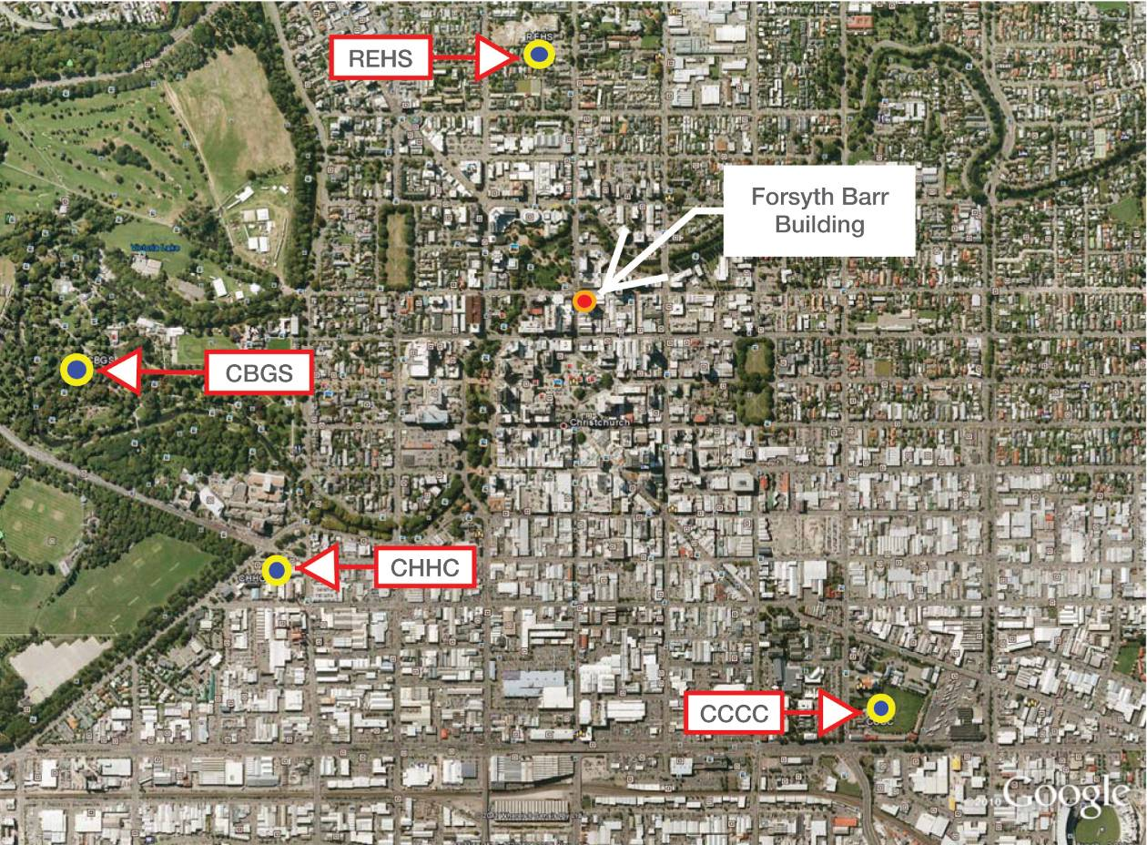
Figure 51: Location of Forsyth Barr building in relation to seismic measuring stations

4.4 Between the September and February earthquakes
As discussed elsewhere in this Report, after the September earthquake a state of local emergency was declared and the CCC (under guidance from DBH) initiated a civil defence emergency management response. As we have noted in our discussion of the failure of the PGC building, from 5 September teams were sent to all commercial parts of the Central Business District (CBD) to undertake Level 1 Rapid Assessments. These were exterior inspections to look for obvious signs of damage indicating immediate danger, or to determine whether further investigations were required before use of the buildings. A Level 2 Rapid Assessment is a more extensive visual inspection that includes the interior.
The Forsyth Barr building was the subject of a Level 1 Rapid Assessment on 5 September. As a result, a red placard was placed on the building, stating “UNSAFE – do not enter or occupy”. Subsequent to this assessment, and on the same day, a Level 2 Rapid Assessment was carried out by Mr Peter Beazley and Mr Rob Jury of Beca, as instructed by the owner. This resulted in a yellow placard, marked “Restricted Use – no entry except on essential business”. The classification was, “Y2– no entry to parts until repaired or demolished”. The general concern was that the stairs had settled and might have become unstable.
In a report written after a further inspection on the following day, there was reference to “damage to the scissor stair around the landing area” and it was noted that a contractor had been brought in to assist with removal of the stair bulkhead on the level 7 landing. This was considered to be the most damaged stair, but the report said that the majority of the flights had similar damage. The report observed: “[Although] the deformations in the stairs are significant, we believe that the stairs still contain sufficient capacity for normal use.” A steel beam under the car ramp was also identified as having a failure in a welded connection, and propping of this was recommended.
It is apparent that debris had been observed in the areas supposed to function as seismic gaps at the bottom landing of each flight of stairs. The report recommended that the debris be cleared from the gaps of “each stairflight to allow movement as originally intended”.
The car ramp had been temporarily propped by the time the report was written, but access was restricted to pedestrians only (no vehicles). The placard was changed to green, “Inspected – no restrictions on occupancy or use” and, more specifically “G2 – Occupiable, repairs required”. In evidence, Mr Jury expressed the opinion that it was not appropriate for a green placard to be withheld pending removal of the debris in the seismic gap. He said the stair flights did not appear to be significantly compromised as a result of the September earthquake and debris removal was something to be attended to by the building manager in due course. It did not make the building unsafe to occupy.
At about this time, although the exact date has not been provided to us, Pace Project Management Ltd (Pace) was engaged by Colliers to manage the earthquake repairs to the building. On 10 September Pace provided a quote to replace the vinyl on the stairs.
Two further inspections were carried out by Beca on 13 and 15 September. These are not relevant to the current investigation.
Beca expected to continue with inspections and assessment of the building. However, it had no further involvement from this time on. In mid-September the building managers engaged HCG to carry out further structural assessments.
On 8 October HCG provided a fee proposal that included as its first stage:
1. To complete a preliminary structural survey of the building to identify the general form and location of earthquake damage.
2. To complete a review of available documentation of the building to identify potential “hot spots”
for more detailed investigation.
3. To coordinate with a contractor or maintenance staff to expose key structural members as required and/or commission testing if required for key elements.
4. To make an assessment of any strength reduction due to the damage and, if applicable, to estimate the remaining available strength of the building in terms of full code loading, in order to establish compliance with the CCC’s 2006 Earthquake-Prone, Dangerous and Insanitary Buildings Policy³, and to enable an informed decision to be made regarding future re-use.
The proposal also included some details of future stages should they be necessary.
On 12 October, Mr Andrew Christian of Pace wrote to Mr Michael Connelly at Colliers by email, reporting that the stopping on the stairwell was almost completed, and checking that this is what was expected.
On the same day, Mr Connolly sent an email to Mr John Hare at HCG saying:
Please proceed with this report asap. Andy Christian of Pace has done a survey of the building so can advise on some areas of concern. I want to be sure the stairs are ok and fixed correctly. Please note some cracks were covered by the plasterer and these need to be double checked and probably fixed correctly.
On 1, 2 and 3 November HCG carried out the inspections that it relied on in the preparation of its report provided later that month.
On 3 November, Mr Hare wrote to Mr Connolly by email with an update. He expressed his opinion that the building had performed well and that it appeared to have suffered no significant structural damage. Mr Hare also said that HCG was happy with the repairs that had been completed and others that were ongoing.
On 4 November Mr Connolly responded to Mr Hare by email: “Thanks for this. I have concern about the apparent ‘drop’ in the stairs. I assume your report will cover this and the best way to repair”.
Mr Hare gave evidence that he did not read this email until some time after it was sent, although there were some telephone discussions about the stairs at about this time. Mr Hare stated that he did not consider the sag in the stairs was of immediate concern as “there was no sign of significant lateral drift of the primary structure that might have alerted HCG to significant concern”.
On 29 November, HCG presented a report titled “Forsyth Barr Tower Post-Earthquake Assessment and Repair Report.” The report was written by Mr Mark Sturgess, as Project Engineer, and reviewed by Mr Hare. This was a substantial report but it did not refer to any specific inspections of the stairs or details of damage to them. Mr Hare’s evidence was that an assumption was made that as Beca had already inspected the stairs and commented on them, the focus of the HCG report should be on the building’s primary structure. However, HCG had not seen the Beca assessments of the building as it had not been provided to them.
The only mention of stairs was in Appendix E of the report, which detailed the post-earthquake damage repair. In “1.7.1 Crack Damage”, the contractor is instructed to identify cracks to be repaired following the work detailed within that appendix, and to contact the engineer to arrange an inspection after preparation for, but prior to, epoxy injection or grouting. The stairs were one of the elements where cracks were to be repaired. This report was intended as a live document that would be updated and amended as work proceeded.
The Royal Commission has not been provided with any details or evidence of inspections after the
29 November report and there is no evidence of any inspection after the Boxing Day 2010 earthquake. In a written statement of evidence provided to the Royal Commission, Mr Christian stated that work necessary to replace the vinyl on the stairs was scheduled to commence in the week after the 22 February earthquake. Mr Christian said that his intention had been to advise HGC when the vinyl was lifted that the landings should be inspected further, and that this should take place before the vinyl was re-laid. Unfortunately, the 22 February earthquake intervened.
It is unclear from the evidence that a closer inspection of the stairs would have exposed the inadequacy of the seismic gaps.

4.5 The February earthquake
The nature and intensity of the February earthquake are described in section 2 of Volume 1 of this Report.
The shaking was mainly in the east–west direction, with a significant vertical component. It was of a short duration, but had high accelerations and displacements because its epicentre was close to the CBD.
When the earthquake struck, the Forsyth Barr building was evidently subjected to strong accelerations in the east–west direction, resulting in rapid failure of the scissor stairs. The reasons for failure and the likely sequence of events are addressed later in this Report.
As the failure occurred in the middle of a working day, many people were trapped in the upper floors. Fortunately, no one fell down the remains of the stairwell (a significant risk, as both the main and emergency lighting systems to the stairwell failed so the only light available was when a door to the landing was opened). Evacuation of the occupants required lowering a number of people on ropes to the podium roof to the east, and the rest by crane some hours later. The Royal Commission was impressed by the account of the evacuation given in evidence by Mr Grant Cameron, a solicitor who practised on the sixth floor of the building, and we consider it worth setting this out in full:
At the time of the earthquake on the 22nd of February 2011, I was sitting in my office talking with Shaun Cottrell. He’s one of our associates. It was immediately a lot more violent than anything we had previously experienced and I crouched forward in my chair pondering whether to jump under my desk. As I leaned forward I noticed a very large book case beginning to fall from the wall behind Shaun and although I thought it was going to hit him, I didn’t have a chance to yell a warning because we were consumed by a tremendous noise and all the violence of the earthquake. Fortunately the bookcase missed Shaun but all of my other furniture and belongings crashed to the ground and we could hear furniture falling all around the office, women screaming and there was general chaos.
Although my office was positioned on the Armagh Street frontage immediately adjacent to our boardroom which in turn is situated right on the corner of Colombo and Armagh Streets, the interior wall of my office was glass and so I could see clearly into the interior of the firm. My wife Ilze is the office manager and from the outset I could see her standing by her desk with her eyes and mouth wide open in obvious astonishment but strangely with thick clouds of dust swirling around her. Later we discovered that these clouds were formed by concrete dust from the collapsing stairs being blasted back into our suite through the air conditioning ducts.
Shaun and I clambered over furniture, files and other debris and rushed out into the main body of the office. I began calling for the staff to all come down to the Board Room where we could start a head count and get ourselves sorted out. Naturally there was a lot of concern and people were quite upset. I should add there that I also sent a staff member next door, the adjacent tenancy was the Ombudsman and we got all of their staff into our Board Room as well.

As we returned to our Board Room David Maclaurin, one of our solicitors, came into the reception area from the direction of the lift wells. I noticed half of his shirt was hanging out of his trousers and he exclaimed that he had been in the toilets when the quake struck. He looked utterly shocked and then blurted out, “You won’t believe it but the bloody stairs have collapsed.” It took me a moment to register what he was saying but he was quite insistent that the stairs had completely disappeared. He also commented that “half the bloody landing has gone as well” and then described having to carefully clutch to the walls around the sixth floor landing in the dark in order to get from the toilet back into our offices.
Suddenly we realised that we could be trapped. Two or three of us then ran round to the corridor on the south-west side of the lift wells to see if the stairs leading away from the landing beside the ladies’ toilets were in place. However, the internal door between the corridor and the stairwell landing was jammed shut with a lot of rubble behind it. It took quite a few shoulder shoves to slowly push it open and even then we probably only got it open 12 to 15 inches. There was about 18 inches of concrete rubble jammed up behind it. As I put my head through the now partly opened door I could see that all the stairs had disappeared, as had the dividing wall between the stairwells. There was just a gaping hole stretching down through the middle of the building with blackness both above and below.
There were other people standing on other levels both above and below who had also opened the same doors on their respective landings and so there was a little bit of light shining in from behind these various doors and just enough for us to all take in the damage. It was now plain that everybody was trapped on their respective floors.
This reinforced my view that the big risk factor was fire. With all the stairs gone there had to be a real risk that electrical fittings would have been damaged or destroyed and at the same time there was a good chance that the fire hydrants might not operate because the plumbing to those may also have been damaged.
We returned to the Board Room and had a very quick talk about the options. I suggested to everyone that we probably had enough electrical extension cords in the office to provide ourselves with a form of rope whereby perhaps we could lower people to the carpark on the eastern side of the building. On that eastern elevation the car park extended up for three floors from ground level and jutted out from the main tower block. Our office overlooked that carpark and as the distance from our floor to that carpark was about 30 feet I was reasonably sure that we would have enough extension cords to come up with a solution. If we could lower staff to that level they could either then run down the car park ramps to the street or if they were damaged they could escape over rooftops on the eastern side of the building.
The staff quickly began retrieving extension cords from around the office and I set about tying reef knots to link them up. The first cord formed from two such extension leads would probably have been of the right length but other such ropes would likely require at least a couple of joins. As I was busy with this exercise one of the secretaries from the Ombudsman’s Office grabbed my sleeve and told me there was a Civil Defence cabinet situated at the back of their office. I asked her what was in it but she didn’t know and so a few of us rushed around to find a large steel cabinet with double doors situated in the back corner of their office. Upon opening it we found there were several coils of rope, quite a few sets of gloves and, to my great surprise, a sledgehammer. We grabbed these materials and shot back around to our boardroom.
I then explained to all our staff that we had a simple choice. We could stay where we were and wait for some form of rescue or we could attempt to escape down the side of the building. To await rescue necessarily meant some sort of crane being found and we had no way of knowing if and when such a crane might be available. After all it was plain to all that this earthquake had been very serious and emergency services would have many other priorities right at that time. I should add there that from our offices we could see the PGC building flat on the ground and we could also see the smoke coming from what later proved to be CTV. Also as we were experiencing some nasty aftershocks and given that the stairs had collapsed we couldn’t be sure how secure the building might be. Although there didn’t appear to be any column damage we had no way of knowing if the building had been seriously weakened.
I explained if there was a fire we may have very limited time to react and described how we intended to use the ropes we’d just found and the unanimous view was that we should attempt to leave the building. We then jammed a desk into an office doorway near the window through which we intended leaving. Once that had been positioned and all furniture was cleared away from our departure point the relevant window was quickly removed with a sledge hammer and we organised two or three males on each rope and having been a mountaineer John Haines from the Ombudsman’s Office took responsibility for tying the two ropes, or tying two ropes around each person. I called for volunteers, Jai Moss one of our associates stepped forward. I asked him to remain in the car park level so that he could help others following untie the ropes. He was happy with that. He was safely lowered to the car park. I called for further volunteers but when nobody moved my wife stepped forward. She too was lowered without incident and at this point the others began to realise that this was quite a safe exit methodology. So this [Figure 52] is a photograph showing the exercise.
The photograph depicts David Maclaurin on the right-hand side, my wife about to go out the window, my head’s just behind, about to push her out and you can see the – but you can see the vehicle situated on the car park below.
MR MILLS:
Q. Who’s in the lower window?
A. That was another office. I can’t remember exactly who was in that particular one.
Q. That’s a different operation from yours?
A. Different operation and when the cranes arrived were able to assist them and there was the Japanese ambassador may have been, I think, on the third one. You can see another window missing there as well.
WITNESS CONTINUES READING BRIEF OF EVIDENCE
Over the next 90 minutes or so we were able to lower about 15 people. Ultimately, only three of us remained when two cranes arrived on the scene. One was positioned at the eastern end of the building, that’s in Armagh Street, and the operator advised he could soon uplift us in a cage. So we used the short interval while he was setting up to lower as many computers and other equipment that we could and shortly after 4:00pm the remaining three of us were lowered to Armagh Street in that crane.
The Royal Commission has been assisted in its understanding of the failure of the stairs by:
• the Beca report;
• the Expert Panel report; and
• a review of both of the above by Mr Holmes prepared at the request of the Royal Commission. Mr Holmes indicated his agreement with the conclusions in both the Beca and Expert Panel reports, and we do not need to discuss his review further.
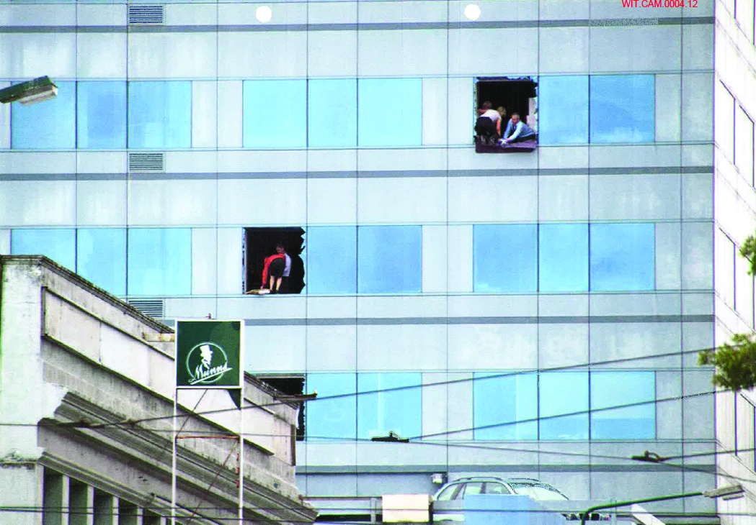
Figure 52: Post-February evacuation. Mr and Mrs Cameron are in the top right broken window

4.6 The Beca investigation
The findings of the Beca investigation were presented to the Royal Commission at the hearing on 23 February 2012 by Mr Robert Jury (the author of the Beca report) and Dr Richard Sharpe, both from Beca. The collapse scenario that they inferred is illustrated in Figure 53.
The Beca report contained the following as the executive summary:
In our opinion:
Original Design
• The stairs as designed met the 1988 design requirements for the prescribed earthquake loads.
• The precast stair units in the tower were cast into the floor at their upper levels, and free to slide horizontally, within limits, at their lower ends.
• Testing of concrete and reinforcing steel from some elements after the collapse did not indicate that they were less strong than required by the design.

Modifications
• We have viewed the stairs removed from the building after the 22nd February 2011 earthquake.
• We have inspected the seismic gaps at the lower landings of stair units still in place at Levels 14, 15 and 16.
• It would appear that the stair units were precast as one unit rather than two flights interconnected with a cast in situ concrete mid-height landing. It is considered unlikely that this change had any effect on the collapse.
• There is evidence of modification to the lower end of at least four stair units that may indicate the prescribed seismic gap at that end was not achieved in all cases during construction.
• Repair of the floor coverings in the seismic gap areas of the landings was underway at the time of the 22nd February 2011 earthquake. No evidence that these repairs had an impact on the stair collapse has been identified during this investigation.
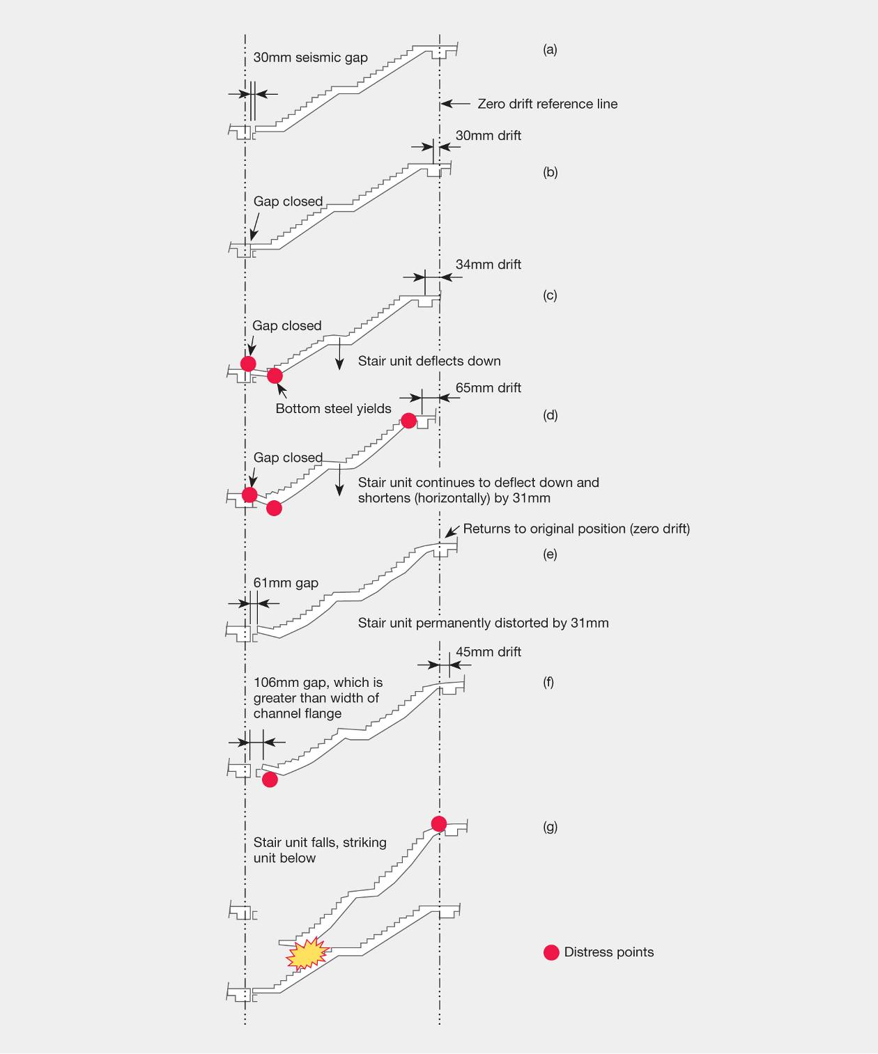
Figure 53: Inferred collapse sequence (source: Beca report)
Comparison with Current Code
• The clearance requirements for stairs from structure are essentially the same as was the case in 1988.
• The seismic gap provided in the original design would not meet current requirements by a factor of approximately 1.2.
Damage prior to 22nd February 2011
• Damage to the stairs and the structure was observed and/or reported after the 4th September 2010 earthquake as follows:
− Cracking and vertical displacement in some of the stair units and to the floor coverings at the landings.
− Cracking in the main structural frame members.
− Failure of a weld in the region of a carpark ramp.
• Inspections of the most-damaged stair units carried out immediately after the September earthquake did not indicate that there had been any significant movement at the lower support.
Damage after the 22nd February 2011 Earthquake
• The main stairs from the ground to Level 15 (on one side) and ground to Level 14 (on the other side) collapsed, bringing with them the light-weight wall between them in the stairwell.
• The upper part of a column supporting the south-east corner of the podium roof was significantly damaged.
• We have not inspected the interior of the building other than at Levels 14, 15 and 16, but we have sighted two reports dated 31 March 2011 and 13 April 2011 that have been prepared by the owner’s engineer that describe the extent of damage to the structure.
• Our interpretation of these reports is that the damage to the structure is relatively minor.
• Laser scanning of the north and west facades of the building does not indicate any significant permanent distortion of the structure.
• The removal of the collapsed stair units necessitated cutting them in half at their middle landings, and no records are available of which units were already broken/damaged at their mid-height landings or from which levels the various pieces originated.

Mode of Collapse
• The sequence of the stairs collapsing has not been determined. It seems likely that the uppermost stair units collapsed first, possibly progressively spearing the units below.
• Interviews with occupants suggest that all the stair collapses occurred during the main shock over a short period of time.
• It is likely that support at the bottom landing of one or more units was lost first, allowing the unit to pivot downwards about its upper end which was cast into the upper landing. In most cases, the cast-in reinforcing steel at the upper landing has yielded and then snapped, presumably allowing the stair unit to fall down the building in a near vertical attitude. We have been advised that at least some of the units did not detach from their upper connections and were left hanging in the stairwell until removed by USAR.
• On any one unit, the lower seating support could have been lost for one of (or combination of) three reasons:
– A stair flight has been compressed, resulting in bending downwards and yielding of the reinforcement, because the seismic gap was smaller than needed in the earthquake of 22nd February 2011. The resultant permanent shortening of the flight was sufficient for the lower landing to fall off the steel seat on the reversal of the relative motion. Analyses completed by Beca indicate that inter-storey displacements (drifts) were likely to be highest between Levels 10 and 14.
– The lower stair landing failed in shear when the unit was subjected to compression after the seismic gap was closed.
– The effective horizontal length of the flight was shortened when struck by the flight above after the flight above lost its seating and rotated downwards about its upper landing. The consequent V-shaped lower flight would drag its lower landing off its seat.
– A free-falling stair unit simply “pole-axed” the still-intact flight, causing it to fail catastrophically and fall.
Reasons for Collapse
• The damage observed and/or reported after the 4th September 2010 and 26th December 2010 earthquakes is not considered to have significantly weakened the stairs to make them more vulnerable in the 22nd February 2011 earthquake.
• The actual seismic gaps at the bottom landings were too small for the earthquake shaking experienced on 22nd February 2011.
• The stair units were not designed to resist compression that would arise from the closing up of the seismic gap.
• The characteristics of the lower seat did not allow any latitude if the building inter-storey displacements in an extreme event were such that they exceeded the gap provided.
• Construction tolerances and the possibility that the seismic gap at the lower stair support had been filled (construction debris or mortar), would have reduced the level of building horizontal displacement required to fail the stair.
• Our analyses predict that the stairs would have collapsed even if the gaps were clear
of obstructions.
Commentary
• The seismic gap specified on the drawings met the prevailing design standards at the time the building was designed.
• We have been unable to definitively establish whether the specified gap was provided everywhere, and whether there was construction rubble/dirt/mortar in the gaps that would have reduced their effectiveness.
• The specified gap would have not been sufficient to avoid compression if the current Code derived displacements had been applied.
• There is evidence that the available seismic gap was not large enough to prevent some stair flights being compressed and slightly damaged during the 4th September 2010 earthquake.
• The specified gap was sufficient for the shaking experienced in the 26th December earthquake.
• The owner’s structural engineers inspected the building after the 4th September and 26th December earthquakes, and advised the owner that it was acceptable to occupy.
• General instructions had been given after the 4th September earthquake for any cracks over a certain size to be repaired by injection of an epoxy mortar. No evidence could be found to suggest that vertical accelerations (or response of the stair over its length) experienced in the 22nd February earthquake caused the stair failure.
Recommendation
• Known alternatives to the seismic gap detail used in this building should be used on all new buildings, and for replacing the stairs in this building. These alternatives minimise significantly any likelihood of the stair collapsing because of insufficient displacement allowance.
• DBH should issue an advisory note, warning of the potential issues and lack of resilience with the gap and ledge stair detail for new and existing buildings.
• Consideration should be given to including a provision in the Building Code requiring clearances and seatings for stairs to be capable of sustaining a nominal drift of twice that estimated for the Ultimate Limit State (ULS), after allowances for construction tolerances.
• The concept that a specified seismic gap must not be compromised under any circumstances should be promoted.

4.7 DBH Expert Panel review
The Expert Panel report concurred with the conclusions of the Beca report.
The findings were presented to the Royal Commission at the hearing on 23 February 2012 by Professor Nigel Priestley, one of the members of the Expert Panel.
The conclusions and recommendations of the Expert Panel were set out in paragraphs 8.12 and 8.13 of its final report, as follows:
8.12 Conclusions
Although the seismic gap at the lower stair support met the code of the day, it was too small for the aftershock event of 22 February 2011. There is also evidence that the available seismic gap was not large enough to prevent some stair flights being compressed and slightly damaged during the 4 September 2010 earthquake. The specified gap was sufficient for the shaking experienced in the 26 December 2010 aftershock.
The seismic gap specified on the drawings met the design standards prevailing at the time the building was designed. The specified gap would not have been sufficient to avoid compression if the current (2010) code-derived displacements had been applied.
When comparing the stairs as constructed in the Forsyth Barr Building with the current code, it was found that the original design would not meet current requirements (introduced in 1992) as the 1988 design requirements for clearance between stairs and structure would only be 80% of current requirements.
It could not be definitively established whether the specified seismic gap was provided everywhere, or whether there was debris, mortar or polystyrene in the gaps everywhere, which would have reduced the effectiveness of the gap. Despite the presence of extraneous material in the spaces intended for seismic movement, indications are that the stairs would have collapsed even if this material had not been present and the stairs had been fully free to move.
There was no evidence found in the investigation that indicated that repairs that were underway to the stair coverings prior to 22 February 2011 had an impact on the stair collapse.
The fact that the stairs had been precast as one unit, rather than as two separate units to be connected at mid-height landing, was not considered to have been likely to have had any effect on the collapse.
No evidence (physical or analytical) could be found to suggest that vertical earthquake motion (or response of the stair over its length) experienced in the 22 February 2011 aftershock caused or significantly contributed to the stair failure.
8.13 Recommendations
Following the investigation of the Forsyth Barr Building stairs and subsequent discussions with the Panel, a number of issues have arisen that the Department should give consideration to:
• Alternatives to seismic gap detail
Known alternatives to the seismic gap detail used in this building should be used on all new buildings, and for replacing the stairs in this building. These alternatives minimise significantly any likelihood of the stair collapsing because of insufficient displacement allowance.
• Advisory note for gap-and-ledge stair detail
An advisory note that warns of the potential issues and lack of resilience with the gap-and-ledge stair detail for new and existing buildings should be issued.
• Building Code provision for clearances and seatings for stairs
A provision should be included in the Building Code requiring clearances and seatings for stairs to be capable of sustaining at least twice the Ultimate Limit State (ULS) inter-store displacements, after allowances for construction tolerances.
• No compromise on seismic gaps
The concept that a specified seismic gap must not be compromised under any circumstances should be promoted.

4.8 Discussion
In the February earthquake there was extensive damage to stairs in a wide range of buildings and in a number of cases the stairs collapsed. The failure of the means of egress from several multi-storey buildings caused the public considerable concern. The Forsyth Barr building was a relatively modern building in which an extensive collapse of stairs trapped people in the building for a number of hours. The public concern raised by this issue was one of the reasons why the performance of the Forsyth Barr building was one of the buildings specifically named in the Royal Commission’s Terms of Reference as part of the representative sample, and why the seismic performance of the Forsyth Barr building was assessed in detail by DBH. We record that, apart from the failure of the stairs, the building’s structure performed well in the earthquakes and sustained little damage.

4.8.1 Cause of collapse
The Royal Commission accepts the conclusion given by Beca as to the cause of the collapse of the stairs in the Forsyth Barr building in the February earthquake and supports the recommendations related to the performance of stairs in multi-storey buildings made by the Expert Panel. These have been reproduced above. However, we note that in our Interim Report we made more conservative recommendations on the inter-storey drift that stairs should be designed to sustain. In particular, we note that the Expert Panel recommendations make no allowance for loss of seating caused by elongation of beams, an effect that can be significant. We also note that there are two references dealing with the design and assessment of stairs for new and existing buildings, “Report to the Royal Commission – Stairs and Access Ramps between Floors in Multi-storey Buildings”⁴, and a report that is being prepared for DBH by the Engineering Advisory Group and will be available later in 2012⁵. The second reference, which we have seen in draft, contains a comprehensive treatment of design and assessment of stairs in multi-storey buildings.
We highlight four other matters:
1. Critical importance of the seismic gap
In the light of the evidence of Mr Tonkin, as discussed above, we record that it is very important that contractors be aware of the critical importance of the seismic gap specified on construction drawings, and that this be kept clear of extraneous materials at all times. In the present case it was unclear whether the full gap was, in fact, allowed for each flight in the construction process, and it may be that the weight and overall dimensions of the precast units (which were cast as a single unit before being manoeuvred into place) made their precise positioning difficult.
2. Maintenance of seismic gap
We consider that it would have been desirable to remove the debris observed when the building was inspected after the September earthquake, as a matter of urgency. We accept, however, that strict adherence to the original design, and timely maintenance of the specified gap to be free of debris would have been unlikely to prevent the collapse.
3. Emergency lighting
It is of concern that, as noted by Mr Cameron, the emergency lighting system failed in the stairwells as a result of the shaking in the February earthquake. We consider that multi-storey buildings should be equipped with emergency lights that are activated when power is cut to the normal lighting system, without the need for communication or power delivery by wires that might be vulnerable to local explosions, fires or material falling during earthquakes.
4. Analytical method
There were a number of points made in the hearing about the robustness of the analysis of the structure of the building. While these do not affect the conclusions reached in the Beca report, it is important that potential weaknesses in the approach should be identified so that other structural engineers, who may be following the same approach to the assessment of other multi-storey buildings, are made aware of the potential shortcomings.
In the assessment Beca applied the earthquake record obtained at the REHS site to its analytical model of the building, using an elastic time history method of analysis. The authors of the Beca report were asked a number of questions about the choice of this earthquake ground motion record in their analyses. Answers to these questions were given by Mr Jury, and Professor Priestley also responded on this issue.
The questions from the Royal Commission concerned the choice of the REHS earthquake record and approximations inherent in the method of analysis. In particular, it is noted that of the four earthquake records obtained in the CBD, the displacement spectra for the REHS site stand out as inducing appreciably greater displacements than the others in the period of interest, which is 2.0–2.5 seconds. The second point related to the underestimation of inter-storey drifts that occur when elastic methods of analysis are applied, compared to inelastic time history analyses. In the design of new buildings an allowance is required for this effect by application of the drift modification factor (NZS 1170.5 clause 7.3) when the design is based on elastic-based methods of analysis such as the modal response spectrum and elastic time history methods.
Mr Jury answered that the REHS record was chosen as it was the closest to the site of the Forsyth Barr building and there was no specific information available to indicate that the foundation soils were significantly different from those at the REHS site. Subsequently, Professor Priestley indicated that the analysis would have been more robust if the analysis had been repeated for other earthquake records available in the CBD. He made the additional point that in assessing inter-storey drifts allowance should be made for inter-storey displacements associated with both first and second modes of response. The elastic time history analysis does allow for this effect.
Professor Priestley also agreed that elastic time history analyses are likely to underestimate inter-storey drifts because of a change in the deflected shape profile that occurs as a result of inelastic deformation. He noted that his estimates gave displacement ductility values of the order of 2–3. He pointed out that the inelastic deformation associated with this level of ductility could be expected to increase inter-storey drifts compared with those obtained from an elastic time history analysis. We agree.

References:
1. Beca Carter Hollings & Ferner Ltd (Beca). (2011). Investigation into the Collapse of the Forsyth Barr Building Stairs on 22nd February 2011. Jury, R. http://dbh.govt.nz/User-Files/File/Reports/quake-forsyth-barr-stairs-report.pdf
2. Department of Building and Housing Expert Panel. (2011). Structural Performance of Christchurch CBD Buildings in the 22 February 2011 Aftershock – Stage 1 Expert Panel Report. Williams, S., Priestley, N Anderson, H., Cook, M., Fehl, P., Hyland, C., Jury, R., Millar, P., Pampanin, S., Skimming, G. and Thornton, A.
http://www.dbh.govt.nz/UserFiles/File/Reports/quake-stage1-expert-panel-report.pdf
3. Christchurch City Council. (2006). Earthquake-Prone, Dangerous and Insanitary Buildings Policy 2006. Available on request from the Christchurch City Council.
4. Bull, D. K. (2011). Report to the Royal Commission. Stairs and Access Ramps between Floors in Multi-storey Buildings. Christchurch, New Zealand: Canterbury Earthquakes Royal Commission.
5. Engineering Advisory Group. (2012). Guidance on Detailed Engineering Evaluation of Non-residential buildings, Part 3 Technical Guidance. Section 13. Engineering Advisory Group for the Department of Building and Housing, Wellington. (This will be available later in 2012.)

