Section 3:
Hotel Grand Chancellor

During the February earthquake, a shear wall located on the ground floor of the Hotel Grand Chancellor (HGC) at 161 Cashel Street failed. The failure came close to causing a catastrophic collapse of the building.
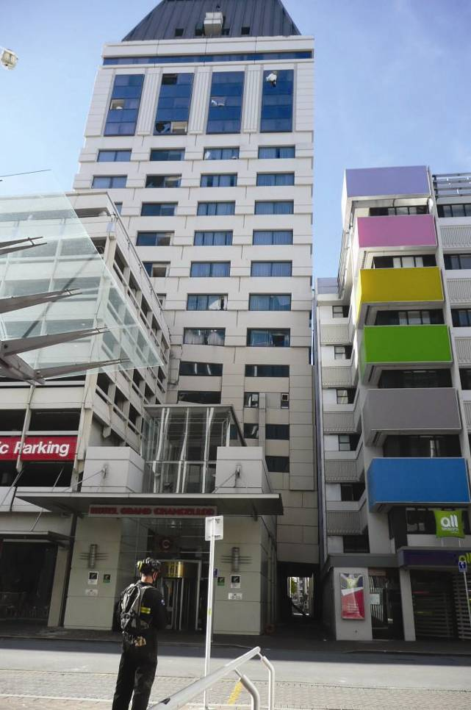
Figure 17: A view from the south after the February earthquake; the podium is on the left side
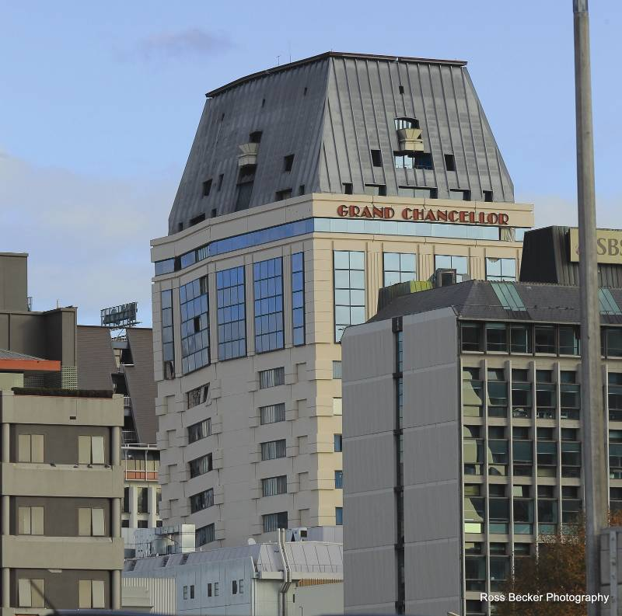
Figure 18: A view from the north-east after the earthquake (source: Ross Becker Photography)
At the time of the 22 February 2011 earthquake there were about 50 staff members in the building and an unknown number of guests. Stair flights on one side of the scissor stairs in the tower collapsed, also collapsing the stairs in the upper section of the car park levels. About 30 people were trapped on the upper levels. Fortunately, there were two maintenance staff members with tools on level 26, who were able to force open doors that had become jammed and allow people down the stairs that remained and out on to the roof of the podium. They were lowered by crane down from there.
The following discussion covers:
• the history of the HGC building prior to the September earthquake;
• the September earthquake and Boxing Day aftershock, the performance of the building in these earthquakes, and the actions taken as a result;
• the February earthquake and the failure of the building; and
• lessons that the Royal Commission considers should be learned from this failure.
It reflects information gathered from a variety of sources, including:
• the Christchurch City Council (CCC) as the regulatory authority administering building controls in Christchurch;
• Grand Central (NZ) Ltd, the building owner on 22 February 2011;
• the Dunning Thornton Consultants Ltd investigation into the failure for the Department of Building and Housing (DBH); (the Dunning Thornton report)1;
• the DBH Expert Panel review of the Dunning Thornton investigation (the Expert Panel report)2;
• a review of the Dunning Thornton and Expert Panel reports carried out on behalf of the Royal Commission by Mr William T. Holmes; and
• evidence given and submissions made to the Royal Commission at a public hearing held on 17 and 18 January 2012.
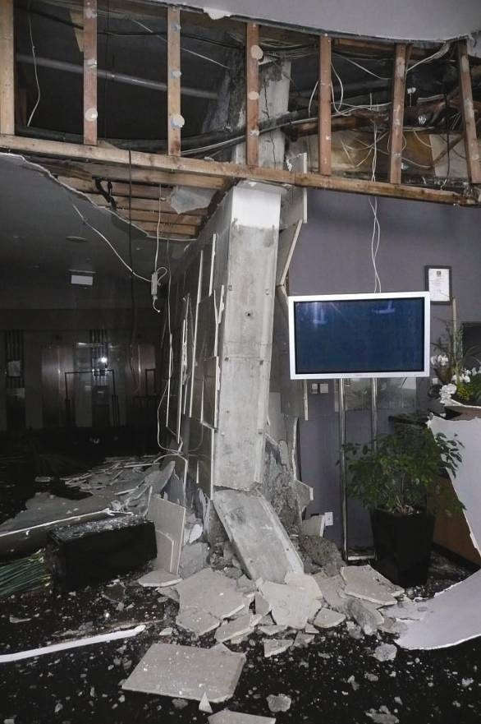
Figure 19: Failed wall on ground floor
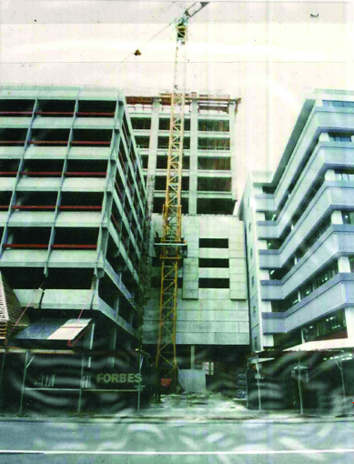
Figure 20: Photograph taken during original construction, looking from the south

