2.3 The September earthquake
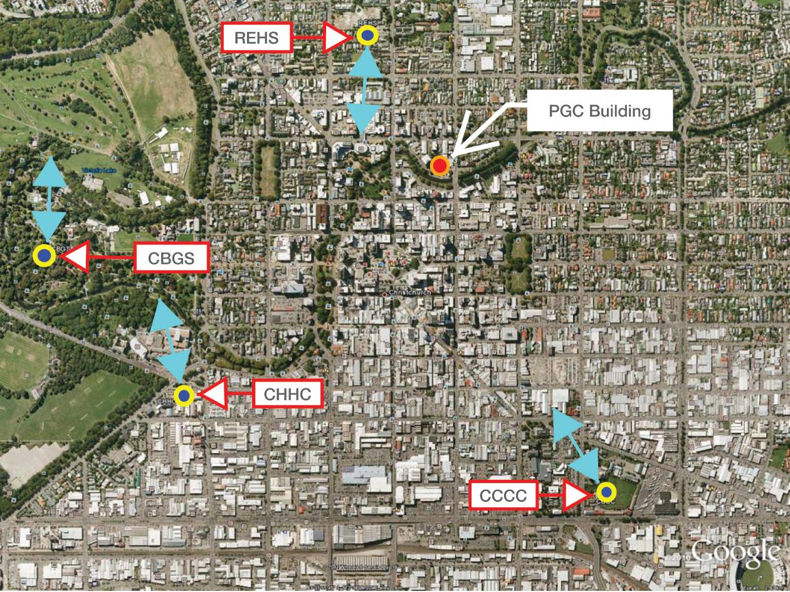
Figure 12: Location of seismic measuring stations and predominant direction of acceleration, September 2010
The nature and intensity of the September earthquake are described in section 2 of Volume 1 of this Report.
On the basis of available information “Inelastic Response Spectra for the Christchurch Earthquake Records”⁹, and assuming the actual ground motion at the site was similar to that at the REHS site, the severity of the ground motion in the September earthquake was comparable to a design-level earthquake event for the ultimate limit state specified in NZS 1170.5:2004¹⁰.
In this earthquake record the greatest shaking was in the north–south direction, which was the stronger direction of the building. In this direction the primary load resistance was by long shear walls on either side of the central core, symmetrically placed around the centre. The ground floor had a greater number of shear walls, making it significantly stronger than the floors above. Minimal torsional action was induced for ground motion in the north–south direction as the structure was symmetrical on this axis.
Under these seismic actions some damage could be anticipated, but as the spectral displacement in the north–south direction is of the order of 30mm, and the corresponding displacement in the east–west direction is of the order of 80mm, extensive damage would not be anticipated. It should be noted that the spectral displacement corresponding to the fundamental mode of an equivalent single degree of freedom structure is at a height of about 70 per cent of the height of the main part of the structure.
The Beca inelastic time history analysis for the September earthquake predicted that some minor yielding of reinforcement would have occurred in the structural walls but there would be no failure.
The predicted cracking in the walls was consistent with that observed during inspections of the building immediately after the September earthquake.

2.4 Between the September earthquake and the Boxing Day aftershock
As discussed elsewhere in this Report, soon after the September earthquake a state of local emergency was declared under section 68 of the Civil Defence Emergency Management Act 2002 and the CCC initiated a civil defence emergency management response. The state of emergency continued until midday on 16 September, when it lapsed.
Starting on the day after the earthquake, teams were sent out to all of the commercial parts of the central business district (CBD) to undertake a Level 1 Rapid Assessment. These teams included at least one CCC officer, who was usually accompanied by a Chartered Professional Engineer (CPEng). A Level 1 Rapid Assessment is an exterior inspection to look for obvious signs of damage that indicate immediate dangers, or to determine whether further investigations are required before the building can be used.
On the morning of 5 September such an inspection was made of the PGC building, resulting in the building being given a green placard in the standard form signifying that it had “No restriction on use or occupancy”. The placard was placed on the main entrance door to the southern side of the building facing Cambridge Terrace. The standard form advised that the inspection was brief and no apparent structural or other safety hazards had been found. However, the form also encouraged the owner to obtain a detailed structural engineering assessment of the building as soon as possible. It will be recalled that a previous assessment had been carried out by HCG in 1997, which concluded that the building had 50 per cent of the design performance defined in NZS 4203:1992⁷. This would be less than 50 per cent of new building standard (NBS) in terms of the current Standard, NZS 1170.5:2004¹⁰.
On the morning of the September earthquake, Mr Howard Buchanan of Harcourts contacted Mr Hare of HCG to request that an engineering assessment of Harcourts’ entire portfolio of buildings be undertaken. There was also a telephone conversation between Mr Collins and Mr Buchanan, in which Mr Collins requested that immediate inspections be undertaken by a structural engineer to confirm that it was “safe to occupy” his buildings before the tenants were allowed to re-enter. This was after Mr Buchanan’s instruction to HCG, and there is no indication that there were any monetary restrictions placed on obtaining this assurance. In fact, Mr Buchanan accepted that Harcourts had authority to spend money on the building in the order of “tens of thousands of dollars” without recourse to the owner. Such a sum would have allowed for the commissioning of a detailed structural analysis if that had been recommended by the engineers.
Mr Buchanan met Mr Richard Seville from HCG on 5 September to establish a procedure for the inspection of Harcourts’ managed properties. A short form agreement prepared by HCG was signed by Mr Buchanan and Mr Seville at this time to provide initial earthquake inspection and securing measures as considered necessary.
There was no further elaboration in the contract of the services to be provided. Mr Seville was not called at the Royal Commission hearing but subsequently provided a statutory declaration, in which he stated:
We discussed that HCG would be carrying out level 2 rapid visual inspections (external and internal). If further inspections or securing works were required to any building, to seek to upgrade a yellow placarded building to a green placarded building for example, we were instructed to recommend this. It was made clear that the initial inspections that HCG was instructed to carry out were not detailed evaluations and HCG was to report back to Harcourts if HCG recommended further, and potentially more intrusive, inspections or securing work.
On 7 September 2010, the first inspection by HCG was undertaken by Mr Mark Whiteside. Mr Whiteside had the qualifications Bachelor of Engineering (Civil) and Master of Engineering, was registered as a CPEng and was a member of the Institution of Professional Engineers New Zealand (IPENZ). He had 11 years’ postgraduate experience in engineering at the time of his inspection. Mr Whiteside attended briefings on the requirements for Level 1 and 2 Rapid Assessments at both the CCC and HCG.
Mr Whiteside said in evidence that he was carrying out what he considered to be the equivalent of a Level 2 Rapid Assessment. He did not use the Level 2 assessment form, which may not have been widely available at that time, but prepared a brief written inspection report on HCG letterhead. The inspection report records the work he carried out as:
Rapid Structural Assessment
Walk around exterior, ground, first, fourth floors.
Under a heading “Observations & Comments” Mr Whiteside noted that he had carried out an “initial inspection” of the building, which he described as an “in situ concrete construction building with concrete shear wall to south side”. He accepted in evidence that the reference to the shear wall being on the south side of the building was incorrect: the reference should have been to the north side. Mr Whiteside noted in his report:
Cracks to ground floor and first floor level shear walls.
Fourth floor ceiling grid bracing has failed, ceiling tiles have been removed, electrical and air conditioning services are exposed.
The report concluded:
Confirming ‘green placard’ building okay to occupy (structurally)
In evidence Mr Whiteside stated that his assessment that the building was “okay to occupy (structurally)” was based on his opinion the building did not have “diminished structural capacity” as a result of the September earthquake. He considered that the extent of damage he had observed was “not indicative of a building under immediate distress or having any significant impaired resistance to earthquake shaking”. He also stated that in carrying out the inspections he did not consider the possible magnitude of future aftershocks, concentrating only on the issue of whether the building showed signs of diminished seismic capacity. The possible limitations of that approach were not explained in writing to Harcourts, or to the tenants of the building.
Mr Whiteside had no knowledge of HCG’s previous involvement with the building, and consequently no knowledge of the structural weaknesses previously identified. In cross-examination he expressed the view that such knowledge would not have been of assistance:
Those previous reports were… addressing the capacity of the building. Our inspections were addressing whether the building had any diminished capacity. The building structural system was reasonably obvious and able to be observed and the reports confirmed that the system was a shear core wall so I don’t believe they would have been of any benefit.
Mr Whiteside’s opinion of the accuracy of this assessment had not changed by the time of the hearing before the Royal Commission. His assessment is also considered to have been accurate by Mr Hare, and the authors of the Beca and Expert Panel reports on the collapse. The Royal Commission notes that the shear core of the building (being the primary seismic resisting structure) was visible without removing linings. While we accept that viewing the existing drawings or previous structural analyses would not necessarily have led to a different decision about whether the building had diminished structural capacity as a result of the September earthquake, this information would have been of assistance had a detailed structural analysis been carried out.
As a result of the failure of the level 4 ceiling tiles, Harcourts contracted to remove the existing heavy tiles and replace them with a lighter system. The order for this work was placed on 7 September and the work was completed by 17 September.
On 10 September Ms Golding reported to Ms Louise Sutherland of Harcourts concerns expressed by Leech and Partners Ltd about cracks in the hallway leading to the car park. Ms Golding advised that the hallway was “very badly cracked in a number of areas including one key area that in fact according to Spotless holds up the building”. On 15 September Ms Manawatu-Te Ra of Harcourts replied advising that an HCG engineer would be onsite that morning to investigate the cracks.
In fact it was on the morning of 16 September that a second HCG inspection was carried out, this time by Mr Alistair Boys. Mr Boys has the qualifications Bachelor of Engineering (Civil), and Master of Engineering (Structural). His specialist study area was the performance of poorly detailed reinforced concrete columns including reinforced concrete buildings and the performance of buildings in earthquakes. At the time of his inspection he had about two years’ postgraduate experience. Mr Boys had attended briefings on post-earthquake assessments within HCG. He knew that there had been a previous HCG inspection, but he was not aware who had made it and did not rely on its conclusions. Rather, as he said to Mr Mills QC in cross-examination, he carried out the inspection in the same way he approached all inspections that he did, using the same methodology and “approaching it almost independently of the previous information using it as a verification at the end…against my own conclusions”.
Mr Boys gave evidence that his inspection of the building took about 90 minutes. He first made a preliminary inspection of the exterior to provide an initial gauge of any damage that the building had sustained and to gain an appreciation of the building’s form and primary load paths. He did not see any external evidence of damage. He ascertained that the building was of reinforced concrete with internal core walls (including a lift and stair core) and with a perimeter gravity frame at the exterior façade. Next, Mr Boys made a visual inspection of what he considered were the key accessible structural elements on the ground and first floors. These included the shear walls enclosing the lift and stair core and the perimeter frames of the building. The structural damage he observed was limited to cracking of the shear walls at the central core. He said in evidence that the cracks were typically about 0.2–0.3mm in width. One, however, located on the southern wall of the central core, “measured 0.5 and 0.6mm with minor spalling at the intersection of the opposing inclined cracks”. This spalling was about 10mm deep and confined to the area immediately adjacent to the cracks. Mr Boys also looked at the central core walls and perimeter frames on levels 2, 3 and 4. He saw nothing of significance.
Mr Boys completed the “Christchurch Eq RAPID Assessment Form – Level 2”. The status of the building shown on the form was confirmed as “Green G1”, a category described on the form as signifying that the building was “Occupiable, no immediate further investigation required”. Mr Boys also wrote a brief report in which he recorded, among other things:
All cracks observed minor in shear walls – typically <0.5mm.
One single crack 0.6mm and minor spalling initiated at intersection approximately 100x100x10mm max depth.
Spalling in spandrel beams (outside) initiated by reinforcing corrosion – not significant.
As with Mr Whiteside, Mr Boys inspected the building for the purpose of ascertaining whether there was evidence that it had diminished capacity as a consequence of the earthquake. He confirmed under cross-examination by Mr Mills that he did not consider any issues relating to whether the building could have been considered as earthquake-prone before the earthquake, or what might have previously been known about any structural weaknesses. Such matters were not, in his view, relevant to the damage-based assessment he was carrying out. In cross-examination by Mr Elliott he confirmed that nothing he observed caused him to conclude that any further or more extensive investigation was required.
On 30 September Mr James West of Perpetual sent an email to Harcourts following up a verbal request said to have been made the previous week for an assessment by an engineer of new damage to the building after a series of aftershocks. Ms Sutherland responded for Harcourts on the same day, writing that the building had already been assessed by two structural engineers, and had been “classified as safe to occupy”. Any damage seen was cosmetic. The cracks noted by Mr West, near Perpetual’s storage area backing on to the liftshaft on level 1, would be “taken into account” when repair works were done. Ms Sutherland observed that as long as aftershocks were occurring new damage would appear, but that there was “little point in rushing into repair works until they had stopped”.
On 14 October, Ms Golding of PGC made another request for a further engineering assessment as some external wall cladding appeared to have moved from the wall. Mr Whiteside returned to the site later that day to carry out the third inspection by HCG. On 15 October he wrote a brief report describing the “re-inspection of ground floor window frame gap and second floor partition crack”. He stated:
Ground floor – Window frames span from floor to floor. Aluminium mullions had moved internal cabinetry creating a gap (or enlarging).
No structural issues. Gap should be addressed for weather proofing.
Second floor – Partition crack at concrete interface.
No structural issues.
Building remains structurally okay to occupy on above observations.
On 20 October, following an aftershock the previous day, Ms Glenys Ryan of ERO sent an email to Ms Sutherland about movement of the ceiling tiles on the third floor. Mr Cambray of ERO followed up with an email on 22 October concerning the ceiling tiles and a crack in an internal wall. He also asked whether Harcourts had or planned to develop a full building evacuation plan.
On 5 November Ms Ryan sent an email to Ms Sutherland about a new crack observed between a partition wall and the liftshaft on the eastern side of the building. On 9 November Ms Sutherland replied that there was cracking similar to what Ms Ryan had described on other floors in the building. The cracks had been inspected several times by structural engineers and confirmed as superficial. She advised that Harcourts was working with the building owner’s insurer and intended to appoint a project manager to oversee necessary repairs to the building, which would first be catalogued.

2.5 From the Boxing Day aftershock to the February earthquake
On Boxing Day 2010 an aftershock, described elsewhere in this Report, struck directly under the Christchurch CBD. A civil defence emergency was not declared.
Mr Tucker of ERO inspected its tenancy after the earthquake and contacted Ms Ryan. She went in on 27 December and saw that some tiles had fallen from the ceiling, while others were hanging down at an angle. Harcourts was advised and unsafe tiles were removed in time for the ERO office to re-open on 12 January.
On 20 January, following aftershocks on that day, Ms Sutherland sought that HCG carry out a further inspection of the building, after being advised by staff of Perpetual of a “new large crack that [had] appeared in a wall” and that there had been “damage sustained to the stairs (concrete come loose)”. As a consequence, Mr Whiteside carried out his third inspection of the building on 27 January.
Once again Mr Whiteside produced a written report of his inspection, which he described as a “re-inspection of previously observed damage and new cracks”.
His observations and comments recorded in the report were:
Previous cracks have enlarged. Cracks to level 1 stationary wall now > .2mm, minor spalling also evident. General diagonal cracking to all shear walls.
New cracks to stair connections at level 1 – spalled plaster. Hairline cracks to most landings (stairs appear tied to all floors).
Building remains safe to occupy.
Cracks to shear walls greater than 0.2mm will require epoxy injection repairs.
Cracks to stairs should also be repaired where greater than 0.2mm.

A copy of this report was sent to Perpetual on 28 January.
Because of the high frequency of ground motion and the short duration, the Beca analysis did not predict significant further inelastic deformation for this earthquake.

2.6 The February earthquake
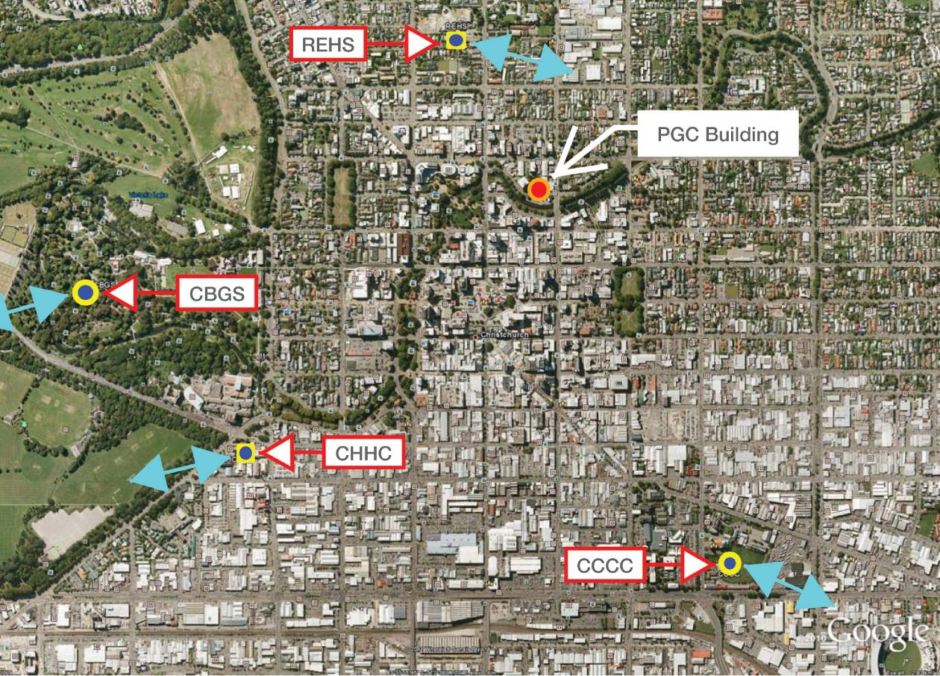
Figure 13: Location of seismic measuring stations and predominant directions of acceleration, February 2011 earthquake
The nature and intensity of the February earthquake are described in section 2 of Volume 1 of this Report.
For all four of the sites where earthquake ground motions were measured, the accelerations and displacement spectra in the February earthquake were appreciably greater in the east–west direction than in the north–south direction. With particular reference to the REHS site the spectral displacements in the north–south direction were of the same order as the NZS 1170.5:2004¹⁰ design values at the corresponding fundamental period of 0.35 seconds, while in the east–west direction the corresponding values at a period of 0.7 seconds were about three times as high as the NZS 1170.5:2004¹⁰ design values.
The earthquake resulted in the rapid catastrophic collapse of the PGC building. The reasons for failure and the likely sequence of events are addressed below.

2.7 The collapse of the building
The Royal Commission has been assisted in its understanding of the collapse of the building by the Beca report¹, the Expert Panel report² and a review of both by Mr Holmes, prepared at the request of the Royal Commission.
In addition, a number of witnesses (including some who were in the building at the time of the earthquake) gave evidence to the Royal Commission about their observations of the collapse.
We refer to this evidence before turning to the experts’ opinions.

2.7.1 The eyewitnesses
Mr Robert Wynn, an electrical engineer employed by Beca, observed the collapse of the building from his office on level 4 of the PricewaterhouseCoopers building at 119 Armagh Street. His view was partially obstructed by trees, which meant that he could only see the two top floors and the mechanical services housing on the top of the structure. He described this as falling very quickly, as if the building had been subjected to a controlled demolition. He said that the eastern side of the building collapsed more quickly than the western side, the former seeming to pull the latter around so that the building rotated as it fell. He thought that the collapse occurred between five to eight seconds after the commencement of the earthquake.
Mrs Helen Guiney was employed by Perpetual. When the earthquake struck she was at her desk on level 1, speaking on the telephone. She immediately dived under her desk. She said:
The last thing I saw as I was getting under my desk was the front window which was to my left-hand side blowing out. The ceiling tiles were falling all around me but it seemed to be progressive from the reception area. The telephone connection was lost and power failed. Everything was dark and silent after the shaking stopped.
I was not aware at that stage that the whole building had collapsed. All I knew was that I was trapped and my hand hurt. Fortunately there was also fresh air coming in. I could feel the draught. Every time I tried to reach my phone I had to give up. My cellphone was ringing at the time, obviously people trying to make contact. There was space around me to roll over onto my back because when I first got under the desk I was in pretty much a foetal position and I could extend my legs but I couldn’t move apart from that. I tried yelling for help and eventually heard my colleague Jim Faithful calling out to me. He told me he was also under his desk, that a concrete slab was on top of him. We were both yelling for help and soon realised that nobody could hear us. The handset of my phone was near to me under the desk so I started tapping out SOS on steel frame of my desk.
Eventually Jim and I heard drilling and hammering but it sounded very far away. There were several more shakes and every time I would hold my breath and pray that we would be safe. The rescuers finally made contact with Jim but they couldn’t hear me, I presumed because I was further inside the building. Jim was able to relay to the rescuers that I was in the building near him.
I was finally rescued about 9.30 am the following day, nearly 21 hours after the building collapsed. [Figure 14.]
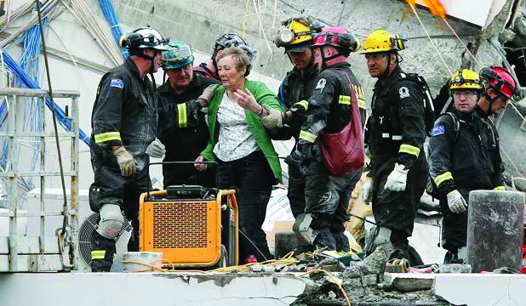
Figure 14: Mrs Helen Guiney being assisted from the building (source: Helen Guiney)
Later she clarified that she in fact thought the ceiling tiles had fallen progressively from the northern side of the building towards the south, which would be consistent with Mr Wynn’s description of a rotational collapse in an easterly direction.
The Royal Commission also heard evidence from Ms Glenys Ryan, who was in the ERO office on level 3 at the time of the earthquake. She was in the tearoom on the southern side of the building, with five colleagues. She remembered the shaking being in the west–east direction. She was able to move into a hallway, where she sat down before the building collapsed. She was rescued after about an hour. A colleague, Ms Ann Bodkin, waited 26 hours for her rescue.
Another who gave evidence about his experience in the building during the earthquake was Mr David Sandeman, who was employed by Marsh. At the time of the onset of the earthquake he was on level 4, talking to a colleague while looking west towards Mt Hutt. He described what happened:
In less than 10 seconds from the violent shaking starting, and it was very definitely in a east–west direction, a Lundia filing system which was immediately on my right here ran on its rails in an easterly direction heading for Manchester Street. I don’t recall it sort of crashing into its bump stops because by then the building had started to collapse and it was under my heels which were – I’d my back to Manchester Street to the east, I could feel it doing that and then the next moment we were – we were plunging down. I estimate it was approximately 40 feet because we ended up on the first floor as I subsequently discovered.
Happily for all of us the floor was relatively horizontal where it – where it ended up but we were in a very confined space. We could all move, none of us happily were pinned but we were most assuredly trapped. I could lie on my tummy or I could turn onto my right-hand side on the floor and with my left shoulder jammed under some furniture. It was too dark to see any details, you couldn’t tell the time on your wrist watch, it was – there was a glimmer of light in the distance I guess from where the floors had just pancaked together, so there were five of us in this small area here and one a bit further away, and after about an hour and a half, two hours, we heard an engine which I figured was the engine on a fire ladder, and indeed that’s what it turned about to be, because after about 10 minutes of that there was a voice coming through the roof, “Anybody there?”. We were able to confirm and give the names of the five of us and say we were stuck but we were not pinned, and they assured us that they would have us out within no more than six hours. Well happily it was significantly less than that. [Figure 15.]
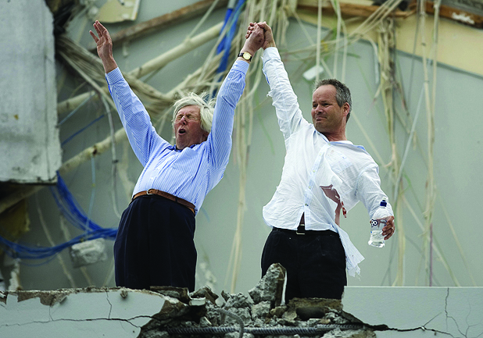
Figure 15: Mr David Sandeman with Mr Jeff McLay celebrating their rescue (source: John Kirk-Anderson/The Press)
The retrieval took place by them sledgehammering a hole through the concrete roof and then getting a big saw that would chomp through the steel reinforcing rods to create a hole big enough for us to be extracted. The lady who was closest to the hole was rescued first and they made it a little larger and a rescuer got in and pulled debris out of the way for the remainder of us, the other four of us to commando crawl across to the opening that had been made. We were assisted onto the roof by someone pulling our hand, but the collapse was such that we literally stepped onto the roof, they didn’t need to bung a ladder down or anything, we just, a big step and we were on the roof, it was then that I realised it was sloping from the centre down here, not dangerously because you could comfortably walk across to here and eventually be laddered, the fire ladder was here which we were all able to climb down and make our way to safety.
We record our appreciation of the evidence from the eyewitnesses, and acknowledge the fortitude of those who were in the building in re-living their ordeals of 22 February. For present purposes we note that we heard nothing from them that would be inconsistent with the key conclusions reached by the experts: that the building was subject to violent shaking in a west–east and east–west direction and quickly collapsed in an easterly and downward movement.

2.7.2 The Beca report¹
The findings of the Beca investigation were presented to the Royal Commission at the hearing on 5 December 2011 by Mr Robert Jury (author of the Beca report) and Dr Richard Sharpe, both from Beca.
The findings of the Beca investigation were set out in the executive summary of the Beca report:
Original Design
• The structure when built met the 1963 design requirements of that time for the prescribed earthquake loads, both in terms of the level of strength and the level of detailing provided.
• Testing of concrete and reinforcing steel from some elements after the collapse did not indicate that they were less strong than required by the design.
Modifications
• Modifications made to structural elements (addition of perimeter steel props and insertion/deletion of doorways in the core walls) during the life of the building were not material with respect to the collapse on 22nd February 2011.
Comparison with Current Code
• Pre-September 2010, the building achieved between 30 and 40%NBS (new building standard) when assessed against the New Zealand Society for Earthquake Engineering Guideline recommendations.
Damage prior to 22nd February 2011
• Damage to the structure was observed and/or reported after the 4th September 2010 and 26th December 2010 earthquakes to the:
– tops and bottoms of the perimeter columns
– core walls (cracking)
– stairs (cracking).
• This damage was relatively minor and not indicative of a building under immediate distress or having a significantly impaired resistance to earthquake shaking.
• The proposed method of repair at that time of grouting the cracks appeared reasonable.
Mode of Collapse
• The building collapsed when the east and west reinforced concrete walls of the core between Level one and Level two failed during the earthquake.
• The west wall yielded in vertical tension, and then the east wall failed catastrophically in vertical compression.
• The ground floor structure stayed intact and virtually undamaged as it was significantly stronger and stiffer than the structure above.
• Torsional response (i.e., twisting of the building about a vertical axis) was not a significant factor.
• Once the west wall had failed, the horizontal deflections to the east increased markedly.
• The perimeter columns and/or joints between the columns and the beams, and the connections between the floor slabs and the shear core, failed consequentially at some levels, causing the floors to pancake.
Reasons for Collapse
• The damage observed and/or reported after the 4th September 2010 and 26th December 2010 earthquakes did not significantly weaken the structure with respect to the mode of collapse on 22nd February 2011.
• The shaking experienced in the east–west direction was almost certainly several times more intense than the capacity of the structure to resist it.
• The connections between the floors and the shear core, and between the perimeter beams and columns were not required at the time of design to take, nor were capable of taking, the distortions associated with the core collapse.
Commentary
• Neither foundation instability nor liquefaction was a factor in the collapse.
• Extensive studies undertaken in 1997 for a previous owner confirmed that the structure was below the current standard at that time with respect to earthquake resilience for new buildings.
• The capacity of the building in 1997, after the addition of the steel props behind the perimeter columns, was judged, at that time, to be in excess of 50% of the then current new building standard.

The collapse scenario that Beca inferred is shown in Figure 16.
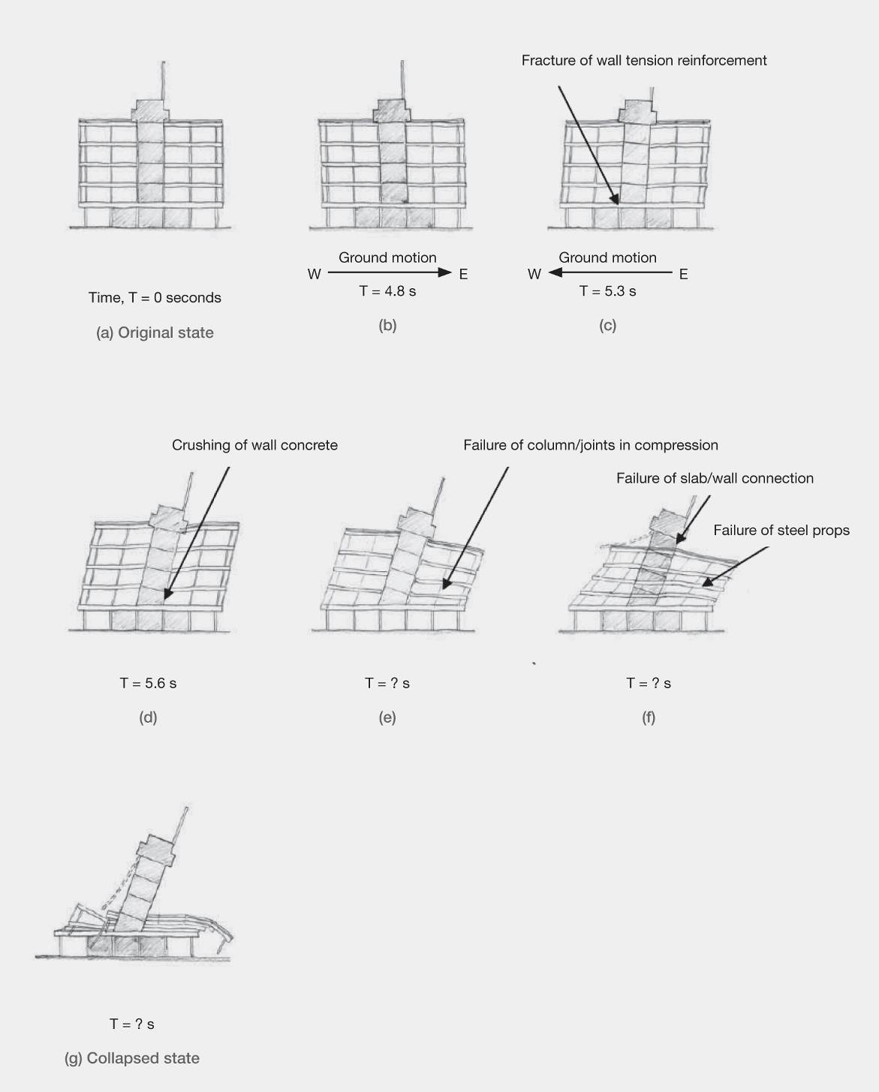
Figure 16: Inferred collapse scenario (source: Beca report)

2.7.3 DBH Expert Panel report²
The Expert Panel report concurred with the conclusions of the Beca report.
The findings were addressed at the Royal Commission hearing on 5 and 6 December 2011 by Professor Nigel Priestley, one of the members of the Expert Panel.
The principal conclusions of the Expert Panel were set out at paragraph 5.11 of the Stage 1 Expert Panel report dated 30 September 2011:
5.11. Conclusions
The PGC building structure was in accordance with the design requirements of the time (1963), both in terms of the level of strength and the level of detailing provided.
Modifications made to structural elements (addition of perimeter steel props and insertion/deletion of doorways in the core walls) during the life of the building were not material with respect to the collapse on 22 February 2011.
When compared to the current code for new buildings (NZS 1170.5: 2004¹⁰, NZS 3101: 2006¹¹), the PGC building would have achieved between 30 and 40 percent NBS (New Building Standard) prior to September 2010, when assessed against the New Zealand Society for Earthquake Engineering Guideline recommendations (NZSEE, 2006¹²).
Testing of concrete and reinforcing steel elements retrieved from the collapsed building indicated that the strength and characteristics of those elements were consistent with those specified at the time of design.
The damage to the building as a result of the 4 September 2010 earthquake and the 26 December 2010 aftershock was relatively minor, and was not indicative of a building under immediate distress or having a significantly impaired resistance to earthquake shaking. The proposed method of repair at that time, of grouting the cracks, appears reasonable.
The investigation concluded that the damage observed and/or reported after the 4 September 2010 earthquake and the 26 December 2010 aftershock did not significantly weaken the structure with respect to the mode of collapse on 22 February 2011.
Analyses and site observations indicate the following sequence of collapse [see also Figure 16]. The PGC building collapsed when the east and west reinforced concrete walls of the core between Level 1 and Level 2 failed during the aftershock. The west wall yielded in vertical tension, and then the east wall failed catastrophically in vertical compression. The ground floor structure stayed intact, virtually undamaged as it was significantly stronger and stiffer than the structure above. Torsional response (i.e., twisting of the building about a vertical axis) was not a significant factor. Once the west wall had failed, the horizontal deflections to the east increased markedly. The perimeter columns and/or joints between the columns and the beams, and the connections between the floor slabs and the shear core failed consequentially at some levels, causing the floors to collapse.
The reason the PGC building collapsed was that the shaking experienced in the east–west direction was almost certainly several times more intense than the capacity of the structure to resist it. In addition, the connections between the floors and the shear core, and between the perimeter beams and columns, were not designed to take the distortions associated with the core collapse. Neither foundation instability nor liquefaction was found to be a factor in the collapse.
Extensive studies undertaken in 1997 for a previous owner confirmed that the structure was below the current standard at that time with respect to earthquake resilience for new buildings.
A final report was released by the Expert Panel during February 2012. The conclusions were essentially the same, the above paragraph being renumbered as 6.11 but the last two paragraphs were removed and a new section, headed “Principal Findings and Recommendations” was added, within which paragraph 9.2.2 applied specifically to the PGC building:
9.2.2 PGC Building
The lack of ductility and strength inherent in the 1963 standards and the strong shaking combined to fail the eastern wall of the building’s shear core. The resulting horizontal displacement of the floors led to the failure of the columns and beam-column joints, causing the floors to collapse on top of one another.
In reviewing the issues arising from the PGC Building investigation, the Panel concludes as follows:
a) Walls with centrally located and light reinforcement may be susceptible to failure when significantly overloaded. In such walls the concrete carrying compressive loads is not confined by reinforcement and will therefore behave in a brittle fashion.
b) Older buildings may lack redundancy and be vulnerable if they have only one lateral load resisting system or no alternative load path.
c) Columns and walls that are not regarded as contributing to earthquake resistance must be capable of sustaining the expected inelastic lateral displacements of the structure.

2.7.4 William T. Holmes review
The Royal Commission retained Mr Holmes to review both the Beca report and the Expert Panel report. Mr Holmes provided written advice dated 2 November 2011, which he amplified at the hearing on 6 December 2011.
Mr Holmes agreed that the failure mechanisms identified by Beca and the Expert Panel were likely to have resulted in the building’s collapse, but also identified further possible weaknesses in the building that could equally have caused the failure. He summarised his views at the hearing in a series of bullet points which read:
• All agree that building collapsed due to failure of the central tower at floor 1-2
• The failure caused large movement of Level 2 downward and to the east (about 3m)
• Some girders supported by the tower pulled away and collapsed (in unknown sequence)
• Props placed behind perimeter columns as a retrofit were to provide supplemental support for the columns under excessive drifts (range of 5 cm), not meters. Exterior columns therefore collapsed (in unknown sequence). It is interesting to speculate if the “props” provided any assistance to the columns in September.
Level 1-2 had many seismic deficiencies
• Light central reinforcement. Weak in global flexure (overturning)
• Weak in EW shear (many openings, low R/F ratio, small trim bars. Piers in North Wall appear to be “shear critical”
Additional Seismic deficiencies
• Discontinuity at north end of east wall
• No confined “column” elements under floor girders
• Poor connection of girders to tower at all levels
• Displacement critical gravity columns at perimeter (retrofit props not intended to support gravity loads under very large displacements.)
Lessons for other “older” concrete buildings
• What conditions should be considered “Critical Structural Weaknesses”? Did it take a combination of the deficiencies to cause failure?
• Use of %NBS
− Assessments of 33%-50% NBS but building was only slightly damaged in September, which, arguably, had shaking of the same order of magnitude as 100% NBS.
− Brittle buildings of 100% NBS may be dangerous with only a small increase in shaking intensity.
- However, it is unrealistic to evaluate buildings for very rare shaking (e.g. 2500 year return)
- Brittle buildings examined for potential catastrophic failure modes at greater than 100% NBS?”

There was consensus among the expert witnesses that the building complied with the relevant standards at the time that it was built. We accept that is so. However, modern concepts of ductile design were then not well understood. While the design met the required strength of the time, the building was brittle beyond those limits.

2.8 Discussion
The principal issues that arise as a result of the Royal Commission’s investigation, including the evidence given at the hearing, can be addressed by considering the building prior to the September earthquake, and the actions taken following the September earthquake and the aftershocks until 22 February. It will then be appropriate to address our findings in relation to the failure of the building in the February earthquake.

2.8.1 The building prior to the September earthquake
Between the time of construction and 4 September 2010 various alterations were made including the addition of steel supports behind the exterior columns to enhance the seismic performance of the building. In addition some maintenance work was undertaken to address corrosion of reinforcement. There was no legal requirement to upgrade the seismic strength of the building during this time, and the Royal Commission accepts that work undertaken did not detract from the overall strength of the building.
The Royal Commission also accepts that the building, when constructed, complied with the CCC’s building by-law in force at the time when the CCC issued the building permit. We are also of the opinion that no works subsequently carried out on the building would have impaired its seismic strength.
However, it was recognised by the time of the HCG reports prepared for Warren and Mahoney in 1997 that the building would be at risk of collapse in a major earthquake. It was for that reason that the attempt was made to improve the building’s ability to withstand earthquake actions by the installation in 1998 of steel props behind the columns above ground floor level. In 2007, HCG was able to revisit the issues concerning the building’s seismic strength, and concluded that the building did not meet the requirements of the then current Loadings Standard. However, the building was not “earthquake-prone” under the CCC’s policy adopted in 2006⁸.
When the strength of the building was considered by HCG in both 1997 and 2007 it was in the context of possible development proposals. It appears that HCG’s advice was not given directly to the PGC Board. However, the substance of HCG’s advice was conveyed to the Board in 1997, and to PGC management in 2007. We do not consider that there was anything in the advice that should have caused PGC, acting responsibly, to have taken action beyond what was done in 1998 to strengthen the building.
The company was entitled to assume, on the basis of the advice received, that appropriate remedial action had been taken, in terms of the 1998 works, to remove weaknesses that posed life-safety issues.
By the time that application was made for consent to carry out the ground floor fit out in 2007, the CCC had adopted its 2006 buildings policy⁸. As we will discuss in more detail elsewhere in this Report, the policy was passive in nature and did not require any action to be taken in the context of the works proposed. We note in addition that HCG had in any event advised that the building was not below the threshold level of one third of current code loading at which it would have been regarded as earthquake-prone under the Building Act 2004. We heard no evidence questioning the correctness of that view, and we accept it.
When the building was purchased by Cambridge 233 Ltd in 2009, the due diligence process resulted in the issue by the CCC of the LIM, to which we have already referred. The LIM described the building, in very qualified language, as one that “may be potentially earthquake-prone”. Mr McCarthy, the CCC’s Environmental Policy and Approvals Manager at the time of the hearing, said in evidence that this was a standard notation applied by the CCC on land information memoranda issued with respect to all buildings built prior to 1976. The Plant & Building Services Management Ltd report, to which we have already referred, simply repeated the information about the potential status of the building set out in the LIM.
Mr Collins gave evidence that he was not aware of the advice about the building’s potential status, and we have no reason to doubt that evidence. We also accept Mr Buchanan’s evidence that he was not made aware by Chapman Tripp of the contents of the LIM, and that he did not advise Mr Collins of the relevant comment in the Plant & Building Services Ltd report. Mr Buchanan explained in cross-examination that he had been instructed to obtain a condition report on the building, and that he had not been asked to obtain a report on its structure.
Although at the hearing counsel assisting the Commission thoroughly tested those involved in decision making about the building prior to the September earthquake, we are satisfied that no criticism can properly be made of any action or omission on their part. Despite references to seismic weaknesses in the reports and correspondence emanating from HCG, the advice of Mr Hare at the relevant times was that the building was not earthquake-prone. We have no reason to doubt the correctness of that advice.

2.8.2 Actions taken following the September earthquake and the aftershocks up to
22 February 2011
2.8.2.1 Harcourts
Harcourts was required to manage the building for the owner. On 4 September, Mr Buchanan of Harcourts promptly requested an inspection by HCG. Soon after he had done so, Mr Collins independently confirmed that he wished the buildings in which he was interested to be checked to ascertain whether they were safe to occupy. Harcourts also requested that HCG carry out inspections on three other occasions as a result of questions raised by tenants concerned about visible cracks to the central shear walls. Harcourts did not request a further inspection as a result of every concern raised, owing to consistent advice from the engineers that the cracks that were visible were superficial.
Harcourts relied on the expertise of HCG engineers to advise whether further work or investigations were required. There were no limitations placed on time or costs. The replacement of ceiling tiles on the fourth floor was promptly arranged in order to reduce falling object hazards in aftershocks. Tenant concerns with regard to the heavy ceiling tiles on the third floor were eventually dealt with during January. Delays appear to have been the result of discussions with the insurer being prolonged by the volume of claims.
It is clear that Harcourts relied on HCG to carry out the necessary assessments and to advise whether anything observed indicated that a more detailed inspection of the building was required. We accept that the work HCG agreed to perform was effectively the carrying out of Level 2 Rapid Inspections. However, we are equally of the view that Harcourts would have expected to be told if it was HCG’s opinion that a more detailed inspection was required. There was no advice to that effect. Rather, after each inspection, the advice given was, successively, to the effect that the building was “okay to occupy (structurally)”, “occupiable, no immediate further investigation required” (this, by use of the standard form classifying the building as “Green G1” on 16 September), “[n]o structural issues. Building remains structurally okay to occupy” and “building remains safe to occupy”. We consider that Harcourts was entitled to rely on the advice received and convey the advice to the building’s tenants that the building could be safely occupied.
As previously noted, at the time of assessments of the PGC building after the September earthquake and until its collapse on 22 February, buildings in Christchurch were being checked to ensure that they were not of “diminished structural capacity” as a result of the earthquake sequence. The assumption made was that the aftershocks would generally follow a decaying sequence and that if a building was considered safe to occupy prior to 4 September and its structural strength had not been adversely affected by the earthquake, then continued occupation would be acceptable. What this assumption did not account for was the location of the building with regard to the epicentre, duration and depth of any potential aftershock.
The initial standard form green “INSPECTED” placard that was placed on the PGC building using emergency civil defence powers noted that it was the result of “a brief inspection only”. It stated that while no apparent structural or other safety hazards had been found, a more comprehensive inspection of the exterior and interior might reveal such hazards. The form “encouraged” owners to obtain a “detailed structural engineering assessment of the building” as soon as possible. It is likely Harcourts considered that in instructing HCG it was acting prudently and in accordance with what had been recommended on the form.
In the course of questioning Mr Buchanan of Harcourts, Mr Elliott put it to him that Harcourts had placed the tenants of the building at the risk of injury or death by not requesting a full detailed structural assessment of the building. The premises of the question included the existence of the two HCG reports of 1997 and 2007, as well as the instruction by Mr Collins to obtain advice that the building was safe to occupy. There is, however, no evidence that Harcourts was aware of the HCG reports, and even if there were such evidence, it would still have been appropriate for Harcourts to rely on HCG to recommend a more detailed inspection of the building if it thought that was required on the basis of the damage observed.
2.8.2.2 HCG
Although Mr Whiteside and Mr Boys were privately instructed, and were not volunteers acting as part of the emergency civil defence response, they carried out inspections to a Level 2 standard, which is the terminology used in the New Zealand Society for Earthquake Engineering publication “Building Safety Evaluation During a State of Emergency: Guidelines for Territorial Authorities” (August 2009)12. Those guidelines have been endorsed by DBH. They provide for a Level 1 Rapid Assessment and a Level 2 Rapid Assessment. Table 1 (page 9) in the Guidelines states that the purpose of these inspections is to ascertain the level of structural damage to individual buildings, to assess building safety, decide on the appropriate level of occupancy and to recommend security and shoring requirements. The Guidelines state that Level 1 Rapid Assessments are based on exterior inspection only. Table 1 of the Guidelines refers to the Level 2 Rapid Assessment process as follows:
Formal system based on inspection of interior and exterior of the building plus reference to available drawings. Calculations not envisaged. May result in revised placards posted on buildings…unsafe areas cordoned off, urgent work recommendations.
Both Mr Whiteside and Mr Boys observed cracks, including cracks in the shear walls, and both concluded that the resilience of the building had not been impaired. Both had been briefed on the inspection process that should be followed, and there is no suggestion that the standard of inspection that they undertook varied from the standard of other engineers in the city at that time. The Beca report also concluded, as set out above, that the damage observed was “relatively minor and not indicative of a building under immediate distress or having a significantly impaired resistance to earthquake shaking”. As Mr Jury emphasised in his evidence to the Royal Commission, the inspections after the September earthquake were designed to establish whether the building’s condition had seriously changed to the point that in any future shaking it might be detrimentally affected.
The observations made by Mr Whiteside and Mr Boys did not lead them to the conclusion that a more detailed assessment of the building was necessary. They appreciated that the shear core wall that failed in the February earthquake was the primary lateral load resisting element of the building’s structure. They did not consider the cracks observed were significant. The evidence before the Royal Commission would not justify a finding that these conclusions were incorrect. We do not doubt that had there been observation of damage with more serious implications they would have raised the issue with a principal of Holmes to consider, together with Harcourts and the building owner, whether a more comprehensive inspection and assessment was needed. Mr Elliott questioned Mr Whiteside about the ethical obligations of engineers to take reasonable steps to safeguard the health and safety of people in the course of their activities as engineers. The suggestion was that he might have been ethically obliged to recommend a more detailed inspection be carried out. We should record our view that this is not a case where there was any ethical shortcoming or failure to meet professional standards.
However, this was not a building designed with ductile detailing, and it is characteristic of brittle buildings that they may give little evidence of structural damage prior to collapse. In the circumstances, reliance only on visual inspection of such buildings after a major earthquake may be problematic, and the issue of how such buildings should be assessed after a significant earthquake is a subject to which we will return in another part of this Report.
It should also be noted that there are inherent limitations in the damage-based assessment approach in cases where a building has critical structural weaknesses. Particularly where the building is also brittle, surviving one earthquake may not mean surviving another of similar or greater intensity. This is another issue to which we will return in another part of the Report, dealing with building assessments after earthquakes.
We noted further that we are satisfied from the evidence we heard in this and other cases that there is a mismatch between the engineering profession’s understanding of the rapid assessment process and that of the clients for whom the assessments are made. For the former, the limitations are well understood and there are strong practical considerations that dictate that in many situations there will be a need for the rapid assessment process to be all that is carried out. However, the phrases “ok to occupy” or “safe to occupy” are likely to convey the meaning to those without engineering knowledge that the building is safe, when in fact all that is intended to be conveyed is that the building does not appear to have been weakened as a result of the earthquake that prompted the assessment. We have encountered a number of cases where this difference was not appreciated by the occupants of buildings, and we consider that it was so in this case too.

2.8.3 Why the building failed
The analysis of any building in the Christchurch CBD is fraught with difficulties owing to uncertainties that exist with regard to the seismic actions at a particular site. Specific uncertainties arise from the lack of knowledge of the actual forces imposed on the building. From bore holes on the site there was no evidence of liquefaction under the building, so this is not considered in the evaluation, although it is acknowledged that assumed ground stiffness may have affected the response of the building. The actual seismic accelerations and displacements on the site are assumed from measuring sites that are a minimum of 670m away. There is no way to know with any great accuracy the actual loadings that were placed on the building.
The Commissioners raised a number of questions concerning the failure mechanism described in the Beca report and further expanded on by Mr Jury and Dr Sharpe during the hearing. Several of these questions were also addressed in the evidence of Professor Priestley and by Mr Holmes. Many of them had been raised in advance of the hearing. The questions and answers are summarised below. We record that at the hearing, Mr Jury and Dr. Sharpe were affirmed and gave evidence together. They were followed by Professor Priestley and Mr Holmes. All four witnesses then participated in a panel discussion.
The Royal Commission questioned why, in the Beca analyses, wall stiffness values had been taken as 0.4 of the stiffness values calculated from the gross section properties. Mr Jury responded that this was a generally accepted value, which was adopted to allow for flexural cracking. Commissioner Fenwick asked whether this was realistic given the apparently very limited crack formation away from the critical section at level 1. Mr Jury expressed the view that it did not appear to significantly affect the predictions obtained in the analyses. In response to a further question, Mr Jury agreed that the low wall stiffness assumed to apply above level 1 could have led to an underestimate of the inelastic deformation induced in the wall close to the critical section at level 1.
Questions were also posed about the significance of the offset in the eastern shear core wall in bay b-c. This offset, which is shown in Figure 10, page 21, was not mentioned in the Beca report. Mr Jury was asked whether this offset could have had any significant influence on the seismic performance of the building. He responded that this offset would cause stress concentrations to occur at or close to grid lines b and c at each end of the offset wall. When asked if the combined shear and compression stress in the wall at these locations could have initiated failure in the concrete, Mr Jury’s response was that the analysis was not able to predict shear stresses in this location. He agreed that when the drawings of the building were considered this could be a critical weakness, which might have been a fatal weakness in the structure. In subsequent evidence both Professor Priestley and Mr Holmes stated that in their opinion the offset in the wall was a potential critical weakness that could have initiated failure.
A number of questions were posed about the cracking in the shear core walls. Mr Jury agreed that the critical section for the shear core wall was at level 1. The structural drawings showed that the walls had a thickness of 203mm and were reinforced with 16mm bars spaced at 380mm centres. Tension force that can be transmitted across a crack is limited by the strength of the reinforcement. Mr Jury agreed it was unlikely that sufficient tension could have been transmitted to initiate a secondary crack in the concrete. Commissioner Fenwick noted that the tensile force that could be resisted by the reinforcement could only induce tensile stresses in the concrete of the order of one half to one third of the expected direct tensile strength of the concrete.
In the finite element model a fibre length of 400mm was assumed for the reinforcement between points where it was coupled to the concrete. With this assumption the displacement of reinforcement crossing a crack would induce uniform strains in a length of 400mm. Given the usual assumption of linearly varying strain over the plastic region this implies a plastic hinge length of 800mm. Mr Jury agreed with this but noted that when this assumption was tested a smaller length did not appear to make a difference to the analytical predictions. Commissioner Fenwick pointed out that in the Beca report it was indicated that yielding could have been limited to a length of about six bar diameters, giving a length of about 80mm, which is an order of magnitude lower than that assumed in the analysis. The question was whether this would have had a significant influence on the predicted behaviour.
Mr Jury responded that in testing, this fibre length was not found to have a significant effect because two thirds of the flexural strength came from the axial load acting on the walls. As a result of further questioning it became clear that the inelastic model of the walls could not predict actual crack widths and hence it was unable to predict when the crack width reached a few millimetres in width owing to either the bars yielding in tension or “more likely” their failure in direct tension. The Royal Commission notes that when crack widths of the order of a few millimetres are sustained, shear transfer across the crack by aggregate interlock action is lost and this results in a major loss of torsional resistance at this section.
As a result of answers to further questions it was clear that the analytical model could not predict either the loss of torsional resistance provided by the concrete, which was due to the opening up of the crack or the loss of torsional resistance provided by the reinforcement when the longitudinal reinforcement yielded in tension owing to flexural actions. For this reason the Royal Commission does not agree that the effective plastic hinge had no significant influence on the seismic behaviour of the building. We note that once a crack of the order of a few millimetres in width had formed in the eastern wall the torsional resistance contribution of both the eastern and western walls would have been lost, leaving only the transverse walls to resist any torsional moment. This is because the centre of resistance would have moved close to the western wall.
With this centre of rotation, torsion induces in-plane displacements and shear forces in the transverse walls, but the eastern wall twists out of plane and cannot significantly contribute to the torsional resistance. The loss in torsional resistance provided by the eastern and western walls results in a major loss in the strength of the structure as a whole.
The high shear forces induced in a transverse wall may result either in shear failure of the wall or in high shear stresses in the compression zone of the wall. As the high shear stresses act in and close to the intersection of the transverse wall and the eastern wall, the high lateral force may induce a local punching-type shear failure, which could lead to the collapse of the shear core. Professor Priestley referred to this failure mechanism in his evidence. Either of these mechanisms could result in collapse of the structure.
One of the conclusions of the Beca report was that the eastern shear core wall failed by crushing at level 1 as the core rocked over towards the east. Commissioner Fenwick asked questions about the shear stress levels induced in the transverse walls associated with their postulated failure mechanism. Interest in this aspect arose as the HCG analysis made in 1997, under seismic actions that were much smaller than those investigated by Beca, had predicted that diagonal cracking could be expected to occur in the transverse walls. No such cracking was predicted by Beca.
Mr Jury and Dr. Sharpe were asked to comment on the results of a conservative approximate hand calculation that indicated high shear stress levels would have been sustained in the transverse wall if the failure mechanism postulated by Beca had occurred. The basis of the hand calculation was as follows.
With reference to Figure 11, page 22, if a crack forms at level 1 the reinforcement at this location can sustain a force that is close to 2500kN. The beams on grid lines b, c, d and e apply gravity loads to both the eastern and western shear core walls. If the gravity load of the wall is included, these forces are of the order of 1250kN at each level on each wall. An assessment based on the locations of the walls and floor beams indicates that up to half the total forces applied to the western shear core wall would be likely to induce shear in the transverse wall W2. This would induce an average shear stress in the concrete above the doorways in excess of 3MPa. This and its associated bending moment could not be sustained by the wall as detailed. On this basis W2 could be expected to fail in a flexural shear mode.
Mr Jury was asked if he agreed with this assessment and replied that the Beca analysis gave a figure of 1.5MPa maximum shear stress. Despite subsequent communication with Mr Jury, the discrepancy in values has not been explained to our satisfaction. Professor Priestley subsequently suggested that the difference might be explained by redistribution of the shear forces in W2 to W1. Mr Holmes stated that a distribution of shear to W1 would have caused it to fail in shear, as in his assessment this wall was more critical in terms of shear strength than W2. Both Professor Priestley and Mr Holmes agreed that shear failure of the transverse walls was a possible failure mechanism.
Issues were raised about the influence of vertical ground motion on the performance of the building. In answer to questions about the representation of the soil in the Beca analytical model Mr Jury indicated that it was represented by elastic springs that disconnected (gapped) when subjected to tension. When asked about possible compaction of the soil in the repeated earthquakes he responded that they found changing the stiffness of the springs did not significantly affect the predicted performance of the building. Mr Jury agreed that changing the spring stiffness did not fully allow for possible compaction of the soil, which might have increased ground stiffness. However, inspection of the site did not indicate that any compaction had occurred in the foundation soils.
Professor Priestley raised a number of other issues that have not been discussed so far. We refer to three of these. First, it was his opinion that the PGC building lacked ductility and consequently there would have been little evidence of damage before the collapse state was reached. This has important consequences for the assessment of similar buildings after an earthquake. One particular point is that a small crack may be evident but owing to its small width it might be assumed not to have caused a significant loss in seismic performance. However, in a lightly reinforced structural wall, which was not designed for ductility, the reinforcement crossing the crack might have either extensively yielded or completely failed at the crack. After the earthquake, the crack, which might have opened to an appreciable width during the earthquake, might close owing to the gravity-induced axial load. This indicates that the visual inspection procedures after an earthquake for buildings such as the PGC building need to be reviewed. This should involve identifying buildings that are not ductile and using different criteria in their assessment from those for more modern ductile buildings.
Both Professor Priestley and Mr Holmes discussed the use of the capacity spectrum approach for assessing the potential failure of a building. This approach is briefly outlined in the “Introduction to seismic design of buildings” section in Volume 1 of this Report. In this approach the displacement spectrum is modified to allow for hysteretic damping and the fundamental period is based on the secant stiffness of the structure.
Finally, Professor Priestley suggested that bi-axial attack could have caused the compression zone to move towards a corner of the shear core. In such an event the reduced size of the compression zone and the increase in compression stresses could have caused a compression failure, leading to collapse of the building.
Three additional observations were made by Mr Holmes. First, he commented on the design of the support zone for the beams on the eastern and western shear core walls. Given the depth of the beams, about 380mm, and the thickness of the walls, 203mm (which supported the end of the beam), it is clear that the beams were not effectively anchored to the walls. In addition, only a small portion of the reinforcement in the beams was anchored into the walls. Because of the small thickness of the walls, anchorage of the bars would not have been fully effective. Furthermore, there was no additional reinforcement placed below the beam support zones. In order to tie the beam effectively into the wall, pilasters should have been used. This would have increased the robustness of the structural system. If the beams had been more effectively tied into the walls they might not have separated from them when collapse occurred. This could have resulted in a tepee shape forming, preventing the pancake-type collapse that occurred, thereby reducing the loss of life in the collapse.
Second, Mr Holmes’s assessment of the drawings was that shear failure in the transverse walls was a likely cause of collapse, as the reinforcement did not appear to be adequate to suppress this mode of failure. He also noted that the transverse wall W1, which was at the northern end of the shear core, looked particularly brittle.
Third, Mr Holmes commented on the use of percentage of NBS as a measure of the potential seismic performance of buildings. He noted that assessed NBS values of the PGC building ranged from 35–60 per cent, but in fact the building had survived the September earthquake with minimal damage and this event was comparable to a design-level earthquake. On this basis perhaps it should have been assigned a rating of 100 per cent NBS. However, it should be pointed out that even a building with a rating of 100 per cent NBS can present a seismic hazard if it is of a non-ductile design.

2.9 Conclusions
The Royal Commission draws the conclusions given below from the investigation into the collapse for the PGC building.

2.9.1 Critical structural weaknesses
The building contained a number of critical structural weaknesses, which we list as follows:
- The offset in the shear core wall at level 1, on grid line E and between bays b and c (as shown in Figures 9 and 10) resulted in local stress concentrations at the ends of the offset.
- The vertical reinforcement content in the shear core walls was too low to initiate secondary cracks. This led to yielding of reinforcement being confined to a short length resulting in a single wide crack in the potential plastic region at level 1. The width of the crack induced in the west shear core wall necessary to accommodate the inelastic seismic displacement would have destroyed the capacity for shear to be transferred across the crack by aggregate interlock action. This would have led to a major decrease in torsional resistance and an increase in the lateral forces acting on the transverse walls. It is likely that the induced crack width was of sufficient magnitude to fail the reinforcement in tension, enabling the shear core to rock about the west wall.
- The eccentric location of the shear core in the building greatly increased the torsional action applied to the shear core, which weakened the building’s seismic performance.
- The beams that were supported by the shear core walls were ineffectively tied into the walls. Pilasters should have been provided to enable the beam reinforcement to be effectively tied into the wall and to prevent localised flexural actions being induced in the walls.
- The perimeter columns and associated beam column joints were inadequately confined to enable them to sustain significant inter-storey drift without failure. This shortcoming was partially overcome by the retrofit carried out in 1998, when rectangular steel props were attached to the columns to enable them to sustain axial loads in the event of an inter-storey drift of a few centimetres.
- The building, designed in the 1960s, was based on the approach to seismic design current at that time. This was before the period when the importance of ductile behaviour was understood. Consequently the building did not contain ductile detailing that is a feature of more modern structures. A feature of non-ductile buildings is that they give little indication of structural damage prior to collapse, which is not the case with ductile buildings. This poses a major problem in assessing the seismic performance of non-ductile structures, such as the PGC building, by visual inspection after an earthquake that is large enough to damage a structure but not cause its collapse. Further guidance is required on how such assessments should be made for this class of structures for use in future earthquakes. We will address this issue in a subsequent part of this Report, which will deal with the assessment of buildings following earthquakes.

2.9.2 Analysing collapse mechanisms
The analysis of a building to determine its collapse mechanism is a difficult process. Of the different analytical techniques that are available, the inelastic time history method potentially gives the most accurate predictions. However, in the use of this approach it is important to be aware of aspects that may not be adequately treated in the analysis package. These are likely to include:
1. The location of wide individual cracks and the implications of these wide cracks on reinforcement strains and shear transfer across the cracks.
2. The significance of loss of shear transfer across cracks on shear and torsional strengths.
3. The significance of flexural torsional interaction, which causes torsion resisted by reinforcement to reduce when the longitudinal reinforcement yields owing to imposed bending moments.
4. The significance of localised forces in structural elements, such as the concentration of shear stresses in beams or walls in the compression zone when either the flexural tension reinforcement yields, or alternatively when the wall is subjected to axial load and the flexural tension reinforcement fails in tension.

2.9.3 Collapse mechanisms
There are a number of different failure mechanisms that individually or in combination may have caused the building to collapse in the February 2011 earthquake. They are:
1. Bi-axial attack could have induced high axial compression stresses in the corners of the shear core, potentially leading to compression failure of the walls. The north-eastern corner of the PGC building is particularly sensitive to such actions owing to the ineffective support of the eastern wall in bay b-c associated with the offset in the wall at level 1 at this location.
2. The transverse walls were inadequately reinforced to sustain high shear forces. It is likely that the additional shear forces applied to these walls, owing to the formation of the wide crack in the eastern wall and the associated loss of torsional resistance provided by the eastern and western walls, would have caused the transverse walls to fail in a shear
or flexural shear mode.
3. If the vertical reinforcement in the western wall failed in tension at the crack at level 1, the shear force in the transverse walls would have been resisted in their compression zones. The high lateral force in these zones would have been applied as a concentrated force directly to the western wall at the junction with the transverse wall. The shear force from one or more of the transverse walls could have caused a local punching-type failure of the eastern wall, which would have initiated collapse of the shear core and of the building.
4. It is possible that the failure occurred as a result of a compression failure of the eastern wall due to axial load and flexure about the weak axis of the shear core, as suggested by Beca.
The Royal Commission concludes from the evidence of witnesses to the collapse, and from the analyses by experts, that failure of the eastern wall (see Figure 9) initiated the collapse. It was important to consider a variety of collapse scenarios in order to record the relevance of different seismic actions and how these might have initiated the collapse. Such possibilities may be relevant in future collapse studies and in the design of new structures.

References:
1. Beca Carter Hollings and Ferner Ltd (Beca). (2011). Investigation into the Collapse of the Pyne Gould Corporation Building on 22nd February 2011. Jury, R. http://www.dbh.govt.nz/UserFiles/File/Reports/quake-pyne-gould-corp-investigation-report.pdf
2. Department of Building and Housing Expert Panel. (2011). Structural Performance of Christchurch CBD Buildings in the 22 February 2011 Aftershock – Stage 1 Expert Panel Report. Williams, S., Priestley, R., Anderson, H., Cook, M., Fehl, P., Hyland, C., Jury, R., Millar, P., Pampanin, S., Skimming, G., Thornton, A.
http://www.dbh.govt.nz/UserFiles/File/Reports/quake-stage1-expert-panel-report.pdf
3. Wilson, J. (1989). Christchurch-Swamp to City: A Short History of the Christchurch Drainage Board 1875-1989. Lincoln, New Zealand: Te Waihora Press.
4. Christchurch City Council. (1962). Christchurch City Council Bylaw Number 44 (Building).
Available on request from the Christchurch City Council.
5. NZSS 95:1955. Model Building Bylaw. New Zealand Standards Institute. Available from Standards New Zealand.
6. NZS 1900:1965. Model Building Bylaw, Part 8: Basic Design Loads. Standards Association of New Zealand. Available from Standards New Zealand.
7. NZS 4203:1992. Loadings Standard, Code of Practice for General Structural Design and Design Loadings for Buildings. Standards New Zealand.
8. Christchurch City Council (2006). Earthquake-Prone, Dangerous and Insanitary Buildings Policy 2006. Available on request from the Christchurch City Council.
9. Carr, A. J. (September 2011). Inelastic Response Spectra for the Christchurch Earthquake Records. Report to the Royal Commission. Christchurch, New Zealand: Canterbury Earthquakes Royal Commission.
10. NZS 1170.5:2004. Structural Design Actions, Part 5: Earthquake actions – New Zealand. Standards New Zealand.
11. NZS 3101:Part 1:2006. Concrete Structures Standard, Part 1: The Design of Concrete Structures. Standards New Zealand.
12. New Zealand Society for Earthquake Engineering Inc. (2009). Building Safety Evaluation During a State of Emergency: Guidelines for Territorial Authorities. http://www.nzsee.org.nz/Guidelines/BuildingSafetyEvaluationAug09.pdf

