Section 2:
Pyne Gould Corporation building

Shortly after the onset of the earthquake of 22 February 2011, the Pyne Gould Corporation (PGC) building at 233 Cambridge Terrace suffered a catastrophic collapse. As a result, 18 people lost their lives in the building.
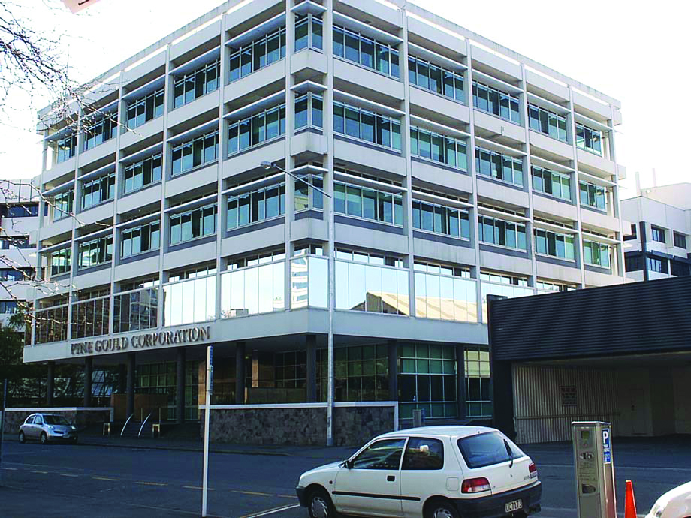
Figure 6: View from south-east prior to the February 2011 earthquake

Pyne Gould Corporation building fatalities
As members of the Royal Commission we are conscious that our Report is largely of a technical nature. However, at the forefront of our minds have been those who lost their lives as result of the earthquake of 22 February 2011 and those left behind who loved them.
Our thoughts have also been with those who were injured and their families. We think particularly of Kate Barron and Brian Coker.
To honour those who died, we asked family members to tell us about their loved ones. The words that follow reflect what they said. We thank the families for their willingness to share this information publicly, given the personal nature of their grief.
The biographies below all relate to people who worked for companies that were tenants in the Pyne Gould Corporation building at 233 Cambridge Terrace, Christchurch. The companies referred to are Perpetual Trust Ltd, Leech and Partners Ltd, Marac Finance and Marsh Insurance Ltd. These people were all at work when the earthquake struck.
Biographies of others who died as a result of the earthquake are published elsewhere in this Report.
Jane-Marie Alberts
Ms Jane-Marie Alberts (known as JM), 44, was an account manager at Marac Finance.
She is remembered for her great love of life and her enthusiasm for so many things. She loved anything with style, anything French, top fashion, gardens with topiaries, glossy magazines, the beach and basking in the sun. If she could incorporate her favourite music and a glass of chardonnay with the preceding list she was even happier. She loved her partner Derek, her sons, and family and friends dearly and would jump at any opportunity to get them all together.
JM was an amazing mother to Jackson and Sam, always loving, supportive and interested in what they were doing. She was very proud of them and their achievements. Derek, who met JM 15 years ago at his first job straight out of university, describes her as just amazing, with a great personality, gorgeous, athletic and outgoing. JM and Derek were soul mates and were very happy together.
JM is survived by Derek Neal (her fiancé and partner of 13 years), Jackson Smith (son, aged 17), and Sam Neal (son, aged 10).
Carey Bird
Mr Carey Bird, 48, was a forensic accountant at Marsh Insurance in Australia but at the time of the February earthquake was working at Marsh’s Christchurch office in the PGC building on claims relating to the earthquake of 4 September 2010. Carey was originally from Dunedin but had lived in Sydney for almost 20 years.
Carey, who had a degree in philosophy in addition to his professional qualifications, is described as laid-back, reliable and dependable, with a dry sense of humour.
He had a keen interest in photography, in particular black and white large format landscape photography, and he displayed his photography on a website: http://members.iinet.net.au/~cbird/index.html. He was also an avid reader.
Carey is survived by Jan Bird (wife), Andrew (son, aged 20), Lauren (daughter, aged 16), Don Bird (father) and Fran Bird (mother).
Melanie Brown
Mrs Melanie Brown (known as Mel), 53, had been a broker support officer for Marsh Insurance for 13 years.
Mel enjoyed gardening, travelling, sewing, photography and arts and crafts. She made scrapbooks for the most important events in her life, including getting married to husband Steve and moving into their new home. Mel and Steve had been married for three years and had plans to pay off their house and go travelling.
Mel is described as modest, unassuming and quiet. Nothing was ever a problem for her. She was a very caring, loving person who always put other people first.
She is survived by Steve Brown (husband), Derek Gentle (father), Patrice, Deborah and Alison (sisters), Nicola, Blair, Sam, Scott, Josh, Michael and Todd (nieces and nephews) and Neve (great-niece).
Helen Chambers
Mrs Helen Chambers, 44, was a chartered accountant and held the position of Corporate Trust Risk Manager at Perpetual Trust.
Helen was conscientiously involved in her local school and parish communities as chairperson of the parent council and financial advisor to her church’s parish finance committee, and she was a very enthusiastic and supportive parent. Before having a family she was involved in the Christchurch Marist Netball Club, first as a senior player then as a coach. She was later made a life member of the club. She had a great love of travel and shopping. She enjoyed playing the piano and encouraged her sons’ love of music. She was extremely competitive and would confidently back herself in any task or challenge the boys would throw at her. She loved being involved with their sports as team manager, coach, scorer, taxi driver, or just cheering from the sidelines.
Helen is described as the most kind, generous, welcoming, fun-loving person one could ever hope to meet. She loved to laugh and had a wicked sense of humour. She had a huge circle of friends who very much valued her wisdom, sincerity, support and warmth.
Helen is survived by her husband of 20 years, Brett Chambers, two boys, Will and George aged 15 and 13 respectively, and Toby (a five-year-old Border Collie). Helen was the sixth of 10 children of Mr and Mrs Mervyn and Margaret Johnston. She was a much-loved favourite aunty to 36 nephews and nieces.
Patrick Coupe
Mr Patrick Coupe, 46, spent his childhood and teenage years in New Zealand and Australia. After graduating from Massey University he started working in foreign exchange, which ultimately led to his position as Financial Services Manager at Marac.
Patrick was a no-nonsense person who was passionate about life, his work and especially his children, whom he supported whole-heartedly in all of their endeavours. Through his big-heartedness and keen support for his children’s interests, he had a real impact on Harewood Hockey Club and Canterbury Hockey Association where he spent years as a manager, administrator and amazing supporter.
Patrick’s mother said, “He became everything I could have ever asked for.” Patrick is deeply missed by family and friends and the huge support the family has gratefully received has been testament to his personality and the relationships he held with colleagues, friends and family members.
He is survived by Joanne (wife), Sean and Liam (sons), Allie (daughter), Sally (mother), Michael (father), Anna and Rachael (sisters).
Barry Craig
Mr Barry Craig, 68, was an insurance broker and risk advisor for Marsh Insurance Ltd.
Barry loved all sport. He played golf (10 handicap), was a long distance runner and an outstanding rugby league player who represented Canterbury many times. After his playing days ended Barry took up coaching. One of his proudest moments was coaching a Canterbury Under-19 side to victory over Auckland at a national tournament. In his later years Barry spent many happy hours salmon fishing at a secret spot up the Rakaia River and he kept his family well supplied with smoked salmon.
Barry is described as a gentleman, widely known for his tremendous integrity and values. He believed that tomorrow is always an opportunity and he refused to let yesterday’s disappointments put an end to his dreams for the future.
He is survived by Val Craig (wife), Mark and Andrea (children), Amanda (daughter-in-law), Vanessa and Jacob (grandchildren).
Estelle Cullen
Ms Estelle Cullen, 32, was a client administration manager for Perpetual Trust.
Estelle’s hobbies included Rosie (her bulldog), music, travel, socialising and home renovations. She is described as intelligent, funny, loyal, insightful, meticulous, caring and compassionate; a very beautiful person.
She is survived by Melissa Blackler and Hayley Cullen (sisters), Jacob Orchard (partner), Lloyd Cullen (father), Jocelyn Cullen (mother) and Rosie (her dog).
Adam Fisher
Mr Adam Fisher, 27, worked as a financial advisor for Perpetual Trust.
Adam enjoyed playing soccer and also played indoor netball with his fiancée, Becky. He loved watching all sport, especially rugby, and was a Crusaders fan. He was admired and well liked by others in the finance industry who commented that he was sympathetic, empathetic and cared dearly for his clients.
Adam was a loving, kind, happy and positive person throughout his life. Everyone who knew him loved him. He was funny, supportive and an amazing big brother to Simon and Sarah. He loved to tease Sarah. He adored and respected Becky, his fiancée.
He was a humble man and was caring and considerate to everyone he met.
He was besotted with his son Jack and loved being his dad. Adam’s family was very important to him and he talked constantly about his son Ashton’s arrival, which he was eagerly awaiting. He loved life and most of all his family.
Adam is survived by Gaye Fisher (mother), Steve Fisher (father), Simon (brother), Sarah (sister), Becky Gane (fiancée), Jack (son, aged four) and baby Ashton, who was born 10 days after his father died.
Amanda Hooper
Mrs Amanda Hooper, 30, was an account manager at Marac Finance.
Amanda had represented New Zealand as a member of the Black Sticks, gaining 40 international caps between 2001 and 2003.
She also participated in the 2002 Commonwealth Games in Manchester, the 2002 Women’s Hockey World Cup and Champions Trophy and was nominated for World Junior Player of the Year in 2002. With 77 caps as a Canterbury representative, Amanda also played locally for Carlton Redcliffs.
Amanda completed the Coast to Coast race in 2005 and also ran a number of half marathons.
Her greatest achievement in life, however, was becoming a mum, which she loved immensely; she is described as an awesome mum to her daughters, Aimee and Keily.
She was an organised, very friendly, outgoing, loving, caring, motivated, committed, diligent, respectful, devoted, giving and sharing person.
Amanda is survived by Richard Hooper (husband), Aimee (daughter, aged 4) and Keily (daughter, aged 2).
Catherine Lunney
Mrs Catherine Lunney, 62, was a credit officer for Marac Finance.
She was a very strong Scottish woman who had a great sense of humour. She is described as the best friend and mum that anyone could ask for: amazing, funny, loved and deeply missed.
Catherine loved shopping weekends and looking for bargains, but what she really enjoyed was doing everything for her daughters – making them happy made her happy.
Her family are Romaine (daughter, aged 29), Ailsa (daughter, aged 25) and the late Edward Lunney (husband). Catherine had recently adopted two little Schnoodles, Shadu and Wookie, because she was unable to choose between the two and separate a brother and sister.
Kelly Maynard
Mrs Kelly Maynard, 43, worked part-time at Perpetual Trust as an estate administrator.
Kelly enjoyed walking and watching sport. She was a hard-working person who would always put others before herself. She had a lovely smile.
She is survived by Mark Maynard (husband), Molly (daughter, aged five), Matilda (daughter, aged three) and Don and Pam Hlaca (parents).
Philip McDonald
Mr Philip McDonald, 57, was a partner at the accountancy firm, Leech & Partners. He was a Mid Canterbury Rugby Union director and a Crusaders Canterbury Rugby Union Board director. He was also a keen sailor and skier.
Philip is described as being enthusiastic, supportive and loving; he was an achiever.
Philip is survived by Sharon McDonald (wife), Chantelle (daughter, aged 28 at the time of the earthquake), Andrea (daughter, aged 23 at the time) and Michael (son, aged 22 at the time).
Adrienne Meredith
Ms Adrienne Meredith, 36, was an investment support administrator for Perpetual Trust.
Adrienne loved tramping and the outdoors. She also had a dream of becoming a full-time clothes designer and sold her clothes at the Lyttelton market on Saturdays. Adrienne had returned to New Zealand three years ago after spending eight years working in the United Kingdom and travelling extensively throughout Europe.
Adrienne was very loyal to her many friends. She was funny, witty, thoughtful, and very talented in everything she did. She had an affinity with the sea.
Adrienne is survived by Anita Meredith (mother) and Paul Meredith (father).
Blair O’Connor
Mr Blair O’Connor, 34, was a managed fund accountant at Perpetual Trust.
Blair is described as being very generous and hard-working, a devoted family man and a true gentleman. Blair learned the piano and skied when younger, but more recently enjoyed spending time with his family and children, camping and reading. He was involved in helping his local church with the children’s liturgy and was on the church’s finance committee.
He is survived by Bryan and Jan O’Connor (parents), Marie O’Connor (wife), Charlotte (daughter) and Caleb (son).
John O’Connor
Mr John O’Connor, 40, was a senior investment accountant at Perpetual Trust.
John was an Irishman, born in Tralee, County Kerry. He graduated as an accountant from Trinity College and the College of Commerce in Dublin. John met his New Zealand wife, Sarah, in London in 1999 and they moved to Christchurch in October 2010 with their baby, Dan.
John is described as a family man who was charismatic and quick-witted, with a great sense of humour. He had an amazing knowledge of most sports and always followed the fortunes of the Irish national teams as well as his favourite premiership football team, Manchester United. Sport was one of his great passions in life.
John’s family are Sarah O’Connor (wife), Dan (son, aged three), Sean (son, aged 10 months; John did not get to meet Sean as he was born in May 2011), Sheila O’Connor (mother), the late Donal O’Connor (father), Marie O’Connor (sister), Thomas O’Connor (brother), Don O’Connor (brother) and Anne O’Connor (sister).
Emma Shaharudin
Ms Emma Shaharudin, 35, was an accountant for Perpetual Trust.
Emma was a loving and caring partner, daughter, sister and sister-in-law, and a proud and devoted aunty to her two young nephews, Jacob and Leo. She was a fun-loving friend and respected work colleague. She is described as always being in the hearts and thoughts of those who knew her; they will cherish the wonderful memories forever.
Emma is survived by Paul Winter (partner), Miranda Cahn (mother), Ahmad Shaharudin (father), Melanie Shaharudin (sister) and David Shahar-Yu (brother).
Michael Styant
Mr Michael Styant, 41, was a business development consultant at Perpetual Trust. Before this he had been the South Island regional manager, corporate trust division, at Perpetual.
Michael was passionate about mountain biking, snowboarding, travel, hunting and working outdoors on the family’s lifestyle property. He was especially committed to his family; loved spending all his spare time with family and friends and being a hands-on dad.
He is described as unfailingly loyal and trustworthy and endlessly kind, caring and generous. Michael was solid as a rock, intelligent and practical, clever with his hands, building and DIY. He was beautiful inside and out.
Michael is survived by Rachel Fairweather (wife of 15 years), Gabriel (son, aged 11), Zachary (son, aged nine), Isabella (daughter, aged seven), Alexandra (daughter, aged five), Patricia Brooker (mother) and Alan Martin (father). Michael was one of four boys born to Patricia and Alan.
Julie Wong
Mrs Julie Kathryn Wong, 37, was an accountant at Perpetual Trust.
Julie was an active Christian, had a keen sense of adventure and loved exploring new cultures. Her personality is described as patient, gentle, mischievous and incredibly accepting of other people’s faults.
She is survived by David Wong (husband), Ethan Wong (son) and Robin and Eunice Johnston (parents).
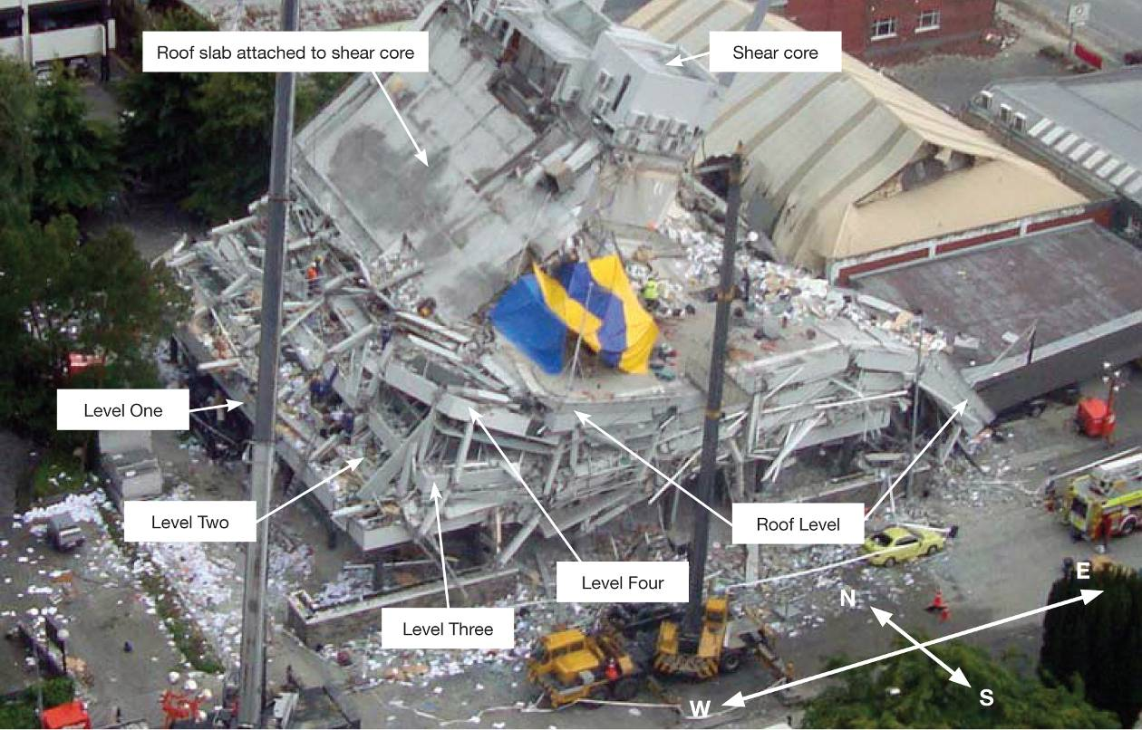
Figure 7: Aerial view from north-east after February earthquake
At the time of the February earthquake Pyne Gould Corporation Ltd (PGC) occupied the ground floor of the building, and related companies Perpetual Group Ltd (Perpetual) and Marac Finance Ltd (Marac Finance) occupied the first and second floors (levels 1 and 2). An unrelated company, Leech and Partners Ltd, also occupied part of level 1. The third floor (level 3) was occupied by the Education Review Office (ERO), and the fourth floor (level 4) by Marsh Ltd (Marsh).
The building had been purchased by PGC from the Christchurch City Council (CCC) in 1997 but was sold to Cambridge 233 Ltd in 2009. Notwithstanding the sale, the building continued to be known as the PGC building.
The discussion below covers:
• the history of the PGC building prior to the September earthquake;
• the performance of the building in the September earthquake and the Boxing Day aftershock, and the assessments of the building after those events;
• the February earthquake and the reasons the building failed; and
• lessons the Royal Commission considers should be learned from this failure.
It reflects information gathered from a variety of sources including:
• the CCC as both the regulatory authority administering building controls in Christchurch, and also as a former owner of the building;
• PGC as a former owner, and then as a tenant up until 22 February 2011;
• Cambridge 233 Ltd, the owner at 22 February 2011;
• the Beca Carter Hollings and Ferner Ltd (Beca) investigation into the failure for the Department of Building and Housing (DBH) (the Beca report)¹;
• the DBH Expert Panel review of the Beca investigation (the Expert Panel report)²;
• a review of the Beca and Expert Panel reports carried out on behalf of the Royal Commission by Mr William T. Holmes of Rutherford and Chekene;
• evidence given and submissions made to the Royal Commission at the hearing held on 28, 29 and 30 November and 5 and 6 December 2011; and
• witnesses to the collapse.

2.1 Original construction of the PGC building
The building was originally designed as the main administration office building for the then Christchurch Drainage Board (CDB). Architectural plans for the building were prepared by the firm Paul Pascoe and Linton Architects in 1963. Structural plans (reference 691/180, S1 to S17) were prepared by I.L. Holmes Structural Engineers. These plans are available and have been considered by the Royal Commission. They are variously dated 29/10/63 and 5/12/63, and all stamped as approved by the CCC on 18 or 19 March 1964. Although a copy of the building permit has not been located, the CCC’s electronic records indicate that a building permit (reference PER 63400604) was issued under the CCC’s Building Bylaw No. 44 on 25 March 1964.
The book “Christchurch – Swamp to City: A Short History of the Christchurch Drainage Board 1875-1989”³ states that construction commenced at the end of March 1964 and was completed in 1966. The building was designed, approved and constructed during the period when Building By-law No. 44⁴ (in force from 1 December 1962 to 1 September 1969) applied. This particular bylaw was relatively self-contained in that it included provisions relating to design without significant reference to New Zealand Standards. It was not, however, inconsistent with design Standards of the time, although there were minor wording differences from the New Zealand Standard that could have allowed an engineer to apply lower loadings than if the Standard was used.
The Beca report refers to Part IV of NZSS 95⁵ applying at the time of design and approval. However, the CCC bylaw did not in fact specify those design standards as a means of compliance. This is of little consequence to the building as constructed, as analysis by the Beca report indicates that it would have met the higher standards of NZSS 1900: Chapter 8⁶, which superseded NZSS 95⁵ in July 1964.
The PGC building had a plan area of 28m by 28m, which in both directions was built up from five bays of 5.08m with an additional 1.32m strip around the perimeter of the structure. The building had five floors, with housing for lift machinery and services on the roof.
Figures 8 and 9 show the general arrangement of structural walls and columns in the ground and elevated levels respectively. The lateral force resistance was provided by a shear core of structural walls, which were centred on the north–south centre line of the building but offset towards the northern side of the east–west centre line.
The arrangement was such that the eastern and western walls of the shear core, which ran in the north–south direction, were three times as long as the transverse walls labelled W1, W2, W3 and W4 in Figure 9. The figure shows two internal walls to the shear core, W2 and W3, that linked the eastern and western walls. This structural arrangement gave the building a greater lateral strength and stiffness for lateral forces acting in the north–south direction than the corresponding actions in the east–west direction. The wall thickness was 203mm throughout.
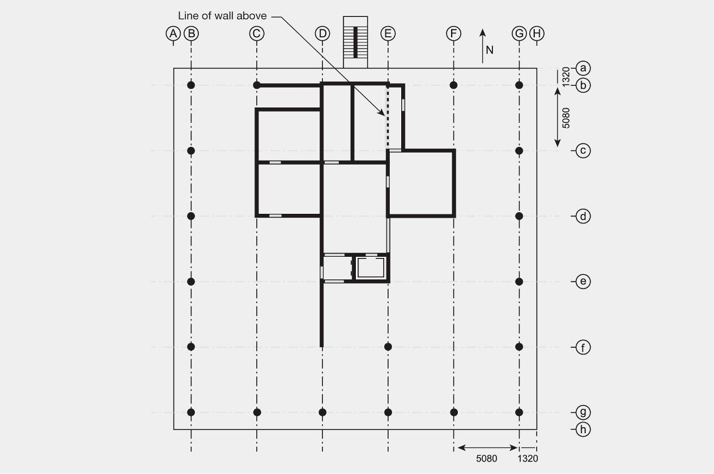
Figure 8: Ground floor plan
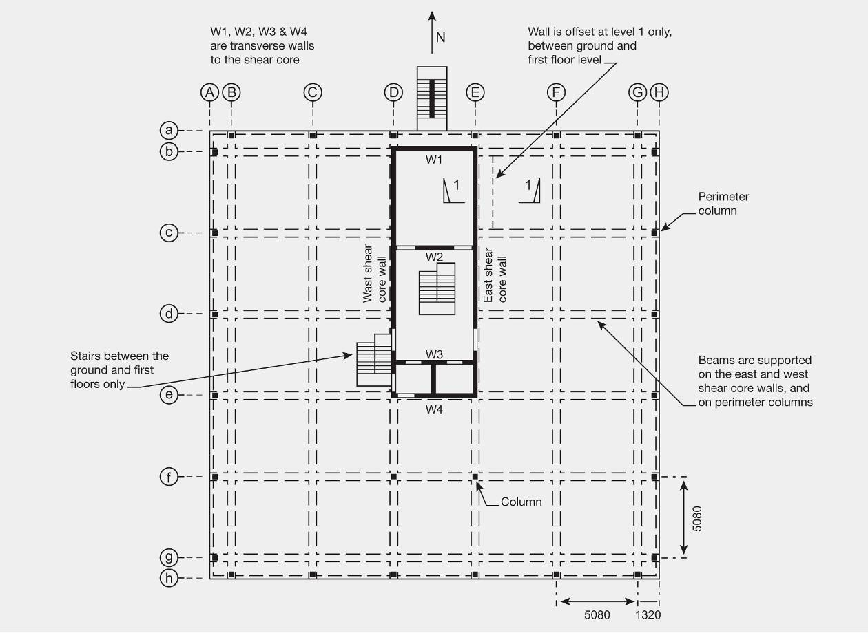
Figure 9: Upper level plan (typical)
A number of structural details appear to have had important implications for the performance of the building:
1. There were considerably more structural walls on the ground floor (Figure 8) than in the elevated levels. This gave the ground floor greater seismic protection than the elevated levels.
2. The elevated floors at each level consisted of a 152mm thick reinforced concrete slab supported on a grid of beams that were spaced at 5.08m in each direction (Figure 9). The span of the beams in the east–west direction on grid lines b to g was close to 11.5m.
3. The two transverse walls W1 (on grid line b) and W2 (close to grid line c) are shown in elevation in Figure 11. W2 was penetrated by doors at each level while W1 was penetrated by windows. There were a number of less significant openings in the transverse walls W3 and W4 located between grid lines d and e.
4. The beams supporting the floor slabs were supported by the eastern and western shear core walls on grid lines D and E and by internal columns located at the intersections of grid line f with grid lines D and E, and by columns located close to the building perimeter.
5. On the ground floor the perimeter columns were located in grid lines B, G, b and g. In the elevated levels the perimeter columns were moved out to grid lines A, H, a and h. This was achieved by supporting the perimeter columns on beams at the first elevated level that cantilevered out from the columns on the ground floor (see Figures 8 and 9).
6. The shear core walls are continuous in elevation, with one major exception. In the eastern shear core wall there is a discontinuity at level 1, where the wall in bay b-c is offset by a distance of 1.17m from the ground floor wall. This offset is illustrated in Figure 10.
7. The building was designed to codes of practice used in the 1960s. This was before ductile detailing had been developed and consequently the ductile performance of the building was both poor and not representative of more modern buildings. In particular, in terms of ductile detailing compared with current practice, there was inadequate confinement of the columns, inadequate longitudinal reinforcement in the walls, no confinement in the walls, and inadequate connection between the beams and the walls. A building with this combination of features could not lawfully be constructed today.
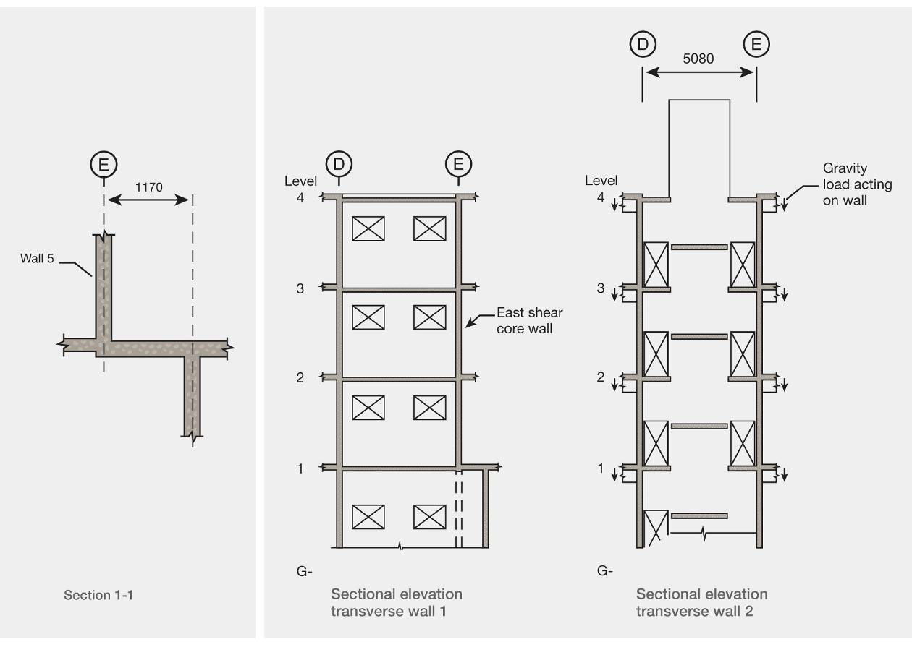
Figure 10: Cross-section 1–1 Figure 11: Elevations of transverse walls W1 and W2

2.2 Up until 4 September 2010
A number of the permits and consents issued by the CCC (including resource consents) were for work that had no relevance to the structural performance of the building. These approvals are not discussed in this Report.
In 1989 the CDB was abolished and its assets and liabilities were transferred to the new CCC established as a result of the nationwide reorganisation of local government implemented during that year.
In 1993 a prospective purchaser made an unsolicited offer to buy the building subject to a structural analysis being carried out by the CCC. The offer was rejected as the CCC considered that it should be the purchaser’s responsibility to carry out any necessary investigations for its proposed use. However, in 1994 the CCC offered the building for sale by tender as it was surplus to requirements. The tender process was unsuccessful.
In 1996 feasibility studies for other uses were carried out by Arrow International Ltd on behalf of the CCC, preparatory to the sale of the building. Arrow presented a report to the CCC dated July 1996. This report included advice from a CCC senior structural engineer that no analysis of the building or structural upgrade would be required, unless there was a change of use or alterations to structural members were made. That advice was correct under the Building Act 1991: the building could not be defined as earthquake-prone because it was not constructed of unreinforced or predominantly unreinforced masonry (section 66), it could not be defined as dangerous because earthquake weaknesses were excluded from this definition (section 64), and the owner could not be compelled to upgrade the building unless specifically allowed for in the Act (section 8). There is no record of any structural analysis at this time.
The building was again offered for sale by tender in the latter part of 1996, with a closing date for tenders of 29 November. On 24 January 1997 a sale was confirmed to PGC, and the transfer was registered on the title to the land on 5 March 1997.
Mr Colin Hair, who was PGC’s Company Secretary at the time of the acquisition (and remained in that role at the time of the Royal Commission hearing) gave evidence about events that occurred after the acquisition, beginning with a refurbishment of the building. PGC engaged Mr William Fox to project manage the refurbishment, and Architecture Warren and Mahoney Ltd (Warren and Mahoney) to provide architectural services. Holmes Consulting Group Ltd (HCG) was engaged by Warren and Mahoney for structural engineering services.
In relation to the refurbishment we record that:
1. On 17 February 1997, Mr Grant Wilkinson of HCG wrote to Mr Barry Dacombe of Warren and Mahoney discussing the proposed work. Among other things, Mr Wilkinson wrote:
The building is now 34 years old and while it was designed and built to the structural standards of the day it cannot be expected to perform as well as more modern building [sic] designed and built to current standards. We recently made a preliminary study of the building and have found a potential for seismic damage to some of the columns and to the base of sections of some of the shear walls. The shear walls can be expected to “rock” in a major seismic event, so damage to secondary elements will be likely.

2. On 25 March Mr Wilkinson sent a fax to Mr Fox headed “Interim Report – Preliminary analysis”. The fax included the following statements:
The potential failure of the columns is a life safety issue, as it could result in the loss of support and consequential collapse of all or part of the building…
The cracking and movement of the walls does not appear to carry any life safety implications. …
Note that we consider the life safety issues above are essential, but the damage reduction measures are optional.

There was no explanation putting the term “life safety” into context. The comment “the cracking and movement of the walls does not appear to carry any life safety implications” is a reasonably conclusive statement, and a person reading this might assume safety in any reasonably foreseeable event.
3. In April HCG produced a report titled “Seismic Evaluation of Existing Building”. This report gave a detailed assessment of the potential seismic performance of the PGC building using an inelastic time history analysis. A detailed finite element model of the building was made. In the modelling, inelastic hysteretic deformation rules for both flexure and shear were defined for the individual structural elements. The shear stiffness degradation hysteretic rule was based on published results of tests made on walls.
The ground motion inputs used in the analyses were based on two ground motion records. The first was developed from the 1940 El Centro earthquake’s north–south ground motion and the second was from the east–west ground motion in that event. In both cases the motion was modified so that the acceleration response spectra corresponded closely to the NZS 4203:1992⁷ design response spectrum for Christchurch with deep alluvial soils. The two earthquake records were applied to the model at different levels of intensity so that the proportion of design level earthquake (as defined in NZS 4203:1992⁷) that could be sustained was able to be calculated.
The analyses indicated that the weakest link was in the performance of the perimeter columns in the elevated storeys. The concern was that these columns were highly loaded and not effectively confined, and consequently they could fail at relatively small inter-storey drifts. To ensure that they could act as props in the event of a major earthquake it was recommended that rectangular steel sections be added to the columns to maintain their axial load carrying capacity. This was assessed as a life-safety issue with potential failure occurring in an earthquake of one third or less of the design level given in NZS 4203:1992⁷ if the props were not added.
The analysis indicated that some uplift of foundation pads could occur, flexural cracking could be anticipated in the walls and that there was a potential weakness in the transverse walls in the shear core. It was anticipated that extensive shear cracking could occur in these walls. None of this potential cracking was assessed as a life-safety issue but it was assessed as a potential problem in terms of serviceability. It should be noted that the analyses were made to the level of the design seismic loading in NZS 4203:1992⁷, which were considerably less in magnitude than the actions associated with the February 2011 earthquake.
With the addition of the recommended rectangular steel props to the perimeter columns HCG rated the potential seismic performance of the building as being equivalent to 50 per cent of the seismic design loading given in NZS 4203:1992⁷.
4. From 5 May 1997, building consent applications (the project was split into more than one application) were submitted by Mr Fox for the alterations. These included:
• installation of steel props behind the external columns on the upper four floors to address
the most critical issue identified by the HCG report;
• removing and reinstating a stair flight;
• infilling a stair void;
• re-glazing;
• removal of precast concrete sunscreens; and
• removal of existing shell concrete roof projections.
The work was completed and a code compliance certificate was issued by the CCC on 17 June 1998.
5. Warren and Mahoney provided a written report for the PGC Board meeting of 30 May 1997. The report dealt with the refurbishment and fitting out of the building, and discussed costs and options.
Part of the report was headed “Structural Strengthening” and it referred to the advice previously provided by HCG. The report said:
Structural Strengthening
Prior to purchase of 233 Cambridge Terrace, Holmes Consulting Group provided preliminary structural comment on the structural adequacy of the building with respect to code obligations and anticipated performance of structural elements under seismic loading.
While the building is a good one from a structural viewpoint it is 34 years old and cannot be expected to perform as well as a modern building built to upgraded structural standards.
Since this report they have been commissioned and have prepared a more detailed structural analysis using computer modelling and have reported their findings and recommendations
for strengthening work.
Essentially their recommendations fall into two categories:
1. Those considered imperative to preserve life safety in the event of a major earthquake.
2. Those recommended as damage reduction measures.
Cost estimates were prepared for the strengthening work recommended and these were subsequently evaluated in relation to risk and life cycle cost.
The additional cost of damage reduction measures was estimated at $30,400.00.
As a consequence only the strengthening work considered necessary to preserve life safety has been adopted and the documentation for this aspect is nearing completion.

We accept Mr Hair’s evidence that there are no records to suggest HCG’s written advice of February and April was provided directly to the Board. However, its substance was conveyed in the above passage from the report.
On 21 April 1998 an application (CCC reference CON98002794) was made for building consent for an office fit out on level 4. The proposal included penetrations in shear walls for which HCG provided structural drawings. The work was completed and a code compliance certificate was issued by the CCC on 3 November 1998.
On 29 January 2001 an application (CCC reference ABA10013069) was made for building consent for a roof support beam in the roof-level tearoom. Structural engineering services were provided by HCG. This was a small beam that was not of relevance to the overall structure. The work was completed and a code compliance certificate was issued by the CCC on 30 May 2001.
In 2007 PGC commissioned Warren and Mahoney to investigate the potential for further development of the site and building. A number of possible concepts were addressed, but according to Mr Hair, PGC management considered that none was economically viable and Warren and Mahoney’s report was not presented to the Board. In the course of this process, Mr John Hare of HCG sent a memorandum dated 4 July 2007 to Mr Bisman of Warren and Mahoney headed “PGC Building Review-Study Findings”. The memorandum stated:
I have reviewed briefly the findings of our 1997 study when PGC purchased the building. At that stage we concluded that there were severe deficiencies with the exterior columns at the upper levels, but that the basic shear wall system was reasonably robust. Assuming the column failure were mitigated in all cases by placing secondary steel props behind them, the capacity of the building was judged at the time to be in excess of 2/3 of current seismic code loading at the time.
The loading code has subsequently been updated, and probably represents a 10% increase for this building but this is not significant in the context of an existing building. It is certainly not considered earthquake-prone which is at a threshold level of 1/3 of current code loading.
Later in this memorandum Mr Hare referred to the building’s “unusual structural form that may work to our benefit”, noting that the columns “step across at the first floor to create the structural setback…” He referred to this as “a severe structural weakness seismically as this discontinuity has the potential for severe failure”.
Mr Hare sent a handwritten fax to Mr Bisman on 4 September 2007 regarding a further development option under consideration, called Option D. This involved a low addition to the rear of the existing building. Mr Hare wrote:
Potentially we may need to look a lot more closely at the existing exterior gravity structure as the walls may rock a long way even with the proposed new structure.

On 2 November 2007 an application (CCC reference ABA10081446) was made for building consent for a fit out on the ground floor. This fit out included structural alterations to walls, for which HCG provided the engineering design. The Project Information Memorandum (PIM) issued by the CCC for this work on 12 December 2007 included a statement on earthquake-prone buildings:
Due to changes to the definition for Earthquake Prone Buildings in the Building Act 2004, Council’s current records do not fully identify all buildings which may be potentially earthquake-prone.
The [effect] of this change is that buildings built prior to 1976 may now need to be assessed to ascertain if they meet the standard of a third of current New Zealand Building Code as specified in the Building Act Regulations.
Consent applicants may be asked to engage a structural engineer to assess the building to determine if the building is above the Earthquake Prone Standard as specified in the Building Act Regulations and to provide this information with any consent application to the Council.
Note: Prior strengthening work may no longer be sufficient to comply with the Building Act 2004.
The application included a document prepared by HCG: “PGC Office Relocation-Project Features Report”. It stated (referring to work carried out in 1997):
At that time a full seismic assessment was carried out by Holmes Consulting Group, and it was determined that although the building does not conform with current codes, it is expected to behave reasonably well in an earthquake, provided that sufficient secondary supports were installed to provide back-up to the exterior precast column elements above the ground floor. The general lateral support system of the building comprises a system of structural walls on rocking foundations. These walls are also gravity load bearing, although the overall floor loads are not high.
The expression “reasonably well” is not quantified in the report but this was evidently accepted by the CCC and there is no evidence of further consideration of the building’s seismic strength.
Under the CCC’s Earthquake-Prone, Dangerous and Insanitary Buildings Policy 20068, as the value of the work was less that 25 per cent of the rateable value of the building, an assessment of the seismic strength of the building was not required, provided there was compliance with section 112 of the Building Act 2004. Relevantly, that meant that the building had to comply with the structural provisions of the Building Code to at least the same extent as before the alteration. Mr Hare’s memorandum of 4 July 2007, discussed above, had effectively dealt with that issue. The relevant part of section 112 of the Act, and an extract from the CCC’s 2006 policy are set out below.
The work was completed and a code compliance certificate was issued by the CCC on 30 October 2009.
Extract from Building Act 2004, Section 112, Alterations to existing buildings
(1) A building consent authority must not grant a building consent for the alteration of an existing building, or part of an existing building, unless the building consent authority is satisfied that, after the alteration, the building will—
(a) comply, as nearly as is reasonably practicable, with the provisions of the building code that relate to—
(i) means of escape from fire; and
(ii) access and facilities for persons with disabilities (if this is a requirement in terms of section 118); and
(b) continue to comply with the other provisions of the building code to at least the same extent as before the alteration.
Note that part 2 of this clause gives some exceptions that can be applied by a territorial authority in some limited situations.
Extract from Christchurch City Council Earthquake-Prone, Dangerous and Insanitary Buildings Policy 2006
1.2 Definitions
Significant alteration
Significant alteration, for the purpose of the Policy, is building work on the structural support of the building or building work that has a value of more than 25 per cent of the rateable value of the building.
1.7 Interaction between earthquake-prone building policy and related sections of the Building Act 2004
When an application for a consent for a Significant Alteration to a building is received and the building has an earthquake-prone strength of less than 10 per cent of the Code, the building will be required to be strengthened to at least 33 per cent of Code as part of the consent.
Owners of buildings with a strength between 10 per cent and 33 per cent will be given consent for alterations and will be formally advised that when the first review of the policy is completed and timeframes for action set, the owner is likely to be served formal notice requiring action to strengthen or demolish the building within the timeframe set in the policy review.
When an application for a consent involving a change of use is received, the requirements of the Building Act, section 115, for the building to be strengthened to as near as is reasonably practicable to the strength of a new building will be followed.

On 2 October 2008 a building consent application (CCC reference ABA10088473) was made to install a 12m telecommunications mast on the roof of the building. Engineering details were provided by Opus International Consultants Ltd. The PIM for the project contained the same information with regard to buildings that was provided by the 2 November 2007 building consent application. As with the ground floor fit out discussed previously, the value of the work was less than 25 per cent of the rateable valuation of the building, and the CCC’s 2006 Earthquake-Prone, Dangerous and Insanitary Buildings Policy⁸ did not require a consideration of the seismic strength provided there was compliance with section 112 of the Building Act 2004. There is no evidence that the Opus engineer or the CCC considered this provision of the Building Act in the context of this alteration to the structure. The work was completed and a code compliance certificate was issued by the CCC on 23 December 2008.
On 13 March 2009 Mr Hare wrote to Ms Golding at PGC. His letter was headed “Column Cracking Review” and recorded that he had been to the building on 9 March to inspect damage that had been reported to a column, towards the centre of the eastern face of the building. He expressed his view that the cracking was likely to be the result of plaster bond failure. However, he recommended that a specialist concrete repair contractor be engaged to assess the position, as in the worst case there could be a worsening problem with corroding reinforcing.
On 23 March Mr Hare wrote again to Ms Golding stating:
I received your email last Friday instructing us to proceed with engaging Construction Techniques to complete the investigation and repair work so we will proceed on that as soon as possible.
On 26 April Mr Hare sent an email to Ms Golding in which he wrote:
I now believe that almost all of the cracking that is visible on the columns (including most likely the one that we were looking at) is happening on the site of previous repairs. This makes it much more likely that the damage is indicative of corroded reinforcing… I am sorry that this looks like the worst case scenario from my earlier letter, but we will do our best through this process to control your costs and to keep you informed. We will look at alternative repair measures with Contech and present these if it makes sense from a whole of life perspective.
On 1 July 2009 an agreement for sale and purchase of the building was entered into between PGC and Mr Stephen Collins or nominee. Cambridge 233 Ltd was subsequently nominated as the purchaser. Mr Collins was the sole director of Cambridge 233 Ltd and a trustee of the trust that was its sole shareholder. At this stage it appears that NAI Harcourts Pty Ltd (Harcourts) was engaged to obtain a building condition report to help the purchaser carry out due diligence in respect of the purchase. Harcourts commissioned and obtained two reports on the building, one from Spotless Facilities Services (NZ) Ltd and the other from Plant & Building Safety Ltd. Harcourts was also to be wholly responsible for the management of the building, including arranging repairs where required throughout the period of Cambridge 233 Ltd’s ownership.
A building condition report (which was undated) was prepared by Mr Scott Thompson of Spotless. The report included some information with regard to the structure, including details of where water had penetrated under plaster on the eastern side of the building, breaking away a section, and where steel had expanded “spalling off” concrete under a beam. Cost estimates were given for repair. The report referred to some outstanding items of deferred maintenance, and Mr Thompson wrote that “hopefully” the report would “give the prospective building owner a better insight into the current condition of the building and services”.
The Plant & Building Safety Ltd report was prepared by Mr John Phillips. It focused on the building’s warrant of fitness and also identified the potential for the building to be earthquake-prone, stating that remedial works might be required as a condition of future building consents. In doing so, it essentially repeated information that was set out in a land information memorandum (LIM) that was obtained by Chapman Tripp Sheffield Young Ltd, solicitors acting for Cambridge 233 Ltd as part of the due diligence process.
The LIM (Council reference LIM70108939) was issued on 21 July 2009. It included information about earthquake-prone buildings, which repeated the warnings given in the 2007 building consent. During the hearing Mr Collins claimed that he was not made aware of the potential of the building to be earthquake-prone. Mr Buchanan also confirmed that at no time had he told Mr Collins that the building had the potential to be earthquake-prone owing to its age.
On 15 September 2009 the purchase by Cambridge 233 Ltd was registered on the title to the land. Pyne Gould Corporation Ltd and Cambridge 233 Ltd entered into a lease of the ground floor.

2.2.1 Seismic analyses carried out by Beca
We break the narrative at this point to refer to some of the work that was carried out for the purposes of the Beca report¹, as it will assist the following discussion of the performance of the building in the earthquakes. To assess the cause of failure of the building in the February earthquake and its likely seismic performance in the 4 September and the Boxing Day 2010 earthquakes, Beca made a series of analyses. These included:
• a simple non-linear pushover analysis for forces in the east–west direction, but excluding torsion and ignoring the offset in the eastern wall in bay b-c at level 1 (see Figures 9 and 10);
• response spectrum analyses;
• a number of pushover analyses; and
• a number of non-linear inelastic time history analyses.
The conclusions about the structural performance of the building were determined from the time history analyses predictions. In these analyses the non-linear hysteretic response of reinforcement and the concrete were modelled. However, it is not clear from the report how shear strength and shear stress deformations were modelled.
The ground motion records used in the analysis were obtained from the Resthaven Retirement Home (REHS) site near Peacock Street in the north-west of the CBD, some 670m from the PGC site. These records were chosen as this was the closest site where ground motion during the earthquake was measured. However, it was noted in the Beca report that there were differences between the PGC building site and the REHS soil profiles, with the soils at the former being somewhat stiffer. Also, the REHS ground motion record is generally more energetic than the other records. The Royal Commission considers that owing to the sensitivity of predicted performance to the ground motion record, the use of at least one other record in a few analyses would have given more robust predictions.
Beca does not give an estimate of the initial fundamental period of the building. However, Professor Nigel Priestley gave an estimate of 0.7 seconds for this value, which the Royal Commission assumes applies to vibration in the east–west direction. Given the rectangular shape of the shear core, it could be anticipated that the fundamental period in the north– south direction would have been of the order of 0.35 seconds, although this value is not stated in the report.

