2.7.1.1 The September earthquake
On 4 September 2010, at 4:35am, an earthquake of 7.1M_{w} struck Christchurch and the surrounding Canterbury region. Its epicentre was about 40km west of Christchurch, on a previously unknown fault beneath the Canterbury Plains. GNS Science advised in its report that this was a rare event that had occurred in an area where previous seismic activity was relatively low for New Zealand.
A number of estimates have been made for the return period of this earthquake, from 8000 years upwards. The 8000-year figure is a minimum period from the previous earthquake on this fault. GNS Science advises that this figure is likely to be conservative. The value was determined by examining disturbance in the layers deposited by rivers on the plains since the last ice age.
The earthquake caused extensive damage to unreinforced masonry buildings and to old stone buildings of heritage value in Christchurch and the surrounding region. In the eastern suburbs of Christchurch and in Kaiapoi there was significant liquefaction, with silt oozing to the surface and lateral spreading of the land causing damage to houses and infrastructure. The fault left a well-defined surface rupture along what is now known as the Greendale Fault, a fault not previously known to exist.
It was the first earthquake to produce a ground-surface rupture in New Zealand since the 1987 M_{w} 6.5 earthquake at Edgecumbe in the North Island. At its eastern end, the Greendale Fault is covered by more recent alluvial gravel deposited on the Canterbury plains. The surface rupture extended for about 29.5km across farmland to the west of Christchurch. It is represented by the red line in Figure 13.

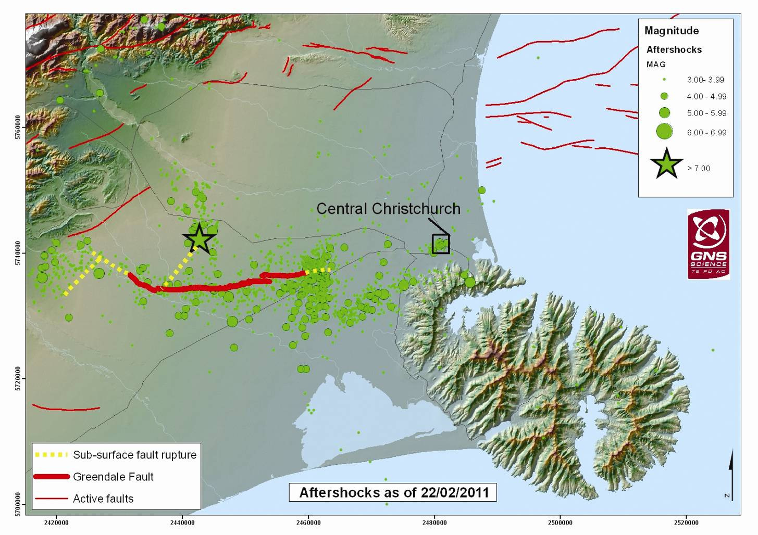
Figure 13: Earthquakes of the Canterbury sequence through to 21 February 2011 (source: GNS Science report 2011/183, July 2011)
The figure shows the faults that ruptured in the September earthquake (as well as the locations of subsequent aftershocks up until 21 February 2011). The green star indicates the point at which it is thought the main shock rupture originated.
The GNS Science report stated that movement on the Greendale Fault was predominantly right-lateral strike-slip with an average horizontal displacement of about 2.5m and a maximum displacement of 5m horizontally and 1.5m vertically. The rupture was not in a continuous line. There was a series of offset fault traces up to 1km apart. It is estimated that the rupture recurrence interval for the Greendale Fault is at least 8000 years.¹⁵
It is thought that the rupture did not initiate on the Greendale Fault but on another blind fault that intersects with it and is now known as the Charing Cross Fault. After that fault ruptured, the rupture spread to the Greendale Fault and then in both directions along that fault but mainly to the east. There was another smaller thrust fault that intersected with the Greendale Fault at its western end, which probably ruptured later in the earthquake.
Analysis since the 4 September 2010 earthquake suggests that the dominant fault displacements responsible for generating it were very shallow and confined within the upper seven to eight kilometres of the crust.
The rupture on the Greendale Fault was predominantly towards the centre of Christchurch. With this direction of rupture, the shock waves released at the start of the earthquake were reinforced by the shock waves released further along the fault and closer to the city. This increased the intensity of shaking in the direction of Christchurch and reduced it in the other direction. This “directivity” of the earthquake shaking also had the effect of reducing the duration of the strong shaking in the direction of Christchurch and increasing it in the opposite direction. As noted in Table 1, the duration of strong shaking in Christchurch was about 8–15 seconds.
Peak ground accelerations caused by this earthquake reached 1.26g at the Greendale seismic station and were up to 0.3g in central Christchurch. Accelerations measured at various locations in and near Christchurch are shown in Figure 8.
GNS Science advised that peak ground accelerations recorded close to the source were greatest in the vertical direction, while horizontal ground motions were dominant at greater distances away from the source. In central Christchurch they were close to those that would have been used for building design under the current Earthquake Actions Standard, NZS 1170.5 (although exceeding the Standard’s requirements in the vicinity of the rupture). Further, the horizontal ground accelerations at the 1.0s period were generally comparable to those predicted for deep or very soft soils (Class D soils in NZS 1170.5) in the ground motion attenuation model used in the National Seismic Hazard Model (NSHM) discussed in section 2.8. Some variations observed in the CBD are likely to be attributable to complex wave interactions due to basin effects and soil characteristics. It can be said, with some qualification, that the shaking was generally comparable with that anticipated for a design 500-year return period earthquake for Christchurch, although the duration of the strong ground motion was comparatively short. The qualification is that the acceleration response spectrum is on the low side for buildings with a period range of 0–0.25 seconds, and high for a period of 2–4.5 seconds.

2.7.1.2 The Boxing Day earthquake
There was a series of shallow aftershocks on 26 December 2010 which GNS Science refers to as the “Boxing Day sequence”. The sequence began with a M_{W} 4.7 earthquake at 10:30am, and this was followed by magnitude (M_{L}) 4.6 and 4.7 events on that day (note that GNS has not attributed M_{W} magnitude to the latter events). In the following weeks, more than 30 aftershocks occurred, closely clustered around the epicentre of the initial event. The initial earthquake was the most damaging. Although it was of short duration, it caused significant damage in the CBD. We refer to it as the Boxing Day earthquake in the discussion that follows.
The Boxing Day earthquake was located at a depth of about 4km, with an epicentre 1.8km north-west of Christ Church Cathedral. Most of the aftershocks associated with this earthquake occurred at depths of 3.5–7km and in close proximity, having epicentres within an area measuring less than one square kilometre. The GNS Science report stated that the earthquakes involved a right-lateral strike-slip movement and their distribution was consistent with an approximately east–west fault plane striking at about 74º east of north and dipping steeply.
Figure 9 shows the maximum horizontal and vertical peak ground accelerations recorded in the Boxing Day earthquake at the GeoNet stations and at temporary accelerometers that had been installed.
The maximum peak ground acceleration of 0.4g was measured at the Christchurch Botanic Gardens. While “felt” reports indicated strong ground motions, the smaller magnitude of the event meant that these motions were confined to central Christchurch. Directivity effects were not significant for this earthquake.

2.7.1.3 The February earthquake
The most destructive of the earthquakes occurred at 12:51pm on 22 February 2011 on what is now known as the Port Hills Fault. Of magnitude 6.2, the rupture occurred on a northeast–southwest oriented fault at a shallow depth, reaching to within one kilometre of the surface. This led to the catastrophic collapse of two large buildings in the CBD, the Canterbury Television (CTV) building and the Pyne Gould Corporation (PGC) building, and caused the partial collapse and serious damage of many others. The official death toll now stands at 185 and numerous people were injured. There was widespread liquefaction, especially in Christchurch’s eastern suburbs.
The existence of this fault was unknown before the February earthquake, but there had been some aftershock activity in this area prior to the 22 February event. As the fault has no surface expression, it is very difficult to determine a return period. However, there is evidence to indicate that no significant earthquake had occurred on this fault (or the fault that ruptured on 13 June 2011) within the last 8000 years. The evidence comes from rock falls in the Redcliffs and Sumner area, where the cliffs formed when the sea level was higher. Both the February and June earthquakes generated large rock falls from these cliffs. The absence of evidence of previous falls indicates that there was no major earthquake involving these faults during the previous 8000 years.
GNS Science advised that the faulting movement in this event was also complex, with overall oblique-reverse (a combination of right-lateral strike-slip and thrust faulting) displacements. The rupture produced a maximum slip of 2.5–4.0 metres at a depth of 4–5km on a fault plane dipping by about 70º. GNS Science stated that the main rupture may have been accompanied by a smaller strike-slip rupture on a smaller fault to the south-west beneath the Port Hills and orientated east-northeast to west-southwest.
The resulting ground motions were extremely high. Vertical accelerations reached 2.2g, with horizontal accelerations of 1.7g in the Heathcote Valley near the epicentre and up to 0.8g in the CBD. Both horizontal and vertical accelerations are important for the performance of structures.
Close to the Port Hills Fault, and within a distance of five kilometres, peak horizontal accelerations were stronger than in the September event. At greater distances, peak horizontal accelerations were higher in the September earthquake than at comparable distances in the February earthquake.
GNS Science also compared the earthquake response spectra (there is a discussion of this concept in section 3 of this Volume) of recorded horizontal ground motions at the four measurement sites maintained by GeoNet in central Christchurch, with spectra from the current Earthquake Actions Standard used in building design, NZS 1170.5.¹⁶ This comparison showed that the recorded response spectra exceeded the 2500-year recurrence interval spectra, especially for longer periods, being a little lower for shorter periods of about 0.3 seconds or less. The results of this comparison are shown in Figure 14.
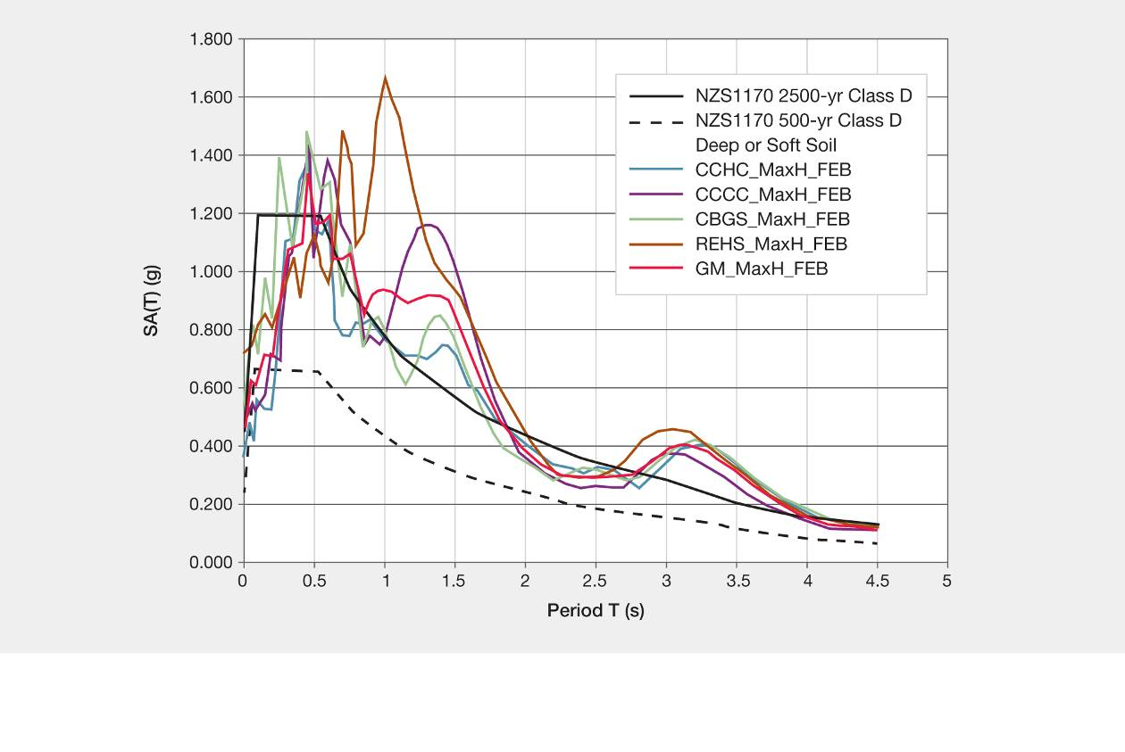
Figure 14: Comparison of recorded response spectra in Christchurch and the design spectra in NZS 1170.5 for deep or soft soil sites (source: GNS Science report 2011/183, July 2011)
The high accelerations experienced in central Christchurch because of the February earthquake may be attributed to the shallowness of the rupture and its proximity to the city. Basin and topographical effects and the high water table are likely to have added to the force of the earthquake. These have contributed to the high vertical accelerations observed, which were greater than the horizontal accelerations nearer the epicentre. The GNS Science report notes that complex wave interactions due to the shape of the basin and deep soils below Christchurch are likely to have caused the peaks observed in ground acceleration over longer periods.

2.7.1.4 The 13 June 2011 earthquake
The epicentre of the earthquake that occurred on 13 June 2011 was close to the suburb of Sumner. There were in fact two significant earthquakes on that day, one of magnitude 6 at 2:20pm that had been preceded by another of magnitude 5.7 a little over an hour earlier. The following discussion focuses on the later and stronger earthquake.
GNS Science has advised that the June earthquake followed the rupture of a right-lateral strike-slip fault, orientated in a north north-west to south-southeast direction. The earthquake was felt strongly in the southern and eastern suburbs of Christchurch (where there was widespread liquefaction) but it also caused damage to vulnerable structures in the CBD, and further cliff collapses and rock falls on slopes in the southern Port Hills.
Peak ground accelerations were again high, with horizontal shaking reaching 2g in Sumner and 0.4g in the CBD. The accelerations are shown in Figure 11.
It can be seen that horizontal peak ground accelerations were dominant. The extremely high accelerations at the Sumner station, which sits on rock, is likely to be the result of the strike-slip nature of the rupture and a degree of amplification of the seismic waves due to the shape of the surface topography.

2.7.1.5 The 23 December 2011 earthquake
An earthquake of magnitude 5.8 struck at 1:58pm on 23 December 2011. It was centred six kilometres off the coast of New Brighton and caused liquefaction in the eastern suburbs of Christchurch. There were a number of aftershocks later that day and overnight, several of which were magnitude 5 or greater. They included a magnitude 5.9 event at 3:18pm that day. The sequence was located east of the 13 June sequence of aftershocks and was not characterised by the very high ground motions of earlier events, apart from one isolated high recording at Brighton Beach in the initial aftershock. GNS Science considers this is likely to be explained as a local site effect.
The lower energy magnitudes meant that these earthquakes were not as damaging as the other earthquakes that have been discussed previously.

2.7.1.6 Comparisons of the earthquake characteristics
The GNS Science report summarised the main features of the four earthquakes discussed in the report in Table 1.
Table 1: Summary of the main features of the significant earthquakes in the Canterbury sequence (source: GNS Science report 2011/183, July 2011)
Earthquake |  | Sep 4 2010 | Dec 26 2010 | Feb 22 2011 | June 13 2011 | Dec 23 2011 | Dec 23 2011
Magnitude | M_{w} | 7.1 | 4.7 | 6.2 | 6.0 | 5.8 | 5.9
 | M_{L} | 7.1 | 4.9 | 6.3 | 6.3 | 5.85 | 6.0
 | M_{e} | 8.0 | Not known | 6.75 | 6.7 | 5.6 | 6.0
Source fault | Rupture | Complex | Strike-slip | Oblique-reverse | Oblique-reverse | Oblique-reverse | Oblique-reverse
 | Orientation | E-W surface rupture | E-W | NE-SW | NE-SW N-S | NE-SW | NE-SW
Max. PGA recorded | Horiz. (g) | 0.8 | 0.4 | 1.7 | 2.0 | 0.4 | 0.7
 | Vert. (g) | 1.3 | 0.5 | 2.2 | 1.1 | 1.0 | 0.4
 | Dist. (km) | 1.3 | ~2* | 2 | 3 | 13* Horiz. 6* Vert. | 8* Horiz. 6* Vert
Max. PGA recorded in CBD | Horiz. (g) | 0.3 | 0.4 | 0.7 | 0.4 | 0.3 | 0.4
 | Vert. (g) | 0.2 | 0.4 | 0.8 | 0.2 | 0.2 | 0.2
 | Dist. (km) | 20–22 | ~ 2–3* | 5–9 | 9–10 | 13–15* | 10–12*
Duration of shaking >0.1g in CBD(s) |  | 8–15 | 1–1.7 | 8–10 | 6–7.5 | 2–4 | 3–4

Distances are the distance from the fault trace, where available, but those marked with an asterisk are taken from the earthquake hypocentre. The duration is defined by the approximate length of record containing accelerations over 0.1g.
The sequence included a mixture of strike-slip and reverse faulting at shallow depths on previously unidentified faults at varying distances from the Christchurch CBD. The three largest events had high energy magnitudes (M_{e}) compared to their moment magnitude (M_{w}), which resulted in the radiation of above-average amounts of seismic energy. This led GNS Science to infer that the earthquakes had high stress drops, meaning that the rupture plane area was relatively small for the energy released, implying that the faults were very strong. Professor Abrahamson, in his peer review of the GNS Science report, expressed doubts about GNS Science’s conclusion that the earthquakes were high stress drop events, although Professor Archuleta appeared to accept the GNS approach. GNS Science advises that this matter is the subject of ongoing consideration and research in conjunction with experts from the United States and Europe.
Figure 15 compares the response spectra in the Christchurch CBD during the four earthquakes. Each coloured line is an average of the strongest responses calculated from the horizontal ground motions recorded at the four sites in the CBD.
This graph shows that the damage potential for buildings with response periods in the range of 0.1–0.3 seconds (such as houses and other low-rise buildings) would be, in descending order, 22 February, 26 December, 4 September and 13 June. For buildings of four to 0 storeys, with periods typically in the range of 0.4–1.5 seconds, the 22 February event was likely to be significantly more damaging, followed by the 4 September and 13 June events, with 26 December significantly less serious. For high-rise buildings with a response period in the range of 2–3.5 seconds, the February, September and June events would have had a similar damage potential. The Boxing Day earthquake had little potential to cause damage to buildings of more than five storeys.

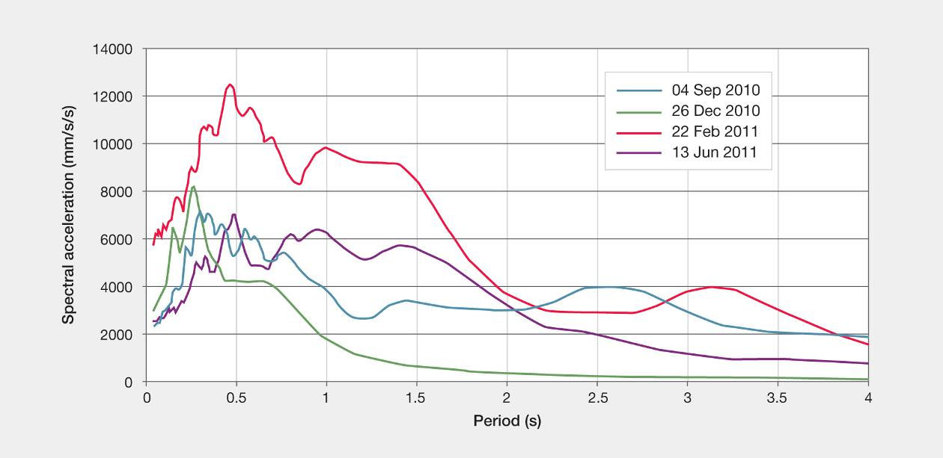
Figure 15: Peak response-spectral accelerations averaged over the CBD recording sites (source: GNS Science report 2011/183, July 2011)

2.7.1.7 Comparison with a rupture of the Alpine Fault
The Alpine Fault is a major geological feature and a potential source of major earthquakes in the South Island of New Zealand. The average return period of ruptures on the fault is 260–400 years. GNS Science advises that no major event has occurred on the fault in the last 295 years and there is an assessed 30 per cent likelihood of rupture within the next 50 years. It has also been estimated that an Alpine Fault event could be of magnitude 8 or greater.¹⁷ At its closest, the Alpine Fault is 125km from Christchurch.
For the purposes of advising the Royal Commission on the implications for Christchurch of a rupture on the Alpine Fault, GNS Science estimated ground motions in Christchurch from a magnitude 8.2 event with the rupture propagating from south to north. The modelling was designed to demonstrate the shaking effects at the Christchurch Botanic Gardens site (CBGS in the GeoNet network). Figure 16, which is extracted from the GNS Science report, compares the modelled ground surface motions (in terms of ground accelerations) for a potential Alpine Fault earthquake with those for the September and February earthquakes.
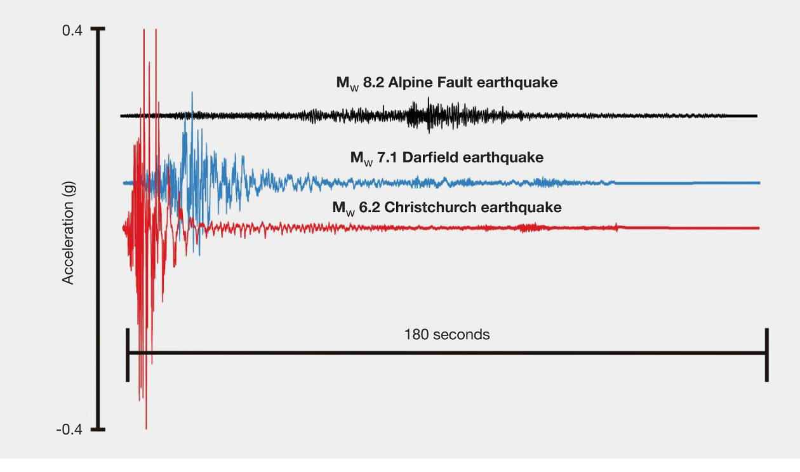
Figure 16: Comparison of modelled ground surface motions for a potential Alpine Fault event and the September 2010 and February 2011 earthquakes (source: GNS Science report 2011/183, July 2011)
Notes: Three minutes of synthetic acceleration time histories for the larger of the two horizontal components, in terms of PGA, for a potential Alpine Fault event (black), compared with the accelerations for the magnitude 7.1 4 September earthquake (blue) and the 22 February magnitude 6.2 Christchurch earthquake (red), as recorded in the Christchurch Botanic Gardens GeoNet station (CBGS).

2.7.1.8 Aftershocks
Figure 17 illustrates the pattern of aftershocks that followed the September 2010 earthquake.
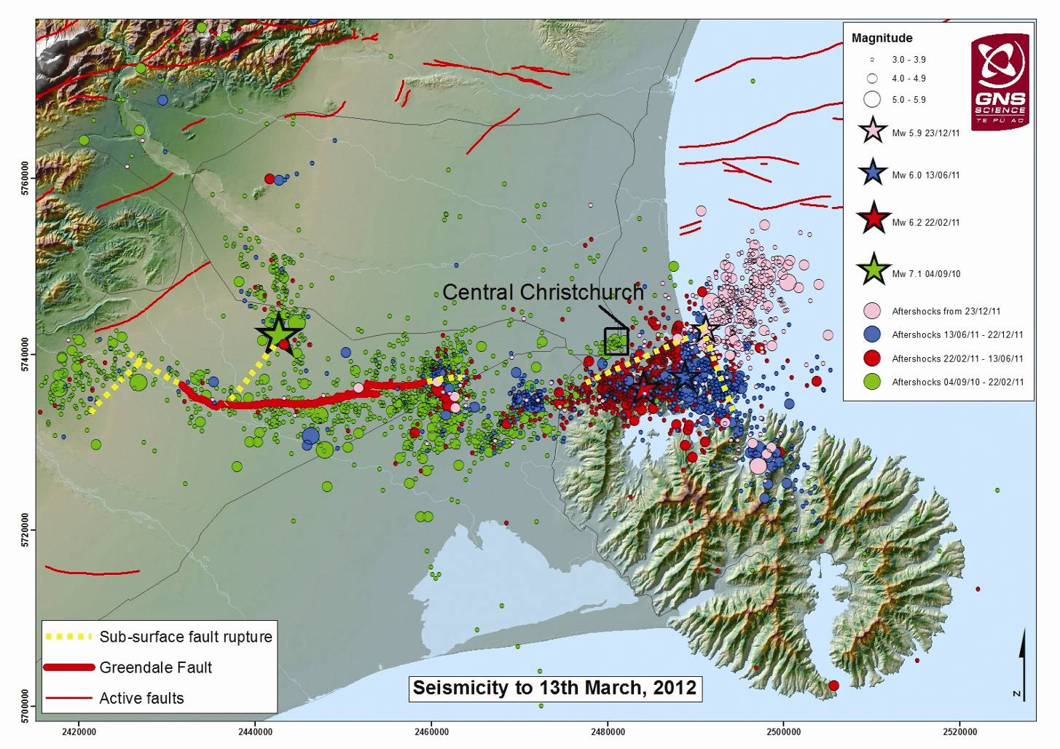
Figure 17: Pattern of aftershocks following September 2010 earthquake (source: GNS Science letter to the Royal Commission, 2 April 2012)¹⁸
Notes: Seismicity up to 13 March 2012, showing the Greendale Fault, the epicentres of the September, February, June and December earthquakes and the associated aftershock activity. The coloured stars indicate the main aftershocks. Circles represent the aftershocks triggered by each event.
We understand that, strictly speaking, an aftershock is an event that subsequently occurs on the same fault as the original earthquake. While aftershocks of that kind have occurred in the Canterbury earthquake sequence, the pattern observed has involved significant earthquakes on faults other than the Greendale Fault. The Boxing Day, February, June and December events were all in that category. We infer from the evidence given by Dr. Webb at the hearing that they can loosely be regarded as aftershocks. However, they can be seen as probably having been triggered by the September earthquake.
Aftershock behaviour normally follows predictable patterns, enabling a rough estimate to be made of what can be expected during the aftershock sequence. It is possible to make estimates of the number of aftershocks that will occur, based on the historic aftershock sequences. As the ongoing aftershocks are now recorded (in the GeoNet database), if there is a large aftershock, a brief increase in the rate of aftershocks can be anticipated and GNS Science updates its estimates accordingly. It is difficult to predict when the sequence will end, but it appears to be a function of the magnitude of the main shock. The aftershock sequence is not regarded as complete until the rate of occurrence of the aftershocks falls to the rate at which earthquakes were occurring before the main shock. The science also assumes that aftershocks will occur near to the main shock and often within a distance of slightly more than the fault length of the initial rupture. However, that was not true for theFebruary earthquake: the surface expression of the Greendale Fault is 29.5km in length, with an additional 10km or so beneath the surface. However, the epicentre distance between the September and February earthquakes is about 42km.
For the purposes of the Royal Commission’s work, among the significant features of the sequence of events are the facts that the September earthquake of magnitude 7.1 was followed by three aftershocks with magnitudes greater than magnitude 6; that a significant period (five and a half months) elapsed between the September and February events; and that the epicentres of the September and February events were separated by an apparently significant distance. We asked GNS Science to advise us whether these features of the earthquake sequence were unusual.
GNS Science conducted a search of the information recorded in the Centennial Catalogue, a global catalogue of earthquakes occurring in the period from 1900 to 2008.¹⁹ The catalogue has some shortcomings in the early years because of the lack of instrument recording. GNS Science selected earthquakes shallower than 35km and with a magnitude of 6 or more. This meant that information from about 4345 earthquakes was able to be considered.
GNS Science first examined the occasions when there had been large aftershocks following the initial event, looking in particular for aftershocks within a magnitude of 1.1 of the initial shock. The database included 211 main shocks of magnitude 7.1 or more. GNS Science noted that the large number of earthquakes not followed by aftershocks within a magnitude of 1.1 was exaggerated due to the shortcomings in the database. Nevertheless, the analyses suggest that the comparatively high magnitude of three of the aftershocks in the Canterbury sequence is not the usual pattern, with only 1.4 per cent of all the earthquakes analysed having more than three such major aftershocks.
GNS Science also analysed the information about the time difference between the main shock and the largest aftershock, at intervals of one month. Most large aftershocks occurred within the first month, with a very long tail of events over the first year. The period of five and a half months between the September and February events was not exceptional, but only 17 per cent of the earthquakes analysed had major aftershocks more than six months after the initial event.
GNS Science also investigated the distance between the epicentre of each main shock and the largest aftershock. The analysis showed that the 42km distance between the epicentres of the September and February earthquakes was not exceptional: 38 per cent of the earthquake sequences considered had distances greater than 50km.
What these analyses do not consider is the effects of the proximity of the February earthquake to the Christchurch CBD, its very shallow depth and the orientation of the energy produced by the rupture towards the city. It is clear that these aspects of the February event were not anticipated and could not have been, given that the rupture occurred on a previously unknown fault.

2.7.1.9 Some conclusions about the characteristics of the earthquakes
The earthquakes were all shallow, with the majority of the seismic energy released within seven to eight kilometres of the ground surface. Shallow earthquakes cause more intense shaking near the fault than do deep earthquakes. With a shallow earthquake, less dispersion of the released energy can occur. Consequently, shallow earthquakes give intense localised shaking while deep earthquakes give a lower intensity of shaking but over a greater area. The shallowness partly explains the very intense shaking that occurred within a few kilometres of the fault zone. An exception to this was the September earthquake where, as noted previously, directivity effects focused the earthquake’s energy towards Christchurch.
The earthquakes were the result of strike-slip and thrust-faulting movements, with the September earthquake occurring on a mixture of blind faults and a fault that was expressed on the surface after the event. The other significant earthquakes, in February, June and December 2011, occurred on blind faults.
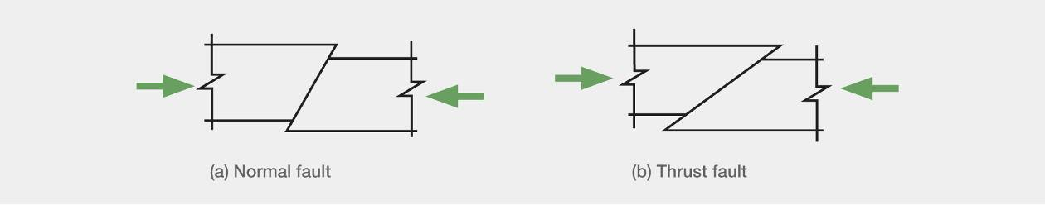
Figure 18: Normal and thrust faults
The faults in the general locality of Christchurch were initially formed more than 25 million years ago when tectonic movements were stretching the area. This caused normal faults to develop, which are steeply inclined to the horizontal, as illustrated in Figure 18(a). If these faults had been generated due to compression in the rock, they would have been less steeply inclined, as shown in Figure 18(b).
In more recent times (in geological terms) the tectonic situation changed, with the area being subjected to compression in the east south-east to west-northwest direction. This change resulted in steeply inclined faults being subjected to compression. The high pressure transmitted across these faults acted to clamp the surfaces together, increasing the friction force sustained before failure, and increasing the strain energy in the rock. The effect is much greater with the steeply inclined fault shown in Figure 18(a) than with the thrust fault shown in Figure 18(b). The steepness of the faults, the compression force that acts across the faults, and the relatively high strength of the greywacke rock underlying the area act to increase the strain energy that can be resisted near the fault.
The faults that generated the Christchurch earthquakes are in a zone of moderate to low seismicity in an area with a low strain rate, as shown in Figure 2. The faults have infrequent movement (with recurrence intervals of each of the faults in excess of 8000 years) and consequently the rock adjacent to the faults is relatively undamaged. Faults that move frequently (i.e., every few hundred years) have relatively low friction zones at the fault interface, and this reduces the shear stress that can be sustained at fracture. Consequently, these major faults often have (for the same fault area) lower levels of strain energy to release when failure occurs. This means that there is a lower intensity of shaking close to the fault.
In summary, faults that:
• are steeply inclined and subject to compression across the plane of the fault;
• generate shallow earthquakes; and
• have long return periods (fail infrequently) due to the low tectonic strain rate;
can be expected to generate high-intensity shaking in an area close to the fault.
A number of other factors that may have influenced the intensity of ground shaking observed in the February earthquake include:
• directivity;
• basin effects; and
• the interaction of deep alluvial soils with softer layers in the top 30m of the ground surface.
The influence of these factors is still being investigated in current research projects.

2.8 The New Zealand National Seismic Hazard Model
GNS Science has built and maintains a National Seismic Hazard Model (NSHM) that uses likely magnitudes and frequencies of occurrence of future significant earthquakes to estimate ground shaking levels for use in engineering design. The NSHM estimates future earthquake activity and associated ground shaking for New Zealand.
The NSHM has been developed since the early 1980s and the model as it stood in 2002 was the basis for the design spectra contained in NZS 1170.5: 2004, the current Standard covering earthquake design actions in New Zealand.²⁰ Section 3 of this Volume explains the design spectra used to assess how different building structures will respond to earthquake actions. The NSHM was significantly updated in 2010 and continues to be developed.²¹
The two main components of the NSHM are the earthquake source model and the predicted ground motions that the source earthquakes are likely to produce.
The 2002 earthquake source model has two main elements. The first, the “fault source” model, is based on over 300 fault sources that have been recognised from detailed geological and geophysical studies. The second, the “background source” model, reflects the fact that it is not practical to identify all active faults in a region because smaller faults of magnitude 7 and lower often lack any surface expression. For this reason, a model of background seismicity comprising earthquakes located at points (as opposed to faults) is used, based on the location of earthquakes occurring between 1840 and 1997 that have not been associated with the known faults.
The GNS Science report explains:
The above two source models are combined by using a regional maximum magnitude, M_{cutoff}, below which the background seismicity model is used, with some contribution from the fault model, and above which only the fault source model is used. The implication of this is that an earthquake above M_{cutoff} is considered implausible if not identified by an active fault. In the 2010 update to the NSHM (Stirling et al., 2011), the M_{cutoff} was revised to M=7.2 for all regions except the Taupo Volcanic Zone, which was assigned M_{cutoff}=6.5. The 2002 version of the model used M_{cutoff}=7.0 for Canterbury. The choice of M_{cutoff} is subjective, but ultimately comes down to understanding how complete the knowledge is of the number of active faults capable of producing earthquakes above a given magnitude. In low seismicity areas, or areas with few active faults, the choice of M_{cutoff} can have significant implications for the estimated hazard.²²
The second key component of the NSHM is a ground motion attenuation model that predicts the strength of ground shaking from future earthquakes depending on their magnitude and distance, taking into account the effect of near-surface site conditions and different types of earthquakes.
The attenuation relationship used in the NSHM is based on international models and is modified to reflect local records of earthquake ground shaking. The model also takes into account directivity effects that may occur near to major fault ruptures. In its application in NZS 1170.5, it is assumed that the estimated shaking may be enhanced in the direction perpendicular to the fault for structures with fundamental periods beyond 1.5 seconds for locations within 20km of any of the 11 major faults named in the Standard.

2.8.1 Updates to the National Seismic Hazard Model since 2002
Two major updates of the NSHM model were made after publication of the 2002 NSHM. The first was completed in 2008 and focused on the Canterbury region. It included newly identified fault sources that were mainly offshore from North Canterbury, Kaikoura and north-eastern Marlborough. In addition, all fault sources in the Canterbury region were assigned “characteristic” earthquake magnitudes derived from the length and estimated width of each fault source. These were estimates based on the new New Zealand and international scaling relationships. The background seismicity model for all New Zealand was updated to reflect the new Canterbury earthquake data gathered in the period from 1998 to mid-2006.
The second major update was completed in 2010 and included over 200 new fault sources (mainly offshore), bringing the total number to about 530. The New Zealand and international scaling equations used in the Canterbury model were applied to all faults. The Greendale Fault, the source of the September earthquake, was included in the fault source model at a late stage on the basis of a very long estimated recurrence interval. The long recurrence interval means that it has very little effect on the estimated seismic hazard for Christchurch. The background seismicity model was also updated with earthquake data from 2006 to mid-2009 and the associated modelling method was changed after an evaluation of the various methods available.²³
The GNS Science report advises that probabilistic seismic hazard maps produced from the 2010 revision of the NSHM show a similar pattern of hazard to the 2002 model on a national scale, with some significant reductions and increases in hazard in certain regions. The most significant differences seen on hazard maps and in uniform hazard spectra are:
• reductions in Auckland and Northland, which are due to the new distributed seismicity model (e.g., Auckland’s PGAs show a reduction from just over 0.1g to 0.08g for the approximately 500-year return period);
• increases in the south-east of the North Island due to the new Hikurangi subduction zone modelling (uniform hazard spectra increase at periods of 0.4 seconds and greater in Wellington);
• slight increases in Christchurch for periods lower than about 0.6 seconds due to the new distributed seismicity model; and
• slight increases for Dunedin due to the new distributed seismicity model.

2.8.2 Implications of the Canterbury earthquakes for seismic hazard levels in Canterbury
Apart from inclusion of the Greendale Fault, as discussed previously, no attempt was made to include post-September 2010 seismicity in the 2010 NSHM update. It was recognised that hazard estimates would need to be addressed separately for Canterbury. By July 2011, when GNS Science reported to the Royal Commission, it was able to advise that a new seismic model had been developed that reflected its assessment, based on the Canterbury earthquake sequence, that there would be elevated levels of seismic activity in the region, probably for a number of decades. The GNS Science report explained:
This is because shallow crustal earthquakes are always followed by numerous aftershocks, although these do decrease in frequency with time. In addition, there is a possibility that an earthquake of a size comparable to the main shock might be triggered, even if the probability of this remains low. This elevated level of hazard must be considered when reassessing the safety of existing structures and when designing new buildings and infrastructure.²⁴
The new seismic hazard model for Canterbury developed by GNS Science led to the adoption of new seismic design coefficients for Canterbury, as discussed below. Before embarking on that discussion, it will be appropriate to explain the process by which the knowledge about seismicity reflected in the NSHM is translated into the rules that govern the design of buildings.

2.8.3 Use of the National Seismic Hazard Model in earthquake design
The NSHM is used as the basis for the specification of design motions in NZS 1170.5 and in specific hazard analyses performed for major projects.
As explained in section 3 of this Volume, buildings are designed in accordance with response spectra that are used to gauge how buildings will respond to earthquake motions on different ground conditions. Under NZS 1170.5, the elastic site hazard spectrum used as a basis for structural design is defined by C(T) where T is the period of vibration, by:
C(T) = C_{h}(T) Z R N(T,D)
where
C_{h}(T) = the spectral shape factor, which depends on the type of soils;
Z = the hazard factor, a figure that varies with the seismicity of the locality;
R = the return period factor, which reflects the strength of earthquake motions with differing return periods;
N(T,D) = the near-fault factor determined from Clause 3.1.6, which applies within 20km of 11 major faults; and
D = distance from a major fault in km.
In other clauses of the Standard to which the equation refers, the numerical values given are derived from the information in the NSHM. The spectral shape factor differs according to the class of subsoil at the site of interest (Classes A to E are provided for, ranging from strong rock to very soft soil sites). The soil-type classification reflects broad categories of soils that have differing characteristics and depths.
Hazard factors (Z), taken from a contour plot of seismicity and values for particular cities and towns, are stated in a table set out in the Standard. The values range from 0.13 (the lowest hazard) to 0.6 (the highest). This is a mapped quantity, derived directly from the NSHM, corresponding to half the 0.5 second value of the “magnitude-weighted” shallow soil spectrum for a return period of 500 years.²⁵ The Z value of 0.13, applicable in low-seismicity regions such as Northland, Auckland and Dunedin, is a minimum allowable value under the method used and corresponds to stronger earthquake motions than those with a return period of 500 years in those locations. The minimum Z value corresponds to two thirds of the 84th percentile motions from a magnitude 6.5 earthquake at a distance of 20km.
The return period is derived from a table that sets out a numerical value for the required annual probability of exceedence for the “limit state” under consideration, as explained further in section 3 of this Volume. There is a range of return periods provided for: in the case of commercial buildings of normal importance, the design earthquake for the Ultimate Limit State is assumed to have a return period of 500 years. Other buildings judged to be of a high level of importance are designed for earthquakes that have return periods of either 1000 or 2500 years.
The near fault factor is based on the distance of the site under consideration from 11 major faults listed in the Standard.
It should also be noted that while NZS 1170.5 deals comprehensively with horizontal earthquake motions, a simpler approach is taken with vertical motions. These are generally taken to be 0.7 times the horizontal spectrum at the same location. The commentary to NZS 1170.5 notes, however, that at locations where the seismic hazard is dominated by a fault closer than 10km, it will be more appropriate to assume that the vertical spectrum is the same as the horizontal spectrum for periods of 0.3 seconds and lower. GNS Science states that the observations in the commentary have been borne out by the nature of some of the vertical spectra in Christchurch, although before the February 2011 earthquake there was no suggestion that the seismic hazard for Christchurch was dominated by nearby faults. In the Royal Commission’s opinion, the provisions of the Standard relating to vertical accelerations need to be reassessed in view of the spectral shapes and magnitudes derived from the recorded ground motions in the Canterbury earthquakes.

2.8.4 Modifications to seismic hazard modelling for Christchurch
GNS Science has advised that the level of seismic hazard in Christchurch is currently higher than the long-term average and that this will continue to be the case for several decades, because of the likely continuation of aftershocks. Although the aftershocks will decrease in frequency with the passage of time, there is also a possibility that an earthquake of an intensity comparable to the main September earthquake will be triggered.
GNS Science has developed a new seismic hazard model for Canterbury to reflect this increased level of hazard. The model takes into account an assessment of likely rates of aftershocks, the small possibility that larger earthquakes may be triggered and, as with previous models, the normal background seismicity and expectation that large earthquakes will rupture on known faults in the Canterbury region. The model relates to the 50-year period from March 2011.²⁶ This model was developed using the short-term earthquake probability (STEP) model, which attempts to forecast the short-term behaviour of aftershocks by estimating future rates of earthquakes of various sizes and their spatial distribution.²⁷ GNS Science has also used the “Every Earthquake a Precursor According to Scale” (EEPAS) model, in which every new earthquake slightly increases the probabilities of future higher-magnitude earthquakes, as well as other models to develop the new approach.²⁸ The Z factor, which was prescribed in NZS 1170.5 at 0.22, was subsequently raised to 0.3 with a corresponding increase in the return factor R for the serviceability limit state from 0.25 to 0.33.
In November 2011, GNS Science convened an expert panel to further update the seismic hazard model for Canterbury. This update considered recent scientific understanding of the earthquake sequence and responded to the GNS Science evidence to the Royal Commission. The 12-person panel was made up of international and New Zealand-based scientists across a range of fields related to seismic hazard assessment. After presentations on various aspects of the hazard modelling for the Christchurch region, each panel member responded to 50 questions relating to the modelling. The process led to recommendations for weighted combinations of multiple seismicity models for each of the short-term, mid-term and long-term components of the model. Similar weightings were elicited for other aspects of the hazard modelling (e.g. source depth, minimum magnitude, stress-drop modification and epistemic variability in the ground-motion prediction equations (GMPEs)).
A second five-person expert panel workshop convened in March 2012 to decide on the weightings that should be accorded to two New Zealand-specific GMPEs – that of McVerry, which had been used previously, and that of Bradley²⁹. Bradley and Cubrinovski showed that the Bradley model, developed before the Canterbury earthquakes, provided a good match for the short-period motions (peak ground acceleration and 0.2s spectral acceleration) recorded in the September and February earthquakes at all distances, and for 1.0s spectral accelerations, except for under-predicting a few sites at source-to-site distances of less than 10km.³⁰
This process addressed several issues raised by the reviewers of GNS Science’s evidence to the Royal Commission by:
• allowing for the variation between different GMPEs (epistemic uncertainty) by increasing the variance of the McVerry model and adding the Bradley model as a second GMPE that has been evaluated against New Zealand data;
• allowing for different values (5.0, 5.25 and 5.5) of the minimum magnitude to be included in the hazard analysis;
• allowing for different values of the maximum magnitudes (7.2, 7.5 and 8.0) to be included for the distributed-seismicity component of the seismicity modelling;
• adopting a distribution of focal depths from 1–30km and considering finite-source effects by placing the upper limit of the rupturing fault plane at a magnitude-dependent distance above the focus; and
• considering estimates with and without stress-drop modifications.
Directivity effects have not yet been incorporated and GNS Science advises that they will not be until the importance of directivity has been demonstrated through further research.
Revised seismicity rates from the “Expert Elicitation” model have recently been released and incorporate seismicity up to early January 2012. The short-term values are about two-thirds those estimated in June 2011, while the long-term values are about one third of the earlier estimates (see Figure 19). These were incorporated, along with the other changes to hazard modelling (including the addition of the Bradley GMPE), in late March 2012. The percentage changes in the ground motions are lower than those in the seismicity rates.
We understand that GNS Science has provided the Department of Building and Housing (DBH) with estimates of deep soil peak ground accelerations for use in liquefaction assessment that are slightly lower than those used previously: 0.13g instead of 0.15g for an average annual exceedance rate of 1/25. Updates of the peak ground accelerations estimated for shallow soil sites in the Port Hills, and of acceleration response spectra for the CBD and elsewhere, are expected to be available shortly.
The reduced earthquake activity estimates from the expert elicitation process may lead to a different hazard factor, Z, compared to the 0.3 value that currently applies. This issue is the subject of ongoing consideration as we write.
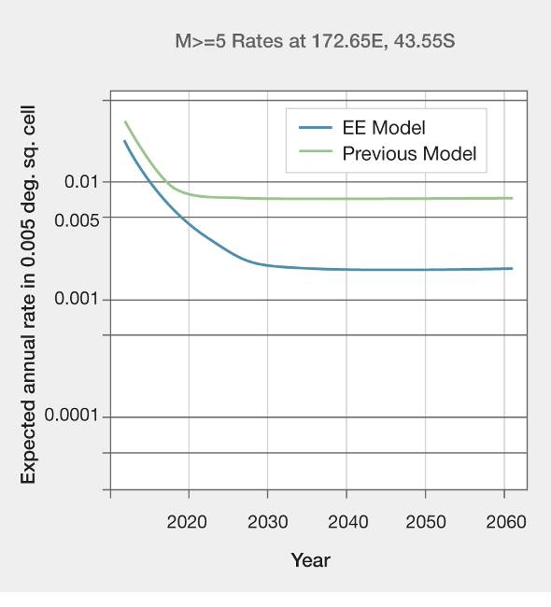
Figure 19: The reduction in estimated seismicity rates from the June 2011 model (upper curve) to the current model (lower curve) (source: Email from GNS Science to the Royal Commission, 24 April 2012)³¹

2.8.5 Magnitude weighting
The duration of strong ground shaking influences the extent of the damage that occurs in an earthquake. A major factor influencing the duration is the length of the fault and this is reflected in the magnitude (M_{w}) of the earthquake. To make allowance for the duration of shaking from different potential earthquakes, a magnitude weighting factor can be used to assess the contribution of each potential earthquake considered in developing the design response spectrum. The magnitude weighting factor takes the form of the expression
(M_{w}/7.5)^{x}, where x can take different values for different types of application.
The design response spectra in NZS 1170.5 were developed using a magnitude weighting factor for the period range of 0 to 0.5 seconds, with a value of x = 1.285. Above 0.5 seconds the factor was not applied.
We understand that for the proposed design spectra for Christchurch, magnitude weighting factors are to be applied to the full period range. We agree that this is logical. Different values of x are to be used for structural design (1.285), for liquefaction (2.5) and for rock fall (1). We understand that the 2.5 value comes from recent research and that for rockfall the critical value is the peak acceleration and hence a value of 1 is logical. However, the value of 1.285 appears to come from a previous liquefaction study³² and following limited consideration it was assumed it could be applied to ductile structures.³³ We recommend that research be undertaken to provide a more logical basis for the weighting magnification factor for structures. In the meantime the value of x should be taken as 1.285.
Allowance should be made for the magnitude weighting factor for the purpose of comparing an earthquake with a design spectrum. The February earthquake had a magnitude, M_{w}, of 6.2 and the corresponding magnitude weighting factor is (^{6.2}/_{7.5})^{1.285} = 0.78. To compare this spectrum calculated from the recorded ground motion with a design spectrum it should be multiplied by 0.78. Figure 20 illustrates the effect that this modification has on a comparison with the design spectrum for Christchurch on type D soils with a seismic hazard factor of 0.22. The earthquake response spectrum shown in the figure was calculated from the averaged ground motions at the four sites in the CBD for the east–west motion.

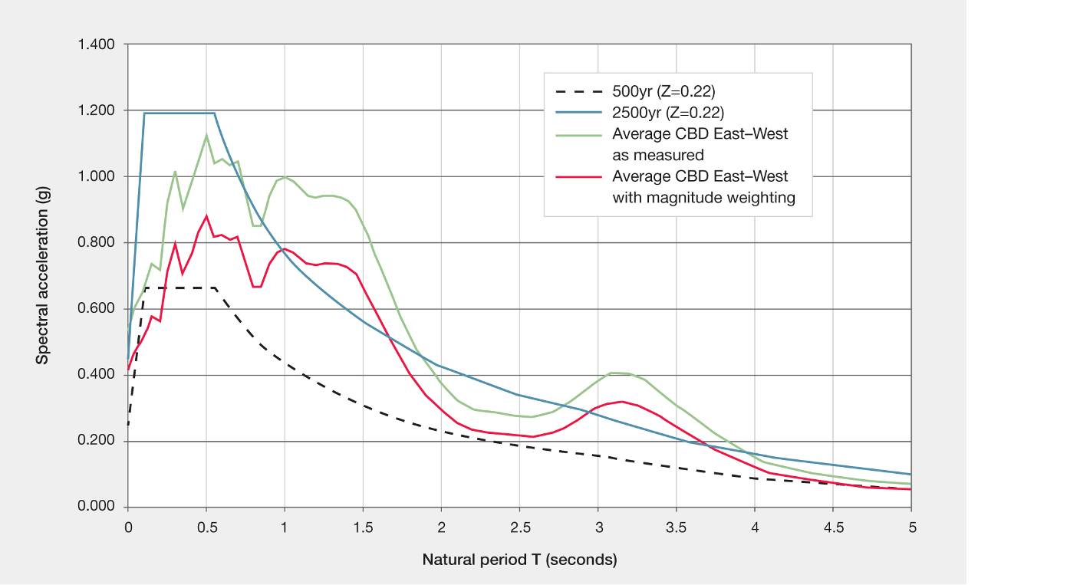
Figure 20: Influence of the magnitude weighting on average east–west spectra values for the 22 February 2011 earthquake
2.9 Conclusions
For the reasons addressed at the outset of this section, it was necessary for us to understand the nature and severity of the Canterbury earthquakes and also to understand the nature of the earthquake risk that affects the country as a whole.
Uncertainty is inherent in the prediction of earthquakes, particularly in terms of the locations, magnitude and timing of events. There is growing knowledge about the number of active faults in New Zealand, but it is difficult to locate some of them in advance where there is no history of rupture with surface expression. This is a particular problem in the Canterbury region because of the nature of the subsurface conditions.
Although we are not required by the Terms of Reference to make recommendations on the subject of seismicity, we do recommend that research continues into the location of active faults near Christchurch and other population centres in New Zealand. While it will not be possible to build a picture that is complete, we consider that there is obvious merit in developing the knowledge of active faults whose rupture might impact on our cities and major towns.
The September earthquake was a significant event in New Zealand terms and has triggered an ongoing sequence of aftershocks. The return periods of the September and February earthquakes have been estimated as at least 8000 years. The shaking that was produced by the September earthquake was, with some qualifications, generally comparable with that anticipated for a design earthquake with a return period of 500 years in the current Earthquake Actions Standard (NZS 1170.5) that is used for building design purposes. The shaking produced by the February earthquake was much more intense than envisaged by NZS 1170.5 for the ultimate limit state. The contrast between the September and February earthquakes is such as to question assumptions that might otherwise have continued to be made that an aftershock will be less damaging than the earthquake that triggered it. The February earthquake was the result of a rupture on a different fault, closer to the Christchurch CBD. As a consequence its effects on the city were much more pronounced. Further, the predominant direction of the shaking meant that buildings were tested from a different direction to that which applied in September.
We consider that the country can have confidence in the degree of knowledge and understanding of the seismicity of New Zealand possessed by GNS Science and in the manner in which the knowledge of earthquake risk is reflected in the ongoing development of the building Standards. The response to the Canterbury earthquakes has included the gathering of further knowledge about the number and location of active faults in the Canterbury region and those efforts should continue. In addition, GNS Science has responded in a measured way to suggestions made in the reviews of the GNS Science report and in the evidence of Adjunct Professor Abrahamson. Refinements to the NSHM are being made. These will result in appropriate adjustments being made to the relevant building design standards. This is not a subject we can advance by this Report. It is a matter for ongoing research and consideration. However, in our view, confidence is justified in the processes being followed.
Over the last 160 years Christchurch has been subjected to a number of earthquakes. The majority of these were generated on faults to the north of Canterbury or in the mountains to the west. There have been a few earthquakes from local faults but none anywhere near as intense as the earthquake sequence that started in September 2010.
Finally, we repeat our view that the provisions of NZS 1170.5 relating to vertical accelerations need review and that research should be undertaken to give a firmer analytical basis to magnitude weighting used in developing the response spectra for structural design.
Recommendations
We recommend that:
1. Research continues into the location of active faults near Christchurch and other population centres in New Zealand, to build as complete a picture as possible for cities and major towns.
2. The provisions of the Earthquake Actions Standard, NZS 1170.5, relating to vertical accelerations be reviewed. (See also recommendations 33 and 34 in Volume 2 of this Report.)

Annex 1: Tectonic structure of the Canterbury region
Much of the Canterbury region is located within the wide zone of active earth deformation associated with the oblique collision between the Australian and Pacific tectonic plates east of the Alpine Fault (see Figure 21).
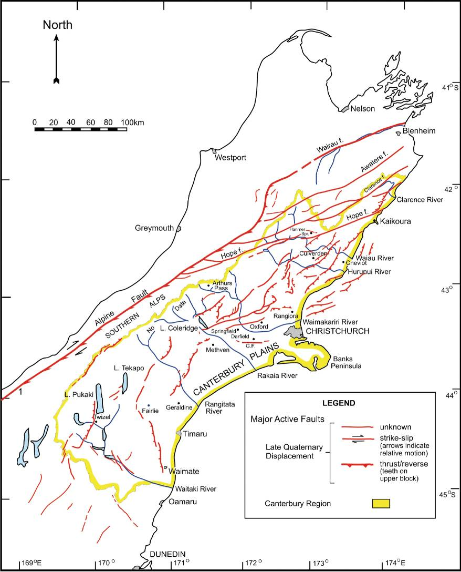
Figure 21: Map of the known active faults in the Canterbury region (source: GNS Science report 2011/183, July 2011, modified from Pettinga et. al. (1998))
The present-day tectonic tempo of active earth deformation is greatest along the narrow zone adjacent to the Alpine Fault, and where the plate boundary zone transfers across the South Island, through the Marlborough and North Canterbury regions to link with the offshore trench and subduction zone from near Kaikoura northward. In the North Canterbury region, the southward transition from subduction to continental collision is associated with tectonic shortening, crustal thickening and uplift. Landforms reflect the ongoing nature of this active earth deformation, and also show that the Australia-Pacific Plate boundary zone deformation has progressively widened here, and continues to do so, during the Quaternary (~ last 1-2 million years). East of the main divide of the Southern Alps, in central and south Canterbury, the tempo of tectonic deformation progressively diminishes to the east and south-east.
The upper crustal geological structure of the north Canterbury region is dominated by north-east trending active faults and folds that accommodate the transfer of relative plate motion between the Hikurangi Trough and the Alpine Fault and the Southern Alps to the south-west. For the central and south Canterbury region, structures are generally more northerly in trend and are forming in response to the continent to continent collision zone of the eastern side of the deformation wedge to the Southern Alps.
The regions in and around Canterbury can be divided into eight distinct structural domains in which individual active faults are fundamentally related in terms of their tectonic setting, style, geometry and rates of deformation with respect to the plate boundary zone. These domains are set out in Figure 22.
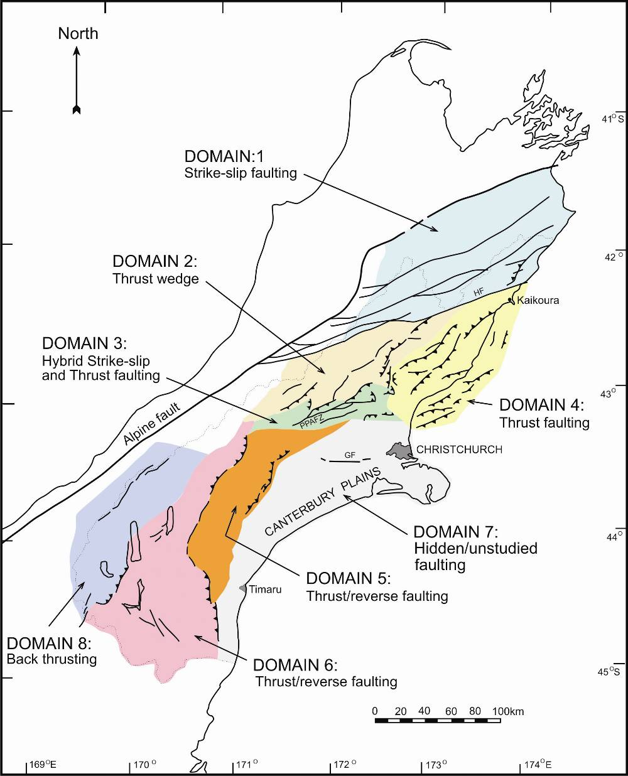

Figure 22: Summary map of structural domains 1–8 for the Canterbury region (source: GNS Science report 2011/183, July 2011, modified from Pettinga et al. (1998)
The eight domains are:
• Domain 1 – Marlborough Fault Zone: A major system of north-eastern-trending strike-slip faults including the Hope, Clarence, Awatere and Wairau Faults, which near their south-western and north-eastern terminations splay and form into oblique thrust faults. Along the Kaikoura coast, both north and south of the Hope Fault, thrust faults, dipping mainly due west, serve to dissipate motion on this fault and accommodate crustal shortening associated with subduction of oceanic crust of the Pacific Plate.
• Domain 2 – West Culverden Fault Zone: A west- dipping system of thrusts and/or reverse faults and fault-related folds are mapped to the west of Culverden Basin. This range-front system of faults represents the eastern margin of the wedge-shaped Southern Alps foothills forming this structural domain in North Canterbury.
• Domain 3 – Porters Pass-Amberley Fault Zone: The Southern Alps foothills, and range front along the north-western margin of the Canterbury plains, are evolving in response to a hybrid system of interconnected east-northeast-trending strike-slip faults, and linking oblique thrusts and/or reverse faults with associated fault-related folds. The Porters Pass-Amberley Fault Zone is a juvenile fault system reflecting the latest phase of plate boundary zone widening in the late Pleistocene (0.5 to ~1 million years).
• Domain 4 – North Canterbury Fold and Fault Belt: Southwest from Kaikoura, thrust faults extend through the north-eastern part of the onshore Canterbury region, and offshore across the continental shelf and slope. The thrusts are evolving in response to oblique plate convergence and the transition to continent to continent collision west of the Chatham Rise. Thrust faults are typically associated with strongly asymmetric folds involving greywacke basement and Tertiary cover rocks, and are expressed as topographic ridges separated by fault-related synclinal valleys floored by Quaternary alluvium and Tertiary formations. These north-eastern-striking thrusts extend to within five kilometres of the Hope Fault, implying that major right-lateral shear associated with the transfer of plate motion across the northern South Island is mainly restricted to the Hope Fault and other faults of the Marlborough Fault System. Further south, the east-dipping thrusts extend west to the foot of the main ranges, along the north margin of the Canterbury plains and south-western end of Culverden basin.
• Domain 5 – Mt Hutt-Mt Peel Fault Zone: The active earth deformation forming the Southern Alps and eastern foothills is driven by the continent to continent plate collision across the central South Island. The eastern range front is characterised by active thrust faulting forming a complex segmented array of faults, folds and associated ground warping along the western margin of the Canterbury plains from near Mt Hutt to south of Mt Peel.
• Domain 6 – South Canterbury Zone: Further south, the margin of the Southern Alps is again defined by a number of thrust faults east of the Mackenzie Basin and south of the Rangitata River. Major fault zones are mapped along the eastern range front of the Hunter Hills, and the Fox Peak Fault Zone defines the boundary between Domains 5 and 6.
• Domain 7 – Canterbury Plains Zone: Active earth deformation, mostly obscured beneath the Quaternary alluvium of the Canterbury plains is indicated by earthquake activity. The 4 September 2010 right-lateral-slip Greendale Fault surface rupture associated with the M7.1 September earthquake is one such structure. This was further reinforced by the subsurface ruptures associated with the 22 February and 13 June 2011 earthquakes, both on previously unrecognised buried faults in the subsurface beneath Christchurch and surrounds. The Canterbury plains region thus needs to be a target for future research to locate and document other hidden faults capable of generating moderate to large earthquakes in the region.
• Domain 8 – Southern Alps Zone: Major active faults located in the area east of the main divide in central South Island include the Ostler Thrust Fault Zone and the Main Divide Fault Zone. Deformation is accommodated on numerous oblique reverse/thrust faults, and is reflected by the crustal uplift within the Southern Alps.

References:
1. Webb, T.H. (compiler). (July 2011). The Canterbury Earthquake Sequence and Implications for Seismic Design Levels. GNS Science Consultancy Report 2011/183. Christchurch, New Zealand: Canterbury Earthquakes Royal Commission.
2. Messrs Webb, McVerry and Berryman of GNS Science, and Professor Pettinga of the University of Canterbury.
3. GNS Science Consultancy Report 2011/183. (July 2011).
4. Cox, S., & Southerland, R. (2007). Regional geological framework of South Island, New Zealand, and its significance for understanding the active plate boundary. In Okaya, D., Stern, T., & Davey, F. (Eds.), A Continental Plate Boundary: Tectonics at South Island, New Zealand. American Geophysical Union Geophysical Monograph series 175: 19-46; And Pettinga, J.R., Yetton, M.D., Van Dissen, R.J., Downes, G.L. (2001) Earthquake Source Identification and Characterisation for the Canterbury Region, South Island, New Zealand. Bulletin of the NZ Society for Earthquake Engineering, 34(4): 282-317; And Wallace, L.M., Beavan, R.J., McCaffrey, R., Berryman, K.R., Denys, P. (2007) Balancing the Plate Motion Budgets in the South Island, New Zealand using GPS, geological and seismological data. Geophysical Journal International, 168 (1): 332-352.
5. Wallace L.M., et al. (2007). Balancing the plate motion budget in the South Island, New Zealand using GPS, geological and seismological data. Geophysical Journal International, 168(1): 332-352.
6. GNS Science Consultancy Report 2011/183. (July 2011).
7. Pettinga, J.R., et al. (2001).
8. GNS Science Consultancy Report 2011/183. (July 2011)
9. The description uses the terminology earlier set out to define the nature of the faults.
10. The GNS Science Consultancy Report 2011/183 (July 2011) defines an active fault as one that is likely to move within a period of concern to society, and states that a fault is considered to be active in the Canterbury region if it has moved in the last 125,000 years.
11. GNS Science Consultancy Report 2011/183. (July 2011).
12. GeoNet is a project funded by the Earthquake Commission (EQC) in which geophysical data is collected from field instruments and third party sources, and subsequently processed and maintained in archives. The information about earthquakes is derived from a countrywide network of seismic stations that transmit their data to the GeoNet Management Centre where it is analysed by automated processes. The seismic stations operated by GeoNet consist of a seismometer and a seismograph. The former generates a small electrical current in response to ground shaking, which is digitised by the seismograph and transmitted continuously to the data management centre in real time. This information is used to locate the earthquakes. There is also a network of strong-motion seismographs, which only transmit data whenever they detect a higher level of shaking. The GeoNet website has been frequently referred to by members of the public in Canterbury after 4 September 2010. It has enabled them to check their own estimates of the strength of the latest aftershock against what the instruments are reporting.
13. GNS Science Consultancy Report 2011/183. (July 2011)
14. Bradley, B. (January 2012). Ground Motion and Seismicity Aspects of the 4 September 2010 Darfield and 22 February 2011 Christchurch Earthquakes: Technical paper prepared for the Canterbury Earthquakes Royal Commission. Christchurch, New Zealand: Canterbury Earthquakes Royal Commission.
15. Villamor P., Barrell, D., Litchfield, N., Van Dissen, R., Hornblow, S., and Levick, S. (2011). Greendale Fault investigation of surface rupture characteristics for fault avoidance zonation. GNS Science Consultancy Report 2011/121. Lower Hutt, New Zealand: GNS Science.
16. These are the CHHC (Christchurch Hospital), CCCC (Christchurch Catholic Cathedral College), CBGS (Christchurch Botanic Gardens) and REHS (Christchurch Resthaven) sites.
17. Sutherland, R., Eberhart-Phillips, D., Harris, R.A., Stern, T.A., Beavan, R.J., Ellis, S.M., Henrys, S.A., Cox, S.C., Norris, R.J., Berryman, K.R., Townend, J., Bannister, S.C., Pettinga, J., Leitner, B., Wallace, L.M., Little, T.A., Cooper, A.F., Yetton, M., Stirling, M.W. (2007). Do great earthquakes occur on the Alpine Fault in central South Island, New Zealand? In Okaya, D., Stern, T., & Davey, F. (Eds.), A Continental Plate Boundary: Tectonics at South Island, New Zealand. American Geophysical Union Geophysical Monograph series 175: 235-251.
18. Letter from Terry Webb, Anna Kaiser and Stephen Bannister, GNS Science, to Justine Gilliland, Executive Director, the Royal Commission, 2 April 2012. Letter Report No. CR 2012/94 LR.
19. Engdahl, E.R., & Villaseñor, A. (2002). Global Seismicity: 1900–1999. In Lee, W.H.K., Kanamori, H., Jennings, P.C., & Kisslinger, C. (Eds). International Handbook of Earthquake and Engineering Seismology (pp. 665–690). United States: Academic Press.
20. NZS 1170.5:2004. Structural Design Actions Part 5 – Earthquake Actions-New Zealand. Standards New Zealand.
21. Stirling, M.W., McVerry, G.H., Gerstenberger, M., Litchfield, N.J., Van Dissen, R., Berryman, K.R., Langridge, R.M., Nicol, A., Smith, W.D., Villamor, P., Wallace, L., Clark, K., Reyners, M., Barnes, P., Lamarche, G., Nodder, S., Pettinga, J., Bradley, B., Buxton, R., Rhoades, D. and Jacobs, K. (2011). National Seismic Hazard Model for New Zealand:2010 Update. Bulletin of the Seismological Society of America (submitted).
22. GNS Science Consultancy Report 2011/183. (July 2011)
23. Stirling, M. W., et al. (2011).
24. GNS Science Consultancy Report 2011/183. (July 2011).
25. The GNS Science report contained an explanation of ‘magnitude weighting’, which we set out in section 2.8.5.
26. The model is explained in Gerstenberger, M.C., Rhoades, D.A., Berryman, K., McVerry, G.H., Stirling, M.W., and Webb, T. (2011). Update of the Z-factor for Christchurch considering earthquake clustering following the Darfield earthquake. GNS Science Report 2011/29. Lower Hutt, Wellington: GNS Science.
27. Gerstenberger, M., Weimer, S., Jones, L. M. and Reasenberg, P., A. (2005). Real-time forecasts of tomorrow’s earthquakes in California. Nature, 435:328-331.
28. Rhoades, D.A., & Evison, F.F. (2004). Long-range earthquake forecasting with every earthquake a precursor according to scale. Pure and applied geophysics, 161(1): 47-72.
29. Bradley, B.A. (2010). New Zealand-specific pseudo-spectral acceleration ground motion prediction equations based on foreign models. Report No. 2010-13. Department of Civil and Natural Resources Engineering. Christchurch, New Zealand: University of Canterbury; And McVerry, G.H, Zhao, J.X., Abrahamson, N.A., Somerville, P.G. (2006). New Zealand acceleration response spectrum attenuation relations for crustal and subduction zone earthquakes. Bulletin of the New Zealand National Society for Earthquake Engineering, 39(1): 1-58.
30. Bradley, B.A. and Cubrinovski, M. (2011). Near-source strong ground motions observed in the 22 February 2011 Christchurch earthquake. Bulletin of the New Zealand Society for Earthquake Engineering, 44(4): 181-194.
31. Email from T. Webb, GNS Science to Linda Gibb, Senior Analyst, Royal Commission, 24 April 2012.
32. Seed, H.B. and Idris, I.M. (1982). Ground motions and soil liquefaction during earthquakes. Monograph MNO-5. Oakland, California, United States of America: Earthquake Engineering Research Institute. And Idriss, I.M. (1985). Evaluating seismic risk in engineering practice. Proceedings of the 11th International Conference of Soil Mechanics and Foundation Engineering, 1:255-320.
33. Kennedy, R.P., Short, S.A., Merz, K.L., Tokarz, F.F., Idriss, I.M., Power, M.S. and Sadigh, K. (1984). Engineering characterization of ground motion. Report by Structural Mechanics Associates, Inc. and Woodward-Clyde Consultants to the US Nuclear Regulatory Commission. NUREG/CR-3805.

