2.6 Earthquakes

2.6.1 Earthquake magnitude
The magnitude of earthquakes has been described by various magnitude scales, of which the most well known is the Richter scale. Other earthquake magnitude scales are calculated after more sophisticated data processing and analysis.
The Richter magnitude (in modified form) is the magnitude often initially reported by GNS Science on the GeoNet website (www.geonet.org.nz) because it can be quickly ascertained using nearby seismographs. This is referred to as the M_{L} magnitude in the following extract from the GNS Science report, which also describes the other magnitude measures frequently used.
Earthquake magnitude
M_{L} (‘Richter’ magnitude) is the initial magnitude assigned to an earthquake with routine GeoNet processing. The GeoNet M_{L} is a modification of the original magnitude scale defined by C.F. Richter in 1935. M_{L} is derived from measurements of the peak amplitude on seismographs and is thus a preliminary estimate of the amount of energy released by the earthquake. It is measured on a logarithmic scale, so each magnitude increment of one represents an order of magnitude increase in the measured amplitude or about 30 times more energy released.
M_{w} (Moment magnitude) is a measure of the final displacement of a fault after an earthquake. It is proportional to the average slip on the fault times the fault area. M_{w} is more complicated to determine than M_{L}, but is much more accurate, although the standard methods used to determine it are valid only for larger earthquakes (~M_{w}>4.0). M_{w} is a rough proxy for the amount of low-frequency energy radiated by an earthquake and is commonly used worldwide to characterise large earthquakes.
M_{e} (Energy magnitude) is a measure of the amount of energy released in an earthquake so it is very useful for determining an earthquake’s potential for damage. M_{e} is determined from the amplitude of all frequencies of seismic waves as measured on seismographs (as opposed to just the peak amplitude for M_{L}) and thus contains more information about the overall energy released in an earthquake and hence its destructive power. Two earthquakes with identical M_{w} (i.e., identical fault area times average slip) can have differing M_{e} if the strength of the faults that ruptured is different. Earthquakes on strong faults have relatively high M_{e}, whereas those on weak faults have relatively low M_{e}.
Modified Mercalli Intensity scale is a measure of how ground shaking from an earthquake is perceived by people and how it affects the built environment at a particular location. In any given large earthquake, the Mercalli Intensity will depend on the location of the observer and will usually be greatest nearer to the earthquake’s hypocentre. This information is complementary to “static” magnitude estimations (M_{L}, M_{w}, M_{e}) that describe the earthquake source rather than the ground shaking experienced.¹³
Thus, ground shaking as described by Modified Mercalli Intensities is derived from the initial ground acceleration values, felt reports and observed damage.

2.6.2 Accelerations
Earthquakes give rise to violent ground motions, which can be measured in terms of their acceleration. Forces generated by earthquake motions are the product of the mass of an object subject to the earthquake and the acceleration to which it is subject. The generally accepted measure for acceleration is to refer to the acceleration produced by the action of gravity. The convention is to use ‘g’ as the constant for the acceleration due to gravity. Hence accelerations are shown as a proportion of g (9.81m/s²).

2.6.3 Historic earthquakes in New Zealand
Given the tectonic setting outlined above, it is not surprising that New Zealand has a long history of earthquakes, ranging from insignificant minor tremors to violent ground movements. Where the latter have coincided with centres of population, they have caused major damage and significant fatalities.
Figure 7 shows the distribution of earthquakes with a magnitude of 6.5 or greater since 1840 to June 2011.
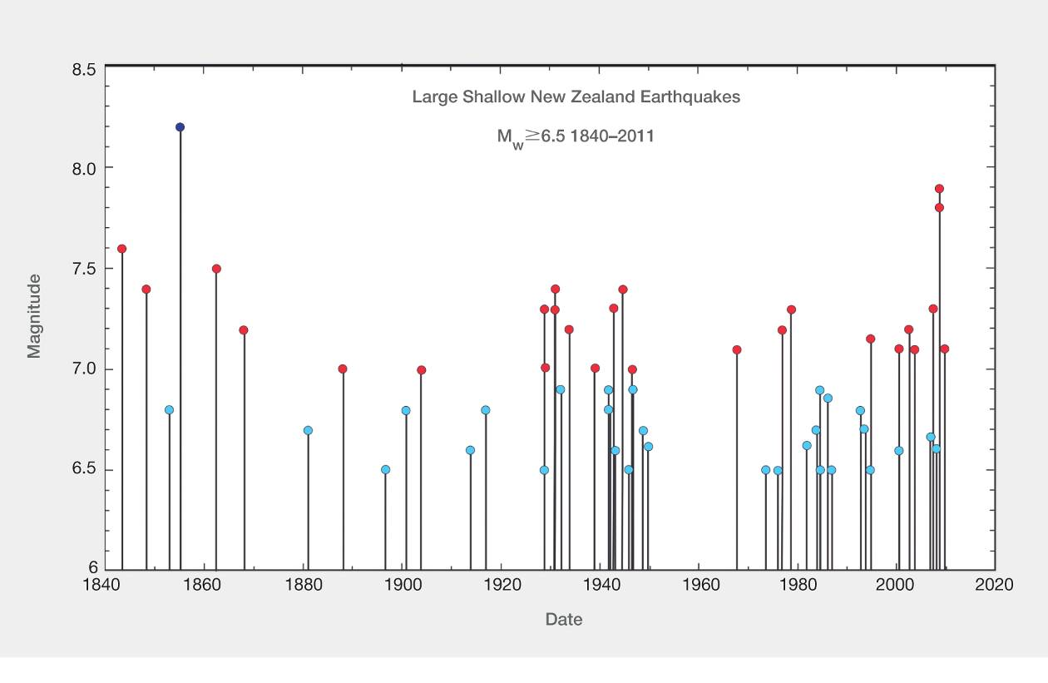

Figure 7: Large shallow New Zealand earthquakes (magnitude 6.5 or greater) (source: GNS Science Consultancy Report 2011/183, July 2011)
The February 2011 earthquake is not represented here, because its magnitude was less than M_{w} 6.5. Some of the large earthquakes occurred too far offshore to cause any damage on land.
Most of these earthquakes pre-dated modern methods of measurement so the magnitudes of the earthquakes is a matter of inference from physical evidence and eyewitness observations. There are accounts of large earthquakes in Ma-ori oral tradition and between 1840 and 1904 there were at least seven earthquakes of magnitude 7 or greater. New Zealand’s most powerful earthquake remains the Wairarapa earthquake of 1855, which had an estimated magnitude of 8.2. There was a relatively quiet period between 1905 and 1928. However, between 1929 and 1942 there was a substantial increase in earthquake activity and, in the three-year period from 1929 to 1931, there were five magnitude 7 earthquakes. These included the Buller (or Murchison) earthquake on 16 June 1929, which resulted in 17 deaths, and the Napier earthquake on 3 February 1931, in which 256 people lost their lives.
The latter half of the twentieth century was comparatively quiet with only a few large-magnitude earthquakes and most were too far offshore to cause much damage. An exception was the magnitude 7 earthquake that struck Inangahua on 24 May 1968, which resulted in three deaths and caused significant property damage.
Since 2000, however, there has been an increase in the number of earthquakes of magnitude 7 or more, although until September 2010 these had all occurred away from population centres, with several in Fiordland.

2.6.4 Previous earthquakes in Canterbury
The GNS Science report notes that since organised European settlement of the Canterbury plains began in the mid-nineteenth century, Christchurch has experienced earthquakes causing intermittent damage. Until the present earthquake sequence commenced, most of the damaging earthquakes had occurred as a result of ruptures on more distant faults. However, the two earliest damaging earthquakes, which occurred in 1869 and 1870, had epicentres in the region.
The earthquake of 5 June 1869 was centred beneath the city, probably around the Addington–Spreydon area and is thought to have had a magnitude of 4.7–4.9. The earthquake was shallow, damaging buildings in the CBD and in areas now referred to as Avonside, Linwood, Fendalton and Papanui. Many chimneys fell and there was minor damage to some stone buildings, including the tower of St John’s Church in Latimer Square.
On 31 August 1870 an earthquake with an estimated magnitude of 5.6–5.8 occurred. The earthquake was shallow and had an epicentre near Lake Ellesmere to the south-west of Banks Peninsula. It was felt over a larger area than the 1869 earthquake and caused damage to brick buildings in Temuka. Damage in Christchurch was minor, with fallen chimneys and minor structural damage occurring to a few buildings. The shaking was felt strongly in Lyttelton and Akaroa, and rocks fell from cliffs around Lyttelton Harbour.
The other notable earthquakes in Canterbury occurred as a result of ruptures on faults more distant from Christchurch. They included:
• an earthquake on 5 December 1881 centred in the Torlesse Range–Castle Hill area. It had an estimated magnitude of 6 and caused minor damage to stone and brick buildings in Christchurch. Some parts of the stonework on the spire of Christ Church Cathedral fell during this earthquake;
• an earthquake on 1 September 1888 centred in the Amuri District in North Canterbury. The earthquake had an estimated magnitude of 7.0–7.3. This was a rupture of the Hope Fault, one of the first documented examples in the world of horizontal ground movement along a fault in an earthquake. There was extensive building damage, landslides and liquefaction of river terrace sediments in the Amuri District. In Christchurch, the cathedral lost the top eight metres of its stone spire. There was some damage to other stone buildings and chimneys and minor rock falls occurred around Lyttelton Harbour;
• an earthquake on 16 November 1901 with an estimated magnitude of 6.8 was centred near Cheviot. Most brick and sod buildings in Cheviot collapsed. There were many broken windows in Christchurch buildings, cracked stonework and toppled chimneys. Once again, the spire on Christ Church Cathedral was damaged and lost its top metre and a half. In the town of Kaiapoi, liquefaction affected two or three blocks of the town;
• an earthquake on Christmas Day 1922 with a magnitude of 6.4 and an epicentre near Motunau. Chimneys on buildings between Cheviot and Christchurch were damaged and there was other minor structural damage. On this occasion, the large stone cross on Christ Church Cathedral fell to the ground, breaking some of the slate roof tiles. There is evidence that there was liquefaction at Waikuku and Leithfield beaches;
• a magnitude 7 earthquake on 9 March 1929 occurred along the Poulter Fault in Arthur’s Pass National Park. It resulted in many landslides and the closure of the highway to the West Coast for several months. There was only minor damage in Christchurch, including damage to the northern wall and oriel window of the Provincial Council Chambers;
• a magnitude 7.3 earthquake on 16 June 1929 was centred near Murchison (called the Buller or Murchison earthquake). Damage experienced in Christchurch was minor, affecting a few chimneys and windows; and
• a magnitude 5.2 earthquake on 9 March 1987 was centred in Pegasus Bay about 50km north-east of New Brighton. Some chimneys in North Canterbury were damaged and there was cracked paving in the New Brighton area.

2.7 The Canterbury earthquakes
The Royal Commission’s Terms of Reference define the “Canterbury earthquakes” as follows:
Canterbury earthquakes means any earthquakes or aftershocks in the Canterbury region—
(a) on or after 4 September 2010; and
(b) before or on 22 February 2011.
In our Interim Report, we also dealt with the significant aftershock that occurred on 13 June 2011, which had been addressed in the GNS Science report. It was appropriate to do so (notwithstanding the definition in the Terms of Reference) as the event of 13 June was clearly an important part of the ongoing sequence of aftershocks; we have power under clause (e) of the Terms of Reference to consider “any other matters arising out of, or relating to, the foregoing” that come to our notice and that we consider should be investigated. On the same basis, we have considered the aftershock that occurred on 23 December 2011 and have sought and obtained further advice from GNS Science about that event.
The discussion that follows was largely based on the advice we received in the GNS Science report and from the experts (including Adjunct Professor Abrahamson) who gave evidence at the hearing.

2.7.1 The nature of the Canterbury earthquakes
Before discussing the individual earthquakes in the sequence, we give this introductory overview.
The key aspects of the major events in the sequence are given in Table 1 and set out in section 2.7.1.6 of this Volume. A series of aftershocks accompanied each major event.
The initial earthquake on 4 September 2010 had a magnitude of 7.1M_{w}. The next significant earthquake occurred on Boxing Day 2010. This was significant because, although its magnitude was significantly lower, at 4.7M_{w}, its epicentre was within the CBD and because of its shallow depth it caused some local structural damage. A major aftershock followed some five and a half months after the September earthquake, on 22 February 2011, when the Port Hills Fault ruptured. This earthquake had a magnitude of 6.2M_{w}. The rupture was on a different fault. The epicentre of this event was 42km from that of the September earthquake. Almost four months later, on 13 June 2011, there was another significant earthquake of magnitude 6 and, after an interval of over six months, a magnitude 5.9 earthquake followed on 23 December 2011.
As shown in Table 1 (on page 36), the measured peak ground accelerations (PGAs) in these earthquakes were all high. The previous maximum ground acceleration measured in New Zealand was 0.6g in the Inangahua earthquake of 1968. As the table shows, the peak ground accelerations measured were, in several instances, two to three times as high. Figures 8, 9, 10 and 11 show the peak ground accelerations for the September, Boxing Day, February and June earthquakes respectively.

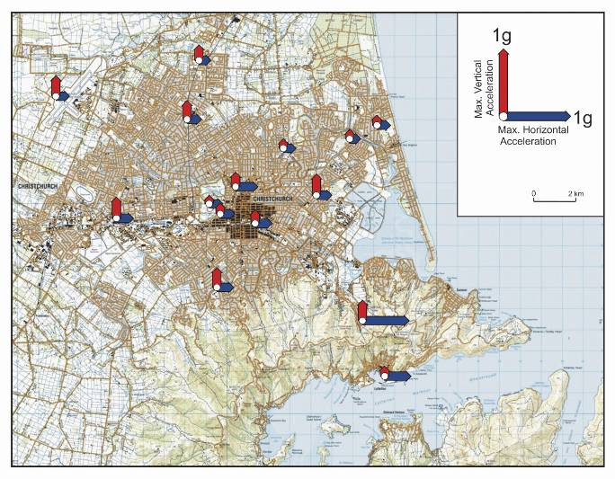
Figure 8: Maximum horizontal and vertical peak ground accelerations during the 4 September 2010 earthquake at GeoNet stations and using temporary accelerometers (source: GNS Science report 2011/183, July 2011)
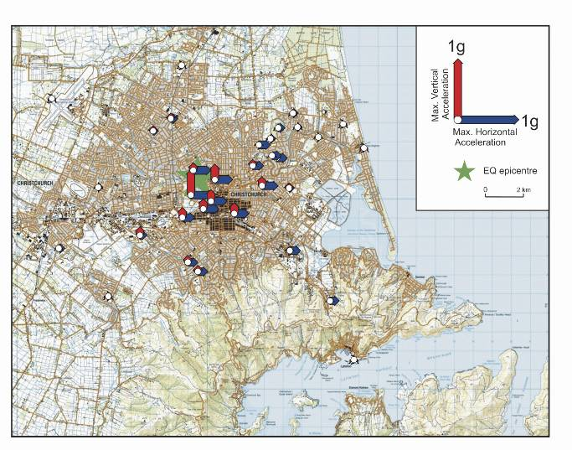
Figure 9: Maximum horizontal and vertical peak ground accelerations during the Boxing Day 2010 earthquake at GeoNet stations and using temporary accelerometers (source: GNS Science report 2011/183, July 2011)
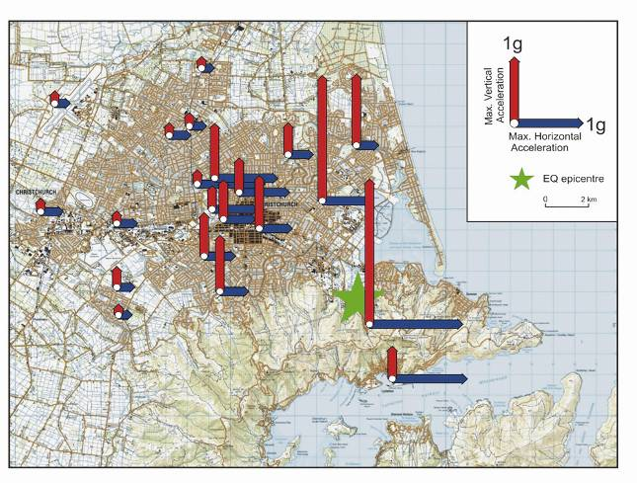
Figure 10: Maximum horizontal and vertical peak ground accelerations during the 22 February 2011 earthquake at GeoNet stations and using temporary accelerometers (source: GNS Science report 2011/183, July 2011)
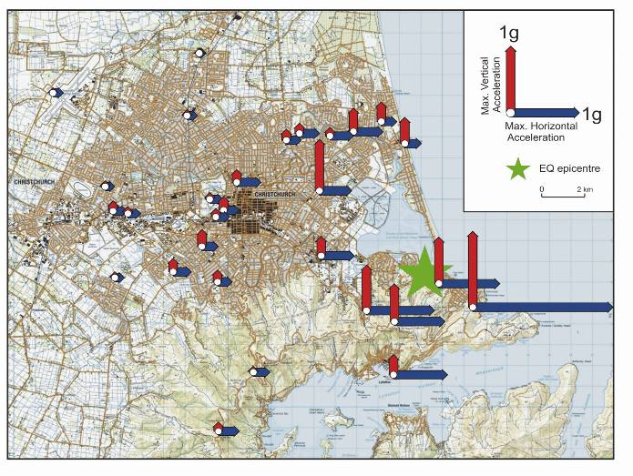
Figure 11: Maximum horizontal and vertical peak ground accelerations during the 13 June 2011 earthquake at GeoNet stations and using temporary accelerometers (source: GNS Science report 2011/183, July 2011)
The significance of the distance from the fault on these ground motions can be seen from response spectra derived from the earthquake ground motions. Design response spectra are used by structural and geotechnical engineers to determine the forces and displacements for which structures should be detailed to sustain to ensure they will perform satisfactorily in a major earthquake. Comparing the design response spectra with spectra obtained from the measured ground motions enables the relative severity of the earthquake to be assessed.
Figure 12 compares the response spectra measured at different distances from the fault with current design spectra for Type D soils for the September and February earthquakes. Two design spectra are given, one for a 500-year return period earthquake, which is the spectrum used in the design of most commercial buildings, and the other for a 2500-year return period earthquake, which is used for special structures required for use during a state of emergency.
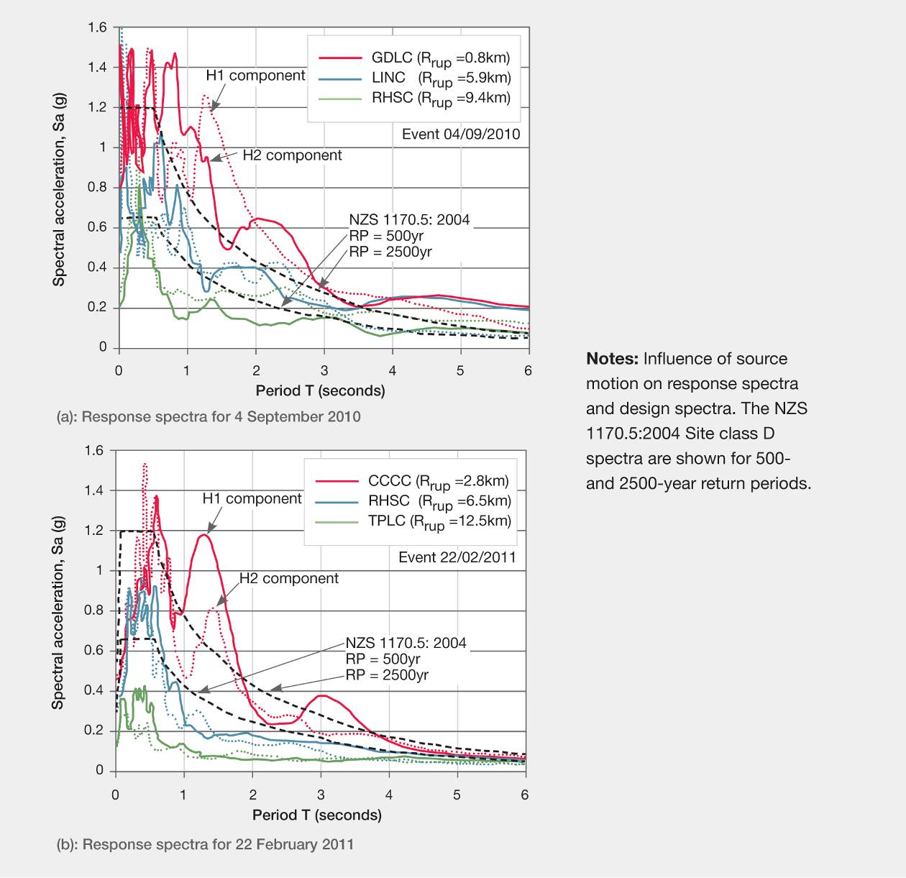
Figure 12: Response spectra for different distances from the faults for the September and February earthquakes (source: Bradley, January 2012)¹⁴
At each site, the ground motion is recorded in the vertical direction and in two horizontal directions, H1 and H2, at right angles to each other. Figures 8–12 show that the very high seismic forces were confined to regions very close to the fault.
The five per cent damped spectra calculated from these ground motions are shown in Figures 12(a) and (b). The distances of the recording stations from the faults are shown as the R_{rup} values on the figures.

