H.2

Canterbury Earthquakes
Royal Commission

Interim Report
October 2011


ISBN: 978-0-477-10344-2 (paperback)
ISBN: 978-0-477-10345-9 (pdf)
ISBN: 978-0-477-10345-9 (pdf) is the official electronic format
of the Canterbury Earthquakes Royal Commission Interim Report

Contents

Letter 1
Foreword 3
Introduction 4
Purpose of the Interim Report 5
Section 1: Summary of Recommendations 6
Section 2: Inquiry Process and Progress 11
Section 3: Inquiry Issues and Recommendations 23
Appendices 1-4 50
1: Royal Commission’s Terms of Reference 50
2: List of Advisors to the Royal Commission 55
3: Concepts Used in Seismic Design 56
4: Glossary 59

Letter of Transmittal
To His Excellency, Lieutenant General The Right Honourable Sir Jerry Mateparae GNZM, QSO Governor General of New Zealand.
Your Excellency
Pursuant to the Order in Council dated 11 April 2011 appointing us to be a Royal Commission of Inquiry into Building Failure caused by the Canterbury Earthquakes and to provide an Interim Report under the stated Terms of Reference no later than 11 October 2011, we now humbly submit our Interim Report for Your Excellency’s consideration.
We have the honour to be
Your Excellency’s most obedient servants
Hon Justice Mark Cooper (Chairperson)
Sir Ronald Carter
Adjunct Associate Professor Richard Fenwick
Dated at Wellington this 10th day of October 2011.

Foreword

The Royal Commission of Inquiry has been at work in Christchurch since 4 May 2011.
In the period since then we have worked out our approach to the Inquiry, and begun implementing it.
Much of our work has been behind the scenes. It has involved gathering facts from people and organisations, collecting engineering reports and other information about the performance of buildings in the earthquakes, and specifying work and reports that the Royal Commission considers it needs to cover the broad ground mapped out in the Terms of Reference. Many of these reports have been received, published on the Royal Commission’s website and are being analysed. Peer reviews of the reports, requested from eminent overseas experts, are also coming in.
The Royal Commission called for expressions of interest in the Inquiry, to be lodged by 22 July 2011. Public hearings will begin on 17 October 2011. In the following weeks and into the New Year the Royal Commission will hear both from those who have filed expressions of interest and from those whom we have specifically sought out as likely to have information or opinions that will assist the work of the Inquiry.
The Terms of Reference specify that the Royal Commission must provide an Interim Report by 11 October 2011. That date comes with the Inquiry well underway, but at a time when it has not been possible to embark on the public hearings. Nor has the Royal Commission had time to consider the results of the separate investigation being carried out by the Department of Building and Housing into the failures of the PGC, Forsyth Barr and Hotel Grand Chancellor buildings, which have only recently been published, while the Department’s investigation of the failure of the CTV building is yet to be concluded.
Our Terms of Reference specify that this Interim Report should contain recommendations that inform early decision-making on rebuilding and repair work that forms part of the recovery from the Canterbury earthquakes. They also envisage interim recommendations that relate to any measures necessary or desirable to prevent or minimise building failures due to earthquakes in New Zealand.
The timing has, of necessity, meant that the Royal Commission has not been able to produce a lengthy list of recommendations. However, this Report does make some recommendations which reflect our view that urgent action is required in respect of some aspects of current building design practice, both in Christchurch and elsewhere, to make some buildings’ elements (particularly stairs and floors in multi-storey buildings) more resilient. The Royal Commission is also of the view that immediate action is necessary to strengthen parts of unreinforced masonry buildings that could fail, causing injury or loss of life, in earthquakes that are less severe than the Canterbury earthquakes were. We have made recommendations accordingly.
Other issues must await the Final Report, including the lessons to be learned from the catastrophic failures of the CTV and PGC buildings.
The Royal Commission is aware that, for all those who lost family and friends in those buildings, and for those bereaved as a result of the other building failures on 22 February 2011, it is vitally important that the explanation for the building failures be provided as soon as possible. We ask for their understanding that it was not possible to provide that explanation in this Interim Report.

Justice Mark Cooper
Chairperson

Introduction
On 4 September 2010, at 4:35am, an earthquake of magnitude 7.1 struck Christchurch and the surrounding Canterbury region. It has been followed by three major earthquake events occurring on Boxing Day 2010, 22 February 2011 and 13 June 2011. The sequence of earthquakes includes the many aftershocks that have occurred since 4 September 2010 and, at the time of writing, are ongoing.
The earthquakes have had a major impact on Christchurch – its people, their physical and psychological well-being, the infrastructure, the economy, residential housing and the buildings in the central business district (CBD).
The Royal Commission has been advised by GNS Science¹ (GNS) that by world standards the earthquake of 4 September 2010 was a major earthquake. Yet there were no fatalities and comparatively few injuries, probably attributable to the early morning time at which the event occurred. The earthquake nevertheless caused damage to ‘unreinforced masonry buildings’ (URM), and to old stone buildings of heritage value. In the eastern suburbs and Kaiapoi there was significant liquefaction, with silt oozing to the surface and lateral spreading of the land, causing damage to houses and infrastructure. The earthquake had its origin on a fault that was previously not known to exist. It left a well-defined surface rupture that is now known as the Greendale fault. According to GNS, this was a rare event, occurring in an area where previous seismic activity has been low in New Zealand terms.
Following numerous aftershocks, there was a further significant event on 26 December 2010. The earthquake on that day had a magnitude of 4.7, lower than other events that have occurred in the sequence of earthquake events. But it was located less than two kilometres from the central city, and so caused further damage to buildings. Two other earthquakes also occurred with magnitudes respectively of 4.6 and 4.4, on that day.
By far the most serious event, in terms of the damage to buildings and the resultant loss of life, was the earthquake that occurred at 12:51pm on 22 February 2011. Its magnitude was 6.2, but it had an epicentre six kilometres southeast of the city centre. It resulted in the deaths of 182 people, and significant numbers suffered injuries, many of them very serious. Much of the loss of life was the result of the catastrophic collapse of two multi-storey office buildings, the Canterbury Television (CTV) and Pyne Gould Corporation (PGC) buildings where, respectively, 115 and 18 people died. Elsewhere, both within the area bounded by the four avenues and outside but near that area, 42 other people died as the result of building failures. There were seven other deaths resulting from the earthquake, but arising from causes not related to building failures and so outside the Royal Commission’s Terms of Reference. They include those attributable to rock falls.
The scale of the tragedy in human terms has touched numerous lives not only in Christchurch but throughout New Zealand, and indeed around the world. Of those who died in the earthquake, 77 were foreign nationals. They came to Christchurch from Australia, Japan, China, South Korea, the Philippines, Thailand, Malaysia, Taiwan, Israel, Canada, the United States, Turkey, Ireland, the United Kingdom and France.
The tragic events of 22 February 2011 resulted in the establishment of the Royal Commission of Inquiry into Building Failure Caused by the Canterbury Earthquakes (the Royal Commission). Under the Terms of Reference, the Royal Commission is required to provide an Interim Report by 11 October 2011 and a Final Report no later than 11 April 2012.
This is the Royal Commission’s Interim Report.

Purpose of the Interim Report

The Royal Commission’s Terms of Reference are set out in Appendix 1. They contain two separate references to the Interim Report. The first states that the Royal Commission is to make both interim and final recommendations upon or for—
(a) any measures necessary or desirable to prevent or minimise the failure of buildings in New Zealand due to earthquakes likely to occur during the lifetime of those buildings; and
(b) the cost of those measures; and
(c) the adequacy of legal and best-practice requirements for building design, construction and maintenance insofar as those requirements apply to managing the risks of building failure caused by earthquakes.
The second reference requires the Interim Report to contain “interim recommendations that inform early decision-making on rebuilding and repair work that forms part of the recovery from the Canterbury earthquakes”.
The Royal Commission understands these provisions as requiring it to consider, at the Interim Report stage, not only measures that should have effect in Christchurch as it rebuilds following the earthquakes, but also in New Zealand as a whole.
This report provides recommendations and conclusions, where possible, on issues about which the Royal Commission has formed preliminary or final views. There are few in the latter category, as could be anticipated given that the Inquiry is only part-way through, and there has been no opportunity to hear what interested parties might wish to contribute in hearings yet to take place.
Structure of Interim Report
The Interim Report is presented in four sections:
1. Summary of Recommendations (page 6);
2. Inquiry Process and Progress (page 11);
3. Inquiry Issues and Recommendations (page 23);
4. Appendices (page 50):
1: Royal Commission’s Terms of Reference
2: List of Advisors to the Royal Commission
3: Concepts Used in Seismic Design
4: Glossary.

Section 1: Summary of Recommendations
Introduction
Uncertainty is inherent in the prediction of earthquakes, particularly in terms of locations, magnitude and timing of events. GNS, New Zealand’s leading research organisation into seismic hazards, is aware of the active faults within New Zealand, but is unable to identify many of the below-ground ‘blind’ faults, such as those in the recent Canterbury earthquake sequence, which show no evidence of a fault on the ground surface.
GNS has built, and maintains, a National Seismic Hazard Model (NSHM) that aims to predict likely magnitudes and frequencies of occurrence of significant earthquakes for use in engineering design. The NSHM estimates future earthquake activity for New Zealand using the locations, estimated magnitudes from geological studies, recurrence intervals and types of ‘characteristic’ earthquakes for fault sources that have been recognised from detailed geological and geophysical studies.
It is not practical for GNS to identify all active faults in a region because many have no surface expression.
Key issues and recommendations
The Royal Commission is, at this stage of its Inquiry, able to make firm recommendations on a handful of matters for which information has been gathered and assessments completed. For most of the Inquiry issues, the Royal Commission is either awaiting further advice and/or yet to undertake analysis of advice recently received. In addition, hearings on the Inquiry issues have not commenced.
The Royal Commission has, however, been able to form conclusions and make recommendations on several matters that will, in its view, “inform early decision-making on rebuilding and repair work that forms part of the recovery from the Canterbury earthquakes” as required of it in its Terms of Reference, and some which have national significance.
This Interim Report presents the following conclusions and recommendations:
1. Seismicity
The Royal Commission recommends that parties with relevant expertise appearing before it in forthcoming hearings address the following issues in the Inquiry:
1. The seismicity model, which is reflected in the relevant New Zealand standard NZS 1170.5 Structural Design Actions, Part 5: Earthquake Actions-New Zealand (“NZS 1170.5:2004”), assumes that the ground motion associated with hidden faults is represented by a magnitude 6.5 earthquake located at a distance of 20km. In the new seismic model developed by GNS this has been replaced by a magnitude 7.2 earthquake at the same distance.
2. Changes were recently made for the new model in the way in which the design ground motions were derived from observed earthquakes. The Royal Commission understands that the peak ground accelerations for different building periods in NZS 1170.5 were deduced from the most critical of the two horizontal ground motions, which were measured at right angles to each other, suitably modified to allow for terrain, attenuation and other effects. However, it appears from a GNS report that in the new seismic model the ground motion has been based on the geometric mean of the observed shaking in the two horizontal directions. This assumption reduces the design seismic ground motions.
3. In the new seismic model a different magnitude weighting factor has been used from that applied for the model in NZS 1170.5.
4. The shape of the design response spectra (which defines how the effective acceleration of a structure in design varies with the period of vibration) is a poor fit to the observed spectra derived from the Canterbury earthquakes for the deep alluvial soils in the Christchurch locality. Some revision of the spectral shapes for these soils would appear to be justified.
5. There is some indication from the damage sustained in the Canterbury earthquakes that vertical ground motion may have contributed to the damage. There is a poor correlation between the calculated spectral shapes from the earthquakes and the specified shape in NZS 1170.5 for actions induced by vertical ground motion. Consequently, the method of defining design actions for vertical ground motion needs to be reviewed.
6. The implications of the points made above should be addressed by structural and geotechnical engineers in addition to seismologists.
The Royal Commission also wishes to receive further information addressing the effect of the high vertical ground motions in the 22 February 2011 earthquake.
2. Geotechnical Considerations
It is necessary to understand the behaviour of the soil-structure system during strong ground shaking and the contribution to this behaviour made by the foundation soils and the foundations themselves. Best practice internationally is for the issues of foundations on deep alluvial soils to be addressed by either:
a) comprehensive geotechnical investigations of the site and robust design methodology considering the soil-foundation-superstructure system including use of in-depth analysis to scrutinise the performance of the system; or
b) avoiding locations with difficult soil conditions.
Recommendations
1. The Christchurch City Council should require thorough soils investigations to be carried out as
a pre-requisite to foundation design.
2. Relevant land use and building controls in the Christchurch CBD should reflect the need for care in the placement of buildings of different structural types and sizes, so that soils issues are minimised. These issues should also be considered by those proposing and designing new buildings.
3. Designers of new buildings should:
a. Carry out in-depth analysis of the soil foundation super-structure system so as to ascertain the likely performance of the system.
b. Consider available local soil improvement techniques where appropriate.
4. CERA and the Christchurch City Council should consider compiling and making available a public database of all bore logs previously recorded in the CBD, in addition to those made for future buildings. In time this would yield valuable information about soil conditions throughout the CBD.

3. General Performance of Buildings – Unreinforced Masonry Buildings
Prior to September 2010, there were estimated to be around 4,000 Unreinforced Masonry (URM) buildings throughout New Zealand (following the Canterbury earthquakes, there may be 500 fewer). The collapse
or partial collapse of URM buildings during the 22 February earthquake in Christchurch resulted in 42 deaths.
In their report for the Royal Commission entitled ‘The Performance of Unreinforced Masonry Buildings in the 2010/2011 Canterbury Earthquake Swarm’, Ingham and Griffith² identified common types of failure of URM buildings in Christchurch as a result of the 4 September 2010 earthquake. They recommend a four-stage improvement process for strengthening URM buildings as follows:
1st stage: ensure public safety by eliminating falling hazards. This is done by securing/strengthening URM building elements that are located at height (eg, chimneys, parapets, ornaments and gable ends).
2nd stage: strengthen masonry walls to prevent out-of-plane failures. This can be done by adding reinforcing materials to the walls and by installing connections between the walls and the roof and floor systems at every level of the building so that walls no longer respond as vertical cantilevers secured only at their base.
3rd stage: ensure adequate connection between all structural elements of the building so that it responds as a cohesive unit rather than individual, isolated building components. In some situations it may be necessary to stiffen the roof and floor diaphragms, flexurally strengthen the masonry walls, and provide strengthening at the intersection between perpendicular walls.
4th stage: if further capacity is required to survive earthquake loading, then the in-plane shear strength of masonry walls can be increased or high-level interventions can be introduced, such as the insertion of steel and/or reinforced concrete frames to supplement or take over the seismic resisting role from the original unreinforced masonry structure.
The Royal Commission will be considering the issues that arise from the Ingham and Griffith report, the peer reviews of it and submissions made by interested persons at public hearings in November. However, considerations of public safety have persuaded it that some actions should be taken as a matter of urgency.
Recommendations
The Royal Commission recommends that:
5. local authorities should ensure that registers of all URM buildings, their locations and characteristics, are compiled or, where they already exist, brought up to date; and
6. throughout New Zealand, URM buildings should be improved by bracing parapets, installing roof ties and securing external falling hazards in the vicinity of public spaces; and
7. in areas where the hazard factor in NZS 1170.5 is 0.15 or higher, additional steps to provide ties at all floors should be implemented, at the same time as the work referred to in recommendation 6; and
8. these recommendations should be implemented as soon as practicable.

4. Design Practice
Two reports (‘Stairs and Access Ramps between Floors in Multi-storey Buildings’ by Des Bull³ and ‘Preliminary Observations from the Christchurch Earthquakes’ by John Hare⁴, provided to the Royal Commission for the purposes of its Inquiry, establish that there are aspects of structural design and construction which need urgent attention in the context of the imminent rebuilding work in the Christchurch CBD.
Further, the reports have raised issues that have public safety implications for multi-storey buildings wherever they are located in New Zealand which the Royal Commission considers should be addressed immediately. The Royal Commission has consulted with structural engineers about the implications of the reports, in the process described in Section 3.4. In doing so, it identified the proposed actions that are set out in that section. The proposed actions involve recommendations for changes to construction practice and design standards, as well as further research. They are set out in Annexure 1 (page 44).
Recommendations
In view of the support for the proposed actions from the structural engineering community, the Royal Commission recommends:
9. establishment of a small group of structural engineers, which involves suitably qualified practising engineers and one or more engineers who are familiar with structural research, to draw up guidelines for the issues raised in this Interim Report (refer Annexure 1);
10. implementation of the guidelines (drawn up from recommendation 9 above) by CERA and the local authorities in greater Christchurch (as that term is defined in the Canterbury Earthquake Recovery Act 2011).
That Act provides the means by which this can be achieved. Where the guidelines require changes to existing practices adopted in order to comply with the Building Act 2004, an Order in Council could be made implementing the guidelines, on the recommendation of the relevant Minister as provided for in section 71 of the Canterbury Earthquake Recovery Act 2011. In the Royal Commission’s view, such an Order in Council would be within the ambit of section 3(a), (f) and (h) of that Act, in that it would:
(a) provide appropriate measures to ensure that greater Christchurch responds to and recovers from the Canterbury earthquakes;
(b) facilitate and direct the rebuilding and recovery of affected communities, including the repair and rebuilding of “land, infrastructure and other property”; and
(c) provide adequate statutory power for those purposes.
The guidelines would apply in greater Christchurch until such time as national building standards have been revised to ensure the shortcomings in current practices have been adequately corrected.
11. that Standards New Zealand be required to initiate the process of amending current building standards in light of the findings from the Canterbury earthquakes referred to above;
12. that the proposed guidelines for the rebuild of greater Christchurch be referred to practising structural engineers to alert them to issues that should be avoided in new construction in other centres in New Zealand; and
13. that the following issues be referred to building consent authorities in other centres in New Zealand:
• the potential vulnerability of buildings where mesh has been used to transfer critical seismic actions to lateral force resisting elements; and
• the vulnerability of stairs in multi-storey buildings designed to meet the minimum inter-storey drift requirements given in previous and current loadings standards (NZS 4203 and NZS 1170.5). This issue has been addressed in Practice Advisory 13, Egress stairs issued by the Department of Building and Housing when this report was in final draft.

5. New Building Technologies
The Royal Commission considers that structural engineers and architects involved in the rebuild of Christchurch should be aware of the content of a report prepared for it entitled ‘Base Isolation and Damage-Resistant Technologies for Improved Seismic Performance of Buildings’ by Professor Andrew Buchanan⁵ et al. It is likely that the adoption of one or more of these new technologies would result in improved seismic performance of new buildings in Christchurch.
The report describes the current approach to seismic design together with a number of alternative technologies namely base isolation, Precast Seismic Structural Systems (PRESSS) technology and non-tearing floor systems, that can be used to improve seismic performance.
Recommendations
The Royal Commission recommends that:
14. designers give consideration to the use of new technologies discussed in Section 3.5 of this Interim Report and described in the report ‘Base Isolation and Damage-Resistant Technologies for Improved Seismic Performance of Buildings’ in designing new structures to be erected in the Christchurch CBD; and
15. urgent work should be carried out to enable appropriate provisions to be incorporated in the relevant structural design actions standards (AS/NZS 1170 and NZS 1170.5) together with the material design standards (NZS 3101 Concrete Structures, NZS 3404 Steel Structures and NZS 3603 Timber Structures) so as to facilitate the use of these technologies.

Section 2: Inquiry Process and Progress
2.1 Issues arising under the Terms of Reference
The principal issues that must be addressed by the Royal Commission under the Terms of Reference may be grouped under the following headings:
• Seismicity. This is a shorthand reference to the nature and extent of earthquake risk that should be provided for in the construction and maintenance of buildings. The Royal Commission must address these issues both for New Zealand generally, and for Christchurch. The Terms of Reference require the Royal Commission to understand the nature and severity of the Canterbury earthquakes, and the susceptibility of land to liquefaction as a result of earthquakes.
• Consideration of a representative sample of buildings in the Christchurch Central Business District (CBD). The Royal Commission is directed by the Terms of Reference that the representative sample must include the CTV, PGC, Forsyth Barr and Hotel Grand Chancellor buildings. It is for the Royal Commission to determine what other buildings it will consider, having regard to its obligations to consider why some buildings failed severely, why the failure of some caused extensive injury and death, why buildings differed in the extent to which they failed, and why some did not fail. Under this heading, the Royal Commission is also investigating the subsurface conditions in the CBD, particular features of buildings that contributed to failures, the extent of compliance of the buildings with relevant building controls and the inspection and remediation processes followed after the 4 September and 26 December 2010 and 22 February 2011 earthquakes.
• Legal and best-practice requirements for the design, construction and maintenance of buildings, including those that are or should be considered as earthquake-prone. This will also include the existing and desirable form of legislative provision for the inspection of buildings and remedial actions following earthquakes, having regard to the lessons learned from the Canterbury earthquakes. The Royal Commission is also considering the respective roles of central and local government, the building and construction industry and the significant inputs of volunteers (in the drafting and amendment of relevant New Zealand standards) in developing and enforcing legal and best-practice requirements.
• Change of New Zealand design standards/codes of practice over time and appropriate future controls for new and existing buildings.
• Development of technical expertise in the design and construction of seismic-resistant buildings.
2.2 The Royal Commission’s approach to the issues arising
The Royal Commission has developed and is implementing an approach to its investigation of the principal issues, which has the elements discussed below.
The approach reflects the breadth of the investigation required by the Terms of Reference, and the fact that, unlike some other investigations that have been referred to commissions of inquiry, this Inquiry is not one that could sensibly be conducted simply by inviting submissions from interested parties, considering what they might be prepared to tell the Commission (supplemented by appropriate questioning by counsel assisting) and make findings based solely on the evidence given at a hearing. That approach would risk some relevant issues being covered incompletely, or even not at all. There would be a risk also that the Royal Commission would not be presented with differing opinions on some important issues, because in the absence of clear disputes (arising plainly or by necessary implication from the Terms of Reference itself) persons having rival opinions might not be aware of what others were saying to the Royal Commission.
The Royal Commission has accordingly set out to ensure that it receives, as far as possible, appropriate advice on all of the relevant issues. On the principal issues that it has identified (discussed in Section 2.1), the Royal Commission:
(a) has commissioned advice from people and organisations within New Zealand who have appropriate expertise. The advisors contracted to date are listed in Appendix 2;
(b) has adopted and is implementing a policy that the advice received will generally be peer reviewed by eminent overseas experts. The peer reviewers contracted to date are set out in Appendix 2;
(c) is publishing on the Royal Commission’s website the advice received under (a) and (b);
(d) has called for expressions of interest in relation to each of the identified principal issues;
(e) in relation to each of the issues, is identifying persons or organisations who, while not filing expressions of interest, are nevertheless likely to have information that will assist the work of the Royal Commission;
(f) is calling for evidence and submissions on the principal issues both from those who have lodged expressions of interest and those others whom the Royal Commission considers will have relevant contributions to make;
(g) will publish on its website the evidence and submissions it receives in relation to the principal issues; and
(h) will conduct hearings, and hear evidence on the issues as appropriate.
The approach outlined brings most aspects of the Inquiry into line with the approach that is required in relation to the four named buildings in the representative sample of buildings in the Christchurch CBD. In the case of those buildings, the Terms of Reference envisage that the Royal Commission will receive and take into account the results of the separate technical investigation being conducted by the Department of Building and Housing (DBH) into the failure of the CTV, PGC, Forsyth Barr and Hotel Grand Chancellor buildings. The DBH has instructed consultants to report on the failure of each of those buildings, and will also receive a report from an expert panel appointed to review the consultants’ reports. The Royal Commission intends to publish these reports on its website as well as seeking its own advice on them. While the Royal Commission expects that the results of the DBH technical investigation will be of significant assistance to it, it will be forming its own views, and the results of the technical investigation will be contestable in the Royal Commission’s hearings process. In the meantime, the Royal Commission’s Inquiry into the failure of those buildings is underway, and the Royal Commission has appointed an eminent structural engineer from San Francisco, Mr William T. Holmes, to assist with that and other aspects of its Inquiry.
2.3 Department of Building and Housing technical investigation – timing
When the DBH technical investigation was established, it was announced that the results would be available by 31 July 2011. However, that has proved to be overly optimistic. As at the date of this report the consultants’ and panel reports have only recently been made available, and they have not covered the collapse of the CTV building. It is presently unclear when the results of the DBH technical investigation concerning the CTV building will be provided. These delays have inevitably had an effect on the Royal Commission’s processes.
In order for the results of the DBH technical investigation to be properly contestable in the Royal Commission’s own Inquiry the results will need to be available to interested parties for a period of time before any hearings before the Royal Commission occur. The interested parties will include those whose interests or reputations might be at risk as a result of conclusions that might be reached by the Royal Commission, as well as the bereaved families.
In considering its future hearings schedule the Royal Commission has recognised the need to take into account the availability of interested persons during the Christmas and New Year period.
Inability to schedule hearings on the four specified buildings has meant that the Royal Commission has also felt unable to schedule hearings in respect of other matters relevant to its Inquiry, which should logically occur after the hearings that focus on the reasons for the failure of those buildings. Such issues include the policies and practices that apply or should apply to the inspection of buildings after significant earthquakes, and the potential need for changes to the building controls that apply to the construction of new buildings.
The hearings in relation to these issues have not been scheduled at the time of writing this Interim Report.
2.4 Other buildings in the representative sample
The Royal Commission has adopted an approach to the consideration of other buildings as part of the “representative sample” referred to in the Terms of Reference, which stands somewhat apart from its approach to the other issues being addressed in the Inquiry.
Here the process followed has been to create a ‘long list’ of buildings of potential interest, considering such matters as structural design, construction type, building materials, building age and usage. The Royal Commission has decided also to consider prominent public buildings, which have attracted significant numbers of members of the public, as well as all the buildings whose failure has resulted in loss of life.
There were 42 deaths that resulted from building failures other than the collapse of the CTV and PGC buildings. In summary, the Royal Commission has decided that the Inquiry will include:
• any building within the CBD that failed causing loss of life, including The Press building in Cathedral Square, the Methodist Church on Durham Street, as well as numerous commercial premises on Colombo, Cashel, Gloucester, Hereford, High, Lichfield and Manchester streets; and
• any other building which failed causing loss of life including commercial premises on Riccarton Road in Riccarton, Coleridge Street in Sydenham, Worcester Street in Linwood and a residential property in St Albans.
The long list, in addition to the buildings described above, includes buildings that:
• withstood the Canterbury earthquakes;
• allow determination of the effectiveness of both damage assessments made and remedial work carried out between the 4 September 2010 and the 22 February 2011 Canterbury earthquakes;
• are of different structural types and forms;
• are of different construction materials;
• have different design and safety features including escape routes, such as stairs;
• have different dates of design and construction, including heritage buildings;
• had been retro-fitted prior to 22 February 2011 to improve earthquake resistance;
• had been identified as ‘earthquake-prone’ or ‘potentially earthquake-prone’ on or before
4 September 2010;
• have different foundation types and underlying soils;
• have different types of usage; and
• are of key public interest.
It will be appreciated that many engineering reports have been prepared, or are in the course of preparation, surveying the state of buildings in the CBD since the 4 September earthquake. The long list has been provided to most of the engineering consultancies operating in Christchurch with the request that they provide information in their possession relating to the buildings on the list, as well as advice as to the interests connected with the buildings. The Royal Commission is seeking the cooperation of the building owners. It has also approached insurance companies to obtain copies of reports of building damage that they have received. In this process the Royal Commission has been able to refer to its powers to require the provision of information under the Commission of Inquiry Act 1908, but there has generally been cooperation without the need to insist. The Royal Commission has also secured the cooperation of Christchurch City Council in providing relevant material (plans, specifications and calculations, and building permits and consents) from its records.
The Royal Commission has employed the Wellington-based engineering consultancy, Spencer Holmes Ltd, to assist in the analysis of this material. It is in the course of refining the representative sample is developing a short list and is successively analysing the explanations for the performance of particular buildings. There will be a process in many cases that will involve discussions with the engineers that have provided reports and individual building owners. As presently advised, the Royal Commission considers that (while there may be some exceptions) it will not be necessary for public hearings to be held before arriving at conclusions explaining the performance of many of the buildings concerned. Such hearings as may be necessary will be scheduled for later in the Inquiry.
Most of the 42 deaths that are attributable to the failure of buildings other than the CTV and PGC buildings were the result of the collapse, in whole or in part, of URM buildings. These are being treated as a special group. It is plain from the Royal Commission’s investigations to date that most of these building failures will have common attributes, reflecting the inability of such buildings to withstand the ground movements caused by the earthquakes. In such cases, the major focus of any hearings is likely to be issues that arise from the inspection processes followed after the 4 September and 26 December 2010 events.
2.5 Summary of progress
The following table lists reports received and pending in respect of the principal issues. It includes hearing dates where these have been scheduled as at the date of the Interim Report. It should be read in the context of the discussion above.
Table 1: Principal Issues – Summary of Position
Issue/Hearing Date | Matter and Reports Received and Pending⁶
Issue 1:  Seismicity  Hearings:  Weeks commencing  17 and 25 October 2011 | 1a New Zealand’s geological setting  1b Seismological model for New Zealand, and in particular for Canterbury  1c Nature and severity of the Canterbury earthquakes  1d Geotechnical knowledge and its implications for foundation types  1e Conditions likely to give rise to liquefaction  Reports Received  ‘The Canterbury Earthquake Sequence and Implications for Seismic Design Levels’, GNS Science  ‘Geotechnical Considerations: Foundations on Deep Alluvial Soils’, Associate Professor Misko Cubrinovski, University of Canterbury and Ian McCahon, Principal, Geotech Consulting Ltd  ‘Geotechnical Investigations and Assessment of Christchurch Central Business District’, Tonkin & Taylor Ltd  Peer Review 1 (Seismicity): Professor Ralph Archuleta, University of California at Santa Barbara  Reports Pending  Peer Review 2 (Seismicity): Adjunct Professor Norman Abrahamson, University of California at Berkeley  Peer Review (Geotechnical Considerations): Professor Jonathan Bray, University of California at Berkeley

Issue/Hearing Date | Matter and Reports Received and Pending⁶
Issue 2:  Inquiry into buildings in the Christchurch CBD  Hearings:  November and December 2011 (excluding CTV building) | 2a Representative sample of buildings in the CBD  2b Why some buildings failed severely, in some cases causing death and injury while others did not  Particular features, or patterns of features, that contributed to the failure of buildings  Nature of foundations and the soils on which these buildings were located and how these affected performance of the buildings  2c Whether failed buildings inquired into in 2b complied with any applicable earthquake risk and other legal and best-practice requirements both when designed and constructed and on or before 4 September 2010  Whether, on or before 4 September 2010, those buildings had been identified as earthquake-prone or were the subject of measures to make the buildings less susceptible to earthquake risk  2d For the buildings inquired into under 2c, the nature and effect of any assessment of them and of any remedial work carried out on them after 4 September or after 26 December 2010, but before the 22 February 2011 earthquakes  2e The policies adopted by the relevant authorities in undertaking the assessments made of buildings after 4 September and 26 December 2010  Reports Received  ‘Briefing: The Building Regulatory Framework’, Department of Building and Housing  ‘Geotechnical Considerations: Foundations on Deep Alluvial Soils’, Associate Professor Misko Cubrinovski, University of Canterbury and Ian McCahon, Principal, Geotech Consulting Ltd  ‘The Performance of Unreinforced Masonry Buildings in the 2010/2011 Canterbury Earthquake Swarm’, Associate Professor Jason M. Ingham, University of Auckland and Professor Michael C. Griffith, University of Adelaide  Peer Review 1 (Performance of Unreinforced Masonry): Mr Fred Turner, Staff Structural Engineer, Seismic Safety Commission, California, USA  Peer Review 2 (Performance of Unreinforced Masonry): Mr Bret Lizundia, Principal, Rutherford and Chekene, Structural and Geotechnical Engineers, San Francisco, USA  ‘Inelastic Response Spectra for the Christchurch Earthquake Records’, Professor Emeritus Athol J. Carr, University of Canterbury  ‘Preliminary Observations from Christchurch Earthquakes’, John Hare, Structural Engineering Society of New Zealand (SESOC)  ‘Base Isolation and Damage-Resistant Technologies for Improved Seismic Performance of Buildings’, Associate Professor Andrew H. Buchanan, Holcim Adjunct Professor Des Bull, Associate Professor Rajesh P. Dhakal, Associate Professor Greg MacRae, Alessandro Palermo, Associate Professor Stefano Pampanin, University of Canterbury

Issue 2 – continued
Issue/Hearing Date | Matter and Reports Received and Pending⁶
Issue 2:  Inquiry into buildings in the Christchurch CBD  Hearings:  November and December 2011 (excluding CTV building) | Reports Received  ‘Report into Building Safety Evaluation Processes in the Central Business District following the 4 September 2010 Earthquake’, Christchurch City Council  ‘Historical Review of Masonry Standards in New Zealand’, Smith P.C. and Devine J.W, Spencer Holmes Ltd.  ‘Processes Used and Lessons Learnt Following the Darfield Earthquake of  4 September 2010’, Esther Griffiths, Director, Sisirc Consulting Ltd and Deane McNulty, McNulty Engineering Management Ltd  ‘Review of NZ Building Codes of Practice’, Associate Professor Gregory MacRae, University of Canterbury, Associate Professor Charles Clifton, University of Auckland and Mr Les Megget  ‘Geotechnical Investigations and Assessment of Christchurch Central Business District’, Tonkin & Taylor Ltd  ‘Building Safety Evaluation following the Canterbury Earthquakes’, David Brunsden, New Zealand Society for Earthquake Engineering Inc (NZSEE)  Technical Investigation (PGC, Forsyth Barr and Hotel Grand Chanchellor buildings), Department of Building and Housing  Reports Pending  Technical Investigation (CTV), Department of Building and Housing  ‘The Performance of Earthquake Strengthened URM Buildings in the Christchurch CBD in the 22 February 2011 Earthquake’, Associate Professor Jason M. Ingham, University of Auckland and Professor Michael C. Griffith, University of Adelaide  ‘Review of Sample Buildings’, William T. Holmes, Principal, Rutherford and Chekene, Structural and Geotechnical Engineering, San Francisco, USA

Issue/Hearing Date | Matter and Reports Received and Pending⁶
Issue 3:  Inquiry into legal and best-practice requirements  Hearings:  Weeks commencing  7 and 14 November 2011  (further hearings to be held in December and early 2012 if required) | 3a The extent to which the knowledge and measurement of seismic events have been used in setting legal and best-practice requirements for earthquake risk management in respect of building design, construction and maintenance  3b The legal requirements for buildings that are ‘earthquake-prone’ under section 122 of the Building Act 2004 and associated regulations, including –  (A) the buildings that are, and those that should be, treated by the law as ‘earthquake-prone’; and  (B) the extent to which existing buildings are, and should be, required by law to meet requirements for the design, construction, and maintenance of new buildings; and  (C) the enforcement of legal requirements.  3c The requirements for existing buildings that are not, as a matter of law, ‘earthquake-prone’, and do not meet current legal and best-practice requirements for the design, construction and maintenance of new buildings, including whether, to what extent, and over what period they should be required to meet those requirements  3d The roles of central government, local government, the building and construction industry, and other elements of the private sector in developing and enforcing legal and best-practice requirements  3e The legal and best-practice requirements for the assessment of, and for remedial work carried out on, buildings after any earthquake, having regard to lessons from the Canterbury earthquakes  3f How the matters specified in subparagraphs (a) to (e) compare to any similar matters in other countries  Reports Received  ‘Briefing: The Building Regulatory Framework’, Department of Building and Housing  ‘Standards and Regulation for Building Construction in New Zealand’, Institution of Professional Engineers New Zealand (IPENZ)  ‘Structural Design for Earthquake Resistance’, Associate Professor Rajesh P. Dhakal, University of Canterbury  ‘Report into Building Safety Evaluation Processes in the Central Building District Following the 4 September 2010 Earthquake’, Christchurch City Council  ‘Processes Used and Lessons Learnt Following the Darfield Earthquake of  4 September 2010’, Esther Griffiths, Director, Sisirc Consulting Ltd and Deane McNulty, McNulty Engineering Management Ltd  ‘Building Safety Evaluation Following the Canterbury Earthquakes’ David Brunsden, New Zealand Society for Earthquake Engineering Inc (NZSEE)

Issue/Hearing Date | Matter and Reports Received and Pending⁶
Issue 4:  Change of  New Zealand design standards and codes  of practice over time  Hearings:  Dates to be advised | Changes in design philosophy for earthquake resistance as reflected in New Zealand design standards over the past 75 years having regard to:  4a Levels of seismicity used to calculate required design strengths and the deflections associated with the design level earthquake  4b Methods to determine design forces and methods used to calculate the strength required to resist them  4c Assumptions regarding stiffness of building elements and calculation of displacements induced by the design earthquake  4d Design principles used to calculate deflections caused by a major earthquake without collapsing or endangering life  Reports Received  ‘Structural Design for Earthquake Resistance’, Associate Professor Rajesh P. Dhakal, University of Canterbury  ‘Preliminary Observations from Christchurch Earthquakes’, John Hare, Structural Engineering Society of New Zealand (SESOC)  ‘Stairs and Access Ramps Between Floors in Multi-storey Buildings’, Holcim Adjunct Professor Des Bull, University of Canterbury  ‘Review of NZ Building Codes of Practice’, Associate Professor Gregory MacRae, University of Canterbury, Associate Professor Charles Clifton, University of Auckland  and Mr Les Megget  Technical Investigation (PGC, Forsyth Barr and Hotel Grand Chanchellor buildings), Department of Building and Housing  Reports Pending  Technical Investigation (CTV), Department of Building and Housing
Issue 5:  Development of technical expertise in the design and construction of seismic resistant buildings  Hearings:  Dates to be advised | 5a Academic and in-practice training of seismic engineers  5b Research to advance seismic performance  5c Application of technical knowledge in setting legislative and regulatory requirements  Reports Received  ‘Standards and Regulation for Building Construction in New Zealand’, Institution of Professional Engineers New Zealand (IPENZ)  ‘Base Isolation and Damage-Resistant Technologies for Improved Seismic Performance of Buildings’, Associate Professor Andrew H Buchanan, Holcim Adjunct Professor  Des Bull, Associate Professor Rajesh Dhakal, Associate Professor Greg MacRae,  Dr Alessandro Palermo, Associate Professor Stefano Pampanin, University of Canterbury  ‘Preliminary Observations from Christchurch Earthquakes’, John Hare, President Structural Engineering Society of New Zealand (SESOC)  ‘Briefing: The Building Regulatory Framework’, Department of Building and Housing
Issue/Hearing Date | Matter and Reports Received and Pending⁶
Issue 6:  Future measures  Hearings:  Dates to be advised | New buildings:  6a Necessary changes to current design practice  6b Consideration of new technologies, including their cost  Existing buildings:  6a New and recent methods of retro-fitting  6b Appropriate level of compliance with new building standards or alternative performance criteria, taking into account the cost of compliance  Reports Received  ‘The Performance of Unreinforced Masonry Buildings in the 2010/2011 Canterbury Earthquake Swarm’, Associate Professor Jason M. Ingham, University of Auckland and Professor Michael C. Griffith, University of Adelaide  Peer Review 1 (Performance of Unreinforced Masonry): Mr Fred Turner, Staff Structural Engineer, Seismic Safety Commission, California, USA  Peer Review 2 (Performance of Unreinforced Masonry): Mr Bret Lizundia, Principal, Rutherford and Chekene, Structural and Geotechnical Engineers, San Francisco, USA  ‘Review of NZ Building Codes of Practice’, Associate Professor Gregory MacRae, University of Canterbury, Associate Professor Charles Clifton, University of Auckland  and Mr Les Megget  ‘Briefing: The Building Regulatory Framework’, Department of Building and Housing  ‘Base Isolation and Damage-Resistant Technologies for Improved Seismic Performance of Buildings’, Associate Professor Andrew H. Buchanan, Holcim Adjunct Professor Des Bull, Associate Professor Rajesh P. Dhakal, Associate Professor Greg MacRae, Dr Alessandro Palermo, Associate Professor Stefano Pampanin, University of Canterbury  ‘Stairs and Access Ramps Between Floors in Multi-storey Buildings’, Holcim Adjunct Professor Des Bull, University of Canterbury  ‘Preliminary Observations from Christchurch Earthquakes’, John Hare, President Structural Engineering Society of New Zealand (SESOC)  Reports Pending  ‘The Performance of Earthquake Strengthened URM Buildings in the Christchurch CBD in the 22 February 2011 Earthquake’, Associate Professor Jason M. Ingham, University of Auckland and Professor Michael C. Griffith, University of Adelaide

2.6 Submissions and hearings
The Royal Commission advertised, calling for expressions of interest, in newspapers throughout New Zealand. Notices were placed in four major metropolitan papers – the New Zealand Herald, Dominion Post, The Press and Otago Daily Times – in their 2 July 2011 editions, and again in The Press and Dominion Post on 13 July 2011. In addition, notices were placed in the following regional daily newspapers on 6 July 2011: Northern Advocate, Bay of Plenty Times, Waikato Times, Gisborne Herald, Wanganui Chronicle, Taranaki Daily News, Manawatu Standard, Hawke’s Bay Today, Nelson Mail, Timaru Herald, Southland Times and Greymouth Star and in the Marlborough Express and Hokitika Guardian on 4 July 2011. People or organisations were invited to meet with the Royal Commission, provide a written submission, participate in public hearings or communicate information to the Royal Commission. The Royal Commission received 80 expressions of interest from interested parties advising that they wished to make submissions. Those advising their intent to make a submission include people who were trapped in buildings as a result of the 22 February 2011 earthquake, building owners and tenants, persons with professional knowledge about matters arising in the Inquiry, learned societies, Auckland Council, the Christchurch and Wellington City Councils, Local Government New Zealand and the Department of Building and Housing.
Public hearings are being scheduled on an issue-by-issue basis. As set out in table 1, the hearings will commence on 17 October 2011. It is not possible to say when they will be concluded, because of the uncertainty about completion of the DBH’s technical investigation.
People wishing to give evidence and/or make submissions will be required to provide them in advance of the hearings. The Royal Commission is asking that this be done in electronic form, to facilitate publication of the material in advance on the Royal Commission’s website, thereby giving notice to other interested parties and the public of what is intended to be said. The Royal Commission will follow this approach in all cases, unless there are compelling reasons for a different approach, to ensure the effectiveness of the Inquiry. Public hearings will be streamed live via the Internet.
Advice received by the Royal Commission from those whom it has asked to provide it will be referred to in the hearings. The hearings will also provide an opportunity for parties with relevant evidence to provide it and be questioned. They include those who have filed expressions of interest and those whom the Royal Commission has itself identified as likely to have information that will assist the Royal Commission in carrying out its task.
The information considered will also include relevant evidence obtained and called by counsel assisting the Royal Commission.
2.7 Counsel assisting
Counsel assisting have a duty to ensure that the Royal Commission has the evidence and information it needs to fulfil its obligations under the Terms of Reference. Initially two counsel assisting the Royal Commission were appointed, Stephen Mills QC and Mark Zarifeh. In mid-August, Marcus Elliott was appointed as a third counsel assisting the Royal Commission, with a specific focus on representing the interests of those bereaved and injured in the February earthquake.
2.8 Meetings with families
The Royal Commission’s chairperson and members of the Royal Commission’s staff have been meeting with families who lost relatives in the February earthquake since the beginning of July. Most of these meetings have been with individual families, but some group meetings have also been held. The Royal Commission has appointed a Family and Community Liaison Officer. Her role includes responding to enquiries from families both New Zealand and overseas-based, and keeping them informed about reports being published and the Royal Commission’s progress in general, with updates by email and post.
In the week beginning 29 August, the Family and Community Liaison Officer attended the Coroner’s inquests and liaised with families, providing them with information about the Royal Commission, answering questions and offering support. The Family and Community Liaison Officer is working closely with the Senior Communications Advisor for the Royal Commission to ensure that families receive communications in a timely way and are advised
of new information before it is released to the media.
2.9 Staffing of the Royal Commission
The Royal Commission is now fully staffed, including the executive director, a project manager, a senior communications advisor, senior policy analysts, information managers, hearings planner and administration team. Additional administrative support is provided to the Royal Commission by the Department of Internal Affairs.

Section 3: Inquiry Issues and Recommendations
This part of the Interim Report discusses some of the principal issues that the Royal Commission must consider under the Terms of Reference. It sets out some conclusions that have already been reached and some possible conclusions on the basis of the information that has been gathered to date. There are some definite recommendations for change, and other recommendations for further processes, whether in subsequent stages of the Royal Commission’s Inquiry or in other forums.
There are few definite recommendations on substantive matters because the Inquiry is only part-way through, the peer reviews of advice to the Royal Commission have not all been received, the evidence and submissions of interested parties have yet to be received and no hearings have been held. The Royal Commission is mindful of the limitations, which therefore apply to stating conclusions at this point, and considers it inappropriate, for example, to make any findings about the reasons for the failure of the CTV and PGC buildings, or the implications of those failures. Possible implications for existing building controls arising out of the study of the representative sample of buildings would also generally be premature at this point, with a few exceptions. In the case of the failure of URM buildings, enough is presently known for some clear recommendations to be made. Safety considerations have also led us to make other recommendations. On the basis of reports that we have received from structural engineers familiar with the effects of the earthquakes on buildings in the CBD, there appears to be a clear need to reconsider some practices associated with the construction of stairs, floors, structural concrete members and structural walls.
The Royal Commission is conscious of the need to produce an Interim Report that responds appropriately to the obligation in the Terms of Reference to make interim recommendations that will “inform early decision-making on rebuilding and repair work that forms part of the recovery from the Canterbury earthquakes”. The Royal Commission considers that this obligation cannot properly be fulfilled by deferring every issue to the Final Report, and has stated some conclusions and made some recommendations for change accordingly. If persuaded at a later stage of the Inquiry that any of these conclusions and recommendations need to be reconsidered, the Royal Commission will do so.
The recommendations are discussed later in this section of the report, and highlighted in the preceding Section 1.
3.1 Seismicity
The advice that the Royal Commission has received from GNS describes the forces that give rise to earthquakes in New Zealand generally, and Canterbury and Christchurch in particular⁷:
“New Zealand straddles the boundary zone between the Australian and Pacific tectonic plates, which are moving relative to each other at 35-45 mm/yr. In the North Island, the plates are converging and the relatively thin ocean crust of the Pacific Plate dives down westward beneath the eastern North Island just offshore of the east coast. Similarly offshore of Fiordland the thin ocean crust of the Australian Plate is diving eastward beneath Fiordland.
“In the central and northern South Island, however, the crust of both the Pacific and Australian plates is very thick, so one cannot be driven beneath the other. Here the plates collide, with 75% of the motion between the plates being built up and then released during major earthquakes along the Alpine Fault. To the east of the Alpine Fault, the remaining 25% of the plate motion occurs through occasional earthquakes on a complex web of active faults. This motion extends all the way to the east coast, where faults such as those beneath the Canterbury Plains accommodate 1-2 mm/yr of the overall plate motion. It is inevitable that this steady build-up of deformation across the Canterbury Plains will occasionally be released as earthquakes.
“Because it straddles a major plate boundary, New Zealand has a long history of earthquakes ranging from tiny tremors detectable only by sensitive instruments to violent earthquakes causing major damage and many fatalities. The more powerful earthquakes have occurred at irregular intervals, separated by relatively quiescent periods. Since European settlement of the Canterbury Plains began in 1853, Christchurch has experienced intermittent damage from earthquake shaking on about 10 occasions.
However, before the earthquakes in 2010 and 2011, few of these damaging earthquakes were local – more frequently, damage was caused by shaking from large earthquakes on more distant faults”.
The GNS report notes that the Canterbury earthquake sequence has included a mixture of sideways (strike-slip) and vertical (reverse) faulting at shallow depths on previously unidentified faults at varying distances from the Christchurch CBD. The three largest events (4 September 2010, 22 February 2011 and 13 June 2011) released levels of energy that were high for the size of the fault.
These faults initially were formed millions of years ago by tectonic movements inducing tension in the base rock, so that they are steeply inclined to the horizontal. Subsequently the tectonic movements changed to induce compression across the faults. The faults seldom fail so that the return period for earthquakes is long and hence there is little disruption of rock adjacent to the fault plane. A consequence of this is that high compression (stress) is sustained in the rock before the slip occurs and when failure does take place there is a high stress drop (strain energy release). The GNS report expresses the opinion that focussing of the seismic shaking, arising from the direction of the fault (‘directivity’) increased the severity of the ground motions experienced in the CBD during the
4 September and 22 February earthquakes, but was not significant for those of 26 December and 13 June.

A description of the earthquakes is set out in the following table:
Table 2: Earthquake Sequence: Characteristics
Date/  Epicentre | Time | Magnitude⁸  M_{w} | Intense Shaking Duration | Major Effects
Date:  4 September 2010  Epicentre:  40km west of Christchurch | 4:35am | 7.1 | 8–15 seconds | • Damage to Christchurch’s older brick and masonry buildings and to historical stone buildings and Canterbury homesteads  • Seriously affected eastern suburbs and Kaiapoi with liquefaction and lateral spreading  • Broken water and sewer pipes causing flooding
Date:  Boxing Day earthquakes – 26 December 2010  Epicentre:  1.8km NW from Christchurch Cathedral | 10:30am | 4.7 | 1–1.7 seconds | • Localised effects that caused further damage to buildings in the CBD
Date:  22 February 2011  Epicentre:  6km southeast of Christchurch CBD | 12:51pm | 6.2 | 8–10 seconds | • 182 deaths  • Many buildings damaged in the September earthquake were brought down; many heritage buildings heavily damaged; a number of modern buildings were damaged beyond repair. The CTV and PGC buildings failed catastrophically, causing respectively 115 and 18 deaths  • Widespread liquefaction
Date:  13 June 2011  Epicentre:  near Sumner | 14:20pm | 6.0 | 6–7.5 seconds | • Damage in Christchurch and Lyttelton  • CBD buildings that were to be repaired following earlier earthquakes were now irreparably damaged  • Widespread liquefaction and rockfalls from cliffs in the Port Hills suburbs

The GNS report observes that there was a close match between the extent of damage caused by the earthquakes and the degree of horizontal ground shaking. However, some structural engineers involved in reviewing damage to buildings in the Christchurch CBD consider that the high magnitudes of vertical ground motion may have contributed significantly to the observed damage. The Royal Commission will want to give further consideration to this issue before providing its Final Report.
The GNS Science report refers to measurements recording peak accelerations at sites close to the Christchurch CBD, which were approximately twice as strong during the 22 February earthquake as during the other three most significant earthquakes. The ground motions on 22 February were extremely high, reaching 1.7g in the horizontal direction and 2.2g in the vertical direction in Heathcote Valley near the epicentre, and up to 0.8g vertically and 0.7g horizontally in the CBD. Although the 4 September earthquake was significantly larger than the other three most significant events, its epicentre was over 35 kilometres from the Christchurch CBD with the result that the ground accelerations in central Christchurch were correspondingly reduced.
The epicentre of the 22 February earthquake was approximately 6km from the Christchurch CBD.
The following diagrams (Figures 1 and 2), extracted from the GNS report (pages 18 and 23), illustrate the maximum horizontal and vertical ground accelerations for the 4 September and 22 February events:
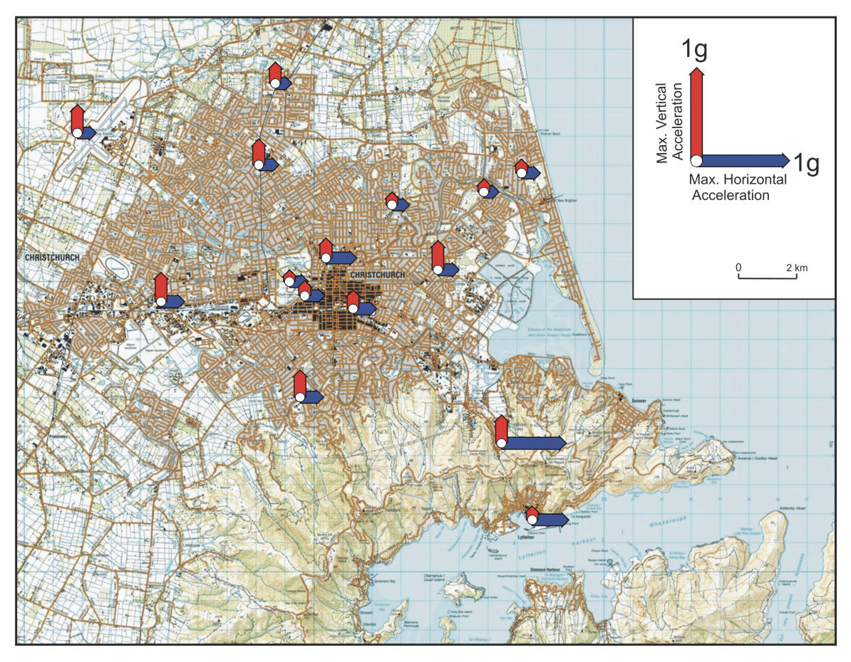
Figure 1: Maximum horizontal and vertical PGAs recorded during the 4 September 2010 earthquake at GeoNet stations
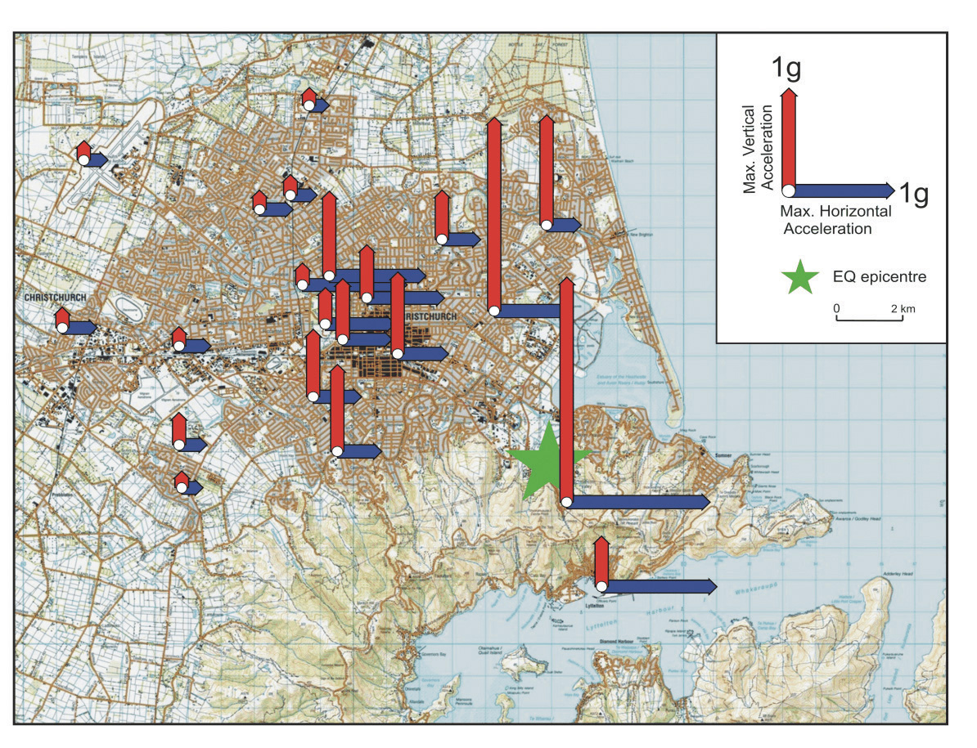
Figure 2: Maximum horizontal and vertical PGAs recorded during the 22 February 2011 earthquake at GeoNet stations
GNS reports that at certain recording sites in the Christchurch CBD shaking from the three largest events exceeded the most stringent of the design levels used in NZS 1170.5 for certain frequencies of shaking.
The GNS report states that “the level of seismic hazard in Canterbury is currently higher than normal because of the numerous aftershocks that are occurring. In addition there is a slight possibility that an earthquake of a size comparable to the main shock might be triggered”. The report observes that the elevated level of hazard must be considered when reassessing the safety of existing structures and when designing new buildings and infrastructure.
As a consequence, GNS is developing a new seismic model for Canterbury that is intended to reflect the increased level of hazard. One consequence of this work has been to increase the seismic hazard factor (‘Z’) for Christchurch. This factor is used to assess the magnitude of design level earthquakes and it varies from location to location in New Zealand according to the assessed risk from earthquakes. Previously, the hazard factor for Christchurch was 0.22. It has now been increased to 0.3, an approximate 35% increase. The corresponding value of Z in Wellington is 0.4, in Hamilton 0.16, Gisborne 0.36, Napier 0.38, Hastings 0.39, and in Auckland and Dunedin 0.13.
There are additional changes in other factors related to seismic design discussed below.
The cost involved would make it impractical to identify all active faults in a region, essentially because small faults associated with earthquakes that are magnitude 6, or less, frequently do not leave a visible trace on the ground surface. It is for this reason that, in evaluating the level of earthquake risk, the National Seismic Hazard Model (the model) currently assumes that an earthquake of up to magnitude 7.2 could occur on an unknown fault virtually anywhere in New Zealand, although in locations of low seismicity the likelihood of such an occurrence is very low. For the purposes of assessing the likely ground motion, it is assumed the fault is located at a distance of 20km from the point of interest as it is (statistically) unlikely that the point of interest will be very close to the fault. GNS refers to the need to ensure that the model correctly accounts for the shaking that can be anticipated from such earthquakes.
GNS also observes that while directivity effects are accounted for in the model for some major active faults, consideration will need to be given to including directivity for smaller earthquakes. The extreme vertical accelerations that were generated by the 22 February earthquake require re-evaluation of the approach to designing for vertical motions that currently applies under NZS 1170.5.
For the Christchurch metropolitan area there is a significant risk of earthquakes associated with ruptures of distant faults such as the 650km long Alpine Fault and Porters Pass – Grey Fault. An Alpine Fault earthquake will not be a ‘high stress drop’ such as the February earthquake. Due to the distance to the Alpine Fault the predicted peak ground accelerations are anticipated to be much lower than those experienced in both the September and February earthquakes. However, the shaking will have a much longer duration, as illustrated in Figure 3, which compares the observed ground accelerations in time with the corresponding values predicted for an earthquake on the Alpine Fault.
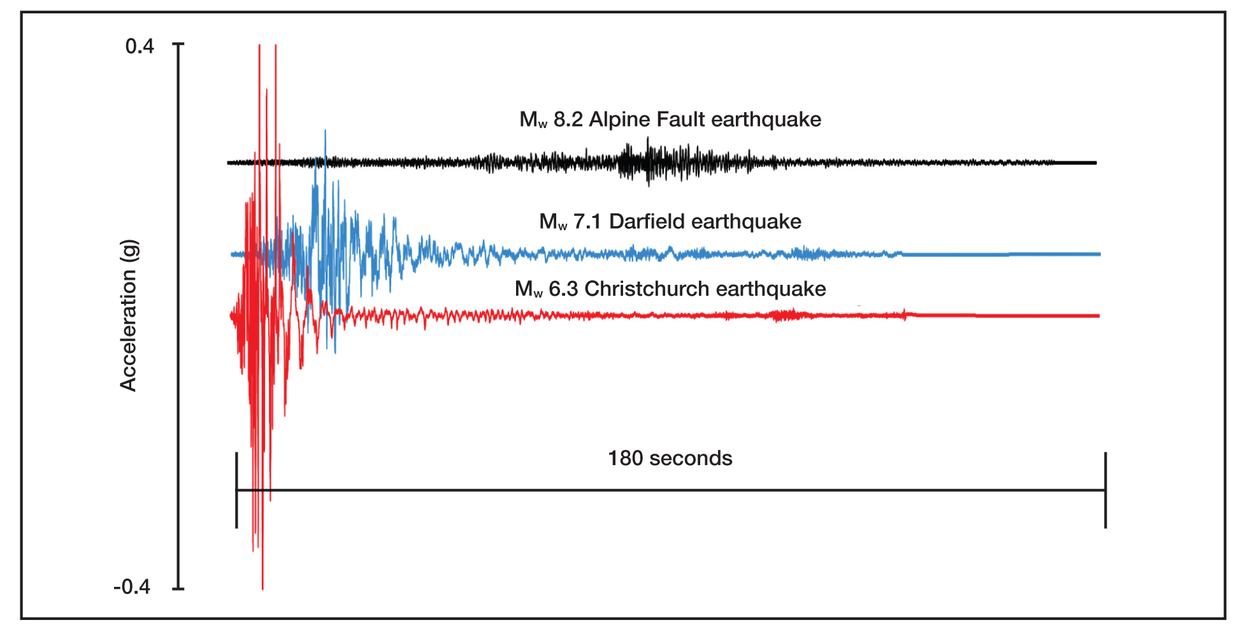
Figure 3: Three minutes of synthetic acceleration time histories for the larger of the two horizontal components, in terms of PGA, for a potential Alpine Fault event (black) compared with the accelerations from the Mw 7.1 Darfield earthquake (blue) and the 22 February Mw 6.3 Christchurch earthquake (red) as recorded at the Christchurch Botanic Gardens GeoNet station (CBGS)
As noted above, a number of changes have been made to the design level earthquakes for Christchurch as a result of seismic modelling carried out by GNS. This resulted in the increase of the seismic hazard factor, Z, from 0.22 to 0.3. The Royal Commission notes that the return factor, R, used for assessing the level of earthquake actions for the serviceability limit state has also been increased from 0.25 to 0.33 to allow for the increased seismicity associated with aftershocks. (An explanation of the ‘serviceability’ and ‘ultimate’ limit states is given in Annexure 1 at the end of Section 3). These changes are very significant in that both factors impact on the design level earthquake for the serviceability limit state where, together, they result in an 80 per cent increase in design actions for this limit state compared to the corresponding values in use until May 2011. It should be noted that serviceability is considered for the design of new buildings but is not considered in the retrofit of existing structures.
The epicentre of the 22 February earthquake was located on the outskirts of Christchurch at a distance of approximately 6km from the centre of the CBD. The damage from this earthquake was predominantly located within a distance of 12km of the fault. This observation supports the decision in the GNS model
to assess the likely ground motions from a hidden fault for an earthquake located at a distance of 20km.
It is unfortunate for Christchurch that:
• this hidden fault was located close to the centre of Christchurch;
• the fault plane was inclined in a direction that directed a high proportion of the strain energy release towards the centre of Christchurch; and
• this fault, which has a very long return period (of the order of 10,000 years), happened to fail in 2011 when a high population density had developed.
Before the Royal Commission can support the adoption of the revised seismic coefficients for the Christchurch region there are a number of aspects that need further investigation:
1. The current seismicity model which is reflected in the New Zealand earthquake actions standard, NZS 1170.5, assumes that the ground motion associated with hidden faults is represented by a magnitude 6.5 earthquake located at a distance of 20km. In the new seismic model this has been replaced by a magnitude 7.2 earthquake at the same distance.
2. Changes were made to the new model for the way in which the design ground motions were derived from observed earthquakes. The Royal Commission understands that the peak ground accelerations for different building periods in NZS 1170.5 were deduced from the most critical of the two horizontal ground motions, which were measured at right angles to each other, suitably modified to allow for terrain, attenuation and other effects. However, it appears from a GNS report⁹ that in the new seismic model the ground motion has been based on the geometric mean of the observed shaking in the two horizontal directions. This assumption reduces the design seismic ground motions.
3. In the new seismic model a different magnitude weighting factor has been used from that applied for the model in NZS 1170.5.
4. The shape of the design response spectra (which defines how the effective acceleration of a structure in design varies with the period of vibration) is a poor fit with the observed spectra derived from the Canterbury earthquake for the deep alluvial soils in the Christchurch locality. Some revision of the spectral shapes for these soils would appear to be justified.
5. There is some indication from the damage sustained in the Canterbury earthquakes that vertical ground motion may have contributed to the damage. There is a poor correlation between the calculated spectral shapes from the earthquakes and the specified shape in NZS 1170.5 for actions induced by vertical ground motion. Consequently, the method of defining design actions for vertical ground motion needs to be reviewed.
6. The implications of the points made above should be addressed by structural and geotechnical engineers in addition to seismologists.
The Royal Commission recommends that parties appearing before the Royal Commission with relevant expertise address the issues listed in the preceding paragraphs when presenting evidence and submissions later in the Inquiry. The Royal Commission also wishes to receive further information addressing the effect of the high vertical ground motions in the 22 February 2011 earthquake.
3.2 Geotechnical considerations
Characteristics of Canterbury soils in the area of the CBD
In the design of foundations on deep alluvial soils it is essential to allow for potential liquefaction, and the strength and stiffness of the soils. These deep alluvial gravels also affect the response spectra.
Complex inter-layered soil formations deposited by eastward flowing rivers from the Southern Alps underlie the CBD to a depth of up to 500m or more. In the top 20 to 25m these layers consist of recent deposits of gravels, sands, silts, peat and their mixtures. The soils are highly variable within relatively short distances both horizontally and vertically. These soils are subject to liquefaction and in some cases when deposited in a loose state exhibit very low resistance to liquefaction. As an example, the nature of soils along Hereford Street is depicted in Figure 4 below.
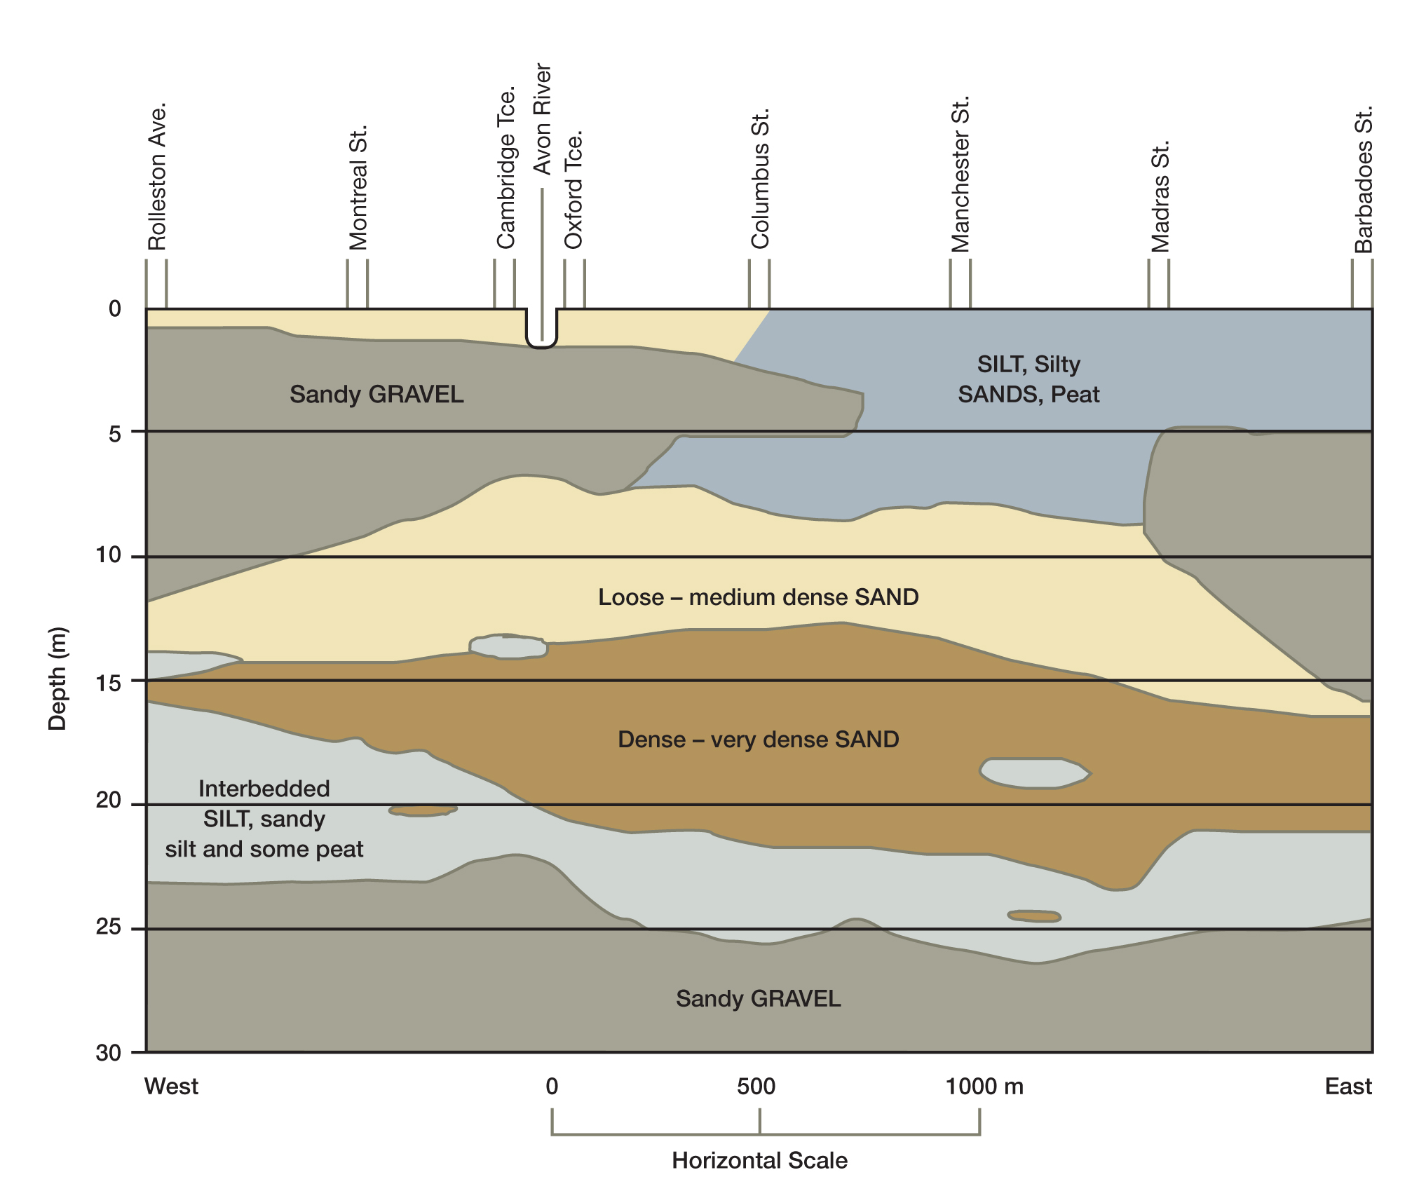
Figure 4: Subsurface cross section of Christchurch CBD along Hereford Street (reproduced and modified from Elder and McCahon, 1990)
The presence of near surface ground water increases the susceptibility to liquefaction. Depths to the water table vary from about 5m in the western suburbs to within 1.0 to 1.5m to the east.
The Royal Commission sought expert advice from Associate Professor Misko Cubrinovski from the University of Canterbury and Ian McCahon, Principal of Geotech Consulting Ltd. Their report entitled ‘Foundations on Deep Alluvial Soils’ provides information on the characteristics and behaviour of soils during the Canterbury earthquakes and has been published on the Royal Commission’s website.
The consequence of subjecting the variable soil structure when subjected to earthquake vibration is the creation of pronounced liquefaction that often, but not always, leads to discharge at the surface of sands, silts and water. The consequences of liquefaction include loss of soil strength, lateral spreading and adverse effects on the performance of foundations. Lateral spreading involves displacement of some areas of the surface layers and typically occurs in sloping ground or level ground close to waterways.
The deep alluvial deposit beneath Christchurch, when subjected to earthquakes, also increases the period of vibration of the subsoil mass, which in turn alters the surface accelerations to which buildings are subjected.
Liquefaction
Liquefaction of soils in the CBD occurred during three of the earthquakes but this effect was much greater in the 22 February earthquake than in the other two events, due to the greater horizontal accelerations experienced in that event. The areas within the CBD subjected to serious liquefaction are indicated in Figure 5. The figure has been constructed from on-site inspections 10 days after the 22 February earthquake (Cubrinovski and McCahon).
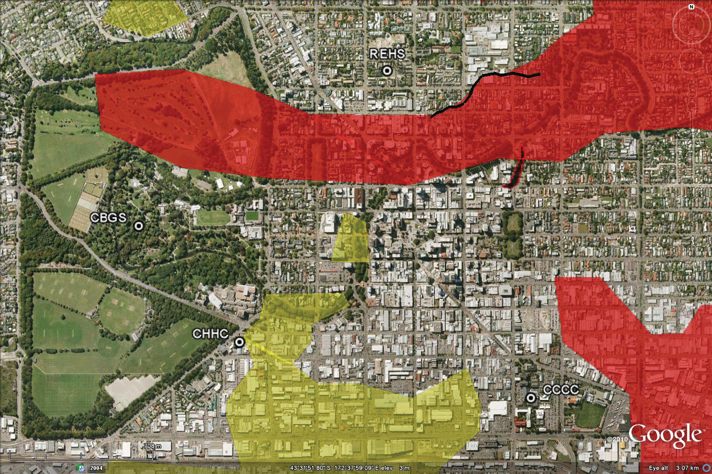
Figure 5: Preliminary liquefaction map indicating areas within the CBD affected by liquefaction in the 22 February earthquake. Legend: red = moderate to severe liquefaction; green = low to moderate liquefaction
When subject to shaking, fully saturated sand and silt soils experience a near instantaneous increase in ground water pressure. This increase in water pressure cancels the gravity loads which have held the particles together and transforms the soil into a heavy liquid state with corresponding loss of stiffness and strength. An upward flow of water to the surface relieves the pressure induced by the weight of the overburden and results in the soil/water mixture spurting from the surface in localised areas.
In its liquefied state the soil allows heavy objects to sink or settle into the ground while lighter buried objects such as empty pipes, tanks and manholes may float upwards.
Lateral Spreading
Lateral land movement is a possible consequence of liquefaction. Even on a gentle slope (2˚ to 3˚) the loss of strength of the soil coupled with the cyclic motion of the earthquake can cause a down-slope movement to occur. This is marked at the free edge of river banks and has occurred in many areas close to the banks of the Avon River. Horizontal movements in the CBD of the order of 50 to 70cm towards the river have occurred with some movements extending to a distance of 150m from the river.

Response Spectrum
The deep gravel silt and sand formations below the CBD amplify some of the periods of vibration generated by the earthquake and de-amplify others. The cyclic movement of the soils on which the structures are supported generates the forces to which the structures are subject. The amplification effect is an important feature of the Canterbury earthquake events.
An example of amplification and de-amplification is indicated in Figure 6.
The diagram shows acceleration occurring in the rock base (the red line). In this example, acceleration in the soft soil site (blue line) is reduced in periods below 0.5 seconds but is increased in longer periods – up to three times the acceleration is indicated.
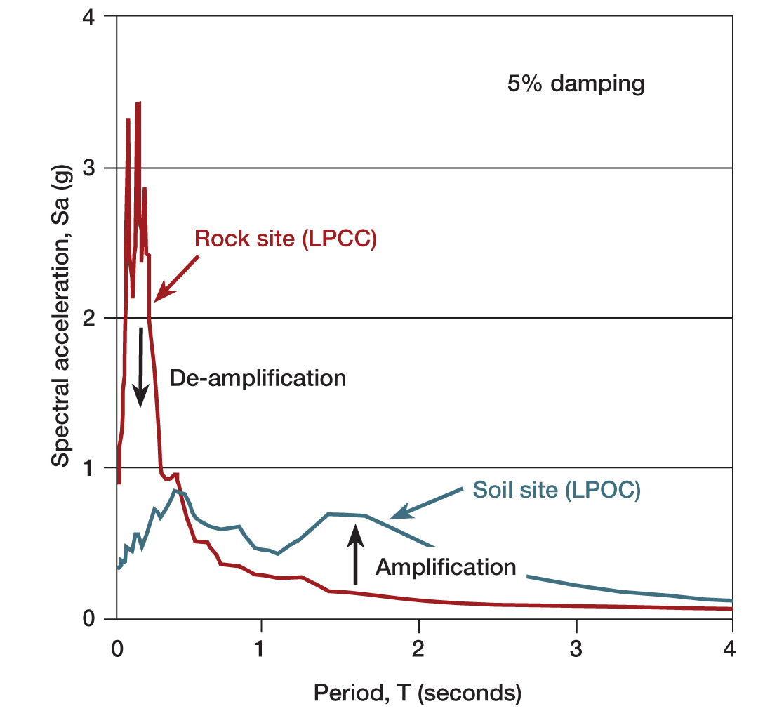
Figure 6. Acceleration response spectra recorded on rock (LPCC) and soil (LPOC) in Lyttelton during the 22 February earthquake illustrating typical effects of alluvial soils on response spectra (5% damped, elastic spectra)
Alpine Fault
The Royal Commission has noted that the Cubrinovski and McCahon report suggests that a magnitude (M_{w}) 8.0 Alpine Fault event can be expected to induce less intense liquefaction than the 22 February 2011 event. While this suggestion appears to be reasonable, it should also be noted that in such an event, areas of liquefaction can be expected to occur in other areas in Canterbury. It should also be acknowledged that there might be cases in which worse effects and poor building performance will result from the much more prolonged duration of shaking caused by an Alpine Fault event. Earthquakes generated by the Alpine Fault, or other major faults in or near the mountains and in North Canterbury, remain the most likely sources of damaging earthquakes in Christchurch once the aftershocks from the recent high stress earthquake swarm subside.

Performance of Foundations
It is obvious that the loss of strength of surface soils will have adverse effects on building foundations. Several buildings in the CBD have experienced serious consequences from the ground movement.
Table 3 below indicates a range of foundation types that have been used in the Christchurch CBD.
Table 3: Typical foundation types used within the CBD
Foundation Type | Building Type | Foundation Soils
Shallow foundations  (isolated spread footings with tie beams) | • Multi-storey buildings  • Low-rise apartment buildings | • Shallow alluvial gravel  • Shallow sands, silty sands
Shallow foundations  (raft foundations) | • Multi-storey buildings  • Low-rise apartment buildings with basement | • Shallow alluvial gravel  • Shallow sands, silty sands
Deep foundations (shallow piles) | • Low-rise apartment buildings | • Medium dense sands (soft silts and peat at shallow depths)
Deep foundations (deep piles) | • Multi-storey buildings | • Medium dense to dense sands (areas of deep soft soils or liquefiable sands underlain by dense sands)
Hybrid foundations (combined shallow and deep foundations or combined shallow and deep piles) | • Multi-storey buildings | • Highly variable foundation soils including shallow gravels and deep silty or sandy soils beneath the footprint of the building

Cubrinovski and McCahon report that the liquefaction in the CBD adversely affected the performance of many buildings resulting in differential settlements, lateral movement of foundations, the tilting of buildings and some bearing failures. The following conclusions are noted:
• buildings on shallow foundations, on loose-medium dense sands and silty sands that liquefied suffered differential settlements and residual tilts. Several buildings sank into the soil;
• pile-supported structures, when the piles reached competent soils at depth, generally showed less differential and residual movements than shallow foundations, even in areas of severe liquefaction;
• multi-storey and high-rise buildings supported on shallow foundations sitting on shallow gravels showed mixed performance. Variability in thickness of gravel and underlying soil layers resulted in some differential settlements, tilt and permanent lateral displacements. These adverse effects were especially pronounced in transition zones where ground conditions change substantially over short distances;
• hybrid building foundations (shallow and deep foundations or piles of different lengths) performed relatively poorly;
• within the CBD, zones of ground weakness (either localised over a relatively small area or sometimes continuous over several blocks) exhibited pronounced ground distortion and liquefaction that adversely affected a number of buildings. Buildings only 20 to 30m apart behaved differently, according to the condition of the ground; and
• the effects of lateral spreading within the CBD were localised but quite damaging to buildings causing sliding and stretching of the foundations and the structures.
Structure-soil-structure interaction of adjacent (multi-storey) buildings was another response feature that influenced the performance of the foundations of buildings in the CBD to some extent.
Although pile-supported structures typically suffered less damage, piles can lose support when supported in or above soils that liquefy.
There is no single foundation system that will be used to support the buildings of the future. Each structure will need foundations chosen with careful consideration of the soils beneath. A number of factors need to be considered in choosing the optimum foundation. Factors will include the size and cost of the building – a lower rise building will be of lower weight. A foundation that spreads building loads over soils in a wider area of a variable nature may be suitable (for example, raft foundations). Piled foundations for higher-rise buildings can penetrate to stronger layers at depth.
Site Investigation
One clear conclusion for the design of buildings in the CBD is the need for a very comprehensive site investigation in which the layering of soils and the soil properties of each layer are clearly understood.
In addition, the rectification of damage to the ground and subsurface due to liquefaction from the 2010
and 2011 earthquakes will need to be addressed.
The variable characteristics of the CBD soils and the extent of foundation damage as a result of the recent earthquakes have highlighted the importance of foundation design in the CBD. Knowledge of the soil layers and their characteristics to a depth of 25m is required. This knowledge may, in part, be ascertained by bores on adjacent sites if these are available. Soil parameters derived from the standard penetration (hammer) test and cone penetration tests add to the knowledge required for assessment of liquefaction and choice of foundation type and should form part of specific site investigations.
Cubrinovski and McCahon conclude that it is necessary to understand the behaviour of the soil-structure system during strong ground shaking and the contribution to this behaviour made by the foundation soils and the foundations themselves. Best practice internationally is for the issues associated with foundations on deep alluvial soils to be addressed by either:
• comprehensive geotechnical investigations of the site and robust design methodology considering the soil-foundation-superstructure system including use of in-depth analysis to scrutinise the performance of the system; or
• avoiding locations with difficult soil conditions.
After considering the discussion in the Cubrinovski and McCahon report the Royal Commission is of the view that the Christchurch City Council should require thorough foundation soils investigations to be carried out as a prerequisite to foundation design.
Piled Foundations
The choice of foundation will be specific to the building proposed. However, in the choice of pile type, the Royal Commission has been informed that driven piles have fallen out of favour. One reason given has been the noise and vibration during construction of these foundations. Piled foundations in which the load capacity of the pile can be inferred from driving records may offer advantages and should again be considered as a possible foundation.
Geotechnical Parameters
The Royal Commission acknowledges the progress that has been made in geotechnical engineering.
There is clearly a need to maintain progress in this way. The Canterbury earthquakes have shown the need for this effort to continue particularly in light of new evidence about foundation performance. Two matters have been highlighted. One is the need for better knowledge of soil profiles and properties. These demand enhanced site investigation.Secondly, the interaction of soils and structures during earthquakes requires further consideration by geotechnical and structural engineers. These matters will be further developed and included in the Royal Commission’s Final Report.
Recommendations
The Royal Commission recommends that:
1. the Christchurch City Council should require thorough soils investigations to be carried out as a prerequisite to foundation design.
2. relevant land use and building controls in the Christchurch CBD should reflect the need for care in the placement of buildings of different structural types and sizes, so that soils issues are minimised. These issues should also be considered by those proposing and designing new buildings.
3. designers of new buildings should:
a. carry out in-depth analysis of the soil- foundation-superstructure system so as to ascertain the likely performance of the system.
b. consider available local soil improvement techniques where appropriate.
4. CERA and the Christchurch City Council should consider compiling and making available a public database of all bore logs previously recorded in the CBD, in addition to those made for future buildings. In time this would yield valuable information about soil conditions throughout the CBD.

3.3 Specific Building Types – Unreinforced Masonry Buildings
URM buildings make up a large number of structures in New Zealand’s building stock. They lack the capability to resist seismic actions in contrast to more recent structures using steel and concrete reinforcing as an integral part of the building fabric. They are predominantly one, two and three storey brick buildings built for commercial purposes before earthquake-resistant building design was introduced in the 1930s.
Also included in this category are stone masonry buildings, churches and some important public buildings. Many URM buildings are treasured as valued records of our history and some continue to be used for the purposes for which they were built. Many others are now used as small-scale commercial premises much valued for their traditional character.
Unfortunately these buildings are brittle in nature and if they have not been strengthened are particularly dangerous as they may fail in moderate earthquakes. Because they are constructed from heavy materials they may inflict injury, serious damage or even death when they collapse.
Prior to the recent Canterbury earthquakes, it has been estimated that there were approximately 4,000 such buildings in New Zealand. Due to the effects of the earthquakes there may now be about 500 fewer.
The collapses that have occurred as a result of the Canterbury earthquakes were mostly within the Christchurch CBD. Altogether 42 people lost their lives due to the failure or partial failure of URM buildings in Christchurch. Their collapse caused the death of pedestrians passing by; motorists; passengers on buses parked alongside a collapsing building and of people inside buildings that fell. In at least three instances failed buildings collapsed onto neighbouring buildings killing people inside.
The Royal Commission sought advice on URM structures from Associate Professor Jason Ingham of the University of Auckland and Professor Michael Griffith of the University of Adelaide, on the performance of URM buildings in the Christchurch earthquakes. A report that they prepared for the Royal Commission, ‘The Performance of Unreinforced Buildings in the 2010/2011 Canterbury Earthquake Swarm’ (August 2011) has been published on the Royal Commission‘s website. The report covers the damage that resulted from the 4 September 2010 earthquake. The Royal Commission has requested the authors to extend their report to cover the consequences of the 22 February 2011 event.
The Ingham and Griffith report makes observations about the particular kinds of failure exhibited by
URM buildings in the 4 September earthquake. The observations need to be considered together
with the information that will be provided in their further report dealing with the 22 February earthquake, the advice of peer reviewers whom the Royal Commission has asked to advise it, the evidence and submissions that are provided by interested parties and the Royal Commission’s own investigation of the URM building failures that caused loss of life. It is however useful to record some of the observations made in the Ingham and Griffith report about the kinds of failure observed after the 4 September event:
• Chimneys – unsupported and unreinforced brick chimneys performed poorly with the majority of chimneys collapsing in domestic as well as small commercial buildings and some churches.
• Parapet failures – numerous parapet failures were observed along both building frontages and their side walls.
• Awning anchorage failures – falling parapets typically landed on awnings, leading to their collapse. Most awning supports in Christchurch involved a tension rod tied back into the building through the front wall of the building. In most cases the force on the rod exceeded the capacity of the masonry wall anchorage, causing a punching shear failure in the masonry wall identified by a crater in the masonry.
• Wall failures – inspections of out-of-plane wall damage typically indicated poor or no anchorage of the wall to its supporting timber diaphragm. It appeared that the walls were not carrying significant vertical gravity loads, other than their self-weight, as evidenced by the fact that the remaining roof structures appeared to be mostly undamaged (see Figure 7).
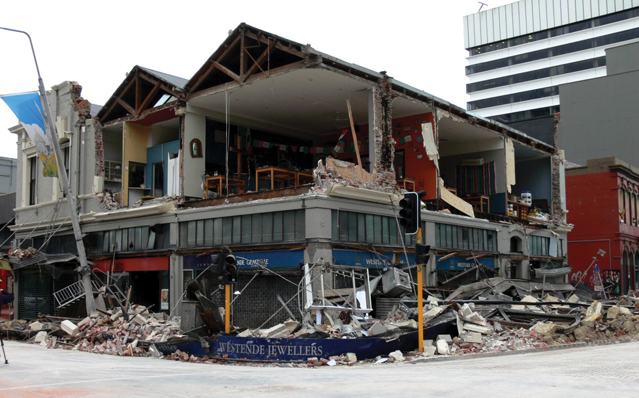
Figure 7: Corner of Worcester and Manchester streets Page 43 URM (Ingham and Griffith)

• Return wall separation – many buildings exhibited substantial cracking between their front wall and side (return) walls. This damage can be mitigated if stiff horizontal diaphragms are well connected to the wall in both directions.
• Pounding – several instances of damage due to buildings of different height pounding against each other during the earthquake were observed.
The Ingham and Griffith report also describes the potential for strengthening buildings and techniques that can be employed. It gives the authors’ opinions on the level of strength buildings should possess to provide a reasonable ability to resist collapse.
The Royal Commission has also studied the approach taken to lessen the risk of URM failure that has been followed in California, where similar forms of construction exist, and it will report on this. The Royal Commission will also discuss the performance of retro-fitted buildings in Christchurch in its Final Report.
The Royal Commission will conduct a hearing on these matters commencing on 7 November 2011 and make recommendations in regard to URM buildings in the Final Report once it has considered all of the available material. It will also be considering and making recommendations on the existing legislative provisions for buildings that are (or should be) considered as ‘earthquake-prone’, the adequacy of existing legislative powers in relation to such buildings and whether the present allocation of functions between central and local government in this area are appropriate.
However, the scale of the issue posed by URM buildings throughout New Zealand has caused the Royal Commission to make interim recommendations with the intention of reducing the current risk to public safety that these structures present.
The Ingham and Griffith report recommended a four-stage improvement process for strengthening such buildings. These stages are¹⁰:
1st stage: ensure public safety by eliminating falling hazards. This is done by securing/strengthening URM building elements that are located at height (eg, chimneys, parapets, ornaments, gable ends).
2nd stage: strengthen masonry walls to prevent out-of-plane failures. This can be done by adding reinforcing materials to the walls and by installing connections between the walls and the roof and floor systems at every level of the building so that walls no longer respond as vertical cantilevers secured only at their base.
3rd stage: ensure adequate connection between all structural elements of the building so that it responds as a cohesive unit rather than individual, isolated building components. In some situations it may be necessary to stiffen the roof and floor diaphragms, flexurally strengthen the masonry walls, and provide strengthening at the intersection between perpendicular walls.
4th stage: if further capacity is required to survive earthquake loading, then the in-plane shear strength of masonry walls can be increased or high-level interventions can be introduced, such as the insertion of steel and/or reinforced concrete frames to supplement or take over the seismic resisting role from the original unreinforced masonry structure.
The level of the hazard that earthquakes present varies according to zones that are described in NZS 1170.5. The different hazard levels alter the degree of strengthening that will be required in different locations in New Zealand. However, the limited strength of URM buildings means that all URM buildings should be retro-fitted to some degree.
The Royal Commission is of the view that steps should be taken to implement the first two of the stages described in the Ingham and Griffith report throughout New Zealand. It considers that action should be taken to implement the second stage in areas of moderate and high seismicity. These areas are where the hazard factor set out in clause 3.1.4 of NZS 1170.5 is 0.15 or higher. In both cases these steps should be taken as soon as practicable.
As a first step in an improvement process it is necessary to identify all URM building stock in New Zealand. It is essential that the presence and characteristics of these buildings is known and the Royal Commission considers that such registers should be compiled (or, where they already exist, brought up to date) with urgency.
The Royal Commission will give consideration to stages 3 and 4 discussed in the Ingham and Griffith report later in the Inquiry.
Recommendations
The Royal Commission recommends that:
5. local authorities should ensure that registers of all URM buildings, their locations and characteristics, are compiled or, where they already exist, brought up to date.
6. throughout New Zealand, URM buildings should be improved by bracing parapets, installing roof ties and securing external falling hazards in the vicinity of public spaces.
7. in areas where the hazard factor is 0.15 or higher, additional steps to provide ties at all floors should be implemented, at the same time as the work referred to in recommendation 6.
8. these recommendations should be implemented as soon as practicable.
3.4 Recommended Changes to Design Practice
Basis of recommendations
Two reports containing detailed observations by structural engineers of the effects of the earthquakes have been provided to the Royal Commission in its processes to date. They are:
1. ‘Stairs and Access Ramps between Floors in Multi-storey Buildings’, by Professor Des Bull of the University of Canterbury. This was requested by the Royal Commission because of the extensive damage observed in these elements after the 22 February earthquake. That damage hindered evacuation from a number of buildings and could have had serious consequences if more severe aftershocks had occurred. We refer to this report as the Stairs report.
2. ‘Preliminary Observations from the Christchurch Earthquakes’, by John Hare, President of the Structural Engineering Society of New Zealand (SESOC). Before this report was submitted to the Royal Commission it was considered by the management committee of SESOC and input was obtained from a number of other specialist structural engineers. This report identified shortcomings in design codes and construction practice, which had been noted by structural engineers involved in the inspection of buildings in Christchurch following the earthquakes. We refer to this report as the SESOC report.
Both reports have been placed on the Royal Commission’s website to make them available to interested structural engineers in New Zealand and elsewhere.
The reports establish that there are aspects of structural design and construction which need urgent attention in the context of the imminent rebuilding work in the central Christchurch CBD. Two of the issues raised have public safety implications for multi-storey buildings wherever they are located in New Zealand; the first relates to stairs and the second to the use of mesh to transfer critical diaphragm forces. These are referred to in recommendation 10 and discussed under Issue 4 and Issue 7 in Annexure 1 attached to this section of the Interim Report.
The issues raised involve changes to construction practice and to design standards (for example in NZS 1170.5). It is clearly important that the most pressing of the issues are addressed to prevent repetition in new construction of the same details that have been shown to have performed poorly in the Canterbury earthquakes. There is considerable urgency in taking action to avoid costly problems for the future.
The Royal Commission divided issues raised in the reports into two groups. The first consisted of seven urgent issues, which could be considered within a short time period. The second comprised issues which either required more time for consideration, or were related to further work that the Royal Commission has initiated. The issues in this category will be addressed in subsequent stages of the Inquiry.
The Royal Commission drafted a memorandum that addressed the seven issues that it considered should be dealt with urgently. The memorandum set out the issues, provided possible responses to them, and it sought feedback on these and other matters raised in the Stairs and SESOC reports. The memorandum and the two reports were then provided to all members of SESOC and to members of the Canterbury Structural Group. This resulted in the memorandum and reports being sent out to approximately 1500 practising structural engineers and senior university students interested in structural engineering. At a well-attended Canterbury Structural Group meeting one of the Commissioners briefly described the seven issues identified in the memorandum. Nine written responses were received by the nominated date.
The seven issues are outlined in Annexure 1.
The discussion is of a technical nature, principally aimed at the professional engineering community. Each discussion includes:
• the description of the issue, as stated in the memorandum, and giving the references to the relevant parts of the Stairs and SESOC reports that gave rise to that issue;
• the proposed action set out the memorandum; and
• additional background information on each issue.
Discussion
The Royal Commission has considered the responses that were received to the memorandum. Of the responses to the seven specific issues, all the comments were supportive of the proposed actions, with one exception. The exception was where one contributor disagreed with the proposed action for Issue 2, which related to the need to allow for the effects of elongation on floors and the development of a method to assess diaphragm forces in floors. The submitter asserted that “item 2 – elongation and diaphragms is completely misleading”, and finished the comment by indicating that code provisions should not be required for a structural engineer to design diaphragms. The Royal Commission is not able to follow or accept his argument.
Recommendations
In view of the support for the proposed actions in the memorandum from the structural engineering community, the Royal Commission now endorses
the proposals and recommends:
9. establishment of a small group of structural engineers, which involves suitably qualified practising engineers and one or more engineers who are familiar with structural research, to draw up guidelines for the issues raised in this Interim Report (refer Annexure 1);
10. implementation of the guidelines (drawn up from recommendation 9 above) by CERA and the local authorities in greater Christchurch (as that term is defined in the Canterbury Earthquake Recovery
Act 2011).
That Act provides the means by which this can be achieved. Where the guidelines require changes to existing practices adopted in order to comply with the Building Act 2004, an Order in Council could be made implementing the guidelines, on the recommendation of the relevant Minister as provided for in section 71 of the Canterbury Earthquake Recovery Act 2011. In the Royal Commission’s view, such an Order in Council would be within the ambit of section 3(a), (f) and (h) of that Act, in that it would:
(a) provide appropriate measures to ensure that greater Christchurch responds to and recovers from the Canterbury earthquakes;
(b) facilitate and direct the rebuilding and recovery of affected communities, including the repair and rebuilding of “land, infrastructure and other property”; and
(c) provide adequate statutory power for those purposes.
The guidelines would apply in greater Christchurch until such time as national building standards have been revised to ensure the shortcomings in current practices have been adequately corrected.
11. that Standards New Zealand be required to initiate the process of amending current building standards in light of the findings from the Canterbury earthquakes referred to above;
12. that the proposed guidelines for the rebuild of greater Christchurch be referred to practising structural engineers to alert them to issues that should be avoided in new construction in other centres in New Zealand; and
13. that the following issues be referred to building consent authorities in other centres in New Zealand:
• the potential vulnerability of buildings where mesh has been used to transfer critical seismic actions to lateral force resisting elements; and
• the vulnerability of stairs in multi-storey buildings designed to meet the minimum inter-storey drift requirements given in previous and current loadings standards (NZS 4203 and NZS 1170.5). This issue has been addressed in Practice Advisory 13, Egress stairs issued by the Department of Building and Housing when this report was in final draft.
3.5 New Building Technologies
Alternative building technologies have been and are being developed, which enable the damage sustained in major earthquakes to be reduced. The Royal Commission has received and published on its website a report entitled ‘Base Isolation and Damage-Resistant Technologies for Improved Seismic Performance of Buildings’, which has been prepared for it by Professor Andrew Buchanan and others of the University of Canterbury. The Royal Commission considers that structural engineers and architects involved in the rebuild of Christchurch should be aware of the content of the report. It is likely that adoption of one or more of these new technologies would result in improved seismic performance of new buildings in Christchurch.
Several new technologies are described in the report. The first is base isolation, which has been used for a number of new buildings and the seismic retrofit of existing structures. This methodology involves the incorporation in the structure of devices which allow the building to move relative to the ground. It is probably not accurate to describe the methodology as new. The lead rubber bearing, used in the majority of cases, was developed in 1974 by Bill Robinson, a New Zealander, who at the time worked for the DSIR in Wellington. Lead rubber bearings have been used extensively around the world and it is now estimated that buildings worth more than US$100 billion have been base-isolated using these bearings. In New Zealand, lead rubber bearings were used for base isolation of the William Clayton building in Wellington. This was the first building to be base-isolated using this technique. Such bearings have subsequently been used in New Zealand in the construction of Te Papa, the new Wellington Hospital, Victoria University library and the seismic retrofit of Parliament Buildings.
Lead rubber bearings, or other base isolation devices, do not work for all buildings. They work best for stiff relatively low-rise structures, preferably located on firm soils. However, one Christchurch building, the Christchurch Women’s Hospital is base-isolated, and it came through the Christchurch earthquakes with no significant damage. Base isolation is ineffective for high-rise buildings, particularly where they are mounted on deep soft soils.
The current approach to the seismic design of structures in New Zealand and other developed countries is to limit the forces that can be induced into a structure by limiting the strength at key locations in structural elements. This approach is referred to as capacity design. The flexural or shear strength at specific locations in key structural members is limited and these zones are detailed to enable them to sustain the required level of inelastic deformation without losing strength. This deformation occurs as a result of yielding of reinforcement or structural steel members, and/or crushing of concrete. When the limiting structural action ceases, the inelastic deformation remains, the structure does not return to its original position and it sustains structural damage.
PRESSS technology was initially developed in California in the 1990s, but has been further researched and developed in New Zealand. This approach has some similarity to the current approach in that the flexural strength at key locations in structural members is limited. However, in this case the individual structural components are designed to remain elastic, so that after the shaking has stopped the structure returns to its initial position and any structural damage that is sustained is minimal. It has been used on a number of buildings in New Zealand, including the Southern Cross Hospital Endoscopy Building in Christchurch, which came through the Christchurch earthquakes with minimal damage.
In the PRESSS structural system, structural components are held in position by unbonded post-tensioned cables. Walls, for example, are stressed down to foundation beams so that when subjected to major shaking the wall can rock on the foundation, but when the shaking stops the wall returns to its initial position in an undamaged state. Beams are stressed by cables to the columns supporting them. Again, under intense shaking the beam can rock against the column, but it returns to its initial position when the shaking stops. The rocking action limits the magnitude of the forces that are induced in the structural components, which prevents significant structural damage from occurring. The motion of the building is reduced by incorporating damping devices (devices that dissipate energy) into the structure and this reduces the non-structural damage sustained by wall linings, other components of the building and to the contents of the building.
After a major earthquake it may be necessary to replace the damping devices. There are a number of issues that need to be resolved with this structural system. However, structural testing has shown that the system can provide better seismic performance than that resulting from conventional design practice. PRESSS technology has been used in a number of overseas buildings.
PRESSS technology has been extended to structural timber buildings by research and development carried out in New Zealand and it shows considerable promise. It has been tested in a 2/3 full-scale test and it has been used in a number of recent buildings in New Zealand. The first building using this technology was the NMIT building in Nelson and the second building was the Carterton Events Centre, north of Wellington. The technology potentially has much to recommend it. It is a technology developed in New Zealand, which uses a renewable New Zealand resource and it is an environmentally friendly method of construction.
A problem with PRESSS buildings arises from gapping, which occurs with rocking, as illustrated in Figure 8 on page 43. The problem is that the gap that opens up between the column and the top of the beam can tear the floor attached to the beam. This can cause reinforcement in the floor slab to fail and it can degrade the ability of the floor to hold the buildings’ components together, which is an essential feature of floors. This appears to be less of a problem with timber buildings than with structural concrete or structural steel buildings due to the flexibility of the timber and its fastening. To overcome the problem with concrete and structural steel buildings, non-tearing systems have been developed where the relative rotation between beams and columns is restricted by forming slots in the beams against the column faces. With this system, which is illustrated in Figure 9 below, rotation occurs by the slot closing on one side and opening on the other. In its simplest form the reinforcement in the bottom of the beam yields in tension on the opening side and it yields in compression on the closing side. Similar arrangements can be used with structural steel members, but in this case the tension/compression force on the bottom of the beam is transferred across the slot by plates, which are welded to the columns but clamped to the bottom flange of the beams by high tensile friction grip bolts. When the force in the plate reaches a critical level the plate slides against the bottom flange of the beam allowing the gap to open or close. The friction acts to dissipate energy and as such it acts as a damper.
A problem with the non-tearing floor construction method is that after an earthquake the structure does not return to its original position. However, by including non-tearing floor construction with walls held down to foundations by unbonded cables (as in PRESSS systems), the rocking action of the wall can push the building back into its initial, undistorted shape.
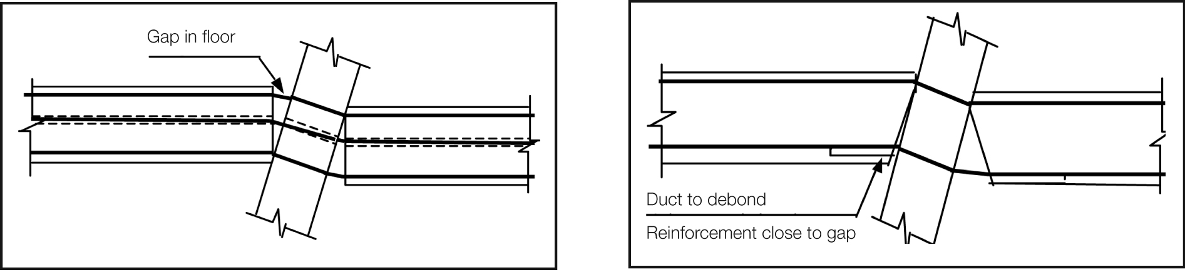
Figure 8: Gapping in floor Figure 9: Non-tearing floor

Recommendations
The Royal Commission recommends that:
14. designers give consideration to the use of the new technologies discussed above and described in the report ‘Base Isolation and Damage-Resistant Technologies for Improved Seismic Performance of Buildings’ in designing new structures to be erected in the Christchurch CBD; and
15. urgent work be carried out to enable appropriate provisions to be incorporated in the relevant structural design actions standards (AS/NZS 1170.0:2022, Structural design actions – Part O: General principles and NZS 1170.5 together with the material design standards (NZS 3101:1995, Concrete Structures Standard – The design of Concrete Structures, NZS 3404.1:2009, Steel Structures Standard – Materials, fabrication and construction and NZ 3603:1993, Timber Structures Standard) so as to facilitate the use of these technologies.

Annexure 1
Issue 1: Maximum Considered Earthquake Design Actions
(a) Design for the Maximum Considered Earthquake (MCE)
is mentioned in the commentary to the Earthquake Actions Standard, NZS 1170.5, where it indicates that material strain limits for the Ultimate Limit State (ULS) have been provided to give a margin of safety against collapse for the MCE limit state. However, the standard does not contain reference to this limit state or indicate where this limit state should be considered.
(b) The return period for the MCE needs to be clearly identified for the different building classifications. Should the MCE be based on a return period of 2,500 years for all building classifications, or should this change with building importance?
See SESOC report sections 1.1 and 2.3 and Stairs report
Proposed actions
Introduce the MCE limit state into the Earthquake Actions Standard, NZS 1170.5 and identify how this limit state should be satisfied.
Additional background information on Issue 1
Structural Design Actions, Part 5: Earthquake Actions New Zealand, NZS 1170.5 defines the earthquake actions that need to be considered in design. Clause 2.1.1 requires that all structures comply with the requirements set out in the standard for the ‘ultimate limit state’ (ULS) and the ‘serviceability limit state’ (SLS).
The ULS is designed to provide a high level of protection against loss of life in a major earthquake (typically having a return period of 500 years, or more if the building has a high ‘importance level’). The importance level classification of buildings is set out in Structural Design Actions Part 0: General principles, AS/NZS 1170.0:2002.
The SLS provides protection against damage in an earthquake that has a return period which is generally of the same order as the design life of the structure. In the case of some buildings, classified as those with ‘special post-disaster functions’ (for example, major infrastructure facilities and medical emergency facilities) the SLS is raised to a return period of 500 years.
The commentary to NZS1170.5 states in clause C2.1, on page 9, that “[I]t is inherent within” NZS 1170.5 that “in order to ensure an acceptable risk of collapse, there should be a reasonable margin between the performance of material and structural form combinations at the ULS and at the collapse limit state.” The ‘collapse limit state’ is based on the MCE. The clause goes on to indicate that a margin of at least 1.5 to 1.8 is required. This comment suggests that regardless of the ULS return period the material strain limits required for the MCE are equal to a constant 1.8 (or 1.5) times the corresponding value given for the ULS, which implies that the return period for the MCE increases as the importance of the building (classification) increases.
Clause C1.4 of the commentary to NZS 1170.5 provides for ‘special studies’, which may be carried out to justify variations from specific provisions of NZS 1170.5. C1.4(d) gives as an example of special studies: “[d]etermination of maximum material strains for a specific detail shall be capable of dependably sustaining the deformations resulting from the design level event and having sufficient reserve capacity to contribute to a resistant system when subjected to deformations resulting from a very rare (2,500 year return period) event.” This indicates the MCE return period should be 2,500 years and that it is independent of the building’s classification. For normal commercial buildings with a return period for the ULS of 500 years, the 1.8 (or 1.5) factor implies a return period for the MCE design action of 2,500 years.
Setting material strain limits so that they satisfy the ULS and MCE conditions is logical for the majority of design of earthquake actions. An exception arises when designing elements that are sensitive to inter-storey drift or lateral deflection. Stairs are a particular case in point. At present the Standard contains no reference to, or requirements for, consideration of the MCE. Consequently the inter-storey drift limits for stairs are calculated based on ULS design actions. However, after a major earthquake rapid egress from buildings is highly desirable, particularly in view of the heightened chance of fire. It is important that stairs and other means of egress remain available for use, and as such it would seem logical that they be designed to sustain, without collapse, the displacements associated with the MCE actions. Likewise other structural elements that may cause the egress ways to be blocked should be designed to sustain the MCE actions.
Issue 2: Elongation in reinforced concrete members
Elongation, which occurs in structural concrete members when flexural cracks form, greatly increases when plastic hinges develop. This action has been observed to cause damage in beams, floors and potentially in walls. The damage in floors constructed with precast units to have been particularly significant with:
• wide cracks developing at the boundaries of the precast units preventing the floor acting as a diaphragm that transfers forces or restrains columns from buckling;
• the wide cracks inducing high strains in reinforcement leading to either failure of the bars or strain levels that
call into question the remaining life of the reinforcement;
• a suitable design method required to enable design diaphragm actions to be established and to identify how such forces can be transmitted to the lateral force resisting elements making a rational allowance for the existence of the wide cracks; and
• in addition elongation in walls can increase the axial load carried by these elements.
See SESOC report sections 3.2.5; 3.2.6; 3.3.1; 3.3.6; 6.1.1.1 and 10.4.2.1 and Stairs report section 3.0
Proposed actions
Introduce information on the magnitudes of elongation in the Concrete Structures Standard, NZS 3101: 2006 and where wide cracks may be initiated due to elongation.
Recommend that research is initiated to establish a practical method for determining design actions in diaphragms.
Additional background information on Issue 2
Elongation of beams associated with the formation of plastic hinges has been observed and recorded in many structural tests of beams, columns and beam-column-slab sub-assemblies. In addition, a number of tests have been made of sub-assemblies consisting of floors, built up from precast units and in situ concrete, which are supported by reinforced concrete beams and columns. Under lateral loading, representative of seismic actions, elongation in the plastic hinges has resulted in wide cracks forming between the junctions of the floors and the supporting beams, and separation of some perimeter columns from the floors.
Observation of the seismic damage in the Christchurch earthquakes shows that the behaviour observed in the laboratories occurred in an appreciable number of buildings. In particular, wide cracks have developed and caused reinforcement to be strained to a high level and a considerable amount of mesh reinforcement fractured. In at least one case the connection of several columns to the floor slabs has been seriously weakened.
To enable rational design to allow for actions induced by elongation:
• design magnitudes of elongation associated with material strain levels in reinforced concrete members should be specified in the Concrete Structures Standard, NZS 3101: 2006;
• details should be given of where the resultant elongation induced cracks may be expected to form in a major earthquake and the implications this has for diaphragm actions in floors; and
• a rational method is required for assessing diaphragm forces that floors are required to sustain in design level earthquakes.
Issue 3: Performance of structural walls
Structural walls have not performed as anticipated from the results of structural testing. A number of issues need to be addressed as noted below:
• flexural cracking in walls in some cases has been limited to one crack, which has implications for the distribution and quantity of longitudinal reinforcement in walls;
• anti-buckling reinforcement may be required in mid regions of walls in addition to the end zones;
• compression failure occurred in a number of cases in the outstanding legs of T and L walls;
• increased axial compression force associated with elongation; and
• significance of out-of-plane displacements acting on structural walls.
See SESOC report sections 3.3.5; 3.3.6; 3.3.7; 6.1.3.3; 6.2.1; 6.2.2 and 6.2.6
Proposed actions
Revise existing minimum longitudinal reinforcement requirements in the Concrete Structures Standard to give higher reinforcement proportions in the critical flexural tension regions of walls, and revise requirements for buckling restraint.
Recommend that research is initiated on the influence of elongation on axial forces in walls and on the significance of out-of-plane displacements being applied to structural walls sustaining in-plane forces.
Additional background information on Issue 3
In the Concrete Standard, NZS 3101: 2006, clause 11.3.11.2 (c), the minimum proportion of longitudinal reinforcement in beams and walls is given as √_ ƒ´_{c} 4ƒ_{y}, which corresponds to a direct tensile stress in the concrete of √_ƒ´_{c} 4. This is only a small proportion of the likely direct tensile strength of concrete, which could be of the order of 0.75√_ƒ´_{c} if the supplied concrete has a compressive strength of close to 50 per cent in excess of the minimum specified value and a tensile strength that is consistent with an upper characteristic value. With the current specified minimum reinforcement proportions it could be anticipated that only one crack may form causing yielding of the reinforcement to be confined to a short length, potentially resulting in brittle failure. Concentrating longitudinal reinforcement in the critical tension zones of walls and beams should enable the tension force transmitted across cracks to be of a sufficient magnitude to cause additional cracks to form, thus allowing yielding to spread over an increased length of reinforcement so that ductile behaviour is achieved.
Current requirements for confinement of concrete in potential plastic hinge zones in walls are based on the length of the compression zone when it is subjected to maximum capacity design actions. However, under these actions high tensile strains can be induced in the mid region of a wall, which makes this reinforcement sensitive to buckling when the lateral forces decrease but the axial force remains. For this situation anti-buckling reinforcement may be required for stability of longitudinal reinforcement in the mid-regions of walls between the extreme tension and compression fibres. It should also be noted that with longitudinal reinforcement in tension in the mid region of a wall elongation is implied. Floors located above the plastic hinge zone may act to restrain this elongation by transferring forces to other vertical elements (columns or other walls). This restraint can greatly increase the magnitude of the axial force acting on a wall containing a plastic region. As this action is not considered in standard methods of analysis the design axial force in a wall sustaining a plastic hinge may be very significantly under-estimated, and hence potential crushing and buckling failures may not be predicted.
Tests on structural walls have in general been carried out by applying in-plane forces. However, in an earthquake, in-plane actions are invariably associated with out-of-plane displacements that induce out-of-plane shear and bending actions. While these actions are of a small magnitude, it is possible that they may have a significant effect on behaviour. The effect of these out-of-plane forces needs to be studied particularly in the situations where the distance from the neutral axis to the extreme compression fibre is an appreciable length of the wall. The likely adverse effects associated with out-of-plane actions and increased axial forces due to elongation can in part be reduced by providing structural walls with boundary elements.
A number of T and L shaped walls, which lack symmetry, have not performed as well as anticipated in design standards. Further study of these structural elements is required to enable rational design criteria to be developed.
Issue 4: Performance of stairs in multi-storey buildings
Stairs are required for egress after a major earthquake. Consequently it is proposed that they should be designed on the basis of the MCE. The Stairs report indicates that the inter-storey drifts found from previous and current design standards are inadequate to satisfy even the ULS. The report contains a number of recommendations on design actions for stairs in multi-storey buildings.
See the entire Stairs report and the SESOC report sections 1.1.3.1 and 2.3
Proposed actions
Recommend amendment of NZS 1170.5 to require stairs and access ramps to be designed to sustain the peak inter-storey displacements appropriate for the MCE limit state.
Additional background information on Issue 4
In the Stairs report it is noted that serious damage was sustained to stairs in an appreciable number of multi-storey buildings, which indicates that there is an urgent need to change design and construction practice for these elements. A review of previous loadings standards (NZS 4203:1976 to 1992, Code of Practice for General Structural Design and Design Loadings for Buildings) and the current standard (NZS 1170.5) indicates that there is a basic flaw in previous and current design criteria for stairs. The inter-storey drift that these elements are required to sustain does not correspond to the peak displacement implied by the design concepts on which the standards are based. Currently the design inter-storey drift is taken as a value that is appreciably smaller than the peak predicted drift. This arises from the use of the structural performance factor, S_{p}, to reduce the design level accelerations. In the commentary to NZS 1170.5 clause C4.4 states that “calculated loads correspond to the peak acceleration which happens only once and therefore are unlikely to lead to significant damage”. However, the peak displacement is linked to the peak acceleration, hence the use of the S_{p} factor gives an inter-storey drift that is less than the maximum value. It is strongly recommended that design criteria contained in NZS 1170.5 are amended to correct this anomaly and that stairs, access ramps and passages required for egress are designed to sustain actions associated with the MCE to ensure that they are available for egress in the event of a major earthquake.
Issue 5: Significance of vertical acceleration on seismic performance
In a number of clauses in the SESOC report it was indicated that research was required on the impact of vertical accelerations on structures.
See SESOC report sections 1.1.3.2; 3.1.7 and 3.3.4
Proposed action
Recommend that research be initiated to determine the impact of vertical seismic ground motion on the performance of structures.
Additional background information on Issue 5
Recorded vertical ground motions in the Canterbury region indicate that there is a major mismatch between observed and design spectra for vertical seismic ground motion. The significance of vertical ground motion needs to be examined to see if current design criteria should be amended to require greater consideration for this action. The mismatch between current design spectra for vertical ground motion and observed spectra for vertical ground motion also needs to be addressed.
Issue 6: Behaviour of structural walls
and beams
In an appreciable number of cases it was noted that the observed crack patterns in reinforced concrete walls and beams did not correspond to those observed in structural tests carried out in laboratories. In some cases the observed performance was poorer than expected. Several possible reasons have been advanced to explain this situation.
• In structural tests small cycles of displacement are applied and these are increased in subsequent cycles.
The initial cycles may cause significant bond deterioration to occur, which by allowing slip to develop may reduce peak reinforcement strains considerably below those that would be sustained if the peak displacement had been applied near the start of the test; and
• In laboratory tests the concrete strength is generally well controlled. However, in practice the concrete strength can be very much higher than was assumed in design. The greater tensile strength can limit the distribution of cracks and consequently minimum reinforcement contents may be inadequate to ensure ductile performance. Research is required on loading sequences used in tests, which are not representative of all seismic conditions.
See SESOC report sections 3.3.7; 6.1.1.2; 6.1.3.1; 6.1.3.2; 6.1.3.3; 6.1.3.4; and 6.2.1
Proposed actions
Recommend that research is initiated to assess the significance of the sequence of loading on structural performance of structural walls and beams with reinforcement contents typical of construction practice.
Recommend that concrete strengths be assessed by taking cores, or other appropriate methods, from walls and other structural elements, where the crack pattern differs significantly from the anticipated crack pattern obtained in structural tests.
Additional background information on Issue 6
Since the early 1970s it has been common practice to test reinforced concrete structural elements under cyclic loading, where the magnitude of displacement cycles is progressively increased as the test progresses. With reinforced concrete members, at each inelastic displacement, the reinforcement yields at the critical section. For beam-column sub-assemblies this section is in the beams at the face of the column, while for walls and columns it is at the face of the foundation beam. The application of gradually increasing cyclic displacements has two effects:
• each time the bar yields it is forced to slip relative to the surrounding concrete, and this movement degrades the bond capacity over a length of bar, which increases yield penetration adjacent to the critical section; and
• the reversing load cycles reduce the shear resistance provided by concrete and this leads to diagonal cracking, which increases the length over which longitudinal reinforcement yields in a member (tension lag).
A consequence of this is that applications of gradually increasing magnitude of inelastic displacements during tests significantly increases the length over which longitudinal reinforcement yields, when the critical displacement is applied. For this situation the critical strain level in the reinforcement is reduced compared to that which would have been sustained if the major displacement had been applied without the initial inelastic load cycles.
Research is required to establish the significance of loading sequence on behaviour to see if current test results are representative of those that would be sustained where the peak displacements are induced at the start of the test, or earthquake, as was the case with the Canterbury earthquakes of 2010 and 2011.
Issue 7: Mesh reinforcement in existing buildings
Mesh in topping concrete placed above precast units or tray-deck type sections has been observed to fail in a number of buildings in a brittle manner. Due to its brittle characteristics doubt exists as to this material’s ability to safely transfer tension forces between structural elements.
See SESOC report section 3.2.5
Proposed action
Recommend that where mesh has been designed to transfer forces, which are essential for the stability of a building, retrofit is carried out to ensure the critical forces can be transmitted by ductile reinforcement or other structural members.
Additional background information on Issue 7
Brittle failure of mesh was observed in several multi-storey buildings. This confirmed observations made in structural tests of the poor performance of this material in terms of its ductility. The brittle failure of mesh appears to have serious adverse effects on the stability of buildings in the Canterbury earthquakes, where it has been designed to transfer critical seismic actions to lateral force resisting elements.

Appendix 1
Terms of Reference
Royal Commission of Inquiry into Building Failure caused by Canterbury Earthquakes
Elizabeth the Second, by the Grace of God Queen of New Zealand and her Other Realms and Territories, Head of the Commonwealth, Defender of the Faith:
To The Honourable MARK LESLIE SMITH COOPER, of Auckland, Judge of the High Court of New Zealand; Sir RONALD POWELL CARTER, KNZM, of Auckland, Engineer and Strategic Advisor; and RICHARD COLLINGWOOD FENWICK, of Christchurch, Associate Professor of Civil Engineering:
GREETING:
Recitals
WHEREAS the Canterbury region, including Christchurch City, suffered an earthquake on 4 September 2010 and numerous aftershocks, for example—
(a) the 26 December 2010 (or Boxing Day) aftershock; and
(b) the 22 February 2011 aftershock:
WHEREAS approximately 180 people died of injuries suffered in the 22 February 2011 aftershock, with most of those deaths caused by injuries suffered wholly or partly because of the failure of certain buildings in the Christchurch City central business district (CBD), namely the following 2 buildings:
(a) the Canterbury Television (or CTV) Building; and
(b) the Pyne Gould Corporation (or PGC) Building:
WHEREAS other buildings in the Christchurch City CBD, or in suburban commercial or residential areas in the Canterbury region, failed in the Canterbury earthquakes, causing injury and death:
WHEREAS a number of buildings in the Christchurch City CBD have been identified as unsafe to enter following the 22 February 2011 aftershock, and accordingly have been identified with a red card to prevent persons from entering them:
WHEREAS the Department of Building and Housing has begun to investigate the causes of the failure of 4 buildings in the Christchurch City CBD (the 4 specified buildings), namely the 2 buildings specified above, and the following 2 other buildings:
(a) the Forsyth Barr Building; and
(b) the Hotel Grand Chancellor Building:
WHEREAS it is desirable to inquire into the building failures in the Christchurch City CBD, to establish—
(a) why the 4 specified buildings failed severely; and
(b) why the failure of those buildings caused such extensive injury and death; and
(c) why certain buildings failed severely while others failed less severely or there was no readily perceptible failure:
WHEREAS the results of the inquiry should be available to inform decision-making on rebuilding and repair work in the Christchurch City CBD and other areas of the Canterbury region:
Appointment and order of reference
KNOW YE that We, reposing trust and confidence in your integrity, knowledge, and ability, do, by this Our Commission, nominate, constitute, and appoint you, The Honourable MARK LESLIE SMITH COOPER, Sir RONALD POWELL CARTER, and RICHARD COLLINGWOOD FENWICK, to be a Commission to inquire into and report (making any interim or final recommendations that you think fit) upon (having regard, in the case of paragraphs (a) to (c), to the nature and severity of the Canterbury earthquakes)—
Inquiry into sample of buildings and 4 specified buildings
(a) in relation to a reasonably representative sample of buildings in the Christchurch City CBD, including the 4 specified buildings as well as buildings that did not fail or did not fail severely in the Canterbury earthquakes—
(i) why some buildings failed severely; and
(ii) why the failure of some buildings caused extensive injury and death; and
(iii) why buildings differed in the extent to which—
(A) they failed as a result of the Canterbury earthquakes; and
(B) their failure caused injury and death; and
(iv) the nature of the land associated with the buildings inquired into under this paragraph and how it was affected by the Canterbury earthquakes; and
(v) whether there were particular features of a building (or a pattern of features) that contributed to whether a building failed, including (but not limited to) factors such as—
(A) the age of the building; and
(B) the location of the building; and
(C) the design, construction, and maintenance of the building; and
(D) the design and availability of safety features such as escape routes; and
(b) in relation to all of the buildings inquired into under paragraph (a), or a selection of them that you consider appropriate but including the 4 specified buildings,—
(i) whether those buildings (as originally designed and constructed and, if applicable, as altered and maintained) complied with earthquake-risk and other legal and best-practice requirements (if any) that were current—
(A) when those buildings were designed and constructed; and
(B) on or before 4 September 2010; and
(ii) whether, on or before 4 September 2010, those buildings had been identified as “earthquake-prone” or were the subject of required or voluntary measures (for example, alterations or strengthening) to make the buildings less susceptible to earthquake risk, and the compliance or standards they had achieved; and
(c) in relation to the buildings inquired into under paragraph (b), the nature and effectiveness of any assessment of them, and of any remedial work carried out on them, after the 4 September 2010 earthquake, or after the 26 December 2010 (or Boxing Day) aftershock, but before the 22 February 2011 aftershock; and
Inquiry into legal and best-practice requirements
(d) the adequacy of the current legal and best-practice requirements for the design, construction, and maintenance of buildings in central business districts in New Zealand to address the known risk of earthquakes and, in particular—
(i) the extent to which the knowledge and measurement of seismic events have been used in setting legal and best-practice requirements for earthquake-risk management in respect of building design, construction, and maintenance; and
(ii) the legal requirements for buildings that are “earthquake-prone” under section 122 of the Building Act 2004 and associated regulations, including—
(A) the buildings that are, and those that should be, treated by the law as “earthquake-prone”; and
(B) the extent to which existing buildings are, and should be, required by law to meet requirements for the design, construction, and maintenance of new buildings; and
(C) the enforcement of legal requirements; and
(iii) the requirements for existing buildings that are not, as a matter of law, “earthquake-prone”, and do not meet current legal and best-practice requirements for the design, construction, and maintenance of new buildings, including whether, to what extent, and over what period they should be required to meet those requirements; and
(iv) the roles of central government, local government, the building and construction industry, and other elements of the private sector in developing and enforcing legal and best-practice requirements; and
(v) the legal and best-practice requirements for the assessment of, and for remedial work carried out on, buildings after any earthquake, having regard to lessons from the Canterbury earthquakes; and
(vi) how the matters specified in subparagraphs (i) to (v) compare with any similar matters in other countries; and
Other incidental matters arising
(e) any other matters arising out of, or relating to, the foregoing that come to the Commission’s notice in the course of its inquiries and that it considers it should investigate:
Matters upon or for which recommendations required
And, without limiting the order of reference set out above, We declare and direct that this Our Commission also requires you to make both interim and final recommendations upon or for—
(a) any measures necessary or desirable to prevent or minimise the failure of buildings in New Zealand due to earthquakes likely to occur during the lifetime of those buildings; and
(b) the cost of those measures; and
(c) the adequacy of legal and best-practice requirements for building design, construction, and maintenance insofar as those requirements apply to managing risks of building failure caused by earthquakes:
Exclusions from inquiry and scope of recommendations
But, We declare that you are not, under this Our Commission, to inquire into, determine, or report in an interim or final way upon the following matters (but paragraph (b) does not limit the generality of your order of reference, or of your required recommendations):
(a) whether any questions of liability arise; and
(b) matters for which the Minister for Canterbury Earthquake Recovery, the Canterbury Earthquake Recovery Authority, or both are responsible, such as design, planning, or options for rebuilding in the Christchurch City CBD; and
(c) the role and response of any person acting under the Civil Defence Emergency Management Act 2002, or providing any emergency or recovery services or other response, after the 22 February 2011 aftershock:
Definitions
And, We declare that, in this Our Commission, unless the context otherwise requires,—
best-practice requirements
includes any New Zealand, overseas country’s, or international standards that are not legal requirements
Canterbury earthquakes
means any earthquakes or aftershocks in the Canterbury region—
(a) on or after 4 September 2010; and
(b) before or on 22 February 2011
Christchurch City CBD
means the area bounded by the following:
(a) the 4 avenues (Bealey Avenue, Fitzgerald Avenue, Moorhouse Avenue, and Deans Avenue); and
(b) Harper Avenue
failure
in relation to a building, includes the following, regardless of their nature or level of severity:
(a) the collapse of the building; and
(b) damage to the building; and
(c) other failure of the building
legal requirements
includes requirements of an enactment (for example, the building code):
Appointment of chairperson
And We appoint you, The Honourable MARK LESLIE SMITH COOPER, to be the chairperson of the Commission:
Power to adjourn
And for better enabling you to carry this Our Commission into effect, you are authorised and empowered, subject to the provisions of this Our Commission, to make and conduct any inquiry or investigation under this Our Commission in
the manner and at any time and place that you think expedient, with power to adjourn from time to time and from place to place as you think fit, and so that this Our Commission will continue in force and that inquiry may at any time and place be resumed although not regularly adjourned from time to time or from place to place:
Information and views, relevant expertise, and research
And you are directed, in carrying this Our Commission into effect, to consider whether to do, and to do if you think fit, the following:
(a) adopt procedures that facilitate the provision of information or views related to any of the matters referred to in the order of reference above; and
(b) use relevant expertise, including consultancy services and secretarial services; and
(c) conduct, where appropriate, your own research; and
(d) determine the sequence of your inquiry, having regard to the availability of the outcome of the investigation by the Department of Building and Housing and other essential information, and the need to produce an interim report:
General provisions
And, without limiting any of your other powers to hear proceedings in private or to exclude any person from any of your proceedings, you are empowered to exclude any person from any hearing, including a hearing at which evidence is being taken, if you think it proper to do so:
And you are strictly charged and directed that you may not at any time publish or otherwise disclose, except to His Excellency the Governor-General of New Zealand in pursuance of this Our Commission or by His Excellency’s direction, the contents or purport of any interim or final report so made or to be made by you:
And it is declared that the powers conferred by this Our Commission are exercisable despite the absence at any time of any 1 member appointed by this Our Commission, so long as the Chairperson, or a member deputed by the Chairperson to act in the place of the Chairperson, and at least 1 other member, are present and concur in the exercise of the powers:
Interim and final reporting dates
And, using all due diligence, you are required to report to His Excellency the Governor-General of
New Zealand in writing under your hands as follows:
(a) not later than 11 October 2011, an interim report, with interim recommendations that inform early decision-making on rebuilding and repair work that forms part of the recovery from the Canterbury earthquakes; and
(b) not later than 11 April 2012, a final report:
And, lastly, it is declared that these presents are issued under the authority of the Letters Patent of Her Majesty Queen Elizabeth the Second constituting the office of Governor-General of New Zealand, dated 28 October 1983*, and under the authority of and subject to the provisions of the Commissions of Inquiry Act 1908, and with the advice and consent of the Executive Council of New Zealand.
In witness whereof We have caused this Our Commission to be issued and the Seal of New Zealand to be hereunto affixed at Wellington this 11th day of April 2011.
Witness Our Trusty and Well-beloved The Right Honourable Sir Anand Satyanand, Chancellor and Principal Knight Grand Companion of Our New Zealand Order of Merit, Principal Companion of Our Service Order, Governor-General and Commander-in-Chief in and over Our Realm of New Zealand.
ANAND SATYANAND, Governor-General.
By His Excellency’s Command—
JOHN KEY, Prime Minister.
Approved in Council—
REBECCA KITTERIDGE, Clerk of the Executive Council.
*SR 1983/225

Appendix 2
List of Expert Advisors
Andrew Buchanan, Professor of Timber Design, Department of Civil and Natural Resources Engineering, University of Canterbury
Desmond Bull, Holcim Adjunct Professor in Concrete Design, University of Canterbury
Athol J. Carr, Professor Emeritus, Department of Civil and Natural Resources Engineering, University of Canterbury
Misko Cubrinovski, Associate Professor Emeritus, Department of Civil and Natural Resources Engineering, University of Canterbury
Rajesh Dhakal, Associate Professor, Civil and Natural Resources Engineering, University of Canterbury
GNS Science, Wellington
Michael C. Griffith, Professor, Department of Civil, Environmental and Mining Engineering, University
of Adelaide
William T. Holmes, Senior Consultant, Rutherford and Chekene, San Francisco, USA
Jason M. Ingham, Associate Professor, Department of Civil and Environmental Engineering, University
of Auckland
Institution of Professional Engineers New Zealand (IPENZ)
Ian McCahon, Principal, Geotech Consulting Ltd, Christchurch
John Berrill, Director, Canterbury Seismic Instruments
David Brunsdon, Kestral Group, Wellington
Michael Pender, Professor, Civil and Environmental Engineering, University of Auckland
Kevin McManus, Geotechnical Engineer, Nelson
Gregory MacRae, Associate Professor, Department
of Civil and Natural Resources Engineering, University of Canterbury
New Zealand Society for Earthquake Engineering Inc (NZSEE)
Stefano Pampanin, Associate Professor, Department of Civil and Natural Resources Engineering, University of Canterbury
Jarg Pettinga, Professor, Department of Geological Sciences, University of Canterbury
Spencer Holmes Ltd, Civil and Structural Engineers, Wellington
Structural Engineering Society of New Zealand (SESOC)
Tonkin & Taylor Ltd, Environmental and Engineering Consultants, Christchurch
International Peer Reviewers
Norman Abrahamson, Adjunct Professor, University
of California at Berkeley
Ralph Archuleta, Professor, University of California at Santa Barbara
Jonathan Bray, Professor, University of California at Berkeley
Bret Lizundia, Principal, Rutherford and Chekene, Structural and Geotechnical Engineers, San Francisco
Fred Turner, Staff Structural Engineer, Alfred E. Alquist, Seismic Safety Commission, California

Appendix 3
Concepts Used in Seismic Design
Structural actions
When a structural member, such as a beam, column or wall, is subjected to forces that are normal ( i.e. at right angles) to the span of the member, bending moments and shear forces are induced. These actions are internal to the member and are most simply envisaged by considering the actions at a cut in the member. The portion of the member separated by the cut is known as a free body, see Figure App 1(a) and (b).
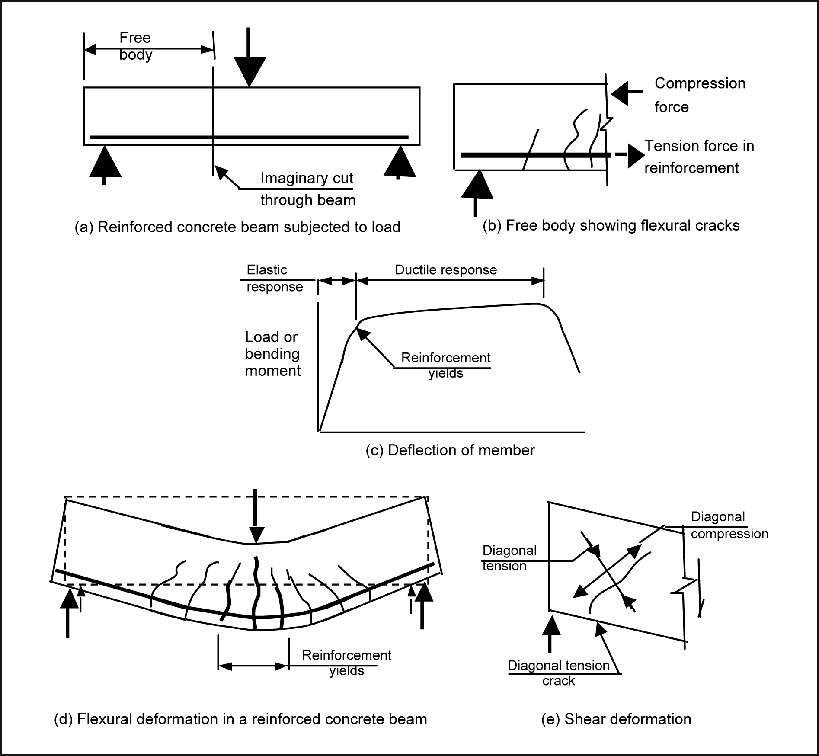
Figure App 1: Structural actions
Forces applied in a direction normal to the axis of a structural member cause it to bend. The internal actions associated with this action are known as a bending moment. Bending moments induce tension on one side of the members and compression on the other side. With reinforced concrete members, due to the low tensile strength of concrete, cracks form in the concrete subjected to tension. When these cracks are initiated the tension force previously resisted by the concrete is transferred to the reinforcement, see Figure App 1(b).
If the forces are increased to a sufficient level the tension force in the reinforcement results in the stress in the steel reaching its yield point. At this stage any further increase in force results in the cracks widening and the deflection of the member increasing. Once yielding of the reinforcement occurs any subsequent increase in force on the member is small; see the load deflection diagram in Figure App 1(c). Figure App 1(d) shows a beam subject to a load which causes the reinforcement to yield. The ability of the member to deform without losing strength above the point where the reinforcement yields is referred to as ductile behaviour. The zone containing the yielding reinforcement is known as a plastic hinge or plastic region. The tensile strains in the reinforcement are greater than the compression strains in the concrete and as a result the member as a whole increases in length. This is known as elongation. Figure App 1(e) shows deformations associated with shear forces. The shear force is an internal force that acts in a direction normal to the longitudinal axis of the member, which is required for equilibrium. Shear forces induce deformation as illustrated in Figure App 1(e) with diagonal tensile and diagonal compression stresses. Due to the low tensile strength of concrete the diagonal tensile stresses can cause diagonal cracks to form. These are often referred to as shear cracks.
Seismic design of buildings
The description below gives a very brief outline of the concepts involved in seismic design of multi-storey buildings.
Current New Zealand practice is to design buildings to satisfy two sets of design criteria, serviceability
and ultimate limit states.
The serviceability limit state involves designing the building to remain fit for its intended use in the event of an earthquake that has a magnitude of shaking that may be expected to occur, for normal buildings, once or twice during the design life of the building. Structures that may contain a significant number of people, or are necessary to provide essential services after a major earthquake, such as hospitals, are designed to sustain a higher level of seismic actions.
For the ultimate limit state the design criteria have been developed to ensure that in the event of a major earthquake life is protected. This is achieved by requiring the building to have suitable levels of strength, stiffness and ductility. The ultimate limit state criteria act to ensure that buildings subjected to earthquakes, which are greater than that assumed for the serviceability limit state, can be repaired, and that in earthquakes appreciably greater than that on which the ultimate limit state is based will not collapse and cause loss of life. For normal multi-storey buildings the ultimate limit state design actions are based on an earthquake with a return period of 500 years. For important buildings providing essential services the return period is increased and in some cases it reaches 2,500 years. Ensuring the building has adequate ductility is achieved through a process called ‘capacity design’. In conventionally designed buildings ductile behaviour is accompanied by structural damage.
Design seismic actions, consisting of forces and displacements that a building must be able to sustain, are specified in NZS 1170.5. The design actions for a proposed structure are determined from the nominated return period of the earthquake, the predicted dynamic characteristics of the structure, the seismicity of the region and the type of soils on which the building is founded. In Christchurch the soils consist of deep alluvial deposits of sand, silt and shingle. The dynamic characteristics depend on the periods of vibration of the building if it is left to freely oscillate. For the ultimate limit state the ability of the structure to behave in a ductile manner is also included.
The basis of capacity design is to ensure that in the event of a major earthquake brittle failure modes cannot develop. Ductile behaviour is obtained by designing the structures so that inelastic deformation is confined to identified locations, known as potential plastic hinges. This is achieved by designing all the structural elements outside the potential plastic hinges to have a higher level of strength so that inelastic deformation is confined to the chosen locations.
The potential plastic hinges are detailed to enable them to sustain the necessary deformation associated with the required level of ductility. A simple illustration of a ductile mechanism is shown in Figure App 2. The beam sway mode results in ductile performance while the high inelastic rotations induced in the columns with the column sway mechanism causes these elements to fail at a low level of ductility.
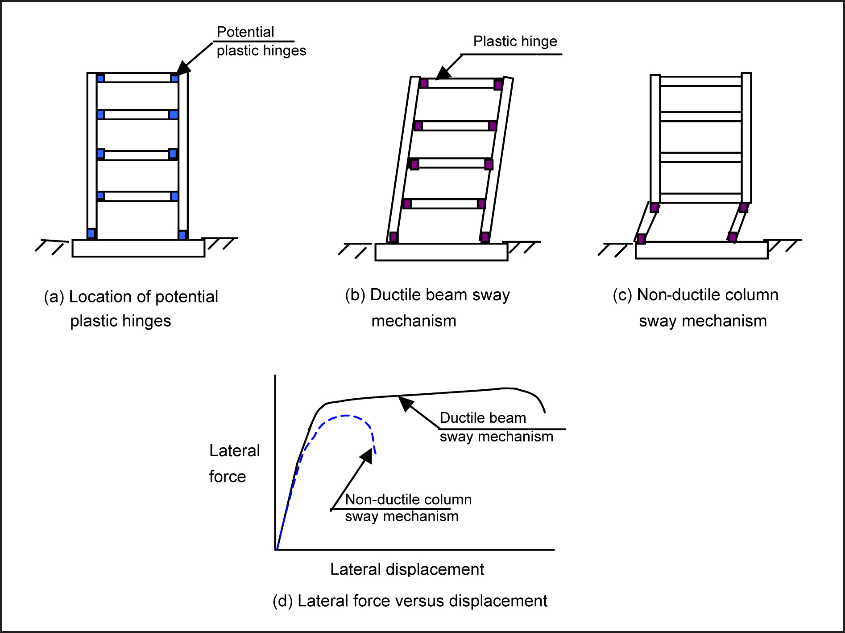
Figure App 2: Ductile and non-ductile sway mechanisms
Appendix 4
Glossary
Base isolation | A means of limiting the seismic forces induced in a building by supporting the structure on devices that enable relative movement to occur between the foundation and superstructure when the force rises to a predetermined level
Base shear | Base shear is the shear force acting between the foundation soils and the building due to the inertial force induced in the structure due to the ground motion
Bending moment | See structural actions
Building classification | Buildings are classified in terms of importance levels 1 to 5 in AS/NZS 1170.0. Level 1 is for the lowest level of importance, for example, for isolated farm buildings. Level 2 covers most multi-storey structures, while level 3 is for buildings, which may contain a large number of people, such as hotels, offices and apartment buildings, or for buildings of 15 storeys or more. Level 4 is assigned to buildings required to be operational immediately following a major earthquake. Classification 5 is not covered
Diagonal cracking | Often referred to as shear cracking, see structural actions
Diaphragm | A structural element that transmits in-plane forces (diaphragm forces) to and between lateral force resisting elements. In buildings, floors usually act as, and are occasionally called, diaphragms.
Double tees | Precast prestressed units that are used in the construction of some floors
Earthquake-prone | The definition of an earthquake-prone building is given in section 122 of the Building Act 2004. In summary an earthquake-prone building is one that if assessed against current (new) buildings standards (NBS) would be assessed as not sustaining more than 33% of the minimum design actions for strength and ductility for the ultimate limit state
Earthquake  risk buildings | A building is assessed as an earthquake risk building, if when assessed against the minimum requirements in current buildings standards, it sustains between 33% and 67% of the minimum design actions for strength and ductility for the ultimate limit state
Eccentrically braced  frame | A structural steel frame consisting of beams and columns but with diagonal bracing in one or more bays that reduces the magnitudes of the bending moments in the beams. The short section of beam between the diagonal braces is subjected to high shear forces in a major earthquake and this zone yields in a ductile manner due to the high shear stresses
Element | A structural member such as a beam, column, wall or frame that is used to resist  structural actions
Elongation | See structural actions
Hollow-core | Precast prestressed units that are used in the construction of some floors
In-plane and  out-of-plane forces | Forces acting in the plane of a wall as distinct from out-of-plane forces, which act  in a direction normal (at right angles) to the face of the wall

Low damage or damage avoidance design | There are a number of methods for reducing the structural damage sustained in major earthquakes; base isolation is one of these and the PRESSS and non-tearing floor systems are two other methods that may be used
Maximum considered earthquake (MCE) | Generally taken as an earthquake with a return period of 2,500 years. Multi-storey buildings designed to current New Zealand Standards are intended to have a small margin of safety against collapse in the MCE
Moment resisting frame | A structural frame consisting of beams and columns which is designed to provide lateral force resistance to the buildings
New Building Standards (NBS) | The building standards in force at the time when an assessment of an existing building is made
NZ Standards (NZS) | Sets of rules that are used in the design of buildings. The Earthquake Actions Standard (NZS 1170.5) defines the required combination of strength, stiffness and ductility that a proposed building must be designed to contain, while the material Standards for Structural Concrete, Structural Steel and Structural Timber Standards provide rules on how these requirements can be satisfied.
Period | The time in seconds it takes for a structure to complete one oscillation.  Frequency is the inverse of period, that is the number of cycles per second
Potential plastic hinge | See structural actions
Precast Structural Seismic Systems (PRESSS) | Precast concrete members (beams, columns or walls) are stressed together by unbonded prestressed cables which causes the structure to spring back to its original position at the end of the earthquake
Response spectra | The peak accelerations (or displacements) with the period of vibration of structures due to an earthquake or a design earthquake
Return period | The average time in years between earthquakes of a given magnitude on a fault or in a locality. The magnitude of the earthquake and the associated actions are assumed to increase with the return period. Hence the design actions for an earthquake with a return period of 2,500 years is assumed to be 1.5 (or 1.8) times the corresponding values for an earthquake with a return period of 500 years
Seismic design | See appendix 3
Serviceability limit state | See seismic design of buildings
Shear force | See structural actions
Shear wall | A structural wall that is used to resist lateral forces induced by earthquake actions, sometimes referred to as a structural wall
Single degree of freedom | A simple structural model that can only vibrate in one mode
Strain | The change in length divided by the original length
Stress | Force divided by area of element resisting the force, i.e. stress in reinforcement is equal to the force carried by the reinforcement divided by the area of reinforcement
Structural actions | See appendix 3
Ultimate limit state (ULS) | See seismic design of buildings
Unreinforced masonry (URM) | May consist of brick buildings or buildings built using stone masonry

Footnotes

- GNS Science is the Crown Research Institute, the Institute of Geological and Nuclear Sciences Limited
- Associate Professor Jason Ingham, University of Auckland and Professor Michael C. Griffith, University of Adelaide
- Professor Des Bull, University of Canterbury
- John Hare, President of the Structural Engineering Society of New Zealand (SESOC)
- Andrew Buchanan, Professor of Timber Design, Department of Civil and Natural Resources Engineering, University of Canterbury
- Reports may be applicable to more than one Inquiry topic and/or matter relevant thereto
- Webb T. H., Beaven J., Brackley H., Gerstenberger M., Kaiser A., McSaveney E., Reyners M., Somerville P., Van Dissen R., Wallace L., Bannister S., Berryman K., Fry B., Holden C., McVerry G., Pettinga J., Rhoades D., Stirling M., Villamor P., and Zhao J., ‘The Canterbury Earthquake Sequence and Implications for Seismic Design Levels’, GNS Science Report 2011/128, July 2011.
- The magnitude stated in this table is defined as ‘Moment Magnitude’ (MW) which GNS Science advises is commonly used worldwide to characterise large earthquakes. It is a measure of the final displacement of a fault after an earthquake. MW is a rough proxy for the amount of low-frequency energy radiated by an earthquake. ‘Richter Magnitude’ (ML) is the initial magnitude assigned to an earthquake with routine GeoNet processing. It is derived from measurements of the peak amplitude on seismographs and is thus a preliminary estimate of the amount of energy released by the earthquake. References to magnitude in this report are to the Moment Magnitude.
- Gerstenberger M. C., Rhoades D. A., Berryman K., McVerry G. H., Stirling M. W., and Webb T. 'Update of the Z-factor for Christchurch considering earthquake clustering following the Darfield earthquake’, GNS Science Report 2011/29, May 2011
- Ingham, J.M. & Griffith, M.C., (2011), The Performance of Unreinforced Masonry Buildings in the 2010/2011 Canterbury Earthquake Swarm. Page 113-114

ISBN: 978-0-477-10344-2 (paperback)
ISBN: 978-0-477-10345-9 (pdf)

Canterbury EarthquakesRoyal Commission
PO Box 14053
Christchurch Mail Centre 8544
Christchurch New Zealand
0800 337 468
+64 3 741 3000
canterbury@royalcommission.govt.nz

