Section 4:
Individual unreinforced masonry buildings that caused fatalities

Forty-two people died as a result of building failures (other than the Canterbury Television and Pyne Gould Corporation buildings) in the 22 February 2011 earthquake. This section of the Report discusses the circumstances in which those deaths occurred.

4.1 Introduction

Thirty-six of those killed were in the Central Business
District (CBD). The other six were in the suburbs. Over
a period of six weeks the Royal Commission conducted hearings into the failure of the buildings that caused the deaths.

The collapse of an exposed brick internal chimney breast, which resulted in the death of a five-month-old baby, was not the subject of a hearing. However, the Royal Commission has investigated what occurred and that event also forms part of this Report.

The investigation into buildings that failed and caused the deaths of these 42 people is important because all but one of the buildings involved were older, unreinforced masonry (URM) buildings or brick or block structures.

Of the 42 deaths caused by the failure of individual buildings:

(a) 35 were as a result of the façade or walls of URM
buildings collapsing onto:

• pedestrians or persons in vehicles (26);

• people in a neighbouring building (6);

• people who had run out of a building to escape (3);
(b) four people were killed inside a URM building;

(c) one five-month-old baby was killed by a chimney breast collapse;
(d) one person who had run out of a building was crushed by a free-standing wall; and
(e) one person was killed when she was crushed by a six-tonne concrete spandrel that fell from a car park building onto her vehicle.
The fact that nearly 70 per cent of the deaths caused by these building failures were of people outside the buildings – in the main, pedestrians and persons in vehicles – highlights the issue of what to do about URM buildings as a very real community problem. It also graphically highlights the inadequacy of a passive earthquake-prone buildings policy and the need to urgently implement policies throughout New Zealand to, at the very least, address the potential dangers these buildings pose from collapsing façades, walls and parapets.

These hearings also addressed other issues raised by the Royal Commission’s Terms of Reference including:

• the strengthening or retrofitting of URM buildings and the need for retrofit or strengthening measures to provide effective protection and not fail in a significant earthquake;
• the inspection and assessment of buildings following a large earthquake – in this case the 4 September 2010 and Boxing Day 2010 earthquakes;
• the way these buildings are assessed and the potential for collapse in a significant aftershock;
• the management of cordons in front of a damaged building following a significant earthquake, and the placement of such cordons so as to provide protection for the public by blocking off footpaths or, if necessary, roads; and
• communication of potential dangers posed by a building after a significant earthquake to relevant authorities, and to the owners and occupiers of potentially affected neighbouring properties.

The nature and characteristics of URM buildings, and techniques for and costs of strengthening these buildings are discussed in this Volume. Assessing and strengthening all existing buildings is discussed in section 6 and the legal requirements for earthquake- prone buildings are discussed in sections 2 and 7. Post-earthquake assessment and management of buildings is discussed in a later Volume of the Royal Commission’s Report.

The Royal Commission’s consideration of the buildings addressed in this section has been informed by information obtained during the course of our investigation, including information from building owners and occupiers, the Christchurch City Council (CCC) and, in some cases, witnesses to the collapse of the buildings. We were assisted in developing our understanding of the history and failure of the buildings by reports prepared for our inquiry by Mr Peter Smith, a structural engineer and principal of Spencer Holmes Ltd, an engineering firm based in Wellington. Mr Smith’s reports were published on our website and he gave evidence at each hearing. So too did Mr Stephen McCarthy, Environmental Policy and Approvals Manager for the CCC, who supervised the collection of information from the CCC’s files. We acknowledge their assistance.

We acknowledge too those who spoke at the hearings of the harrowing events they experienced and witnessed on 22 February and the suffering of the bereaved and those who were seriously injured.

The accounts given of the failure of the individual buildings have been intended to give as full an explanation as possible of why there was loss of life. We have also tried to make each account reasonably self-contained in the expectation that some of those who lost family members and friends may not wish to read all parts of this section in full. The result is a degree of repetition, which was unavoidable. However, it may also serve to emphasise the recurring observations about the consequences of passive earthquake-prone buildings policies. Taken collectively, the failures of these buildings and resultant loss of life have mounted a case which the Royal Commission finds compelling for definite timeframes to be imposed for the strengthening of earthquake-prone buildings.

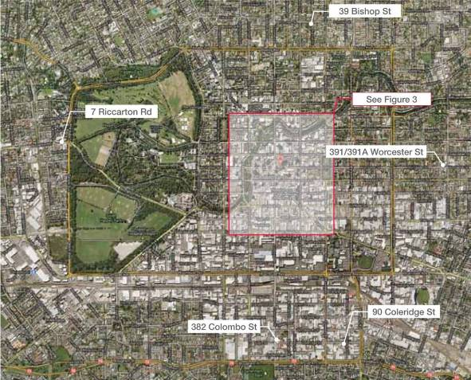
Figure 2: The locations of buildings outside the CBD discussed in this section

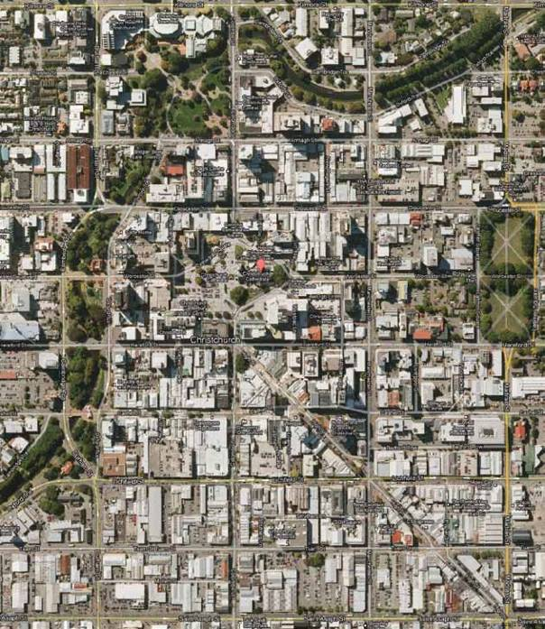

309 Durham St North

753–759 Colombo St

738 Colombo St
265–271 Manchester St

194 Gloucester St

200–204 Manchester St

32 Cathedral Sq

194 Hereford St

89–95 Cashel St
246 High St

43 Lichfield St
116 Lichfield St

617– 625 Colombo St

605–613 Colombo St

603 Colombo St

601/601A Colombo St

595/595A Colombo St

Figure 3: The locations of the individual buildings within the CBD discussed in this section

4.2 The CCC’s earthquake-prone buildings policies

The discussion of the individual buildings that failed in the February earthquake frequently includes reference to the CCC’s role as a local authority in relation to earthquake-prone buildings. As discussed in section 2 of this Volume, the powers of territorial authorities in relation to earthquake-prone and dangerous buildings have been derived from statutory provisions that have been changed on a number of occasions over the period relevant to the Royal Commission’s inquiry. It is important that actions taken or not taken in relation to the individual buildings are seen in the context of the extent and limits of the CCC’s statutory powers.

These issues were addressed by the CCC in its report to the Royal Commission on Building Safety Evaluation Processes in the Central Business District following the 4 September 2010 Earthquake1. They were also addressed in a brief of evidence by Mr R. Buchan, which has not been formally read at a public hearing but has been provided to the Royal Commission and published on the Royal Commission’s website. Mr Buchan’s statement outlined the history of relevant statutory provisions, starting with section 301A of the Municipal Corporations Act 1954 that was applied to the CCC on 12 June 1969. In addition, Mr McCarthy referred to the CCC’s powers in his evidence at the hearings about some of the individual buildings.

The history of the development of the statutory provisions in relation to the control of earthquake-prone and dangerous buildings is outlined in section 2 of this Volume and the present law is addressed in more detail in section 7. It is appropriate to reiterate here that under the Municipal Corporations Act regime, the CCC adopted policies that were designed to secure the seismic strengthening of buildings when or if building alterations, repairs, additions or refurbishment works were proposed. In this respect, the CCC (and other councils) were able to rely on bylaws made under the Municipal Corporations Act, and the Local Government Act. Under the Act, the powers of the CCC were to give notice requiring the owner “to secure the building to the satisfaction of the Council” and a notice could be given in the case of buildings that would have their ultimate load capacity exceeded in a moderate earthquake and were considered to “constitute a danger to persons therein or in any adjoining building or on any adjoining land or to passers-by”. Mr Buchan gave details of the manner in which the CCC exercised those powers, down to the enactment of the Building Act 1991. It is clear that some progress, albeit slow, was made in the
1970s and 1980s and we record that in the latter part of 1975, CCC began a comprehensive survey of the central area with the aim of classifying each building.

The Building Act 1991 introduced a definition of “earthquake-prone building” that was in some respects more restrictive than had previously applied. This required that the building be “likely to suffer catastrophic collapse causing bodily injury or death to persons” in a moderate earthquake. In addition, unless a building was considered to be dangerous, seismic strengthening could generally only be required where there was a change of use, in accordance with section 46(2). Councils could no longer rely on their building bylaws to require strengthening where repair, additions or refurbishments were proposed. Further, section 8 of the 1991 Act provided that nothing in the Act was to be read as requiring any building completed before the Act’s coming into force to meet the requirements of the Building Code. The CCC evidently took the view that these changes prevented it from requiring owners to upgrade their buildings notwithstanding that the building may have been identified as needing to be strengthened in the processes that had been followed under the previous legislation. Overall, we accept that the CCC’s ability to require seismic strengthening was reduced by the enactment of the 1991 Act.

Under section 131 of the Building Act 2004, all territorial authorities are required to adopt a policy on dangerous and earthquake-prone buildings. The CCC2 conducted seminars in the period from 14 June to 5 October 2005 before resolving to publish a draft policy for consultation purposes on 15 December 2005. In formulating the draft policy, the CCC had regard to guidance material that had been provided by the former Department of Building and Housing3 (DBH), which we refer to as the DBH Guidelines. That document is discussed in section 7 of this Volume but it is appropriate to also refer to some of the same material here because it will give context for the discussion of the CCC’s earthquake-prone buildings policies. We record that the DBH Guidelines envisaged a process in which territorial authorities would carry out a desktop evaluation of their building stock to ascertain which buildings had the potential to be earthquake-prone and therefore suitable for closer consideration. Buildings in that category would then be subject to an Initial Evaluation Process (IEP). If the building was considered to be earthquake-prone, it would be subject to further steps, depending on the substance of the CCC’s policy. The former DBH Guidelines, reflecting the permissive nature of the provisions of the Building Act, outlined two “Principal Approaches” that territorial authorities could adopt. It described these as “active” or “passive”.

Under an active approach, it was said that the territorial authority would set timetables for action and guidelines of performance levels for upgrading. Under the passive approach, a detailed assessment of a building and any action taken to improve its structural performance would be triggered by an application under the Building Act for building alteration, change of use, extension of the life of the building or subdivision. The DBH Guidelines noted:

…this second approach has the significant disadvantage that it relies on a somewhat haphazard order of remediation based essentially on an owner’s intention for a building. This could lead to some significant high-risk buildings being untouched for a long period of time.

On the other hand, the cost of administering such a programme would be significantly less than for an active programme.

The CCC’s draft policy2 published in December 2005 included timeframes for strengthening earthquake- prone buildings of 15–30 years. However, having considered the submissions received in the consultation process the CCC4 decided to remove the timeframes.

Under section 132 of the Building Act, the CCC was required to review its policy, which it did in a process that included the adoption of a draft new policy5 in March 2010. The major change recommended in the new draft policy was the introduction of timeframes for strengthening that would apply from 1 July 2012. The CCC heard submissions on the draft new policy in June 2010. The new policy had not been finalised by the time of the September earthquake.

The CCC has suggested that it was pursuing an active approach in relation to earthquake-prone buildings. We accept that the CCC had undertaken a process in which it was endeavoring to identify likely earthquake- prone buildings by carrying out a desktop review of buildings within its district, that it reviewed its 2006 policy ahead of the five-year deadline proposed by the Building Act and that it had decided when it published the 2010 draft policy that timeframes for action should be established. To that extent, it was taking action. In the case of most URM buildings, the requirement of the CCC policy was that strengthening should take place within 30 years from the date that the owners were notified that their building was potentially earthquake- prone. The CCC committee6 that heard submissions on the draft policy recommended that the 30-year period be reduced to 20 years. The committee’s reasoning included the following:

The Panel considers that an active approach involving timeframes for strengthening is necessary to reduce the risk to the public in an earthquake, and that the proposed categories and timeframes are largely appropriate. It is concerned, however, about the level of hazard posed by unreinforced buildings, many of which have been known to be
an earthquake risk since the late 1960s or early
1970s. This is the type of building that failed with catastrophic effects, including for people in the streets, in the Napier earthquake of 1931.

When the policy was formally adopted on 10 September
2010 (six days after the September earthquake), the
30-year period was reduced to 20 years.

During the hearing at which the Royal Commission considered the issue of earthquake-prone buildings policies, on 14 November 2011 the Mayor of Christchurch, Mr Bob Parker, described the policy as “a relatively passive approach”. Having considered Mr Buchan’s statement, the CCC’s report and the evidence given at the hearings on the individual buildings, the Royal Commission considers that the CCC’s earthquake-prone buildings policies as they stood in 2006 and at the time of the September earthquake can fairly be described as passive in nature. The CCC then resolved that timeframes should be imposed. We accept that, even if a more active approach had been taken from 2006, it is still unlikely that the URM buildings that failed in the February earthquake would have been strengthened prior to the earthquake.

There are observations in the accounts given of the individual building failures that are critical of actions or omissions of the CCC. Those observations must be seen in the context of the difficult challenges that were presented by the September earthquake and subsequent aftershocks. The CCC was not the only territorial authority that adopted a passive approach to the strengthening of earthquake-prone buildings. It was, however, the only territorial authority to experience such a destructive earthquake since the Napier earthquake of February 1931.

4.3 Building fatalities

The Commissioners are conscious that our Report is largely of a technical nature. However, at the forefront of our minds have been those who lost their lives as a result of the earthquake of 22 February 2011 and those left behind who loved them. Our thoughts have also been with those who were injured and their families.

To honour those who died, we asked their families to tell us about their loved ones. The words that follow reflect what they said. We thank the families for their willingness to share this information publicly, given the personal nature of their grief.

All but one of the biographies relate to people who were killed by older, unreinforced masonry (URM) buildings or brick or block structures. The one exception is Linda Arnold.

Biographies of other people who died as a result of the earthquake in the PGC and CTV buildings are published elsewhere in this Report.

39 Bishop Street, St Albans

Baxtor Gowland

Master Baxtor Gowland, five months, was only 2.6 kilograms when born as the surviving boy of twins. When the earthquake struck he was lying on a blanket in front of the fireplace, asleep at Flat 3, 39 Bishop Street, St Albans. The exposed brick fireplace collapsed in the earthquake and Baxtor was found by his mother, underneath the fireguard which had been covered in bricks.

The flat had been damaged as a result of the September 2010 earthquake, including damage to the chimney which had been removed. However, the exposed brick fireplace had not been removed.

Baxtor, who already loved Postman Pat, sport and music, is described as a smiley, sociable and alert baby. Baxtor is survived by Breanna Gowland (mother).

89/89A, 91 and 93 Cashel Street

Melissa Neale

Ms Melissa Neale, 41, was walking in Cashel Street with her mother, Margaret Neale, intending to go to the Trocadero Bakery for lunch. They were a short distance from the building when the earthquake struck. Melissa’s body was located under collapsed building material around 89/89A, 91 and 93 Cashel Street.

Melissa, who was an operations manager for artworks retailer Real Aotearoa, was born at St George’s Hospital, Christchurch, on St Patrick’s Day 1969, the beloved identical twin sister of Amanda. Melissa also had a close relationship with her brother, Damian.

Melissa is described as a vibrant, happy, positive, loving person with plenty of energy and a love of life. Family and friends were very important in her life and her hobbies were walking, gardening, cooking, reading, and especially travelling, which she spent a lot of her life doing.

Melissa is survived by Margaret Neale, Amanda Neale and Damian Neale.

Jillian Murphy

Ms Jillian Murphy (known as ‘Jilly’), 48, had arranged to meet friends for lunch in Oxford Terrace. She was meeting her friend Debbie Lawson, owner of Deval clothes shop, 89A Cashel Street, in her store before lunch. Jilly was trying on a jacket when the earthquake struck. Debbie, a staff member and another customer went out the front door. Jilly, who was facing the back part of the store, chose to exit the building via the rear door. The neighbouring building at 91 and 93 Cashel Street, City Mall, collapsed onto the rear part of the store.

Jilly, an air traffic controller, loved the outdoors and would often cycle with her partner Richard. She was extremely fit, capable of riding 100km with ease. She went to the gym frequently and enjoyed walking her golden retrievers Milly and Bayley. She loved clothes and shopping. She always looked stunning no matter what she wore.

Jilly was very family-oriented and loved family holidays. She is described as a truly beautiful woman in the complete sense of the word. She was a devoted and loving mother and partner, and also a well-respected colleague of her workmates. She had a significant number of friends both in New Zealand and around the world. Jilly was an attractive, bright, intelligent woman who always had time for anyone and everyone.

She is survived by her children Bond (aged 16) and Taylor (aged 18), partner Richard Green and his son Sam (aged 21).

93 Cashel Street

Christopher Homan

Mr Christopher Homan (known as ‘Chris’), 34, and his wife Christine were in Cashel Street, standing in the vicinity of 93 Cashel Street, when the front of the buildings at 89/89A, 91 and 93 Cashel Street collapsed.

Chris had a great sense of humour. As a child, he would tell people his name was Fred Jackson and he was an adopted child from Ireland. Ever since, his family had known him as Fred.

Chris gained an apprenticeship as a painter when he left school and remained with the same painting company up until his death. He worked his way up from a brush hand to an operations manager over the years. He also enjoyed basketball and cricket.

He was thoughtful, generous and loving. At 1.95m, he was a tall man with a huge heart.

He is survived by Chris (his wife), Liam (son, aged two), Nanette (mother), Adrian (father, known as ‘Sam’), Patrick
(brother) and Melanie (sister).

Shane Tomlin

Mr Shane Tomlin, 42, was a pastry baker at the Trocadero Bakery, 93 Cashel Street, in Cashel Mall. He was working at the bakery, on the first floor, when the earthquake struck.

A work colleague was standing near Shane and after the earthquake stopped, she saw a hole in the floor where he had been standing. Shane was located, conscious but badly injured, on the ground floor under the bakery premises in the TS Retail Store. He was taken to Christchurch Hospital but subsequently died as a result of his injuries.

Shane loved his work, his pet turtle, watching Star Trek and Doctor Who, cooking and gardening (but not flowers, only vegetables).

Shane valued his privacy and liked doing things alone. His family feel he would not have liked having his photo and information about him sent all over the world, being called the “face of the earthquake” and he would have said, “just leave me alone”.

Shane’s family are Doreen Tomlin (mother), Judith McLaughlin (sister), Raelene Miller (sister), Karen Franicevic (sister)
and nine nieces and nephews ranging in age from five to 16 years. His father was the late Bernie Tomlin.

32 Cathedral Square

Adrienne Lindsay

Mrs Adrienne Lindsay (known as ‘Ady’), 54, was at work as an accounts clerk at The Press newspaper, Christchurch Press Building, 32 Cathedral Square, when the earthquake struck. She was in her office on the top floor of the Press building and was last seen ducking under her desk by a work colleague.

Ady, who enjoyed sports, is survived by Phil (husband), Josh and Kieran (sons).

90 Coleridge Street

Stephen Cochrane

Mr Stephen Cochrane (known as ‘Steve’), 43, was a cabinetmaker at Classique Furniture, 90 Coleridge Street.
Steve was passionate about his trade and is best described as a craftsman cabinetmaker, an absolute perfectionist.

When the earthquake struck he was working at his bench inside the premises. He ran out the side door and down the driveway, where an unsupported concrete block wall toppled over, crushing him underneath it.

Steve loved sport, especially rugby, cricket, motor racing and golf. He was very proud of his garden, especially his new fruit trees just planted the weekend before he died, and now already bearing fruit a year later. He was happiest when spending time with his girls, Tania and Kylie-Marie.

Steve is described as an amazing man who did not have a bad bone in his body. Everyone, without exception, was warmed by and drawn to him. Kylie-Marie described her dad as “cool, friendly, caring, funny, awesome, fantastic, creative, loving, cruisy and happy”.

Steve’s family includes Tania Cochrane (wife), Kylie-Marie (daughter, aged 11), Marie Cochrane (mother), John Cochrane, Euan Cochrane and the late Dave Cochrane (brothers), Lyn Johannis and Jill Cochrane-Williams (sisters), and Hunter (Steve’s dog).

382 Colombo Street

Maureen Fletcher

Ms Maureen Fletcher, 75, was eating lunch at the Tasty Tucker Bakery, 380A Colombo Street, Sydenham, when the earthquake struck. She was sitting with a couple she had met only a few minutes before the earthquake, Margaret and Bruce Moon. A gable wall from the building next to the bakery collapsed onto the bakery premises.

Maureen was an outgoing person who had spent 18 years in Waiwera Ashram giving readings as a spiritual consultant before she moved back to Christchurch in 2005.

She is survived by her children Rodney, Malcolm, Jeffrey and 11 grandchildren.

593 Colombo Street

Matthew McEachen

Mr Matthew McEachen (known as ‘Matti’ or ‘Matt’), 25, was employed as a tattooist at Southern Ink, 593 Colombo Street. He was last seen by a work colleague, Matthew Parkin, sitting at his desk. It appears that Matt ran out of the front door, as his body was found at the front of the building.

Matt, who was a very talented artist and tattooist, had a love of creative arts and music. He was a graphic artist and musician. He also loved family holidays and during his life had travelled to Australia, Fiji, Singapore, Malaysia, Borneo and Thailand with his family.

Matt was an inspiration to all who met him. He was an extremely positive, sensitive and caring person. He was creative, spiritual, and strongly believed that everyone’s talents and potential were infinite. Matt always put other people’s
feelings before his own. He lived for his art, music, family and friends. It was often said that Matt was everybody’s best friend.

Matt is survived by Jeanette and Bruce McEachen (parents) and Sarah (sister, aged 23).

595/595A Colombo Street

Rachel Conley

Ms Rachel Conley, 27, from the United States of America, had been on a working holiday in New Zealand with her good friend, Jessica Kinder. They had planned to visit Christchurch before flying home to the United States on 23 February 2011. While in Christchurch they decided to get tattoos and had been in the Southern Ink premises (593 Colombo St) minutes before the earthquake to make an appointment.

When the earthquake struck, Rachel had exited the building, walked several metres north along Colombo Street, and was adjacent to 595 Colombo Street. Jessica was with Rachel at the time but on the way out of the shop, Jessica paused to close the heavy sliding door while Rachel walked ahead. It was as Jessica walked to catch up with Rachel that the earthquake struck and Jessica saw Rachel struck by a falling slab of concrete.

Rachel had a passion for music, especially live shows. She loved to write. She had been living in New York City for seven years, originally to attend school. Prior to leaving for her trip, she was the assistant to the general manager of a Manhattan hotel. Her personality is described by her father as beautiful, with a smile not to be forgotten. She had friends from every walk of life and was an incredibly unbiased person. She was full of goodwill for everyone.

She is survived by Steve (father), Farris (mother), Deb (stepmother), Sam (brother) and Lauren (stepsister).

601/601A Colombo Street

Normand Lee

Mr Normand Lee, 25, died outside 601/601A Colombo St. He was a pedestrian walking near the building when the earthquake struck.

Normand had attended Cashmere High School and spent one year at Christchurch Polytechnic Institute of Technology before studying management at the University of Canterbury. After university he did a personal training course and worked on a cruise liner as a trainer. He returned to New Zealand in December 2010 and was about to start his own personal training business at Snap Fitness.

Normand was a keen sportsman who loved cricket and had played since he was young. He had been a member of the Sydenham Cricket Club and also played touch rugby, indoor soccer and indoor cricket. He had a keen interest in martial arts.

Normand is described as laidback, quiet by nature and easygoing. He had a quirky sense of humour and was very sociable. He did not worry about much and went out of his way to help family and friends. He was a very generous person.

His family include Karen and the late Sharon (sisters), Raymond (brother) and Mee Lai and Bak Cheong Lee (parents).

603 Colombo Street

Gabi Ingel

Mr Gabi Ingel, 23, died outside 603 Colombo Street (the intersection of Mollett and Colombo Streets). Gabi came to New Zealand in December 2010 to enjoy the scenery after backpacking around Asia for a few months. He met up with Ofer Levy, his best friend since the age of five, and the pair were travelling and hiking around New Zealand together. When the earthquake struck, they had just left Frienz Backpackers on Worcester Street and were heading towards a meeting point to be picked up to work for a day in a vineyard.

Gabi was due to return home to Israel to begin his studies in mathematics and computer science.

He enjoyed a variety of sports, including martial arts (he was the first person in Israel to get a black belt in Meijin Kai before the age of 18), rock climbing, trekking and kite surfing. He also loved music, computers and fixing things, from small devices to cars.

Gabi was a gifted boy who could do everything he set his mind to. He was very talented both in science subjects and physical activities. He was a very friendly person who made a lot of friends in Israel and the different countries he was travelling in. Gabi was also very sensitive, always willing to help others and had a great sense of humour. He and his family had great plans and expectations for his future.

He is survived by Gil Ingel (father), Fanya Ingel (mother), Ayelet Ingel (sister) and Ben Ingel (brother).

Ofer Levy

Ofer Levy, 22, an Israeli, was travelling around New Zealand with Gabi Ingel, his friend since the age of five. When the earthquake struck, they had just left Frienz Backpackers on Worcester Street and were heading towards a meeting point with a vineyard owner to work with him for the day. Ofer’s body was found outside 603 Colombo Street, on the corner of Colombo and Mollett Streets.

Ofer had just completed his compulsory military service at home and travelled to New Zealand. He was due to return home three days after the earthquake and was looking forward to seeing his girlfriend and continuing to work on an old Volkswagen Beetle he was doing up. He also planned to start studying computer science at university.

Ofer was busy with many hobbies and activities, such as extreme downhill mountain biking, martial arts, car mechanics and nature trips with friends. He played jazz on the alto saxophone.

Ofer is described as good-looking, with a very big and tender heart. He always had a smile on his face, animated gestures, and he made people feel that it was never a problem to help them. Ofer was very friendly and honest, able to quickly have an open and honest conversation with complete strangers. He was a loving and caring son to his parents who welcomed a boy after having three daughters. Ofer was extremely responsible, generous, talented and graceful.

He is survived by Gliliah Levy (mother), Mordechai Levy (father), Michal Levy (sister), Dafi Toupotte (sister), Tamar Levy
(sister), and a fish called Tony.

Joan and Graham Weild

Mrs Joan Weild, 76, was with her husband Mr Graham Weild, 77, when the earthquake struck. They were pedestrians on the west side of Colombo Street near the intersection of Mollett and Colombo Streets, outside 603 Colombo Street. The couple always did everything together and they were on their way home to Heathcote Valley at the time.

Joan was totally family-oriented and loved spoiling her grandchildren. She spent many hours knitting soft toys to donate to charities as gifts for Christmas.

Graham was an avid sailor and member of the Christchurch Yacht Club where he raced Lasers and Zephyrs. He was also a motorbike enthusiast and had owned many bikes over the years. In his early 70s he was still riding a trail bike.

Joan and Graham are survived by John Weild (son), Nicki Weild (daughter-in-law), Susan Davis (daughter), Michael
Davis (son-in-law) and Andrew Weild (son).

605–613 Colombo Street

The Red Bus No. 702 was travelling north along Colombo Street when the earthquake struck. The bus was brought to an immediate stop approximately adjacent to 605 Colombo Street. A large amount of masonry and bricks fell onto the left side of the vehicle killing or injuring the occupants.

Jayden Andrews-Howland

School had finished early on 22 February 2011 and Master Jayden Andrews-Howland, 14, was travelling home on the bus. He had decided to take the bus that took a longer route home because he enjoyed riding on the buses.

Jayden was a much loved only child of Helen Andrews and John Howland. He enjoyed staying with his grandfather Archie and his dog. He liked playing on his Playstation and riding his bike. He loved to travel and dreamed of becoming a driver when he left school. He also had a dream of buying a campervan and travelling around New Zealand. Jayden’s parents will now take on that dream in his honour.

Jayden is described as caring and honest, quiet, kind and loyal. He would do anything for anybody and he didn’t judge anybody else but always accepted them for who they were.

Andrew Craig

The bus driver Mr Andrew Craig, 46, was taken to hospital, where he died later that afternoon as a result of his injuries.

Andrew had gained a diploma in horticulture from Lincoln University. He worked as a groundsman at Queen Mary Hospital for several years and was a volunteer fire fighter in Hanmer Springs. He went on to work for the Canterbury District Health Board as a driver for the elderly before becoming a driver for Red Bus about ten years before his death.

Andrew was a keen bargain hunter who often frequented the Riccarton Market and was well known at the local Salvation Army store. He is survived by Hugh (brother), Janine (sister-in-law), Lachlan (nephew, aged eight) and Rebecca (niece, aged four). He was the son of the late Ross and Gwynne Craig.

Philip Coppeard

Mr Philip Coppeard (known as ‘Phil’), 41, had boarded the bus in Redcliffs half an hour before the earthquake and was heading to Canterbury University for an economics lecture. His ultimate aim was to complete a PhD in economics.

Phil was learning classical guitar. He was passionate about the environment and was a keen member of the Eastenders group (part of the Summit Road Society) as well as the Avon-Heathcote Estuary Ihutai Trust. He enjoyed walking in the Port Hills and playing golf. He loved sports and was a keen supporter of the Highlanders and Southland rugby teams as well as Ipswich Town Football Club.

Phil is survived by Barry and Barbara Coppeard (parents), Suzanne Craig (wife) and Joanne Morley (sister).

Lucy and Stuart Routledge

Mr Joseph Stuart Routledge (known as ‘Stuart’), 74, and his wife Lucy, 74, were very close and always together. It was never Lucy or Stuart, but always Lucy and Stuart.

They were to change buses at the Christchurch Bus Exchange and travel to Akaroa, their favourite holiday destination, for a short break.

The couple lived in Sumner and were both very active in the Sumner community. They did volunteer work around the seaside village and were the caretakers for the key to the community pool.

Stuart loved botany and Lucy loved gardening. For years Stuart and Lucy tended the gardens at the Sumner Redcliffs
RSA, of which they were active members.

Lucy had beaten cancer only eight months before. She is described as one of a kind – funny, thoughtful, caring, kind and loving.

Lucy and Stuart are survived by Stuart and John Cowen (nephews) and Marian Longmore (cousin).

Jeff Sanft

Mr Jeff Sanft, 32, was on his way to meet his two beloved little daughters for lunch.

Jeff, a butcher and boner, was well known in Canterbury rugby league circles. He was also very talented in art and music. He was the first cousin of Christchurch rapper ‘Scribe’, who had been staying with Jeff for two weeks prior to the earthquake.

Jeff was a very loving and caring man who had a lot of friends and time for everyone. His children were his everything. He is survived by Jeff and Christine Sanft (parents), Hazel (daughter, aged four) and Olive (daughter, aged two), and Hope Asi (partner).

Beverley and Earl Stick

Mr Earl Stick, 78, and his wife Mrs Beverley Stick, 71, had left their car at the Redcliffs supermarket and taken the bus so they could talk to one another and walk to the hospital from town. They were devoted to each other and had been married for 51 years.

Earl was a retired former builder and businessman. He had been involved in building hotels and was part of Trans
Tours, with his work taking him to Mount Cook, Queenstown and even Vanuatu for a year.

Earl was a practical and resourceful man who gave of his time to the community. He had volunteered on community fire brigades and was a Rotary member in Queenstown and Christchurch. He received the Paul Harris Fellowship long life of active service award for tree planting.

Beverley was a hard-working person who had supported her husband’s business as well as being a loving and wonderful mother and grandmother. She was a brilliant cook, baker and knitter and had made five home-spun wool blankets that were waiting in her cupboard for her great grandchildren. She loved her garden, played mah-jong and was active in her church and community.

The couple had travelled extensively around New Zealand and the world together.

Their family are Raemon Greenwood (daughter), Nicholas Stick (son), James and Christina Greenwood, Ellen and George Stick, and Charlize and Pascalle Stick (grandchildren), Olive Downes (sister), Crystal and Stuart Munro (sister and brother-in-law), Beryl and Ray Dineen (sister and brother-in-law), Coral and Les Nordstrand (sister and brother-in- law), and the late Gordon and Keith Stick (brothers).

625 Colombo Street

Jennifer Donaldson

Ms Jennifer Donaldson, 55, had been walking along Colombo Street after buying a birthday card on Colombo Street when the earthquake struck. She had been to a medical appointment at QEII Medical Centre at 11am and had planned to do some shopping outside the CBD in the afternoon. She was found in rubble from a collapsed building next to the building on the north-west corner of Tuam and Colombo Streets (outside 625 Colombo Street).

Jennifer liked walking and also enjoyed watching television. She loved knitting and was a caring, helpful mum and grandmother.

She is survived by Robb Donaldson (husband of 34 years), Brent (son, aged 32), Marie (daughter, aged 31) and Hayley
(granddaughter, aged five).

738 Colombo Street

Desley Thomson

Ms Desley Thomson (known as ‘Des’), 32, was on her lunch break when the earthquake struck. She was killed by falling masonry outside 738 Colombo Street.

Desley, who worked as a logistics manager for Gardiner Smith, is described as having a bright personality, wonderful sense of style and a great can-do attitude.

She was passionate about cooking and entertaining, played touch rugby, was an avid reader and loved to walk. She had also travelled extensively overseas.

Desley is survived by Rae Maxted (mother), Ross Thomson (father) and Amy Pateman (sister).

753 Colombo Street

Marielle Falardeau

Ms Marielle Falardeau, 60, a French Canadian, was found under collapsed building material outside 753 Colombo
Street. She had been walking along the footpath when the earthquake struck.

Marielle, who worked as a nurse in Canada, was celebrating her semi-retirement by doing the trip of her life, travelling around New Zealand with her sister. She was scheduled to fly home on 23 February 2011 and had been shopping in Colombo Street for toy sheep souvenirs to take home for her friends.

Marielle enjoyed painting, singing, nature and her vegetable garden. She often said it was important to savour the present moment. She is dearly missed by four brothers, three sisters and many friends.

309 Durham Street North

Paul Dunlop

Mr Paul Dunlop, 67, was working inside the Methodist Church at 309 Durham Street North, dismantling and removing the pipe organ when the earthquake struck and the church collapsed. Paul was last seen approximately four metres from the altar. Paul was a passionate organist who played in churches around Christchurch. He also enjoyed woodturning.

He was a well-known Christchurch optometrist. The family practice, Paul Dunlop & Associates in New Regent Street, has served the Christchurch community for more than 110 years. Paul qualified as an optometrist in 1965 and ran the business with his wife Sue.

Paul is described as outgoing and with a huge love of people. He is survived by Sue (wife), Steven, Christopher and
Peter (sons), Keith (brother) and Ruth (sister).

Scott Lucy

Mr Scott Lucy, 38, was working inside the Methodist Church, 309 Durham Street North, with colleagues, dismantling and removing the pipe organ when the earthquake struck. Scott was last seen running down the stairs inside the church during the earthquake.

Scott was a keen pilot and held private and commercial pilot’s licences for both fixed-wing aircraft and helicopters. He also enjoyed fishing, shooting, model making and computers.

Scott had spent two years in the territorial force and 10 years in the hydrographic branch of the New Zealand Navy, where he received a personal commendation from the Marine Commander in 1996. From 2000–2011 he performed a variety of occupations including instructor, then chief instructor of a Boeing 737 flight simulator.

Scott was outgoing, kind, generous to a fault and very supportive and loyal to his family, friends and work associates. He displayed wide-ranging talents and abilities. He is survived by Gemma Shefford (fiancée), Aaron Lucy (brother), Tokyo (niece) and Bill and Hazel Lucy (parents).

Neil Stocker

Mr Neil Stocker, 58, was working inside the Methodist Church, 309 Durham Street North, dismantling and removing the pipe organ when the earthquake stuck. Neil was last seen standing on scaffolding inside the church.

Neil had worked for the South Island Organ Company for 42 years and was the company foreman. He had trained
12 apprentices in his time with the company and was a skilled craftsman. He had an extensive knowledge about organs, both mechanically and technically. He was methodical and self-disciplined, always checking everything.

Neil loved outdoor adventures and enjoyed tramping, mountain biking and road biking alongside his wife. He loved four-wheel driving and exploring the South Island’s back country. In 2010 he travelled to an isolated village in Nepal with his wife, doing voluntary work, installing solar lighting in a Sherpa village in the middle hills called Damar.

Neil possessed a quiet inner strength. He was kind and caring with a smile that would light up a room. He was a perfectionist and no job was ever done half-heartedly. He is described as a “salt of the earth” man who was loyal and humble with a good sense of humour and a generous heart.

Neil is survived by Margaret Isobel Stocker (wife), Graham Stocker (brother), James Nicol (brother-in-law), Louise (daughter, aged 32), Shane (son, aged 24), grandchildren Ben, Caleb and Katie, and sisters-in-law Laura and Janet Nicol.

194 Gloucester Street

Ofer Mizrahi

Mr Ofer Mizrahi, 22, an Israeli, was in the driver’s seat of a van parked outside 194 Gloucester Street, with three friends, when the earthquake struck. He saved his friends’ lives by warning them it was an earthquake, then was crushed himself by falling concrete.

Ofer was born and raised at Kibbutz Magal in Israel, in an agricultural environment. He loved playing sport, especially football. He was a good handyman, willing to assist any of his friends when they needed it and always offering to help others. Friends and social life were very important to him and he was very much involved in initiating social activities, like parties, or helping small children in their summer camp to build a structure with rope and wood. For some time he was in charge of a local pub.

Ofer had just completed his compulsory military service in Israel and was thinking of studying agriculture, but before starting his studies he wanted to travel around the world and get to know it better. He had gone with a friend to South Africa to watch the Mondial football games and then joined another friend to travel in Australia and New Zealand. They met up with two girlfriends from school and were about to start their tour of New Zealand when the earthquake struck.

Ofer was warm and friendly. He loved his family: Rimona Mizrahi (mother), Gad Mizrahi (father), Omri (brother, aged 32), Oran (brother, aged 30) and Inbar (sister, aged 28).

194 Hereford Street

Gregory Tobin

Mr Gregory Tobin (known as ‘Greg’), 25, an Englishman, worked as a chef at Joe’s Garage, 194 Hereford Street.
He was in the kitchen at the time of the earthquake and was last seen by a work colleague, running out the front door onto Hereford Street where he was hit by falling masonry.

Greg served in the Royal Electrical and Mechanical Engineers section of the British Army before he trained as a chef at Hazlewood Castle, a prestigious hotel in England. Greg is remembered as an avid reader, talented wordsmith and MC. Music was also a big part of his life.

He was a loving and kind person, inspirational, creative and motivated. He had a passion for living and lived life to the full. He was a cherished son, brother and friend.

Greg is survived by Caroline and Alex Tobin (parents), and Alexander and Elliott Tobin (brothers).

246 High Street

Joseph Pohio

Mr Joseph Tehau Pohio (known as ‘Joe’), 40, had bought his lunch in the Link Centre, 248 High Street, and was on his way out through the High Street entrance when the earthquake struck. He saw a woman on the ground and bent over and reached out his hand to help her up, but he was killed when debris fell on him approximately five metres inside the High Street entrance. The adjacent building had collapsed and fallen through the roof of the Link Centre. The woman Joe tried to help described him in that moment as having a smile on his face, as if to reassure her, and seeming to be completely calm and in control.

Joe was a computer-aided draughtsman with the Christchurch City Council where he had worked for the past 23 years. He had also done Civil Defence training through the Council and had been a member of Urban Search and Rescue for
23 years.

Joe had a passion for old cars, was a keen musician and loved blues, reggae and rock music. He was keen on mountain biking and surfing and enjoyed spending time with his nephew Max, and watching Star Wars DVDs.

Joe is described as unassuming, a warm and caring man who fully valued life. He loved life but most of all he loved the people in it. He could relate particularly well to the very young and the elderly.

Joe’s family includes Arnold and Joy Pohio (parents), Hayley (sister), Max (nephew), Lucy (a cat which was killed
10 days before Joe died) and Henry (his dog, aged 14, which died three months after Joe).

43 Lichfield Street

Linda Arnold

Ms Linda Arnold, 57, an account manager, was sitting in her car speaking on her cell phone when the earthquake struck. The car was parked at 43 Lichfield Street, which was a complex of four buildings owned by the retailing company J. Ballantyne & Co (Ballantynes).

Linda, who was a vivacious and outgoing person, enjoyed spending time with her friends and family. She also played an active part in church activities. Linda had a passion for acting, fashion and jewellery. She enjoyed helping others.

Linda is survived by Peter (husband), Alaster and Adrian (sons), Amanda, Erica and Karen (grandchildren).

116 Lichfield Street

Owen McKenna

Mr Owen McKenna, 40, an Irishman from Emyvale, County Monaghan, was in his vehicle when the earthquake struck. It was the middle of three vehicles stationary at the traffic lights in the northbound lane of Manchester Street, at
the intersection of Lichfield Street. Part of the Ruben Blades building at 116 Lichfield Street (corner of Manchester and Lichfield Streets) collapsed onto his car.

Owen, who was a trauma nurse/clinical coordinator at Christchurch Hospital, was a very kind and caring person who would go out of his way to help people. He was also a fun and hands-on dad.

Owen was passionate about all things Irish, especially Gaelic football. He was an excellent Irish dancer and was learning the tin whistle with his daughter, Grace.

Owen’s family are Sarah Lothian (wife), Grace (daughter, aged eight), Tadhg (son, aged five), Bernadette, Maria, Kieran, Angela, Enda, Brendan and Catherine (brothers and sisters), Teresa McKenna (mother) and the late Michael McKenna (father). Owen was the sixth of the eight children.

Kelsey Moore

Ms Kelsey Moore, 18, was carrying her five-week old daughter, Taneysha Prattley, and was walking with her partner, Glenn Prattley, near the intersection of Lichfield and Manchester Streets when the earthquake struck and the Ruben Blades building at 116 Lichfield Street collapsed.

Kelsey was a friendly, happy, caring, beautiful girl who was always willing to help others out, especially with children. She loved life, was always happy and planned to train as a childcare worker.

She is survived by Jason Moore (father), Adrienne Haines (mother), Glen Prattley (partner), Logan Moore (brother), Flynn
Moore (brother) and Maia Moore (sister).

Taneysha Prattley

Miss Taneysha Prattley, five weeks old, was the youngest person to lose their life in the earthquake. She was with her mother Kelsey Moore when the front of the Ruben Blades building, 116 Lichfield Street, on the corner of Lichfield and Manchester Streets, collapsed, killing both Taneysha and her mother. Glen Prattley (father) and Rochelle Prattley (aunt) had been walking a few metres ahead when the earthquake struck.

Taneysha is described as a quiet baby who was light as a feather and enjoyed being with her mother and ‘Nan Nan’ (her grandmother).

She is survived by Glen Prattley (father), Jason Moore (pop/grandfather), Adrienne Haines (Nan Nan/grandmother), Logan and Flynn Moore (uncles), Maia Moore (aunt), Rochelle and Renee Prattley (aunts), Jeff, Glenn and Nick Prattley (uncles), Gail Prattley (grandmother) and Stan Prattley (grandfather).

Lisa Willems

Mrs Lisa Willems, 43, was in her car waiting at the lights near 116 Lichfield Street, at the corner of Lichfield and
Manchester Streets, when the earthquake struck.

Lisa was a talented artist and musician who was also passionate about the outdoors. She was an avid tramper, mountain runner, sea kayaker and gardener. She enjoyed cycling and had cycle-toured around Europe.

Lisa was completing her final year of a law degree at Canterbury University and prior to this was a qualified psychiatric nurse and nurse practice consultant.

Lisa is described as a warm and loving person who brightened any room she walked into. She had a bubbly, effervescent personality and a beautiful smile. She was full of the joys of life. She devoted all her energy and love to her family and in particular her children, Olivia and Sam, whom she adored and doted over.

Lisa is survived by Ben Willems (husband), Olivia (aged 10), Sam (aged 8) and Shaid Darque (sister).

200–204 Manchester Street

Jaime Gilbert

Mr Jaime Gilbert, 22, was working as a hospitality supervisor at the Iconic Bar, 200–204 Manchester Street, with his sister Amy Cooney when the earthquake struck. They both exited the building and were showered with debris as the front of the building collapsed. Jaime died holding his sister’s hand.

Jaime had trained at the National Academy of Singing and Dramatic Art, and was a talented musician and actor who enjoyed writing, performance music and acting in plays. He was also good at sport. Jaime was due to play the role of Laertes in the Repertory Theatre production of Hamlet three months after the earthquake. His father, Robert Gilbert, filled the role in his honour.

Jaime was a delightful, vibrant, spiritual young man. He loved his partner, Natalie, and cherished his two children. Jaime made each of his friends feel as though they were special to him. He was a person who gave of himself.
He was talented yet humble, and he was destined to have a bright future in the arts.

He is survived by Natalie O’Brien (partner), Levi (son, aged six), India (daughter, aged six months), Robert Gilbert (father), Vicki McDowell (mother), Michelle Gilbert (stepmother), Peter Cooney and Jackson Gilbert (brothers), Amy Cooney and Olivia Harvey (sisters). Also the dog Jaime loved, Lady, an Irish wolfhound.

265–271 Manchester Street

Christopher Smith

Mr Christopher Smith (known as ‘Smitty’), 48, died outside 269 Manchester Street when building debris fell on his car during the earthquake. Christopher had just dropped his son, Dean, off at school. He was rescued by the New Zealand Fire Service from inside the vehicle and taken across the road to the Orion Building, 218 Manchester Street. Despite medical treatment and CPR, Christopher died as a result of his injuries.

Christopher, who worked for Bosch Appliances, loved rugby and fishing. He was a man with a great wit and sense of humour. He had good friends and loved playing a practical joke on anyone he could. He was a family-oriented man who loved spending quality time with his wife and boys. He just loved life.

His family are: Liz Smith (wife), Marc, Jed (deceased), Dale, Dean and Craig (sons).

7 Riccarton Road

Ross Bush

Mr Ross Bush, 75, a self-employed bricklayer, had been driving his motor vehicle and towing a trailer on the day of the earthquake. He was last seen at a job site in Glandovey Road, Fendalton. Ross had stopped at a dairy near 7 Riccarton Road to buy his lunch and was eating it in his parked vehicle when the earthquake struck.

Ross was a passionate cyclist who had been involved in competitions for 61 years. He was well known in the
Christchurch cycling community and holds the New Zealand record for riding from Cape Reinga to Half Moon Bay. Ross is described as an outgoing and sociable person who loved people, loved life and never wasted a moment.
He is survived by Suzanne (wife of 45 years), Nadine, Liana, Monique, Nicole and Greg (children), and Khalia, Corey, Dylan, Jordan, Amber, Daniel, Caitlin, Curtis, Tyler and Beau (grandchildren).

391/391A Worcester Street

Betty Dickson

When the earthquake struck, Ms Betty Dickson, 82, was a customer ordering fish at Wicks Fish Shop, 389A Worcester Street, as she had done every Tuesday for the past 15 years. During the earthquake, a large brick wall from the upper storey of 391A Worcester Street collapsed onto and through the roof of 389A Worcester Street. Betty died with Natasha Hadfield, who was serving her at the time.

Betty was a very active person. She was a life member of the Mount Pleasant bridge and gardening clubs and she frequently played tennis, golf and petanque. Betty did a lot of community and voluntary work including Meals on Wheels and Lifeline, as well as reading to the children at Woolston Primary School.

Betty is described as a person who was bright, bubbly and always had a smile on her face. She is survived by Kay
(daughter), John and Scott (sons).

Natasha Hadfield

Mrs Natasha Hadfield, 38, was the co-proprietor of Wicks Fish Shop, 389A Worcester Street, with her husband Geoffrey. Natasha had worked in the shop for 10 years and had bought it with her husband in 2005. She was at work serving Ms Betty Dickson, when the earthquake struck. A large brick wall from the upper storey of 391A Worcester Street collapsed onto and through the roof of 389A Worcester Street during the earthquake, killing both women.

Natasha is described as ambitious, hardworking, reliable, honest and friendly. She loved all her family, and cherished her little boy Jayme, now nearly two years old. Natasha was kind-hearted and liked to help others less fortunate than herself. She had considered a career in nursing while at school.

She enjoyed motor racing and was a loyal Ford fan. She also liked rugby, supporting the Crusaders and the All Blacks. She played hockey and tennis, and was a good swimmer.

Natasha is survived by Geoffrey Hadfield (husband), Jayme (son, aged 1 year 11 months), Shirley-Anne Epere (mother), Kevin West (father), Shane and Michael West (brothers), Kaye Hadfield (mother-in-law), Errol Hadfield (father-in-law) and two pet cats, Stella and Bailey.

4.4 39 Bishop Street, St Albans

4.4.1 Introduction

Five-month-old Baxtor Gowland was killed in the February earthquake when an internal exposed brick chimney breast collapsed and crushed him at 39 Bishop Street (also known as 3/35 Bishop Street).

4.4.2 Background

Mrs Cheryl Baird and her former husband bought a property on the corner of Bishop and Purchas Streets together in 1978. In 1985 the title for the property was separated into three cross-leased titles and two units were sold. Mrs Baird retained the corner unit, 39 Bishop Street.

Mrs Baird has advised that at the time separate titles were formed, the CCC required strengthening of the building with five steel girders: one at the first floor landing level, one at the adjoining wall, one at each end of the building and one inside the apex of the roof. The CCC records obtained show no reference to this work. Mr Peter Smith, who prepared an independent assessment on the earthquake performance of the building, commented that the intent of this strengthening was unclear.

Mrs Baird has said that in the 1980s the internal chimney breast was remodelled by removing the mantelpiece and re-bricking from floor to ceiling with the original mantelpiece retained, resting on bricks that jutted out as part of that new brick work.

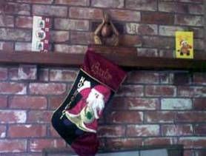

Figure 4: The internal chimney breast at 39 Bishop
Street
This work was carried out by an Englishman who had immigrated to New Zealand to work as a mason. He was retired at the time. In Mrs Baird’s opinion, the job appeared to have been competently carried out and the bricks seemed very secure.

4.4.3 The September earthquake Information on events following the September earthquake has come from Mrs Baird and Ms Breanna Gowland. Mrs Baird’s son, Mr Shaun McKenna, was living in the property with his then partner, Ms Gowland, and her baby son, Baxtor. As a result of the September earthquake there was significant cracking in the plaster adjacent to the chimney breast in the lounge. However, there was no cracking apparent in the brickwork. There were numerous other cracks in the plaster in the lounge.

The only significant damage to the exterior of the house appears to have been to the top of the chimney, from which bricks fell. However, the rest of the external chimney, which was against the side of the house, did not appear to be cracked or damaged. The chimney was subsequently removed and a tarpaulin cover placed over the hole, but no internal part of the chimney or chimney breast was removed.

Mrs Baird made a claim with the Earthquake Commission (EQC) and with her insurer in relation to damage to the house. Mr McKenna spoke to some EQC assessors who were looking at the middle flat in late January 2011 and asked them to look at the back flat as he was worried about whether they should be living there. The assessors said they could not themselves look at the flat but if he sent details of the EQC claim into EQC, EQC would attend to the matter. Apparently this was done but no reply was received.

No one from EQC had inspected the property or made an appointment to do so before 22 February 2011. No one from the CCC or any other official organisation had been to the property either.

4.4.4 The February earthquake

In the February earthquake all the brick chimney breast area inside the lounge collapsed (as did the external chimney). Just before the earthquake struck, Ms Gowland had left Baxtor sleeping on the floor in front of the fireplace. When the bricks collapsed they fell onto the baby, covering him under a fireguard. Although Baxtor was alive when the bricks were removed, he later died in hospital from his injuries.

Mrs Baird said her son Shaun later commented to her that when he was removing bricks to try to rescue Baxtor, he found that they were in big chunks rather than single bricks.

4.4.5 Issues

Although the potential for external chimneys to collapse now appears to be common knowledge in the community, we believe that the potential for internal fireplace brickwork to collapse is not as widely known. Removal of chimneys at and above roof level may be insufficient to prevent injury or death. We note that in a reply to an inquiry by counsel assisting the Royal Commission, EQC expressed the view that there is a greater need for public awareness of this. However, EQC noted that it is not a property inspection organisation and, therefore, does not have a policy in relation to the inspection of internal chimneys. It follows, therefore, that even if EQC had inspected the building before the February earthquake, it would not have been likely to recommend any remedial work, as there were no obvious signs of damage to the internal chimney breast.

In his report on the building, Mr Smith concluded that it was not possible to assess accurately the cause of the chimney failure that resulted in the death of Baxtor Gowland, whether the modification to the fireplace breast might have weakened the chimney and whether the chimney breast might not have been adequately secured to the remaining chimney elements. However, he has noted that chimneys constructed of unreinforced masonry are a hazard in severe earthquake shaking and that, where there are modifications to chimneys, the structure of the chimney is often weakened as the modifications are unlikely to be integrated into the original chimney structure.

We agree with Mr Smith’s view that consideration should be given to requiring domestic chimneys to be strengthened or demolished and that, following a significant earthquake, external brick chimneys and any exposed brick internal chimney breast may be hazards that need to be assessed and dealt with. We make an appropriate recommendation about this issue in section 7 of this Volume.

4.5 89, 91 and 93 Cashel Street

4.5.1 Introduction

These three buildings were situated side by side on the northern side of Cashel Street between Oxford Terrace and Colombo Street.

Information from police records established that when the February earthquake occurred:

• Mr Shane Tomlin was working at the Trocadero Bakery at 93 Cashel Street, on the first floor. Immediately after the earthquake, a work colleague who had been standing next to Mr Tomlin saw a hole in the floor where he had been standing. Mr Tomlin was found, conscious but badly injured, in the TS Retail Store on the ground floor underneath. He was taken to Christchurch Hospital but died as a result of his injuries.

• Ms Jillian Murphy was shopping with two friends
in Deval, which was situated at 89A Cashel Street. It is unclear exactly where she and her friends were when the earthquake hit because the group appears to have exited the shop but Ms Murphy was in the building when it collapsed, trapping her under rubble. Her body was found under collapsed building material.
• Mr Christopher Homan and his wife Mrs Christine
Homan were in Cashel Street, standing in the
vicinity of 93 Cashel Street when the earthquake hit. Mr Homan’s legs were trapped under rubble that fell as a result of the collapse of 91 Cashel Street. CPR was performed on him but he died at the scene.
• Ms Melissa Neale was walking in Cashel Street with her mother, Mrs Margaret Neale, intending to go to the Trocadero Bakery for lunch. They were a short distance from the building when the earthquake hit. Ms Neale’s body was found under collapsed building material in the vicinity of 89, 91 and 93 Cashel Street (the evidence does not allow us to be more precise).

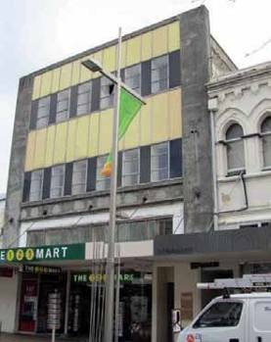

Figure 5: 91 Cashel Street before the February earthquake

4.5.2 The buildings

The buildings at 89 and 93 Cashel Street (on either side of the building at 91 Cashel Street) were owned by Hereford Holdings Ltd, the principal of which was Mr Antony Gough. The building at 91 Cashel Street was owned by West Mall Properties Ltd, the principal of which was Mr Tracy Gough (the brother of Mr Antony Gough).

We note that 89 Cashel Street was also referred to as
87–89A Cashel Street, and 93 Cashel Street was also referred to as 93–95 Cashel Street.

4.5.2.1 89 Cashel Street

The structure at 89 Cashel Street was a two storey URM
and timber building with a lightweight roof. It appears to have been built around 1878 and was not listed as a heritage or protected building.

Although 89 Cashel Street appears to have had some work carried out on it historically, the degree to which this was structural is unclear. In any event, the building was likely to be earthquake-prone under the Building Act 2004.

Correspondence between the owners and the CCC in the 1980s indicated that the intention was to demolish the building and redevelop it, although this never took place. The building was occupied on the ground floor by two retail premises, Deval and 3 Wise Men, with accommodation on the first floor.

4.5.2.2 91 Cashel Street

The building at 91 Cashel Street (which included 91A) was a three storey unreinforced concrete and masonry structure with a lightweight roof on timber trusses. It was not listed as a heritage or historic building.

There was no evidence of any structural strengthening to 91 Cashel Street and it appears that it was in a relatively original state as at 4 September 2010. It was also likely to have been earthquake-prone in terms of the Building Act 2004. The building was occupied on the ground floor by 123 Mart. Mr Kurt Langer, a photographer, occupied the upper floors.

Mr Bryan Bluck of the CCC wrote to West Mall Properties on 22 August 1995 stating that an inspection had revealed that the upper floors were being used for residential purposes but no change of use from commercial to residential had ever been authorised. A reply from West Mall Properties on 24 August 1995 made no reference to whether there had been a change of use. However, it confirmed a discussion in relation to the installation of a fire alarm and the fact that it was intended that the building would be demolished within the next two years. There does not appear to be any further correspondence on the CCC file in relation to this issue.

At the hearing Mr Tracy Gough was referred to the CCC’s letter of 22 August 1995. He said he had spoken to the tenant at that time and subsequently written to tell him he was not entitled to live in the building. When asked in cross-examination whether he had inspected the property to see whether there was any evidence of residential use, such as a bed, after he sent the letter to the tenant, Mr Gough said, “Yes, I have inspected the premises after. I wouldn’t call it bedding but there was sort of, there was strange couches and things there…”

After the hearing, counsel assisting the Royal Commission obtained a report from the CCC’s building file for 91A Cashel Street, which had been completed after the February earthquake. That report recorded that “Kurt and Karen Langer both live and operate Photography Studio on the second floor”. The report listed various items they wished to have retrieved from the building by reference to their location in the building. That included a reference to “south side front bedroom” and “east side back bedroom”. Counsel assisting the Royal Commission also obtained an email dated 13 April 2011 from Mr Langer to Mr Buzz March of Buzz March Construction, which stated, “We literally do have everything we own up there …” and listed various possessions he wanted to retrieve from the property. Counsel wrote to Mr Langer asking if he
had lived in the building. Mr Langer sent a reply stating that he leased the top two floors of the building for a photography business but that he was “not living at the address”.

Enquiries to the CCC revealed that the CCC report form referred to above was prepared by Ms Nicole Chen. Ms Chen has advised the CCC that she is no longer certain where the information on that form to the effect that Mr and Mrs Langer lived in the building came from.

The Royal Commission received a letter dated 26
March 2012 from Mr Gough’s solicitor, enclosing a letter from Thompson Wentworth, the owner’s property manager. That letter referred to an inspection of Mr Langer’s tenancy in December 2011 (presumably this should have read 2010). Thompson Wentworth summarised its inspection by stating, “The premises was leased as a commercial property, was sign written Kurt Langer Photography and appeared to be a working photography studio inside”. The letter from Mr Gough’s solicitor recorded that they had contacted the property manager and enquired whether he had seen any bedding on his visits. Mr Andre Thompson,
of Thompson Wentworth, said that he had seen no bedding, and that during his inspection there was nothing about the way the area was being occupied that led him to think that the occupation was anything but commercial.

4.5.2.3 93 Cashel Street

The building at 93 Cashel Street was a two storey URM structure built around 1885. It does not appear to have had any heritage or historic places classification.

Although the building appears to have had reasonably extensive structural strengthening carried out progressively from 2007 to 2009 on individual tenancies on the ground floor, the CCC still considered the building to be earthquake-prone. The Trocadero Bakery occupied the ground floor and first floor, and TS Retail Store was also on the ground floor.

4.5.3 Events relating to 91 Cashel Street following the September earthquake

After the September earthquake, it was noted in a
CCC Level 1 Rapid Assessment on 6 September that
91 Cashel Street had a fallen chimney and accordingly a yellow placard was allocated.

In early September, a visual inspection of the ground floor was carried out by Harrison Grierson Consultants Ltd, structural engineers, on behalf of the owner. Harrison Grierson concluded that “the ground floor

retail is structurally sound and safe to occupy, and the status has been assessed as green. Upper levels to remain as yellow, limited access until debris are removed”. They noted that the assessment was based on a visual inspection of accessible areas only.

On 10 September 2010, Powell Fenwick, structural engineers, carried out a walk-through inspection for the owner. The inspection noted that the building was “not in immediate danger of structural collapse” but that brick chimneys on the upper floor should be removed urgently. They recommended a more detailed structural inspection and evaluation “in due course to confirm the ongoing structural stability of the building”.

A second walk-through inspection by Powell Fenwick on 29 September noted significant cracks in the parapet to the rear of the building, which it said should be further investigated from the roof level. There was no evidence to suggest that this further and more detailed inspection was ever carried out. In fact, Mr Tracy Gough conceded in evidence that he did not obtain a detailed structural inspection of the building before 22 February 2011.

A CCC Level 2 Rapid Assessment on 12 October 2010 noted that the chimney had been removed. It also noted a vertical crack the full height of the inside of the external wall of the stairwell, which needed to be checked by a Chartered Professional Engineer (CPEng). This was categorised as low risk and the building was assigned a green placard.

Two days later, on 14 October, the building was checked by a CPEng, Mr Martin Crundwell, from Opus. Mr Crundwell was not able to gain access to the building to inspect the crack in the stairwell, but he examined the building as best he could externally, including using binoculars from the other side of the street. He noted vertical cracking in the western wall (which could have been old), corresponding to the location of the crack in the eastern wall that had been observed on 12 October. He suspected that the mechanism of this crack was the same as for the crack seen on the opposite side of the building. He also noted cracks in the street frontage at the joint between the walls and horizontal members. Mr Crundwell requested a CPEng report, because “how [the] building works structurally [is] not clearly understood and requires further study”. He recorded his concern that “if [the] mechanism of seismic restraint is not well understood, there may be repercussions during subsequent aftershocks that are not apparent at this stage”.

Mr Crundwell was asked in evidence why he had assigned a green placard to the building when further investigation was required. He said he thought that
there would be a follow-up within a few days and that because he considered the cracks posed no more than a low risk, he considered “G2 (occupiable - repairs required)” was appropriate.

Mr Stephen McCarthy, from the CCC, gave evidence that Mr Crundwell’s request was never actioned. He said that he and others at the CCC had questioned themselves as to why this was so and the answer they came up with was that from 14 October to 26 December there was a period of transition from Civil Defence notices to section 124 Building Act notices. Further, because the building had been allocated a green placard, it did not receive the same priority as buildings with red and yellow placards.

After the Boxing Day earthquake, a Level 1 Rapid Assessment of 91 Cashel Street noted “Loose bricks either end. Horizontal cracking”. The building was assigned a red placard. The CCC served a notice under section 124 of the Building Act 2004 on the owner of 91 Cashel Street, recording those defects and requiring work to be completed by 31 January 2011. The notice affected the properties on either side (89 and 93) because of the risk to those buildings from the parapets at 91 Cashel Street.

A CCC Level 1 Rapid Assessment of 93–95 Cashel Street on 26 December 2010 assigned a green placard but noted cracking in the front façade, which it recommended should be reviewed by a structural engineer. This never happened. Mr McCarthy explained that the reason for this was that “the whole situation got over-run by the Boxing Day event”.

Mr Andrew Brown, a structural engineer from Opus, acting on behalf of the owner, designed and oversaw make-safe work for 91 Cashel Street to address the damage indicated in the Building Act notice. Mr Brown conducted a brief external visual inspection to determine whether there was any other damage as a result of the Boxing Day earthquake, and a brief internal examination (excluding the ground floor, to which he could not obtain access).

Mr Alistair Boyce of Opus inspected the make-safe work and then completed a standard CCC CPEng certificate (modified to refer to the structural integrity of the building being restored or partly restored to its state prior to 26 December 2010, rather than its state before 4 September 2010). Mr Boyce said that in completing the certificate he relied on Mr Brown’s advice that he had inspected the building for any additional damage. Neither Mr Brown nor Mr Boyce was aware of the inspection and recommendations by their colleague Mr Crundwell on 14 October 2010.

Mr Peter Smith, who provided an independent report to the Royal Commission, stated that in the February earthquake large sections of the eastern wall of 91 Cashel Street fell onto 93 Cashel Street. Equally significant portions of the western wall façade failed and fell onto the building at 89 Cashel Street. A portion of the frontage fell onto Cashel Street.

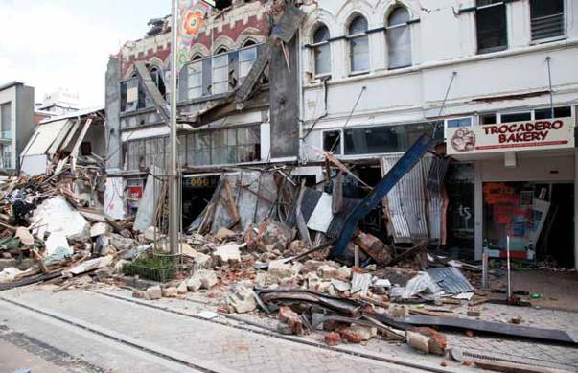

Figure 6: 89, 91 and 93 Cashel Street after the February earthquake

4.5.4 Issues

4.5.4.1 Application of the CCC’s Earthquake- Prone Dangerous and Insanitary Buildings Policy

4.5.4.1.1 Approach to earthquake-prone buildings

We do not know whether the failure of 91 Cashel Street would have been prevented if any strengthening had been carried out before the February earthquake. However, as Associate Professor Jason Ingham’s reports7 to the Royal Commission showed, any significant strengthening gives a building a better chance of withstanding an earthquake. This highlights the problem inherent in a passive approach by a territorial authority to earthquake-prone buildings.
4.5.4.1.2 Possible change of use

We have referred above to the evidence and information about the “change of use” issue in regard to 91 Cashel Street. There appears to be an inconsistency between the information on the CCC file on the one hand and the letters from Mr Gough’s solicitor and Thomas Wentworth on the other. Clearly the matter is relevant to the issue of whether the building was required to be substantially strengthened prior to the September earthquake. We are unable to resolve this issue on the evidence before us. We direct the attention of the CCC to this issue and recommend that it should consider making further enquiries.

4.5.4.2 Assessment of the building following the September and Boxing Day earthquakes

This case highlights the risks inherent in relying solely on a damage-based assessment of a URM building after a significant earthquake.

In this case we note:

• the lack of follow up by the owner of 91 Cashel Street in relation to the recommendation by Powell Fenwick for a more detailed engineering inspection;
• the failure of the CCC to action Mr Crundwell’s request for a detailed CPEng engineering evaluation of 91 Cashel Street;
• the limited nature of the inspection carried out
by Mr Brown following the make-safe work after Boxing Day prior to completion of the CPEng certificate; and
• the lack of follow up of the Level 1 Rapid Assessment of 93-95 Cashel Street following Boxing Day in which a structural evaluation by an engineer was recommended.
We cannot speculate what might have been the outcome if a detailed evaluation of 91 Cashel Street had been carried out. We are left only with the certainties that there was no such evaluation and that the building suffered a significant failure in the February earthquake with the resulting loss of four lives.

4.6 32 Cathedral Square

4.6.1 Introduction

The Press building was situated at 32 Cathedral Square. It was an ornate four storey heritage building constructed in 1906.

At the time of the February earthquake,
Ms Adrienne Lindsay was working on the top floor with seven or eight other staff members of The Press newspaper. She was killed when the roof collapsed as she sheltered under her desk on the top floor. Survivors were rescued by Urban Search and Rescue (USAR), who had to cut a hole through the collapsed roof to
gain access to the top floor.
4.6.2 The building

The building consisted of four suspended concrete floors with a concrete basement car park and a concrete roof. Typical floor beams were a combination of steel angles and concrete. There were numerous iron and steel beams, and cast iron columns. Thick brickwork walls wrapped the perimeter of the building to the north, east and across the centre, in a combination of reinforced concrete brickwork and stonework frames to the southern and western walls. A large brick-and-stonework turret was located at the south-western corner, extending above roof level.

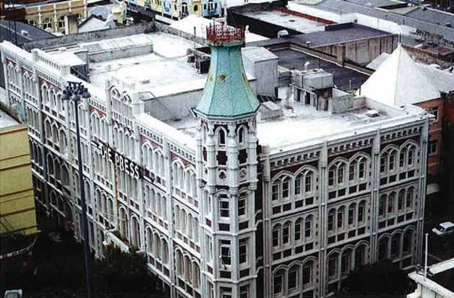

Figure 7: The south-western corner of The Press building before the February earthquake

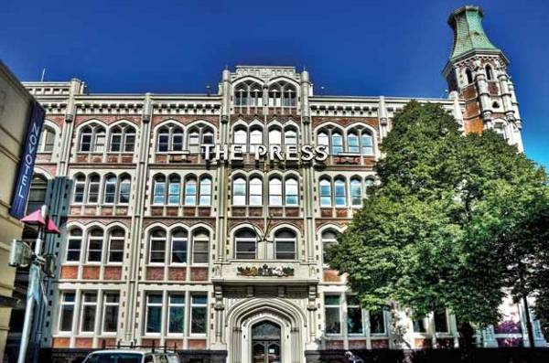

Figure 8: The western wall of The Press building before the February earthquake

The original brick-and-stonework parapet extending above roof level was reduced in height in the 1970s, along with the installation of structural steel securing works to the southern and western wall parapets. It is thought that this was the only strengthening work undertaken on the building since it was first built.

A seismic risk buildings survey conducted by the CCC in 1991 gave the building a score of 13, which resulted in a B classification, meaning that remedial action was recommended within two years. A CCC hazardous appendage survey in 1992 recorded noticeable loose masonry and significant mortar deterioration.

Mr Stephen McCarthy from the CCC gave evidence that the CCC had not contemplated any action under its 2006 Earthquake-Prone Dangerous and Insanitary Buildings Policy, as it had been in discussions with the owner of the building, Ganellen Pty Ltd (Ganellen), for about three years regarding the owner’s plan to strengthen the building. Mr McCarthy also noted that under the 2010 policy, this being a Category C building, the owner would have had up to 30 years to complete strengthening work unless a building consent application for significant alteration had been received by the CCC. No such application was received.
4.6.3 Events following the September earthquake

After the September earthquake, CCC Level 1 and 2
Rapid Assessments on 5 September recorded minor damage including cracking, which was to be assessed by the owner. The building was assigned a green placard and classified as G1 (Occupiable, no further investigation required). On 6 September a further Level 2 Rapid Assessment noted cracking to a masonry wall and a loose balustrade to the turret tower. The building was assigned G2 (Occupiable, repairs required) and the owner notified of the repairs required.

Ganellen obtained a structural evaluation report from Lewis Bradford, Consulting Engineers (Lewis Bradford), dated 16 September 2010. It was recorded that the inspection was of a general nature and was an initial structural evaluation but no detailed seismic analysis had been undertaken. The report noted that Lewis Bradford had been asked to inspect the payroll area in the north-western corner of the third floor. Significant cracks in the brick wall on the north-western corner of level three were observed, temporary structural steel securing was designed and installed to secure that corner, and the area was cordoned off.

Lewis Bradford recommended the construction of a new in situ shear wall within the following two to three weeks. However, it transpired at the hearing that, on reconsideration, Mr Ashley Wilson, the structural engineer who had carried out the Lewis Bradford inspection, was of the view that this timescale had been ambitious and it might take longer to devise a permanent solution. In his view, while the interim securing that was provided for the northern wall could not be a permanent solution because of weather- proofing and heritage issues, it should have provided adequate support in the weeks and months that followed. At that time he considered that the work carried out would be sufficient for the period in which The Press intended to remain in the building: the newspaper was intending to move out in February 2011.

The tenants, The Press newspaper, instructed Harrison Grierson Consultants Ltd (Harrison Grierson) to inspect the building and report on its structural integrity. In his report of 15 September, Mr Andrew Thompson of that firm noted various items of damage, although the only ones said to require further assessment were diagonal cracking and loose bricks in the north-eastern corner of the eastern exterior of the third level. Harrison Grierson recommended that the interior pinboard lining be removed to enable inspection of the interior face of this wall. Large cracks in the north-western corner of the third storey were noted, as well as the “emergency strengthening” that had been applied to the wall. The view was expressed that this wall had been sufficiently stabilised until permanent remedial works were designed and constructed.

The report concluded that, with the exception of the areas identified, the building was structurally sound and safe to occupy and that the green placard status was appropriate.

The following areas of damage were noted in an earthquake response report completed by Ganellen:

• payroll office at north-western corner of level three
(suspected diagonal shear failure);

• turret railing; and

• stone parapet above main entrance.

Lewis Bradford submitted a structural damage report to Ganellen in October 2010. As with the September report, it was based on a visual inspection. While observing that the building had performed surprisingly well considering the large floor plates, heavy construction and its age, the report noted structural damage throughout. There was significant damage in three main areas: the north-western brick wall at level
three, the north-eastern brick wall at level three, and the stonework to the southern and western perimeter frames. The report detailed specific repair work for each of those areas.

Ganellen then put the ongoing structural work required up for tender. Mr Michael Doig, the New Zealand Development and Business Director of Ganellen, said that a tender from Holmes Consulting Group (HCG) was accepted, essentially because it was believed that the analytical methodology (which had been outlined by Mr John Hare of HCG to the owner) “…would provide a better structural solution for the repair of the building”.

HCG took over from 10 November 2010 and undertook a number of inspections in November and December, before providing its initial findings to Ganellen in a report dated 22 December 2010. HCG noted that the strength of the building in its then damaged but temporarily secured state would equate to about 50% of the current new building standard (NBS).

After the Boxing Day earthquake, a CCC Level 1
Rapid Assessment on 26 December 2010 on the same day noted “general brick cracking including risk that neighbour’s parapet on east side could fall on the Press building”. The building was assigned a red placard and a notice under section 124 of the Building Act 2004 was served on the owners.

As a result, the building was evacuated and inspected by HCG on 26 December 2010. Damage was noted to the northern wall and central shear wall on level three, the base of the brick turret at roof level and the piers at the southern wall on levels one to three. In a site report dated 27 December 2010, Mr Hare recommended propping and shoring of the northern and southern walls and propping and shoring to restore the pier strength to the northern and southern façades, which were considered critical load-bearing elements.

A second site visit was conducted by Mr Ben Dare of HCG on 7 January 2011 to inspect the securing works that had been carried out as recommended in Mr Hare’s site report of 27 December and to observe any further damage. Mr Dare noted that the work recommended by Mr Hare to the southern and northern walls and the stairwell had been completed. He also observed that the parapet from the adjacent building (Worcester Tower) had collapsed into the lightwell of The Press building and that a concrete lintel beam below the parapet had sustained a series of moderate-sized cracks. He recommended that temporary waterproofing be installed and the owner of Worcester Tower be notified to deal with the parapet issue. Later that day,

Mr Dare sent an email to Mr Nick Jennings of Ganellen, attaching his site report dated 7 January 2011 and stating, “If the additional securing works have been completed, the immediate threat to the tenants of the building will have been removed and it should be safe to occupy on Monday”. He then received a phone call from Mr Jennings, who told him that the loose sections of the parapet had been removed and temporary waterproofing installed.

On 12 January 2011 Mr Dare completed a CPEng certificate, a form the CCC required to be signed by
a chartered professional engineer (CPEng) before the yellow or red placard on a building could be changed to green and the CCC would accept that the issues
raised by a notice under section 124 of the Building Act had been dealt with. The certificate stated that interim securing measures had been taken to restore the structural integrity and performance of the building to
at least the condition that existed prior to the earthquake on 26 December 2010. It was sent to the CCC, which then treated the requirements of
the Building Act notice as having been satisfied and
approved the building for occupation. The Press reoccupied the building at that point and remained in occupation until the February earthquake.

Various proposals for strengthening work were provided by HCG because, although a formal assessment had not been completed, it was clear that the building’s residual strength after the September and Boxing Day earthquakes would have been less than 33% NBS had it not been for the securing work that had been done. None of these proposals was able to be put into effect before the February earthquake.

In the February earthquake the building suffered severe structural damage including:

• collapse of the third (top) floor including the roof;

• collapse of most of the parapets;

• collapse of the turret; and

• cracks to the southern and western façades.

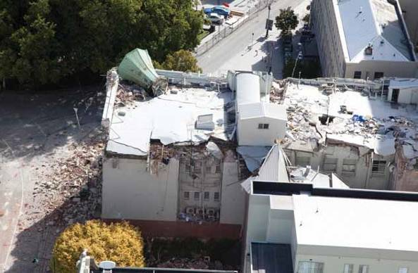

Figure 9: The roof and eastern wall of The Press building after the February earthquake

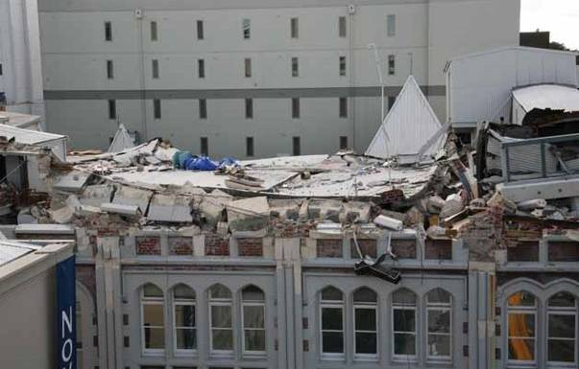

Figure 10: The western wall and roof of The Press building following the February earthquake

In his report to the Royal Commission, Mr Peter Smith noted that subsequent photos of the building indicated that “failure of the roof diaphragm over the internal wall allowed the northern portion of the roof to translate in a north-easterly direction, rotating about the junction of the internal unreinforced masonry wall and the east wall. As the northern portion of the wall translated, the northern portion of the roof failed at several of the supporting beam lines”.

In Mr Smith’s opinion, the northern wall was a very significant part of the torsional resistance to the building. He noted that unfortunately it had not been possible to draw any conclusion as to what had happened to that wall when the building failed. However, he raised a concern with the allocation of a green placard to the building following a Level 1 Rapid Assessment when in fact there was “some reasonably significant damage at the upper level of the building”. This was particularly of concern, he said, given that this was a four storey building. He also sounded a caution in relation to the allocation of the green placard when the securing work put in place by Lewis Bradford was seen as temporary. In his view, “we need to be careful to make sure when we give a building a green sticker that we are totally happy this could stay on for some time”.
Mr Smith also noted that the issue of vertical acceleration was an important one in relation to the upper floors of unreinforced masonry (URM) buildings. In his view, steps would have to be taken in future “to provide resistance against the detrimental effects of vertical accelerations”.

4.6.4 Issues

4.6.4.1 Application of the CCC’s Earthquake- Prone Dangerous and Insanitary Buildings Policy

This building had remained in a relatively original condition and does not appear to have had any significant structural strengthening carried out during its history. In common with many other URM buildings, it is an example of an approach that did not require any structural strengthening under the relevant CCC policies because there was never any application for a building consent.

4.6.4.2 Assessment of the building after the
September and Boxing Day earthquakes

We note that after the September earthquake both
Ganellen and the The Press took considerable care
to ensure that the building was properly assessed by engineers.

We agree with Mr Smith’s comments that care has to
be taken in assessing URM buildings, particularly of this nature. The post-earthquake assessment of buildings is discussed in a Volume 7 of this Report.

We think there is merit in Mr Smith’s view that, in designing the type of strengthening work that was completed on the north-western wall on the third floor of this building, it would have been appropriate for there to have been a more extensive consideration of the likely load that would come onto the wall in the event of a significant earthquake. As he said, this was an important element in the building at the upper level that should have been subjected to some analysis to be sure that it provided an appropriate level of strength.

Although we will never know now, had there been a more detailed engineering assessment of the building following the September earthquake, and a detailed assessment of the likely load on the north-western wall, higher levels of strengthening may have been required.

4.7 90 Coleridge Street

4.7.1 Introduction

Mr Stephen Cochrane was killed in the February earthquake when a concrete block wall collapsed and crushed him as he ran out of Classique Furniture at 90 Coleridge Street.

Mr Cochrane, who had been working in the building when the earthquake struck, ran out of the side door. Just as he began to run down the driveway the wall toppled over, crushing him underneath it. Efforts were made to rescue him by lifting the wall but he died as a result of being crushed.

4.7.2 The building

Mr Graeme Dreaver, the owner of Classique Furniture, bought the building about 10–12 years ago. On the eastern side of the building there is a driveway that accesses a sliding door. The wall in question was also on the eastern side of the property, very close and parallel to the boundary wall (which is the concrete side wall of the neighbouring building). The wall that failed was free-standing, about six metres high and three metres long.

When Mr Dreaver bought the property the wall was in the same state as prior to the February earthquake. The previous owner told him at the time of purchase that it had been part of a lean-to connected to the building by a roof extending across the driveway. Apparently that roof collapsed in heavy snows (likely in 1992), leaving the wall standing near the boundary where it had remained ever since.
4.7.3 Events following the September earthquake

There did not appear to be any structural problems with the factory building after the September and Boxing Day earthquakes. There was no Civil Defence or CCC assessment of the building between the September and February earthquakes.

During the February earthquake, sideways movement of the wall resulted in the top two layers of concrete blocks breaking off the wall and landing on the roof of the neighbouring building to the east. The rest of the wall fell in one piece in the opposite direction, towards the Classique Furniture building. Because the top two layers of blocks had already come off, the wall just cleared the sidewall of the building as it toppled over.

Mr Peter Smith stated in his report to the
Royal Commission that the wall had two reinforcement rods (both approximately 20mm in width), one at each end. The owner has since advised the Royal Commission that there were four vertical reinforcing rods in the wall. Whatever the position was, it is apparent that the wall was inadequately reinforced to resist the effects of the February earthquake.

Wall that collapsed

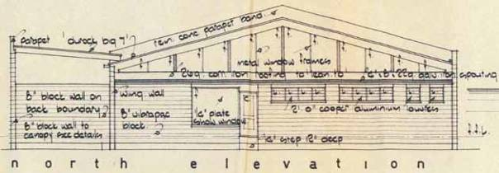Figure 11: A section from the original plan of the building, showing the wall at left with its lean-to roof attached

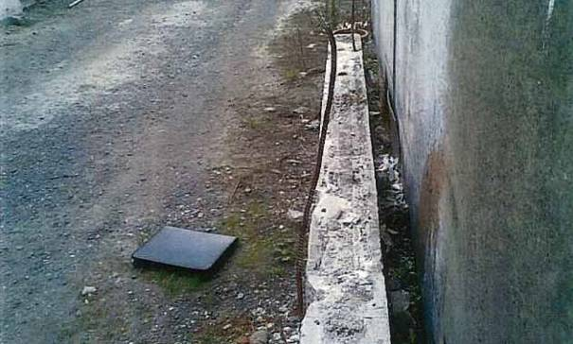

Figure 12: The base of the wall after the collapse and removal of the wall

Mrs Tania Cochrane, Mr Cochrane’s widow, gave evidence that she had expressed concerns to her late husband about the state of the wall and the danger it posed. She said she had seen cracking in the wall and that the wall was on a slight lean towards the building.

Mr Dreaver did not accept that the wall was cracked or on a lean. He said he had not really given any thought to the potential danger it might pose and that after the September earthquake he thought it must have had some reinforcing to have withstood that event. That evidence was supported by Mr Dreaver’s employee, Mr Marc Hobson.

4.7.4 Issue

This case highlights the need for a cautious approach towards a free-standing masonry wall, the structural strength of which is unknown. Even putting to one side the difference in accounts of Mrs Cochrane on the one hand and Mr Dreaver and Mr Hobson on the other,
and accepting there is an element of hindsight, we would have thought that a free-standing wall some six metres high and three metres long should have raised concerns after the September earthquake, given the ongoing significant aftershocks.

This case should serve as a lesson to other owners or occupiers of properties with masonry walls, the strength of which is unknown. Such walls should either be adequately restrained or demolished.

Recommendation

We recommend that:

71. Free-standing masonry walls of unknown structural strength should be adequately restrained or demolished.

4.8 382 Colombo Street

4.8.1 Introduction

A two storey URM (brick) building on the eastern side
of Colombo Street in Sydenham housed two addresses, numbers 382 and 384. The southern end of that
building was number 382. It was immediately adjacent to and north of number 380, which housed The Tasty Tucker Bakery and Coffee Bar. The bakery was part of a single storey building with a light metal roof, which had been constructed around 1972 and also housed the Sydenham branch of the ANZ Bank.

In the February earthquake, the parapet wall of the southern end of 382 Colombo Street collapsed outwards and through the roof of the Tasty Tucker Bakery.
Ms Cheryl Armour gave evidence at the hearing that she was working in the Tasty Tucker Bakery at the time of the February earthquake. When the earthquake struck, she had just served Mrs Maureen Fletcher, who was having her lunch in the bakery with a Mr and Mrs Moon. Ms Armour said that Mrs Fletcher was struck by a beam that fell from the roof. She said there were bricks falling from the ceiling and she thought Mrs Fletcher would have been killed instantly. Another customer, Ms Beverly Edwards, was pinned by a beam and Ms Armour attended to her. Ms Edwards was rendered paraplegic as a result of her injuries. Mr and Mrs Moon sustained some injuries but survived.

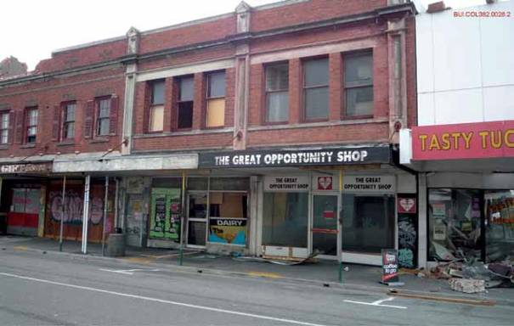

Figure 13: 382 Colombo Street and (at right) the Tasty Tucker Bakery, after the February earthquake

4.8.2 The building

The 382 Colombo Street address housed an opportunity shop and dairy downstairs and what appears to have been residential space upstairs (although that seems to be inconsistent with the CCC file). It was constructed with unreinforced brick walls, timber roof framing and a timber first floor. It was part of an integrated development involving buildings at 382–402 Colombo Street, which had common party walls.

Both the ground floor and the first floor façades had significant penetrations for windows. The south wall of the building, which adjoined the common boundary with 380 Colombo Street, was free of penetrations. The building had prominent parapets on Colombo Street and lower parapets along each side wall. CCC records indicate it was built in the 1920s. There appear to have been very few alterations to the building since its construction.

A CCC seismic risk buildings and hazardous appendage survey in 1993 gave the building a score of 12, which resulted in a classification of B/C, meaning recommended remedial action within two to 10 years. This was not followed up before the September earthquake.

Mr Yan Kin Min (also known as David Yan), a computer systems analyst, is the son of the owner, Mrs Boi Fong Yan. She is 83 years old. It appears that the building was effectively managed on her behalf by Mr Yan, his brother Mr Michael Yan (who lived in Auckland) and his sister Ms Eileen Yan (who lived in Christchurch). Mr David Yan said that no strengthening work had been carried out in the approximately 40 years that his mother had owned the property.

In 2007 the owner applied for a Project Information
Memorandum (PIM) in relation to proposed alterations
to create living quarters upstairs. The CCC issued a PIM that identified the building as potentially earthquake- prone. The owner then applied for a building consent. This was later cancelled at the request of the owner after the CCC asked for more information. It transpired at the hearing that the further information sought was details of earthquake strengthening that would be required, as the CCC viewed this as a change of use of the property. Mr Robert Ling, an engineer and friend of the owner, acted on behalf of the owner in relation to this application. In evidence, Mr Ling said that he submitted that it was not a change of use, but that this was not accepted. Mr Yan also claimed that residential use had pre-existed the application. Mr Ling said that the owner did not further pursue the building consent
application because of the high cost of strengthening that would be required. They were also difficulties in providing suitable access arrangements.

4.8.3 Events following the September earthquake

4.8.3.1 Tasty Tucker Bakery: 380 Colombo Street

It appears from the CCC file that following an assessment on 7 September 2010, the Tasty Tucker Bakery building was allocated a green placard and continued to be occupied and used as a bakery/café.

4.8.3.2 382 Colombo Street

On 7 September a CCC Level 1 Rapid Assessment of the block of shops extending from 382–402 Colombo Street noted minor damage to the brick façade, which “could be damaged further by future aftershocks and the collapsed north wall of [a building to the north of that block]”. The building was allocated a yellow placard.

Mr David Yan said in evidence that he inspected the building with Mr Ling about 10 days after the earthquake. Mr Ling told the Royal Commission that there was a lot of cosmetic internal damage. He said there was substantial damage to the parapet walls on the north end and at the rear (eastern side) of the building. Mr Ling’s evidence was unclear as to the extent of any damage to the internal side of the south wall. However, when asked if he gave any thought to the stability of the building, Mr Ling said that he had looked at the external wall and did not see any external signs of distress on that wall.

Email correspondence of 29 October 2010 between Ms Esther Griffiths, project manager of the CCC’s Building Evaluation Transition Team (BETT), and Mr Gary Lennan indicates that the CCC had unsuccessfully attempted to contact the owner of 382, 384 and 490 Colombo Street. Mr Ling had been contacted that morning; apparently nothing had been done about these properties and Mr Ling had given no indication of urgency. The BETT view was that a notice under section 124(1)(c) of the Building Act 2004 should be served, requiring action by 15 November 2010.

The CCC wrote to Mrs Boi Fong Yan on 29 October
2010 enclosing the Building Act notice. The notice recorded “significant damage to structural walls, party walls, fire walls and/or structural frame (cracking, bowing, failed connections, spalling)”. The notice required work to be carried out by 15 November 2010 and gave the owner the option of seeking a time extension.

No repair work was ever carried out by the owner in response to that notice. Mr David Yan said in evidence that the CCC’s letter of 29 October and the notice had been received by his sister Eileen, whose address was on the CCC’s file as the mailing address for their mother. His sister, who he said could read English, had opened the letter and noticed that it related to the earthquake. She then passed it on to their brother, Mr Michael Yan, who was in Christchurch at the time, knowing that he would be visiting Mr David Yan. The latter said that his brother was a barrister in Auckland and had had some dealings with the CCC in relation to the building in late 2010 or early 2011. Mr Yan said that his brother had put the letter and notice in a bag, then taken the bag to Auckland and put it in a cupboard where it remained until after the February earthquake.

There was no CCC rapid assessment of the building following the Boxing Day earthquake. Mr Ling said that he considered the rear walls of the building were not safe, that he had told Mr Yan this after Boxing Day and that they should be propped. Mr Ling said that they had been propped with a timber beam and he thought that Mr Yan had had a friend carry this out. However, Mr Yan said in evidence that he had not had any work done on the building.

Mr David Yan gave evidence that a man called “John” (he did not know his surname) was living upstairs at 382 Colombo Street before the September earthquake and remained there after it. He said there was no tenancy agreement but John was paying rent in cash and he collected it occasionally.

Mr Yan said that he thought the reason 382 Colombo Street had a yellow placard was because of the collapse of the building to the north of it, and the potential danger to the front of number 382. Initially he said he thought that if John was not supposed to be there, someone like the CCC would have told him to leave; but later in evidence he said he did not think John should be there because of the yellow placard and he had told him a couple of times that he “should be moving on”. He agreed that he had never told the CCC that John was living there. Later it was put to Mr Yan that the statement of Mr Peter Avnell (an Australian loss adjustor for Mr Yan’s insurer) to the Royal Commission noted that tenants were still in occupancy. Mr Yan responded that there were two people living at 384 Colombo Street, which also had a yellow placard. He said that he believed they had subsequently moved out to the section “at the back”.
Mr Ling said that when he became aware that there were tenants at 384 Colombo Street, he told Mr Yan and the tenants that the latter should not be there. He understood that the tenants moved out into a caravan at the rear of the property but that they were still using the bathroom in the building. Mr Ling accepted in evidence that he had certain obligations as an engineer if he was aware of potential danger from a building. However, he contended that he had effectively discharged this obligation by telling both Mr Yan and John that the latter should not be there. He said did not consider contacting the CCC.

Mr Avnell gave evidence that he inspected the building in January 2011 with Mr David Yan and Mr Ling. He formed the view that, because of the amount of damage (mainly inside), the building was a total loss and he told Mr Yan that. Mr Ling’s evidence was at odds with this, in that he said Mr Avnell wanted to have the building repaired.

In relation to the south parapet wall, which he described as the “wing wall”, Mr Avnell was concerned because it displayed signs of aged cracking and was on a tilt towards the north. His impression was that the tilt was quite old and he could not detect any signs of fresh cracking at the base of the wall. The main crack that concerned him did not appear to have been exacerbated by the recent earthquakes. Despite this, he was concerned that there could be further problems so he considered the wall potentially dangerous. Mr Avnell said that he did not recall making any specific reference to the integrity of the parapet or wall during his discussions with Mr Ling.

Mr Avnell said that he asked Mr Ling to complete a structural damage report and scope of works on the building. Mr Ling said in evidence that he was still working on this report at the time of the February earthquake. Mr Avnell suggested to Mr Yan that it “might be an idea” if the tenants in the property were asked to move out, because he did not consider it a safe place for people to be living in. Mr Ling said that at the time of the inspection he did not consider the south parapet wall to be dangerous. In cross-examination he conceded that, after looking at the evidence at the hearing and in particular the close-up photographs that Mr Avnell had taken, there might have been “an element of slight potential risk that it might collapse”.

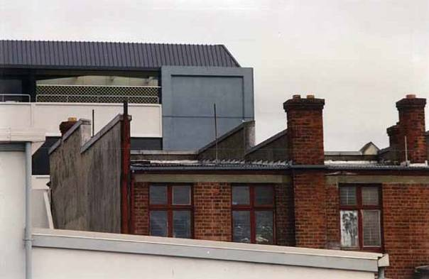Figure 14: The rear of 382 and 384 Colombo Street, showing the wall and parapet of 382 (arrowed)

On 4 February 2011 Mr Mark Ryburn, a structural engineer on secondment from Opus, conducted an inspection, noting moderate damage to parapets, columns, plaster, corbels, walls and “damage to parapets and/or chimneys, and/or ornamental features that may pose a risk to the public and/or adjacent property”. His report recommended that work be completed by 4 April 2011. The record noted that the building had been abandoned, although there were signs of occupation in the upper storey. This was not further investigated.

Mr Ryburn said that the purpose of the re-inspection appeared to have been to update the status of the building and check if there had been any further damage that might have necessitated a different placard. He said that he changed the placard of the building to red because there seemed to have been nothing done to the building, and because he also wanted to make sure that the occupants who appeared to be there knew that they should not be.

Mr Ryburn said he could not recall examining the south wall. He said that access and visibility from both the front and the rear of the property were limited, and that a fence prevented him from getting any closer at the rear of the property than the boundary between 384 and 386 Colombo Street.
The owner of the building housing the Tasty Tucker
Bakery was not aware of the potential danger from
the neighbouring parapet wall at 382 Colombo Street, although he knew there were problems with the building given the barricade fencing in front of it.

Mr Peter Smith said in his evidence to the
Royal Commission that in the February earthquake, the south wall parapet failed along the roofline, following what appeared to be the ceiling lining, as if the ceiling had provided some restraint to that wall and stopped a total façade failure. He noted that the crack referred to by Mr Avnell in the parapet was about 600mm above the roofline.

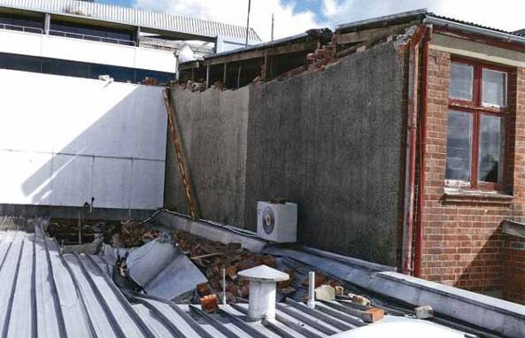

Figure 15: The southern parapet wall of 382 Colombo Street, which collapsed onto the roof of the Tasty Tucker Bakery

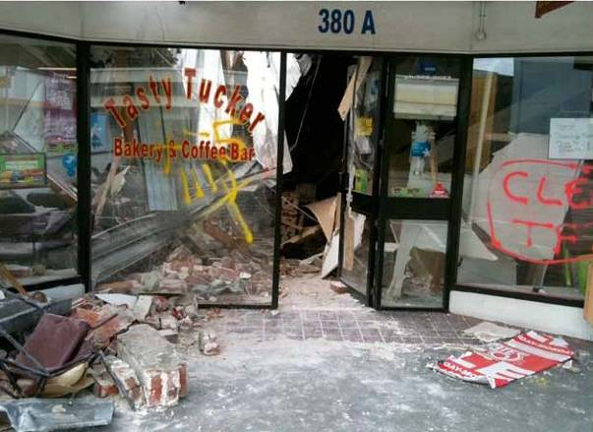

Figure 16: The Tasty Tucker Bakery and Coffee Bar after the February earthquake

4.8.4 Issues

4.8.4.1 Application of CCC’s Earthquake-Prone Dangerous and Insanitary Buildings Policy

The requirement to complete substantial earthquake strengthening arose when the owner applied for a building consent in 2007. However, because of the cost of that strengthening, the application was not pursued.

A building that clearly required strengthening was consequently not strengthened. This illustrates the ineffectiveness of a passive earthquake-prone buildings policy in which the trigger for the requirement to strengthen was not consideration of public safety, but a proposal to alter a building for a change in use.

4.8.4.2 Assessment of the building (and in particular the south parapet wall) following the September earthquake

As we have commented in relation to other URM buildings, we agree with Mr Smith that, where there is the potential for a parapet to fall on an adjoining building, there is a risk in not assessing the capacity of the building in sufficient detail to include consideration of the connections of the walls to the roof framing.

In this case, Mr Ling’s inspection appears to have been purely damage-based and focused on insurance issues. He did not give any consideration to the capacity of the south wall to withstand ongoing aftershocks. Mr Ryburn also conducted an essentially damage-based assessment as directed by the CCC. He was there to inspect the building for any further damage. His recollection was that he did not look at the south wall, so it follows that he did not give any specific consideration to whether it posed a danger to the adjoining property.

In our view, in future following a substantial earthquake a building such as this should have been allocated a red placard from the outset (and so too an adjoining premises such as Tasty Tucker Bakery) until falling hazard risks had been properly assessed.

We did not have any information before us in relation to the building that existed at 380 Colombo Street at the time of the redevelopment in 1972. However, it may well have been a two storey building adjacent to the existing two storey building at 382 Colombo Street. With the demolition of that building and its replacement by a single storey building, there was the potential of danger from the then exposed second storey of the south wall of 382 Colombo Street. There is a need for greater awareness of such potential danger. We also comment on this issue in our discussion on the failure of the building at 246 High Street.
4.8.4.3 Inaction by the owner

We have difficulty accepting the explanation given by Mr David Yan as to why the Building Act notice was not complied with. It must have been evident that this was an important document that required attention. An owner is legally obliged to respond to a Building Act notice and in this case the owner failed to take any steps to comply with the notice.

Compliance with the Building Act notice might not have addressed the potential risk posed by the south parapet wall, but a detailed assessment of the building by a competent engineer might have addressed that risk.

In relation to the issue of occupants in the building after it had been assigned a yellow placard, Mr Yan said that he had told John that he “should be moving on”. Mr Ling said he told Mr Yan that John should not be there. Both men knew that the tenant should not be in the building. While they could have advised the CCC, neither took that action. It also became apparent at the hearing that there were two people occupying 384 Colombo Street who at some stage moved out to a caravan at the rear of the property but were still coming and going from the building. This should not have been the case, as 384 bore a yellow placard as well.

Further, the form completed by Mr Ryburn on
4 February 2011 indicated that people may have been occupying the building. However, the CCC had taken no action to investigate this prior to the February earthquake.

Although there is no evidence that John suffered any injuries in the February earthquake, in our view this case highlights the need for owners and territorial authorities to take steps to warn those using dangerous buildings about the risks they face, and to take action to prevent the occupation of such buildings.

We are also concerned that there were residential tenants at 382 and 384 Colombo Street after an application for a building consent for a change of use to convert the buildings to residential use had been withdrawn in 2007 because of the costs of the strengthening required. Mr Yan has claimed subsequent to the hearing that the use had pre-existed the application and that the application was simply to establish separate access. There is insufficient evidence for us to resolve this issue.

We draw this matter to the attention of the CCC to take such further action as they see fit.

4.9 593 Colombo Street

4.9.1 Introduction

Mr Matthew McEachan worked as a tattooist at Southern Ink Tattoos and was a tenant in the building at 593 Colombo Street. He was killed by falling rubble from the collapse of the Colombo Street façade as he tried to flee the building in the February earthquake.

4.9.2 The building

The building at 593 Colombo Street was a two storey URM building constructed in the early 1900s. It was situated on the corner of St Asaph and Colombo Streets with tenancies on both street frontages (187 St Asaph Street and 593A and 593B Colombo Street).

Southern Ink was the only tenant in the building at the time of the February earthquake.

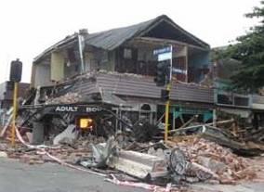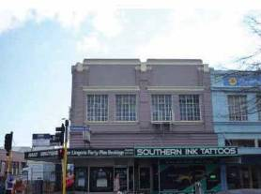

Figure 17: 593 Colombo Street pictured before and after the February earthquake

It appears that no structural strengthening had ever been carried out and the building was essentially in its original condition on 4 September 2010. As there had been no applications for building consents in the past, the owners had not been required to carry out any structural strengthening.

Seismic risk and hazardous appendage surveys in
1991 and 1992 respectively highlighted concerns with the building’s masonry. The seismic risk survey recommended remedial action within two years but no action was taken.

In evidence Mr Stephen McCarthy from the CCC
said that the seismic risk survey was not followed up because the Building Act 1991 came into force in April 1992 and section 8 of the Act provided that the CCC could not require buildings to be upgraded to a higher standard than they had been built to previously.
Mr McCarthy agreed that an initial desktop evaluation of buildings was carried out when the CCC’s Earthquake-Prone Dangerous and Insanitary Buildings Policy 2006 came into effect and that this would have highlighted the result of the seismic risk survey for this building, but no action had been taken in relation to that survey.

Mr McCarthy speculated that the hazardous appendage survey was not followed up because it did not reveal an immediate danger.

4.9.3 Events following the September earthquake

The evidence the Royal Commission heard focused on events following the September earthquake. That evidence highlighted confusion and a breakdown in communication, both of which may have contributed to Southern Ink remaining in occupation of the building at the time of the February earthquake when that should not have been the case.

Mr Simon Wall, a CPEng of seven and a half years’ experience, worked as a volunteer in the days following the September earthquake. He conducted a Level 1 Rapid Assessment on 5 September 2010. He allocated two different placards to the building: a yellow placard on 187 St Asaph Street and a green placard on the Colombo Street frontage.

His reason for doing this was that there was visible damage to the south-western corner of the building but not to the Colombo Street (eastern) end. He considered that the visible damage did not affect the eastern end. He said that he intended to put green placards on the door of each of the tenancies on Colombo Street, although he could not specifically recall doing this.

Evidence was given by Mr Peter Smith, who carried out an independent assessment of the earthquake performance of the building for the Royal Commission. In his view, the assignment of a yellow placard to the tenancy of 187 St Asaph Street should have resulted in yellow placards to all other tenancies in that building, so that the whole building should not have been occupied. Mr Smith was involved in the volunteer effort following the September earthquake and recalled a briefing in which an instruction was given to placard tenancies in the same building in that manner. Mr McCarthy expressed the view that the briefings for volunteers were comprehensive and included the instruction that Mr Smith had recalled. However, he noted that the damage to this building after September was limited to the south-western corner and that this may have been why the focus was on that part of the building. Mr McCarthy also said that on receipt of the rapid assessment reports for 187 St Asaph Street and 593 Colombo Street, the CCC would have opened separate files in relation to those tenancies.

On 13 October 2010, a CCC Level 2 Rapid Assessment of 187 St Asaph Street confirmed the yellow placard and recommended a detailed structural engineering evaluation. That same day, a CCC “Enforcement Team Notices Coversheet” noted under “Further Action” that a CPEng was to provide a report on the safety of the
building and that there should be a Notice to Fix for work relating to the south-western street frontage. Mr McCarthy said in evidence that although the CPEng report was not followed up by the CCC, “there were priorities set, and where it was scheduled it would have eventually got done”. There was no communication from the CCC to the owners at any stage of the need for such a report.

Mr Christopher Chapman, a property manager from Grenadier Real Estate Ltd, which trades as NAI Harcourts, gave evidence that Harcourts were contacted a few weeks before the September earth- quake by the owners of the building (the Chang family, who at that time were living overseas) about the possibility of Harcourts managing the building. However, no management agreement was entered into. Then, after the September earthquake, the owners contacted Mr Chapman to see if he could help them deal with the building in the aftermath of the earthquake. Mr Chapman made it clear that at no time was there any concluded property management agreement, but said that he was “acting as a facilitator”, assisting the owners and in effect representing their interests in discussions with engineers and tenants.

We note that Mr Matthew Parkin (one of the owners of the Southern Ink business) sent an email to Mr Chapman on 20 September 2010 in which he said he understood that Mr Chapman was the new property manager. In responding to that email, Mr Chapman did not disabuse Mr Parkin of this notion. Whatever the exact contractual position, Mr Chapman was effectively acting as a property manager. Consistent with Harcourts’ approach to all of the buildings under their management, Mr Chapman arranged for an “initial earthquake inspection” of the building by Holmes Consulting Group (HCG).

A Level 2 Rapid Assessment was carried out by
Mr Alistair Boys of HCG on 24 September 2010.
Mr Boys’ evidence was that there was a yellow placard at that time located on or adjacent to the front entry of the lingerie store at 593A Colombo Street, next to Southern Ink. Counsel for HCG produced a photograph taken on 4 October 2010, said to show a yellow placard on that entrance. Due to damage observed on internal inspection of the building, Mr Boys was of the view that the whole of the building should retain its yellow placard status and be unoccupied. He said that he was not aware that Southern Ink was still in occupation of 593B. He did not see any tenants in the building and did not go into the Southern Ink tenancy. He could not recall whether there was a placard on the entrance to Southern Ink. Mr Boys said that he spoke to

Mr Chapman on 24 September to report on his inspection of the building. While Mr Boys could not specifically recall telling Mr Chapman that the building “was yellow”, he said he would have given him that information at a meeting following his inspection that day. It was his evidence that he told Mr Chapman that the yellow placard status of the building should remain.

At that meeting he handed Mr Chapman a handwritten site report that he had completed. That report did not include any reference to the yellow placarding. Subsequently, Mr Boys completed a typed site report which recorded, “Not safe to occupy (YELLOW tag remains in place)”. This notation did not appear on the handwritten site report. Mr Chapman maintained at the hearing that he never received the typed site report. Subsequent to the hearing, HCG located an email that forwarded the typed site report to Harcourts on 29 September 2010, along with many other similar reports. A statutory declaration from Mr Ryan McCarvill of HCG confirmed that he had checked that this email had left HCG’s email server and there was no evidence of any “non delivery report” being received. In a statutory declaration completed subsequent to the hearing, Mr Chapman said that he had never received this email and that his inquiries had established that this might have been because of the size of the attachments. He referred to another unrelated email that had been sent by Harcourts but never received and for which no “non delivery report” was received. We are unable to resolve this conflict in the evidence.

Mr Parkin confirmed that after the September earthquake the front door of Southern Ink initially had a green placard but that at some point it had been removed. He could not say when. It does not appear in the photograph taken on 4 October 2010. He confirmed that he recalled seeing the yellow placard on the central door of 593 Colombo Street, but again could not say when. We are aware from our inquiries into other buildings that the colour of some of the placards on buildings faded from green to yellow over time. While that may have happened in this case, we think it unlikely in the comparatively short period that elapsed before Mr Boys’ inspection. Having considered all the evidence, we have concluded on the balance of probabilities that at some point between 5 September 2010 and 24 September 2010 a yellow placard was placed on the central doorway to 593 Colombo Street. However, there is no evidence before us to establish who placed the placard there and the date when that was done. It does not appear that there were any CCC- initiated inspections during that time, nor were any inspections initiated by the owners.
The next inspection of the building took place on
4 October 2010. It was carried out by Mr Richard Seville of HCG. Access to the building was gained via the Southern Ink premises. At that time Mr Kerry Parkin, Matthew Parkin’s brother and business partner, was present and the business was in operation. Mr Seville said in evidence that when he saw Southern Ink in occupation it was his view that they should not be there, but he did not believe there was an immediate safety issue. Although it was not referred to in his brief of evidence or examination-in-chief, Mr Seville said in cross-examination that following the inspection of 4 October, he had contacted Mr Chapman by telephone and told him that the building was yellow-stickered and that the tenants should not be there. When Mr Chapman was recalled to give evidence on this issue, he said that Mr Seville had not told him that the building was yellow-stickered and that tenants should not be there. He produced a copy of his diary for 4 October 2010. Although it recorded a telephone call from Mr Seville, Mr Chapman said the call related to a property at 124 Lichfield Street. In submissions dated 27 January 2012, counsel for HCG, Mr Beadle, referred to the fact that on that page in Mr Chapman’s diary there appeared to be a reference to 593 Colombo Street. This diary note indicates either that there was a conversation or at least there was an attempt by Mr Seville to contact Mr Chapman about this property, although it does not assist as to the content of any conversation.

Mr Seville emailed Mr Chapman on 6 October 2010 referring to the inspection on 4 October and the fact that the external walls of the building appeared to be moving out on three elevations and that a further inspection was necessary. He attached a site report dated 4 October 2010 that did not contain any reference to the placard or occupancy issue. The email also attached a short form agreement for the owners to sign in relation to temporary shoring and strengthening design. This was signed by the owners on 19 October 2010.

On 8 October 2010 Mr Chapman emailed Matthew Parkin and advised him that, from the structural engineer’s report he had received “the other day”, it might be some time before the building could be “tenanted legally”. In evidence Mr Chapman explained that by “tenanted legally” he meant that the building could not be re-tenanted until the immediate repairs required had been carried out. It was not intended to imply that the Southern Ink premises were not “tenanted legally”.

There was other email correspondence between
Matthew Parkin and Mr Chapman between September
2010 and February 2011. In some of those emails Mr Parkin asked whether Southern Ink should be in occupation, given the damage to the building. Mr Chapman’s replies were essentially to assure Mr Parkin that the building was being assessed by engineers who would report in due course. For example, in an email of 18 November 2010 Mr Parkin said, “It makes me nervous bringing the general public into the studio when you still haven’t confirmed whether the building has been deemed safe or not”. Mr Chapman replied on 19 November advising that he had a meeting scheduled with the owners on the following Monday to “sort out how we get this property sorted”. Mr Chapman met with the owners and a representative from HCG (likely to have been Mr Paul Roberts) at the building on 24 November 2010. It appears that there was no advice from Mr Chapman regarding the result of this inspection until January 2011.

In an email dated 28 January 2011 Mr Chapman advised Mr Parkin that the engineers were at that time working on the “whole rebuilding/repair work required as well as having to build into that the requirement to earthquake strengthen to 67 per cent of the building code”. Mr Parkin replied by email on 28 January 2011, “Sixty seven per cent sounds like a lot, is there quite a bit of damage up there? And if so how safe are we downstairs”. Mr Chapman replied on 16 February 2011 saying, “I have finally received some repair plans which I have forwarded on to a contractor to price – these plans include repairs required now so we can re-tenant the empty spaces as well as works required to meet the CCC’s 67 per cent seismic requirement”. These plans had been forwarded by Mr Seville to Mr Chapman on 11 February 2011. Referred to by Mr Seville as “mark-ups”, they showed the general concept for strengthening of the building, “split into what is required to be done now for occupancy and what is required to aim for 67 per cent”. The immediate repairs required were marked in red and included strengthening work on the eastern (Colombo Street) frontage, including replacing columns on that side.

Mr Chapman forwarded the plans to the Chang family, care of Ms Joy Chang, despite having received an email from Ms Chang dated 23 January 2011 advising him that her family had decided that they would like to “hold off the repairs of the property” and “take over the property management” themselves while they were deciding “what to do with the property”.
On 14 February 2011, Mr Mark Ryburn, a structural engineer on secondment to the CCC from Opus International Consultants Ltd, conducted a re- inspection of 187 St Asaph Street. His evidence was that he received a form from the CCC (headed “Engineer’s Re-Inspection of Damaged Buildings”) that had the address “187 St Asaph Street” typed on it. Mr Ryburn said that he inspected the St Asaph Street frontage of the building. He could not recall inspecting the Colombo Street frontage. He changed the placard on the 187 entrance from yellow to red. When asked to describe the level of such re-inspections, Mr Ryburn said they were “probably less thorough than a Level 1”.

Mr Ryburn considered it was acceptable to place a red placard on part of a building as his inspection was not an overall assessment of the building but rather focused on the damage to which he had been directed. He noted on the re-inspection form that no work appeared to have been carried out on the south- western corner since 12 October 2010.

Mr Smith’s report to the Royal Commission stated that the first-floor façade of the building failed by an outward rotation of the façade above the first-floor support in the severe shaking during the February earthquake.

Mr Smith made the point in evidence that there would only have been strength in the connections between the Colombo Street façade and the transverse walls if there was no damage. However, from the exterior it was virtually impossible to tell if there was any damage and in fact it might have been necessary to remove internal linings to identify any damage. Therefore a Level 1 Rapid Assessment was unlikely to reveal such damage and an internal inspection in which linings were also removed might be required.

4.9.4 Issues

4.9.4.1 Application of the CCC’s Earthquake- Prone Dangerous and Insanitary Buildings Policy

The CCC had identified concerns with the masonry
in this building in 1991 and 1992. Mr McCarthy noted that the building would have been deemed to be earthquake-prone under section 66 of the Building Act 1991 and would have continued to be regarded by the CCC as possibly earthquake-prone under the Building Act 2004.

The CCC’s 2006 Earthquake-Prone Dangerous and Insanitary Buildings Policy did not require any structural strengthening of the building, given that no application for a building consent for change of use or significant

alteration was lodged. The building was, therefore, in a relatively original state when the earthquakes began in September 2010.

The failure of this building in the February earthquake illustrates the risk to human life inherent in a passive approach in relation to earthquake-prone buildings. As Associate Professor Ingham’s reports7 to the Royal Commission show, and as Mr Smith noted in his evidence, the façade of an URM building has a much better chance of withstanding earthquake forces when it has been significantly strengthened.

4.9.5 Assessment of the building following the September earthquake

4.9.5.1 Placarding of individual tenancies

While we can understand how Mr Wall concluded that different placards could be assigned to the different tenancies in the same building (given his focus on the damage to the south-western corner), we are of the view that the intended CCC approach is preferable: tenancies within the same building should be assigned the same placard. Viewing a building as a multiple structure because of units or titles when it is a single structure is not helpful from a seismic resistance perspective, and results in the type of confusion that ensued in this case following the allocation of different placards.

It would seem that Mr Wall was not alone in assigning placards to a building in this way. Mr Chapman gave evidence of a property managed by Harcourts at 124 Lichfield Street that had two street frontages with different placards on each.

When Mr Ryburn inspected the building on 14 February
2011 he was directed by the address on the form he was given by the CCC to 187 St Asaph Street. This meant that he concentrated on that frontage.

We make recommendations about adjoining structures and buildings divided into separate units and tenancies in section 7 of this Volume.
4.9.5.2 Communication of assessments

Following the inspection by Mr Boys on 24 September
2010, HCG concluded that the whole of the building was “not safe to occupy (YELLOW tag remains in place)”. While in the past the presence of a yellow or red placard on a building was understood by owners, property managers and engineers to be notice to occupiers that the building was unsafe to occupy, the misunderstandings apparent from this case lead us to conclude that where an engineer finds damage to a building that is inconsistent with it being occupied, this needs to be clearly conveyed to those at risk by the owner, engineer and property manager alike, notwithstanding the presence of the yellow or red placard.

While there are factual issues that we cannot resolve (for example, in relation to the placement of the yellow placard on the central entrance of the Colombo Street frontage), it is clear to us that events occurred that sometimes were not entirely the fault of any individual, but which resulted in a breakdown in communication. In particular:

1. It is unfortunate that Mr Boys did not record his understanding of the placard status of the building in his handwritten site report dated 24 September 2010. While there is a dispute in the evidence that we cannot resolve (between Mr Boys and Mr Chapman over the content of their conversation following the inspection), and uncertainty as to whether the typewritten site report was received by Harcourts, if it had been made clear in the handwritten report given to Mr Chapman, it would have been obvious that the tenants should not remain in occupation. However, we accept that Mr Boys said he was not aware that the tenants remained in occupation and therefore would not have seen any immediate need to clarify the issue.
2. Mr Seville inspected the building on 4 October
2010 at a time when he must have known that the building was assigned a yellow placard and should not be occupied. He gave evidence that he did not have any immediate safety concerns but that he told Mr Chapman on the day of the inspection that the tenants should not be there. Mr Chapman denied being told this by Mr Seville. There is again insufficient basis for us to decide which of these accounts is correct. In hindsight, it would have been preferable for Mr Seville to have told the tenants directly of his concerns at the time of this inspection, which might have avoided any misunderstanding.

3. Mr Chapman was an experienced property manager who was faced with persistent queries from the tenants about the safety of the building. We are concerned that he does not appear to have communicated to the tenants at any stage that they should not be occupying the building, and in particular after receiving the email dated 11 February 2011 from Mr Seville with the mark- up plans showing the strengthening that had to be done before occupancy (some of that strengthening work involving the Colombo Street frontage). Mr Chapman conceded in evidence that he “possibly” should have told the tenants of Southern Ink about the fact that work was required before occupancy, rather than letting them continue to occupy the premises after receiving this email.
Subsequent to the hearing, copies of management reports for September and December 2010 sent by Harcourts to the owners of the building were received by the Royal Commission. Both of these reports contain the following statements:
a) under “Current Status”, the phrase: “Structurally unsafe to occupy”; and
b) under “Recommended Actions – Harcourts”, the phrase: “Advise the tattoo tenant that landlord
is unable to renew the lease as the premises are untenable (sic)”.
In an explanation sought by counsel for the
Royal Commission in relation to the latter phrase, counsel for Harcourts advised that the word “untenable” should have been “untenantable” and that this advice to the owner reflected the extent of the structural work likely to be required to repair the building and to bring it up to an acceptable standard “which meant that no tenants would be able to enjoy meaningful occupation of the building while work was being carried out”. Further, counsel submitted that Mr Chapman was effectively saying that the owner should not renew Southern Ink’s tenancy. That lease was not renewed but went to a monthly tenancy at a reduced rental, to reflect the fact that there was some damage to the premises. Reliance was also placed on the confusion said to have been caused by the initial green placarding of those premises. In relation to the phrase “structurally unsafe to occupy”, counsel in further submissions relied on the same explanation.
Counsel for HCG submitted that the use of these phrases, in particular the latter, supports the proposition that Mr Chapman must have been aware that the premises as a whole were unsafe to occupy. We are reluctant to come to that
conclusion in the absence of cross-examination on this further material. However, this does not alter, and if anything reinforces, the concerns we have expressed above, namely that Mr Chapman did not communicate to the tenants that they should not be in occupation of the building.
4. The same could be said of the owners who must have been aware that the Southern Ink premises remained occupied throughout, although we accept that they were relying on Mr Chapman to deal with the engineers and tenants.

While the various parties have given explanations for the continued occupation of a building that had been assigned a yellow placard, this will afford little comfort to the family of Matthew McEachen.

4.9.5.3 Cordons

The allocation of a yellow placard to the tenancy at
187 St Asaph Street led to a Level 2 Rapid Assessment of that damage and to a cordon being erected on the St Asaph Street frontage.

As Mr Smith noted, a Level 1 Rapid Assessment of the Colombo Street frontage would have been insufficient to determine whether there was any potential damage to the connections between the Colombo Street façade and the transverse walls. However, the initial allocation of green placards to the Colombo Street frontage meant that no Level 2 Rapid Assessment was carried out by the CCC, which was unaware of the detailed inspections by HCG. While we accept that it was not common practice for an engineer to notify the CCC of the results of an inspection carried out for an owner when the engineer was not aware of any change in placard status consequential on the report, this case raises the issue of whether in future the results of any such inspections should be notified to the relevant territorial authority. Had the CCC been advised of those inspections, the issue of a cordon in front of the Colombo Street frontage might have been reassessed.

In evidence, Mr McCarthy said that, until an owner provided a report from a CPEng as to the structural stability of a building, the CCC was not in a position to properly assess placement of a cordon. He agreed (as is the case) that only the Council can control the location of cordons. In our view, this highlights the risk with lack of communication of the results of inspections following a substantial earthquake, not only to owners and tenants who could be at risk, but also to the territorial authority responsible for ensuring public safety.

Post-earthquake building management is discussed in Volume 7 of this Report.

4.10 595 and 595A Colombo Street

4.10.1 Introduction

The building at 595 Colombo Street was a two storey unreinforced masonry building situated immediately to the north of 593 Colombo Street.

On 22 February 2011 Ms Rachel Conley had been in the Southern Ink premises (593B Colombo Street) minutes before the earthquake, to make an appointment. She left Southern Ink and walked north along Colombo Street. Her friend Ms Jessica Kinder was with her. In a written statement Ms Kinder described seeing a heavy concrete slab fall and strike Ms Conley’s body during the earthquake, trapping her. Shortly after, a group
of men began to dig at the pile of rubble Ms Kinder indicated. Ms Conley was found and her pulse checked but she was dead.

Ms Kinder’s written statement makes it reasonably clear that Ms Conley was outside 595 Colombo Street when the earthquake struck. That evidence is supported by
the written statement of Ms Denise Healy, who saw men frantically trying to remove masonry covering a person in front of the Lotus Heart (the restaurant at 595 Colombo Street).

Mr Hayato Sakaguchi, one of the owners of 595A Colombo Street, the building adjacent to 595, was summonsed to appear at the hearing but did not attend. In an email to counsel assisting the Royal Commission, Mr Sakaguchi stated that just after the February earthquake he heard a voice calling a lady’s name, “Rachel”, at the shop front and that about 10 people were calling her name and trying to pull debris away from her. He said that they did not find anyone. Had Mr Sakaguchi answered the summons, this observation could have been clarified. However, counsel assisting the Royal Commission investigated and called evidence about the failure of 595A Colombo Street in case there was any uncertainty as to where Ms Conley was at the time of the earthquake and which building failure caused her death.

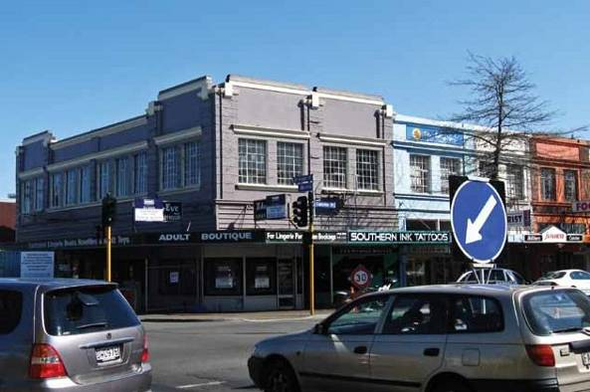
Figure 18: 595 Colombo Street (blue frontage), pictured before the February earthquake. The Japanese restaurant is 595A

4.10.2 The buildings

Both buildings were of similar construction to
593 Colombo Street and are thought to have been built in the early 1900s.

The building at 595 Colombo Street had not had any structural strengthening before the September earthquake, while 595A had had some strengthening in 2001 to remove its earthquake-prone status under the law then in place (the Building Act 1991). However, as at 4 September 2010, that building (and 595 Colombo Street) would have been earthquake-prone in terms of the Building Act 2004.

In 2004 the tenant of 595 Colombo Street applied for a retrospective building consent for alterations that had already been started. Subsequently, the CCC determined, and advised the owners, that because there was no change of use and the alteration work was not considered to be “substantial” the CCC would not require any structural strengthening to be carried out. The building consent was granted but the tenant subsequently decided not to proceed with the work and asked for the consent to be cancelled.

As part of that building consent application, the tenant had obtained an engineering assessment of the building from Endel Lust Civil Engineering Ltd, which recommended a five-year securing programme for the building. The programme included:

• mortar work (immediate – within one year);

• installing ties to ground floor cavity brick walls
(intermediate – within three years); and

• installing independent steel frames to support the first floor and roof (long-term – within five years).

4.10.3 Events following the September earthquake

After the September earthquake, both buildings were assigned green placards after a Level 1 Rapid Assessment in which minor or no damage was noted. In line with the CCC’s policy at the time in relation to buildings that had been assigned a green placard after the September event, there was no further inspection following the Boxing Day earthquake, unless the CCC was aware of the need for one to be made.
Mr and Mrs Patel, the owners of 595 Colombo Street, arranged through their son Hitem Patel (who gave evidence) for an engineering inspection by a structural engineer, Mr Noel Hanham from TH Consultants Ltd. Mr Hanham gave evidence that the Patels wanted him to investigate the extent of the damage and ascertain whether there were any immediate safety concerns associated with the building. From his discussions with Hitem Patel, Mr Hanham concluded that the Patels did not want a detailed inspection.

Mr Hanham carried out a Level 2 Rapid Assessment that did not involve consideration of plans, removal of linings or inspection of the ceiling cavity. He concluded that while the building was likely to be earthquake- prone, there was no substantial structural damage and it was “essentially safe”. In evidence, Mr Hanham explained that by this he meant that the building had not suffered any significant structural damage, so its condition was similar to what it was before 4 September 2010. His approach was encapsulated in the report he prepared dated 3 February 2011 in which he described the damage that he had observed, and then wrote:

Building conclusion:

• The building has not been severely damaged by the earthquake;
• There is no evidence of significant structural damage;
• The ground floor remains in a habitable condition;
• The first floor requires work to restore to pre- earthquake condition; and
• The first floor ceiling presents a potential hazard from plaster falling off the laths.

Mr Hanham gave evidence that, in hindsight, the damage-based test for occupancy (which was adopted by most if not all engineers before 22 February) was the wrong test.

Mr Peter Smith, who prepared an independent report for the Royal Commission, concluded that both buildings failed in the February earthquake by an outward rotation of their first-floor façades, including the parapets, which collapsed onto Colombo Street.

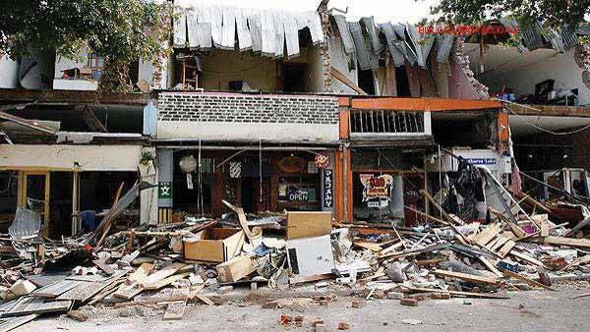

Figure 19: 595 (to the left) and 595A (adjacent to it) Colombo Street after the February earthquake

4.10.4 Issues

4.10.4.1 Application of CCC’s Earthquake- Prone Dangerous and Insanitary Buildings Policy

The failure of both of these buildings illustrates the risks to human life inherent in a passive approach to earthquake-prone buildings policy.

In relation to 595 Colombo Street, the tenant’s engineer had recommended securing works. Yet legally the owner could not be required to carry out those works, even those said to be required in the immediate future unless the CCC considered the building was dangerous.

The experience with both of these buildings provides support for the recommendations made in section 7 of this Volume that territorial authorities should adopt active and more immediate earthquake-prone buildings policies.

4.10.4.2 Post-earthquake assessments

We are of the view that the damage-based test applied by most engineers to building assessments following the September earthquake needs further consideration. As Mr Hanham noted, the lessons from the February earthquake show the inadequacy of placing sole reliance on such a test insofar as URM buildings are concerned.

We will make a recommendation as to the approach we consider appropriate in Volume 7 of our Report.
4.10.4.3 Upgrading of unreinforced masonry buildings

The strengthening carried out at 595A Colombo Street failed to prevent the façade from collapsing, although it appears to have had some minimal effect. This underscores the urgent need for unreinforced masonry buildings to be adequately strengthened, with parapets and façades restrained, as discussed in section 6 of this Volume.

4.11 601 and 601A Colombo Street

4.11.1 Introduction

The building at 601 and 601A Colombo Street was a two storey URM building situated at the end of a block of similarly constructed buildings on the south-western corner of Mollett and Colombo Streets.

On 22 February 2011 Mr Normand Lee was a pedestrian on Colombo Street. After the earthquake, his body was found in rubble in front of 601 and 601A Colombo Street.

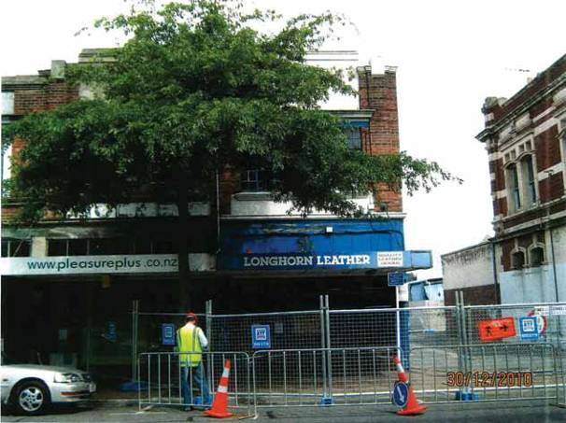

Figure 20: 601 (Pleasure Plus) and 601A (Longhorn Leather) Colombo Street following the September earthquake

4.11.2 The building

The building appears to have been constructed in the early 1900s with timber roof framing and a timber first floor. There was a party wall between tenancies and a party wall with the adjoining building to the south.
The building had a reasonably open façade to Colombo Street but was less heavily penetrated on the Mollett Street frontage. It had a high parapet on the Colombo Street façade, the parapet sloped downwards along the Mollett Street frontage. Before the September earthquake the building was essentially in its original condition, no earthquake strengthening having been carried out.

The building was assigned a red placard by the CCC following the September earthquake, owing to the partial collapse of the Mollett Street façade. Cordons were placed blocking off Mollett Street and the footpath adjacent to 601A Colombo Street. It appears that those cordons remained in place until 22 February 2011.

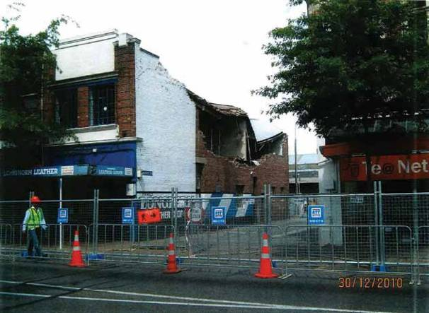

Figure 21: The damaged Mollett Street frontage of 601A Colombo Street after the September earthquake

The building was owned by Mr Simon Yee, Mr Leo Yee, Mr Donald Yee, Mr Ewan Yee and Mr Sun Nam Yee. Mr Marton Sinclair, of Eliot Sinclair & Partners, inspected the building on behalf of the owners on 15 September 2010. He concluded that it was unsafe to occupy.

On 15 October 2010 there was a further CCC Level 2
Rapid Assessment, which confirmed the red placard and noted that demolition was likely. The inspector recommended an engineer’s report be obtained and accordingly the CCC wrote to the owners requesting that they provide a report from a CPEng. Mr Stephen McCarthy from the CCC gave evidence that the reason the CCC requested this was to help assess the stability of the building. It was not for the purpose of assessing the adequacy of the existing cordon, although he said it would have helped with this assessment.
Following the Boxing Day earthquake, a Level 1 Rapid Assessment was carried out on 27 December 2010. The red placard status was confirmed and either a Level 2 Rapid Assessment or a detailed structural engineering evaluation was recommended.

On 28 December 2010 the CCC served the owners a notice under section 124 of the Building Act 2004 requiring work to be done by 31 January 2011 to reduce or remove the danger posed by the building. Mr McCarthy conceded that no Level 2 Rapid Assessment was carried out as had been recommended in the Level 1 Rapid Assessment on 27 December 2010. However, he explained that was because no state of emergency was declared following the Boxing Day earthquake and the CCC was relying on Building Act notices rather than requiring Level 2 assessments.

Mr John Dallison, a principal in the Christchurch law firm Harold Smith & Dallison, acted for the building owners and effectively managed the property for them. He gave evidence that, although following receipt of Mr Sinclair’s report in September 2010 consideration was initially given to demolishing the building but retaining the façade, the owners eventually decided to demolish the whole building towards the end of 2010. Mr Dallison said that he had discussions with the CCC before 24 January 2011 in which demolition had been raised but he agreed that the CCC record produced in evidence, of a telephone conversation between him and the case manager on 24 January 2011, was the first record of that issue being raised with the CCC. In that conversation, Mr Dallison advised that the owners wished to demolish the building and they would soon be going through the consent process.

Mr Sinclair carried out a brief external inspection in late
January 2011 following a request from Mr Dallison.
He observed significant cracking to the upper northern end of the building close to the Colombo Street façade. His evidence was that despite this cracking and the internal cracking that had been observed in September 2010 (including vertical cracking to the transverse wall between 601 and 601A, close to the Colombo Street façade), he did not believe the Colombo Street façade was at risk of collapse. Rather, he thought that at worst there was a risk of collapse of the parapet on the north-eastern corner of the building. Although he said that he did not directly turn his mind to the adequacy of the cordon, he considered that it was sufficient, given the damage observed and the similar cordons in place around the city at that time.

On 31 January 2011 Mr Paul Campbell, a structural engineer on secondment to the CCC from Opus, carried out a re-inspection of the building. This was part of a follow-up by the CCC in relation to buildings subject to Building Act notices. That inspection was external only. Mr Campbell confirmed the red placard status of the building. He requested an engineer’s report on the Colombo Street façade and any temporary works required to move barriers. Mr Campbell said in evidence that from his assessment of the damage to the building he believed that the cordon was adequate. Further, he said that a CPEng’s report was required to confirm whether the cordon was in the right place and whether it could be moved back closer to the building.
Mr Campbell carried out a further re-inspection on
14 February. He noted that the northern end of the building (601A) had more damage than 601 but that it was all one structure so the building as a whole was compromised. He also recorded, “Urgent CPEng report required.” When asked why the report was urgent when he thought the cordon was adequate, Mr Campbell said it was because there had been no action from the owner and it was important to get some action.

It is unfortunate that, given that the building did not have heritage status, the owners did not proceed with demolition in a more timely manner or at least signal that intention to the CCC at an earlier stage. We accept, however, the explanation of Mr Dallison that there were delays as a result of having to deal with insurers, and note his assumption that because the building was unoccupied and cordoned off, the demolition was not urgent.

Mr Peter Smith said in his report to the Royal Commission that in the February earthquake the failure of the Colombo Street façade and the remainder of the Mollett Street façade was an outward rotation of the façade about the first-floor support.

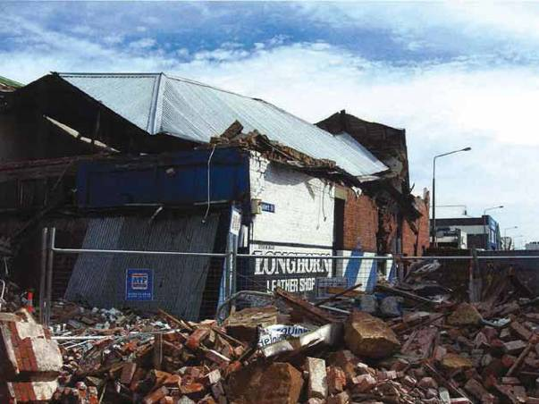
Figure 22: The building at 601 and 601A Colombo Street after the February earthquake

4.11.3 Issues

4.11.3.1 Application of the CCC’s Earthquake- Prone Dangerous and Insanitary Buildings Policy

This building remained in its original state and there had never been any requirement for seismic strengthening due to the CCC’s passive Earthquake-Prone Dangerous and Insanitary Buildings Policy. Had the CCC adopted a more active policy, the building might have been strengthened at least to some extent before the Canterbury earthquakes (although this still may not have prevented the failure of the building). We accept the CCC’s submission, however, that had its policy allowed a timeframe of 15 or more years to carry out strengthening work, it is probably unlikely that anything would have been done.
4.11.3.2 Adequacy of the cordon

Mr Smith expressed the opinion that, in hindsight, the combination of the cracking to the upper north side of 601A and to the transverse wall between 601 and 601A should have led to the cordon being placed further out in Colombo Street. Due to the height of the façade, this would have essentially meant that Colombo Street would have had to have been blocked off. Mr Sinclair’s assessment of the damage, and the appropriate cordon, would appear to differ from Mr Smith’s, but as Mr Sinclair noted, the purpose of his assessment was not to ascertain the adequacy of the cordon.

Mr Smith also observed that it was important that the
CCC undertake Level 2 assessments in such cases to adequately assess damage to the building and ascertain the necessary extent of the cordon. Mr Campbell said that, with hindsight, he wished he had carried out an internal inspection.

It is unfortunate that there was no Level 2 assessment after the Boxing Day earthquake as recommended in the Level 1 assessment on 27 December 2010. Such an assessment might have been informative on the issue of the adequacy of the cordon.

As Mr McCarthy noted, the engineer’s report that the CCC was seeking from the owners could have informed the CCC on the issue. However, the difficulty with that approach is that it relied on the owner to give the CCC information necessary to assess the adequacy of the cordon. The owner might not provide such a report,
as was the case with this building.

This case also illustrates the shortcomings of only applying a damage-based assessment to URM buildings after a significant earthquake.

4.12 603 and 605–613 Colombo Street The Royal Commission’s hearings into the failure of the buildings at 603 Colombo Street and 605–613 Colombo Street were conducted concurrently. We consider that
it is appropriate to report on the issues relating to both
consecutively.

4.12.1 603 Colombo Street

4.12.1.1 603 Colombo Street: Introduction

The building at 603 Colombo Street was part of a two storey row URM building (situated at the end of the row) at the intersection of Colombo and Mollett Streets. Adjacent to 603 was the building known as 605–613 Colombo Street (and next to that 615). All were part of the same original development, known as the Austral Buildings, which were divided into separate tenancies by party walls.

According to information provided to the Royal Commission by the New Zealand Police, at the time of the February earthquake, Mr Graham Weild and Mrs Joan Weild were walking on the west side of Colombo Street near the intersection with Mollett Street. They were killed when the façades of 603 and 605–613 Colombo Street collapsed out onto the street. Their bodies were found
under the rubble in front of 603 Colombo Street.
Mr Gabi Ingel and Mr Ofer Levy were also pedestrians in that vicinity. Their bodies were found in rubble in the vicinity of 603 Colombo Street.

4.12.1.2 603 Colombo Street: The building

The Austral Buildings were listed in the Christchurch City Plan as Group 4 heritage buildings. This meant that they were of “metropolitan significance” and/or made “a contribution to the heritage of the city, the protection of which is seen as desirable by the Council”. A resource consent was therefore required to alter or demolish the buildings.

The CCC considered the buildings to be earthquake- prone in terms of the 1991 and 2004 Building Acts.

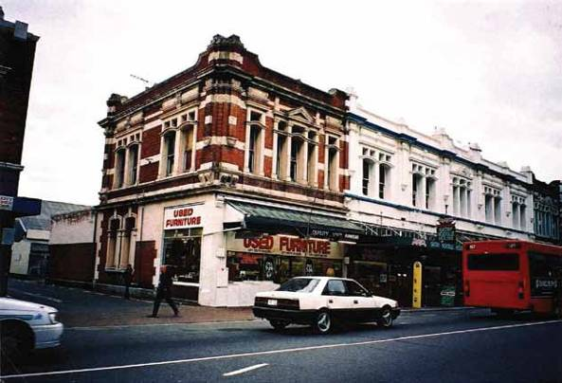
Figure 23: The building at 603 Colombo Street, shown in a photograph from the CCC file which appears to have been taken around 1992. Mollett Street is on the left

A seismic risk building survey of 603 Colombo Street carried out by the CCC in 1991 identified the cornice, parapet and chimney as hazards. Mortar deterioration was also noted on the corner of the parapet on the street elevations. Immediate action was recommended.

A hazardous appendage survey conducted by the CCC in 1992 identified noticeable mortar deterioration and cracking, and a cracked parapet, cornice and wall.

4.12.1.3 603 Colombo Street: Events following the September earthquake

The building was severely damaged in the September earthquake, in particular the south wall adjacent to Mollett Street. As a result, following a CCC Level 1 Rapid Assessment on 5 September 2010, a yellow placard was placed on the building. A Level 2 Rapid Assessment was recommended.
A CCC Level 2 Rapid Assessment on 11 September
2010 confirmed the yellow placard status and recommended barricades. The Level 2 Rapid Assessment form noted: “Barricades need extension to cover front of Colombo Street and entry to Mollett Street”. The form also stated: “Risk to public – structural engineers assessment critical”.

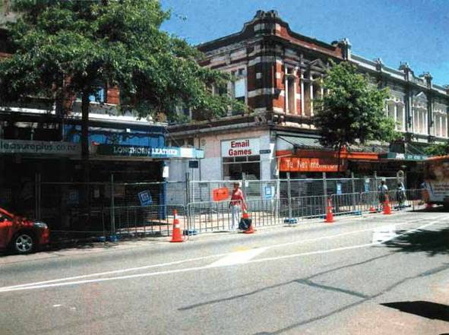

Figure 24: 603 Colombo Street following the September earthquake. The Te@ Net Internet Café occupied the ground floor of the building

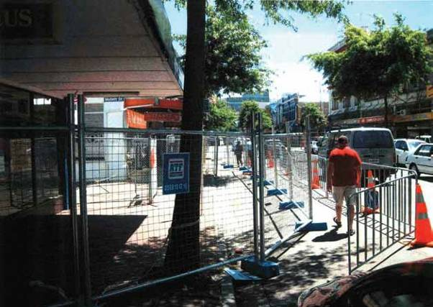

Figure 25: A closer view of the barricades from the area outside 601 Colombo Street. The pedestrian is walking north towards 603 Colombo Street

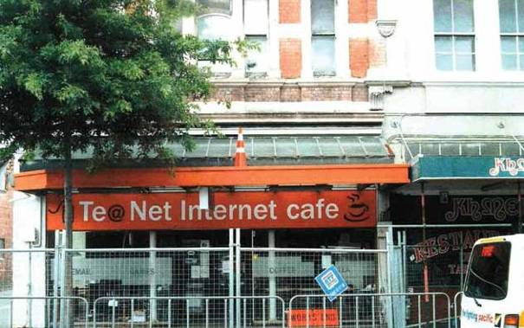

Figure 26: The barricades in front of 603 Colombo Street

The Yee Brothers Syndicate (comprising Mr Simon Yee, Mr Leo Yee, Mr Donald Yee, Mr Ewan Yee and Mr Sun Nam Yee) had owned 603 Colombo Street since April 1973.

Mr John Dallison, a principal in the Christchurch law firm Harold Smith & Dallison, acted as the owners’ solicitor and agent. Following the September earthquake, on 6 September 2010 Mr Dallison instructed Mr Marton Sinclair, a structural engineer of Eliot Sinclair & Partners Ltd, to inspect the building. After inspections on 16 and 19 September Mr Sinclair sent a report dated 20 September 2010 to Mr Dallison. He advised that, given the extensive cracking in the Mollett Street façade, the building was potentially unsafe and should remain unoccupied until investigation and structural strengthening could be undertaken.

A CCC Level 2 Rapid Assessment by a structural engineer on 12 October 2010 confirmed the yellow placard and recommended a detailed engineering evaluation and temporary propping of the south wall. The CCC wrote to the owners on 15 October 2010 (care of Harold Smith & Dallison) requesting a CPEng report on the building and recommending that they provide temporary support to the south wall.

The CCC served a notice under section 124 of the Building Act on the owners on 20 October 2010, once again care of Harold Smith & Dallison. The notice recorded the need to provide temporary support to the south wall and gave the owners until 31 January 2011 to complete the work required.

A CCC Level 1 Rapid Assessment after the Boxing Day earthquake resulted in the yellow placard being maintained. However, it became apparent from the evidence of Mr Stephen McCarthy of the CCC that the placard status was subsequently upgraded by a CCC officer to red, and a further Level 1 Rapid Assessment was carried out the next day, 27 December 2010. That inspection confirmed the red placard status. Under “Comments” the rapid assessment form noted: “Major cracks, south wall. Potentially more severe since September. Reassess current barricade”. It also said, “Urgent Attn. Main Thoroughfare. Urgent Engineer Assessment.” Under the heading “Further Action Recommended”, the box marked “Barricades are needed (state location)” was ticked and the words “Mollett Lane” were written next to it. A Level 2 Rapid Assessment or detailed structural engineering evaluation was also recommended.
In a “Particulars of Building Damage” form on the CCC file that appears to relate to the Level 1 Rapid Assessment on 27 December 2011, it was noted that an internal assessment was needed but the rapid assessment form made it clear that only an exterior inspection had been carried out. The Particulars of Building Damage form also noted that protection measures (barricades) were in place but needed upgrading.

It became apparent at the hearing that there was no Level 2 or detailed engineering evaluation as recommended in the rapid assessment form of 27 December, nor was there any reassessment or upgrading of the barricades that were in place.

Ms Vincie Billante, an environmental policy consultant who worked as the team leader of the CCC’s Building Recovery Office in late 2010, gave evidence at the hearing. She was asked to comment on the systems that were in place at that time and that might have contributed to a Level 2 Rapid Assessment not being obtained in this case. She said, “…we had very little guidance or framework on which to go on because no one in New Zealand had experienced anything to this degree, and it would be fair to say that there was a certain amount of chaos immediately afterwards while the systems were being put into place...” Further, she said that the CCC did not have the resources to carry out Level 2 Rapid Assessments or detailed engineering evaluations and that a recommendation to carry out such an inspection could be conveyed to the building’s owner, which took place in this case by following up with a Building Act notice.

Ms Billante offered the view that the reference on the Level 1 Rapid Assessment form to “Urgent Attn. Main Thoroughfare” could be a reference to Mollett Lane. Counsel assisting the Royal Commission has unsuccessfully attempted to contact the inspector who completed that form, but we are of the view that “Main Thoroughfare” must have been a reference to Colombo Street. Hence the need for urgent attention and the request for a Level 2 assessment and a reassessment of the barricades.

Mr Sinclair undertook a further external inspection for the owners after the Boxing Day earthquake but found no obvious additional cracking. When questioned at the hearing about his inspections, Mr Sinclair said that he was not involved in the placement of the barricades. He expressed the view that, given the presence of dangerous façades on both sides of Colombo Street, the whole street should have been closed until the buildings could be made safe or demolished. However,

when questioned by counsel for the CCC he agreed that, at the time, he considered the barricade was adequate and entirely consistent with barricades that had been put up around other parts of the city. Mr Sinclair also gave evidence that the damage he saw on the Mollett Street frontage did not “strongly point” him to “a potential failure of the Colombo Street façade”.

On 28 December 2010 the CCC served another Building Act notice that recorded structural defects in the building, in particular cracking of the south wall. The notice required work to be carried out by 31 January 2011. A CCC file note recorded that a “walkabout” on 20 January 2011 revealed the barricade was still in place.

According to a further file note, a CCC officer spoke to Mr Dallison on 24 January 2011 who “advised that they are working through this at the moment”. The CCC officer requested that he send an engineer’s report in relation to the building if possible and also contact details for the engineer.

No work was carried out on the building by the owners. Mr Dallison gave evidence that, following a period of assessment, a decision was made in January 2011 to demolish the building. This does not appear to have been communicated to the CCC until a meeting on 1 February 2011. According to notes kept by Mr Sean Ward, a senior planner with the CCC, those present at the meeting on 1 February were Mr Ward, Mr Dallison, Mr Sinclair, Ms Trudi Burney (a planner from Eliot Sinclair), Mr Matthew Bushnell (of Bushnell Builders Ltd, who was working for the insurer of 605– 613 Colombo Street), Mr Philip Hector (a senior building consent officer with the CCC), Mr John Barry (a CCC case manager) and Ms Amanda Ohs (a policy planner in the CCC heritage team).

Mr Dallison said that the proposed demolition of the Austral Buildings was discussed at the meeting and that the procedure to obtain consent for demolition was discussed in detail. He said it was agreed that it would be more cost-effective to have one engineer carry out a full assessment of the whole building and that on 15 February he instructed Buchanan & Fletcher Ltd to proceed with this. Mr Dallison said he left the meeting with the clear impression that public notification of the necessary application for a resource consent for demolition would be mandatory. Mr Ward gave evidence that it could take up to six months to obtain a resource consent for demolition, but he said that this was an estimate only and would depend upon whether notification was required. He said he advised those present at the meeting that a requirement for notification was a strong possibility.
On 16 February 2011 Mr Mark Ryburn, a structural engineer on secondment to the CCC from Opus, carried out a re-inspection of 603 Colombo Street. His inspection was part of the CCC’s process of visiting buildings that had been assigned a yellow or red placard. He said in evidence that part of his overall purpose was to consider the position of the barricades.

As part of its report to the Royal Commission on building safety evaluation processes in the central business district following the September earthquake, the CCC produced a form entitled “Guidance for Monitoring and Reviewing Barricades”. The form, which was dated 15–16 September 2010, listed factors to consider in determining where a barricade should be placed. Mr Ryburn said he was not given a copy of the form, nor was he told that a barricade should be situated at a distance of one and a half times the top storey height away from the façade of a building where failure of the top storey was a possibility.

On 16 February Mr Ryburn completed an “Engineers Re-inspection of Damaged Building” form. He noted “significant cracking to south wall which is leaning outwards – likely connection failure…” He recorded that a barricade was in place and should remain, and recommended that work be completed by 16 March 2011. In evidence Mr Ryburn said he did not expect the masonry would fail by rotating outwards but rather that any failure would probably consist of vertical crumbling, as had happened with other buildings. He also said he did not think that a failure of the Mollett Street frontage would necessarily have caused the collapse of the Colombo Street façade. However, he accepted that it could have contributed to a possible collapse of the façade or compromised it in some way.

Mr Paul Campbell, who was also seconded to the CCC from Opus, carried out another re-inspection of the building. Once again, this was part of the CCC’s process of carrying out follow-up inspections of buildings with yellow and red placards. Neither Mr Ryburn nor Mr Campbell was given a copy of the CCC’s complete file for the inspections. However, they were provided with some documents relating to the period following the September earthquake. Although the “Engineers Re-inspection of Damaged Building” form he completed was undated, Mr Campbell said in evidence that it would have been filled out on or about 16 February 2011. He noted bad cracking to the Mollett Street elevation and was unable to access the building because of the barricade. Mr Campbell said that the collapse of the Mollett Street frontage could have weakened the top right-hand corner of the Colombo Street frontage, although he said that at that stage he had been

satisfied with the position of the barricades on Colombo Street, given the practices that were adopted at the time.

Mr Peter Smith said in his report to the Royal Commission that “The first floor façade to Mollett Street and Colombo Street failed by an outward rotation of the façade about the first-floor support in the severe shaking during the 22 February 2011 earthquake”. He expressed the view that, in terms of public safety, after an earthquake there needed to be a rapid assessment of both the exterior and interior of such buildings, especially to assess connections between facades and floor and roof diaphragms. He said it was unfortunate that no internal inspection took place with this building.

Mr Smith said that the February earthquake “demonstrated beyond question the danger of these façades and the need to cordon off in front of buildings where the building does not have integrity to restrain that façade to a reasonable strength level”.

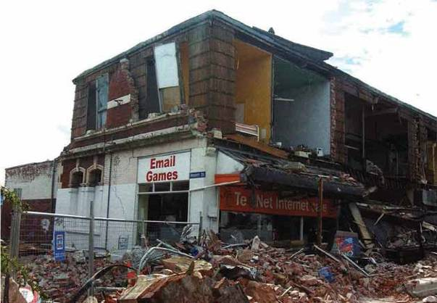

Figure 27: 603 Colombo Street following the February earthquake

4.12.1.4 603 Colombo Street: Issues

4.12.1.4.1 Application of the CCC’s Earthquake- Prone Dangerous and Insanitary Buildings Policy to the building
This building again provides an illustration of the risks inherent in a passive approach to earthquake-prone buildings. We refer to this issue in more detail in section 7 of this Volume.

4.12.1.4.2 Assessment of the building following the September earthquake, in particular the Colombo Street façade
This building failure highlights the risk with conducting only a rapid, external inspection of a URM building following a substantial earthquake. In this case, the Level 1 Rapid Assessment following the Boxing Day earthquake recommended a Level 2 inspection or a detailed structural evaluation, but neither was carried out.

The inspections carried out by Mr Ryburn and Mr Campbell for the CCC were brief exterior inspections only, and it was apparent from their evidence that they were never intended to be otherwise. With this level of inspection, it is not possible to be confident of the structural integrity of an unreinforced masonry building. In particular, the integrity of the wall- to-floor/ceiling connections cannot be ascertained from the exterior. This can directly affect the decision as to the appropriate placement of barricades. If there is a risk of façade collapse, as opposed to the hazard of a falling parapet, this will markedly affect the appropriate location of a barricade.

In this case, all of the external inspections noted significant damage to the south wall. In our view, this had the potential to compromise the Colombo Street façade if the south wall collapsed in an aftershock. Thus it was all the more important that there be an internal inspection of the Colombo Street façade connections so that the CCC could consider whether the existing barricades needed to be extended.

We do not consider that a lack of resources to carry out a more detailed internal and external inspection is a sufficient answer to what is a public safety issue. Nor is it sufficient to rely on a Building Act notice requiring the owner to engage a structural engineer to carry out such an inspection. This would effectively be passing on to an owner the Council’s responsibility to the public for barricade placement. An owner may or may not take the appropriate action.
We accept that at this time the CCC was dealing with many hundreds of damaged buildings. The scale of the CCC’s task after the September earthquake was further exacerbated by the Boxing Day aftershock. We understand that at the end of December 2010 there were approximately 140 cordons within the city centre, measuring approximately 7.5 kilometres in length, and numerous Building Act notices had been issued. Two notices had been served on the owner in the present case, on 20 October and 28 December requiring action to be taken by 31 January, so the CCC had not been inactive. However, nothing was done.

In this case, Mr Sinclair clearly never carried out an internal inspection of the building. He said this was because he could not gain access due to the barricade that had been erected by the CCC. It was evident that both Mr Dallison and Mr Sinclair considered that, because the building had been barricaded off, there was no urgency to make any decisions in relation to the building and they believed that public safety concerns had been met by the CCC. As we have indicated, we are of the view that, although consideration was obviously given to the placement of barricades on Colombo Street, the fact that no internal inspection was carried out meant that the issue was not considered as fully as it should have been.

4.12.2 605–613 Colombo Street

4.12.2.1 605–613 Colombo Street: Introduction

The address designated 605–613 Colombo St was the middle portion of the two storey Austral Buildings that have been described in relation to 603 Colombo Street.

At the time of the February earthquake,
Mr Andrew Craig was driving a Red Bus Company
bus north along Colombo Street approximately adjacent to 605 Colombo Street. During the earthquake a large amount of masonry and bricks fell from the building
onto the left side of the bus. This was witnessed by Mr Kenneth Edwards, who was driving a Leopard bus immediately behind Mr Craig’s bus. The Leopard bus was partially crushed by falling bricks and masonry that brought both of the buses to an immediate stop. Mr Edwards sustained moderate injuries but went to the assistance of the occupants of the other bus.

Mr Craig was subsequently transported to Christchurch Hospital but died two days later from his injuries. The following people were found deceased on the Red Bus following the earthquake: Master Jayden Andrews-Howland, Mr Jeff Sanft, Mr Philip Coppeard, Mr Joseph Routledge, Mrs Lucy Routledge, Mr Earl Stick and Mrs Beverley Stick.

At the hearing, we heard from a survivor from the Red Bus, Ms Ann Brower, who gave evidence of her ordeal and resulting injuries.

4.12.2.2 605–613 Colombo Street: The building

According to Mr Michael Fletcher of Buchanan & Fletcher Ltd, the engineer engaged by the owner’s insurer, this part of the building was about 26 metres long parallel to Colombo Street, and 12 metres deep. It was divided into five equal units, each about five metres long. The brick parapet along the Colombo Street frontage was estimated to be 1200mm high by 450mm thick.

According to a CCC seismic risk buildings survey, the building was constructed in 1906.

The building at 605–613 was owned by Benson Cheng Holdings Ltd and occupied by the Khmer Satay Noodle House and Kiwi Disposals.

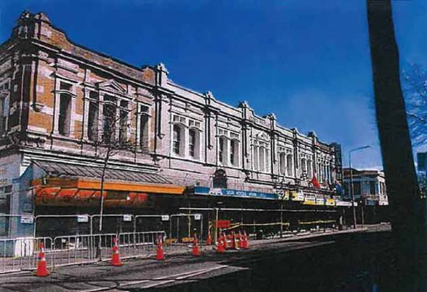

Figure 28: The building comprising 603–615 Colombo Street

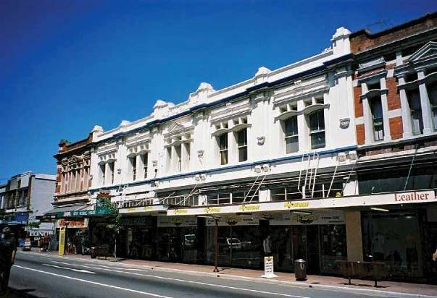

Figure 29: The building at 603–615 Colombo Street viewed from the northern end

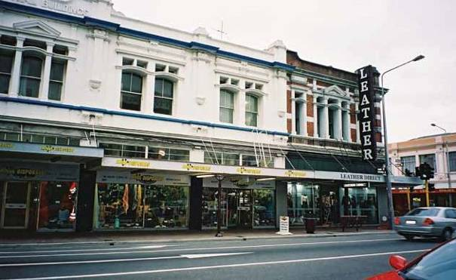

Figure 30: The northern part of the building. Leather Direct occupied 615 Colombo Street

A letter from the CCC to a previous owner dated
16 December 1982 records that the CCC was concerned about the stability of the building in a moderate earthquake. A seismic risk survey in 1991 recommended that remedial action be taken within two years. A hazardous appendage survey in 1992 identified noticeable mortar deterioration and a crack along the top of a heavy parapet.

As at 4 September 2010 the CCC considered the building to be earthquake-prone in terms of the Building Act 2004.

4.12.2.3 605–613 Colombo Street: Events following the September earthquake

A CCC Level 1 Rapid Assessment was carried out on
5 September 2010 and a green placard was placed on the building. The only damage recorded on the assessment form was “minor parapet cracks in the back wall”.

Mr David Eaton, a co-director of Buchanan & Fletcher, carried out an inspection on 14 September 2010. He noted cracking in the east-west walls and recommended propping of the front edge of the veranda along the Colombo Street frontage. This work was carried out by Bushnell Builders Ltd.

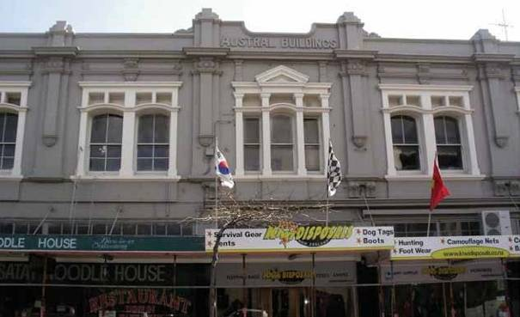

Figure 31: The building viewed from the opposite footpath on Colombo Street. Propping can be seen under the awning

Mr Fletcher inspected the building on 27 October 2010 after a number of significant aftershocks. He considered that there were no new cracks in the crosswalls (walls perpendicular to the façade, to which the façade is usually attached) near the Colombo Street frontage but that existing cracks had widened. The east wall had separated from the crosswalls at each end of the building with a gap of more than 20mm but the parapet and east walls showed no signs of damage. Mr Fletcher expressed the view that the building was likely to be earthquake-prone and recommended that the Colombo Street wall and parapet be tied back to the crosswalls. These tiebacks would be “interim securing work to restore the building’s structural performance to pre-4 September 2010 levels”. In a letter to the insurer dated 23 November 2010, Mr Fletcher attached sketches for the tiebacks and said, “As the building is occupied, the repair work should be carried out promptly”. On 13 December 2010 Bushnell Builders provided an estimate of $200,000 plus GST for this work to the owner’s insurer. The work was never carried out.

A CCC Level 1 Rapid Assessment was made by
Mr Anthony Raper, a CPEng volunteer, on 26 December
2010. The assessment form recorded that the front façade was leaning out and that the parapets above the roofline, which he viewed from behind on a Fire Department hoist, appeared to have separated from the crosswalls. Mr Raper assigned 605 Colombo Street a yellow placard. He recommended a structural engineering evaluation and noted on the form, “Needs check from upper floor (interior) of transverse/outer façade”.

Mr Raper gave evidence that he wanted the façade checked more thoroughly than he had been able to but that he did not consider an immediate barricade needed to be erected as there was only a moderate risk of the façade collapsing. Also, he envisaged that the inspection would take place within a short period of time, so if that inspection showed a need for a barricade, it would be put in place. It appears from the CCC’s records that the yellow placard recommendation was subsequently changed to red by a CCC officer, as occurred in the case of 603 Colombo Street.

A notice under section 124 of the Building Act was served on the owner on 28 December 2010. The notice stated that the building was damaged, there were structural defects and the parapets above the roofline appeared to have separated from crosswalls. Work was required to be carried out by 31 January 2011. The covering letter from the CCC said that advice on how to remove the danger should be sought from a qualified structural engineer.
A CCC file note dated 7 January 2011 stated, “Please inspect building. Owner has called in saying that a wall has gaps over 40mm after the 4.9 shock”. Despite this file note and the Level 1 Rapid Assessment form dated 26 December 2010 recommending a check of the interior of the upper floor, no such check was ever carried out by the CCC. However, on 17 January 2011 Mr Fletcher carried out an inspection, accompanied by Mr Robin Cheng, Mr Matthew Bushnell and Mr Peter McLeod (a loss adjustor from Mainland Claims Management Ltd). Mr Fletcher found that the existing cracks between the east wall and crosswalls had widened and new cracks had appeared. At the south end, where the separation was greatest, the gap was 50–60mm. The separation was worse as one moved southwards along the building and there were signs of separation at every crosswall. He said that the proposed securing could still be carried out, but that more and/or longer steel straps might be required.

Mr Fletcher told the owner’s loss adjustor that the Khmer Noodle House should not be occupied until the securing work was carried out. He said that the Kiwi Disposable tenancy was “currently ok to occupy, but this should be monitored daily”. He advised Mr McLeod that “It is now becoming urgent that a decision is made to either secure or demolish the building”. He said in evidence that he was concerned that the Colombo Street façade could fall off in a significant aftershock. However, he was not concerned that the façade was in immediate danger of collapsing. When asked about his opinion that it was “currently ok” for the Kiwi Disposals’ section of the building to be occupied, Mr Fletcher referred to the presence of a tieback in place where that unit met 615 Colombo St. He also said that he had spoken to the tenant and made it clear that he should monitor the existing cracks and contact his office if they increased in size. If they had increased to a similar size to those at the southern end, he said he would have recommended a red placard for that section of the building.

Mr McLeod said in evidence that because the securing work was difficult and would cost over $200,000, the decision was made to demolish the building. A meeting took place with the CCC on 1 February 2011 in relation to 605–613 Colombo Street. The buildings at 603 and 626 Colombo Street were also discussed at that meeting. Mr Bushnell attended the meeting on behalf of the owner of 605–613 Colombo Street. He gave evidence that he clearly remembered “saying that I thought the building was dangerous and that I believed that the most appropriate action was demolition”.

The main reaction he recalled from the CCC officers present was “their advice that the building could not be demolished because of its heritage status without a resource consent and that the resource consent would be notified”. He said that “Mr Sinclair put it to them that that process was likely to take about six months and they agreed that…was the likely timescale”. He also said that the “…CCC officers were professional and helpful but their hands were tied by the requirements of the Resource Management Act”.

Mr Sinclair also attended the meeting as the owner’s engineer for the buildings at 603–615 and 626 Colombo Street. He prepared an agenda for the meeting, which was produced at the hearing. The agenda dealt with these two buildings separately and in each case included as the first item “Extent of earthquake damage – danger to public”. In evidence, Mr Sinclair said that at the meeting both he and Mr Bushnell expressed their concerns over “the buildings” and the risk of failure of the walls. In response to a question from the Royal Commission, Mr Sinclair explained that he was more concerned about parts of the Austral Buildings other than 603 Colombo Street. He also said that Mr Bushnell was particularly concerned because he had been into the Benson Cheng Buildings (i.e., 605– 613) and had seen “the wall opening up”. Mr Sinclair’s prime concern at that time was 626 Colombo Street.

Sean Ward, a senior planner in the CCC’s resource consents team, who was present at the meeting on 1 February 2011, said in evidence that neither Mr Bushnell nor Mr Sinclair indicated that 605–613 Colombo Street needed to be barricaded. His notes contained no record of such comments and nor did he recall any mention that the whole of Colombo Street needed to be closed because of the danger posed by the building. He did not recall any safety concerns being raised about the Austral Buildings (605–613). When questioned by counsel assisting the Royal Commission, he accepted that Mr Bushnell could have expressed concerns about the potential failure of the façade, although he was confident he would have recorded that in his notes if it had been said. Mr Ward also acknowledged that at the time of the meeting on 1 February 2011 he was aware of the CCC’s power under section 129 of the Building Act 2004 to demolish a building. The Canterbury Earthquake (Resource Management Act) Order 2010 provided an exemption from the usual Resource Management Act requirements, meaning this power could be exercised without the need for a resource consent.

Mr John Higgins, a resource consents manager from the CCC, gave evidence about the CCC’s approach
to resource consents for the demolition of heritage buildings after the September earthquake. He said that apart from the exemption in relation to the use of section 129, there was no change to the regulatory framework for dealing with the demolition of heritage buildings that had been in place before the September earthquake. This meant that, unless the CCC exercised its power under section 129, a resource consent would be required for demolition. An application for a resource consent could have triggered public notification, although notification was not mandatory. He said notification could mean that processing the application could take three to six months.

Mr Higgins said that “Given the need for damaged buildings to be made safe and secure pending decisions as to the future of damaged heritage buildings, the CCC was facilitating a stabilisation of heritage buildings with the requirement of lodging a retrospective resource consent application when the repair or demolition of the building was determined”. He noted that no resource consent application for demolition was ever lodged in relation to this building.

Mr Paul Campbell carried out an engineer’s re- inspection for the CCC on or about 2 February 2011. He said in evidence that at that time he was not aware that the CCC had received a call informing them that the wall had a gap of over 40mm following the Boxing Day earthquake. Mr Campbell was aware of the comments on the Level 1 Rapid Assessment of 26 December. He recorded that the canopy had been propped and that no other work had been carried
out. He did not have access to the roof and therefore referred to the 26 December report that indicated the parapets above the roofline appeared to be leaning out. He placed a question mark next to the words “Protection fencing required”.

In evidence he said he was not sure why he put a question mark there but that if he had seen “anything that needed a fence [he] would have definitely ticked yes and made some notes”. In response to questions from the Royal Commission, he agreed that the question mark indicated he thought it was an issue that should be addressed. He said that in hindsight he should have written some notes on the form about this issue. Although he accepted that there would need to be an internal inspection of load paths to determine whether the building was going to collapse outwards, he did not agree that he should have recommended
a barricade.

Apart from the area immediately in front of 603, there was no barricade in front of the rest of the Austral Buildings at the time of the February earthquake.

Mr Smith said in his report to the Royal Commission that “The first floor façade of the buildings failed by an outward rotation of the façade about the first floor support beams in severe shaking during the 22 February 2011 earthquake”.

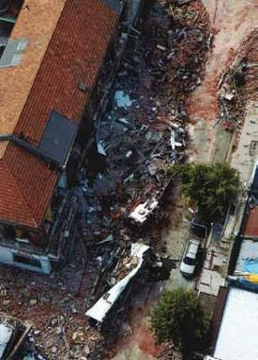

Figure 32: An aerial view of the south end of the building, showing the two damaged buses on Colombo Street after the February earthquake

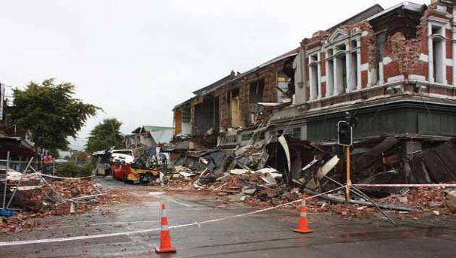

Figure 33: The building at right following the February earthquake

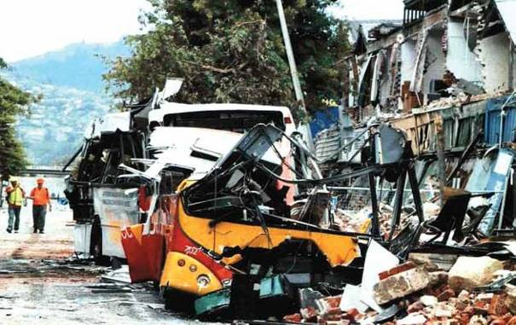

Figure 34: The damaged buses

4.12.2.4 605–613 Colombo Street: Issues

4.12.2.4.1 Application of the CCC’s Earthquake- Prone Dangerous and Insanitary Buildings Policy to the building
As with many other inherently weak unreinforced masonry buildings, no strengthening of this building had been required. As a result it remained in a relatively original condition.

The collapse emphasises the need for the façades of URM buildings to be effectively restrained, and the desirability of an active policy for earthquake-prone buildings. While significant strengthening may not have prevented the façade collapsing given the severity of the February earthquake, it would at least have given it a better chance.

4.12.2.4.2 Failure to place barricades in front of the building to ensure safety of the public
At no stage was there ever a barricade erected in front of this building apart from the section of the barricade that extended across Mollett Street and in front of 603.

We consider that there should have been such a barricade, given the nature of the damage to the building after the Boxing Day earthquake and in particular the apparent separation of the façade from the transverse walls. We consider it would have been
prudent for Mr Raper to adopt a more conservative approach and to recommend a barricade pending the more detailed structural engineering evaluation that he recommended. Although he said he only considered there was a moderate risk of the façade collapsing (and recommended a yellow placard), the reason he recommended an engineering evaluation was to confirm the position. We accept he envisaged that the CCC evaluation would take place a short time later, but a significant aftershock could have occurred at any time. In any event, no structural engineering evaluation was ever carried out by the CCC as recommended by Mr Raper. We add that there can be no certainty that any barrier erected would have been effective to prevent the loss of life that occurred.

A notice under section 124 of the Building Act was served on the owner two days after Mr Raper’s inspection, and reference was made to the apparent separation of the parapet from the crosswalls. However, no remedial work was carried out by the owners because by January 2011 they had decided it was not economic to repair the building and they intended to demolish it.

We are of the view that serving the Building Act notice on the owner was insufficient to deal with Mr Raper’s recommendation to further evaluate the building, in particular its façade. The assessment he recommended

would have provided the information upon which a decision could be made regarding the barricade. That was a matter of public safety and therefore one for the CCC to determine, whereas an owner, as in this case, might decide to take no action.

In relation to Mr Fletcher’s assessment of the building following Boxing Day, we are of the view that, as with Mr Raper, it would have been prudent for Mr Fletcher to adopt a more conservative approach following his assessment of the building on 17 January 2011. In an email to the loss adjustor on that day, Mr Fletcher referred to the separation of the façade and said that the matter was becoming urgent. In evidence, he conceded that one of the reasons for that urgency was his concern about the potential danger the façade posed. However, he had formed the view that it was not in imminent danger of collapse, given that the pattern of aftershocks is normally a diminishing one. The difficulty with this is that in confirming the CCC’s red placard on the Khmer Noodle House tenancy, Mr Fletcher clearly considered the building a potential danger to at least that tenancy in the south end of the building. If a tenant could be in danger inside the premises, so too could a pedestrian outside.

Mr Fletcher gave evidence that he had spoken to the tenant of Kiwi Disposals, located in the northern part of the building, and told him to advise Mr Fletcher’s office if the cracks above his tenancy increased. In our view, it would be preferable for such advice of potential dangers to be in writing.

However, a more fundamental difficulty is the separate consideration of the north end of the building from the south. It appears that 605–613 Colombo Street (considered to include Leather Direct, though this is in fact at 615) was allocated a green placard on 5 September 2010. Then on 26 December 2010, following the Level 1 Rapid Assessment, a red placard was placed on 605 Colombo Street (the Khmer Satay Noodle House). In our view, it would have been better to consider all tenancies in the building. (This is an issue we have also addressed in relation to 593 Colombo Street.) As Mr Fletcher conceded, the façade above the noodle house could have come away in a significant aftershock and potentially pulled off the whole of the façade of that portion of the building up to 615.

As Mr Campbell agreed, by placing a question mark on his re-inspection form, he was indicating that he thought protection fencing was an issue that should be addressed. There is no record of that happening. In our view, it would also have been prudent for Mr Campbell to adopt a more conservative approach
to the issue of a barricade based on the information he had available to him (namely, the observations of Mr Raper as set out on the Level 1 Rapid Assessment form, Mr Raper’s recommendation for further evaluation, and the absence of any further inspection).

4.12.2.4.3 Heritage issues

The owners of the building were given until 31 January
2011 to carry out the work referred to in the Building Act notice. The next day, on 1 February 2011, the meeting took place between CCC representatives and representatives of the owners of 603 and 605–613.

Both Messrs Bushnell and Sinclair said that the issue of potential danger from the façade of 605–613 was raised at the meeting. Mr Ward from the CCC did not recall that issue being raised. He referred to the fact that the issue was not recorded in the notes he made, a copy of which he produced. However, he accepted the possibility that it was raised but that he could not recall it. On the balance of probabilities we find that the issue was raised at the meeting. However, it seems that, perhaps because of the particular concerns raised in relation to 626 Colombo Street, the concerns of Mr Bushnell about 605–613 Colombo Street were not fully appreciated. It appears that the case manager for the building, Mr Barry, who was at the meeting (and was presumably aware of the concerns expressed by Mr Raper in the Level 1 Rapid Assessment form on Boxing Day), also did not appreciate the extent of Mr Bushnell’s concern. As with Mr Raper’s recommendation, there was no follow-up by the CCC.

The heritage status of the Austral Buildings meant that, even though the owners had decided to demolish, it would not have been possible for them to do so without a resource consent. The practical effect of this was that a dangerous building would remain standing until the resource consent application had run its course. Given that the owners wanted to demolish, they had no incentive to carry out the expensive interim securing work.

The absence of such work made the CCC’s decision about whether to place a barricade in front of the building even more important. If an appropriately located barricade had been in position, public safety would have been ensured pending resolution of a resource consent application. We consider that it would also have been open to the CCC to consider exercising its power under section 129 of the Building Act 2004 (as amended by the Canterbury Earthquake (Building Act) Order 2010) to demolish the building without a resource consent. We deal with this issue in section 7 of this Volume.

4.13 617–625 Colombo Street

4.13.1 Introduction

Jennifer Donaldson was a pedestrian on Colombo Street at the time of the February earthquake. Her body was found by the New Zealand Police under rubble outside 625 Colombo Street.

4.13.2 The buildings

The buildings at 617–625 Colombo Street and 143
Tuam Street were adjacent two storeyed URM buildings on the north-western corner of Tuam and Colombo Streets. Although they may not have been one building originally, they had been connected together in the past and were regarded as one structural unit. They were built with a lightweight roof on timber trusses supported on the perimeter by masonry walls. Their street frontages on Colombo and Tuam Streets were relatively open.

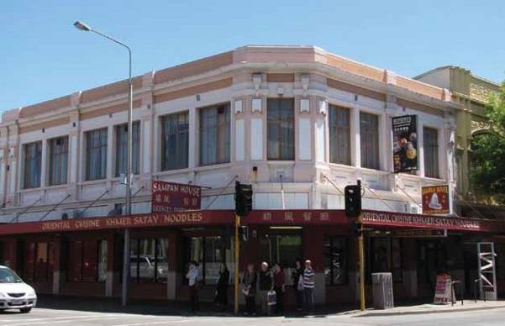

Figure 35: The corner of 617 Colombo Street before the September earthquake. The vehicle at left is pointing east along Tuam Street

North

623-625 (Lot 3)
Colombo Street

143 (Lot 5)

617-621 (Lot 5)

Tuam Street

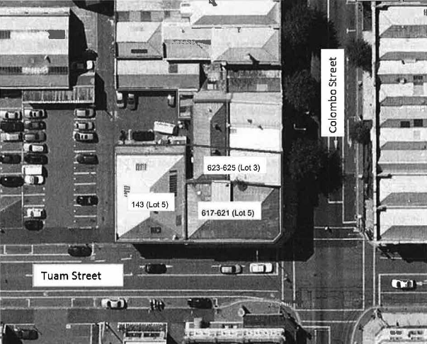Figure 36: An aerial photograph of the locality before the February earthquake

In 1982 the CCC wrote to the owner of the building at 617 Colombo Street/143 Tuam Street suggesting that, as there was scaffolding in place, it would be an appropriate time to consider the structural stability of the building. There does not appear to have been any reply or follow-up to that letter.

A CCC seismic risk buildings survey in 1991 gave the building at 617 Colombo Street a score of 15, which resulted in a classification that meant immediate remedial action was recommended. A hazardous appendage survey in 1992 identified noticeable mortar deterioration, loose masonry and significant cracking.

Mr Peter Smith said in his report to the Royal Commission that there had been few alterations to the buildings other than strengthening work carried out in 1994 and
2000. His interpretation of CCC correspondence was that a second stage of seismic strengthening had been undertaken in September 2000. He estimated that this increased the strength of the buildings to about 20% of the level stipulated by the Building Code at the time.
When engineers from Beca Carter Hollings & Ferner Ltd (Beca) conducted a seismic evaluation after the September earthquake, they calculated the buildings to be 11% of the current new building standard (NBS). The buildings would therefore have been considered earthquake-prone in September 2010.

4.13.3 Events following the September earthquake

Level 1 Rapid Assessments were conducted on the buildings after the September earthquake. All of the buildings were allocated green placards on 5 September 2010.

On 7 September 2010 Mr Matt Cameron, a Beca engineer, conducted a visual inspection of the building at 143 Tuam Street on instructions from Colliers, the owner’s property managers. As a result of this, a Level 2 Rapid Assessment form was completed and submitted to the CCC.

On 10 September 2010, following a number of large aftershocks, Mr Cameron re-inspected the building and recommended a green placard but also recommended repairs to parapets on the south-western corner of the building (in Tuam Street).

A visual inspection of 625 Colombo Street was carried out by Mr Mark Humphrey of Beca on 15 September 2010. A Level 2 Rapid Assessment form was completed, which noted cracking in the internal blockwork walls. A subsequent inspection of the party wall between 623–625 and 627 Colombo Street (from the 627 side) revealed a number of cracks in the wall that were not evident from the other side. The Level 2 Rapid Assessments were delivered to Civil Defence by Beca. However, they were not on the CCC file.

Beca was then commissioned to complete a detailed structural evaluation of the buildings. This was provided to the owner on 10 December 2010. The report concluded that the building was 11% NBS and therefore earthquake-prone but that it did not pose an immediate risk to the occupants. Various repairs and further investigations were recommended.

Mr Jonathan Barnett, a Beca structural engineer, gave evidence that while the 11% score confirmed that the building was earthquake-prone, it was not an unusual score for a very old URM building. He said the conclusion that the building did not pose an immediate risk to the occupants was based on the damage observed. The Beca report had identified the need for damage to be repaired in the short term, but had stressed that the repairs recommended would not improve the 11% score. What was required for that to happen was a detailed strengthening scheme to be fully investigated, designed and implemented. The repairs specified were to cracking of the reinforced blockwork walls and unreinforced masonry brickwork walls of 617–625 Colombo Street and the parapets of 143 Tuam Street.
Mr David Ehlers, one of the owners of the buildings, gave evidence that the parapet of 143 Tuam Street was repaired and some minor repairs at 625 Colombo Street were carried out to comply with health and safety requirements. However, the structural repairs recommended in the report had not been carried out by the time of the February earthquake. Mr Ehlers said he understood from the Beca report that although the parapet repairs had been identified as urgent, the other repairs were not. However, the owners had lodged claims with their insurer and were awaiting approval to carry out the other repairs.

In the February earthquake, the façade of the buildings at 623 and 625 Colombo Street (as well as the adjacent buildings at 627 and 629 Colombo Street) failed through an outward rotation from the first floor and parapet about the first-floor support.

Mr Smith noted that the façades of the buildings at
617–621 Colombo Street did not fail, presumably as a result of the strengthening work undertaken; and he compared this to the failure of the end buildings of a series of interconnected URM buildings of similar height (at 593, 601A and 603 Colombo Street), which had not previously been strengthened. He said that this demonstrated the potential benefit of strengthening even to such a low level as 20% of the current Code. However, the failure of the façades at 623 and 625 Colombo Street (and also 627 and 629) highlighted the fact that such minimal strengthening of URM building façades is unlikely to be effective in a severe earthquake.

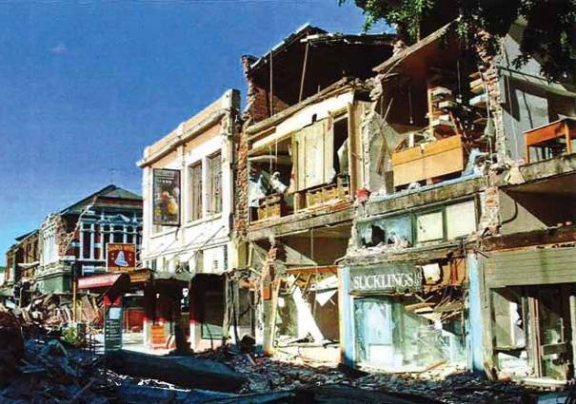

Figure 37: Damage to 617–625 Colombo Street after the February earthquake (looking south along Colombo Street)

4.13.4 Issues

4.13.4.1 Application of the CCC’s Earthquake- Prone Dangerous and Insanitary Buildings Policy

Earthquake strengthening was carried out on the building in 1994 and 2000. However, because of the increased strength requirements imposed under the Building Act 2004, the building was still earthquake- prone.

4.13.4.2 Structural assessment of the building after the September earthquake

In this case, the owners (through their property manager) obtained a detailed structural evaluation from Beca. Although the test applied by Beca was a damage-based one, they also carried out an initial evaluation procedure to assess the strength of the building.

Beca’s conclusion that the building had a strength of about 11% NBS confirmed that the building was earthquake-prone. However, on the damage-based test it was considered that the building did not pose an immediate risk to the occupants, despite the requirement for various repairs to be carried out.
In our view, this highlights the shortcomings of
a damage-based assessment after a significant earthquake. It also raises the question of whether there needs to be a minimum standard set for the capacity of a building.

4.14 738 Colombo Street

4.14.1 Introduction

The building situated at 738 Colombo Street was a two storey structure of combined URM and early reinforced concrete construction with timber roof framing and a timber first floor.

Christchurch Police records have confirmed that the body of Desley Thomson, who was a pedestrian on Colombo Street at the time of the February earthquake, was found on the road close to the footpath under collapsed building material outside the OK Gift Shop premises at 738 Colombo Street.

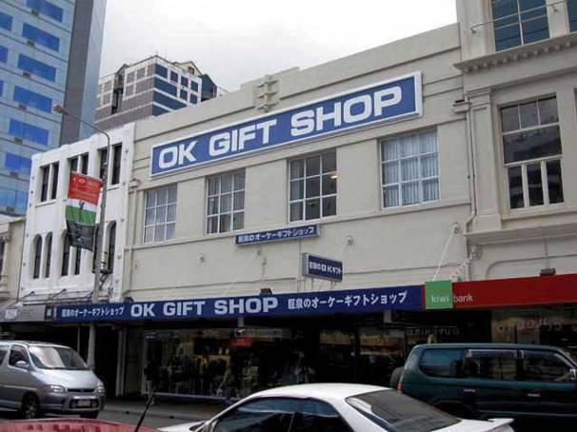

Figure 38: The building before the September earthquake

4.14.2 The building

The building had a concrete beam and column construction with infill brick in the north wall, concrete panels at the upper levels of the eastern and western walls and structural steel columns in the south wall. The steel columns supported steel beams which in turn supported the timber floor. Timber trusses supported the roof off the north and south walls.

The building adjacent to it at 736 Colombo Street was a four level concrete-framed building with brick infill walls including a basement. At the first-floor level, the two buildings were opened to each other in order to allow a larger space to be utilised. Seven hundred and thirty-six Colombo Street was built in the early 1900s and 738 Colombo Street in 1937.

It appears that strengthening work was completed in relation to 738 Colombo Street, designed by Buchanan & Fletcher Ltd, structural engineers, in 1991. This included securing the upper level concrete walls at ceiling and first-floor level using an epoxy bolting system and the installation of steel bracing at ceiling level and horizontal ply and steel beams at floor level. Brick parapets to the north and east were restrained in 1996. However, the building would still have been assessed as earthquake-prone under the Building
Act 2004.

The owner of the building, Mr Jonathon Liu, bought the building through his company (Natural Blessings Ltd) in August 2008 from OK Gift Shop Ltd (OK Gift Shop). OK Gift Shop remained as a tenant of the building. At that time Mr Liu entered into a property management agreement with Simes Ltd, which later became Knight Frank. Mr Liu said in evidence that he essentially left all of the management of the property to Simes Ltd and later Knight Frank. At the time of the September earthquake, Mr Liu also owned 736 Colombo Street, which was also managed by Knight Frank.

4.14.3 Events following the September earthquake

Following the September earthquake, there was a Level 1 Rapid Assessment of the building on 5 September 2010, which noted minor damage. The building was assigned a green placard.

OK Gift Shop arranged for an engineer’s inspection of the building by Powell Fenwick Consultants Ltd. Mr Liu said in evidence that, on being advised by the tenant that an engineering check was required, he called Mr Luke Rees-Thomas (of Knight Frank). However, this cannot have been the case. From the evidence
given by Mr Rees-Thomas and Mr Andrew Bell, both of Knight Frank, it is clear that Knight Frank did not have any contact with Mr Liu following the September earthquake in relation to this inspection. Further, Mr Rees-Thomas was not involved in the management of this building until 27 October 2010. A written statement to the Royal Commission from Mr Akira Yoshikane, manager of the OK Gift Shop, advised that he had instructed Powell Fenwick because he could not contact Knight Frank or Mr Liu at the time.

Powell Fenwick conducted a ‘walk-through inspection’ of the building on 6 September 2010 and provided a brief written report on the same day. That report noted “preliminary indications are that this building is not in immediate danger of structural collapse” and that there was nothing requiring urgent attention to ensure the ongoing stability of the building. It was noted that these conclusions were based on a visual walk- through inspection only and it was possible there was unobserved damage that might require remedial work. The report recommended a more detailed/full structural inspection.

The Powell Fenwick report of 6 September 2010 was addressed to Mr Liu at a post office box (which it transpired was that of the OK Gift Shop) but was also emailed to Mr Liu at treasure@ihug.co.nz. In evidence Mr Liu confirmed that this was his email address but he could not recall receiving the report. Mr Liu also said that he had received correspondence from the Royal Commission addressed to the same address, although he later said that he was not sure if he did actually receive it. Michael Freeman, structural engineer from Powell Fenwick, was able to confirm that, from Powell Fenwick’s records, the report had been sent by email to Mr Liu and there was no notification of non- delivery. On the basis of this evidence, we find that the report was received by Mr Liu at his email address.

Mr Bell gave evidence that he was responsible for the management of the property until 27 October 2010 when Mr Rees-Thomas took over. Mr Bell said that he became aware of the Powell Fenwick report after speaking to the tenant on 7 September 2010 and he requested a copy of it. The report was subsequently emailed to Mr Rees-Thomas on 2 November 2010.

On 9 September 2010, Mr Hamish Mackinven of Lewis Bradford (who had been instructed by Knight Frank to inspect 736 Colombo Street) emailed Mr Bell advising that he had completed a brief structural inspection of 736 Colombo Street and that it appeared that there was no structural reason that this building could not be occupied. That email was forwarded by Mr Bell

to Mr Rees-Thomas, who then emailed Mr Mackinven on 24 November 2010 to “arrange a full structural engineer’s report on the buildings 736–740 Colombo Street”. Mr Mackinven said that, although that email referred to the buildings 736–740 Colombo Street, he was only ever involved in the one building at 736 Colombo Street and he took that email to be referring to that building.

Mr Rees-Thomas’ evidence was that he intended Mr Mackinven to carry out full inspections of both buildings. There is some support for that in Mr Rees-Thomas’ email of 25 November 2010 to the tenant of the OK Gift Shop advising that there would be an inspection by a structural engineer the next day “to assess the building’s damage and safety in full”.

On 26 November, Mr Rees-Thomas met Mr Mackinven at 736 Colombo Street. He left Mr Mackinven at that building. It appears that Mr Rees-Thomas thought that Mr Mackinven would complete his inspection of 736 and then inspect 738. However, Mr Mackinven understood that he was only to complete his inspection of 736. Mr Mackinven provided a report in relation to 736 dated 30 November 2010. Mr Rees-Thomas said in evidence that when he received that report and noticed that it only related to 736, he contacted Mr Mackinven and told him that a report was also required for 738. Mr Rees-Thomas could not recall any of the detail of that conversation. Mr Mackinven could not recall the conversation taking place.

Mr Rees-Thomas said that he subsequently had a conversation with the loss adjustor, Mr Phil Buckman, in which Mr Rees-Thomas said he conveyed the need for a report on 738 as well. Mr Buckman did not give evidence at the hearing but email correspondence received from him following the hearing confirmed that his understanding was that Lewis Bradford had only ever been engaged to carry out assessments of 736 Colombo Street.

Mr Mackinven proceeded to prepare a detailed report on 736 Colombo Street. Lewis Bradford had entered into a short-form agreement (signed by Mr Rees-Thomas on 25 November). They entered into another agreement in relation to a full structural assessment with Mr Buckman in relation to 736 on 22 January 2011. There was never any short-form agreement completed in relation to 738 Colombo Street.

Mr Mackinven had asked Mr Rees-Thomas to obtain plans from the CCC. It appears that plans for both buildings were on the same CCC file and these were eventually forwarded by Mr Rees-Thomas to
Mr Mackinven on 8 February. When the 22 February earthquake occurred, Mr Mackinven was still in the process of preparing a full assessment of 736 Colombo Street. He confirmed that, even if he had understood that the same was required for 738 Colombo Street, he would not have been able to complete that before 22 February.

A CCC Level 1 Rapid Assessment of 738 took place on 27 December 2010 following the Boxing Day earthquake. This resulted in the building being allocated a green placard. There is a reference on that form to a Powell Fenwick report, although there was no report on the CCC file.

Mr Freeman gave evidence that he carried out a Level 2 assessment on 26 December following the Boxing Day earthquake, on instructions from the tenant, the OK Gift Shop. He said that the shop was open for business at the time of the inspection. He was given a limited tour of the buildings, which included access to the lower level shop, access to the rear storeroom at the lower level and access to the storeroom in the first-floor level at the rear of the building only. He was not able to access the upper level tenancy, which extended to the Colombo Street frontage of the shop. He said that his inspection involved a visual inspection only and, given the extent of the fit-out on the lower level of the shop, the inspection was very limited. He said that he was not invited during his inspection to conduct any intrusive testing or remove shop fit-out items to gain better access to the structural elements of the building.

He recalled seeing minor damage consisting of cracking to lath and plaster partition walls in the rear area of the shop only. There was no visual damage to any of the masonry walls, including the front wall of the building, which was inspected from Colombo Street. Mr Freeman said that he did not consider the observed damage to be detrimental to the structure of the building and did not consider the structural integrity of the building had been diminished by the Boxing Day earthquake. Mr Freeman confirmed in evidence that he concluded that the building remained structurally sound and fit to be occupied. He said that there was no evidence to suggest that the areas he was not able to access might be damaged. However, in retrospect, given the events in February, he conceded that the lack of access to some areas may have affected his conclusions. He added that, in retrospect, a Level 2 inspection would not have been sufficient. What was required was the removal of linings, consideration of building plans and minor preliminary calculations to work out the capacity of the building.

On 19 January 2011, Mr Rees-Thomas received an email from FHS Roofing Ltd, who had been instructed by him to inspect a roof leak at the building. It was noted in that email that the “Colombo Street parapet (3m tall) has come adrift from the walls on either side and will need refixing to the adjacent buildings to
re-secure”. Mr Rees-Thomas forwarded this email
to Mr Buckman on 26 January 2011. Two days later Mr Buckman forwarded it to Mr Mackinven and asked him to “inspect this and report as part of your investigations into the damage”.

That same day, Mr Mackinven inspected the parapet and sent Mr Buckman an email in which he gave Mr Buckman a report of the damage to 736 Colombo Street. He also noted, “As requested I have inspected the parapet of the adjacent building at 738 Colombo Street. The damage to this parapet was noted in our previous inspection and is captured in our report. It has been caused by the lack of a seismic gap between the two buildings and movement occurring between them”. In evidence, Mr Mackinven conceded that he had not inspected the other end of the parapet but explained by reference to photographs that were taken at the time that the parapet of 738 was not connected to the adjacent building. He said that the observed damage was not of concern.

The building was extensively damaged in the February earthquake, including collapse of the façade onto
the street. Mr Peter Smith stated in his report to the Royal Commission that “from the photographs it would appear that the front façade above first-floor window-sill level rotated outwards from the support at the window-sill level, collapsing onto the footpath as a result of the severe shaking experienced during the earthquake”.

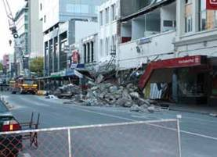

Figure 39: 738 Colombo Street after the February earthquake
4.14.4 Issues

4.14.4.1 Application of the CCC’s Earthquake- Prone Dangerous and Insanitary Buildings Policy

In this case, it appears that the earthquake strengthening that was considered necessary in 1991 and 1996 was carried out. However, because of the increased strength requirements imposed under the Building Act 2004, the building was still earthquake-prone. Even if it had been strengthened so that it was no longer earthquake-prone under the Building Act 2004, it is likely that, given the severity of the shaking in the February earthquake, the walls would still have failed.

While it is difficult to eliminate entirely the dangers posed by such buildings during a significant earthquake, this highlights the need for urgency in the retrofit of URM buildings.

4.14.4.2 Assessment of the building following the September and Boxing Day earthquakes

This building again highlights the risks of undertaking only a damage-based assessment for an URM building following a substantial earthquake.

The issues that arose in relation to this building, namely the misunderstanding and miscommunication that arose about a more detailed inspection, the delay before one could have been obtained in any event, and the reliance on brief walk-through inspections after both the September and Boxing Day earthquakes, which Mr Freeman conceded in retrospect were inadequate, require consideration.

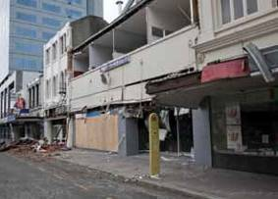While it is clear that a detailed report could not have been obtained before the February earthquake, it is unfortunate that there was miscommunication and misunderstanding about it. It highlights the consequences of a lack of clear communication.

4.15 753–759 Colombo Street

4.15.1 Introduction

The building at 753–759 Colombo Street was a two storey URM structure on the western side of Colombo Street between Gloucester and Armagh Streets, and was divided into four tenancies. Visually it appeared to be one building together with 751 Colombo Street, but each was separated by a party wall from its neighbour.

Ms Marielle Falardeau appears to have been a pedestrian on the footpath on the western side of Colombo Street at the time of the February earthquake. Her body was found under collapsed building material outside 753 Colombo Street, which housed a shop called Colombo Souvenirs.

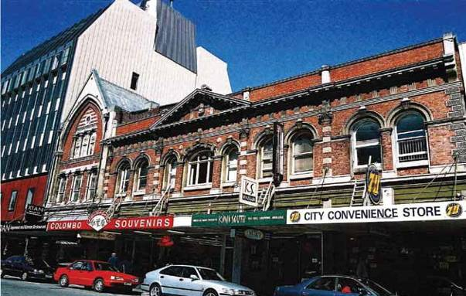

Figure 40: The buildings at 751–759 Colombo Street before the September earthquake. The taller URM building at left bearing the sign “Xian” is 751 Colombo Street. Colombo Souvenirs was a tenant at 753 Colombo Street

4.15.2 The building

The building was listed as a heritage building in the CCC District Plan and was registered as an historic building by the Historic Places Trust.

A CCC seismic risk buildings survey in 1991 noted “seemingly complete mortar deterioration on feature parapet” and gave the building a score of 16, which resulted in its being classified as A, meaning immediate
remedial action was recommended. A hazardous appendage survey carried out around the same time on 751–757 Colombo Street referred to:

• significant loose masonry, mortar deterioration and cracking;
• “One of the worst examples in Christchurch”; and

• “Probably an area of the heaviest pedestrian traffic in central Christchurch”.

The building was jointly owned by the Church Property Trustees and the Jason Richards Trust. Ms Elizabeth Clarke, an employee of Church Property Trustees, was the property manager. She gave evidence that, as a result of a change of tenancy of 753 Colombo Street and resulting work required, a building consent was applied for in 1994. In April 1994 the CCC advised that it believed the building as a whole was earthquake- prone in terms of section 66 of the Building Act 1991, and that no building consent would be given until this issue was addressed.

Strengthening work was carried out on 753 Colombo Street in 1994. Mr Stephen McCarthy of the CCC gave evidence that this work appeared to include the installation of two concrete frames and a diaphragm on the first floor, and steel members to strengthen the walls. The walls and roof were also tied to the structures with steel members and ChemsetTM (chemically anchored) bolts.

Mr McCarthy was asked when giving evidence why the CCC would not have insisted on the building as a whole being strengthened, rather than just 753 Colombo Street. He said that often with these types of buildings the CCC treated each tenancy or each part of the building as a separate building, and this was a way to get at least some strengthening done.

Mr McCarthy’s evidence was that 755 Colombo Street appeared to have been strengthened in 1994 by the installation of two concrete frames. This work only affected the ground floor. CCC records show that 757 Colombo Street appeared not to have been strengthened. The building at 759 Colombo Street was strengthened in 1999 in a similar manner to 753.

All the strengthening work had been carried out before the CCC’s Earthquake-Prone Dangerous and Insanitary Buildings Policy was introduced in 2006. It is likely that all of the tenancies would have been regarded as earthquake-prone for the purposes of the policy. No applications for building consents to make significant alterations were submitted after the introduction of the policy, so the requirement to consider strengthening in terms of the policy had not been triggered.
4.15.3 Events following the September earthquake

Following the September earthquake, a CCC Level 1
Rapid Assessment of 751–759 Colombo Street was carried out on 5 September 2010. Minor damage was noted and the building was allocated a green placard. A further Level 1 Rapid Assessment was conducted on 7 September 2010 for 751–759 Colombo Street. This recorded a detailed inspection of parapets and corbels and also resulted in a green placard.

A brief structural inspection was carried out on behalf of the owners by Mr Hamish Mackinven of Lewis Bradford, consulting engineers, on 8 September 2010. In relation to the tenancies at 753, 755 and 759 Colombo Street, nothing was noted to indicate that the building was structurally compromised. There did not appear to be any reason why the building could not be occupied. In relation to 753 and 755, Mr Mackinven noted chimneys that were not in immediate danger of falling but recommended that they should be removed in the near future. Ms Clarke gave evidence that this work was completed.

In relation to 757 Colombo Street, Mr Mackinven noted some damage to a concrete wall at the rear of the building, which required strengthening. The wall had also pulled away from the masonry wall and needed to be structurally tied to it. He noted that this tenancy was then unoccupied but that the work would need to be completed before it was re-tenanted.

Mr Mackinven gave evidence that he considered his inspection of the building to be more thorough than a normal Level 2 inspection. He inspected both the interior and exterior of the building, went out onto the canopy to inspect the front façade, twice climbed up onto the roof to inspect the roof structure and front façade, and inspected the front façade from the opposite side of the street with a pair of binoculars. He confirmed that his assessment was a damage- based assessment and that because the damage he observed was minor, he did not believe it had diminished the capacity of the building.

Mr Mackinven gave evidence that the remedial work required at 757 Colombo Street was carried out under his supervision between 18 and 21 October 2010.

There were no inspections, either by the CCC or on behalf of the owners, following the Boxing Day earthquake. Ms Clarke said that she relied on advice from their property managers, Knight Frank, previously Simes Ltd, who did not advise of any structural damage.

Mr Mackinven had no further involvement with the building after 21 October 2010. In evidence he was asked whether his assumptions in relation to aftershocks changed after the Boxing Day earthquake. He said that they had indeed changed, because that earthquake had been on a different fault to the Greendale fault and was close to the central city. He said that the way that he assessed buildings following Boxing Day changed, in that he had become more aware of the potential for another fault to appear close to the city.

The Royal Commission heard evidence from
Mr Craig Lewis, a structural engineer with 25 years’ experience and Director of Lewis Bradford Consulting Engineers. He spoke of the damage-based test applied after the September earthquake, and how his firm and other colleagues he spoke to took a decidedly more
cautious approach to the assessment of buildings
after the Boxing Day earthquake for the same reasons given by Mr Mackinven. He said that he thought that if his firm had been inspecting this building post- Boxing Day, they would have taken a slightly different approach. They would have conducted a more risk- based assessment and recommended that drawings be accessed. Although original drawings might not have been available for this building owing to its age, the Council did hold drawings for alteration and strengthening work carried out to parts of the building.

In the February earthquake the building suffered severe structural damage, including collapse of the upper storey façade onto the street. Mr Peter Smith said in his report to the Royal Commission that the front façades rotated outwards at the point of connection above the windows and collapsed onto the footpath
on Colombo Street.

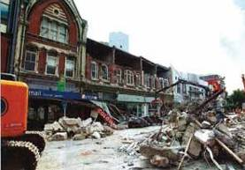

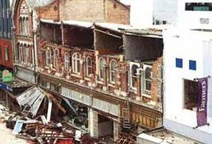Figure 41: Two views of the building after the February earthquake

4.15.4 Issues

4.15.4.1 Application of the CCC’s Earthquake- Prone Dangerous and Insanitary Buildings Policy

The CCC building surveys in 1991 identified significant mortar deterioration and described this building as “one of the worst examples in Christchurch”. Some strengthening work was carried out but the building was likely to have still been earthquake-prone under the Building Act 2004.

We note that when 759 Colombo Street was strengthened in 1999 the CCC contributed $35,000 to the cost of this work, which it secured by way of a conservation covenant with the owners. Mr McCarthy was asked in evidence whether this type of assistance was a realistic way to deal with the economic difficulties of upgrading URM buildings. He replied, “I think realistically it is and I think local government generally accepts that they have a part to play in making it easier to upgrade unreinforced masonry buildings, indeed any earthquake-prone buildings”. He said that before the September earthquake the CCC was contemplating establishing a fund to help facilitate building upgrades.

4.15.4.2 Assessments of the building following the September earthquake

The engineers who assessed this building following the September earthquake adopted a damage-based test to determine fitness for occupancy.

URM buildings are susceptible to sudden failure in earthquakes because of the materials and methods used in their construction. Even when the danger is reduced by seismic strengthening they continue to have a higher risk of collapse than other structures. Therefore, consideration needs to be given to whether these buildings should be occupied after a significant earthquake. The level of strength and degree of improvement necessary to make URM buildings safer in the event of a moderate earthquake is discussed in sections 6 and 7 of this Volume.

4.16 309 Durham Street North

4.16.1 Introduction

The Durham Street Methodist Church at 309 Durham Street North was a URM building constructed of stone in Gothic style. The building was divided into three parts: the church proper, the annex (adjacent to the western end of the church) and the hall (adjacent to the south side of the annex and south-western corner of the church). The church and the annex were classified as Category I by the Historic Places Trust (i.e., they were considered to be of special or outstanding historical or cultural heritage significance or value).

When the February earthquake struck, a group of eight workmen from the South Island Organ Company Ltd was removing the pipe organ from the church. The building suffered a catastrophic collapse in the earthquake.

Police information provided to the Royal Commission indicated that six workmen including Mr Scott Lucy, Mr Paul Dunlop and Mr Neil Stocker were working inside the church, dismantling and moving the organ. Two of their other colleagues were on the outside of the building. After the earthquake hit and the church collapsed, Mr Lucy, Mr Dunlop and Mr Stocker were trapped under rubble, but the other three managed to get out. Mr Lucy was last seen running down the stairs inside the church during the earthquake. Mr Dunlop was last seen about four metres from the altar, and Mr Stocker was last seen standing on scaffolding. Their bodies were found by Urban Search and Rescue (USAR) on 23 February 2011.

4.16.2 The building

The church was built in 1864, the annex constructed as an addition in 1869, and the hall as a further addition in 1873. In the church, ornate tied timber trusses spanned buttress columns supporting the roof structure. There was a gallery at first floor level encircling the central ground floor seating. The first floor was supported by the external walls and internal columns. Both the annex and the hall also had timber trusses supporting their roofs.

On the southern side of the church (and in front of the hall) was a more modern building known as Aldersgate, which housed the Methodist City Mission and church administration.
It appears that no structural strengthening had been carried out on the church in the past. A structural report by an R. D. Sullivan structural engineer in September
2009 noted that the three parts of the building were earthquake-prone and would collapse in a moderate earthquake. Various strengthening options were proposed but none adopted. A proposal was made by Mr Sullivan in May 2010 to provide design details for strengthening the building. Mr Gregory Wright, Executive Officer of the Methodist Connexional Property Committee, gave evidence that before the September earthquake the Methodist Church was waiting to see what the CCC’s strengthening requirements would be.

4.16.3 Events following the September earthquake

In the September earthquake some parts of the building suffered significant damage that would have required extensive reconstruction of the eastern towers of the church, the hall and (to a lesser extent) the annex. The building was allocated a red placard on 5 September
2010 and a full cordon recommended.

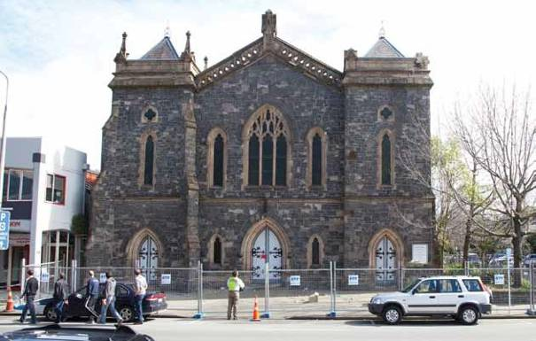

Figure 42: The eastern façade of the Durham Street Church after the September earthquake

After the September earthquake, the owner engaged
Arrow International Ltd (Arrow) in relation to the
building. Arrow engaged Mr Sullivan to prepare an initial damage assessment because of his prior knowledge
of the building. Mr Sullivan noted that the church had been very extensively cracked and he designed steel frames to provide temporary support. He also noted that the organ in the church would have to be removed to storage while repairs were undertaken.

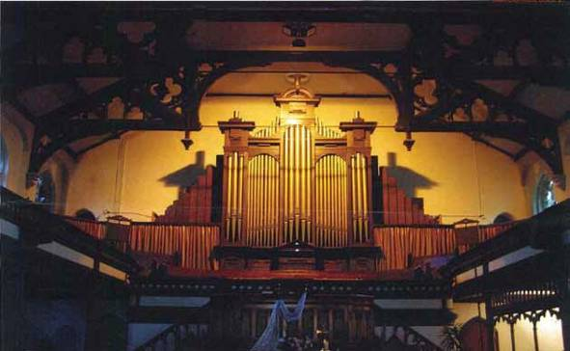

Figure 43: The organ in the Durham Street Methodist Church

The pipe organ had been inspected by the South Island Organ Company Ltd on 22 September 2010 and found to have sustained little damage. The decision was made to remove the organ from the church. Mr Wright explained that he understood this was necessary for remedial work to be carried out on the western wall of the church and he was advised that it could be done safely.

As the building had a heritage classification, it was necessary to involve the CCC in any repair work or removal of items such as the organ. Although the CCC Environmental Policy and Approvals Unit gave approval for the organ to be removed, this was based on a consideration of heritage issues rather than safety.

As the building had been allocated a red placard after the September earthquake and a full cordon had been erected, a notice under section 124 of the Building Act 2004 was never issued. By the time the CCC approval to remove the organ was sought early in 2011, the red placard status had expired. Therefore, although CCC approval still had to be obtained because of the heritage status of the building, Mr McCarthy of the CCC said any safety issues regarding the removal of the organ or access to the church were for the owner to address.

It was apparent that although a resource consent was required to remove the organ, the CCC approved its removal on the basis that a retrospective application
would be filed. In submissions filed after the hearing, the CCC accepted that although there was no legal basis for allowing this, it had taken a pragmatic approach to Resource Management Act compliance in respect of listed heritage buildings requiring urgent minor works such as temporary securing and repair.

As Mr Sullivan was busy in the weeks that followed, Mr Gary Haverland of Structex Metro Ltd (Structex) was engaged to prepare a report on the damage and review temporary propping details prepared by Mr Sullivan. Mr Haverland said that he was asked to provide a second opinion on the appropriateness of the proposed propping but not the design calculations for that propping. Mr Haverland completed a structural assessment report on the building dated 4 October 2010, noting that the church and hall had suffered significant damage.

In a further report dated 21 October 2010, Mr Haverland commented on the temporary propping that had been designed by Mr Sullivan. He concluded that the proposed propping system and details were appropriate to provide temporary medium-term support to the eastern wall and north-eastern tower. Mr Haverland recorded that, based on Structex’s inspection and report dated 4 October 2010, Structex believed that the main church auditorium had not had significant structural damage and was therefore “unlikely to collapse as a result of significant aftershocks”.

He did not consider that additional temporary propping of the north-eastern tower was necessary to enable the organ to be removed. He recommended that “building occupancy be minimised to assist in reducing risks to persons carrying out the removal work”. In evidence, Mr Haverland said he considered that the building had performed well in the September earthquake and that the aftershocks being experienced at the time were of a shorter duration and lesser magnitude. Further, he said that the organ was situated at the western end of the church, where the degree of damage was low, and it was distant from the area of greatest damage (the eastern wall of the church and the north-eastern tower).

In relation to his recommendation that “building occupancy be minimised”, Mr Haverland said that in considering this he had regard to Structural Design Actions Part 0: General Principles, Standards Australia/ Standards New Zealand (AS/NZS 1170.0:2002), which incorporates risk factors. He said the risk factor was lower for temporary propping and construction works in which a small number of persons worked on site for a shorter period. That risk factor, he said, recognised the reduced likelihood of a large earthquake occurring during a shorter period of time when construction work or removal work was being carried out.

Structex had been engaged by Arrow to ascertain whether it was safe to remove the organ, and further advice was received by Arrow from Structex following the Boxing Day earthquake. Details were provided of a safe access via the Aldersgate building next to the church and safety measures were put in place.

Mr Timothy Fahy, project manager employed by Arrow, dealt with Mr Haverland. Mr Fahy also liaised with the CCC Heritage and Planning sections in relation to the proposed removal of the organ. The South Island Organ Company Ltd was engaged to enter the church and remove the organ.

On 19 January 2011 Mr Haverland carried out a further inspection to observe any additional damage as a result of the Boxing Day earthquake and subsequent aftershocks, and also to determine any safety issues associated with removing the organ. He noted significant further damage. In a later inspection he also noted that there was a bow in the western gable wall of the church. While it appeared to be mainly historical, as a precaution he recommended that brackets be installed to that wall to provide additional stability while the organ and other chattels were removed.
Mr Haverland said that by then it was becoming less likely that the building would be able to be repaired and retained, but that he was proceeding with a detailed assessment for repair. Although there had been further damage, Mr Haverland did not consider that the church was in a state that would prevent the organ from being removed because:

• the deterioration was gradual and most additional damage was likely to be the result of the Boxing Day event, which was considered to be a very significant aftershock in itself;
• stonework generally fell out from the building and all work was being carried out inside;
• the roof and gallery structure would normally prevent the walls falling in;
• a safe protected path had been constructed through Aldersgate;
• the roof trusses were tied together with a steel rod providing a good tie between the stone sidewall buttresses; and
• the main risk identified at that stage was associated with individual stones falling from the exterior of
the building.

On 1 February 2011 Mr Haverland inspected the site with Mr Fahy to consider the possibility of providing access through the northern door of the annex. Mr Haverland said that if access were to be provided through this area, protective scaffolding should be placed over the door.

Mr Haverland gave evidence that at each stage he undertook a risk assessment having regard to the damage to the building. Given the damage sustained, he said that it was not possible to eliminate the risk during the organ removal process, but it could be minimised by limiting access to a short period of time, holding safety briefings (by Arrow) to highlight the risk, providing protective scaffolding and safe paths, and installing additional brackets to stabilise the annex wall behind the organ.

Mr Haverland completed a seismic assessment report on the church dated 17 February 2011, which recorded that “the building has been assessed as having a longitudinal (along the building) strength of 15 per cent of current code, and a transverse (across the building) strength of 10 per cent current code”. In evidence, Mr Haverland said that the lateral load capacity would have been improved by the propping installed at the eastern end and the significant additional strength the gallery provided to the church building.

In a letter to Mr Fahy dated 16 February 2011 Mr Haverland said:

The weakest area of the building is the Auditorium of the main church which has a transverse lateral load capacity of 10 per cent of current code. This assessment and strength is based on the building in its pre-earthquake condition, with no cracks. The building in its current state will have a strength less than its assessed value.

Following our recent visits to the building, which have been carried out after the Boxing Day earthquakes, there has been noticeable additional damage, particularly to the north wall annex. Cracking of the side wall buttresses also appears to have increased.

Further damage will continue to occur as a result of on-going aftershocks, which could result in the building becoming unsafe.

We understand that the building, as well as its contents are of significant historical value. It is therefore necessary that additional temporary bracing be installed to the north wall of the auditorium, as well as the west wall of the hall to provide longer term protection to the building and its contents in the event of significant ongoing aftershocks.

In evidence, Mr Haverland explained that this work related to longer-term protection of the building. He did not consider it was unsafe for short-term access. He thought that it still had a low probability of collapse during an aftershock, particularly given the nature of the aftershocks that were being experienced. He did not consider that additional propping would be required before the organ could be removed. The proposed bracing of the western wall of the hall was outside the area of occupancy and the northern wall was not considered to be at high risk of collapse in the aftershocks being experienced at the time.

Mr Fahy contacted Mr Haverland after receiving a draft copy of Mr Haverland’s report of 17 February and asked whether it was appropriate for the organ removal to proceed. Mr Haverland told him that he considered that it was. In evidence, Mr Haverland said he pointed out that the building had performed well and beyond expectations during the September and Boxing Day earthquakes: apart from the eastern wall and the towers, which were braced, it did not show significant signs of collapse under lateral loads associated with the aftershocks that were being experienced. He also said that assessments at this level of analysis were typically conservative: the calculations used for the building assessment were for a 50-year design life with crowd loading. Furthermore, there were other redundancies in the structure that were not taken into
account in the analysis, which would have provided significant improvement in stability, such as the gallery floor at mid-height and the steel roof ties.

Mr Haverland stated in evidence:

My view remained that it was appropriate to use
a risk factor of 0.5 for construction loads as these were appropriate for short term access. This would also be consistent with the propping design carried out by Dick Sullivan. A risk factor of 1.3 would have assumed full use with full occupancy for a 50 year life. In assessing the risk involved with contractors being on site at this stage it was appropriate, in my view, to scale these figures to take into account the factors referred to in AS/NZS 1170.0:2002 such as the limited access. In that sense it would have been possible to scale the figures in relation to contractor short term access from 10 per cent to 26 per cent or in the case of the west wall adjacent to the organ from 87 per cent to 226 per cent.

Mr Haverland was questioned at some length on this issue by counsel assisting the Royal Commission and by the Commissioners. He explained that the risk factor (and the scaling-up of the strength assessment of the building) was used as part of the qualitative assessment to allow people to go into the building for short periods of time, but was not used as a tool to assess the strength of the building. Further, he emphasised that it was based on AS/NZS 1170.0:20028, which he understood took into account the elevated risk during an earthquake.

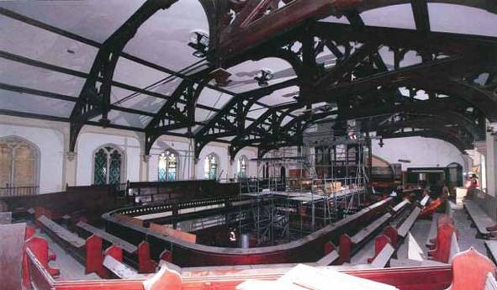

Figure 44: The interior of the church, showing scaffolding erected as part of the removal process

Mr John Hargraves, director of the South Island Organ Company Ltd, dealt with Arrow and relied on the assurances Mr Fahy gave that Mr Haverland had assessed the building and the risks involved. Mr Hargraves gave evidence that he was not aware of the report from Mr Haverland dated 17 February 2011.
The company began removing the organ on
14 February 2011. The work was expected to take two weeks but was almost complete on 22 February. When the earthquake struck the church suffered a catastrophic collapse.

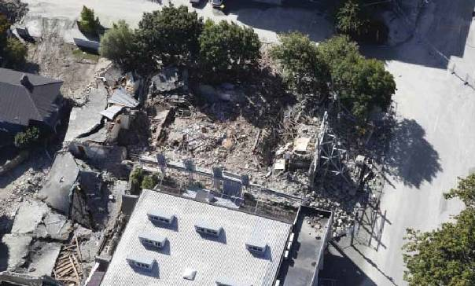

Figure 45: An aerial view of the Durham Street Methodist Church site after the February earthquake

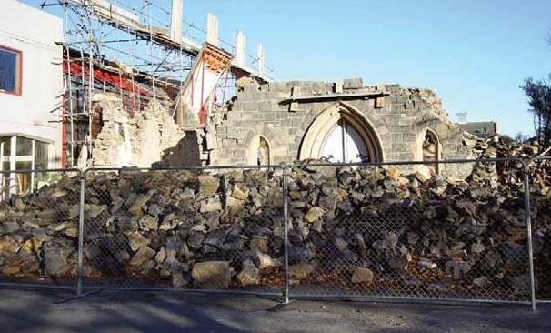
Figure 46: The eastern side of the Durham Street Methodist Church after the February earthquake

Mr Peter Smith, who conducted an independent assessment of the failure of the building for the Royal Commission, said in evidence that the building effectively disintegrated in the high level of shaking, particularly the vertical acceleration that occurred during the February earthquake.

In relation to the propping, while Mr Smith considered that Mr Sullivan’s interpretation of what was needed was more conservative than Mr Haverland’s, he was of the opinion that even if the propping designed by Mr Sullivan had been installed, it would still not have prevented the collapse of the building.

Mr Smith considered that the performance of the building in the Boxing Day earthquake would have afforded some confidence to Mr Haverland in his assessment, but he noted that the connections between the various components of the building had not been investigated as part of that assessment. That would have required exposure of the connections to enable them to be examined, whereas Mr Haverland had inferred they were in good condition because he observed little movement between the roof trusses, mezzanine floor beams and the side walls. Mr Smith also commented that the latest thinking in terms of propping of such buildings was that it could actually be detrimental rather than helpful, and that in Italy the current thinking is to wrap the building and try to tie it together as a unit.
In relation to the assessment of risk in entering such a building, Mr Smith did not consider that the New Zealand Standards addressed this issue. As there were no clear guidelines for an engineer in making such an assessment, Mr Smith thought that risk factors in AS/NZS 1170.0:20028 were often used as a reference point by engineers to assess risk. He considered that there was scope for the development of guidelines that might assist engineers in assessing such risks.

4.16.4 Issues

4.16.4.1 Application of the CCC’s Earthquake- Prone Dangerous and Insanitary Buildings Policy

The failure of this very old building provides a striking illustration of the problem that results from a passive approach to earthquake-prone buildings. This was a building where the owner knew before 4 September 2010 that it would likely collapse in a moderate earthquake and that it therefore required strengthening. The owner was waiting to see what the CCC’s policy on strengthening would be, rather than having the work done at its own initiative.

4.16.4.2 Assessment of the risk associated with removing the organ

While we accept that hindsight can colour this issue, we are of the view that it would have been prudent to adopt a more conservative approach to the assessment of the risk involved in removing the organ. We say this for the following reasons:

1. This was clearly an earthquake-prone building.

2. It had suffered substantial damage in the
September and Boxing Day earthquakes.

3. Mr Haverland’s evidence was that by mid-January
2011 he considered it was becoming less likely that the building would be able to be repaired and retained. Although Mr Fahy expressed the view that to his knowledge deconstruction of buildings was not occurring at that time and that the CCC was unlikely to have agreed to the building not being retained, he said that this possibility had only been considered very briefly.
4. Mr Haverland considered that it would be necessary to fit additional temporary bracing to the northern wall of the church. While Mr Haverland explained that this related to longer-term protection of the building and its contents in the event of significant ongoing aftershocks, there could of course have been a significant aftershock at any stage.
5. Mr Haverland did not examine connections.

6. In regard to the risk factor of 0.5 applied by
Mr Haverland and the theoretical scaling-up of the assessed strength of the building for the purposes of considering the risk, we doubt that this was the appropriate way to assess the risk. It could have artificially increased confidence in the building’s structural integrity. Further, we have reservations about applying this methodology to a building at a time when there is an active ongoing sequence of earthquakes

We agree with the comments of Mr Smith (and
Mr Haverland) that there is a lack of clear guidelines for engineers and others in assessing the risk of entering what is essentially a dangerous building. Such guidelines could stipulate the methodology and safety measures that would be put in place where access is to be permitted. This is a matter that we address in Volume 7 of our Report.
In this case it was apparent that no notice under section 124 of the Building Act 2004 was issued after the allocation of a red placard because a full cordon was in place and the owner was restricting access. This meant that, while the heritage section of the CCC was involved in the decision to remove the organ, the CCC was not involved in the safety assessment as it had no role under the Building Act.

We discuss dealing with dangerous buildings and the consideration of heritage concerns in section 7 of this Volume.

4.17 194 Gloucester Street

4.17.1 Introduction

The three-storey URM building that was situated at
194 Gloucester Street (known as Wave House) housed
Winnie Bagoes, a pizzeria. The building was listed as a Group 3 heritage building in the CCC District Plan and registered as a Category II historic building by the Historic Places Trust.

When the February earthquake struck, Mr Ofer Mizrahi, an Israeli tourist, was in a white Mitsubishi van parked outside the building. The van was crushed by falling rubble from the collapse of the northern wall of the building. Mr Mizrahi died as a result of the injuries he sustained.

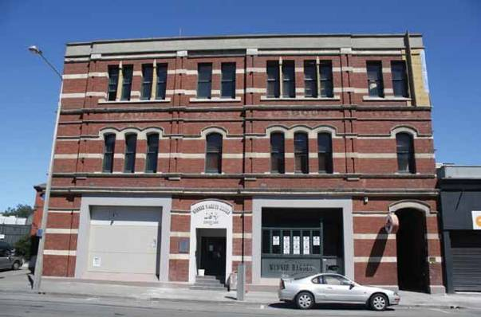
Figure 47: The front (northern) side of 194 Gloucester Street before the February earthquake

4.17.2 The building

The building was constructed in 1906 as the Trades and Labour Hall and originally comprised two floors fronting Gloucester Street and a single storey hall to the rear. In 1916 a second floor was added to the hall. Third- floor offices were added to the front section in 1924. A reinforced concrete liftshaft was added to the front side of the internal masonry wall in 1960.
It appears that a structural assessment by Holmes
Wood Poole & Johnstone, structural engineers, in
1975–76 led to structural strengthening being undertaken to meet a seismic load level of 0.05g.

Mr Peter Smith, who carried out an independent assessment of the building for the Royal Commission, gave evidence that from his perusal of the CCC records there had been some strengthening work completed in 1975–76 but there was some uncertainty as to its extent.

A seismic report was prepared by Holmes Consulting Group (HCG) in 2002 for Mr Christopher James, a prospective purchaser who wanted to convert the ground floor into a restaurant. The report concluded that significant strengthening involving the introduction of new shear wall elements and concrete facing was likely to be required to satisfy section 46 of the Building Act 1991, which related to change of use of buildings. The HCG report was provided to the CCC by Mr James, who submitted to the CCC that café-style dining on the ground floor and office space on the first and second floors did not constitute a change of use. Further, he said that the cost of “significant strengthening” referred to in the report would make future renovations of the property unfeasible and would therefore probably result in the termination of the purchase agreement.

In a facsimile dated 21 February 2002, the CCC advised
Mr James, “We have taken appropriate advice based on your amended proposal based on café-style dining on the ground floor and office space on the upper floor. We are now of the opinion that your amended proposal is not a change of use in terms of section 46 of the Building Act 1991”. In January 2003 the CCC confirmed that the establishment of a bar/restaurant in the building did not constitute a change of use so no engineering report was required.

Mr Stephen McCarthy, from the CCC, gave evidence that the proposal for café-style dining on the ground floor in 2002 would not have constituted a change of use because there had previously been a kitchen servicing an assembly hall and this would have been considered part of the hospitality industry even though it had not been in use for some nine years. He said that there were no written records of this and he was relying on the knowledge of people who worked for the CCC at the time, in particular the legal section, which would have provided the advice referred to in the CCC facsimile of 21 February 2002.

Mr David Wallace of Devonia Realty Ltd (Devonia), who managed the building for the building’s overseas owner, gave evidence that when the building was purchased in 2008 the vendor’s agent advised that earthquake strengthening had been done in 2003 during refurbishment. However, after the September earthquake they were told by Beca Carter Hollings and Ferner Ltd (Beca), who Devonia had instructed to inspect the building, that it could not see any indication of this.

Mr Samir Govind, a Beca structural engineer, designed and supervised remedial work on the building after the 4 September and Boxing Day earthquakes. He gave evidence that his firm obtained CCC records to try
and ascertain whether any seismic strengthening work had been carried out in 2003 but could not find any evidence of such work.

It appears therefore that, although work was completed when the fit-out for Winnie Bagoes was carried out in 2003, no seismic upgrade was required or carried out as it was not considered a change of use of the building.

4.17.3 Events following the September earthquake

After the September earthquake, a CCC Level 1 Rapid Assessment on 5 September 2010 noted that the parapet on the south side (at the rear of the building) had fallen into a courtyard. The building was allocated a green placard.

However, a Level 2 Rapid Assessment carried out by
Mr Govind on behalf of the owner the next day resulted in the building being assigned a yellow placard. He noted the collapsed parapet at the rear and also cracking to upper-level brick walls.

A CCC Level 2 Rapid Assessment on 5 October 2010 noted cracking to the rear parapet and the yellow placard was confirmed. Then on 12 October 2010 the CCC served a notice on the owner under section 124 of the Building Act, requiring work to be completed by 31 January 2011.

Devonia instructed Beca to complete a preliminary structural engineering evaluation, which was completed on 14 December 2010. That evaluation assessed the building’s capacity as 5% NBS but was supplemented by further assessment calculations that indicated a capacity range of 15–25% NBS if some reliable diaphragm connection was available. Mr Govind noted that in a building such as this there was potentially very little reliable diaphragm connection.

The day after the Boxing Day earthquake the building was inspected by USAR. Severe parapet damage was noted and damage to the northern and north- western parts of the building. A second Building Act notice was served on the owners, care of Devonia, on 27 December 2010, requiring make-safe work to be completed by 31 January 2011.

Mr Wallace gave evidence that on 6 January 2011
Devonia advised the CCC that Beca had carried out a closer inspection of the upper parts of the building with a crane and concluded that the level 3 western wall was precarious and needed to be taken down immediately, both to make the building safe and to enable an internal inspection for further damage.

Devonia sent another email to the CCC later that day reiterating the danger to persons and property and advising that the building contractor was starting on site that week. The make-safe work was approved by the CCC by email that same day, subject to a retrospective application being made for a resource consent in due course.

Devonia engaged contractors to be briefed by Beca and then carry out the make-safe work under Beca’s supervision. On 3 February 2011 a CCC engineer’s re-inspection form recorded that this repair work was in progress and that the protective fencing around the building was adequate. Mr Wallace said in evidence that Beca was subsequently instructed to inspect the work that was carried out by the contractor. The make-safe work was completed by 14 February 2011. Mr Govind of Beca sent an email to Mr Wallace (with a copy to the CCC) stating: “As promised the works at 194 Gloucester are now complete – refer letter to remove fences. I presume with this letter the adjacent buildings can be opened up as well as the concern with 194 Gloucester is closed out”.

That email attached a letter from Mr Govind to the owner of the building, which stated:

On the basis of a visual inspection of the building conducted on 14 February 2011, we are satisfied, on reasonable grounds, that any potentially dangerous features have been removed or secured, and that the stability of the structure is sufficient that it does not pose a threat to adjacent buildings or the public that is significantly greater than prior to the earthquake.

Notwithstanding the above, the building has suffered damage from the recent earthquake and is potentially earthquake prone. The inherent risks due to being a potentially earthquake prone building still exist. We are currently undertaking further investigations and assessment work to develop appropriate remedial/strengthening works (if required) for the building.

The CCC relied on the email and letter from Mr Govind and subsequently removed the barriers that had been in place in front of the building, positioned about halfway into the traffic lane on Gloucester Street nearest to the building.

On 15 February 2011, Ms Sharon Weir of the CCC sent an email to other CCC officers stating:

We have a[n] urgent requirement to remove the cordons of the 192–194 Gloucester Street block. This has been signed off by the engineer to remove, Neville Higgs.

We have loaded a[n] RFS number 91246304 marked urgent, this does need to be completed today as the property owners have been in contact with Chris Kerr and the Media is a threat to us…

Mr Wallace gave evidence that neither the building owner nor Devonia had any involvement in the removal of the cordons. Although he confirmed that the same owner also owned 192 Gloucester Street and that Devonia managed that building as well, he said that as far as he was aware neither the owner nor Devonia had made any request to the CCC or Beca to remove the cordons. Mr Wallace said that 194 Gloucester Street was empty and that there was no reason to remove the cordon in front of the building. The only reason to remove any fences would have been to provide parking for customers of a pharmacist, Mr Phil Berry, who was seeking to reoccupy his premises at the western end of 192 Gloucester Street. Mr Wallace said he suspected that the email from Ms Weir might have mistakenly referred to the building owner when she had meant to refer to Mr Berry, who operated the pharmacy and to whom a subsequent email sent by Ms Weir that same day referred.

While Mr McCarthy disapproved of the terms of the email Ms Weir had sent, he presumed that there was pressure from a nearby business owner to remove the cordon, as was not uncommon. He said that although a decision to remove a cordon would normally be recorded on the CCC file, there was no written record of it in this case. Mr McCarthy said he believed that the file was sufficiently complete to satisfy Mr Higgs, the CCC engineer, that he could make the decision. He conceded in cross-examination that the letter from Mr Govind dated 14 February 2011 did not confirm that the building was “safe to occupy”, and that this was a requirement in the CCC’s procedure for removal of temporary fencing/barricades from buildings with yellow or red placards.

In cross-examination, Mr Govind maintained that, despite the reference to fences in his email, he was not intending to advise the removal of the fences, but rather was addressing the Building Act notice requirements. However, Mr McCarthy was of the view that, although the CCC relied on Mr Govind’s letter to remove the fences, the Building Act notice remained in place as there were more permanent works required to the building before it could have been reoccupied. In fact it remained unoccupied.

Mr Smith gave evidence that in the February earthquake the building suffered a substantial collapse of the eastern and western walls, and of the northern wall above second floor level.

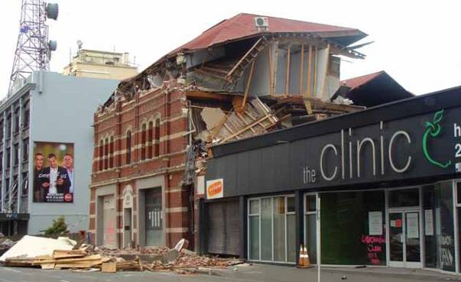

Figure 48: The building after the February earthquake

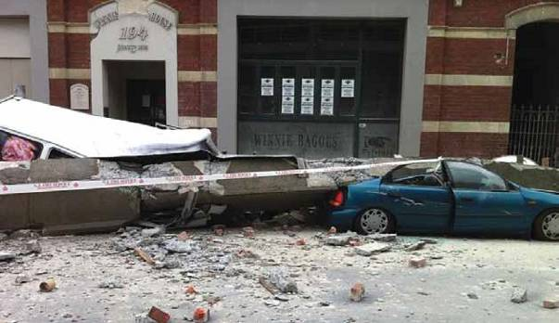

Figure 49: The front of the building after the February earthquake, showing the damaged van to the left

4.17.4 Issues

4.17.4.1 Application of the CCC’s Earthquake- Prone Dangerous and Insanitary Buildings Policy

Again, the history of this building provides an illustration of the passive approach of the CCC to earthquake- prone buildings. In this case, an engineer considered in 2002 that a proposal to convert the ground floor into a restaurant might constitute a change of use that would entail substantial earthquake strengthening. However, although there are no written records, it appears that a change to café-style dining and then to a restaurant and bar was not considered to be a change of use, presumably on the basis that there had been a kitchen in operation on the ground floor some nine years previously. This may have been a permissible application of the legislation at the time, as Mr McCarthy maintained, although there is insufficient information available to the Royal Commission about the historic use of the building for us to confirm that. Nevertheless, we are of the view that this approach was inconsistent with ensuring public safety in relation to a URM building.

4.17.4.2 Removal of the cordons in front of the building

In providing the letter of 14 February 2011, Mr Govind was clearly applying the same test that almost all engineers were applying at that time, namely a damage-based test. In fact, he did qualify his conclusions by saying that the building was potentially earthquake-prone. On the basis of the test he applied, his conclusions cannot necessarily be faulted, but we consider that relying solely on a damage-based test for determining whether it is safe to occupy a URM building after a substantial earthquake is problematic.

The CCC appears to have relied solely on Mr Govind’s letter in deciding to remove the cordons. Although there was reference to Mr Higgs, the CCC engineer who signed off the removal, there was no evidence before us to show that any independent CCC assessment had been made of the building or cordons.

There does seem to have been pressure on the CCC from a business owner in a nearby property to remove the cordon quickly. This may have had some effect on the CCC’s processes but it was clear, as Mr McCarthy said, that the CCC effectively relied on Mr Govind’s letter in arriving at its decision. The terms of the letter of 14 February did not completely comply with the CCC’s procedure for removal of a cordon, in that there was no engineer’s report stating that the building was safe to
occupy. In fact, according to Mr McCarthy, the Building
Act notice would have remained in effect because there was other, more permanent work required before reoccupation. While that omission may not have had any practical effect, it may reflect the apparent pressure on the CCC to remove the cordon quickly.

In our view, this case highlights the issues presented by lack of clear cordon management after a significant earthquake. Post-earthquake building management is discussed in Volume 7 of this Report.

4.18 194 Hereford Street

4.18.1 Introduction

The structure at 194 Hereford Street was a two storey URM building on the corner of Hereford and Liverpool Streets. Mr Gregory Tobin worked as a chef at Joe’s Garage, a café on the ground floor. He was in the kitchen at the time of the February earthquake and was seen by one of the business owners, Ms Christine Watson, running out the front door onto Hereford Street, where he was hit by falling masonry. After the earthquake, USAR searched the rubble outside the building and located Mr Tobin, who was deceased.

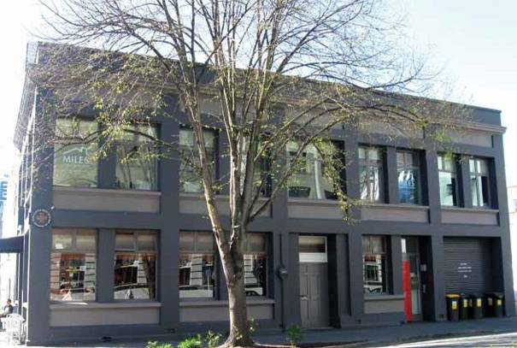
Figure 50: The western side of 194 Hereford Street (viewed from Liverpool Street) before 22 February 2011

4.18.2 The building

The building was likely to have been built in the 1930s with lime-based mortar. It was strengthened and rebuilt internally in 2005–06 under the supervision of O’Loughlin Taylor Spence Ltd, consulting engineers, when the external walls and associated foundations were the only original structural elements retained. The external walls were a combination of double, triple and cavity brick construction. The northern and western façades had reinforced concrete bond beams over the window and door openings at ground and first-floor levels. The ground floor had a new reinforced concrete slab.
Previously the external walls had been laterally strengthened in the east-to-west direction using steel portal frames, which also supported the new floors and roof. The existing parapets had been tied back to the new roof with steel channels anchored into the back of them. The perimeter walls had been tied into the timber floor diaphragms at the first and second floor.

4.18.3 Events following the September earthquake

After the September earthquake, a CCC Level 1 Rapid
Assessment recorded damage as “minor/none” and a green placard was allocated to the building. As the building had a green placard and the CCC was unaware of any damage, there was no further inspection or assessment by the CCC, including after the Boxing Day earthquake.

After the September earthquake the owners of the building arranged for an inspection by O’Loughlin Taylor Spence. Mr Rhys Smith of that firm carried out numerous inspections between September and February, and designed and oversaw remedial work to the building.

The building sustained significant structural damage in the February earthquake, including collapse of the URM parapets on the northern, western and southern elevations, collapse of the northern façade at first-floor level (including two thirds of a reinforced concrete roof- level bond beam) and collapse of the east parapet and firewall at first-floor level.

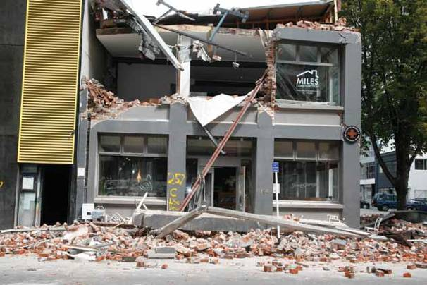
Figure 51: The northern frontage of 194 Hereford Street after the February earthquake

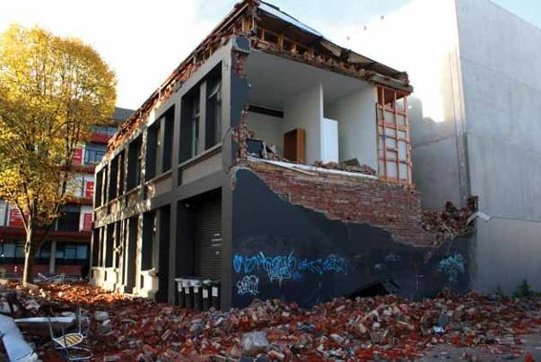
Figure 52: The western and southern walls of 194 Hereford Street after the February earthquake

Mr Peter Smith commented in his report to the Royal Commission that it was possible that workmanship may have contributed to the failure of the connection between the external walls and the strengthening works, because good workmanship was an important factor in the use of epoxy-based fixings to secure the brick walls to the structure of the building. Further, he noted that “heightened industry awareness of the importance of workmanship and temperature in the use of epoxy fixing systems is required and increased construction monitoring or proof testing for quality assurance of these fixings seems justified”.

Mr John O’Loughlin from O’Loughlin Taylor Spence gave evidence of the structural strengthening carried out and in particular commented on the issue raised by Mr Smith in relation to the epoxy fixing. In Mr O’Loughlin’s view, while the quality of workmanship was a factor, “the fact that the bricks are separating during a vertical acceleration far higher than the Code has ever allowed for means that no matter how well or poorly the connections are made they are going to fail under those circumstances”.

Mr O’Loughlin said that although he oversaw the strengthening work, he was only periodically at the site, possibly once a week. Although he observed that the epoxy fixing had been carried out by the contractor,
he said that engineers relied on the contractor to do the work correctly and it was “an observation process the engineer goes through rather than a supervision process”.

Mr Phil Wilby gave evidence that the epoxy fixing work was carried out by staff employed by New Zealand Civil and Construction Ltd, of which he was general manager and a director. Mr Wilby gave evidence that, in his opinion, the work was carried out in a workmanlike manner and in accordance with the manufacturer’s specification. He carried out an analysis of the strength of the fixing rods. In his view, due to the apparent lack of damage to the rods and the fact that they appeared to be well epoxied into the brickwork, it was the bricks and mortar themselves that had failed as they were the weakest building element. Mr Wilby conceded that on this particular contract there was no proof testing or quality-assurance checking.

Mr O’Loughlin and Mr Rhys Smith were both questioned about steel channels on the southern wall in photos taken by the latter, which showed two bolts missing. We accept from their evidence that these would not have made any difference to the structural strength of the building. However, it transpired that an inspection of the building by them after the February earthquake showed that all of the bolts in similar steel

channels on the northern side had been missing, so that the channel had effectively not been attached to the purlins. When asked what that indicated to him as an engineer, Mr Smith replied, “That whoever put that in there didn’t finish their job”. Mr O’Loughlin said that during the strengthening works he was not able to inspect the channels at the northern end of the building as the roof had already been covered at that end when he came to inspect it.

After an inspection of the building on 14 October 2010, Mr Smith had designed a bracket to address cracking of the eastern end of the northern parapet. By that date he had access to the original strengthening drawings, which indicated that brackets should have been fixed from the roof-level framing to the back of the walls to restrain them. At that stage he had not been into the roof space, but he concluded that, given the damage, either the brackets had not been fitted on the north façade, or if they had been, they were ineffective.

Mr O’Loughlin made the point that, although the northern façade collapsed and (as it transpired later) bolts were missing from that side, so too did the western wall, which appeared to have been properly secured.

After the hearing, counsel assisting the
Royal Commission wrote to Armitage Williams Construction Ltd, the contractors who had carried out the strengthening work, asking for comment on this issue. Unfortunately the company could not contact the site manager who had been responsible for the project at the time. However, Armitage Williams noted that there had been a CCC inspection of the roof space before the linings were installed. We are aware from the CCC file that there was a ceiling inspection but this appears to have focused on timber framing, ceiling lining fixings and insulation. Our understanding of the inspection regime at that time is that the CCC would have relied on the design engineer to ensure the strengthening work was installed as designed.

4.18.4 Issues

4.18.4.1 Application of the CCC’s Earthquake- Prone Dangerous and Insanitary Buildings Policy

Despite extensive strengthening works carried out in 2005–06, because of the increase in the strength threshold of an earthquake-prone building, this building would still have been potentially earthquake-prone as at September 2010.
Under the CCC’s 2006 Earthquake-Prone Dangerous and Insanitary Buildings Policy, if an owner applied for a building consent for a significant alteration (as was the case here), there was no requirement to strengthen the building if it was already more than 10% NBS. In this case, the CCC had been satisfied from the information available that the building exceeded 10% NBS.

In our view, this made a passive policy even more passive. It effectively meant that a building owner would not have to strengthen a building unless it was less than 10% of NBS (unless there was a change of use). We note that fortunately this has not been replicated in the CCC’s 2010 policy.

4.18.4.2 Efficacy of the previous structural strengthening

The previous strengthening carried out apparently prevented the collapse of the building apart from the upper levels of external walls and the parapet. Despite the violent shaking to which the building was subjected, much of the interior remained intact and apparently suffered little damage. The problem was with the attachment of the brick walls to the strengthened structure.

4.18.4.2.1 Epoxy fittings

While Mr Peter Smith raised the possibility that workmanship was a factor in the failure of the brick façades, it appears from Mr Wilby’s evidence that the standard of workmanship was unlikely to have been a factor. Nevertheless we are of the view that, consistent with Mr Smith’s opinion, more research is needed into the retrofitting of URM buildings, including the epoxy fixing of masonry walls to the structural elements of a building.

We also agree that there needs to be heightened industry awareness of the importance of workmanship and temperature in the use of such systems, and increased construction monitoring or proof testing for quality assurance.

4.18.4.2.2 Missing bolts

It is a concern that there appear to have been no bolts fixing the steel channel to the purlins on the northern end of the building. This might well have been identified during the strengthening works if the roof had not been covered over at that end of the building before Mr O’Loughlin was able to inspect it. It is unfortunate that Armitage Williams could not make contact with the person who was the site manager at the time, to enable this issue to be explored more fully. In the circumstances we cannot take this issue any further.

While we are not aware that issues of this nature are a widespread problem, they highlight the need for industry awareness and continuing education. We note Mr O’Loughlin’s comments that the western wall, though properly secured, collapsed in the February earthquake.

4.18.4.3 Vertical accelerations

Mr Smith noted that the vertical accelerations in the February earthquake would have significantly reduced the out-of-plane strength of the lime mortar URM northern and southern wall façades. He also noted that the axial load in upper-floor URM walls was relatively low, so these walls were more susceptible to vertical acceleration effects under out-of-plane failure. Mr O’Loughlin agreed with this.

We agree with Mr Smith’s suggestion that, in the interests of public safety, more consideration should be given to the effects of vertical acceleration on the upper storeys of URM buildings. This is an issue that the Ministry of Building, Innovation and Employment and the New Zealand Society for Earthquake Engineering should consider.

4.19 246 High Street

4.19.1 Introduction

The building at 246 High Street was a three storey URM building. Immediately to the north was 248 High Street, which was known as the Link Centre and ran through diagonally to 152 Hereford Street.

Mr Joseph Pohio, who had been a member of USAR
for 23 years, was in the Link Centre at the time of the February earthquake. As he bent over to help a woman on the ground about five metres inside the High Street entrance, the north wall of the building collapsed through the roof and he was struck by rubble. He was dragged clear by members of the public and CPR was performed but he could not be revived and died at the scene. On 22 February 2012 Mr Pohio was posthumously awarded a Christchurch Earthquake Award for heroism for going to the aid of the woman in the Link Centre.

4.19.2 The building

4.19.2.1 The Link Centre

The Link Centre was a modern building comprising
a concrete column-and-wall main tower on Hereford
Street, linked to High Street by a two-level concrete
floor-and-column structure. A large void in the first-floor level allowed light from roof-mounted lightwells into the ground-floor retail area.

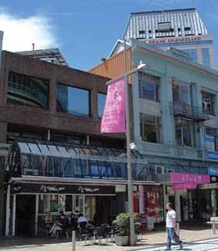

Figure 53: 246 High Street before the February earthquake, viewed from the north-west. The iron-clad mustard-coloured party wall can be seen at top centre
It appears that the Link Centre was built in about 1978 after the demolition of the building that previously occupied the site. The southern wall of the Link Centre was built abutting a brick wall that is likely to have originally been a party wall between 246 and 248 High Street. As the Link Centre was only a two storey building, the upper storey of the northern brick party wall of 246 and 248 High Street was left exposed. It was then covered in a mustard-coloured iron cladding, presumably for aesthetic and weatherproofing reasons. A building survey carried out on 246 High Street in 1975 noted that the northern and southern walls “may be party walls for adjacent buildings”.

4.19.2.2 246 High Street

A CCC seismic risk building survey in 1975 gave the building a score of 15, which resulted in a classification of A, meaning that immediate remedial action under section 301A of the Municipal Corporations Act was recommended.

A letter from the CCC to the owner of the building in
1976 noted that the building would not comply with the provisions of that section (i.e., it would not have sufficient strength to resist a moderate earthquake). In particular, the CCC was concerned about the façade construction and sought advice as to the owner’s future intentions for the building. There does not appear to have been any reply or follow up by the CCC.

A further CCC seismic risk building survey in January
1990 gave the building a score of 14, which resulted in a classification of B, meaning that remedial action within two years was recommended. Earthquake strengthening was also required to be carried out in 1990 as a result of a building permit application by the then owner. The CCC sought to ensure that the strengthening work was completed by requiring the owner to enter into a memorandum of agreement (accompanied by a caveat on the title to the land) that appears to have treated the permit for strengthening and refurbishment work as a permit to erect a temporary building, which the owner agreed would be removed or made to comply with the CCC’s building by-laws by 31 May 2005. During strengthening it was discovered that there were steel columns in the front façade area that appeared to have been installed in about 1960. The then owner’s engineers proposed to the CCC that for this reason there could be a revised seismic strengthening scheme that took into account the existence of the steelwork. The CCC agreed to this, subject to the understanding that the occupancy of the upper floors would not be significantly increased.

The CCC noted that the question of the long-term future of the building remained to be answered but that the present intent to address the problem was covered by the memorandum of agreement.

In 1991 the CCC conducted a hazardous appendage survey that noted five hazardous chimneys on the eastern elevation and significant cracking, although no cracking was visible on the street façade.

On 19 March 2003 the CCC, “in recognition of the substantial strengthening work already completed to the ground floor”, extended the period allowed in the memorandum of agreement for completion of the strengthening work to 31 May 2008. That concession was conditional on the building not undergoing any change of use or significant alterations before that date.

In 2006 the solicitor for a prospective purchaser of the building asked the CCC whether there was still a requirement for strengthening work to be done on the building by 31 May 2008. The CCC replied in August 2006 that it was currently reviewing its policy on earthquake-prone buildings, with the long-term aim of progressively issuing notices requiring structural improvement, and that high-risk buildings were first in line. In the meantime the policy was the same as it had been previously, with buildings being addressed when a building consent application was received.
The CCC advised that generally buildings with a caveat on the title were those in the worst risk category (A), which would mean it was likely that improvement would be required as part of any building consent application. The CCC also noted that the likely requirement for this building was a structural report and that improvement work would probably be required with any future building consent applications. If no such applications were made, it was likely that the owner would be put on notice to carry out improvements within 10–15 years.

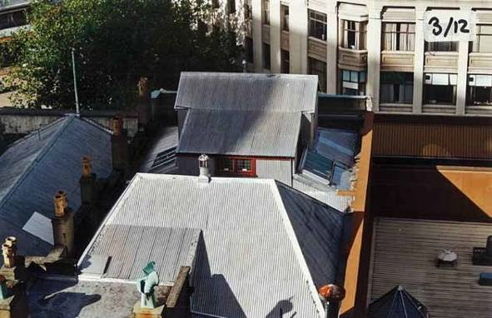

Figure 54: The roof of 246 High Street. The top of the mustard-coloured party wall can be seen on the right

4.19.3 Events following the September earthquake

It appears that after the September earthquake the building was allocated a green placard following a Level 1 Rapid Assessment.

Mr Christopher Chapman, of Grenadier Real Estate Ltd, trading as NAI (Harcourts), managed the building for its owners, Shugborough Properties Ltd. Harcourts arranged for Holmes Consulting Group Ltd (HCG) to carry out an assessment of the building. A Level 2 Rapid Assessment was conducted by HCG on 10 September 2010. That inspection noted damage to the parapet and chimneys on the south-eastern side and changed the existing green placard to yellow.
The CCC was advised.

After a further inspection by Mr Alistair Boys of HCG on
15 September 2010, it was recommended that all loose masonry be removed from the chimney and parapets and that a temporary restraint detail for the parapet on the south-western corner of the building be provided. Mr Boys inspected the northern parapet, which did not show any evidence of damage. In evidence Mr Boys said that he was not able to view the masonry of the top of the north wall/parapet owing to the cladding and capping. He did have a limited view of the portion of the inside of the wall that was visible from the roof area, but was unable to see the exterior of the northern wall as it

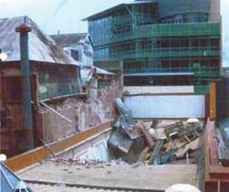

Figure 55: The roof of the Link Centre after the
February earthquake, with 246 High Street on the left
was covered in metal cladding. Mr Boys carried out an interior inspection but this was limited to the accessible areas and he could not be certain that he had looked at the interior of the northern wall. However, in the areas of the building that he did see, he did not observe any evidence of structural separation of the walls.

Mr Boys conducted a further site inspection on
21 September when make-safe work had been completed. He completed a Level 2 Rapid Assessment form, assigning a green placard to the building.

A CCC Level 1 Rapid Assessment carried out on
26 December 2010 after the Boxing Day earthquake recorded damage as “minor/none” and assigned the building a green placard. However, a Level 2 Rapid Assessment or detailed engineering evaluation and structural inspection was recommended, with a note to “check rear walls given age”. The CCC did not follow up this recommendation. Harcourts did not arrange for any further inspection to be carried out after the Boxing Day earthquake, but Mr Chapman said they relied on the CCC’s inspections.

The building was severely damaged in the February
2011 earthquake. In particular, the northern wall collapsed down to first-floor level, and rubble and building material collapsed onto the roof of the adjacent Link Centre atrium and into the area used by pedestrians.

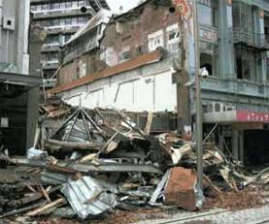

Figure 56: 246 High Street after the February earthquake

At the hearing, Mr Peter Smith, who prepared an independent report for the Royal Commission, raised a significant issue in relation to the northern wall of the building. By referring to a 1978 foundation plan for the Link Centre and a photograph, he was able to explain that the northern brick wall of 246 appeared to have been a party wall shared with the building that formerly occupied the Link Centre site before the Link Centre development. When that former building was demolished and the northern wall of 246 left exposed, the southern block wall of the Link Centre was built 25mm from the party wall. The portion of the third storey of the party wall that was exposed (the Link Centre being only two storeys) must subsequently have been covered in metal cladding to provide weatherproofing.

Mr Smith said the concern was that once the adjoining building had been demolished, the masonry party wall no longer had the adjoining building for support and had only the connections to the building at 246 to restrain it. Many URM buildings had an ineffective restraint at floor level, rendering their walls potentially dangerous. Here the wall had failed above the first-floor level.

A further feature of concern that became apparent after the failure of the building was that the rear portion of the northern wall appeared to cover a corrugated iron portion, raising doubts about any significant fixing at roof level.

Mr Smith expressed the view that consideration needed to be given to the potential danger to public safety from such walls after the demolition of an adjoining property.

4.19.4 Issues

4.19.4.1 Application of the CCC’s Earthquake- Prone Dangerous and Insanitary Buildings Policy

As early as 1975 the building had been identified as not having sufficient strength to resist a moderate earthquake. However, nothing was done until 1990 when the then owner applied for a building permit. Even at this point the owner was able to minimise the structural strengthening carried out, by revising occupancy requirements and relying on the steel columns that appeared to have been installed in 1960. Apparently the longer-term future of the building was still unresolved but the CCC sought to enforce future upgrading by the terms of a memorandum of agreement and caveat. Just how that agreement was ever going to be effective escapes us, as it did counsel for the CCC, Mr Laing. We suspect that such a mechanism would not be used again in the future.
4.19.4.2 Assessment of the building after the
September earthquake

We endorse the views of Mr Smith in relation to the matter of a party wall exposed by demolition of an adjacent building. Mr Boys was not asked to comment on whether, in inspecting the building following the September earthquake, he gave consideration to the issue of the party wall that had been exposed by the demolition of the adjoining building.

However, a difficulty with the damage-based assessment of this building was that the northern wall/parapet was to a large extent obscured by exterior cladding/capping and interior wall linings. Mr Boys accepted in evidence that there could have been obscured damage, but he considered that, from the lack of evidence of damage to other representative areas of the building that he was able to view, it was unlikely that an invasive inspection would have yielded more information. While that might have been the case, it highlights the problems with the inspection of URM buildings using a damage-based assessment after a substantial earthquake.

The Royal Commission considers that when granting permission to demolish a structure it should be normal practice to consider the safety of remaining portions. Further, conditions attached to a building consent for a new building should include a requirement to replace the support that the former building provided to the party wall.

In this case it appears likely that 246 and 248 had a common party wall that subsequently collapsed onto 248. An error of omission occurred when the support previously offered by the former 248 building was not replaced when the Link Centre was built. The loss of support to a party wall when a portion of a row building is demolished is discussed in section 7 of this Volume.

4.20 43 Lichfield Street

4.20.1 Introduction

The building at 43 Lichfield Street (known as the Anderson building) was part of a complex of four buildings owned by the retail company, J. Ballantyne & Co. Ltd (Ballantynes). There were three rows of precast concrete spandrel panels above the Lichfield Street frontage, some of which fell from the building in the February earthquake.

Ms Linda Arnold was sitting in her motor vehicle
near 43 Lichfield Street when the earthquake struck. One of the spandrel panels crushed the car, killing her.

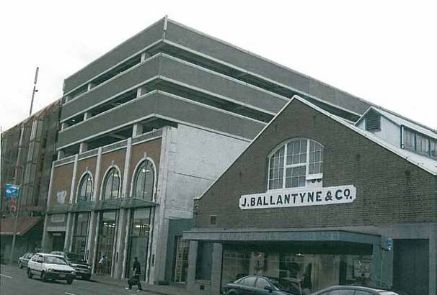

Figure 57: The southern frontage of the building at 43 Lichfield Street is shown at left in this photograph. The three rows of precast concrete façade panels can be seen above the frontage and along the eastern side of the building

4.20.2 The building

The building at 43 Lichfield Street was a seven-level ductile frame building with precast, prestressed floors supported on transverse frames with seismic beams. The building comprised two levels of retail space above ground and a further four levels of parking above (numbered in levels higher than seven in sequence with the neighbouring car park building). There was also one basement level below ground. Three rows of precast
concrete spandrel panels were attached to the upper three levels of the southern and eastern sides of the building.

The head contractor for the construction of the building was C.S. Luney Ltd (Luneys). It engaged LSC Consulting Ltd (LSC Consulting) as structural engineers for the project. Mr Dick Cusiel, a structural engineer and director of LSC Consulting, oversaw the design of the structural elements of the building, including the spandrel panels.

The building plans set out the mechanism of attachment of the spandrel panels to the eastern and southern sides of the building. However, there was a difference between the design of the spandrels panels on each side. On the eastern side, the plans provided for L-shaped steel cast-in ties. These were to be cast into the precast spandrel panels and run into the concrete topping on site. The floor topping was to be poured over the ties, locking the spandrel panels into the structure.

The drawings of the spandrel panels on the southern (Lichfield Street) side did not show steel cast-in ties. However, they did provide for each panel to have four steel bolts connected to weld plates on the columns of the building. Those bolts were not included in the design of the spandrel panels on the eastern side.

4.20.3 Events following the September earthquake

After the September earthquake, a CCC Level 1 Rapid Assessment of the building on 5 September noted minor damage and resulted in a green placard.

Ms Hannah Clarke, a structural engineer with Powell
Fenwick Consultants Ltd, inspected the building on 5
September and 19 November 2010, on the instructions of the owner. In evidence, she said the brief to Powell Fenwick excluded the parking areas in the building. She said that consequently her inspections did not include the spandrel panels. Ms Mary Devine, managing director of Ballantynes, agreed that Powell Fenwick was not instructed to inspect the car park. Mr Cusiel’s firm was asked to inspect this area, as it had been involved in the original design.

Ms Clarke also said in evidence that she was not asked to and did not inspect the exterior of the Anderson building fronting on to Lichfield Street. On this matter, she said that although Ballantynes did not specify
what the engineers should inspect, they relied on the engineers’ expertise as to whether the building could be reoccupied. She pointed out that Powell Fenwick carried out inspections of the exterior of at least some of Ballantynes’ buildings.

After an inspection of the parking areas of the building by a CCC officer, LSC Consulting was asked to inspect some concrete columns on each side of a ramp to level 10A. Mr Matt Cusiel of LSC Consulting carried out an inspection on 23 September 2010. In an email to Ballantynes that day, he reported that some work should be carried out but that the ramp could still be used safely. Mr Dick Cusiel conducted a “walkover” of
the building on 20 October 2010. He said in evidence that he did not note any damage to the spandrel panels during this.

Ms Clarke prepared a report to the owner dated
14 December 2010. The report noted that although there was some damage to the building, its short-term structural integrity was not affected.

Ballantynes asked LSC Consulting to advise on the repairs required to the Anderson building. Mr Dick Cusiel provided a report to Ballantynes dated 22 December 2010 setting out repair procedures. He said, “We are confident the building will continue to comply with the required Building Codes”. Ballantynes proceeded to have the required repairs carried out.

Mr Dick Cusiel carried out an inspection of the Anderson building on 23 December 2010, in which he noted some cracking to a wall and a ground-floor slab. He did not consider the cracks to be significant and did not think they compromised the structural integrity of the building. After the Boxing Day earthquake the CCC carried out a further Level 1 Rapid Assessment. Again this noted minor damage and resulted in a green placard.

At the request of Ballantynes, Mr Dick Cusiel carried out further inspections of the Anderson building on 19 January and 2 February 2011. Once again he did not have any concerns about its structural integrity. In evidence, he said he did not carry out any inspection of the Lichfield Street exterior of the building, nor any interior inspection of potential damage to the connections between the spandrel panels and the columns on the southern side. His assessment of the building did not include an examination of the plans, as there was no damage evident.

The building suffered widespread and significant damage in the February earthquake, indicating that it had been pushed close to its capacity for seismic loading. The damage included failure of transfer beams, column connection and column beam hinging, as well as shear displacement of beams and beam elongation. In addition, some of the spandrel panels on the southern side fell from the building.

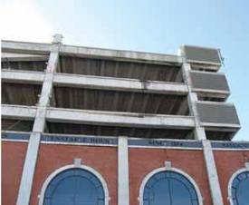

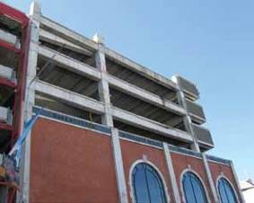Figure 58: The building after the February earthquake

In evidence, Mr Dick Cusiel candidly acknowledged that the absence of the L-shaped cast-in ties on the spandrel panels on the southern side “contributed with the significant force of the earthquake to the spandrel falling away from the structure”. He described the absence of the ties as an omission. He said that the weld plates and angle cleats “were primarily there for the purpose of construction, to put the panels in place while the floor topping was poured. They were unlikely to have been sufficient to keep the panels in place in the event of a major earthquake”.

Mr Dick Cusiel explained that although a draughtsman
in his office had drawn the plans, he had reviewed them prior to their submission to the CCC for consent and he took responsibility for the omission.
In a report to the Royal Commission, Mr Peter Smith said that the spandrel panel fixings for the southern side of the building did not comply with the Building Code that was current at the time. In evidence, Mr Dick Cusiel agreed with this. Mr Smith also said that, as the connections were significantly under strength and the earthquake shaking was in excess of the building code design requirements, failure of the spandrel panels was almost inevitable. Mr Cusiel also agreed with this.

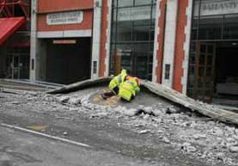

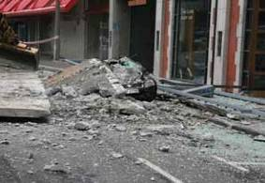Figure 59: A spandrel panel on Ms Arnold’s car (left), and the site after removal of the spandrel panel

4.20.4 Issues

4.20.4.1 Non-compliance with Code

Mr Smith identified that the connections of the spandrels on the southern side of the building did not comply with the Building Code and were significantly under strength. Mr Smith said that failure was almost inevitable in an earthquake as strong as that experienced on 22 February 2011. We note however that, although two of the three large spandrel panels on the southern side fell, one remained attached, notwithstanding the inadequacy of the connections.

As Mr Dick Cusiel acknowledged, the absence of
cast-in ties to the spandrel panels in this section of the building contributed to their falling.

4.20.4.2 Identification of non-compliance by the local authority

Mr Stephen McCarthy from the CCC gave evidence that the CCC agreed with Mr Smith that the spandrel panel fixings as detailed in the drawings did not comply with the Building Code current at the time. He gave evidence that, before issuing the building consent for the work, the CCC received a design features report and a producer statement. There would have been inspections as the work progressed, and once the project was complete, the CCC required a construction review producer statement.

Counsel for Mr Dick Cusiel cross-examined Mr McCarthy about the fact that the CCC had issued a building consent for drawings that it now accepted did not comply with the applicable Building Code. Asked whether he agreed that the engineers in the CCC’s consenting team did not identify the absence of tie-ins for the southern spandrel panels, Mr McCarthy said, “We certainly would have liked to have picked that up. It wasn’t obvious to our engineers, otherwise they would have picked it up”.

Mr McCarthy agreed that “the second line of the
checks at the CCC end effectively failed”. He explained this by saying that, with very competent engineers such as Mr Dick Cusiel, “the level of checking will vary according to the risk profile of the job”. When asked what could happen to avoid a repeat of this type of problem, Mr McCarthy replied, “We will put more emphasis on receiving a second tier of engineering review.”
4.20.4.3 Identification of non-compliance by contractor

At the request of counsel assisting the
Royal Commission, Luneys arranged for an affidavit to be provided by Mr Jay Anderson, the foreman on the site at the time the Anderson building was constructed.

Mr Anderson said that he had a set of plans on site at the time of construction. He said he noticed that the plans had different detailing for connection on the eastern side than those for the southern side. When the spandrel panels were delivered to the site he also noted that there was a difference between them. Mr Anderson said that he regarded the plans as being detailed and clear and they left no doubt as to the method of fixing. As the plans were so clear, he saw no reason to question them. When he saw the spandrel panels he also saw no reason to question the different fixings because they had been manufactured in accordance with the plans.

In his submission to the Royal Commission after the hearing, counsel for Mr Dick Cusiel submitted that Luneys should have identified the potential deficiency in the plans and raised it at the time. On this issue, Mr Smith gave evidence that, although he agreed the form of connection used on the south was a common method of construction, “I would have hoped that an experienced contractor would have looked at the 10 metre-long panel in particular and questioned whether there wasn’t some further fixing required”.

We would like to think that an experienced contractor (and an experienced CCC inspector) would have identified the problem with the spandrel panels on the southern side. However, we accept the evidence that considerable reliance was placed on Mr Dick Cusiel’s undoubted experience.

This highlights issues that can arise from reliance on one engineer’s structural designs during the consent process. We address this in Volume 7 of this Report.

4.21 116 Lichfield Street

4.21.1 Introduction

When the February earthquake struck,
Ms Kelsey Moore was carrying her five-week-old daughter, Teneysha Prattley, as she walked with her partner, Glenn Prattley, along Manchester Street outside the Reuben Blades Hair Academy at 116 Lichfield Street. The building was on the corner of Lichfield and Manchester Streets. The Manchester Street façade of the building collapsed in the earthquake and Ms Moore and her daughter were trapped under rubble. Their bodies were found by USAR on 26 February 2011.

Mr Owen McKenna was in his car, the middle one of three vehicles stationary at the traffic lights in the northbound lane of Manchester Street at the intersection with Lichfield Street. When the earthquake struck, a large amount of building debris fell from 116 Lichfield Street onto the three cars, trapping the occupants. Rescuers removed rubble and found the deceased Mr McKenna in the driver’s seat of his vehicle. Mrs Lisa Willems was also in her car at the time of the earthquake, the third of the three vehicles referred to above. She was rescued and carried across the road but did not respond to first aid and died at the scene.
4.21.2 The building

The building at 116 Lichfield Street was a three storey URM building on the south-western corner of Lichfield and Manchester Streets. It was adjacent to URM buildings on either side. The building was listed as a heritage building in the CCC District Plan.

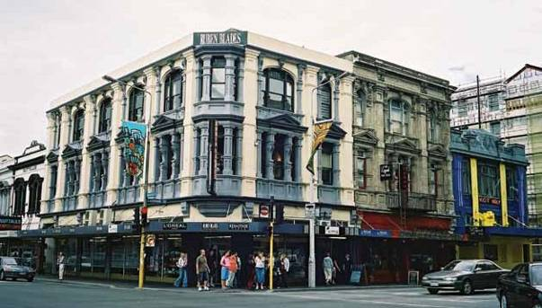

Figure 60: 116 Lichfield Street before the September earthquake

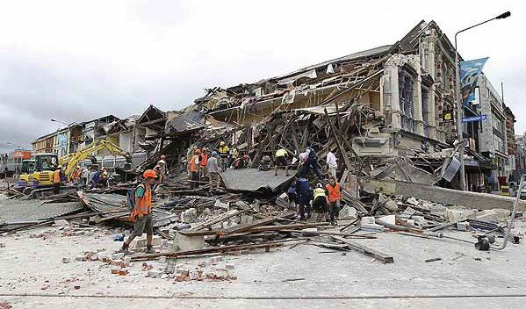

Figure 61: 116 Lichfield Street after the February earthquake

A CCC seismic risk buildings survey in December 1991 gave the building a score of 15, which resulted in a classification of A, meaning that immediate remedial action was recommended. However, no remedial work was carried out. Mr Stephen McCarthy of the CCC explained in evidence that in his view the reason for this was that the Building Act 1991 changed the test the CCC was required to satisfy to require strengthening. This meant that a full assessment was necessary before the CCC could require owners to strengthen buildings. He said this was not possible, given the number of buildings in Christchurch. For this reason, notification was placed on the CCC’s property record for future owners that strengthening would be likely to be required at some stage in the future. In fact, as discussed in section 4.2 of this Volume, the CCC’s ability to require strengthening under the Building Act 1991 would have been dependent on there being a change in the use of the building.

Mr Eelco Wiersma, a representative of the trust that owned the building, gave evidence that he was not aware of any structural strengthening having been carried out in the past. He was also unaware of the CCC’s policy in relation to earthquake-prone buildings. As was the case with many other building owners, Mr Wiersma did not know the structural strength of the building.
4.21.3 Events following the September earthquake

A CCC Level 1 Rapid Assessment on 7 September
2010 resulted in the building being allocated a green placard.

On 20 September 2010 the building was inspected by Mr R.D. Sullivan, structural engineer, on behalf of the owner. Mr Sullivan found that the parapets around an internal central area of the roof had been damaged. He recommended repair work.

Mr Wiersma was then contacted by Mr Sean Gardiner,
a structural engineer then with Structex Metro Ltd, who was carrying out some repairs on the adjacent building at 114 Lichfield Street. Mr Gardiner suggested that he could repair 116 Lichfield Street at the same time. From that point on Mr Gardiner took over the assessment of the building at 116 Lichfield Street on behalf of the owner and insurer. On 7 December 2010 he completed an earthquake damage assessment and concluded that the building had suffered moderate damage. His view was that the parapets around the internal central area remained a fall hazard to the area below, but that there were no apparent structural hazards in the rest of the building. In relation to the building’s strength, he concluded that it was possibly earthquake-prone (i.e., it had a strength of less than 33% of current requirements for new buildings, or ‘NBS’) and that if requested, a detailed engineering strength assessment

could be completed. Mr Wiersma gave evidence that although he was made aware of this and knew that work would have to be carried out to improve the strength of the building, he was waiting until the CCC required that work to be completed.

After the Boxing Day earthquake a Level 1 Rapid Assessment of 110–116 Lichfield Street was completed by the CCC on 27 December 2010. This noted minor damage, including rear parapet wall damage to 110 Lichfield Street. Although the green placard was maintained, the inspector recommended a Level 2 or detailed structural engineering evaluation. A USAR report of the same date noted severe damage to the parapet of 114 Lichfield Street, which required a cordon into the street. This assessment resulted in a cordon being erected outside the frontages of 112, 114 and 116 Lichfield Street. It appears that the cordon was to protect pedestrians from potential parapet fall hazards from 112 and 114 Lichfield Street.

On 29 December 2010 the CCC served a notice
under section 124 of the Building Act on the owner of the building. This noted structural defects including damage to the parapets and gave the owner until 31 January 2011 to complete make-safe work.

Mr Gardiner went to 112–114 Lichfield Street on Boxing Day as there had been a partial collapse of the western wall onto the neighbouring building at 110 Lichfield Street. He viewed the buildings at 110–116 Lichfield Street, inspecting the central stair area and the northern and southern sections of the roof of 116 Lichfield Street from the adjacent roof. He observed further damage to the stair area parapets. Mr Gardiner’s evidence was that the principal damage to 116 Lichfield Street, to which he presumed the Building Act notice referred, was in the fire escape area. After discussing the matter with Mr Gardiner, Mr Wiersma sought an extension from the CCC of the time to complete the works to 31 May 2011.

On 18 January 2011 Mr Gardiner prepared an engineer’s instruction relating to 112–114 Lichfield Street and 116 Lichfield Street. The instruction primarily related to 112–114 Lichfield Street but some of the works affected the parapets around the fire escape shared with 116 Lichfield Street.

On 21 January 2011 Mr Gardiner again inspected
116 Lichfield Street. This was a visual inspection of the exterior (excluding the roof) and the interior. Mr Gardiner’s evidence was that he had been on the roof on Boxing Day and had not noted any change to the condition of the roof compared to Mr Sullivan’s assessment and his own assessment after the
September earthquake. He also inspected the underside of the roof in the areas where there was no ceiling, and lifted ceiling tiles in selected areas.

Mr Gardiner’s observations from that inspection were contained in a report dated 26 January 2011. In his opinion, while there were changes to the internal courtyard parapets, cracking within the building was relatively minor throughout the primary walls and had not significantly reduced the seismic capacity of the building. The walls around the fire escape remained a hazard to the area below and he therefore advised that the fire escape should not be used. There were also areas of loose bricks in the perimeter of the level 2 ceiling and for that reason he advised that level 2 should not be used.

Mr Gardiner noted in the report that there were no apparent structural hazards in the remaining areas of the building. In relation to level 2 he noted, “the crack at the SE corner of the building has increased in size and inspection above the ceiling has revealed the crack extends up towards the parapet. The crack also extends down through L1” and “the eastern façade may have moved away from the L2 ceiling and floor slightly (up to 10mm?) in the middle of the building”.

In evidence, Mr Gardiner said that, having regard to the construction of the building, he did not consider this was a significant concern and that it did not significantly affect “the global structural stability of the building as the physical offsets were minor”. Further, he said that:

…when completing a detailed assessment to determine the face load capacity of the wall one would generally not consider the benefit the connection to the return wall would provide, in that it is limited by the capacity remote from the return walls. This section of the wall was no worse than other sections of the wall along Manchester Street, without return walls.

He remained of the view that no cordon was required on the Manchester Street side of the building. Mr Gardiner stated in his report of 26 January that it was not a detailed structural strength assessment, and suggested that such an assessment be undertaken to progress the reinstatement of the building. However, he was not instructed to proceed with that.

On 2 February 2011 Mr Gardiner signed off repair works that had been completed to the parapet at 112–114 Lichfield Street and confirmed that the CCC could remove the cordon on the Lichfield Street frontage.

The next day, on 3 February, Glen McConnell, who was then working for Fortis (the contractors who were engaged to complete the repair work) sent an email to Mr Gardiner advising:

On inspection of 116 it should have a cordon on Manchester Street. The parapet and corbel are dislodged, the south-east corner on Manchester Street is fractured from the floor to ceiling in multiple case [sic] on the top floor. The parapet over the south wall is cracked, broken and dislodged. This would fall on the building next door from two storeys above.

In a written reply to an information request from counsel assisting the Royal Commission, Mr McConnell said that he considered the building was “in imminent danger of collapse in any significant seismic event”. However, it became clear at the hearing that this was not the case and the danger Mr McConnell anticipated was partial collapse of bricks, parapets or walls.

On 4 February Mr Gardiner conducted a further site inspection to consider the matters Mr McConnell had raised in his email. He inspected the crack in the south- eastern corner of the building. He said in evidence that he did not consider there had been any significant movement since his last inspection and that he did not think it was a structural concern. He did identify high-level bricks along the southern wall as potential fall hazards, and a loose corbel stone on the Manchester Street side. He considered that the strength of these elements had not been significantly compromised but that they were a risk and should be secured or cordoned off.

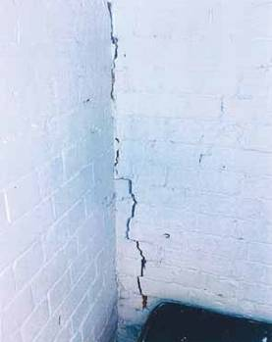

Figure 62: Cracking of the interior wall of the south- eastern corner on level two of the building

Mr Gardiner completed an engineer’s instruction form dated 4 February 2011 on which he recorded the damage he had observed. He noted, “These high-level bricks and stone blocks are potential fall hazards to areas directly adjacent and should be secured as soon as possible, (or the fall areas cordoned off)”. He emailed a copy of that engineer’s instruction to Mr John Barry, the CCC case manager for the building. After referring to the section 124 notice that had been served on the owner and the fact that his firm was involved in the assessment and securing work, Mr Gardiner said in that email, “I have also attached our latest report and securing work proposal (which is in the process of getting insurance authorization to proceed)”.

In evidence, Mr Gardiner said that in the days that followed he was liaising with the building insurer’s loss adjustor in an attempt to obtain authorisation for the securing work. He said that he had not received final authorisation for that work as of 22 February.

On 16 February 2011 Mr Gardiner attended a meeting at the building with a representative of the loss adjustor. In evidence he confirmed that he was aware that there was no cordon on the Manchester Street frontage at that time. Mr Gardiner said that after he had given the instruction of 4 February 2011, he did not subsequently follow up the matter of a cordon with the CCC, as he expected that the CCC would attend to it.

He also thought that the securing works could be completed imminently. In any event, Mr Gardiner said that, if erected, the cordon he had recommended on the Manchester Street side of the building would not have protected against the total failure of the buildingthat occurred in the February earthquake, as the cordon would only have given protection from potential fall hazards on the footpath.

Mr Gardiner was questioned at some length by various
4.21.4 Issues

4.21.4.1 Application of the CCC’s Earthquake- Prone Dangerous and Insanitary Buildings Policy

We do not know whether strengthening of the building, had it been carried out before 4 September 2010, would have prevented its collapse in the February earthquake. However, as Associate Professor Jason

counsel and Commissioner Fenwick in relation to
Ingham’s reports7
to the Royal Commission showed,

the crack in the south-eastern corner of the building. Despite the size and extent of the crack and the fact that, as he accepted, the only viable load transfer mechanism would have been the friction of the bricks (which would have decreased higher up the building), he maintained that it did not lead him to conclude that the Manchester Street façade might be compromised.

He agreed that the maximum width of the crack in the wall was of the order of 15mm decreasing to about half this width at the floor level. He agreed that with this level of movement between the floor and wall, the only viable tie force was friction between the wall and the floor beams in the timber floor. He still maintained that it did not lead him to conclude that the Manchester Street façade might be compromised.

Mr Paul Campbell, a structural engineer on secondment to the CCC from Opus, carried out an engineer’s re-inspection of the building. The exact date of the re-inspection is unclear as the form was undated, but it would appear to have been a day or two before Mr Gardiner’s sign-off of the Lichfield Street cordon.

Mr Campbell said, by reference to his re-inspection form, that it appeared he was there to check on the securing works on 112–114 Lichfield Street. As appears to have been the case with all such re-inspections, it was a brief external inspection.

Mr Campbell was asked by Commissioner Fenwick
for his views on the crack to the south-eastern corner of the building. Mr Campbell’s opinion was that the cracking was evidence (at least on the face of it) that the wall had moved out towards Manchester Street and he would have wanted to do a more detailed examination to confirm whether that was the case.

Mr Peter Smith, who prepared an independent report on the building for the Royal Commission, said that the failure of the building in the February earthquake was caused by an outward rotation of the Manchester Street façade.
any significant strengthening gives a building a better
chance of withstanding an earthquake.

This highlights the problem inherent in a passive approach by a territorial authority to earthquake-prone buildings, particularly where a building owner is not inclined to carry out any strengthening without being required to do so by the territorial authority.

4.21.4.2 Assessment of the building after the
September earthquake

4.21.4.2.1 Mr Gardiner’s assessment of the building as at 4 February 2011
In common with most engineers, Mr Gardiner’s assessment was damage-based. He assessed the crack in the south-eastern corner of the building. He did not consider that the nature of the damage seen meant that the building was structurally compromised or in danger of collapse. However, we think that the damage he observed should have led him to investigate the building’s structural stability more fully. Mr Campbell expressed the opinion that the presence of the crack should have led to further investigation, in particular the removal of linings to examine the state of connections between the façade and return walls. Depending on the result of that further investigation, the conclusion might have been reached that the Manchester Street façade had been compromised and that a cordon, extensive enough to take into account the potential for total collapse of the façade, should be erected on the Manchester Street frontage. However, we must also accept such a conclusion may not have been reached.

The Royal Commission has heard on a number of occasions from Mr Smith and other structural engineers of the need for URM buildings to be inspected by skilled structural engineers with relevant expertise. This building highlights this matter. We address this issue in sections 6 and 7 of this Volume, and in Volume 7.

4.21.4.2.2 Communication of the need for a cordon

Even though the cordon contemplated by Mr Gardiner would not have provided protection from the potential collapse of the façade onto the street, no cordon was established at all. It appears that despite Mr McCarthy accepting that the engineer’s instruction conveyed the potential need for a cordon, the CCC took no action to follow this up. As Mr McCarthy said, had this been properly followed up it would have involved an inspection by an engineer and an assessment of the cordon required. It may be that it would have assisted if Mr Gardiner had drawn attention to the issue, rather than simply mentioning it in the attachment to his email of 9 February. If an inspection of the type suggested by Mr Campbell had been carried out, it may have resulted in the identification of a risk of the collapse of the façade and establishment of a cordon onto Manchester Street, perhaps resulting in the closure of the street.

We note that Mr McCarthy gave an absolute assurance that the lack of a cordon across Manchester Street was not brought about by any desire on the CCC’s part to get the city back to business as usual by keeping Manchester Street open.

4.21.4.2.3 Failure to follow up erection of a cordon

Although Mr Gardiner said he had given an instruction and expected it to be acted upon, he did not follow up the matter of the cordon, even after his visit to the building on 16 February when it was obvious that the cordon he had recommended was not in place. Since he had identified the risk to the public on 4 February, we are of the view that it would have been preferable for him to have contacted the CCC on 16 February to follow this up. We also accept that the cordon he envisaged, which was to protect against failure of the parapet corbel and not against failure of the whole Manchester Street façade, would not have prevented these four deaths.

4.22 200–204 Manchester Street

4.22.1 Introduction

The building at 200–204 Manchester Street was a two storey URM structure on the south-eastern side of the intersection of Manchester and Gloucester Streets. The building housed a business called the Iconic Bar.

A one storey building was adjacent, to the east. There were openings between the two buildings so that they could be used as one.

Ms Amy Cooney gave evidence that her brother, Mr Jaime Gilbert, was working as a barman at the Iconic Bar on 22 February 2011. He had only been in that job some two weeks and she was also working there that day in her role as assistant to the manager. She said that when the earthquake struck they both ran from the building but were hit by falling masonry blocks. Both were covered in rubble as they lay on the footpath outside the building. Rescuers uncovered Ms Cooney and then Mr Gilbert. He was severely injured and was taken to Christchurch Hospital in a van. CPR was performed on him en route but a short time after arrival he was pronounced dead.

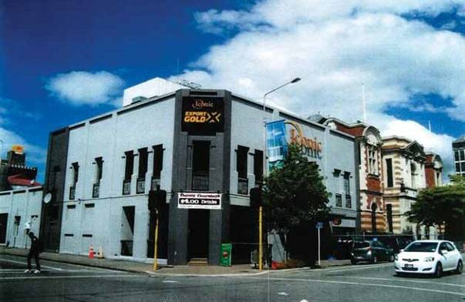

Figure 63: The building at the corner of 200–204 Manchester Street before the February earthquake

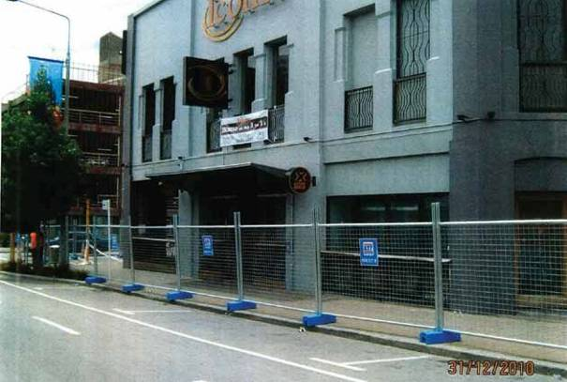

Figure 64: The western side of 200–204 Manchester Street after the Boxing Day earthquake

4.22.2 The building

The two storey URM building had a plaster finish
and walls that were about 400mm thick. It had timber ground and first floors and a lightweight corrugated roof with timber sarking. The bottom cords of the trusses were scarfed onto the brick walls. Structural strengthening had been carried out in 1993 by Holmes Consulting Group (HCG) and in 2004 by Lewis & Barrow Ltd.

Mr Peter Smith carried out an independent assessment of the earthquake performance of the building for the Royal Commission. He gave evidence that, although the strengthening work in 1993 was designed to 67% of the then applicable requirements for new buildings, because of subsequent increases in building requirements, the building would have been about 56% of current building standards at the time of the September earthquake.

The Royal Commission heard evidence from
Mr Warren Lewis of Lewis & Barrow that the 2004 strengthening work did not materially add to the building’s strength.

Mr Stephen McCarthy, from the CCC, gave evidence that because of the previous strengthening work, the building was not considered to be earthquake-prone
in terms of the CCC’s Earthquake-Prone Dangerous and Insanitary Buildings Policy when the policy was introduced in 2006.

4.22.3 Events following the September earthquake

The day after the 4 September 2010 earthquake a CCC Level 1 Rapid Assessment was carried out, resulting in a green placard being assigned to the building. That green placard was confirmed by another Level 1 Rapid Assessment carried out by HCG on behalf of the owners on 8 September 2010.

A further Level 1 Rapid Assessment by the CCC on 10
September 2010 noted cracking in a parapet. The building was again allocated a green placard. That assessment also recommended a Level 2 Rapid Assessment. Mr McCarthy referred to a notation on the form that appeared to relate to an interior inspection, although it was unclear. However, he conceded that the CCC records did not show that any Level 2 assessment had been carried out. Mr McCarthy explained why this might have been the case by saying that the pressure of having to organise the many engineers and volunteers required at that time “was just overwhelming”
for the CCC.

On 22 November 2010 a proposal and plans drawn up by Lewis & Barrow to add a new structural first floor and strengthen the roof was filed with the CCC. This proposal was filed on the instructions of the Iconic Bar’s manager at the time, Mr Darryl Fraser, who was considering purchasing the business. However, CCC records show that eight days later, on 30 November 2010, the applicant requested a hold on this proposal and subsequently withdrew it. Mr Lewis gave evidence of his opinion that the structural work shown on those plans would have helped in some small way to prevent collapse in the south-eastern corner of the building but would have had minimal effect elsewhere.

On 26 December 2010 a CCC Level 2 Rapid Assessment took place after the earthquake on that day. It was noted that the eastern gable wall was badly damaged. On the second page of the assessment form it was also noted that the western wall was damaged, especially at the apex. The building was allocated a red placard. However, on receiving the briefs of evidence for the Lewis & Barrow witnesses, counsel assisting the Royal Commission made further enquiries that confirmed the reference on the second page of that form to damage to the west wall was incorrect. The only damage that had in fact been observed during that inspection was to the eastern wall.

The Rapid Assessment form recommended a detailed structural assessment. A further Level 1 Rapid Assessment the next day, on 27 December 2010, noted “stress fractures on plastered brick walls – upper areas mainly above where the roof trusses connect – parapets”. The building was again assigned a red placard. An Urban Search and Rescue ( USAR) damaged building reconnaissance report, also dated 27 December 2011, noted that an “engineering assessment” was required.

On the same day the CCC served the owner a notice under section 124 of the Building Act 2004. That notice referred to the eastern gable wall damage and, although it was based on the rapid assessment of 26 December 2010, it did not refer to damage to the western wall. Mr Gary Looker, a representative of the owner, Symphony Projects Ltd, gave evidence that although the notice appeared to have been sent to the company’s post office box, he had never received it. Mr Looker gave evidence that Mr Fraser was attending to all matters relating to the assessment and repair of the building after the September earthquake. In a written reply to questions from counsel assisting the Royal Commission, Mr Fraser advised that he did not receive a Building Act notice from the CCC and was only aware of the damage ascertained by the Council
from the red placard on the front door of the building. He instructed Lewis & Barrow in relation to that damage.

In the days that followed, Mr Christopher Gordon of Lewis & Barrow designed and oversaw make-safe work on the building. Mr Gordon gave evidence that he did not see a Building Act notice affixed to the building or to the barricade fencing. However, he did recall seeing the red placard that noted the observed damage.

Mr Gordon inspected the building on 28 December
2010 and prepared a site report detailing interim repair work required, including plywood bracing on the outside of the eastern wall. In evidence he said that such repairs would provide temporary support of the wall so the building could be reoccupied. He left the site report with Mr Fraser for him to arrange a builder to complete the work. Mr Gordon said that before designing the repair works he conducted a visual inspection of the interior and exterior of the building to see if there was any damage requiring repair other than that noted on the red placard. He did not observe any damage other than some cracking to the northern and western faces that appeared to be historic.

The next day Mr Gordon spoke by telephone to
Mr Lewis, who had had previous involvement with the building in relation to the work carried out in 2004. As a result of that discussion they decided to add further strengthening by way of vertical steel angles over the plywood bracing.

On 29 December Mr Gordon inspected the building again. The repair work he had recommended had been started. He recorded the additional details he had agreed on with Mr Lewis, in a further site report dated 29 December 2010.

The next day Mr Gordon visited the site again and saw that the work was proceeding as detailed in his site reports and that it was almost complete (he said all that remained was to affix one or two vertical steel angles to the plywood bracing). On the same day he prepared a Chartered Professional Engineer (CPEng) sign-off statement and sent it by email to the CCC, asking them to remove the red sticker from the site. He also noted that a building consent application had been made (this was a reference to the application filed by Lewis & Barrow on the instructions of Mr Fraser in November 2010) and that “an amendment to the building consent will be made in January to include the removal of the damaged area of the eastern gable end wall and reinstatement with a suitable structure”. He said in evidence that he was anticipating that the building owner or its insurer would engage Lewis & Barrow to

design a permanent repair. Mr Gordon noted in the email that he was not a CPEng but did have 16 years’ experience with Lewis & Barrow.

On the same day Mr Gordon was advised by the
CCC that the certificate had to be signed by a CPEng engineer. Mr Gordon spoke to Mr Simon Gifford, a CPEng engineer with Lewis & Barrow, who reviewed the file and discussed the damage and repair works with Mr Gordon. Mr Gifford had not had any previous involvement with the building and did not inspect it himself. Mr Gordon told Mr Gifford that, based on his inspection of the building and the repair works done, he believed the structural integrity of the building had been restored to the state it had been in prior to 4 September. Mr Gifford signed the CPEng certificate, which was dated 31 December 2010. He said it was the first time he had signed off another engineer’s work so he took the matter seriously.

Mr Gordon accepted that the CPEng certificate had been delivered to the CCC without his having inspected the completed works. However, when asked if that was “the norm”, he said it would depend on whether all the material was on site and whether the builder was thorough. He said that in this case all the steel work was on site and the builder was doing a very good job. Further, he said he had gone to the site the next day, and delivered a copy of the CPEng certificate to Mr Fraser. He had taken some photographs of the building and was able to see that all the steel works were in place.

Mr Peter Smith was asked for his view on the CPEng certificate being completed and forwarded to the CCC before Mr Gordon had inspected the completed repair work. Mr Smith was of the view that this was not appropriate and that a CPEng certificate should not have been completed without the engineer involved having ensured that all of the required work had been completed to his satisfaction. Mr Smith was also asked to comment on the appropriateness of a CPEng engineer completing a CPEng certificate when he had not been involved in the building at all, nor inspected the repair works. Mr Smith considered that this was appropriate and often acted as a quality assurance in that some engineering practices required such certificates to be signed only by a director of the practice. This view was echoed by Mr McCarthy.

The CCC relied on the CPEng certificate and removed the red placard from the building on 31 December 2010, which allowed the business to re-open for New Year’s Eve.
There was subsequent discussion by email between Mr Lewis and the loss adjuster over permanent repairs.

On 9 February 2011 Mr Mark Ryburn, an Opus International Consultants Ltd structural engineer on secondment to the CCC, carried out an inspection of the building. This was part of a series of re-inspections at the time of buildings that had received yellow or red placards.

The Engineer’s Re-inspection of Damaged Buildings form Mr Ryburn completed noted: “Recommend contacting the engineer for a confirmation of the works as lateral load capacity may not exist. Also get comments on the cracking (likely just in the paint)”. The form he completed also noted that protection fencing was required to “cover parapet on Gloucester Street”.

Mr Ryburn said in evidence that when he conducted his re-inspection on 9 February 2011 he was unaware that repairs had been completed and signed off and that the red placard had been removed by the CCC. Rather, he thought he was carrying out a re-inspection of a red- placarded building. At the building that day he spoke to a woman who it transpired was the new owner of the business (having taken possession at the beginning of February 2011). In his evidence-in-chief, Mr Ryburn said the new owner told him that an engineer’s report had been obtained as part of the sale and purchase agreement. He said he told her that this did not appear to be on the CCC file he had been given and that a formal sign-off was needed before the building could be reoccupied. He said that he told her to submit the report within seven days so it could be reviewed and processed.

In cross-examination it was put to Mr Ryburn that the new owner, Ms Leanna Christie, had written to counsel assisting the Royal Commission stating that she did not recall speaking to Mr Ryburn that day. Mr Ryburn maintained that he had spoken to her. However, he did not recall whether she specifically said an engineer’s inspection had taken place, although he understood that there had been an engineer involved. Mr Ryburn conceded that he had not recorded his requirement to have the engineer’s report forwarded to the CCC within seven days. When asked how the CCC would then have followed that matter up, he noted that he had recommended on the form that the CCC contact the engineer. He also said it was possible that he had later mentioned it to the administrator of the Building Review Office team, but he could not recall whether this was the case.

Mr Ryburn had concerns in relation to the building, as evidenced by the comments he made on the report, and he wanted these issues to be followed up with the engineer who had been involved with it. That was the purpose of his comments on the form and his request to the new owner to forward information to the CCC. Mr Ryburn said in evidence that when he returned to the CCC he probably would have separated the form from the usual process “so it didn’t just sit in the queue”, because there were people in what he had presumed to be a building with a red placard.

There appears to be some support for this in that someone (not Mr Ryburn) had placed a Post-it note on the re-inspection form and written the words: “Neville, please view and make a decision”. This was a reference to Mr Neville Higgs, an engineer working at the CCC’s Building Recovery Office at that time. Mr Ryburn had no further dealings in relation to the building, but expected the matters referred to in his form to be followed up.

Owing to a backlog of work, Mr Higgs did not deal
with the formal process for closing off the CCC’s file in relation to this building until the morning of 22 February 2011. Mr Higgs gave evidence that it was apparent from the CCC file that he had seen and checked the CPEng certificate signed by Mr Gifford. However, there
is no record on the CCC file that he saw Mr Ryburn’s re-inspection form. Further, Mr Higgs could not recall whether he saw the re-inspection form, and therefore whether he took any account of it. However, he said in evidence that if he had seen it, he believed he would still have closed the file, given the fact that there was a CPEng certificate and that Mr Ryburn’s inspection would have been “a rapid external inspection from street level” only.

Mr Higgs was able to say from inquiries he had made just before the hearing that the re-inspection form with the Post-it note on it had either been put on his desk or in his in-tray by an employee in the Building Recovery Office, but he was still not able to say whether he had seen it.

Mr Ryburn had also noted on the re-inspection form that protection fencing was required on Gloucester Street. This was not actioned either.

The building sustained substantial damage in the February earthquake. Mr Smith gave evidence that the external walls above the first-floor level of the northern and western façades fell outward onto the street. They appeared to have disintegrated under the severity of the shaking, leaving epoxy fixings projecting from the steelwork above road level.

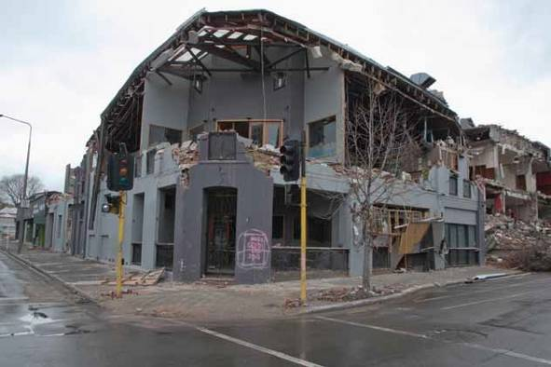

Figure 65: The north-western corner of 200–204 Manchester Street after the February earthquake

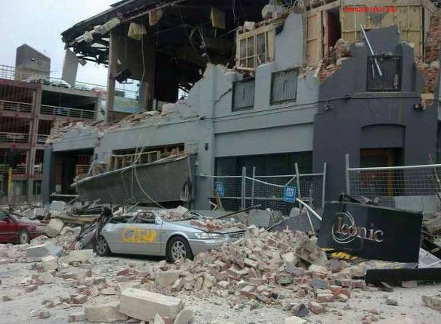
Figure 66: The western wall of 200–204 Manchester Street after the February earthquake

In his assessment of the building’s failure in the February earthquake, Mr Smith raised the possibility that workmanship in the epoxy fixing of dowels through the brick façades might have been a factor in the failure of the connection between the external walls and the strengthening works. He accepted that he could not be certain why those fixings failed, but was of the view that high vertical accelerations certainly played a large part.

Mr Lewis gave evidence that he oversaw the retrofit work completed by Contract Construction in 2004. He carried out site inspections that included random testing of the fixing of the dowels through the brick walls. Mr Mark McKenzie, a carpenter who had been employed by Contract Construction as site foreman for the works in 2004, gave evidence that the steel dowels used to fix the steel angle floor-and-truss braces to the external masonry were installed correctly and in accordance with the manufacturer’s specifications and instructions.

In relation to the similar fixings that had been installed in 1993 under the supervision of HCG, Mr Lewis said that although he had not tested any of the fixings they appeared to be in good condition. Mr McKenzie confirmed that when the work was being completed in
2004, if they had noticed anything in relation to the
1993 work they would have notified the engineer.
In a written communication to the Royal Commission, Mr Craig Lewis, a director of Lewis Bradford Ltd, consulting engineers (who in 1993 had been an engineer with HCG), said that, to the best of his knowledge and recall there were no matters of concern in relation to workmanship during the 1993 works and that he had found the work and quality processes of the contractor, Mr Luney, to be very good.

In relation to the dowels that were epoxy fixed through the bricks, Mr Warren Lewis’s evidence was that the holes for them were drilled horizontally in the 2004 strengthening work but appeared to have been at an angle in the 1993 work. In his view, whether they were drilled at an angle or horizontally should not have affected their strength, and the different method adopted in 2004 would have been related to the thickness of the epoxy.

Mr Warren Lewis did not agree with Mr Smith that there had been a general failure of the epoxy fittings. He referred to photographs that showed some brick or Oamaru stone adhering to the fixing, pointing more,

he said, to the disintegration of the wall masonry. He suggested that in the last 20 years there had been a move away from the use of a “boss” – a large washer on the outside of the masonry wall with the bolt going right through the wall.

Mr Smith gave evidence that the current thinking was that it was preferable to fix the bolts at an angle to ensure better penetration of the masonry (as opposed to the mortar joint), and therefore provide a better fixing. However, he accepted that there was debate within the industry about this issue and that it required more research. As he had also done in relation to the failure of the building at 194 Hereford Street, Mr Smith expressed the view that there needed to be heightened industry awareness of the required temperature in the use of epoxy fixing systems and increased construction monitoring and proof testing for quality assurance.

4.22.4 Issues

4.22.4.1 Application of the CCC’s Earthquake- Prone Dangerous and Insanitary Buildings Policy

The strengthening works carried out in 1993 and 2004 meant that the building was not considered earthquake- prone in terms of the CCC’s earthquake-prone buildings policy introduced in 2006. Despite that, the building (and, in particular, the northern and western upper-level walls) still failed in the February earthquake, highlighting the fact that even a building that is strengthened above the earthquake-prone threshold can still be vulnerable.

This highlights the problem with URM buildings, which despite strengthening are still inherently weak structures because of the materials used in construction (bricks and mortar) and construction methods.

4.22.4.2 Assessment of the building following the Boxing Day earthquake

This building failure highlights a problem that has been apparent in a number of cases, namely the difficulties that can arise when relying solely on a damage-based assessment to determine whether occupancy is safe.

In this case, there was a Level 1 Rapid Assessment after the September earthquake, following which the building was assigned a green placard. This was confirmed after a Level 1 Rapid Assessment by HCG on behalf of the owner on 8 September 2010. Then on 10 September 2010 there was a further Level 1 Rapid Assessment that recommended a Level 2 Rapid Assessment, which, as noted earlier, did not take place.
After the Boxing Day earthquake there was a Level 2 assessment that noted the eastern gable wall damage and recommended a detailed structural engineering evaluation. The Building Act notice procedure followed. Repair work was carried out, overseen by Mr Gordon. At that time Mr Gordon completed what appears to us to have been effectively a Level 2 assessment (a visual inspection of the interior and exterior). On the basis of that and the subsequent repair works, Mr Gifford was able to certify in the CPEng certificate that the structural integrity of the building had been returned to the state it was in before the September earthquake.

While we accept that the CPEng form is not clear about the nature of the inspection required, it could not be said that Mr Gordon’s inspection was a detailed structural engineering evaluation, as recommended in the Level 2 Rapid Assessment form dated 26 December 2010. Mr McCarthy said in evidence that the CCC’s expectation was that engineers would do a full assessment of the building (of the kind that Mr Gordon did in relation to this building) but not a detailed engineering evaluation because “that mechanism wasn’t really in place at that time”. This however, appears to be at odds with the wording of the Level 2 assessment form, which stated “Detailed engineering evaluation recommended”. It is possible that Mr McCarthy was referring to a “strength- based” assessment such as has been required by the Canterbury Earthquakes Recovery Authority since the February earthquake.

It appears that the “damage-based” level of inspection carried out by Mr Gordon was one commonly carried out by engineers who were preparing to certify remedial works. In fact, the approach is set out in the guidelines prepared by the New Zealand Society for Earthquake Engineering. This approach is problematic when applied to URM buildings after a significant earthquake, and will be addressed in Volume 7.

4.22.4.3 CPEng certificate

Clearly, a CPEng certificate should only be signed when all of the required remedial work has been completed and inspected. However, although that did not happen here, the work was completed on the same day the certificate was signed and then observed by Mr Gordon the following day.

The CPEng certificate was accepted by the CCC and the red placard removed. The Iconic Bar was open for New Year’s Eve. Mr McCarthy gave evidence that returning the city to normality was important in the final days of 2010. However, he also gave an assurance that

this did not outweigh safety considerations in relation to this building. The evidence does not justify a conclusion to the contrary.

4.22.4.4 Lack of follow-up of the problems highlighted in the engineer’s re-inspection on 9 February 2011

Mr Ryburn raised potential concerns on 9 February
2011. He expected these to be followed up by the CCC but that did not happen. The reason for this was unclear. It may have been an oversight on Mr Higgs’s part, but in our view it also reflects the pressure that the September and Boxing Day earthquakes brought to bear on the CCC systems.

Mr Higgs did comment that there was “no doubt that some mistakes were made under the pressures the earthquake events was [sic] putting on the people involved and that the systems can and will be improved”. Mr McCarthy also raised concerns as to the systems in place and about communications. In relation to Mr Higgs not seeing the Ryburn re-inspection form, he referred to it as an “overload situation”.

Mr Higgs gave evidence that even if he had considered Mr Ryburn’s form, he would still have decided to close the file. This evidence reflects the CCC’s practice of applying a damage-based assessment as the basis for allowing occupancy. Although Mr Ryburn raised concerns, the CPEng certificate that had been provided satisfied the damage-based requirement set by the CCC for occupancy.

We deal generally with the nature of engineering assessments to determine occupancy in Volume 7 of this Report.

4.22.4.5 Epoxy fixing

As we have noted in relation to the building at 194
Hereford Street, we agree with the views expressed by Mr Smith on the need for further research into epoxy fixing systems and the need for more construction monitoring or proof testing for quality assurance. How this is best achieved needs to be examined by the Ministry of Business, Innovation and Employment. It may be that the technology of 20 years ago referred to by Mr Warren Lewis requires reconsideration.

4.23 265–271 Manchester Street
(also 173 Gloucester Street)

4.23.1 Introduction

The building at 265–271 Manchester Street was a two storey unreinforced masonry (URM) structure on the corner of Manchester and Gloucester Streets. The address of the Gloucester Street frontage was 173 Gloucester Street.

When the 22 February 2011 earthquake struck,
Mr Christopher Smith was in his vehicle parked outside
269 Manchester Street, approximately in the position occupied by the car second from the right in Figure 68. The vehicle was severely damaged by rubble falling from the building. Police inquiries established that Mr Smith was rescued by the New Zealand Fire Service and taken across the road to the Orion building at 218 Manchester Street. Despite medical treatment and CPR, Mr Smith died as a result of his injuries.

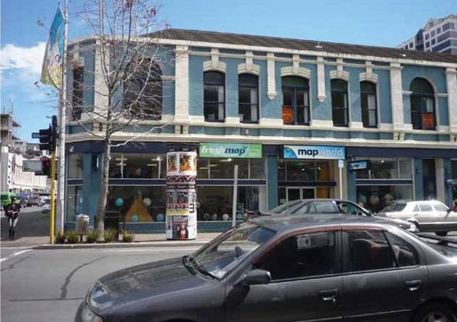

Figure 67: The south-eastern section of 265–271 Manchester Street

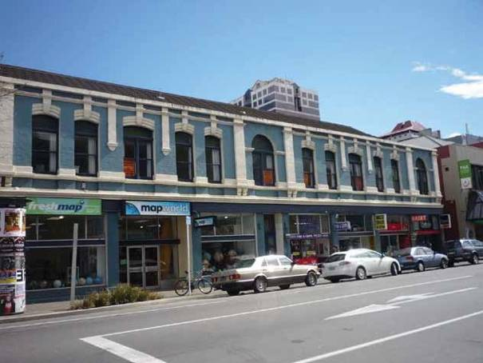

Figure 68: The Manchester Street frontage of the building

4.23.2 The building

According to a letter from the CCC in the early 1980s:

The building was secured in 1976 under two building permits, which included the removal of the street wall parapets and construction of a reinforced concrete bond beam at roof level; the attachment of the first floor and roof trusses to the load bearing walls; the introduction of one laterally placed reinforced concrete frame on the ground floor; re-roofing of the entire building.

In its current condition, the building is regarded as having been adequately secured under the terms of section 624 of the Local Government Act, to prevent sudden collapse in a moderate earthquake. It is not regarded as having been fully strengthened sufficient to preclude damage to the building in a moderate earthquake.

In his report to the Royal Commission, Mr Peter Smith stated that he could not be sure that all of the work described in the CCC letter had actually been carried out.

In 1991 a CCC seismic risk building survey gave the building a score of 13, which resulted in its being classified as B. This meant that remedial action within
two years was recommended. The survey noted that interim securing had been carried out in 1976 and that strengthening was due in 1997. Mr Stephen McCarthy of the CCC explained in evidence that this would have been a guide to the building owners that the CCC would like them to consider further strengthening 20 years after the interim strengthening. No further work was completed in 1997.

The building would have been considered earthquake- prone in terms of the CCC’s 2006 Earthquake-Prone Buildings Policy.

4.23.3 Events after the September earthquake After the September earthquake, a CCC Level 1 Rapid Assessment on 5 September recorded no noticeable damage to the building and assigned it a green placard.

Mr Monty Claxton, a trustee of the family trust that owned the building, gave evidence that the owner relied on the fact that the building had been assigned a green placard by the CCC and did not initiate any engineering inspection of the building. However, the trust did have the services of a very efficient insurance broker who,

soon after the earthquake, arranged for the building to be inspected by structural engineers employed by Opus International Consultants Ltd (Opus).

A Level 2 Rapid Assessment was completed by
Mr Mohanaraj of Opus on 14 September 2010. He noted cracking in the brick walls on the southern and eastern sides, cracking in a window lintel on the southern side and minor internal cracking. Consistent with many other inspections by engineers at the time, this did not involve inspection of connections or removal of linings. The building was assigned a green placard (G2 – occupiable, repairs required).

Mr Mohanaraj recommended:

• repair to the crack in the arch window lintel as soon as possible and repair of the other cracks;
• a check above the dairy (269 Manchester Street) for any loose bricks; and
• the provision of a support arrangement such as steel bands (to external arch lintels) to prevent sudden failure of lintel blocks.

He recommended that a structural engineer’s
assistance be obtained to check and provide appropriate crack repair details. He also recommended a support arrangement for the external arch lintels to prevent sudden failure of lintel blocks – not for the purpose of repairing damage, but to make the building more robust for the future. He recommended that the owner consult with a structural engineer about this recommendation.

It became apparent when Mr Mohanaraj gave evidence that his inspection was a damage-based assessment with a focus on any repair work required. He did not recommend any follow-up or detailed assessment but was of the view that if any such assessment was required, that would be the responsibility of the CCC or the owners. It was not within the scope of his work to recommend such an assessment.

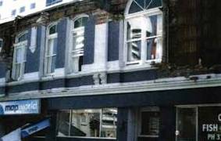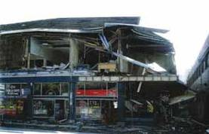

Figure 69: The building after the February earthquake
Maxim Projects Ltd (Maxim), a contractor, was engaged to carry out the repairs identified by Opus. A further assessment of the building was carried out on 20 September 2010 by Mr Roy Hamilton, a structural engineer employed by Maxim. The purpose of this was to ensure the safety of Maxim staff when completing the work. This assessment was consistent with the Opus assessment. Although the assessment by Mr Hamilton considered the safety of people in the building, it was still a damage-based assessment. As with Mr Mohanaraj’s inspection, Mr Hamilton’s inspection did not include any assessment of how the façade was connected to the floor/ceiling or how the bond beam was connected to the roof. However, Mr Hamilton did not observe any apparent separation of the façade that might have indicated a potential problem.

The works recommended by Opus were all carried out by Maxim except a support arrangement to the external arch lintels. Mr Hamilton said that Opus had been asked by Runacres, the loss adjustor, to provide a quote for that work and had assumed that Opus would be providing a design. Maxim also removed the western end portion of the parapet that had not been reduced in 1976, and a water tank in that location.

There was no inspection of the building by either the owner or the CCC following the Boxing Day earthquake.

In the February earthquake the wall on the upper floor of the Manchester Street frontage almost entirely collapsed outwards into the street, including a large section of concrete bond beam on the top of that façade. The wall to the south façade on Gloucester Street suffered less damage, although there was more damage at its western end.

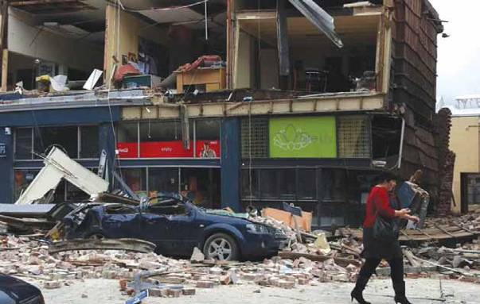

Figure 70: The area outside 269 Manchester Street after the earthquake

Mr Peter Smith expressed the view that, from his observations of the photographs taken after the February earthquake, it appeared that the façades had been very poorly secured and the concrete bond beam was effectively only restrained by gravity. It was also off centre, which would have increased the risk of its falling from its position on top of the brick façade.

4.23.2 Issues

4.23.2.1 Application of the CCC’s Earthquake- Prone Dangerous and Insanitary Buildings Policy

Although some earthquake strengthening was completed in 1976 (the extent of which is unclear), there was no follow-up strengthening as envisaged by the CCC in 1997 and the building would clearly have been earthquake-prone before the September earthquake. This building illustrates the risks inherent in a passive approach to earthquake-prone buildings.
4.23.2.2 Assessment of the building following the September earthquake

In this case the owner of the building effectively relied on the CCC’s green placard and did not consider obtaining any assessment. The owner’s insurance broker or loss adjustor did, however, arrange for what was effectively a Level 2 inspection. The brief was understandably focused on a damage assessment and necessary repair work. Therefore, there was not the level of assessment that would have examined matters such as the connections between the façades and floors/ceilings and considered the connection of the bond beam. The further inspection by Maxim was essentially of the same kind and was only to facilitate the repair work.

As we have commented in relation to the failure of other URM buildings, this case demonstrates the risk of undertaking and relying solely on a damage-based assessment of these buildings after a substantial earthquake. A more detailed assessment would have established the weakness of the building, including the integrity of the connections of the façade and beam bond to the building. This was never ascertained because of the limited nature of the type of inspection being made at the time.

4.24 7 Riccarton Road

4.24.1 Introduction

Mr Henry Ross Bush (known as Ross Bush) was killed in the February earthquake as he sat in his motor vehicle parked outside 7 Riccarton Road. The façade of the building collapsed onto his vehicle.

4.24.2 The building

The building was a stand-alone two storey URM building with timber roof framing and a timber first floor. The building had a relatively high parapet on the street frontage that returned and reduced in height around the side walls. It had a very open ground-floor façade and significant openings in the first-floor façade to Riccarton Road. The return walls had fewer penetrations.

A second-hand book store occupied the ground floor. The first floor, which was in a dilapidated state, was unoccupied.

It appears that the building was in its original condition and no earthquake strengthening had ever been carried out or required by the CCC.
Seismic risk and hazardous appendage surveys in
1991 and 1993 respectively had noted cracking to the parapet, the former recommending remedial action within two years. No action was taken by the owner or the CCC at that time or subsequently.

In evidence, Mr Stephen McCarthy from the CCC tried to explain the reason why nothing had been done about the parapet identified as a hazard in the 1991 survey. He speculated that the cracks might not have affected the structural integrity of the building and said the primary responsibility to identify the cracked parapet as a hazard rested with the owner, not the CCC.

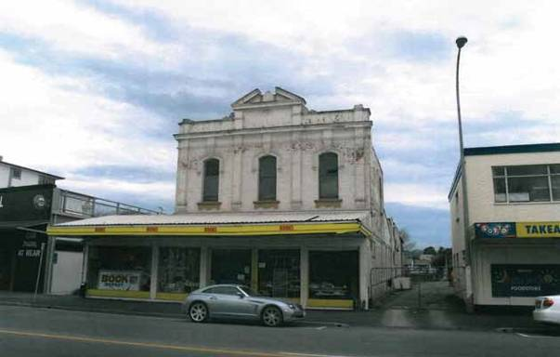

Figure 71: The building at 7 Riccarton Road before the September earthquake

4.24.3 Events following the September earthquake

Mr Nigel Harwood, a chartered professional engineer (CPEng) volunteer, conducted a Level 1 Rapid Assessment on behalf of the CCC on 6 September 2010. He recorded damage as “minor/none” and assigned a green placard to the building. In evidence he confirmed that he was applying a damage-based test and that there appeared to be a mixture of old and new cracks. When referred to photographs taken the next day, he said he did not recall seeing a crack behind the parapet on the western wall. This crack assumed importance as the hearing proceeded.

The next day a Level 2 Rapid Assessment was carried out by Mr David Elliott, a CPEng with Aurecon New Zealand Ltd, who was engaged by Mr Morris North as manager of the St Christopher’s Community Trust, which managed the bookshop on the ground floor. Mr Elliott noted cracks to lintel areas and near the parapets but no major lean or distortion. He also noted that the building was more than 100 years old and in a very poor state of repair before the September earthquake.

In evidence, Mr Elliott said that the majority of the cracks existed before the September earthquake. He knew this because of their appearance, which he said he was able to see when viewing the building from the outside, even without binoculars. He also relied on Mr North telling him that they had been there before the earthquake. However, Mr North said in evidence that he could not recall telling Mr Elliott that the cracks were pre-existing. He said he could not be sure which cracks were pre-existing and that he could not have told Mr Elliott which ones were pre-existing. Regarding the crack on the western wall, which Mr Elliott said they had looked at in detail, Mr North said he had not noticed it before the earthquake. We have not been able to resolve these differences.

The green placard was maintained. The next day, on
8 September, Mr North rang the CCC to advise that the brick-and-concrete façade was badly cracked and he was concerned that it could fall down on pedestrians. He said that a “…structural engineer says with another significant tremor it could come down”. Mr North explained that he had a number of volunteers working in the bookshop who were raising concerns with him and one had commented that a structural engineer had said the building could come down in a significant
tremor. He said that, although Mr Elliott had inspected the building the day before, he felt that a second opinion from the CCC was called for. Mr North also contacted Mr Elliott to carry out a further inspection.

Mr Elliott carried out an exterior inspection of the building on 9 September and confirmed the green placard. He noted on the rapid assessment form he completed that he had checked the front parapet and western wall but could not observe much change and that the parapet still looked vertical and stable.

On 11 September 2010 a further Level 1 Rapid Assessment was conducted on behalf of the CCC as a result of the call by Mr North on 8 September. This inspection was carried out by Mr Vaughan McMillan, a CPEng engineer, and Mr Russell Officer, who at that time was a CCC building inspector. They concluded that the cracking in the front façade and parapet needed to be inspected by an engineer. The building was assigned a yellow placard and a Level 2 Rapid Assessment was recommended. Mr McMillan explained that the cracking to the central area of the façade indicated the possibility of some outward movement of that area. He also said that a weathering pattern was evident below the roof profile, which raised a concern about the state of the façade ties. He believed that it was prudent to assign the building a yellow placard so there could be an internal inspection and the ties could be checked by accessing the ceiling area. The yellow placard was confirmed in a further inspection by a CCC building inspector on 19 October 2010, which noted that the cracking in the parapet needed to be checked by an engineer.

On 15 and 16 September Mr North was in contact with the CCC. He was advised that to have the placard changed from yellow to green, his engineer would have to conduct a Level 2 assessment. Mr North said in evidence that he contacted Mr Elliott and passed on the CCC’s requirements. Mr North said that Mr Elliott told him he was aware of the CCC’s requirements.

Mr Elliott carried out a further inspection of the building on or about 17 September. This inspection was of the exterior only. No documentation of this inspection was completed but Mr Elliott said his view was that there had been no change to the building since his last inspection on 9 September. He said in evidence that he did not carry out an interior inspection because the cracking to the building was visible from the exterior and would not have been visible from the interior. He also said that he expected to be able to see whether the façade had moved outwards by conducting an exterior inspection. Mr Elliott agreed Mr North told him that the CCC required a Level 2 assessment but said he was told this after he had already carried out his inspection. He agreed that he could have gone back and inspected the interior. He also agreed that it was a “big step” to change a building’s status from yellow to green and that the CCC wanted a Level 2 assessment before a placard could be changed, because of the public safety risk.

In order to change a yellow placard to a green one, the
CCC’s policy at that time required a CPEng engineer to complete a prescribed certificate to the effect that interim securing measures had been undertaken and potentially dangerous features removed or secured
to restore the structural integrity and performance of the building to at least that which existed prior to the September earthquake. Whilst the certificate does not contain any reference to a Level 2 inspection before the placard can be changed, it was clearly envisaged that there would be an inspection of at least that standard before there could be such a change. We note that Appendix 24 to the CCC’s Report into Building Safety Evaluation Processes in the Central Business District Following the 4 September 2010 Earthquake1 refers to a structural engineering assessment of the building.

Mr Elliott spoke to and had email contact with a then CCC employee, Ms Laura Bronner, who we understand was an administrative clerk with no engineering training. Mr Elliott said in evidence he was concerned that it was inappropriate for him to sign the form because no securing work had been done. Although he could not recall the details of their discussion, he did recall that she had said he should modify the form as he saw fit. He said there was no persuasion or negotiation on his part. Mr Elliott then amended the certificate, in particular by adding the statement: “The condition is not considered to be worse than prior to EQ”. The relevant portion of that form is shown below.

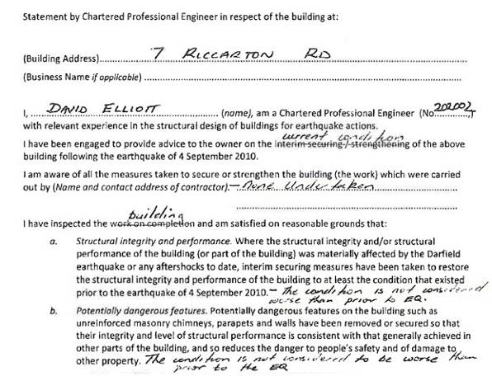

Figure 72: CPEng Certification Form for 7 Riccarton Road

The amended certificate was accepted by the CCC and the status of the placard changed to green on that basis.

The CCC file records that a CCC structural engineer
had reviewed the report and agreed with the information supplied. Enquiries by the CCC for the purposes of the Royal Commission’s inquiry could not establish who that engineer was, what report he reviewed or with what information there was agreement. However, it is clear from the terms of the amended certificate and the only report supplied to the CCC (which was Mr Elliott’s letter incorrectly dated 6 September 2010 but which reported on his inspections of 7 and 9 September 2010) that the CCC could not have agreed with the information supplied. That is because the only statement in those documents to which the CCC could have been agreeing was the handwritten assertion that “the condition is not considered to be worse than prior to the earthquake”.

Given that the building had been yellow-placarded and that status confirmed in a subsequent inspection, it was not acceptable for the CCC to accept that statement by Mr Elliott without carrying out any further inspection.

In evidence, Mr McCarthy said he accepted that the
CCC process could have been done better and that,
in accepting the CPEng form, the CCC was effectively accepting that the yellow placard should never have been issued. Mr Elliott said in evidence that he was never contacted by a CCC engineer, although he was expecting that to happen because he had modified the form. When asked why he did not contact the CCC to speak to an engineer, Mr Elliott said that it was not up to him to advise the CCC how to proceed.
In late December 2010 Mr David Yan, one of the owners of the building, inspected the building with his friend and engineer, Mr Robert Ling, in the company of a loss adjustor, Mr Fritz Muller. Mr Muller’s evidence was that he saw a separation between the front façade and the side wall but that he believed this and the other cracking existed before the September earthquake, although it might well have been exacerbated by it. Mr Ling appears not to have agreed with this assessment. The inspection was left on the basis that Mr Ling would prepare a report to support a claim that the cracking to the building was sustained in the September earthquake. That report was never completed.

After the Boxing Day earthquake Mr Yan and Mr Ling inspected the building. Mr Ling’s evidence was that he was not overly concerned with its structural condition. However, he was concerned with the general state of the building and advised Mr Yan to remove the ceiling and wall linings in preparation for re-development plans he was going to prepare for Mr Yan. Mr Ling was asked in evidence whether he gave any thought to the effect that removing the wall and ceiling linings might have had on the building’s strength. He said that the walls were dilapidated and the ceilings had holes and cracks in them so the strength would not be reduced.

Mr Peter Smith, who carried out an independent assessment for the Royal Commission of the performance of the building in the February earthquake, said that the failure mechanism was an outward rotation of the entire Riccarton Road façade about its first-floor wall support, primarily caused by inadequate restraint at roof level.

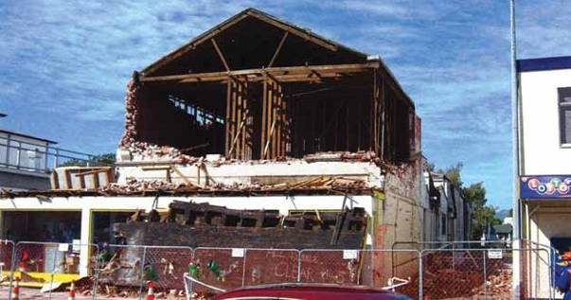

Figure 73: The building after collapse (following removal of rubble)

4.24.4 Issues

4.24.4.1 Application of the CCC’s Earthquake- Prone Dangerous and Insanitary Buildings Policy

The failure of the building in the February earthquake illustrates the risk to human life inherent in a passive approach in relation to earthquake-prone buildings.

In relation to the lack of follow-up of the 1991 and 1993
CCC surveys, we accept Mr McCarthy’s statement that the primary responsibility for a building rests with the owner. However, the CCC also had responsibilities in relation to earthquake-prone buildings under the Building Act 2004 (and its antecedents), particularly in respect of public safety. As this hearing and others have shown, the potential issues relating to URM buildings, and their external walls and parapets, include matters of public safety and cannot be left solely to the owner. We consider that territorial authorities need to have active earthquake-prone buildings policies that ensure appropriate actions are taken within a reasonable timeframe. This is an issue we discuss in section 7 of this Volume.

4.24.4.2 Assessment of the building after the
September earthquake

It was apparent that different views were held by engineers and building inspectors who saw what must have been the same cracking to the façade of this building. Mr Smith expressed the view that this might have been because of a different approach to the assessment of post-earthquake damage by engineers, namely a damage-based approach, whereas the approach by Mr Russell Officer and Mr Vaughan McMillan, who is a CPEng engineer, on 11 September appeared to have been more of a risk-based approach.

Further, this case highlights the need for URM buildings to be treated with caution after a substantial earthquake. It also highlights the skill and experience required to inspect and assess URM buildings. As Mr McMillan noted, when he graduated he had to deal with URM buildings, but engineers currently graduating may not know much about them.

We discuss the assessment and strengthening of existing buildings in section 6 of this Volume.
4.24.4.3 Assessment by Mr Elliott after allocation of yellow placard

Mr Elliott’s inspection of the building on or about
17 September after it had been allocated a yellow placard was insufficient. As he accepted, the CCC requirement was for a Level 2 assessment to be carried out before there could be a placard change. As he also accepted, the reason for this was that it was a significant step involving risk to public safety.

Although Mr Elliott claimed that an internal inspection would not have made any difference to his conclusion, the type of inspection that Mr McMillan referred to was clearly called for. If an internal inspection had been carried out, there would have been a proper basis on which to determine whether the yellow placard should have been maintained.

4.24.4.4 Amendment of the CPEng certificate

The CCC should not have accepted the amended CPEng certificate. The CCC’s file note that records that its engineer had agreed with the information provided made a nonsense of the application of the CCC’s policy in relation to the change of placard status. The only report from Mr Elliott that was provided pre-dated the yellow placard. At best, the modification of the form created an ambiguity about the issues that the CCC had to decide.

In effect, the yellow placard was simply put to one side as a result of the combined actions of Mr Elliott and the CCC, without the relevant matters being given proper consideration.

4.24.4.5 Removal of linings

We accept Mr Smith’s evidence that the wall and ceiling linings would not have prevented the façade collapsing. However, removal of the linings by Mr Yan under Mr Ling’s directions could have had the effect of decreasing the strength of the building at a time when the city was vulnerable to aftershocks and was unwise.

4.25 391 and 391A Worcester Street

4.25.1 Introduction

Wicks Fish Shop was located at 389A Worcester Street. Natasha Hadfield, the co-owner of the business, and Betty Dickson, a customer in the shop, were killed when the western wall of the adjoining property at 391 and 391A collapsed onto and through the shop roof in the 22 February 2011 earthquake.

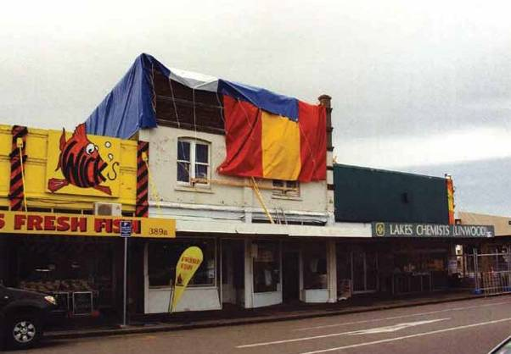

Figure 74: The building at 391 and 391A Worcester Street, with tarpaulins on its roof after the September earthquake

4.25.2 The building

The structure at 391 and 391A Worcester Street was a two storey unreinforced masonry (URM) building housing a pizzeria on the ground floor and a residential flat upstairs. It had timber roofing and a timber ground floor.

It appears that the building had remained in relatively original condition since it was constructed, with no earthquake strengthening. No upgrade of the building was ever required by the CCC, presumably because there was never any significant alteration or change of use.
4.25.3 Events following the September earthquake

As the building was outside the CBD, there was no CCC rapid assessment after the September earthquake. However, the building was damaged when the parapet on the Worcester Street frontage collapsed back onto the roof, damaging the roof framing. Make- safe works were carried out and tarpaulins placed over the roof and the western wall to make the building weathertight. An assessment of the western wall at that time by the contractor, Contract Construction, concluded that it did not appear damaged, but the eastern wall was damaged and was propped with timber bracing against the roof of the adjoining building.

An inspection by TM Consultants, engineers, on behalf of the owner’s insurer, on 11 October 2010 confirmed this damage and that the western wall did not appear to have been damaged.

There was no inspection of the building after the Boxing Day earthquake by either the CCC or any engineer on behalf of the owner.

The building was inspected by an Earthquake Commission (EQC) assessor and estimator in early February 2011 as a result of the owner’s EQC claim for damage to the residential apartment on the first floor. The notes of the assessor, Mr Lindsay Attrill, and the estimator, Mr Bruce Glasgow, record that there was substantial damage to the building. In particular:

• the building was structurally unstable and had suffered a significant collapse of the roof into the building;

• during inspection of the upstairs residential
bedroom it became evident that in windy
conditions the tarpaulin was being lifted and in turn dramatically lifting the upper-level floors, making
the building unsafe and in danger of collapse;

• the roof was unstable and severely damaged, with a major section having collapsed internally so it required a rebuild and replacement of the corrugated iron;

• the east parapet had collapsed and the wall had emergency timber bracing on the roof of the adjoining property. Both brick walls had multiple cracks and were unstable; and

• there was severe damage to all exterior walls and
chimneys (potentially dangerous).

Counsel assisting the Royal Commission wrote to
Mr Attrill, who resides in Australia, on 12 September
2011. His reply dated 3 October 2011 said that at the time of the inspection the assessor and estimator briefly discussed the state of the building with the owner. However, no details of that discussion were given. The owner of the building, Mr Pak Loke, gave evidence that he was given little information by the assessors at that time and was not told of the danger of collapse.

Mr Loke received a letter from EQC dated 15 February
2011 enclosing documents that described the walls of the building as severely damaged and moving and potentially dangerous. Mr Loke conceded that he had done nothing about this letter. However, he said that, although he could not be exact about the date, he received the letter just before 22 February. His evidence
was that when he read that description he had doubts as to its accuracy, given what he had been told by EQC at the time of the inspection. He claimed that he was considering contacting the EQC to clarify the position when the earthquake occurred.

Mr Attrill’s written reply to the Royal Commission stated that he and Mr Glasgow had informed the occupier of the extent of the damage at the time of their inspection. However, the Royal Commission did not hear evidence from the occupier because he had not replied to a written request for information and could not be located by counsel assisting the Royal Commission.

Mr Attrill also said that during the inspection he went into the neighbouring property and spoke to a person behind the counter, and it was most likely that, given the circumstances, the conversation would have been about the state of the adjoining building. In a statutory declaration, Mr Geoffrey Hadfield, who owned Wicks Fish Shop with his wife, recalled a man who was obviously inspecting the adjoining building coming into Wicks Fish Shop but said that there was little or no conversation between them. Mr Hadfield’s statutory declaration is very clear in its terms. He stated that he was not told anything of the state of the adjoining building.

After his inspection Mr Attrill recorded on the EQC file that EQC should appoint an engineer as a matter of urgency. No engineer was ever appointed. EQC could not adequately explain the reason for that, although it appears that it may have been because it was recommended that the claim be declined on the basis of an initial view that the premises were predominantly commercial and not residential.

EQC did not advise the CCC or the owners of the neighbouring properties (including the Hadfields) of its concerns in relation to the building. This was because of EQC’s then understanding of the application of section 32 of the Earthquake Commission Act 1993 and the Privacy Act 1993. Mr Ian Simpson, Chief Executive Officer of EQC, gave evidence that as a result of the Royal Commission’s inquiry into this building failure his organisation had reconsidered that position and developed a new policy that required notifying territorial authorities and neighbours when such a situation arose.

The policy was set out in the evidence of Mr Bruce
Emson of EQC, as follows:

6.1 EQC staff and contractors must advise their supervisor or manager and complete a notification of a dangerous building form where they consider that:
a) a building may pose a serious and imminent risk to health or safety; or
b) residents/neighbours are not complying with a red or yellow sticker and are therefore placing themselves or others at serious risk.
6.2 In the case of an urgent danger to health and safety, staff and contractors can immediately notify emergency services and any persons
at risk, which might include the building owner, occupants and neighbours. Staff and contractors must then inform their supervisor or manager.
6.3 The notification of a dangerous building form is sent to EQC’s Field Operations Manager. The Field Operations Manager checks the details of the form to ensure they are correct
and that personal information is not disclosed, and then sends the form to the respective
local authority, for example the CCC or CERA.

6.4 The details of each notification and actions taken are recorded by EQC in a Dangerous Buildings Register.

The policy was implemented in October 2011.
Mr Simpson gave evidence that 17 such notifications had been made as of 15 December 2011.

After a request from the Royal Commission at the hearing, counsel for EQC provided a memorandum about whether EQC considered that section 32 of the Earthquake Commission Act 1993 restricted EQC’s ability to advise persons such as local authorities or neighbours of buildings that EQC considered were potentially dangerous.

Section 32 gives EQC the power to inspect property, obtain information and enter land “for the purpose of obtaining any information that may be reasonably required by the Commission for the purposes of the EQC Act”. However, section 32(4) limits the circumstances in which such information can be divulged to third parties.
According to the memorandum, EQC does not consider that section 32(4) precludes the disclosure of information “in the ordinary course” because EQC
does not usually obtain such information by exercising its powers under section 32. Typically it obtains its information by consent. However, as counsel for EQC pointed out, it is conceivable that information about a dangerous building could be obtained by exercising the powers under section 32. In such a case it would be subject to the restriction on disclosure stated in section 32(4).

However, EQC says that, if such a situation arose,
it would still be entitled to disclose the information. One of the exceptions to the limitation in section 32(4) allows information to be disclosed “for such purposes as may be specified in any other Act”. EQC’s view was that such information could be disclosed because one of the purposes stated in the Privacy Act relates to the prevention or lessening of a serious and imminent threat to an individual or the public.

Notwithstanding this, EQC invited the Royal Commission to recommend a further exception in section 32(4) of the EQC Act as follows:

(e) For the purpose of preventing or lessening a serious and imminent threat to public health or public safety, or the life or health of any person.

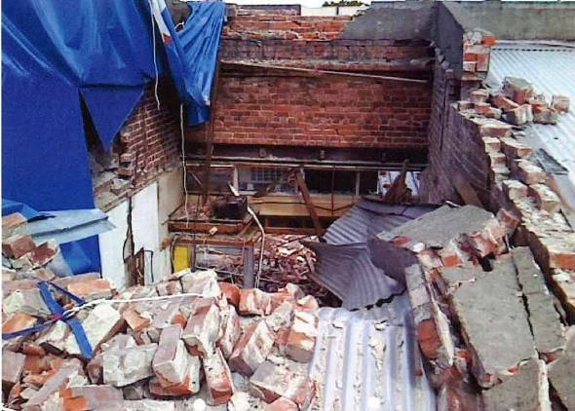
Figure 75: Collapse of the western wall of the building into 389A Worcester Street

4.25.4 Issues

4.25.4.1 Application of the CCC’s Earthquake- Prone Dangerous and Insanitary Buildings Policy

This building failure, as with most others in this category, illustrates the risk to human life inherent in a passive approach in relation to earthquake-prone buildings. The building, which was likely to have been earthquake-prone, remained in a relatively original condition at the time of the Canterbury earthquakes. We address earthquake-prone building policies in section 7 of this Volume.

4.25.4.2 Assessment and occupation of unreinforced masonry buildings following a substantial earthquake

The failure of this building, in common with the failure of other URM buildings, demonstrates the fact that sole reliance on damage-based assessments of URM buildings may be inadequate after a substantial earthquake. Post-earthquake building inspections are discussed in Volume 7 of this Report.
4.25.4.3 Lack of communication of potential danger

We accept the evidence in Mr Hadfield’s statutory declaration that he was not told of the potential danger posed by the building. It is clear that if he had been told of the potential danger the wall posed, he would not have continued to occupy the Wicks Fish Shop premises. It therefore follows that, if the EQC’s new policy had been instituted before the February earthquake, these two lives might well have been saved. We would have recommended that EQC’s policy should be changed but EQC has recognised the need for that and, as a result of these events, adopted what we view to be a sensible and pragmatic policy.

We do, however, recommend that an amendment be made to section 32(4) of the Earthquake Commission Act 1993. It is clearly appropriate and sensible to remove any doubt about the ability to disclose information that might affect personal safety. Our recommended amendment is wider in its terms than that proposed by EQC. We do not think the exception should be limited to cases of “serious and imminent” threats to health and safety. Any threat

would be sufficient to justify disclosure. We therefore recommend that section 32(4) should be amended with the change highlighted here in bold, to read, in full:

(4) A person authorised by the Commission for the purposes of subsection (1) shall not make a record of, divulge, or communicate to any person, any information acquired in exercising the powers conferred by that subsection except—
(a) to the Commission; or

(b) for the purposes of this Act; or

(c) for the purposes of any court proceedings;
or

(d) for such purposes as may be specified in any other Act; or
(e) for the purpose of preventing or lessening a threat to public health or public safety or to the life or health of any person.

Further, we believe that statutory bodies, engineers and other professionals, tradespersons and building owners should all have a duty to disclose to the relevant territorial authority and any affected neighbour any information of which they have become aware to the effect that a building is in a dangerous or potentially dangerous condition. We discuss this further in section 7 of this Volume, where we make an appropriate recommendation.

As we have indicated, we are of the view that a building owner in Mr Loke’s position who is advised of any potential danger his building poses should advise neighbouring owners or tenants of that danger. In this case, it is not clear exactly what Mr Loke was told by EQC on 1 or 2 February 2011. However, he did receive notification in writing from EQC that the wall was potentially dangerous, in the letter dated 15 February 2011. It is unfortunate that Mr Loke did not take some immediate action in relation to this information. In explanation, he said he did not receive this letter until some days after the date of the letter.

While the evidence from the EQC assessor was that
the occupier had been advised of the danger, we would not consider that notification to an occupier (or even an owner) of this type of information would be sufficient to ensure that the appropriate action was taken (as the new EQC policy recognises). Notification must be to the territorial authority, an independent statutory body that has the power to address the danger.

References

1. Christchurch City Council. (2011). Report into Building Safety Evaluation Processes in the Central Business District
Following the 4 September 2010 Earthquake. Christchurch, New Zealand: Canterbury Earthquakes
Royal Commission.

2. Christchurch City Council. (15 December 2005). Minutes of a Meeting of the Christchurch City Council held at
9.30am on Thursday 15 December 2005. Christchurch City Council. (2005). Council Agenda 15 December 2005.

3. Department of Building and Housing. (2005). Earthquake-Prone Building Provisions of the Building Act 2004: Policy Guidance for Territorial Authorities. Wellington, New Zealand: Author.

4. Christchurch City Council. (25 May 2006). Minutes of a Meeting of the Christchurch City Council held at 9.30am on Thursday 25 May 2006.

5. Christchurch City Council. (10 September 2010). Minutes of an Extraordinary Meeting of the Christchurch City Council held at 10am on Friday 10 September 2010. Christchurch City Council. (2010). Christchurch City Council Agenda: Extraordinary Meeting: Friday 10 September 2010: 10am: In the Boardroom Beckenham Service Centre
66 Colombo Street.

6. Christchurch City Council. (2010). Council Agenda 23 September 2010.

7. Ingham, J.M. and Griffith, M.C. (August 2011). The Performance of Unreinforced Masonry Buildings in the
2010/2011 Canterbury Earthquake Swarm: Report to the Royal Commission of Inquiry. Christchurch, New Zealand: Canterbury Earthquakes Royal Commission. And Ingham, J.M. and Griffith, M.C. (October 2011). The Performance of Earthquake Strengthened URM Buildings in the Christchurch CBD in the 22 February 2011 Earthquake: Addendum Report to the Royal Commission of Inquiry. Christchurch, New Zealand: Canterbury Earthquakes
Royal Commission.

8. AS/NZS 1170.0:2002. Structural Design Actions: Part 0 – General Principles, Standards New Zealand/ Standards Australia.

Note: Standards New Zealand was previously known as the Standards Institute of New Zealand.

