3.3.1.4 Important considerations
The Buchanan report outlined some important matters that must be considered when implementing low- damage design.
(a) Damage to floors
The majority of the building mass is in the self-weight of the floors and in the contents they are supporting. As the earthquake accelerates this mass, the forces induced must follow a load path into the lateral load resisting elements (that is, walls or frames) and ultimately into the ground. The floors also have the important function of tying the building together and transmitting lateral forces to the lateral force resisting elements. These forces act in the plane of the floor and are referred to as diaphragm forces.
Damage to the load paths in the floors can significantly compromise the building’s performance and is an issue with both traditional and emerging technologies. Gapping and frame elongation that occurs with some rocking connections will inflict significant cracking of concrete and potential fracturing of reinforcing if it is not carefully detailed.
(b) Limiting slab damage
Some efforts have gone into solving the issue of slab damage. Each solution has its own limitations. The slotted or top-hinging beam concept minimises the gapping and frame elongation effects; other methods involve a system of isolating the slab in some way.
The articulated flooring systems and isolation of floor slabs are described in the Buchanan report and are summarised below.
The articulated flooring system is built so that it is partially detached from the supporting structure, with sliding joints or other innovation details, to avoid damage to the floor but to retain the essential diaphragm action (see Figure 15). In theory this system is able to accommodate the displacement incompatibility between floor and frame by creating an articulated or jointed mechanism that is decoupled in the two directions. However, we have difficulty in seeing how this proposal would work in practice in a building with more than one bay.
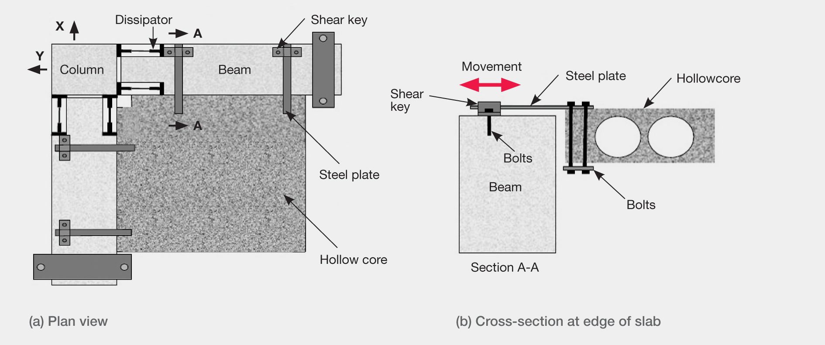
Figure 15: Beam-column joint with articulated floor unit at a corner of a reinforced concrete frame building
(source: Amaris et al, 2007¹²)
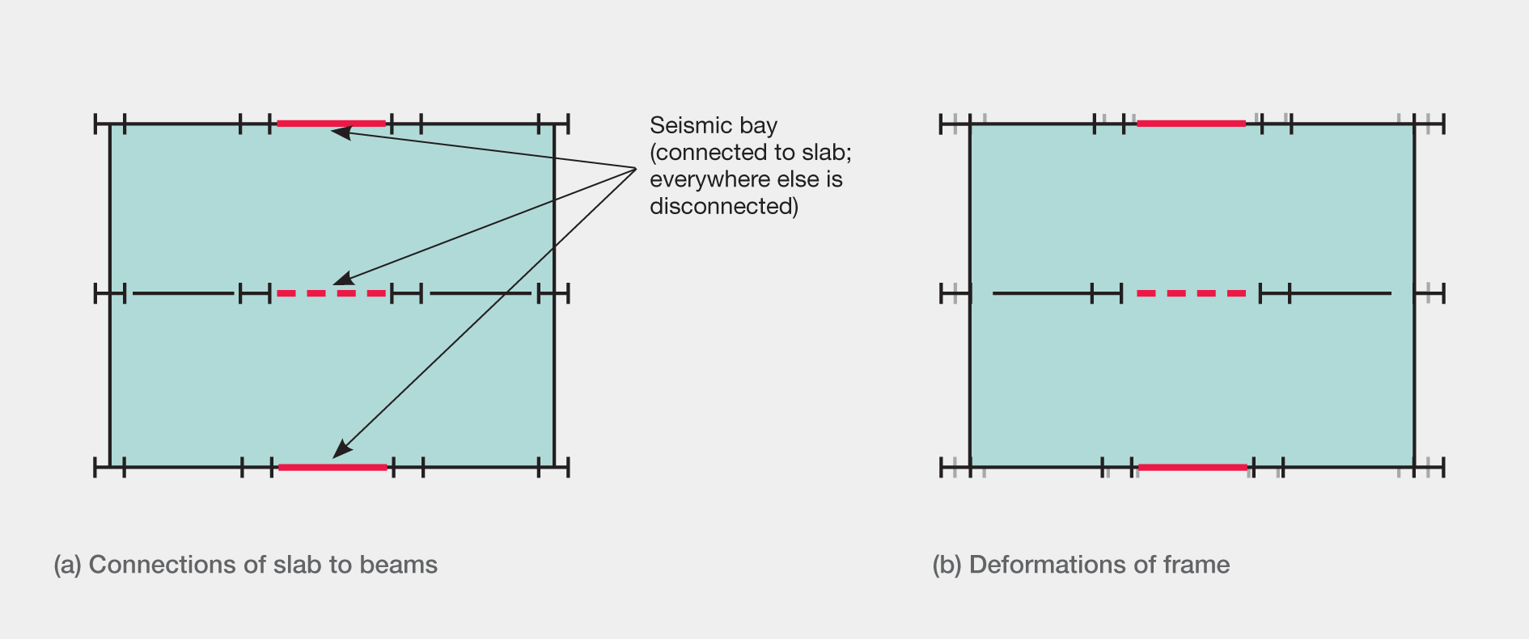
Figure 16: PRESSS technology with slab connected over one bay (source: Buchanan report)
Other ways to isolate floors include connecting the beams to the slab in one bay only, as shown in Figure 16, or by connecting the slab to gravity frames only and isolating the seismic resisting frame. We do not see how this proposal would work, as gapping between the columns and beams in the seismic bay would stretch the slab, which is continuous between the three bays. This stretching action would be likely to damage the slab.
(c) Frame elongation effects
Frame elongation occurs in traditional concrete frames as a result of the formation of plastic hinges, leading to slab damage and a reduced seating for precast floor elements. Post-tensioned rocking frames also suffer this detriment through the gapping that occurs at the beam-end-to-column-face joint.
The Buchanan report explains that for PRESSS (and traditional) frames, as the number of bays increases, so the outward displacement of the end columns increases owing to aggregation of gap opening. When this sway is superimposed with beam elongation, the columns end up being pushed apart in different ways. This cannot cause a column sway mechanism to form but it can increase the curvature imposed on columns.
The beams in a frame are subjected to axial compression or tension forces as the frame is displaced laterally. Designers need to be aware of this behaviour, as standard structural analysis packages do not predict elongation actions.
(d) Non-structural components
Low-damage building technology has been developed to minimise structural damage and is not directly concerned with non-structural components. It works by permitting displacements (which may be large) without structural damage. Therefore, careful detailing is required for non-structural elements (for example, cladding and ceiling systems, mechanical services) so that they can sustain seismic movements. As the structural engineer sometimes is not directly involved in the fit out of a building, it is important that architects and other relevant parties collaborate to ensure that a resilient system is provided.

3.3.2 Applications in reinforced concrete buildings
3.3.2.1 Background
The development of capacity design from the late 1960s to the early 1980s means that many reinforced concrete structures built before the 1980s do not have the necessary steel reinforcement detailing to give toughness and resilience in a major earthquake. The development of capacity design was an essential step in the design of ductile buildings. Professor Bull noted in his evidence that in the post-1980s era, the common way to prevent collapse was to make the building ductile by confining plastic deformation to specially detailed areas, which are referred to as potential plastic hinges. He observed that the problem with plastic hinges, particularly in concrete, is they can be significantly damaged in an earthquake, and they induce elongation. The engineering profession may have thought that these plastic hinges could be repaired, but Professor Bull stated that following laboratory work and in-field observations after the February earthquake, they were typically found to be beyond repair.
The advantage of PRESSS and slotted beam systems is that they suppress the formation of plastic hinges in structural members, dissipating the earthquake’s energy in ductile jointed connections. Professor Pampanin described a PRESSS frame or wall system as consisting of precast concrete elements joined together with unbonded post-tensioning tendons or steel bars, creating a moment resisting structure. Under wind loading and low seismic actions, the clamping action of the post-tensioned bars guarantees strength similar to a typical cast in situ solution, whereas in a major earthquake, a rocking motion is initiated. Structural elements can be prefabricated off-site with high quality control and then assembled quickly and efficiently at the building site. Professor Pampanin also stated that by draping the tendon along the beam, longer span lengths may be achieved.
Steel or fibre-reinforced polymer armouring of the jointed regions between the precast units was used in the Southern Cross Hospital Endoscopy building (see Figure 19(d)) to suppress spalling of cover concrete at the joints.
Professor Bull reported that a slotted beam or non-tearing floor system was also developed as part of the PRESSS programme. By pivoting the beam about its top edge, gapping was limited to one side of the beam, which reduced damage to concrete floor slabs. Figure 17 shows laboratory testing of a two-storey slotted beam frame at the University of Canterbury. The two per cent drift imposed is at an ultimate limit state (ULS) level. Professor Bull described the damage in the beam and floor as only hairline cracking, whereas a conventional connection would typically have a significant accumulation of damage for the same level of imposed drift.
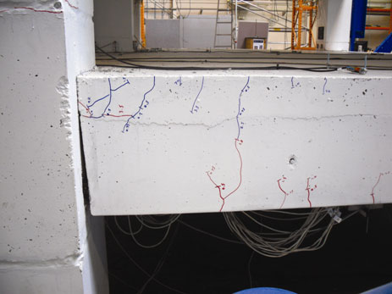
(a) Beam-column joint
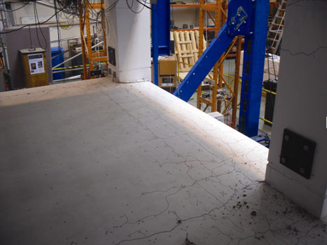
(b) Concrete floor
Figure 17: Slotted beam laboratory testing at ultimate limit state (source: Desmond Bull)
The bottom longitudinal reinforcing bars are partially debonded in the beam close to the slot to avoid premature rupture of the steel. Professor Bull described testing two methods of debonding, namely a steel sleeve and a plastic tube. The steel sleeve performed better, as it provided superior restraint against buckling. Further design considerations include:
• treatment of steel reinforcing across the joint, to reduce its exposure to the environment;
• measures to prevent gaps being filled over the design life of the building, as people may not recognise the significance of the gaps; and
• repair or replacement of steel that has undergone repeated plastic cycles in one or more earthquakes.
Professor Bull described the slotted beam as a higher-performance system as the floor slabs remain intact. However, the replacement of the yielded steel reinforcing is an issue and the building may still not be repairable. This is the same issue as with conventional systems that form plastic hinges. External devices that can be replaced were discussed as a possible solution to this problem.
We note Professor Bull’s opinion that the PRESSS and slotted beam concepts have the advantage of employing current building techniques and will therefore not require significant learning or special tools for builders. The key changes are in the design and detailing of joints, which will give a better performance at a cost that is competitive with conventional systems.
We agree that the concept has merit but further consideration of the three points raised above is required.

