3.3 Emerging forms of low-damage technology

3.3.1 General principles
Research shows that low-damage design technology could limit structural damage in a major earthquake. Several methods use rocking connections, usually combined with supplemental damping devices, to absorb seismic energy. The combination of rocking connections and supplemental damping gives the structure a ductile characteristic, enabling it to be designed as a ductile structure with a reduced seismic response in a major earthquake. However, if these devices perform as intended, there is minimal residual damage to structural components. Regardless of the structural systems and devices used, the designer must carefully detail a building so that it behaves in an expected manner. As the late Dr. Thomas Paulay put it, the designer must “tell the structure what to do”.
3.3.1.1 Controlled rocking concept
Professor Pampanin explained that the idea of a rocking mechanism in structures has been around since ancient Greek times and more recently was employed in the 1970s on the South Rangitikei Railway Viaduct. The viaduct has slender piers that step, or rock, in a major earthquake. An analogy can be drawn to a person resisting a sideways pushing movement by rocking onto one leg and then returning to both, as opposed to standing firm to take the force. The principle is the same with modern structural rocking mechanisms, which use a high-strength, post-tensioned rod acting as a controller to ensure that the structure is clamped back into its original position after the shaking.
In the 1990s a major development in high-performance structural systems was the concept of ductile connections to accommodate high inelastic demand without suffering extensive material damage. A New Zealander, Professor Nigel Priestley, initiated the concept and then acted as the co-ordinator of the Precast Seismic Structural Systems (PRESSS) programme in the United States. The programme was prompted by the 1989 Loma Prieta and 1994 Northridge earthquakes, with testing carried out at the University of California at San Diego (see Figure 11). In PRESSS, prefabricated beams and columns (or walls) are joined together with steel tendons that have been post-tensioned to give rigid connections that rock under large lateral loads (as seen in Figure 12). The traditional plastic hinge mechanism is therefore replaced by a controlled rocking mechanism. A “damage-control limit” state can be achieved under a design level earthquake (typically set at a 500-year return period), leading to an intrinsically high-performance seismic system in higher-intensity earthquakes. This technology has had significant testing with walls, where the post-tensioning goes all the way through to the foundations, as well as in frames, where the tendons pass through the beam-column joints.
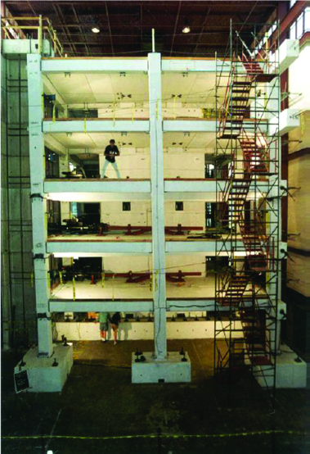
(a) PRESSS frame
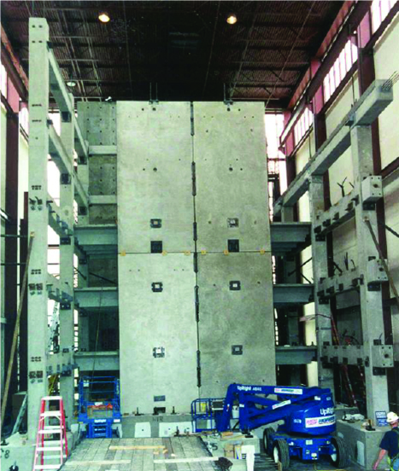
(b) PRESSS wall
Figure 11: Five-storey PRESSS Building tested at the University of California San Diego (source: Priestley et al, 1999¹⁰)
Following theoretical development and large-scale testing, this approach has now been implemented in a number of buildings around the world. Guidance in New Zealand regulatory documents is very limited with only the Concrete Structures Standard NZS 3101, Appendix B11 containing special provisions for the seismic design of these ductile-jointed precast concrete structural systems.
The PRESSS concept has been adapted for use in steel and timber structures. Its application in timber involves the use of highly engineered wood products. Post-tensioned timber structures, known as Pres-Lam, are recent technology that has arisen from research in New Zealand.
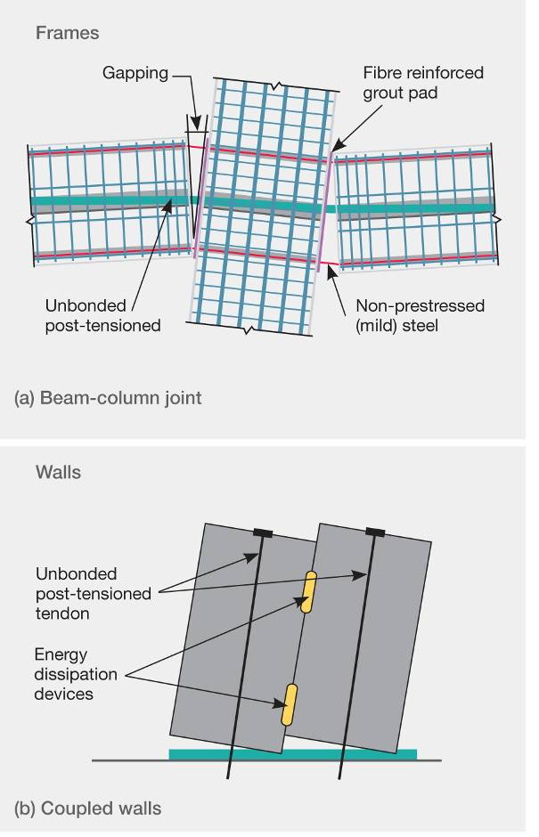
Figure 12: Jointed rocking frame and wall systems illustrating the mechanism developed (source: Buchanan report)
The mechanism of gapping and the detailing for PRESSS frame and wall systems are shown in Figure 12. The system is sometimes called a “flag-shaped” hybrid system because of the way it self-centres and dissipates energy, as shown in Figure 13. The post-tensioning clamps the frame or wall to its original position, whereas partially debonded mild steel or other supplemental damping devices dissipate seismic energy through ductile yielding.
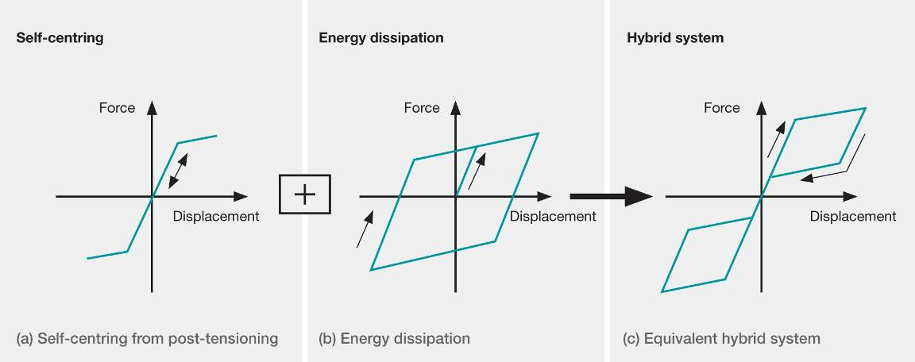
Figure 13: Hybrid system hysteresis for PRESSS (source: Buchanan report)
The PRESSS concept is less common in steel structures. Advances in low-damage design in steel structures use special detailing to allow for easily replaceable yielding elements or the incorporation of supplemental damping devices, such as friction sliding joints at connections.
A problem with the PRESSS concept, which is discussed in the Buchanan report, is the displacement incompatibility that arises with floors in multi-storey buildings. This has the potential to cause significant damage to the floor slabs, which are mainly constructed from reinforced concrete. Professor Bull in his evidence emphasised that floors, acting as diaphragms, are critical structural elements tying the building together and distributing the seismic actions to the lateral load resisting elements. In jointed systems, the gapping that occurs between beams and columns has the potential to tear the floors and compromise load paths. The observation that this diaphragm damage is no worse than in a conventional reinforced concrete frame building is acknowledged, but it raises the question whether PRESSS adequately qualifies as a low-damage technology in all respects.
The Buchanan report does contain a number of proposed methods of overcoming the gapping problem in PRESSS buildings. However, we believe that the proposals may not be practical and further testing and development is required if the gapping problem is to be adequately addressed.
These low-damage technologies can be used in the retrofit of structures. Professor Pampanin addressed the idea of seismic weakening instead of strengthening. An example of this is a sawcut made at the bottom of an existing wall and combined with post-tensioning, so that a controlled rocking mechanism could be achieved.
3.3.1.2 The slotted beam and sliding hinge joint concept
The slotted beam or sliding hinge joint (SHJ) used in concrete, steel and timber construction can be used to minimise damage to concrete slab floors. The point about which rotation occurs is at the slab level, with the gap opening and closing at the bottom edge of the beam. Energy-dissipation devices are located at this bottom edge. Figure 14(a) shows the slotted beam concept in concrete structures; the steel beam with bolted friction plates is shown in Figure 14(b).
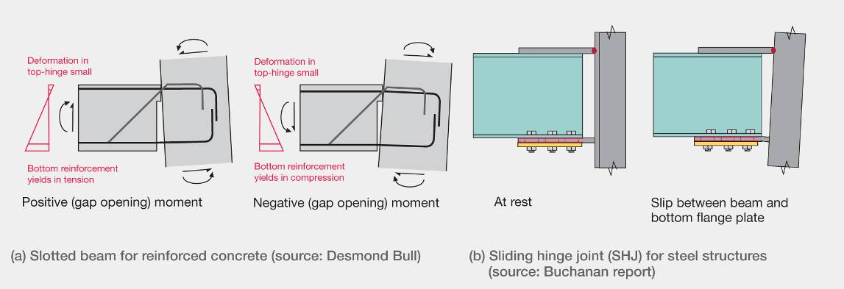
Figure 14: Hinging or slotted beam mechanism
3.3.1.3 Benefits of low-damage technologies
Professor Pampanin described the structural advantages of PRESSS, Pres-Lam and the slotted beam or hinging technologies as follows:
1. Plastic hinge regions are replaced with jointed ductile connections, resulting in less structural damage to beams, columns and walls.
2. Post-tensioning, spring joints and other connected elastic elements enable the building to self-centre, resulting in little residual displacement after an earthquake.
3. The construction time is shorter as structural elements can be prefabricated off-site.
4. Quality assurance is better as structural elements are built in a controlled environment.
5. Construction uses conventional building components so it is not a vastly different technology for builders.
6. The reduced direct (structural repair) cost and indirect (business interruption) losses can result in significant savings after a major earthquake. Whether this last point might result in reduced insurance premiums or has implications for self-insurance is yet to be seen.
We accept this is a fair summary.

