## 6.5 2004 to 2011: Buildings designed to Earthquake Actions Standard NZS 1170.5:200410

### 6.5.1 62 Gloucester Street: Gallery Apartments building

|  |
| --- |
| Current status |
| Demolished. |

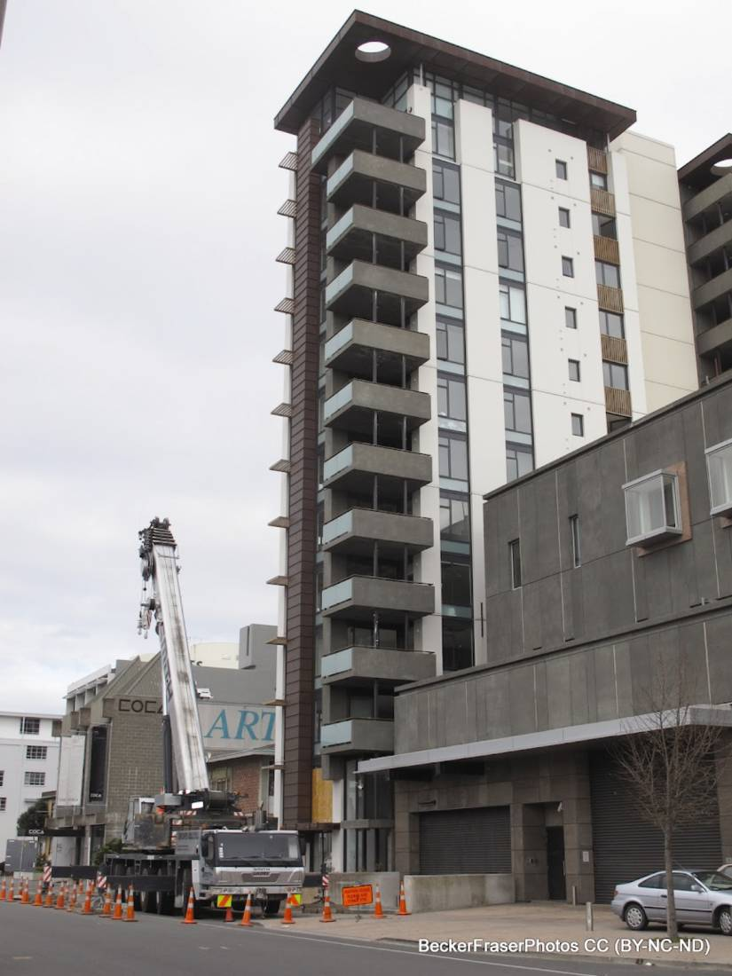

Figure 117: View of the northern tower from Gloucester Street (source: Becker Fraser Photos)

**6.5.1.1 Introduction**

The Gallery Apartments building was located at 62 Gloucester Street, adjacent to the Christchurch Art Gallery. It was designed during 2005 and 2006. Three building consents were issued by the CCC in 2006 and code compliance certificates were issued in 2007. It was a 14-storey building constructed in two seismically separated towers. The southern tower had seven levels of parking and the services core for both towers.

The northern tower comprised a two-level art gallery, with about half of this being of double height. There were 12 levels of residential apartments above this with a single apartment on each floor. The plan dimensions of this tower were about 9.3m by 11m.

For the purposes of this Report only the northern tower has been assessed.

6.5.1.2 Foundations

A geotechnical investigation undertaken for the design of the building indicated a potential liquefaction hazard at depth but it was considered this would not have a significant impact on the building.

The foundations of this tower comprised 900mm diameter reinforced concrete piles that extended to depths of 4m on the eastern side and up to 7m on the western side. These supported 1.5m deep foundation beams at the perimeter and on grid lines 1 to 5 (shown in Figure 118).

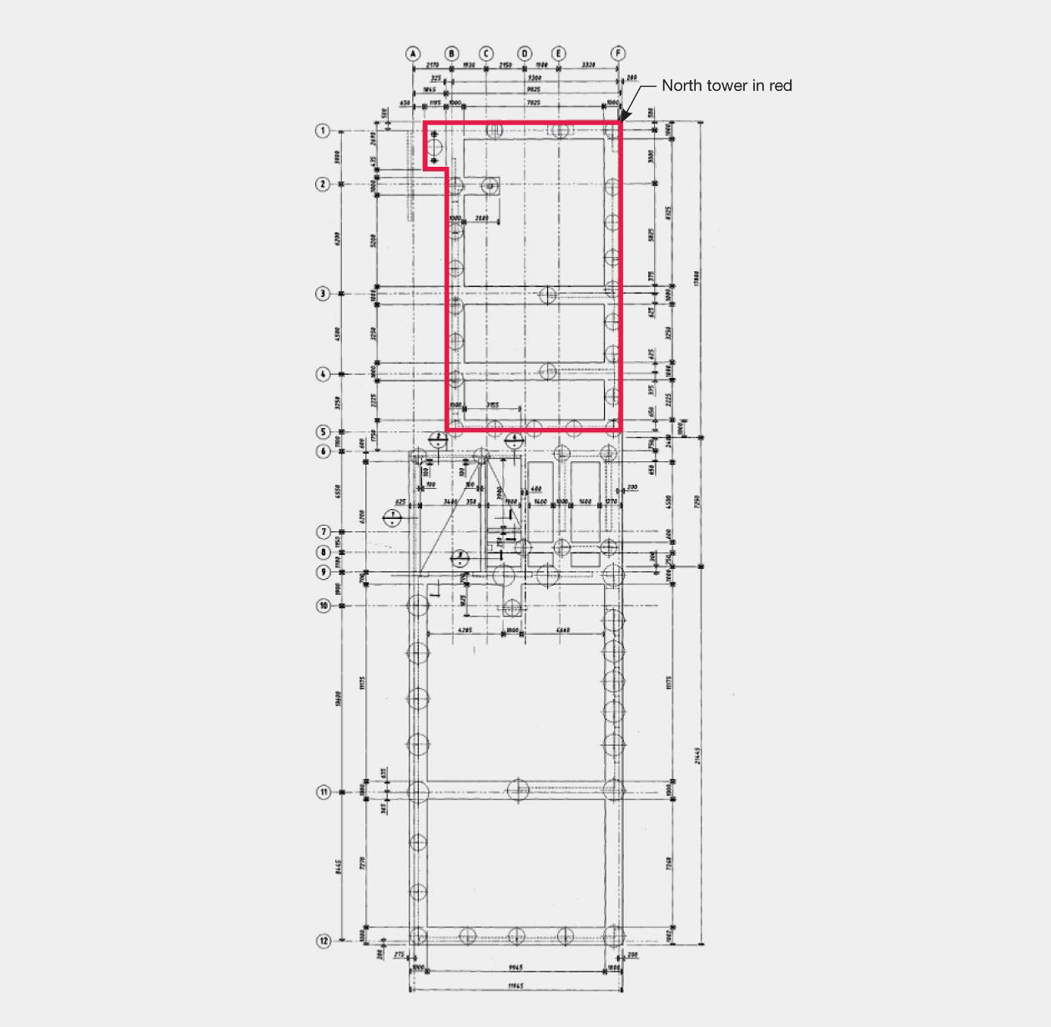

Figure 118: Foundation plan; dimensions shown in Figure 119 on page 182

6.5.1.3 Floors and gravity load system

The ground floor was a 100mm thick on grade reinforced concrete slab. The floors above the ground floor in this tower comprised Interspan precast prestressed concrete ribs with timber infill and a 135mm thick in situ concrete topping reinforced with cold drawn mesh. The ribs spanned between the eastern and western walls. They were supported on a cast-in-situ edge beam (Figure 119).

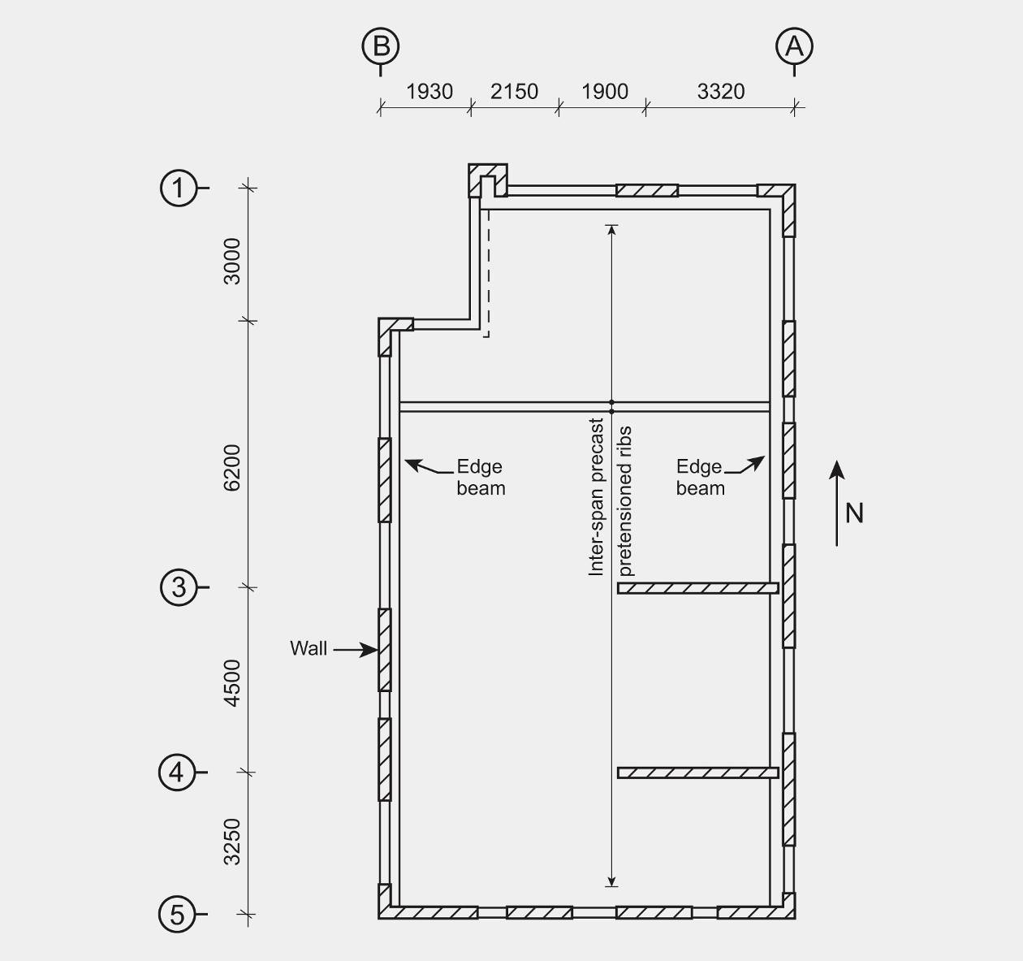

Figure 119: Typical floor plan of northern tower

6.5.1.4 Seismic system

The seismic system consisted of structural walls built up from precast panels 175–325mm thick. Each panel was typically two storeys high and continuity of reinforcement was provided by grouted couplers at the horizontal junctions between the panels.

6.5.1.5 Structural damage

The damage to the northern tower as a result of the February earthquake is recorded in a report dated 20 May 2011 and prepared by the Holmes Consulting Group Ltd (HGC):

|  |
| --- |
| Our inspection did not include invasive opening up of linings or floors and ceilings therefore only a selection of exposed structure was reviewed. The most obvious structural damage observed is as follows:  • The column in the north-west corner of the northern tower appears to have settled. This can be seen from the street and is observable in the suspended floors when walking around the apartments.  • Failure of the precast panel connections on the western elevation of the northern tower. USAR engineers have advised that reinforcing bars have fractured over significant lengths of these walls. External steel straps have been provided by contractors as a temporary securing measure.  • Failure of the internal shear wall at ground floor level in the northern tower. Significant shear cracking is apparent. USAR engineers have advised the reinforcing had buckled in the end of the wall. Prior to our visit contractors have provided a steel jacket to the end of the wall to provide some confinement. Steel straps are welded to the jacket and fixed through the wall to provide some shear capacity and hold the jacket in place. There is a vertical crack in the end of the wall above the steel jacket which may indicate the reinforcing steel is beginning to buckle in this area also.  • Uneven floor surface at the two internal shear wall locations in the northern tower. Floors are raised in these areas suggesting either settlement of the side walls or elongation of the shear walls due to yielding of reinforcing steel.  • Damage to the floor outside the passenger lifts and at the seismic joint between the two towers is evident. The exact extent of this can’t be determined without stripping back the finishes.  • Shear cracking of front wall (northern tower) at level 6 has occurred. “Gib” plasterboard has popped at this level and allowed inspection, other levels were not inspected.  • Flaking of paint to SHS balcony column, possibly due to flexure (level 3).  • There appears to be a lack of grout in the Reid couplers at front of car lift which should be investigated further to confirm. If so, the tension capacity of these reinforcing bars cannot be relied upon.  • Shear cracking has occurred in the in situ concrete floor stitch beams at panel openings. Some concrete spalling of the Interspan rib adjacent to the support connection was also apparent in one location.  • Movement is visible between the precast stair units at the in situ concrete stitches and at the precast unit to landing connection.  In conclusion, the building has sustained severe damage. Although it is not considered an immediate overall collapse hazard, the building is not safe to spend any significant amount of time in due to the extent of structural damage and the high possibility for unknown damage still not identified. |

It can been seen from the floor plan (Figure 119), that the lateral force resisting system in the east–west direction is highly eccentric to the centre of mass, while there is little eccentricity for seismic forces acting in the north–south direction.

6.5.1.6 Structural assessment

The Royal Commission was assisted in the assessment of the performance of this building by a report prepared by Spencer Holmes Ltd.

According to a design features report that was submitted to the CCC with a building consent application, the building was designed using the Earthquake Actions Standard, NZS 1170.5:200410 and the Concrete Structures Standard, NZS 3101:199523. A modal response spectrum analysis was used to determine the seismic design actions. A geotechnical report recommended that the foundation soils be assumed to be type D. The analysis was made based on a seismic hazard factor of 0.22 and a structural ductility factor of 3. From the modal analysis, the designers determined the fundamental periods of vibration of the northern tower in the east–west direction to be close to 4 and 3.5 seconds respectively (depending on whether the accidental eccentricity was placed to the north or south of the calculated centre of mass). The corresponding periods for the north–south direction were close to 3.7 seconds and in this case the offset for accidental torsion to the east or west of the centre of mass had little effect.

In the building assessment carried out by Spencer Holmes, the fundamental periods of vibration in both the east–west and north–south directions were calculated to be close to 3 seconds. This assessment was based on an equivalent static analysis and the assumption that the effective section properties of the walls were equal to 0.34 times the gross section properties. Given the limited spread of cracking observed in the walls, the Royal Commission considers that the effective fundamental period was in the range of 2.0–2.5 seconds in both the east–west and north–south directions. Because of the lower periods of vibration the seismic design forces would have been higher but the displacements would have been smaller than those used in the design.

The relatively long fundamental periods of vibration quoted in the design features report indicated that a relatively low stiffness must have been assumed for the design of the walls. From this it was evident that the predicted inter-storey drifts would have been high.

The commentary to NZS 3101:199523 recommends that the section properties be taken as 0.25 times the gross section properties to allow for flexural cracking. We consider such a low value as 0.25 is not appropriate for structural walls where only limited flexural cracking is possible owing to the low reinforcement content. This problem should be addressed in the commentary to the current edition of NZS 3101:199523.

The centre of lateral resistance in terms of both strength and stiffness was highly eccentric to the centre of mass for seismic actions in the east–west direction (see Figure 119). As a result, earthquake shaking in the east–west direction induced high torsional actions into the building. Spencer Holmes found that this direction of seismic forces induced higher critical actions in the eastern and western perimeter walls than when the corresponding seismic forces were applied in the north–south direction. The eccentricity for the north–south seismic actions was small. In the September event, for the period range of 2.0-3.0 seconds the seismic actions in the north–south direction were dominant and the corresponding values in the east–west direction appreciably smaller (see Figures 2 and 3 in section 1 of this Volume of the Report). In the February earthquake, the east–west motion dominated more than the north–south motion. This could explain why the building was not significantly damaged in the September earthquake but suffered major damage in February.

6.5.1.7 Discussion: Structural detailing

6.5.1.7.1 General

The choice of a structural ductility factor of 3.0 by the designers, combined with the use of the Concrete Structures Standard, NZS 3101:199523, required the use of limited ductile detailing in the structure. However, inspection of the drawings indicated that nominally ductile detailing was used, but referred to as “elastically responding” in NZS 3101:199523. The structural walls did not contain the confinement reinforcement required in their compression zones, as specified in the Concrete Structures Standard, NZS 3101:199523. Hence, there was a mismatch between the assumed design ductility and the detailing. With nominally ductile detailing the structural ductility factor was 1.25; the corresponding base shear should have been at least twice as high as that corresponding to a structural ductility factor of 3.0.

6.5.1.7.2 Structural walls

Appreciable spalling of concrete occurred in the wall on grid line 3 at ground level, to the extent that temporary securing was judged necessary by Urban Search & Rescue (USAR) engineers immediately after the February earthquake. The confinement required for limited ductile structures would have limited this structural damage and the extent of the spalling that occurred at this location, as well as securing structural safety.

Spalling of concrete in the walls was observed to expose some of the couplers used to join the longitudinal reinforcement at the junctions between the precast panels (see Figure 120). The size of these couplers located close to the face of the wall increased the likelihood of spalling. The stability of the couplers would have been assured if they had been restrained by reinforcement anchoring them into the body of the wall.

During an inspection of the building after the February earthquake it was noticed that a number of the couplers joining the wall panels had not been grouted.

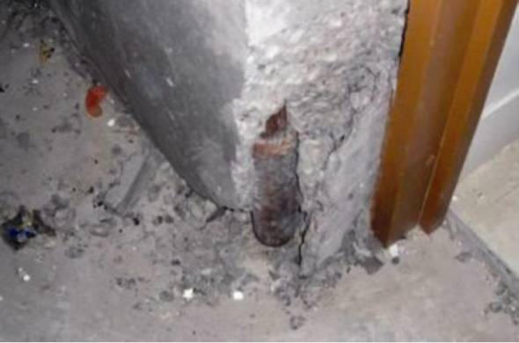

Figure 120: Spalling of concrete exposing the couplers at the bottom of structural walls (source: Spencer Holmes Ltd)

Examination of one of the walls showed that the expected crack pattern of primary and secondary cracks that had been observed in structural tests did not develop in this building. Instead, in many cases only one relatively fine crack was found in the anticipated plastic hinge zone of each wall. When the concrete had broken out at one of these cracks it was found that the bars had failed in tension. We assumed that the gravity load acting on the walls would have been sufficient to close the crack after the earthquake, causing any reinforcement in the mid-region of the wall that had not failed in tension to yield back in compression. Hence, only narrow cracks were evident after the earthquake.

There appeared to be two reasons for this unanticipated behaviour. First, there was insufficient reinforcement to induce the formation of secondary cracks in the concrete and, consequently, yielding of the reinforcement was confined to the vicinity of the primary crack. Secondly, the development and yield penetration into the concrete on each side of the crack was much less than had been anticipated.

To assist in establishing the reason for the formation of single cracks in the walls in the potential plastic hinge zones, the Royal Commission requested Holmes Solutions Ltd to investigate the properties of the concrete. They cut four cores from structural walls near the front of the building. Two were tested in compression and two were subjected to split cylinder tests to determine the tensile strength of the concrete. In addition, Schmidt Hammer tests were carried out on the structural walls on the northern and southern sides of the building. The core tests indicated cylinder compression strengths of 56 and 46.5MPa with associated tensile strengths of 2.4 and 3.4MPa. It should be noted that the coefficient of variation for tensile strengths was very much higher than the corresponding value for the compression strengths. Hence, little reliance should be placed on the tensile strengths. The Schmidt Hammer tests indicated the concrete compression strengths ranged from 54 to 70MPa.

Inspection of the drawings indicated that Grade 500 reinforcement was used on the walls and the proportion of longitudinal reinforcement in the potential plastic hinge zones was generally 0.0017–0.0022. The minimum reinforcement permitted in NZS 3101:199523 was 0.0014. The corresponding minimum given in NZS 3101:200612 is dependent on the grade of concrete used. For 30MPa concrete, the minimum proportion of longitudinal reinforcement is 0.0028.

To form a secondary crack, the strain-hardened strength of the reinforcement crossing a primary crack must be sufficient to stress the concrete surrounding the bars to a level that exceeds its tensile strength. Several walls in the first two storeys were 325 mm thick and were reinforced in the longitudinal direction (vertical) with 12mm Grade 500 reinforcement placed on each side of the wall at a spacing of 420mm. The critical location for the formation of a secondary crack is at a level where there is horizontal reinforcement immediately above the existing crack. Hence, for the purposes of assessing secondary crack formation the effective width of the wall was the width minus the area taken up by the horizontal bars, which in this case was 325 – (2x12) = 301mm. As the longitudinal bars are at a spacing of 420mm, the effective area of concrete related to two bars (one on each side of the wall) was 301 x 420 = 126 420mm2.

The tension force carried by the two bars was equal to the cross-sectional area of the bars multiplied by the strain-hardened stress that may be resisted by the reinforcement. For Grade 500 bars, the strain-hardened stress should be equal to, or greater than, 1.15 times the design yield stress, giving a value of 575MPa and a total tension force of 133kN in the two bars. The corresponding stress in the concrete was 1.02MPa. The minimum measured tensile strength of the concrete was 2.4MPa. For comparison, the corresponding average tensile strength predicted from the CEB-FIP Model Code24 for 30MPa concrete was 2.9MPa, and for 46MPa concrete it was 3.9MPa. Clearly, secondary cracks could not be expected to form.

In the current Concrete Structures Standard NZS 3101:200612 the minimum reinforcement proportion has been increased to

≥ 0.0014 in NZS 3101:199523.   
For 30MPa concrete, the minimum proportion of reinforcement was close to twice the previous minimum value. However, even the more recent provision for minimum reinforcement only corresponds to a tensile strength in the concrete of close to 1.4MPa.



6.5.1.7.3 Incompatible deformation of walls

The walls on grid lines 3 and 4 are positioned close to separate walls on grid line F. These four walls formed two pairs, each in a T-shaped configuration (see Figure 121). In each pair the two walls were connected to the floors but not directly to one another. When the walls were subjected to seismic actions in the east–west direction incompatible displacements were induced between them, as shown in Figure 121. This deformation broke up the floor in the area close to the junction of the walls.

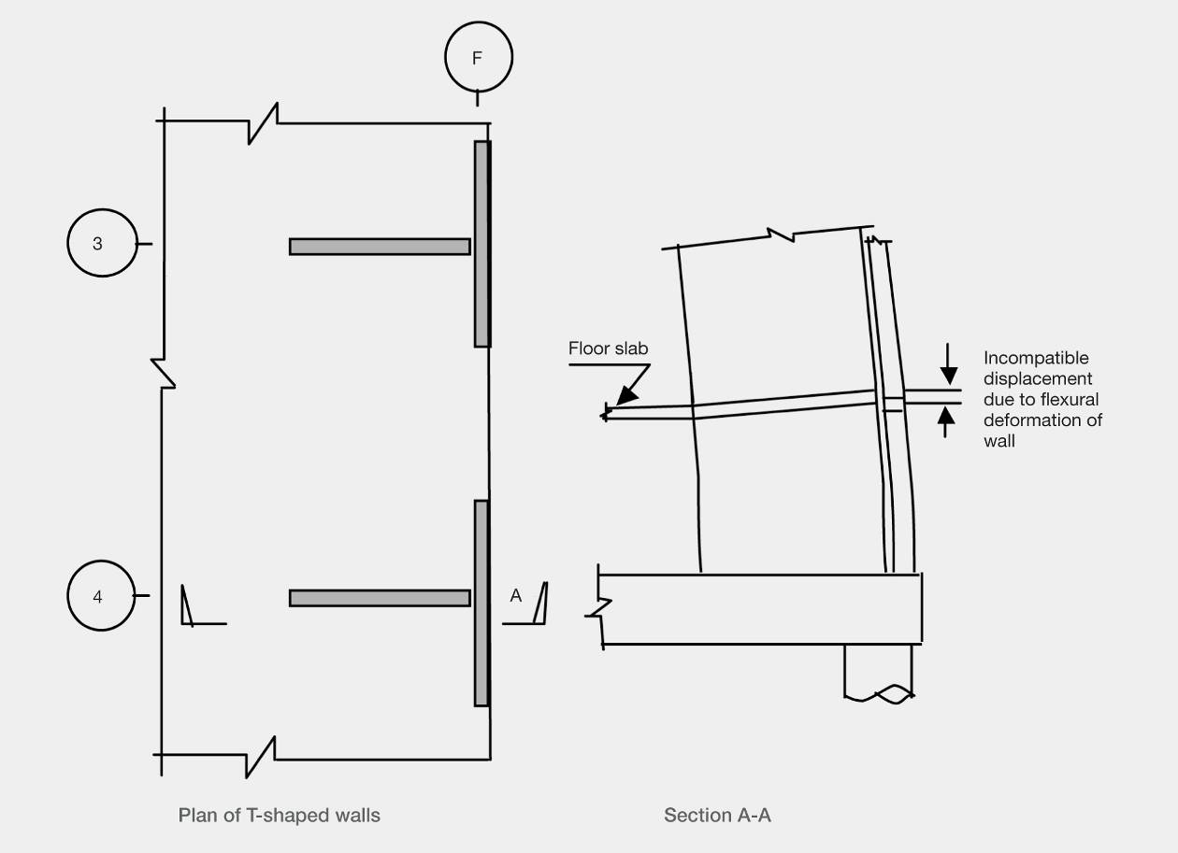

Figure 121: Incompatible displacement between structural walls

6.5.1.7.4 Support of precast ribs on walls

The Interspan ribs were supported on in situ concrete edge beams cast against concrete panels that formed the structural wall. A typical detail is shown in Figure 122. With this arrangement, the web of the pretensioned rib was supported by shear friction. This detail did not perform well and spalling occurred in the ribs and in the edge beam. Figure 123 shows the spalling that exposed the pretensioned strands. At the ends of the ribs in the transfer length of the strands, there were high bond stresses that increased the tendency for spalling to occur.

Shear friction strength decreases with increasing crack width. Reliance on shear friction for load transfer in such situations was uncertain. Out-of-plane displacement of the wall would apply a prising action to the rib and the pretension strands anchoring it into the edge beam. Consequently the clamping force acting across the crack, which supports the rib, can be lost. In this event, the rib relied on support through the in situ concrete topping. A diagonal tension force must be sustained in the web of the rib, as shown in Figure 122, to transmit this force to the topping concrete. This is not a reliable load path, so positive bearing support on the lower surface of precast floor units should be used.

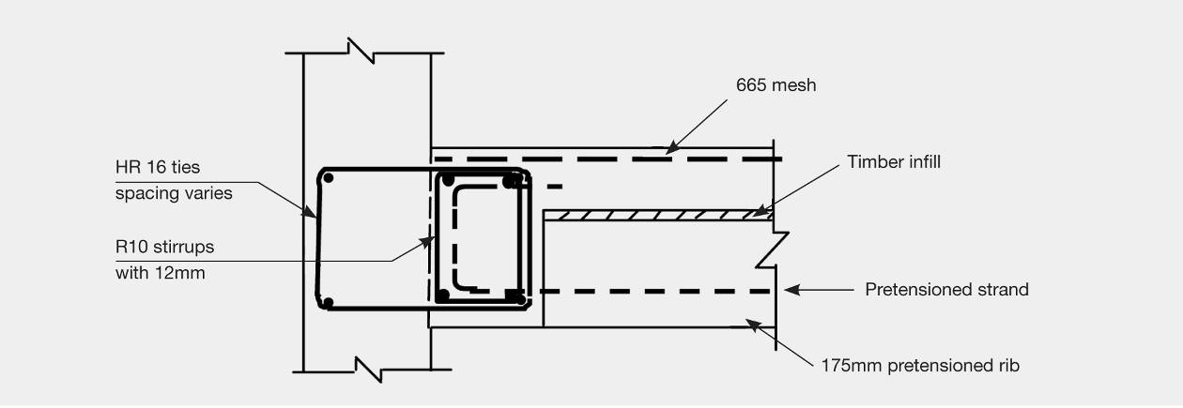

Figure 122: Support of the pretensioned rib on the edge beam

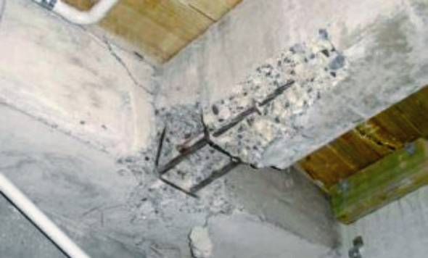

Figure 123: Exposed prestressing strands from the Interspan rib into the edge beam (source: Spencer Holmes Ltd)

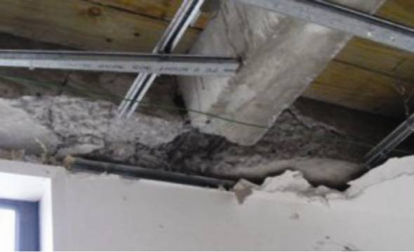

Figure 124: Spalled rib and edge beam (source: Spencer Holmes Ltd)

The longitudinal edge beams were continuous along the eastern and western walls. With in-plane deformation of the walls, high flexural and shear forces were induced in these beams by the imposed deformation. The edge beams were separated from the structural walls for a distance of 800mm at the gap between adjacent walls. These edge beams were not detailed for ductility.   
Figure 124 shows the damage in one of these beams.

6.5.1.8 Conclusions

We conclude that:

1. The building was analysed as having limited ductility but detailed as if it was nominally ductile (elastically responding in terms of NZS 3101:199523). For a nominally ductile structure the Earthquake Actions Standard, NZS 1170.510 would require the building to have a minimum strength of close to twice the corresponding value associated with the assumption of limited ductility (structural ductility factor of 3).

2. The longitudinal reinforcement in the walls complied with the minimum requirements in the Concrete Structures Standard, NZS 3101:199528. However, the crack patterns showed there was insufficient reinforcement to cause secondary cracks to form. The yielding was confined to the primary crack and the high strains imposed caused some of the bars to fail in tension.

3. The current Concrete Structures Standard, NZS 3101:200612, has increased the minimum area of longitudinal reinforcement that must be used in walls. However, even with this increased area it was doubtful whether there would have been adequate reinforcement to generate secondary cracks, which would have allowed the yielding to spread, so reducing peak strains in the reinforcement.

4. The walls were designed and detailed to act as rectangular members. However, in two locations they were mounted at right angles in a T-shape. Both walls were joined to the floor so they were effectively coupled at these locations. Under seismic actions incompatible displacements were imposed on the floor slab and these zones were damaged.

5. In situ concrete edge beams were tied into the precast walls to provide support for the precast floor ribs. At the gap between the walls, the edge beam was separated from the walls by a distance of 800mm. In-plane deformation of the walls resulted in incompatible deformations being imposed on some of these beams and they were extensively damaged. The damage would have been reduced, but not prevented, if the nominally ductile detailing used had been replaced by ductile detailing in the edge beam. We note that the current Standard,   
NZS 3101:200612 would require ductile detailing of this beam, while the 1995 edition only required limited ductile detailing.

6. The precast prestressed floor ribs were supported by shear friction against the side of the in situ edge beams. Appreciable spalling of concrete occurred below the pretensioned strands and into the face of the edge beam. The ability of this form of support to provide safe support to a floor is questionable, because out-of-plane movement of the wall applies a prising action to the units and the pretensioned strands (which apply the clamping force necessary to sustain shear friction transfer). The prising action destroys the clamping force required for shear friction to act.