6.4 1992 to 2008: Buildings designed to Loadings Standard NZS 4203:1992²²

6.4.1 100 Armagh Street: Victoria Square apartment building
Current status
Future yet to be determined, possibly to be relevelled.
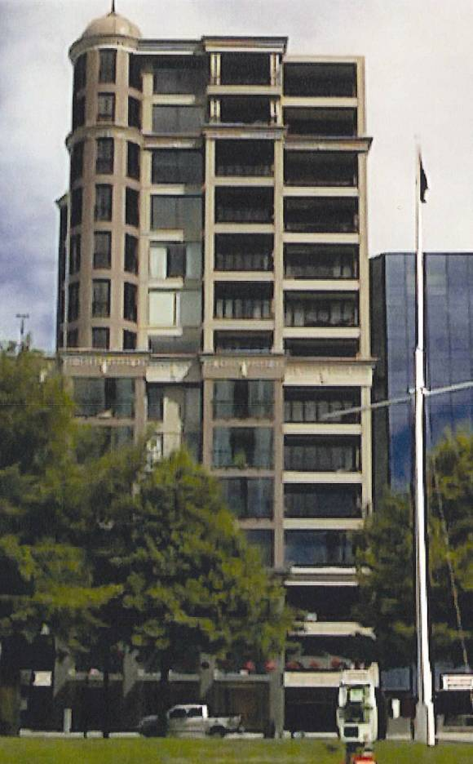
Figure 114: View from north (source: Compusoft)
6.4.1.1 Introduction
Victoria Square is a 14-storey reinforced concrete apartment building designed in 2004 using NZS 3101: 199523 and NZS 4203:199222. A building consent was also approved (in three stages) in 2004, with a final code compliance certificate issued in 2007.
The building consists of a podium from the ground floor to the fourth floor of about 650m2 per floor. The floor area of the fifth to the seventh floors is about 475m2 per floor, and above that the floor areas are about 300m2 per floor (see Figure 114).
6.4.1.2 Ground and foundations
The building foundations consist of a combination of piles and shallow concrete pads.
The piles are 1200mm diameter reinforced in situ concrete tension piles founded within a sandy gravel layer below the building. They vary from 6–18m in depth. They are on the east, west and south on the perimeter of the building, as shown in Figure 115. The piles are linked by foundation beams that are intended to resist compression loads.
The concrete pads are within the building and along its northern perimeter under isolated columns, and also under the liftshaft and other internal walls.
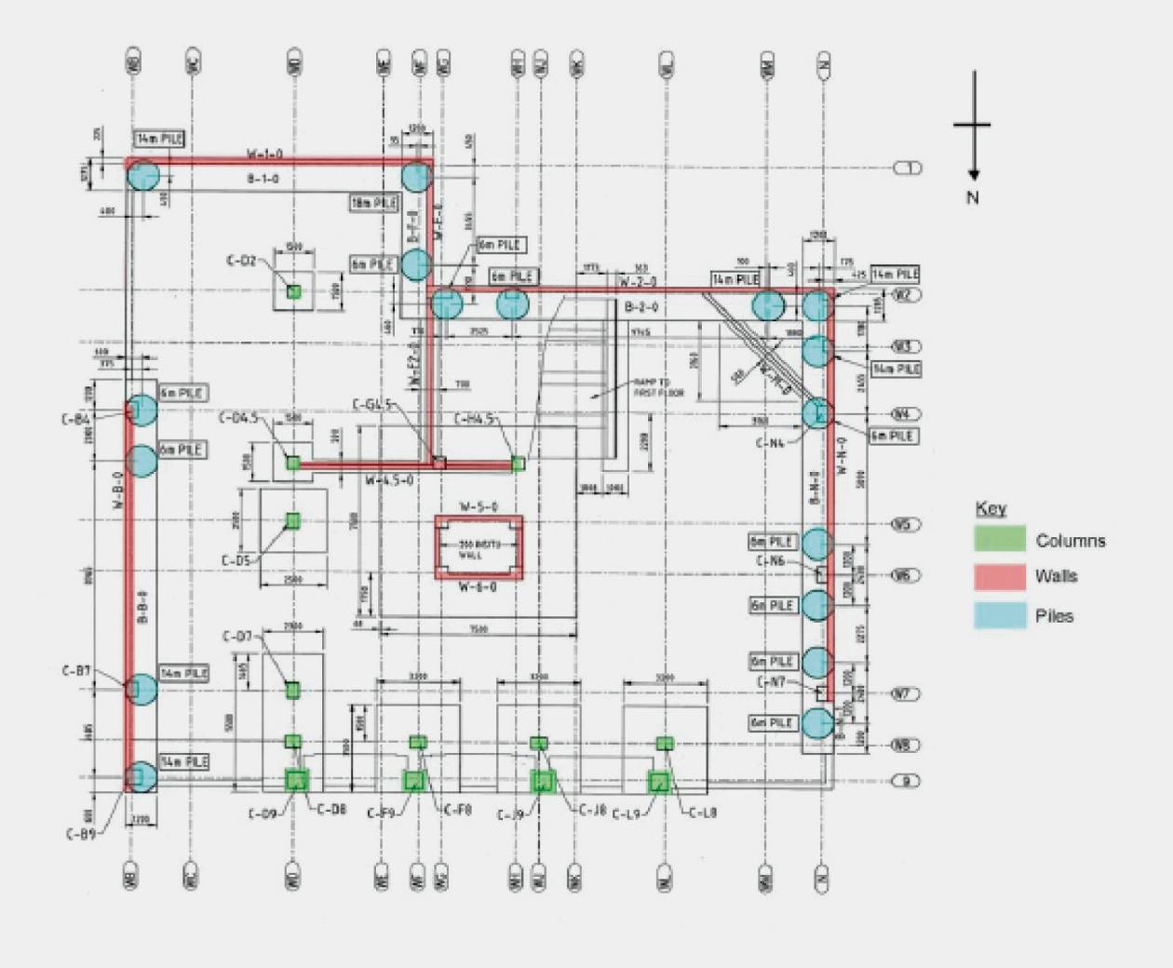
Figure 115: Pile layout (source: Compusoft)
6.4.1.3 Structure
From the information available the Royal Commission concluded that the failure of the foundations was the most significant damage to the building. For this reason the above-ground structure is not discussed further in this Report.
6.4.1.4 Performance of the building
The Royal Commission was assisted in its assessment of the building by a report prepared by Compusoft.
Assessment of the building after the September earthquake indicated that there was no significant structural damage to the Victoria Square building as a result of that earthquake. Only minor non-structural cracking was seen.
After the February earthquake, damage reports included minor cracking of concrete shear walls, spalling of concrete at stair landings and damage to non-structural cladding panels.
Although the structural damage resulting from the February earthquake was minor, the earthquake caused a significant permanent overall displacement of the Victoria Square building. The magnitude of this displacement was reported as about 450mm at the top of the building, or 0.8 per cent drift. This displacement is clearly visible in photographs. Survey results indicated that the total displacement/drift can be attributed to settlement of the foundations. The structure was found to have settled by 220mm at the north-western corner and 160mm at the north-eastern corner (both levels relative to the south-eastern corner).
6.4.1.5 Discussion
The reasons for the foundation settlement appear to be readily explainable. Two different factors contributed to the differential settlement:
• the layout of the different types of foundation element under the structure; and
• the distribution of soil liquefaction in the vicinity of the structure during the earthquake.
From preliminary maps presented in the Royal Commission Interim Report, Compusoft interpreted that the boundary of severe liquefaction extended from the north to the front face of the building. Based on available geotechnical information they considered it was most likely that liquefaction at the northern side of the Victoria Square building would have occurred at depths of 8–14m, with some possibility of liquefaction from 16–20m.
The failure of the ground, together with shallow foundations not designed for liquefaction at the northern side of the building, would have resulted in the significant rotation towards the north. The structure also experienced a less significant rotation to the west. The principal cause of this rotation is likely to have been structure-soil-structure interactions, specifically, the existence of a second large structure immediately to the west of the Victoria Square building (Craigs Investment House, 90 Armagh Street, which is also assessed in this Report) (Figure 88, page 142). This would have resulted in both structures influencing the stress state of the soil in the vicinity of the boundary line. A secondary contribution may have been the provision of piles of only 6m in length at the north-western corner of the structure. Such short piles are unlikely to have penetrated below the liquefiable material under this region of the structure (Figure 116).
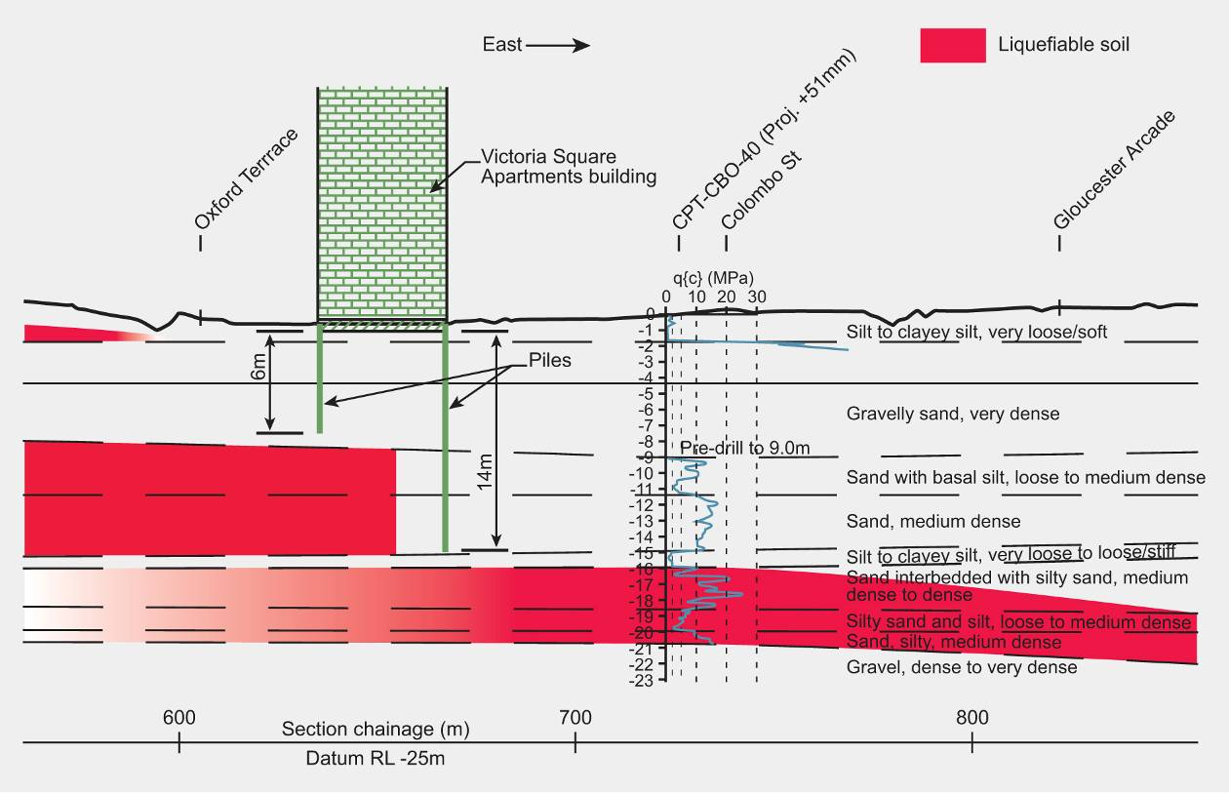
Figure 116: Cross-section from west to east showing the zones of liquefiable soil (source: Compusoft)
6.4.1.6 Conclusions
The February earthquake resulted in a significant overall rotation of the structure. This rotation was caused by severe liquefaction immediately to the north of the structure combined with the shallow foundation elements on that side of the structure. There are two key points from the performance of this building:
1. The geotechnical conditions in the vicinity of a structure, as well as directly under the structure, should be considered as a part of design.
2. Particular consideration should be given to the underlying geotechnical conditions when specifying hybrid foundations for a structure.

