6.3.5 78 Worcester Street: Clarendon Tower building
Current status
Demolition had commenced at the time of writing.
Figure 109: View from the north-west
6.3.5.1 Introduction
The Clarendon Tower building (Figure 109) was designed in 1987 and was approved for construction by the CCC in two building permits issued that year. The building had a total of 20 levels, the lowest level being a part basement and the uppermost two levels being smaller service levels for the plant and lift rooms.
The ground floor and the level above this was a podium that covered the site. It was about 40.4m by 50.5m. The tower (Figure 110) above this was offset to the north-west and measured about 24m by 37m. On part of the northern and western faces of the building the original three-storey historic façade was retained.
The majority of the levels were used as offices, with some retail activities on the ground floor and the level above this. Parking was provided from the basement up to the roof of the podium.
The building was about 43m from the banks of the Avon River at its closest point.
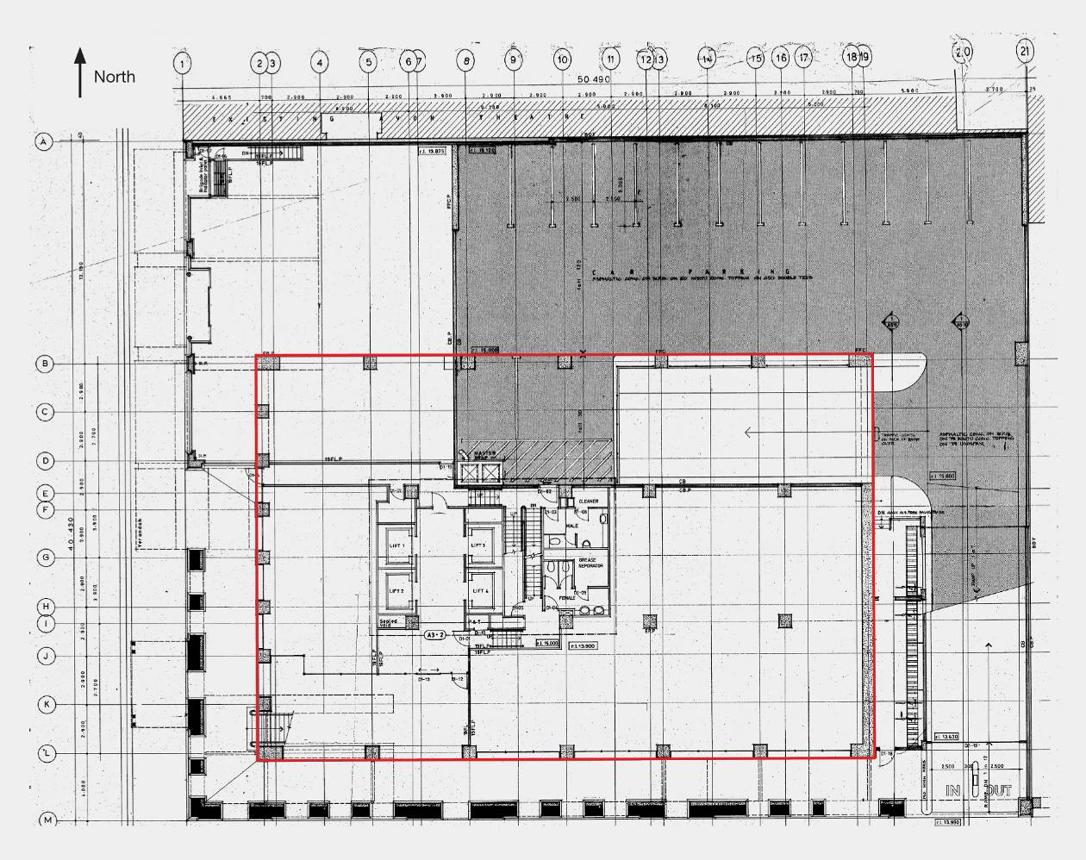
Figure 110: Ground floor. Tower structure above is outlined in red; dimensions of the Tower are shown in Figure 111 on page 170
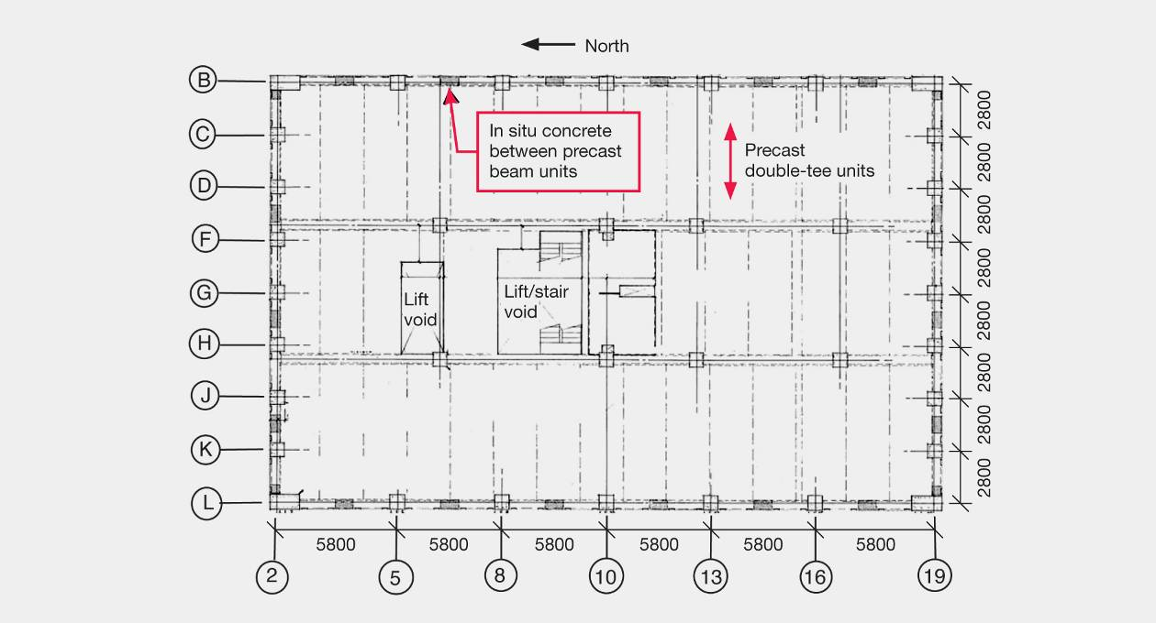
Figure 111: Typical tower plan
6.3.5.2 Building structure
The building was founded on a reinforced concrete spread footing. There was no evidence of liquefaction or ground spreading in the immediate vicinity.
The floors were flange-hung 250mm deep precast double-tee units with 65mm minimum of seating and overlaid with a 60mm cast-in-situ topping reinforced with cold-drawn wire mesh. The topping was required to act as a diaphragm. The tees spanned about 7.7m from east to west, being supported on grid lines B, E, I and L with precast beams, which in turn were supported by cast-in-situ columns.
Lateral force resistance was provided predominately by perimeter moment resisting frames. In the perimeter frames on the eastern and western faces of the tower there were six bays in the frames: four that spanned 5800mm and two that spanned 6500mm. In the corresponding moment resisting frames on the northern and southern faces there were eight bays in the frames, each having a span of 2900mm. A consequence of this was that the building was about twice as stiff for lateral deflection in the east–west direction as in the north–south direction.
The columns in the perimeter frame were cast-in-situ and were 800mm by 800mm, except in the corners, where they were 1500mm by 800mm. The beams were precast so that they fitted over the columns with the column reinforcement passing through ducts in the precast beams, the ducts being grouted after the beams were fitted in place. In situ concrete was cast to join the beams together. In the in situ zone between the beams, the reinforcement was bent into the diagonal, as shown in Figure 112(a). The ends of the reinforcing bars, labelled B in the figure, were welded to steel plates. The plates were bolted together to establish the continuity of the reinforcement. Closely spaced ties were provided over the length of the diagonal bars to prevent buckling of this reinforcement (for clarity these ties are not shown in Figure 112). In the in situ concrete there were some relatively small bars in the top and bottom of the beam, with some stirrups to form a light cage of reinforcement (not shown in Figure 112). Additional reinforcement was placed along the length of the precast beam to increase the flexural strength and prevent yielding caused by flexure.
In the north–south direction continuity was established by hooked laps for the bottom bars and straight laps for the top bars, with stirrups passing around the top and bottom reinforcement.
6.3.5.3 Building performance in the earthquakes
The Royal Commission’s understanding of the performance of the building has been assisted by a report dated February 2012 by Rutherford and Chekene, consulting engineers, of San Francisco, prepared at the request of the Royal Commission. Based on that report, the Royal Commission finds that in the 4 September earthquake there was extensive cracking in the floor and limited cracking in some of the beams. The floor cracks in some cases were several millimetres wide and some of the mesh in the topping concrete had fractured. These cracks were injected with epoxy and where mesh had fractured (or it was suspected to have fractured), additional reinforcement was set into the topping concrete. The repair work on the building was essentially completed before the 22 February 2011 earthquake.
In the February earthquake, very extensive cracking occurred in the floor diaphragm with wide cracks developing between the northern and southern frame perimeter beams and the double-tee precast floor units. The crack widths were of the order of 20–30mm and 10–20mm wide at the northern and southern ends of the building respectively, with the mesh fracturing at these cracks.
Wide cracks of the order of 10mm also developed between the double-tee units and the intermediate internal beams.
There were pronounced flexural and diagonal cracks in the beams, some up to 15mm wide in levels 7 and 8. This cracking was located close to the junctions between the precast beams and in situ concrete joining the beams together. In addition, some cracking occurred in the beams at the column faces. Cracking in the floor caused the mesh in the topping concrete to fail in a number of regions and in some cases the elongation greatly reduced the support length for the double-tee floor units, leading to concern that support for some of the double-tee units could be lost.
Frame elongation was found to be greater in the north perimeter frame and was 20–50mm in some of the floors, resulting in failure of the mesh that connected the topping concrete in the floors to the perimeter beams. With this connection broken, the tie between the floor and some of the columns was lost. Compression forces in the beams caused by elongation resulted in the columns bowing outwards from the floors. The frame on the northern side of the building suffered more damage than the frame on the southern side.
In the February earthquake the stairs collapsed over several levels. This was explained by an inadequate separation that resulted in the stairs being subjected to compression, and led to compression/flexural hinging at the centre of the stairs, in a similar manner to that observed in the Forsyth Barr building.
6.3.5.4 Analysis of the building
Rutherford and Chekene assessed the fundamental periods of vibration to be in the order of 2.5 and 1.9 seconds in the longitudinal (north–south) and transverse (east–west) directions respectively. In addition, they noted that their respective second mode periods were about 0.8 and 0.7 seconds, and that there was a torsional mode with a period of about 1.25 seconds. This torsional mode was a result of the podium being offset from the centre of the tower and the original heavy façade of the previous building on the site being retained with the new structure. The section properties they used in their analysis were comparable to those recommended in the commentary to the Concrete Structures Standard, NZS 3101:2006¹².
With reference to Figures 2–5 shown on pages 9 and 10 in this Volume, it can be seen that in the September earthquake a building with a fundamental period close to two seconds is likely to have been subjected to earthquake actions in the east–west direction that were comparable to design values given in NZS 1170.5¹⁰. In February, the corresponding values were of the order of twice the design level. In the north–south direction, the earthquake actions in the September earthquake were close to twice the design level actions while, in February and June respectively, the corresponding values were about 40 per cent and 20 per cent in excess of design values.
Rutherford and Chekene analysed the building using the Model Response Spectrum method with response spectra for the four earthquake records recorded in the Christchurch CBD and a design response spectrum, including a S_{p} factor of 0.7, as defined in NZS 1170.5¹⁰ for the type D soil conditions of Christchurch. The assessment of inter-storey drifts in levels 5 to 10 ranged from 1.3–2.8 per cent for deflections in the east–west direction. The drifts in the north–south direction were appreciably less. Rutherford and Chekene also indicated that owing to the torsional mode the predicted inter-storey drifts were a little greater in the northern perimeter frame than in the southern perimeter frame.
6.3.5.5 Discussion: beams and floor slab
The beams were designed to deform in a shear mode similar to the approach used in coupling beams between structural walls. With these kinds of beams the diagonal reinforcement is intended to yield in tension and compression. The approach has been well tested in laboratories and used extensively around the world¹⁷. The intention with the Clarendon Tower beams was that any inelastic deformation would be sustained by yielding of the diagonal bars. This arrangement, as noted above, has been observed to give good ductile performance in coupled walls.
To achieve the objective of limiting any inelastic deformation to the diagonal reinforcement when this detail is used in the mid-region of a beam, additional flexural strength must be added to the beam outside the zone containing the diagonal bars. In an attempt to achieve this objective, additional flexural reinforcement was placed in the precast beam unit. Looking at the beam in elevation, we consider this additional reinforcement formed a continuous loop around the perimeter of the beam with the bars bent at 90 degrees in the corners (see bars marked A in Figure 112). As shown in Figure 112, this additional reinforcement was placed on either side of the bars that were bent diagonally down in the in situ concrete. Assessment of the strengths in accordance with standard structural theory would indicate that the flexural strength was adequate to achieve this objective. However, tests of the strengths, which were carried out a few years after the building was constructed, showed that the detail did not work as intended¹⁸.
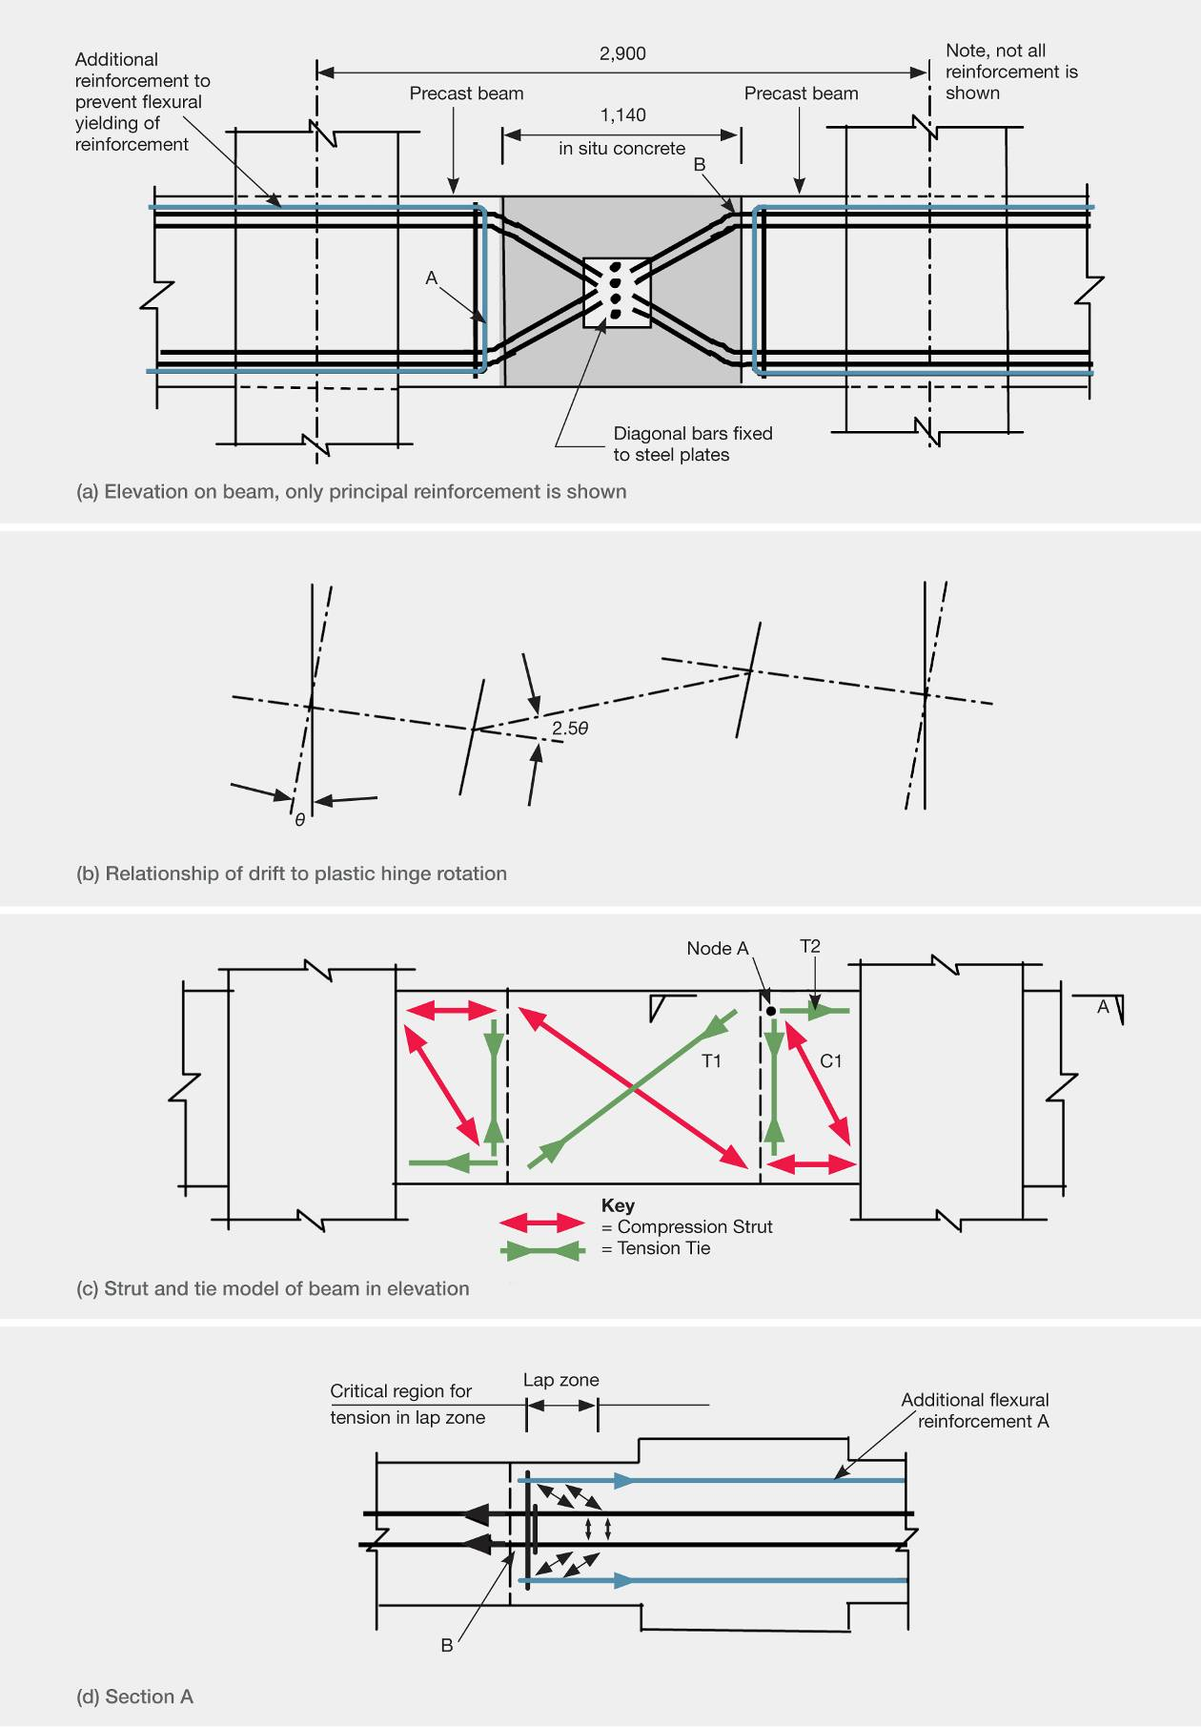
Figure 112: Strut and tie model of a coupling beam in the Clarendon Tower
A strut and tie analysis of the beam indicated that the critical section was located at the interface between the in situ concrete and the precast beam (see Figure 112(a)) and not in the diagonal reinforcement in the in situ concrete, as had been intended. The strut and tie model is shown in Figure 112(c). The magnitude of forces forming the strut and tie truss can be calculated from equilibrium. At node A in Figure 112(c), a tension force in the reinforcement, shown as T2, is equal to the horizontal component of the diagonal strut force, C1, plus the horizontal component of the diagonal bars’ tie force, T1. The diagonal compression force, C1, provides the shear resistance and acts against the bend in the diagonal bars at node A. Consequently, tension force, T2, is resisted in the horizontal extension of the diagonal bars immediately on the column side of the in situ concrete. The magnitude of tension force, T2, in the bars reduces over a short distance as bond action transfers some of this force to the additional bars, marked A in Figure 112(a) and (d). As a result, only a short length of this reinforcement sustains the inelastic deformation. Strain levels in the reinforcement were, therefore, high. The situation was not improved by the location of the bend in the reinforcement that would have strain-hardened the bars and caused strain-ageing to occur.
With the details as described above, it would be anticipated that yielding in the beam would be confined to the central bars in the precast beams where they were bent into the in situ concrete zone. This was shown to be the case in laboratory tests¹⁸. However, only the beam was modelled in the tests and not the floor slab close to the beam. When the floor slab, which contained precast prestressed units, was included in an assessment of the strengths it was found that the slab could add appreciable flexural strength to some regions of the beam but not to others. In some cases it was found that the inclusion of the likely contribution of the slab could explain why yielding had occurred at some column faces in addition to the critical sections at the end of the diagonal bars.
In this structure, elongation due to the formation of plastic hinges in the beams was a major cause of damage and reduced performance of the building in the earthquakes. Tests have shown that the magnitude of elongation in beams is primarily a function of the rotation imposed on the plastic hinges and the number and magnitude of the load cycles^{18,19,20,21}.
Figure 112 shows the deflected shape of the beam associated with inelastic deformation of the bars at the ends of the precast beam segments. It can be seen that the rotation of the plastic hinges is about 2.5 times the drift angle, which is much greater than would have occurred if the plastic hinges had formed at the column faces. It is clear that this detail greatly increased the elongation induced in the east–west direction of the building.
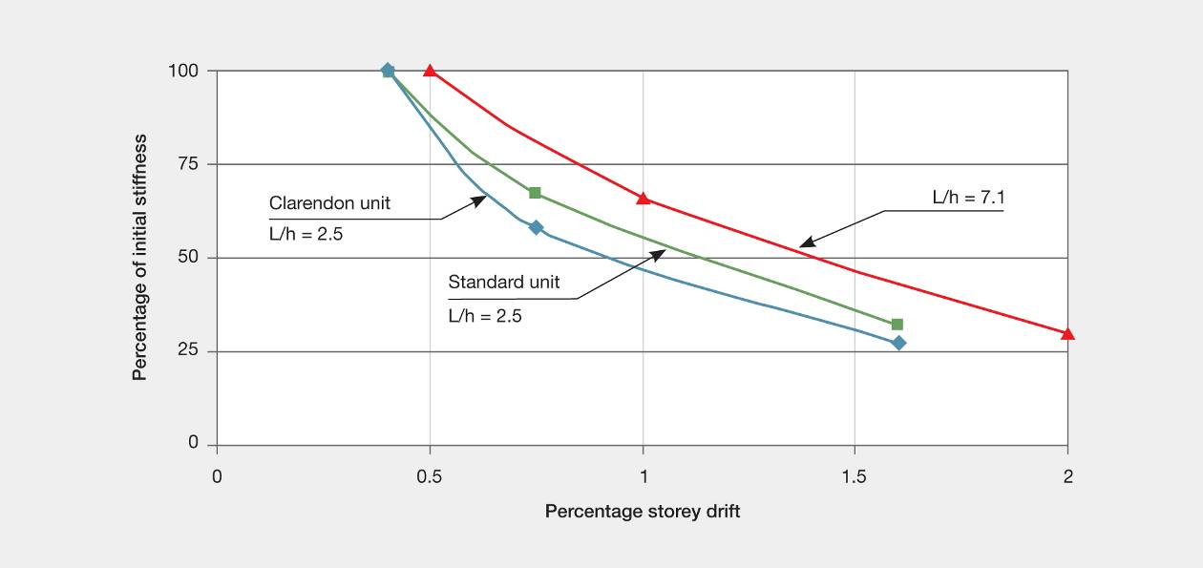
Figure 113: Stiffness shown as a percentage of initial pre-yield stiffness when reloading after the first half-cycle has been applied
Figure 113 shows some results of stiffness degradation of frames that have been subjected to inelastic deformation with plastic hinges forming in the beams. The initial stiffness was based on the load deflection characteristics measured in tests in which the test units were loaded to close to 75 per cent of their calculated flexural strength. The stiffness after inelastic loading to the given drift limit has been calculated from the observed load deflection characteristics when the load direction was reversed after the previous peak displacement. The stiffness was based on displacements in the range of a zero load to a value corresponding to 75 per cent of the theoretical strength. Three cases are shown in the figure. The first two come from reference¹⁸, the first being for the test unit representing the beam used in the Clarendon Tower. The second unit was from the same reference where the horizontal reinforcement between the two precast units was joined by using hooked bar laps. In both cases the ratio of clear span to depth of the beam was close to 2:5. The third test comes from a two-storey frame test²¹. In this case the clear span to depth ratio was close to 7:1. In all three cases no floor slab was included in the test units. It can be seen from Figure 113 that a very significant stiffness decrease occurs when only moderate levels of inelastic deformation have been imposed on the frames. For the beams with a low span to depth ratio the stiffness was reduced to close to 50 per cent of its initial value, while for the unit with a span to depth ratio close to 7:1, the stiffness was reduced to about 67 per cent of its initial value. If the floor slabs had been represented in the test units it is likely the stiffness degradation would have been smaller.
It was noted in the Rutherford and Chekene report that the northern end of the building sustained greater damage than the southern end. From the analysis, it was found that some torsion was induced in the building owing to the heavy façade and the podium in the first three levels; this was assessed as inducing greater lateral displacements of the northern end of the building than the southern end. Once inelastic deformation had been sustained in the northern end frame, the reduction in stiffness would have been significant. Even if this decrease had been half that indicated in Figure 113 it would have significantly increased the eccentricity of the seismic forces and further amplified torsional response; then the damage sustained at the northern end of the structure would have been even more pronounced.
6.3.5.6 Conclusions
We conclude that:
1. Faulty detailing of reinforcing in the perimeter frames on the northern and southern ends of the building led to inelastic deformation in regions where it was not anticipated and this reduced the ductility of the structure. A strut and tie analysis of the detail would have revealed the problem but the building was designed before this method of analysis was widely accepted by the engineering profession.
2. The detail used to connect the floor slabs (which acted as diaphragms) to the perimeter frames was not adequate for the forces that were induced. This was partly due to the high forces associated with elongation and partly to the use of non-ductile mesh. It should be noted that mesh was widely used for reinforcement in the in situ concrete placed above precast floor units until recently (2005).
3. Although the building had only minor irregularities in the structural system, the sustained damage indicates that it was subjected to a high torsional response. We conclude that this was largely due to the loss of stiffness in the northern frame, which greatly increased the eccentricity of the seismic forces to the effective centre of stiffness of the building. Examination of a number of results of tests on moment resisting reinforced concrete frames shows that for the type of beam used in the building, relatively small inelastic displacements
can significantly reduce the lateral stiffness. This would have accentuated the torsional response of the building.

