6.3.4 151 Worcester Street Building
Current status
Demolished.
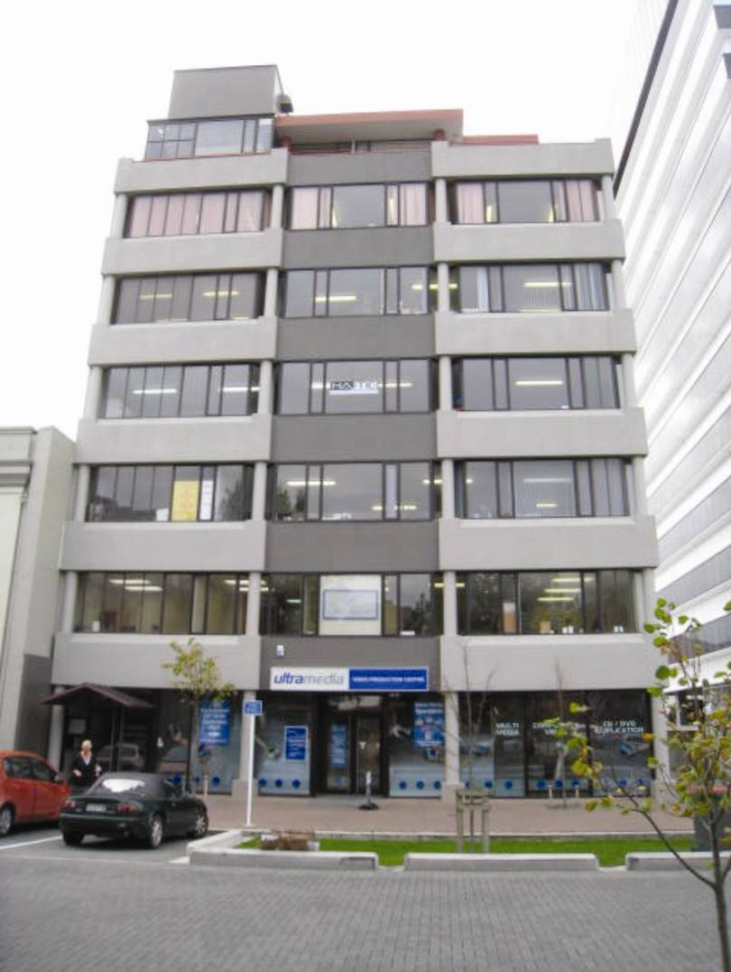
Figure 106: View from Worcester Street
6.3.4.1 Introduction
The building at 151 Worcester Street was designed in early 1987 and received a building permit in November 1987 after a late change in the location of the north-eastern ground floor column to accommodate the turning circle of a loading truck. This change in layout introduced some irregularity to the structure of the ground floor. It is assumed that the building was designed to satisfy the Loadings Standard current at the time, NZS 4203:1984¹³ and the Concrete Structures Standard, NZS 3101:1982¹¹.
The building had seven levels of offices, with parking on part of the ground floor. The plan area was about 18.8m x 17.4m.
6.3.4.2 Building structure
The building was built on reinforced concrete foundation beams supported by 500mm in situ concrete compression bulb piles about 10m long.
The plan shape of the building is rectangular. Above the first level the columns were arranged in a grid pattern of three bays of 5920mm in the north–south direction and three bays of 5415mm in the east–west direction (see Figure 108). The elevated floors were constructed from 100mm deep Stahlton prestressed ribs at 900mm centres with a 25mm timber infill and a 75mm concrete topping reinforced with D10 bars at 375mm centres both ways. The precast units spanned in a north–south direction between beams that were at 5920mm centres. The ground floor was a concrete slab that was cast above a grid of foundation beams.
From the drawings it appeared that the lateral forces in the east–west direction were designed to be resisted primarily by the two internal moment resisting frames located on grid lines 2 and 3, with the external frames on grid lines 1 and 4 primarily providing support for gravity loads. In the north–south direction it appeared that the intent of the design was that the lateral forces would be resisted primarily by the external moment resisting frames on lines A and D.
As noted previously, there was some irregularity in the structure of the ground level owing to the need to set back the column in the north–east corner to accommodate the turning circle for truck access. As shown in Figure 107, the two columns in the second and higher levels on grid line 1 were replaced by a single central column in the first level (ground floor). In addition, the north-eastern corner column in grid line D was set back 1000mm from line 1.
All the columns in the perimeter frames on grid lines 1 and 4 had a diameter of 350mm. The central column on grid line 1 in the ground floor was reinforced with nine Grade 380MPa 24mm bars and an R12mm Grade 275MPa spiral at 75mm centres. All other columns on grid lines 1 and 4 in all storeys were reinforced with six Grade 380MPa 20mm bars and an R10mm Grade 275MPa spiral at 300mm centres.
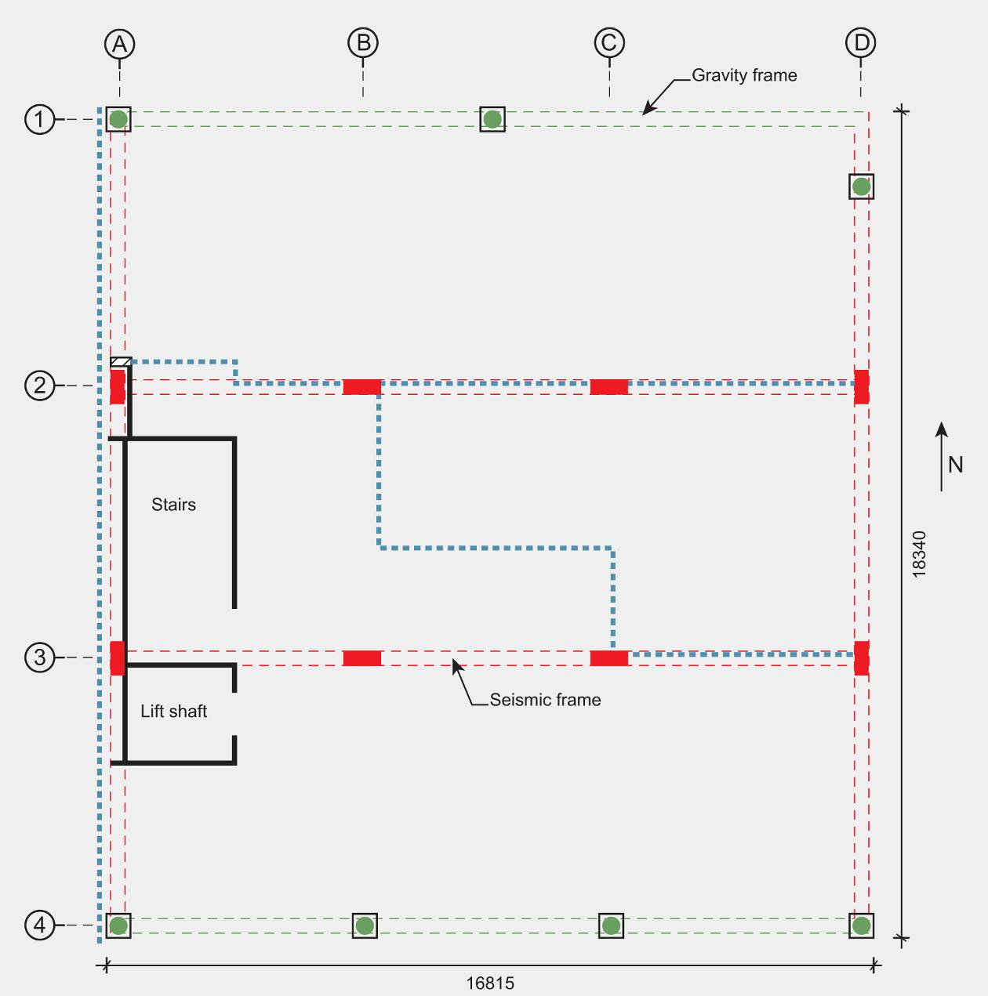
Figure 107: Ground floor: red indicates the seismic frame, green indicates the gravity frames and the western wall cladding
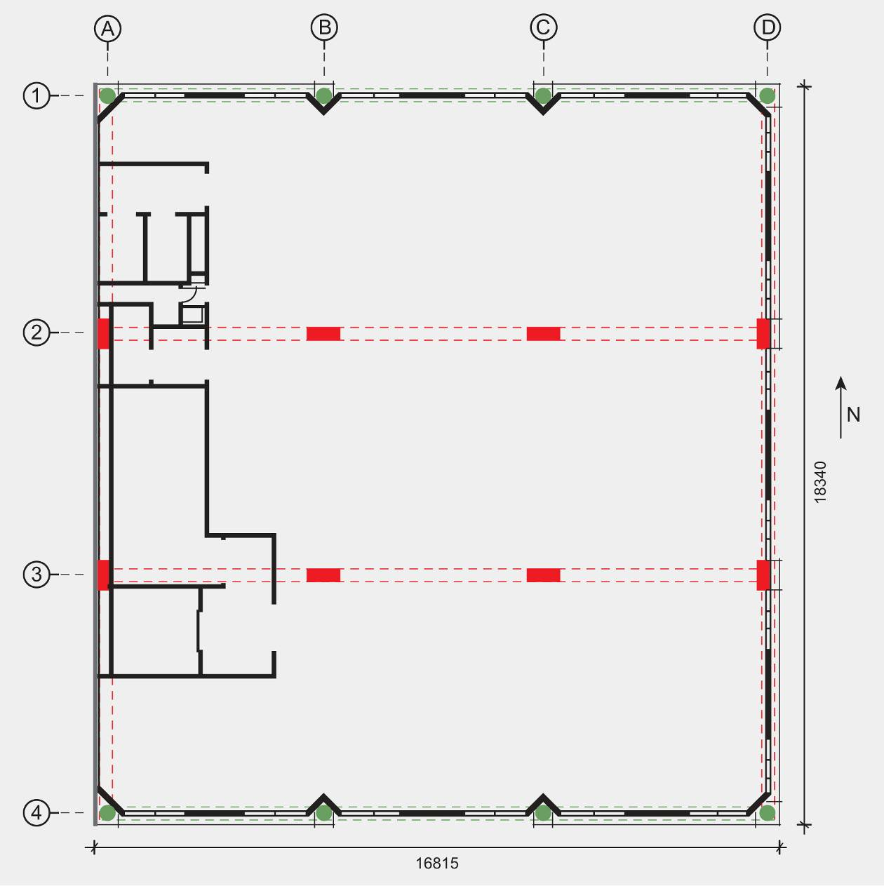
Figure 108: Typical upper floor: red indicates the seismic frame, green indicates the gravity frames and the western wall cladding
The western wall of the building was clad with precast concrete panels, which were detailed with 15mm gaps at all edges. The top floor had a light steel frame and light steel roofing.
The stairs were constructed in reinforced precast concrete with 15mm gaps at both ends of each flight, which were specified as being filled with a flexible sealant. However, photographs show this had been filled with mortar. These gaps were not specified as being seismic gaps, and the purpose may have been principally for construction tolerance.
6.3.4.3 Building performance
The Royal Commission was assisted in the assessment of this building by a report prepared by Spencer Holmes Ltd.
After the 4 September earthquake a Rapid Level 1 Assessment on 5 September found no damage to the building. This was followed by internal and external inspections by Evans Douglas Consulting Engineers Ltd between 6 September and 19 October, when it was noted that there was some non-structural damage to plasterboard walls and some spalling of concrete to the underside of the stairs at the floor/stair junctions. The spalling of the concrete was explained as indicating some hinging of the joints at these points, but it was not considered to have affected the structural integrity of the building.
No information has been provided to the Royal Commission about the building’s performance in the Boxing Day aftershock. However, the February earthquake caused major damage to the building. Below is a summary of the notes recorded by Beca in a report, “Earthquake Damage Assessment – 151 Worcester St” (dated 27 May 2011) about an inspection they carried out in May 2011:
1. A column sway mechanism had formed between levels 1 and 2, resulting in a permanent offset of 20-30mm at the front of the building.
2. There was significant damage to perimeter columns and beam-column joints at the lower three to four levels, indicating column hinging had occurred in the moment resisting frames. Significant damage to internal columns and beam-column joints at the lower three levels was noted, including extensive concrete spalling and exposing of reinforcement that indicated hinging in the interior frames.
3. There were cracks and local failures in the infill concrete block walls in the truck dock area. There was extensive damage to glazing and cladding.
4. It was anticipated that there would be extensive cracking in the floors, but these were not able to be inspected. However, there was some indication of damage to the support zones of the precast units.
5. There was considerable damage to the stairs, which were not considered safe to use.
6. There was extensive damage to glazing and cladding and to the precast panels located on the eastern side of the building. This damage tended to be concentrated around beam-column frame areas on the lower floors.
7. Damage to cladding was observed at the adjacent building site where pounding had occurred.
At the time Beca carried out its inspection any damage to the western wall panels would not have been visible owing to the position of an adjacent building (which was subsequently demolished).
An external inspection was carried out for the Royal Commission when the demolition had just started. The following details were noted:
1. There was damage to the precast concrete panels on the west wall. The panels were detailed with mid-panel connections top and bottom and at mid-height between the floors with a 15mm clearance all round. It appeared that mortar and weathering sealants had reduced the clearance, so that the rotation induced by inter-storey drifts in the building resulted in the compression crushing and spalling of the panels at their corners, and excess tension in the lower connection causing severe cracking and spalling at the base of the panels. The top connections of the panels (with a stronger detail) were relatively unaffected.
2. Inelastic deformation and some hinging had occurred at the lower level of the main frame rectangular columns and at the top and bottom of some circular columns.
3. There was some vertical cracking of the column capital at level 1 in the north-western corner, which was assumed to be as a result of axial load/compression dilation of the column capital.
4. There was some evidence of elongation in the beams in the northern wall. However, the floors could not be accessed to examine the significance of this deformation on their performance.
6.3.4.4 Interpretation of damage
A hand analysis of the building carried out by the Royal Commission indicated that the lateral strength would have satisfied the requirements in NZS 4203:1984.¹³ Even though some of the detailing of the columns would not satisfy the current standards the building would not, in the Royal Commission’s opinion, have been classified as earthquake-prone in February 2011. Our interpretation of the observed damage is that the building responded in a torsional mode in the February earthquake as a result of the high ground accelerations and the eccentricity caused by the combination of:
• the additional stiffness in the west wall due to the lack of effective separation between the precast panels on this wall;
• the additional stiffness from the infill block walls on the ground floor as the walls were not effectively separated from the structure; and
• the lack of adequate seismic gaps between the stairs and the floors.
The locking-up of the panels caused by inadequate separation gaps would have moved the centre of rigidity towards the western wall, which would have significantly increased the torsional response of the building. The two seismic frames, which were designed to resist lateral forces in the east–west direction, would not have been effective in restraining the torsional motion because they were near the centre line of the building.
The block wall in the ground floor may have been partially effective in limiting inter-storey drift as a column sway mechanism appears to have developed in the second storey.
6.3.4.5 Conclusions
A major contribution to the damage sustained by the building arose from its irregularity. While there was some irregularity in the design, this was greatly increased by:
• the failure to effectively isolate the infill block walls from the structure;
• inadequate seismic gaps for the stairs; and
• inadequate seismic gaps for the precast panels and the failure to ensure these gaps did not become filled with weathered sealant and mortar.
The circular columns in the perimeter frames were, with one exception, inadequately confined to resist the imposed displacement. The one exception was the column on the northern side of the building between grid lines B and C. This column was subjected to a relatively high axial load in comparison to the other columns on the perimeter and it was confined by a 12mm bar spiral with a 75mm pitch. All other circular columns contained a 10mm bar spiral with a pitch of 300mm.

