6.3.3 79 Cambridge Terrace: Bradley Nuttall House building
Current status
Unoccupied with temporary repairs in place – future yet to be determined.
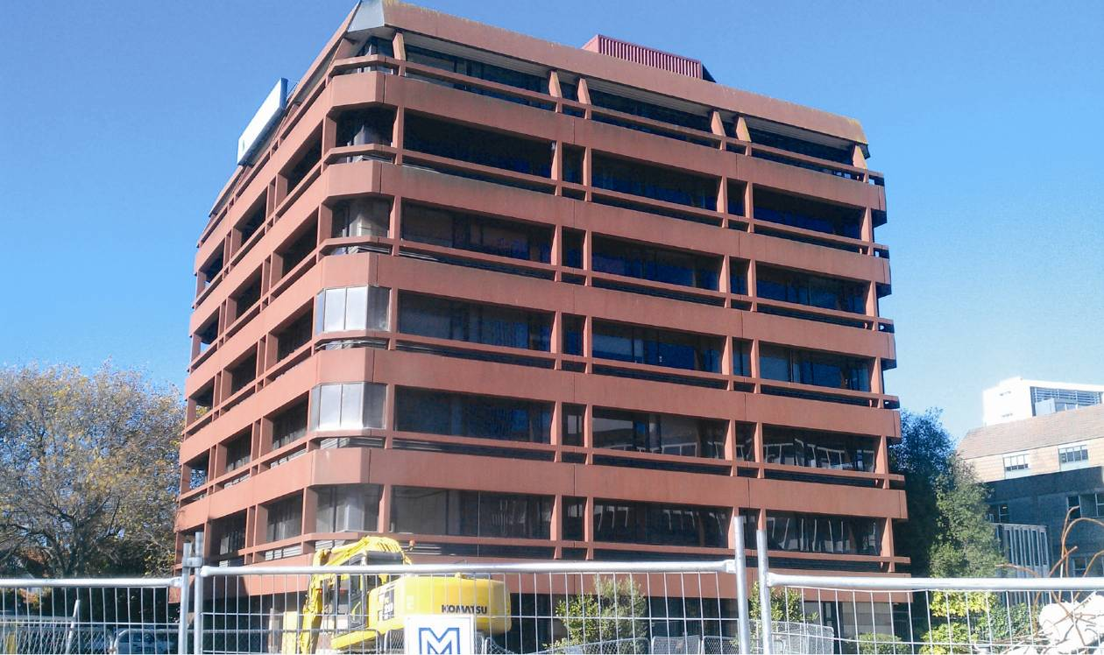
Figure 99: Bradley Nuttall House viewed from Cashel Street
6.3.3.1 Introduction
The reinforced concrete building located at 79 Cambridge Terrace, known as Bradley Nuttall House, is a seven-storey office building situated approximately 40m from the banks of the Avon River (Figure 99). The building is square in plan, measuring about 24m in each direction. A building permit was issued by the CCC in October 1985, indicating that design would have been carried out earlier in that year. The Royal Commission does not have any information as to the construction commencement or completion dates.
6.3.3.2 Building structure
A plan view of the layout of the building with the main structural elements labelled is given in Figure 100. The lateral force resisting structural system consists of four ductile reinforced concrete walls that form a shear core around the stairs, lifts and toilet facilities. To allow for access into the shear core at each level, one wall (wall E) has voids and diagonally reinforced precast coupling beams at each wall end. The coupling beams are positioned above the doorways and act to tie wall E into the perpendicularly-oriented core walls (walls 3 and 4). The shear core is eccentrically positioned on the south-western side of the building.
The concrete floors are connected to the shear walls and act as a primary load path for inertial forces to track back into the walls. The elevated floors consist of 100mm deep prestressed concrete beams spaced at 900mm centres with timber infill that acts as permanent formwork for the 75mm thick cast-in situ concrete floor reinforced with 665 steel mesh. The precast beams are supported on precast shell beams that span 7.2m in the south-western to north-eastern direction between column supports.
The columns extend from the ground floor up to the sixth level. The 400mm square columns are essentially gravity columns that support the weight of the floors and roof. The shear core extends up a further two levels to where the plant and service rooms are, at the seventh level, with the lift motor room on the top level, shown in Figure 101.
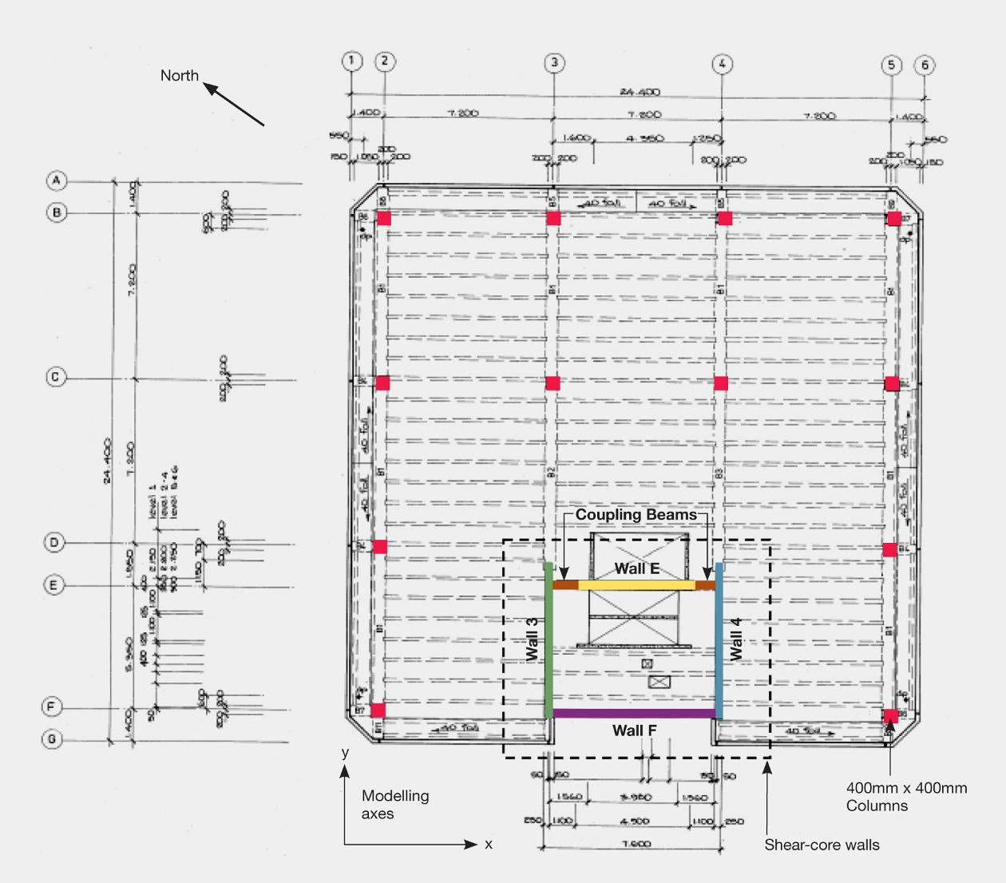
Figure 100: Typical floor plan, levels 1–6 (source: Modified from original approved plans)
The foundations transfer loads to the ground through a combination of shallow pads and bulb piles. The pads that are directly connected to the shear core structure consist of reinforced concrete beams on bulb piles located roughly in a perimeter surrounding the shear core. The reinforced bulb piles extend 9.5m below ground and are assumed to act as tension piles when the shear core is overturning from seismic loadings. The column foundations on the north-western side of the building are separate from the foundation beam and pile system and are simply founded on 2.8m square bearing pads. The ground floor is a 100mm thick unreinforced slab cast on compacted hard fill.
Other features of the building include precast concrete scissor stairs located within the shear core. These stairs have steel extensions top and bottom that are grouted into cast in situ concrete landings. Reinforced block walls that cantilever up from the floor slab are located on the ground floor. Around the liftshaft these block walls are also tied into the concrete floor of level 1. The roof is a light steel structure arrangement of steel roofing, supported on steel purlins, beams and posts. The building exterior is clad with precast concrete panels.
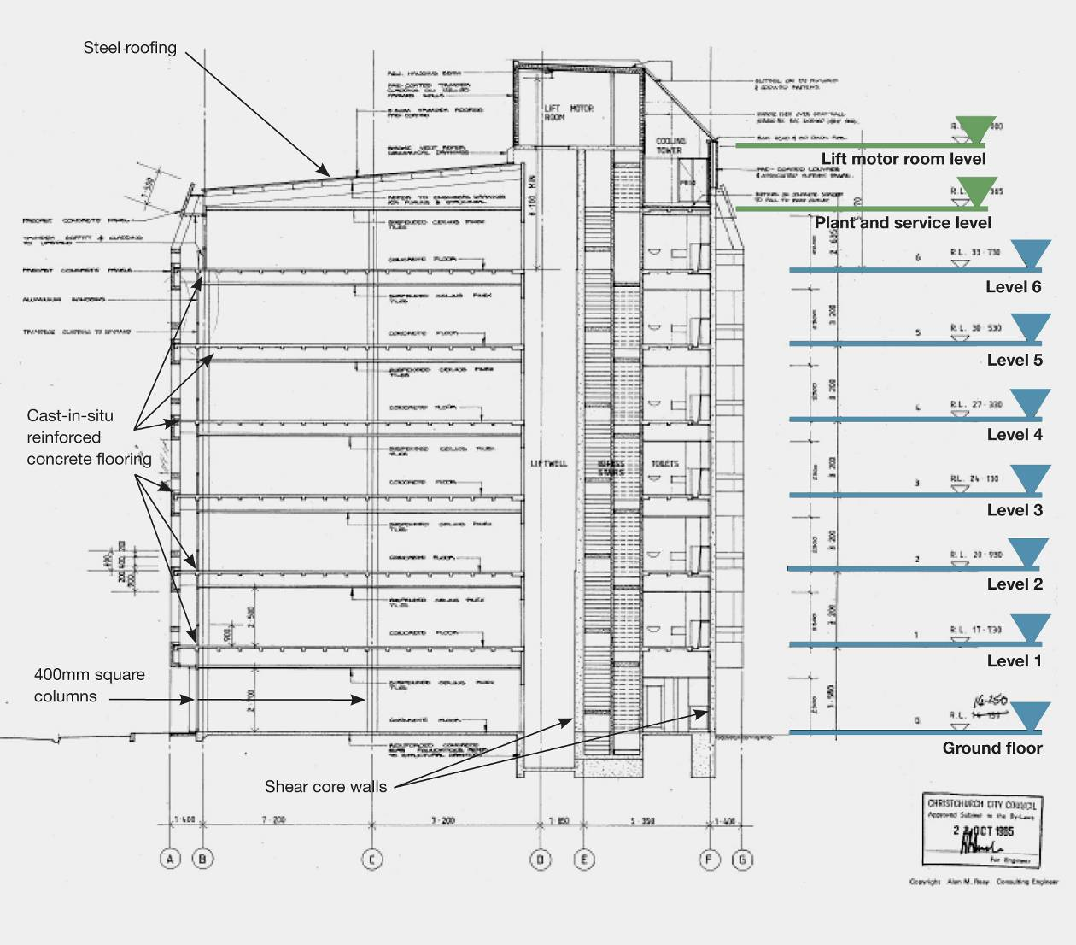
Figure 101: Cross-section through building (source: Modified from original approved plans)
6.3.3.3 Post-earthquake structural inspection
A consulting structural engineer, Mr Michael Fletcher of Buchanan & Fletcher Ltd, was engaged by the owner to carry out structural engineering inspections and assessments after the February earthquake. The account that follows is based on Mr Fletcher’s report.
The main visual inspection was conducted on 14 March 2011. Mr Fletcher’s observations on damage caused by the earthquakes are summarised as follows:
Area of interest | Observed damage
Concrete columns | – Some cracking in ground floor columns  – In the level 3 columns there is some cracking in the cover concrete and in the top of the corner columns
Shear walls | Walls 3 and 4  – These walls show an extensive pattern of diagonal cracking at the lower levels with cracks at about 300mm centres. Cracking in the upper levels is more widely spaced. Where checked, the cracks run right through the walls. The cracks are at about 45 degrees in both directions and extend the full height and length of the walls  – Crack widths are in the order of 0.5mm at the lower levels reducing to 0.2mm near the top of the building  – Generally, the damage to wall 3 is more significant than the damage to wall 4  Wall F  – Multiple horizontal cracks are visible for at least three levels above ground, regularly spaced at about 300mm centres (Figure 102(a))  Wall E  – This is the wall located at the back of the liftshaft and connected to walls 3 and 4 by precast concrete coupling beams  – No cracks were observed in wall E itself but there is vertical cracking visible at the joint between the coupling beams and the main wall at most levels. Crack widths are estimated to be 1.0mm at level 1 down to 0.1mm at level 6. Diagonal cracking in the coupling beams in the lower levels is also noted  Junction between wall 3 and end of wall F  – There is a significant horizontal crack (see Figure 102(b)) up to 0.7mm in width. Adjacent to wall 3 (on the other side) is a door opening in wall F
Shear walls (continued) | – Cover concrete has spalled off at the base of wall F at the north-western end  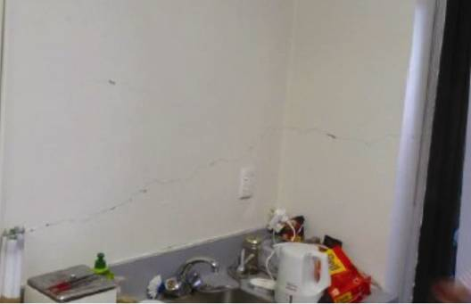  (a) Exterior view of wall F (b) Junction of wall 3 and wall F  Figure 102: Horizontal cracking in shear walls at ground floor
Connections between shear walls and floor beams  (on lines 3 and 4) | The concrete floor beams transfer some of the inertial forces into the end of walls 3 and 4  – Inspections at levels 1, 2, 4 and 6 showed vertical hairline cracking in the beams  – Some moderate damage to the shear-wall-to-beam connection was observed, with some spalling at the end of the shear wall, as well as vertical cracking in the beam and wall (see Figure 103)  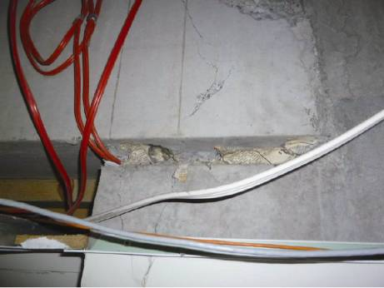  Figure 103: Connection of line 3 beam into the end of wall 3 at level 2
Connections between shear walls and floor slabs | These were checked from the underside at a number of locations with no sign of damage or movement noted
Site and surrounds | The building is located about 40m from the Avon River  In the adjacent building there is slumping in the ramp leading down to the car park basement  There is no evidence of liquefaction or settlement on the other three sides of the building or between the building and the river

Further information on the consultant’s findings and recommendations, results from a detailed elastic seismic analysis and future proposed works have been excluded from this Report.
6.3.3.4 Geotechnical site investigation
Following the post-earthquake structural inspection, a geotechnical investigation was carried out by Geotech Consulting Ltd who prepared a site investigation report dated 29 November 2011. According to the Geotech report, the ground conditions at the site consist of a surface layer of sandy gravel underlain by loose to very loose saturated sands (susceptible to liquefaction between 5–13m), with dense sands located at around 19m depth.
The post-earthquake structural inspection suggested that there were no significant surface manifestations of ground movements. The building may have settled differentially to a small degree (up to 50mm) and some slumping in nearby buildings indicated that some liquefaction occurred in the area.
6.3.3.5 Method of analysis used for this report
The Royal Commission carried out a non-linear time history analysis with the assistance of Professor Athol Carr, in order to study the seismic performance of the building.
The analysis was carried out using the programme, Ruaumoko 3D¹⁵, which is capable of modelling the post-elastic properties of structural elements as they undergo yielding. The inelastic time history method of analysis was used. Some of the key modelling assumptions included:
6.3.3.5.1 Earthquake loading
The earthquake loading was scaled to the current new building design level loading. The three scaled earthquake records chosen¹⁶ were the Tabas (Tabas 16/09/78), Smart (Taiwan 14/11/86) and F52360 (Taft Lincoln School (tunnel 21/07/52)) records. These records were scaled in accordance with NZS 1170.5:2004¹⁰, with a hazard factor (Z) of 0.3and type D soil for a normal-use office building.
An analysis was made using the unscaled Christchurch Hospital (CHHC site) record from the February earthquake.
6.3.3.5.2 Assumptions
1. The weight of the building includes the self-weight of structural elements, dead loads from fixtures and fittings (for example, partitions and cladding) as well as the long-term live load.
2. All analyses were modelled with a rigid foundation. To check the sensitivity of foundation stiffness a trial case with foundation beams and soil springs was modelled.
3. The floor plate is assumed to be rigid for in-plane forces but modelled to allow flexural deformation. The floors were connected to the walls by link elements to allow the transfer forces to be recorded.
4. Beams and columns were assumed to have a cracked stiffness of 0.4 I_{gross} with the shear walls having a cracked stiffness of 0.25 I_{gross} over the full length of the members.
5. Inelastic shear, tension yield and moment-axial interaction capacities were modelled over the first storey of all four walls. The second storey allowed for flexural yielding with the walls elastic above this level. The shear capacity of the walls was based on a concrete contribution, V_{c}, of 0.17√f’_{c}, plus an allowance for axial load, plus the horizontal reinforcement in the wall, V_{s}. Inelastic shear was based on the SINA hysteresis model.
6. The moment-axial interaction capacities of the columns were modelled.
7. Five per cent viscous damping was assumed for all 205 modes of free vibration.
6.3.3.6 Findings
A time step of 1/20,000th a second was required to keep the analysis stable. This is due to the structure having relatively short members with little mass, resulting in a high frequency. The fundamental period of the rigid base structure is 1.0s in the translational north-east to south-west direction (y-direction, see Figure 100) and 1.25s in the fundamental torsional mode. With the flexible foundation modelling these natural periods became 1.32 and 1.26 seconds respectively.
The primary modes of vibration for the structure indicated that an earthquake would induce a highly torsional building response.
The analyses show that the walls are subjected to axial tension forces that have the potential to yield the vertical wall reinforcement. Therefore, to model the flexure and axial behaviour at the base of the walls a multi-spring element was used to represent the concrete and steel properties. A gapping spring element represented the concrete stiffness, with no tension and a bi-linear spring element represented the vertical steel properties.
6.3.3.6.1 Walls
Shear deformations had a significant effect on the building’s response. By modelling the inelastic shear, a different building behaviour was observed compared to modelling the walls with elastic shear stiffness and flexural yield at the base of the walls. Once shear deformation occurs, this type of deformation occurs more easily than deformation caused by flexure in
the walls.
Tension yielding is most critical in wall F owing to the combination of its lower axial compression load and the overturning in the y-direction. All walls indicate cracking during the design-level earthquake excitations, with some yielding of the steel once or twice during the event. For the February earthquake all four walls yielded in axial tension. Wall E yielded numerous times, while wall F underwent the most significant axial forces.
6.3.3.6.2 Connection of floors to walls
The design-level connection force was calculated to be greatest at the upper levels, with the coupled forces from torsional deformation of the building giving about 2200kN acting in opposite directions on walls 3 and 4 at level 6. The connection peak force is achieved only once or twice over the time history record. In the February earthquake analysis the magnitude of these shears reached about 5200kN.
6.3.3.6.3 Columns
The static gravity axial loads on the ground floor in the corner columns were found to be about 1100kN but for the interior columns on grid line C the static axial force was about 2400kN. The columns did not pick up any significant additional axial force caused by seismic motion.
The corner columns underwent the most severe deformations/drifts as they were at the greatest radius from the centre of the shear core. Design level inter-storey drifts of around 0.8 per cent were calculated from the analysis. In the February earthquake the analysis indicated that the inter-storey drifts were about 2.4 per cent. The torsional response of the building was illustrated by the movement of the corner columns, predominately in a direction pivoting about the centre
of the shear core walls.
6.3.3.6.4 Foundations
Modelling the foundation stiffness has the effect of lengthening the building period. The walls sitting directly on the foundation beams show increased vertical and rocking movements. Since the bulb piles are located in a liquefiable layer there is a potential for these piles to uplift under axial tension forces, but this effect was not modelled.
6.3.3.7 Conclusions
Our conclusions are as follows:
1. Walls
The analysis was consistent with the observed damage, in that the walls were highly stressed in the February 2011 earthquake.
Analyses indicate that under a design-level earthquake, walls 3 and 4 underwent shear cracking and some shear yield at the base between the ground floor and level 1. Diagonal shear cracking was observed in both directions along the full height and length of these walls. Wall F was shown to be subjected to high axial tension loads and extension, and the horizontal cracking pattern observed indicated that this occurred. The analyses predicted that the vertical bars in wall F yielded and possibly fractured, or that the wall foundations uplifted to stop bar yield and/or fracture from occurring. Uplift of the foundation for wall F would require tension failure or rocking of the piles under the wall footing. Owing to the weight of the building the structure would have self-centred and closed the cracks that had opened up in wall F, making the damage possibly appear less extensive than it really was.
The building concept results in an eccentricity of the centre of mass from the centre of lateral stiffness. Had this eccentricity been reduced, the seismic performance of the building would have greatly improved.
2. Connection of floors to walls
Damage was observed close to the junction of the precast concrete beams and walls 3 and 4. Vertical cracking indicated that this connection was subjected to axial tension forces. There are two main load paths for the inertial forces to be transferred into the shear walls. The most direct is through the end of the precast beams. The other load path is the connection of the floors to the sides of walls 3 and 4 through steel reinforcing bars placed perpendicular to the length of the walls (see Figure 104). These bars are cast in situ with the concrete floor slab and walls and extend a distance on either side of the wall faces. This load path requires movement and diagonal cracking in the floor to develop the full connection strength. Adding the strength of the two connections together is not a conservative approach, as development of the full strength for each connection will occur at different deformations.
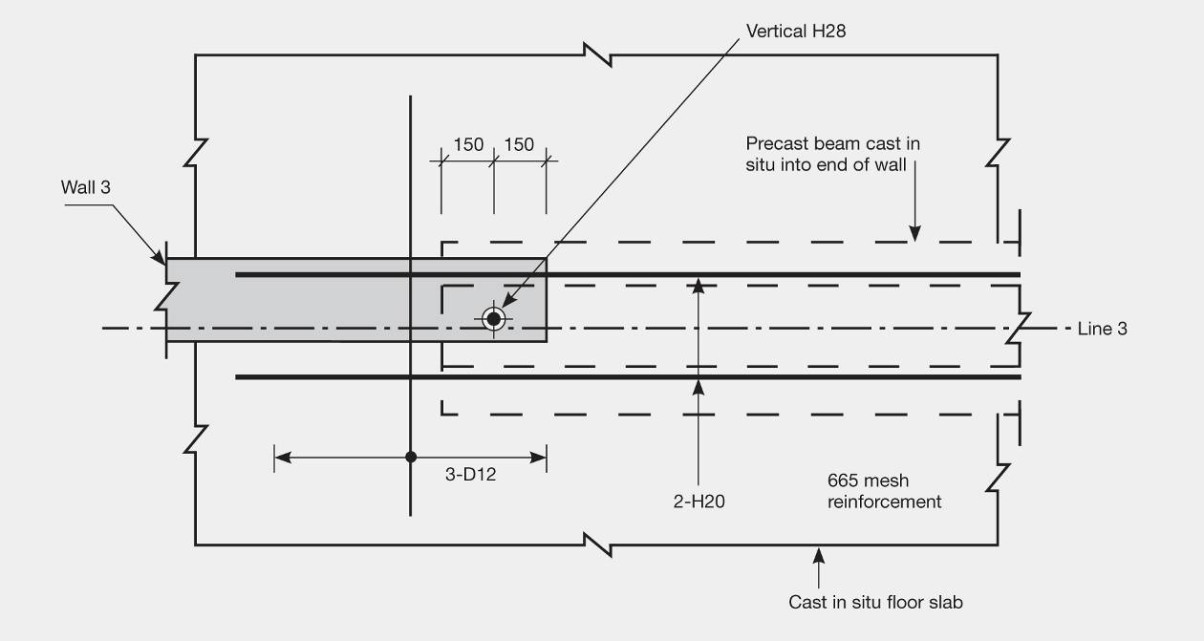
Figure 104: Plan view of floor and precast beam connection to wall 3 (or 4)
The indirect load paths of this connection make it a detail we would not recommend.
A strut and tie calculation of the nominal connection capacity between wall 3 or 4 and the adjacent concrete floor topping is in the order of 2200kN per wall. This is assuming the minimum strut angle of 25 degrees as stated in NZS 3101:2006¹². The Christchurch earthquake record theoretically shows demands that exceeded this nominal capacity. There are a number of possible reasons why this may not have occurred:
1. In practice, the angle between the axes of the strut and the tie could be less than 25 degrees. Since the strut was forming against the concrete there was less chance of slipping and a higher connection force might be achieved.
2. Since the shear core was encompassed by the floors, some slab reinforcement acted in tension to stop the floors from separating perpendicular to the length of the walls, acting like a vice clamp around the walls.
3. The actual ground motions at the site ground surface may have been different from those measured at the Christchurch Hospital site, particularly if liquefaction occurred at depth.
4. The stiffness and ductility in the connection may have reduced the force demands.
3. Columns
The columns have beams framing between them in one direction (along grid lines 2, 3, 4 and 5) with only the concrete slab spanning in the perpendicular direction. A typical column cross-section in the upper levels is illustrated in Figure 105.
Figure 105: Section of columns from levels 2–6
Failure of a column would lead to a loss of gravity support that would highly stress other elements, potentially leading to the collapse of the building. The columns were inadequately confined with R10 stirrups placed at 150mm centres at the top and bottom of the column with minimal longitudinal bars. An approximate calculation of the nominal deformation capacity of the unconfined upper-level columns was in the order of 0.5 per cent inter-storey drift, which was below the design level demand of 0.8 per cent calculated in the inelastic analysis. The theoretical demand during the February earthquake was in the order of 2.4 per cent inter-storey drift.
In the Royal Commission’s analysis, the deformation capacity was calculated conservatively by assuming full fixity at the top and bottom of the columns. In practice the slab would have rotated, reducing the rotations in the columns and accommodating a larger inter-storey drift. The damage observed after the February earthquake indicated that deformations in the columns caused the cover concrete to crack and spall.
It is important that gravity-only structural elements are also designed and detailed to accommodate the seismic-induced deformations of the building, as is required by current standards.
4. Vertical accelerations
In general the vertical accelerations from the analysis do not seem to have a significant effect on the structural behaviour. There is some variation in the axial forces in the columns but the short duration of axial force is not expected to greatly affect the lateral load resistance of the columns. The analysis assumed rigid foundations. The actual characteristics of the soft soil beneath the foundations may have reduced the vertical accelerations that were transmitted into the structure.

