Section 6:
Individual buildings not causing death

This section of the Report includes details of the 14 individual buildings that have been assessed by the Royal Commission.

6.1 Buildings designed prior to the introduction of Loadings Code NZS 4203:1976¹

6.1.1 48 Hereford Street: Christchurch Central Police Station
Current status
In use; repairs may have been undertaken but are presumably of a minor nature as no building consent has been obtained.
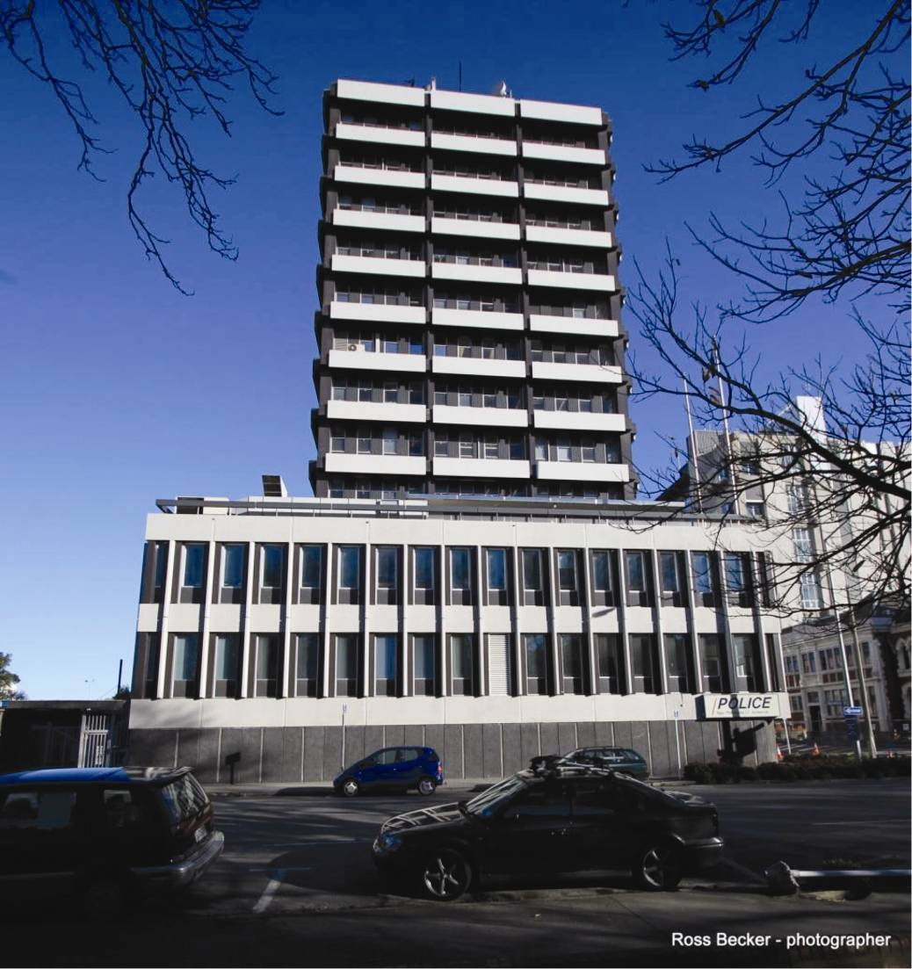
Figure 60: The Christchurch Central Police Station seen from the west bank of the Avon River (source: Ross Becker)
6.1.1.1 Introduction
The Christchurch Central Police Station was designed in 1968 by the Ministry of Works. As a Government building it was built to more rigorous design requirements than the minimum New Zealand Standards of the day. No building permit from the Christchurch Council City (CCC) was required for Crown-owned buildings at the time.
The building is a 15-storey reinforced concrete structure, three levels of which are a podium that is about twice the plan area of the tower above. The tower is approximately central to the major portion of the podium, with a seismically separated portion of the podium to the west, as is shown in Figure 61. It is located about 60m from the western bank of the Avon River.
There is relatively little information on the foundation soils. However, based on an existing soil profile along Hereford Street by Elder and McCahon² we think it likely that the building is founded on sandy gravel for a depth of about seven metres, and below that a layer of about six metres of loose sand of medium density. After the February earthquake it was noted that minor liquefaction had occurred at the north-eastern corner of the building and there was some differential settlement between the seismically isolated portion of the podium and the main structure. In a survey it was found that there was up to a 100mm differential settlement between the eastern and western ends of the main podium (grid lines 1 and 7 in Figure 61).
The foundation system is a deep reinforced concrete cellular raft system. The total depth of this raft is about 2.5m.
6.1.1.2 Building structure
The gravity loads and lateral forces are resisted by ductile reinforced concrete moment resisting frames. The arrangement of structural members on typical floors in the building is shown in Figures 61–63. The floors consist of 152mm thick reinforced concrete. The beams, columns and floor slabs were all cast-in-situ. Precast concrete panels were used as non-structural elements for cladding and also for walls in the vicinity of the lift/stair core. These were installed with seismic gaps to prevent them from interfering with the seismic performance of the building. The stairs were fixed to the floors at their upper level but designed to slide at their lower level on two sheets of polythene.
In the tower there are 20 columns arranged in a grid to give four bays of 6400mm in the east–west direction and three bays of 6400mm in the north–south direction. The columns in the lower levels of the tower are 762 by 762mm and in the upper levels they are 686 by 686mm. Beams are made continuous with the columns. The beams are 762mm deep with a web width of 686mm in the lower levels of the tower, and 686mm deep with a web width of 610mm in the upper levels
of the tower. The 152mm reinforced concrete floor slabs are tied into the beams as illustrated in Figure 64.
Detailing of the structure is of a high standard, having regard to the fact that it was designed in 1968. While it is not up to current standards, in many aspects it is close. It is apparent from the structural details that the columns were designed to be considerably stronger than the beams, which ensured that in the event of a major earthquake a beam sway mode would develop, provided that the beam-column joints did not fail. The detailing of the beams and columns ensures that plastic hinges, should they form, are located in the beams against the column faces. The columns are confined by ties and most of the longitudinal bars are adequately restrained against buckling. In some cases the spacing between the bars was greater than required by current standards. In the beams the stirrups have been placed to enclose all the flexural reinforcement. This detail does not conform to current standards, in that the top and bottom reinforcing bars located in the middle of the beam are not constrained against buckling (see Figure 64). In the beam-column joint zone it is apparent that the joint zone shear reinforcement is less than what would be expected for a building designed to current design standards.
It is clear from the drawings that the design incorporated many of the concepts of capacity design, which was at a very early stage of development in 1968.
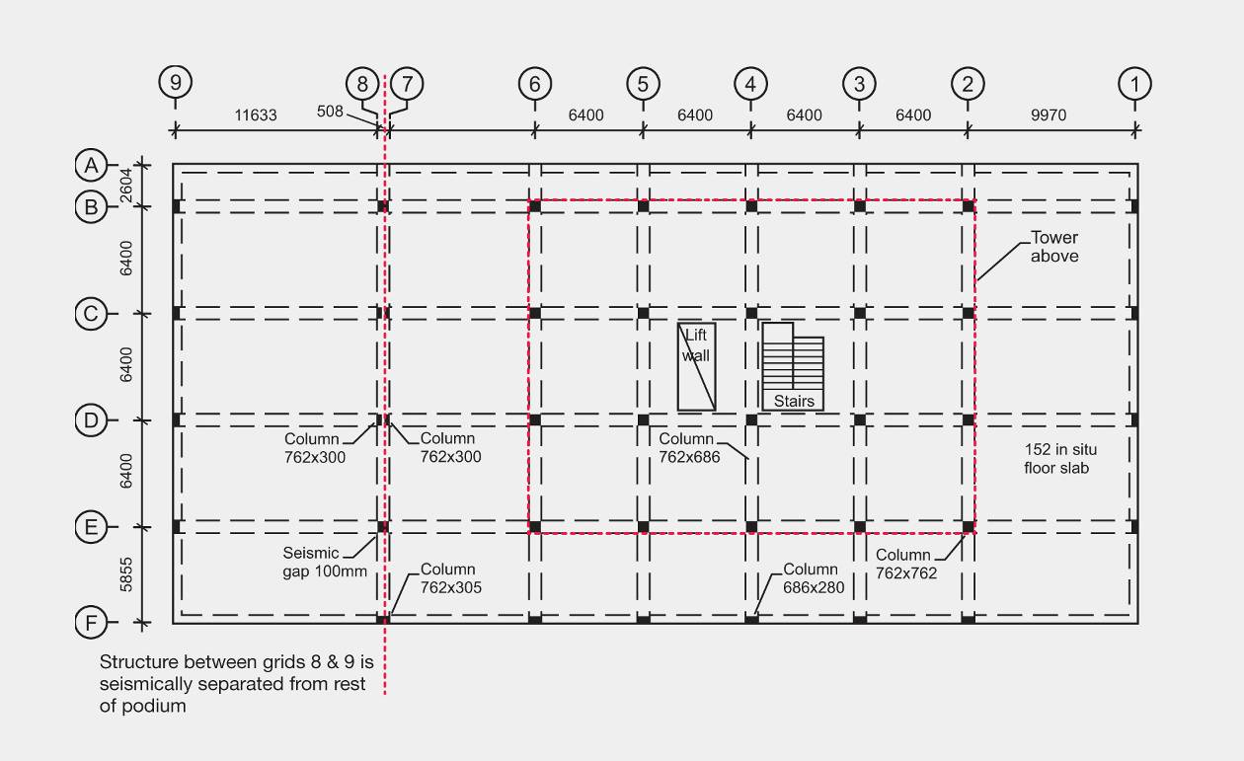
Figure 61: Structural members at podium level
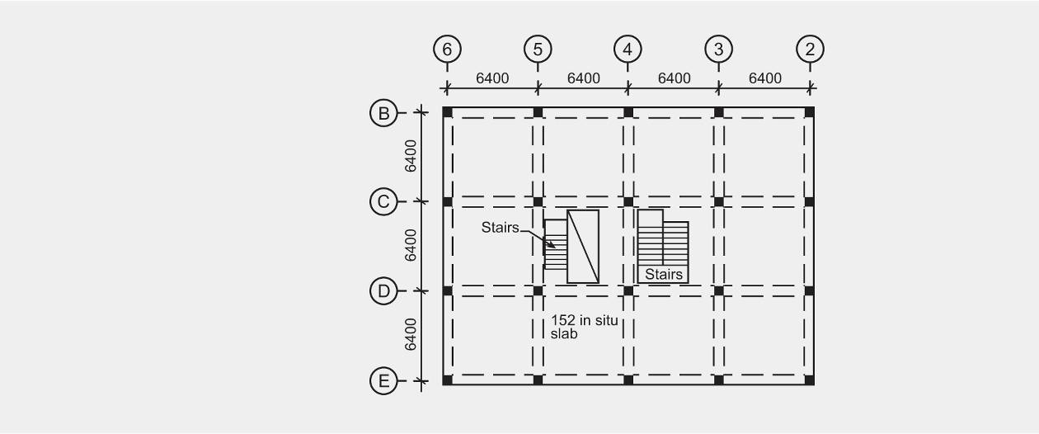
Figure 62: Structural members, levels 5 to 13
Figure 63: Structural members, level 15
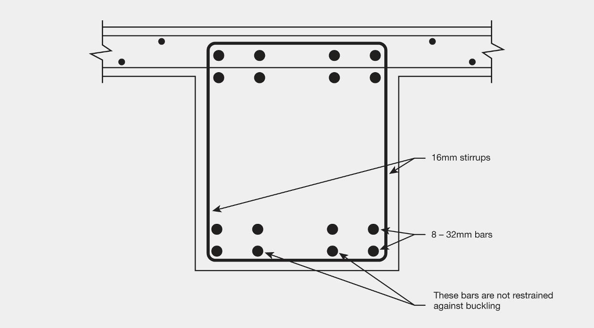
Figure 64: Typical beam details
The structural arrangement is robust in that there is a high level of redundancy, with five moment resisting frames that resist seismic forces in the east–west direction and four frames that resist the forces in the north–south direction. All the columns are effectively tied together by the reinforced concrete in situ floor slabs.
6.1.1.3 Structural damage
No significant structural damage was recorded in structural elements in the September earthquake, though there was some non-structural damage.
In the February earthquake there was appreciable non-structural damage, but relatively minor damage to the main structural elements. As noted previously, a limited amount of differential settlement occurred, possibly because of liquefaction, but this did not have significant adverse effects on the building. The good performance of the building almost certainly owes much to the
sturdy cellular raft foundation that was used. Some cracking was observed in the beams in the floor levels that were inspected, with cracks up to 2mm wide in the beams at the column faces.
6.1.1.4 Assessment of seismic performance
The building was designed to comply with the Ministry of Works code³, and with the then current codes of practice for design loads and concrete structures^{4,5}. The lateral force coefficient for a public building in 1968 was 0.06 for a building with a fundamental period of 1.2 seconds or more. However, to interpret this coefficient in terms of current design standards it is necessary to make allowance for changes in practice since the building was designed. In 1968 elastic design was widely used, while today ultimate strength theory is used. To allow for this change the 0.06 is multiplied by 1.25 (MacRae et al⁶). The design strength is taken as the product of the appropriate strength-reduction factor (0.85 for reinforced concrete) and the nominal flexural strength. For the purpose of assessing probable strength, a strength-reduction factor of 1 should be used. The nominal flexural strength is calculated from the lower characteristic material strengths, which means that in 95 per cent of cases the flexural strength is greater than the nominal value. The ratio of probable material strengths to their corresponding lower characteristic values is about 1.1:1.
In practice, reinforcement contents are greater than the minimum areas required to provide the design strengths found in an analysis, owing to the need to maintain similar reinforcement arrangements along members, and in the 1960s no allowance was made for the contribution of reinforcement in the slabs to the strength of the beams. These two factors would typically increase the strength by a factor of 1.2. Using the ratios given above, the base shear coefficient of 0.06 corresponds to the probable base shear strength, in terms of current practice, of 0.12.
The building was assessed for the Royal Commission by Compusoft Engineering Ltd. As part of its assessment Compusoft examined the acceleration response spectra calculated from the ground motion records obtained at the CCCC, CHHC, and CBGS sites (see section 1.6 of this Volume). The records from the REHS were not included as Compusoft considered the soils in that location were not representative of those on the site of the Police Station. The acceleration response spectra for these three records plotted in terms of acceleration due to gravity (g) are reproduced in Figure 65 for the September earthquake in the north–south direction and Figure 66 for the February earthquakes in the east–west direction. These directions were chosen as they were dominant for the period range of interest. From an analytical model which Compusoft developed, the fundamental periods of vibration were found to be 2.0 seconds in the north–south direction and 2.15 seconds in the east–west direction. Based on these values the figures show that the lateral force coefficients for elastic response are close to 0.25 and 0.32 for the September and February earthquakes respectively. This implies that displacement ductilities were of the order of 2 and 2.6 respectively. The structural damage observed in the February earthquake appears to be consistent with displacement ductilities of this order.
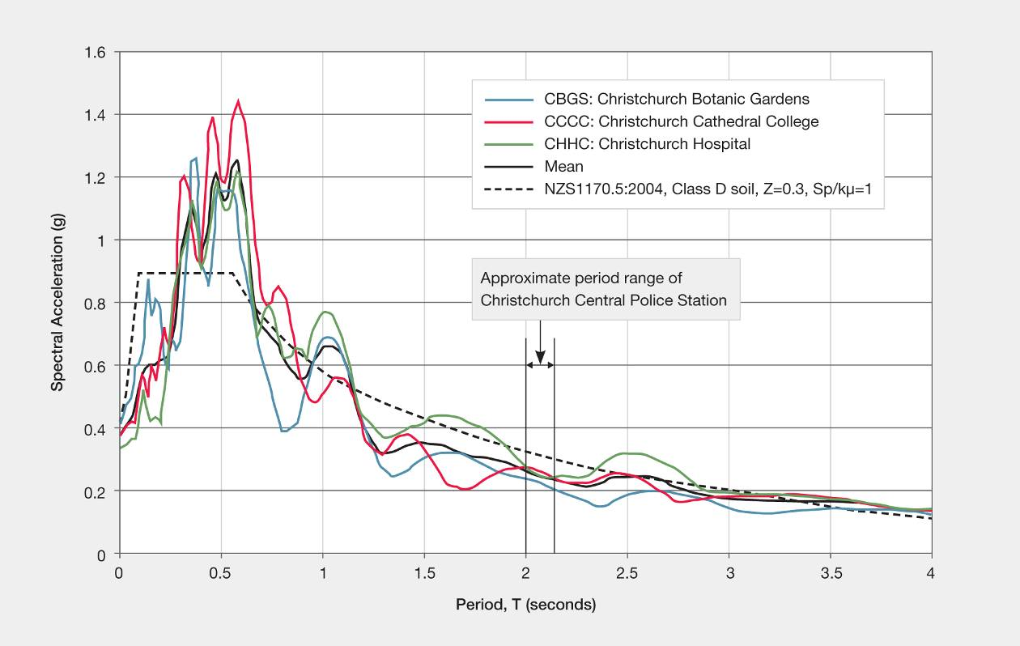
Figure 65: Spectral acceleration in the September earthquake for ground motion in the north–south direction for the stations CBGS, CCCC and CHHC (source: Compusoft)
Figure 66: Spectral acceleration in the February earthquake for ground motion in the east–west direction for the stations CBGS, CCCC and CHHC (source: Compusoft)
In a previous assessment of the building its proportion of compliance with New Building Standard (NBS) was assessed as 20 per cent for an importance level 2 building (in terms of importance in AS/NZS 1170.0:2002⁷), with predicted performance being limited by the detailing of the beams and columns, which do not fully comply with current design standards. However, the performance of this building has been shown to be well beyond the implications of the assessed level. This indicates that there is a need to quantify the performance of structural members that do not fully meet the current design provisions. This should be possible if the results of the numerous tests that have been made in New Zealand and elsewhere were compiled in a readily available document.
6.1.1.5 Non-structural damage
There was significant non-structural damage in the building in linings and to the precast panels. These were detailed with a 25mm clearance gap, which proved inadequate to prevent them from being damaged. This underestimate of the required gap was very likely due to the 1960s practice of assessing deflections on the basis of gross section properties, whereas today practice deflection calculations are based on section properties that allow for the reduction in stiffness associated with flexural cracking (MacRae et al, 2011)⁶.
As noted in the report on Clarendon Tower (see Figure 113, page 74), a reinforced concrete building that sustains inelastic displacement loses some stiffness for subsequent earthquake events. In the present case that may have contributed to the reported observations of occupants that the building felt more lively after the February earthquake, but it would not have been weaker in structural terms. Nevertheless, the acceptable extent of loss in stiffness should be considered in the design of new buildings.
6.1.1.6 Conclusions
1. The performance of the building in the earthquakes was very satisfactory in terms of the structural damage that occurred. The very robust nature of the building, which was due to its high level of redundancy and its symmetrical, regular form, contributed to its good performance.
2. The detailing of the building was excellent for the time it was designed.
3. The building would have lost some stiffness as a consequence of its inelastic deformation (see
Figure 113 on page 174). When considering serviceability of a building, it is important to consider this reduction of stiffness as a part of the design of a ductile structure.
4. There was appreciable non-structural damage to lining and precast panels in the building, which is an issue that needs to be considered for new construction. The precast panels were detailed with 25mm separation to prevent damage in the event of an earthquake.
5. In a previous assessment of the building its proportion of compliance with NBS was assessed as 20 per cent for an importance level 2 building, with predicted performance being limited by the detailing of the beams and columns. Some guidance is required for engineers involved in assessing percentage NBS for the deformation capacity of structural elements that do not fully meet all the requirement of current design standards.

6.1.2 53 Hereford Street: Christchurch City Council Civic Offices
Current status
Repaired and in full use.

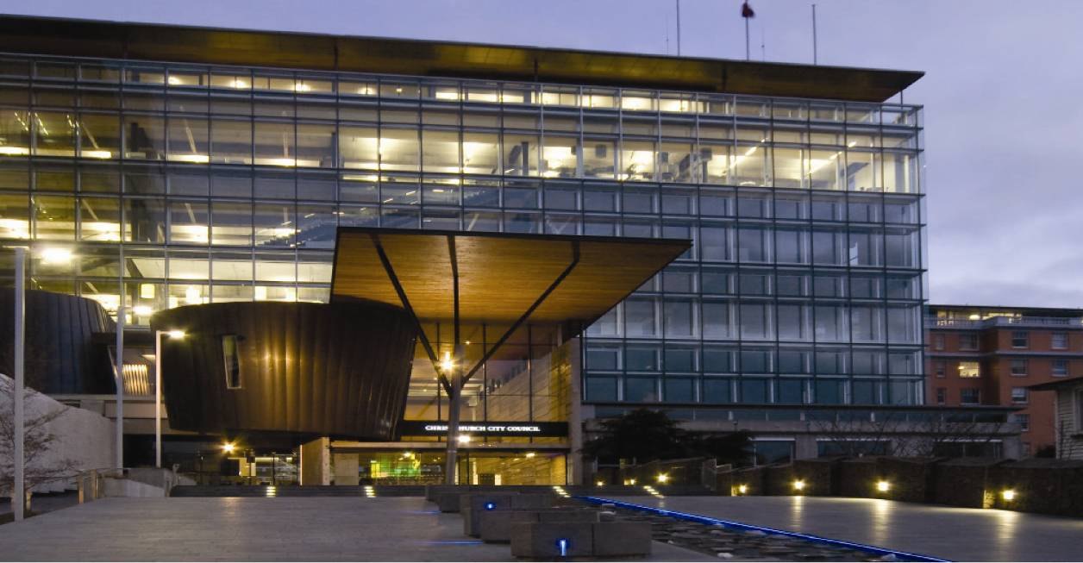
Figure 67: View from Worcester Street
6.1.2.1 Introduction
The building currently used as the CCC civic offices was originally designed as the Post Office mail sorting centre in 1972. As it was owned by the Crown, no building permit was required or obtained. Design and supervision was undertaken by the Ministry of Works, which signed it off as complete in 1974. The original structure was designed using the Ministry of Works Code of Practice for Public Buildings³. Structural details indicate that the fundamental concepts of capacity design, which were being developed at the time, were applied in the structural design.
The building underwent substantial alterations and extensions between 2008 and 2010 to convert it into the civic offices. These works were approved under a series of building consents, with a final code compliance certificate being issued on 18 August 2010. The building is now six storeys plus a basement below the extension area and a sub-basement below the original building, with mezzanines on five levels. The overall plan size is about 78m by 37.6m. The inter-storey heights are close to 5.82m in the upper storeys and 6.9m in the first storey.
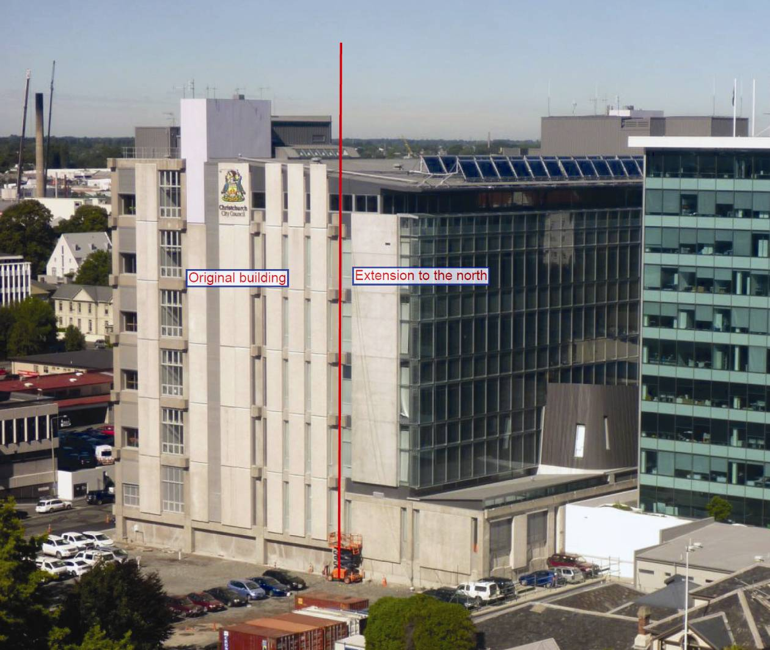
Figure 68: View from the north-east (source: Compusoft)
Foundations for the original building consist of a reinforced concrete cellular raft system with a total depth of about 2.5m. The base of the raft is 1270mm deep and the top slab is 305mm deep. Support between the two slabs is provided by a grillage of 1200mm-wide reinforced concrete beams with numerous openings in them. This formed the sub-basement with limited access that was partially used for water storage.
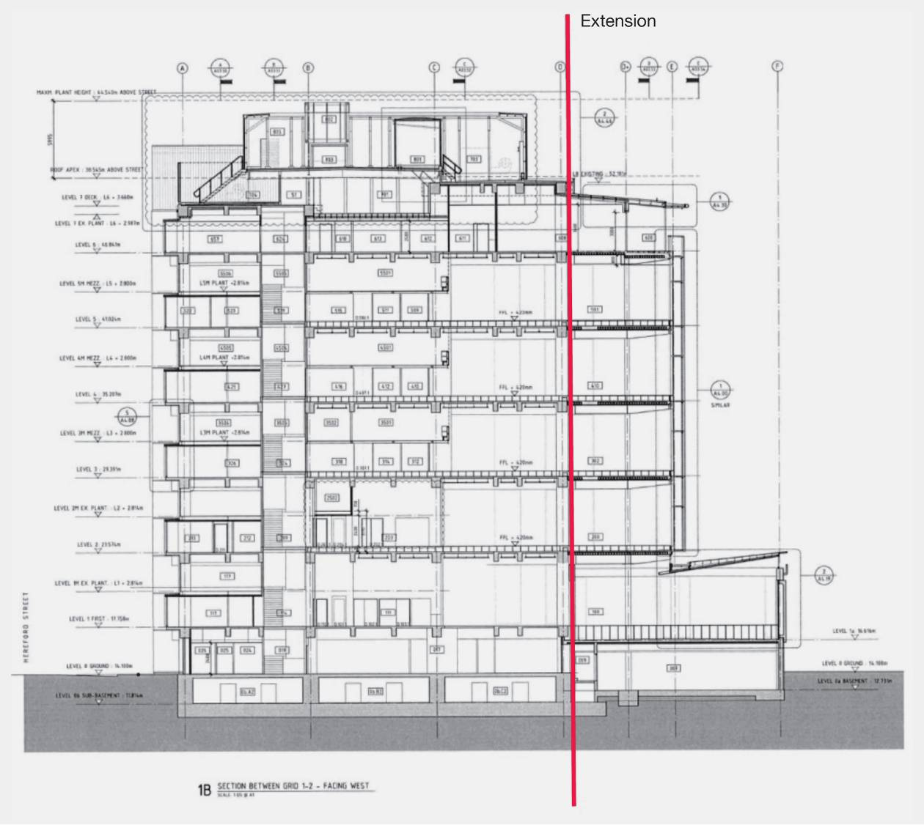
Figure 69: Cross-section (source: modified from original drawings)
The extension of the foundation consists of three foundation beams 1200mm deep and 1500mm wide, two with 2500mm thickenings at their ends to accommodate a high-voltage cable duct. The pad foundation is a 3600mm square with a depth of 1200mm.
The structural system in the original building resisted both gravity loads and lateral forces with moment resisting frames. Reinforced concrete columns were constructed on a grid pattern to give bays of 9754mm in each direction. There are eight bays in the east–west direction and three bays in the north–south direction. Primary beams are supported by the columns to give four moment resisting frames in the east–west direction and nine in the north–south direction. Two secondary beams were added in the bays between moment resisting frames in the east–west direction to provide support for the 127mm reinforced concrete floor slab. The structural arrangement was very similar to that used in the Police Station but in this case there was no podium. With this structural arrangement there was minimal eccentricity between the centre of mass and the centre of lateral stiffness and strength.
Extensions to the building in 2008 involved the addition of a further bay of 8776mm on the northern side for all the elevated floors above the second storey. The support for these floors was provided by 400mm concrete-filled tubular steel columns, which were at 9754mm centres in the east–west direction and at a distance of 5.0m from the northern-most moment resisting frame. The floors are supported by steel beams that span from the moment resisting frames over the columns and for a distance of 3776mm past the columns to provide support to the double-skin façade system on the northern face of the building. The floors were built up of 200mm hollow-core reinforced concrete units that spanned in the east–west direction between the steel beams. This was topped with in situ concrete to a depth of 80mm that was reinforced with mesh, with some additional reinforcement added to the hollow-core units. Below the second floor the bay length was increased as shown in Figure 70.
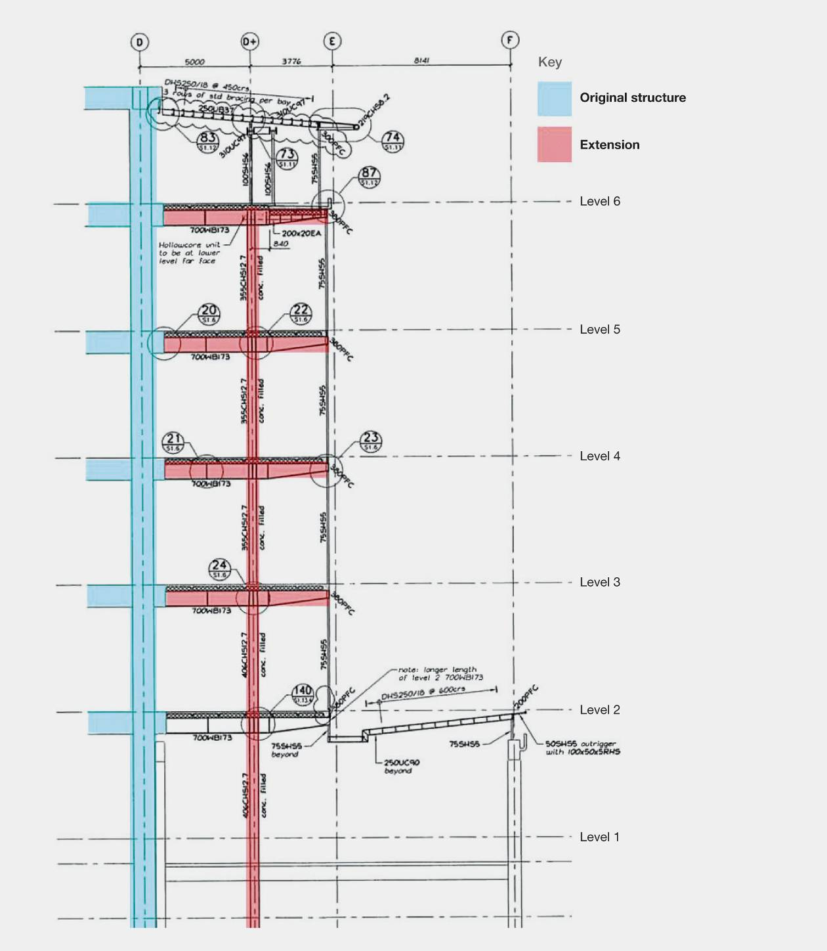
Figure 70: Typical section through extension structure (source: Compusoft)
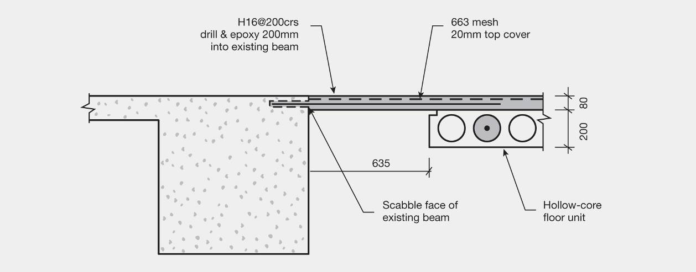
Figure 71: Section at interface of original and extension structure (source: Compusoft)
The lateral seismic forces arising from the extension were carried back into the original part of the building. For this purpose 16mm bars at 200mm centres were placed in the topping concrete and anchored into the main part of the structure (see Figure 71). The addition introduced a limited amount of eccentricity for seismic forces in the east–west direction.
6.1.2.2 Building structural performance
The Royal Commission was assisted in its assessment of the building by a report prepared by Compusoft. The building suffered relatively minor damage as a result of the September 2010, February and June 2011 earthquakes. The primary structural damage has been summarised in the table below:
Structural aspect | Earthquake
 | September 2010 | February 2011 | June 2011
Original frames | - | Spalling of concrete in columns adjacent joints  Shear cracking in beams | Some cracking
Extension structure | Yielding where steel beams connect to existing structure  Crushing and spalling of concrete in the infill slab | No apparent movement at steel beam connections  Cracking of concrete at edge of infill slab | Movement where steel beams connect to existing structure  Cracking and spalling at double-tee seating
Stairs: general | Cracks in topping concrete  at stair landings | Spalling to edges, cracking through stairs in places  Stairs safe to use | Cracks to landings at level 3 and 4, alongside previous repair
Stairs: level 1 to 2 | Cracking and spalling of top connection, cracking of “sliding” base connection | Stairs jammed and considered unsafe to use | -
Foundation | - | Moderate liquefaction at eastern end of structure | -
Summary of primary structural damage over three earthquakes, CCC Civic Offices (source: Compusoft)
6.1.2.3 Damage to elements that are not part of the primary structure
The building suffered from damage to elements that are not part of the primary structure during the earthquake sequence. Fortunately this did not result in injury to people in the building, but failures of this nature are likely to be typical of many buildings in Christchurch. Some of the damage in this building is considered below.
As a result of the September earthquake, long lighting channels that were suspended by wires failed and fell onto the spaces below (see Figure 72). These weighed up to 34kg each so it was fortunate that the building was unoccupied at the time. Analysis by Powell Fenwick Consultants Ltd after the September earthquake indicated that the lighting channels were subjected to loadings well above the design Standards of the time (NZS 4219:1983⁸ and AS/NZS 60598.1:2003⁹). This is with the assumption that the fixtures are only required to perform adequately in a serviceability limit state earthquake, as their failure was considered to be a financial loss issue rather than one related to life-safety. After the September earthquake these lighting channels were re-suspended with steel rods and braced to resist seismic loads in the most critical direction (see Figure 73). They performed adequately in the February earthquake.
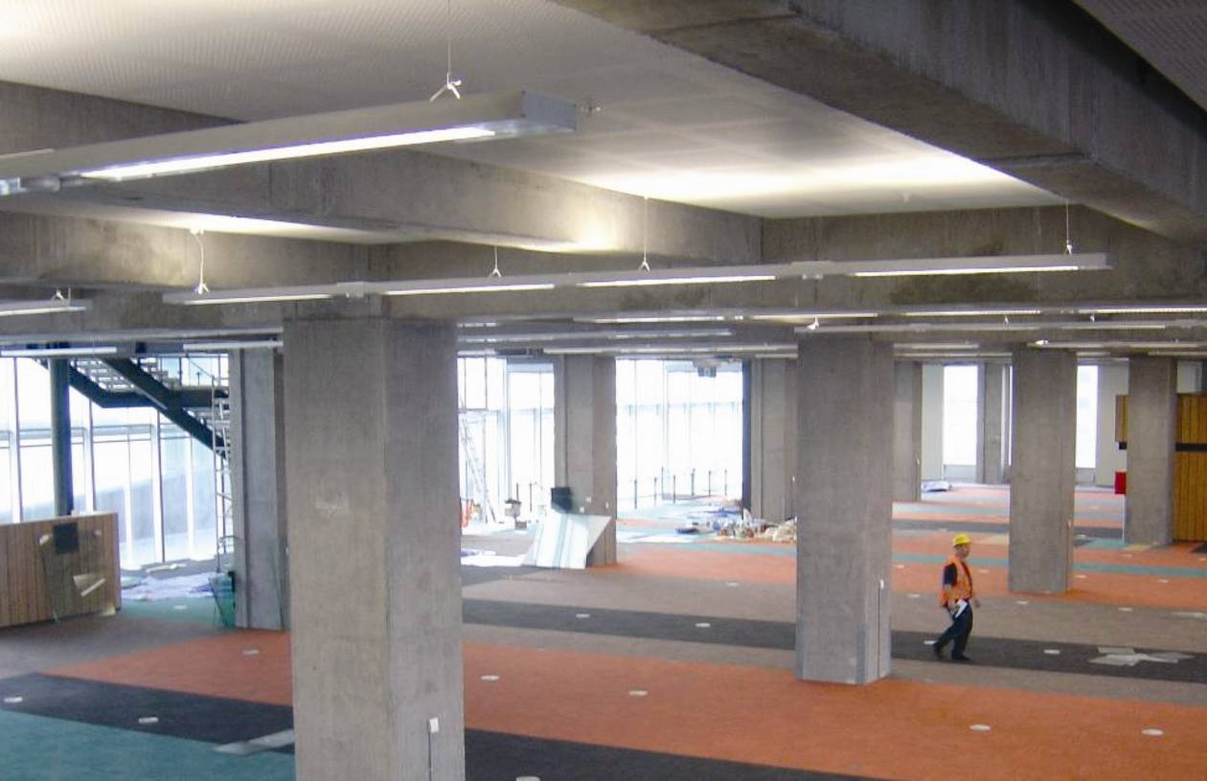
Figure 72: The lighting channels in 2010, prior to occupation of the building by the CCC
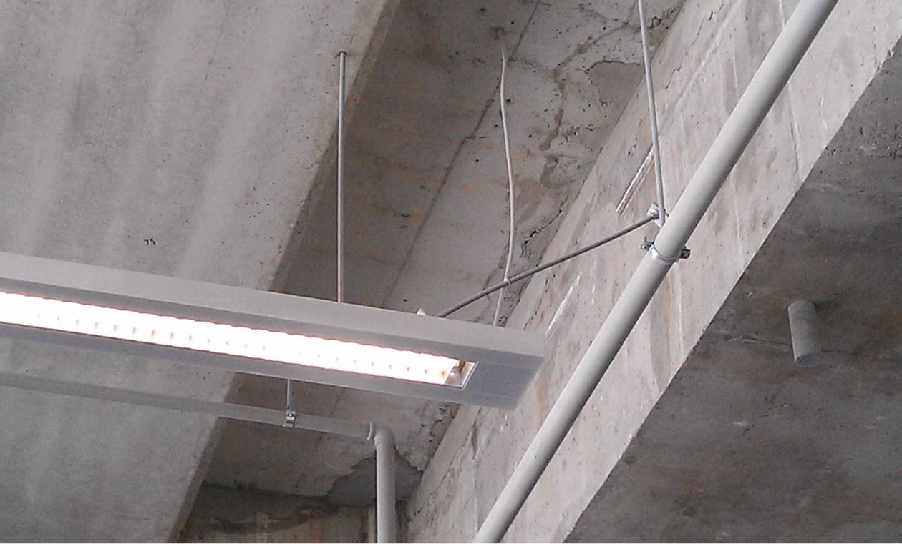
Figure 73: Lighting channels suspended by steel rods, braced for seismic loads in the critical direction
Bookcases also toppled in the September earthquake, and were re-fixed at the base with more consideration of seismic loadings before the February earthquake. We do not have a record of the performance of these in the February earthquake but they are an example of where egress routes can be obstructed.
As was the case with the Police Station there was extensive damage to the linings of the building. Of particular concern was the failure of some of the linings, which obstructed egress routes. The fixing of fire-resistant linings in the stairwells between moment resisting frames did not allow for the movement of those frames in the earthquakes.
6.1.2.4 Conclusions
Performance was comparable to that of the Police Station, with the structure only sustaining relatively minor damage. Its good performance reflects the high quality of its design at a time when the concepts of capacity design were being established. It also reflects the advantages of having:
• a regular structure with multiple lateral force resisting elements;
• minimal eccentricity between the centre of mass and the centre of stiffness and strength of the lateral force resisting system; and
• robust cast-in-situ concrete floors to act as diaphragms.
There was limited damage to the structure at the junction between the extension and the main building. The extension was tied to the main building by 16mm reinforcing bars at 200mm centres that were anchored into the existing structure and the in situ concrete topping above the hollow-core units. While there was sufficient reinforcement to satisfy the requirements of NZS 1170.5:2004¹⁰, the method of calculation was incorrect. The horizontal force was assessed by bending theory applied to the floor loaded by a horizontal force with the floor acting as the beam. The span of this beam was 8m, its depth 87m and the calculations surprisingly assumed that plane sections remained plane. In addition the lateral force coefficient for each level was 0.05, which might have been adequate for the base shear for the building as a whole but it is close to 1/30th of the corresponding value found from a parts and portions analysis. However, the designer had the good sense to ignore his calculations and specify that a much greater quantity of reinforcement be used in the junction than was indicated by the calculations.
The analysis of the failure of the luminaires highlighted the assumption that fixtures and fittings only need to comply with the design load requirements of a serviceability limit state earthquake. The Royal Commission considers that where the failure of a fixture or fitting is likely to risk the life of any person, the ultimate limit state loadings should be applied. Also, the design of linings is principally the responsibility of architects and it is important that the need to ensure that egress routes remain clear in the event of an earthquake is emphasised to them.

