Section 5:
General observations of damage

This section of the Report illustrates common types of damage to primary structure that were observed in the buildings constructed between the 1930s and 1970s. It follows with some common types of damage that were not to the primary structure, but could have affected the safety of the building.

5.1 Damage to the primary structure

5.1.1 Introduction
Unreinforced masonry (URM) and stone buildings are well known to be vulnerable in earthquakes. Construction of these building types came to an end during the 1930s as councils adopted by-laws based on NZSS 95: 1936 – New Zealand Standard Model Building By-Law¹. This Standard was established after the 1931 Napier earthquake. Around this time the importance of inertial seismic forces on buildings was recognised and incorporated in the design of buildings. However, it was not until the 1960s that the significance of ductility on seismic performance was appreciated by practising structural engineers.
A key change in design philosophy occurred during the period from the late 1960s to the late 1970s, when the concept of capacity design was developed and introduced into design standards. There was no single date on which it can be said that the concepts of capacity design and ductility were adopted by designers. A few fundamental concepts were practised by the Ministry of Works, with details in its 1968 Code of Practice². Some ductile detailing requirements from the American Concrete Institute design code ACI 318:1971³ were used by some engineers in New Zealand and in the Provisional New Zealand Standard of the 1970s, which was based on the ACI code. In 1975 the book “Design of Reinforced Concrete Structures” by Park and Paulay⁴ set out a number of the basic concepts of capacity design.
The date of 1976 is often quoted as a milestone as this was when the Loadings Code, NZS 4203: 1976⁵ set out the requirements for capacity design. There was information readily available in 1977 and 1978 on capacity design in the New Zealand National Society for Earthquake Engineering Bulletins⁶, but it was not until 1982 that the Concrete Structures Standard, NZS 3101:1982⁷ defined the detailing necessary to achieve the required ductility. From the late 1960s to the early 1980s there was a wide variation in design practice, with some designers applying
the new concepts while others maintained their previous practice.
Much of the damage that occurred in buildings constructed between the 1930s and 1970s is well known by designers and the issues around these failures have already been addressed in the current standards. Patterns of observed earthquake damage and the lessons that should have been learnt have been described by Paulay and Priestley⁸ in 1992.
Kam et al⁹ have stated that the structural deficiencies in these buildings include:
- no capacity design principles;
- lack of confining stirrups;
- inadequate reinforcing and anchorage details;
- poor material properties and use of plain reinforcing bar; and
- irregular configurations.
Deformed reinforcement was not widely available in New Zealand until the mid-1960s.
The majority of multi-storey buildings in the Christchurch Central Business District (CBD) are reinforced concrete and reinforced masonry structures, with few older steel-framed and timber structures. A draft report dated 5 December 2011 on “The Seismic Performance of Reinforced Concrete Buildings in the Christchurch CBD”¹⁰ was prepared for the Christchurch City Council (CCC) by Pampanin et al from the University of Canterbury. This report describes the damage observed after the 22 February 2011 earthquake.
Many of the observations of building damage were assessed non-invasively, so further damage may have remained hidden by wall linings, ceilings or floor coverings. Nevertheless, typical patterns of damage observed and their severity can be related to the time when the building was designed. Some of the more common forms of damage identified in the Pampanin report are shown in Figures 54–59, with an emphasis on buildings constructed from the 1930s to early 1980s.

5.1.2 Common observed damage patterns
5.1.2.1 Column failures
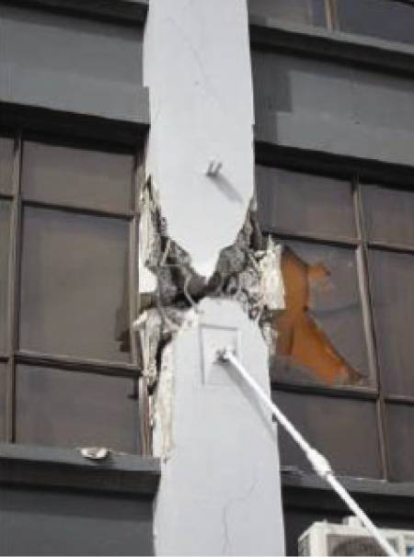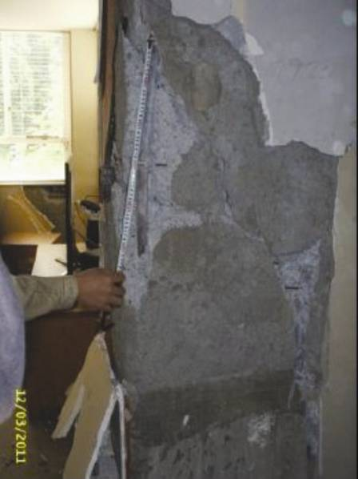
(a) 198 Gloucester Street (1929) (b) 82 Chester Street East (1957)
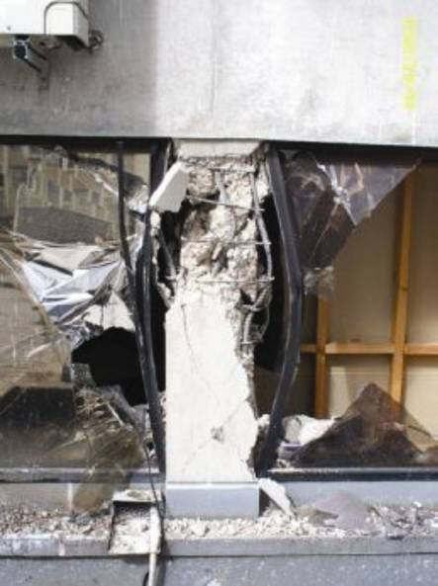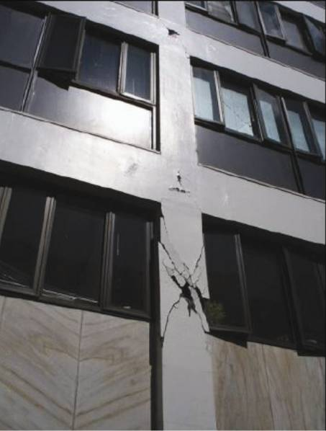
(c) 141 Hereford Street (1979) (d) 221 Gloucester Street (1974)
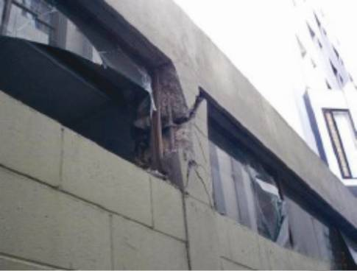
(e) 79–83 Hereford Street (1968)
Figure 54: Typical column failures

Figure 54 illustrates some of the common column failures that occur in earthquakes, affecting buildings that were not detailed for ductility or designed using capacity design principles. In these cases brittle shear failures in columns were relatively common (Figures 54(a) and (b)) and column sway mechanisms formed as shown in (Figure 54(c)). In all cases shown in Figure 54 the columns had inadequate shear and/or confinement to prevent premature failure.
Figures 54(d) and (e) illustrate the “short-column” effect, which leads to premature shear failure. In many cases this was due to the stiffening effect of so-called non-structural masonry infill or spandrels built hard up against the columns. When the infill is partial height, the column is stiffened in comparison with other columns at the same level, which may not have adjacent infills (that is, interior columns). These short, stiff columns attract high shear forces, sometimes with disastrous effects.
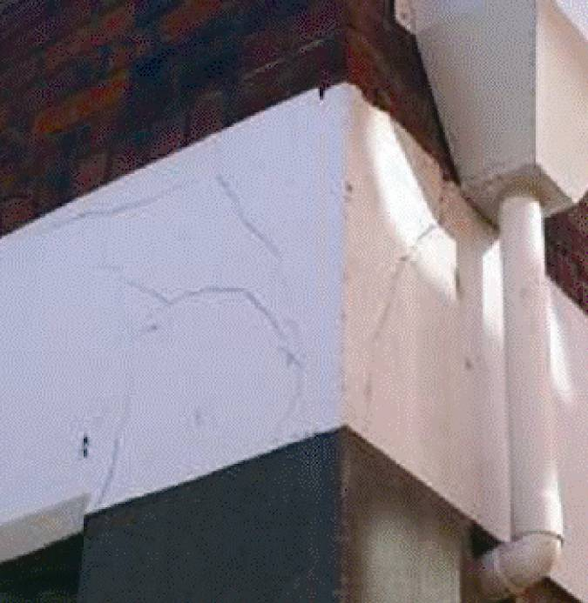
Figure 55: Beam-column joint damage, 277 Manchester Street (1945, with 1953 alterations)

The columns in Figure 54 illustrate lack of ductility associated with inadequate confinement reinforcement in a plastic hinge region. Paulay and Priestley⁸ show that high compression strains can be induced in the concrete from the combined effects of axial force and bending moment. Unless adequate closely spaced well-detailed transverse reinforcement is placed in the potential plastic hinge region, spalling of the concrete can be followed by instability of the compression reinforcement which buckles as shown in Figure 54(c).
5.1.2.2 Beam–column joints
The beam–column joint is the region where the beams at each level connect into the columns. In current design practice these joint zones are designed to be stronger than the beams that frame into them. The beam–column joint zones are subjected to high shear forces during severe earthquakes and, if the joint zones are inadequately reinforced, excessive loss of strength and stiffness can occur. In extreme conditions collapse can occur. Figure 55 illustrates shear cracking developing in a corner beam–column joint.
5.1.2.3 Structural wall failure
Unless adequately designed for the levels of flexural ductility and shear force expected under strong ground shaking, flexural or shear failures may develop in structural walls, as shown in Figure 56.
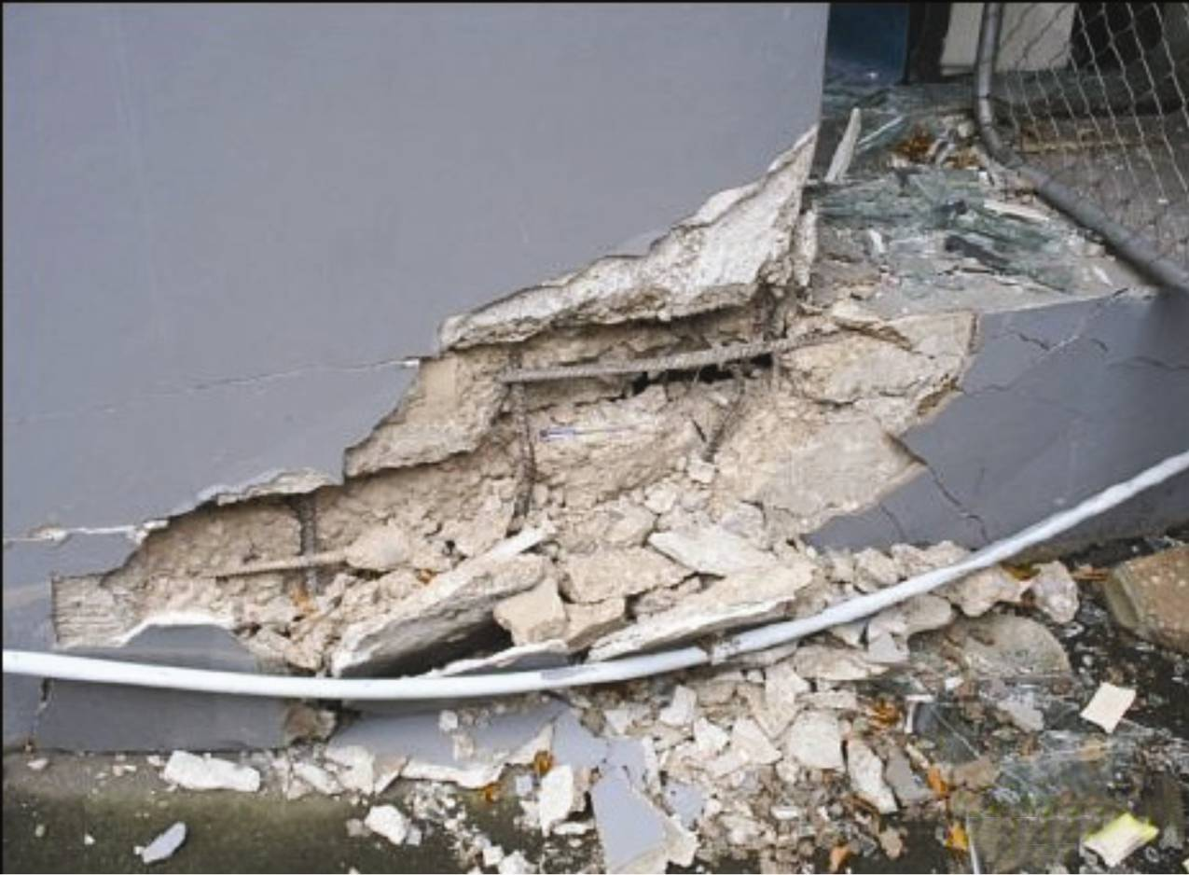
Figure 56: Structural wall failure, 29–35 Latimer Square (1967)
5.1.2.4 Conventional coupling beam failure
Beams coupling structural walls are often subjected to high ductility demands and high shear forces as a consequence of their short length. It is difficult to avoid excessive strength degradation in such elements (as shown in Figure 57) unless they have been diagonally reinforced. The concept of using diagonal reinforcement in coupling beams was not introduced until the mid-1970s.
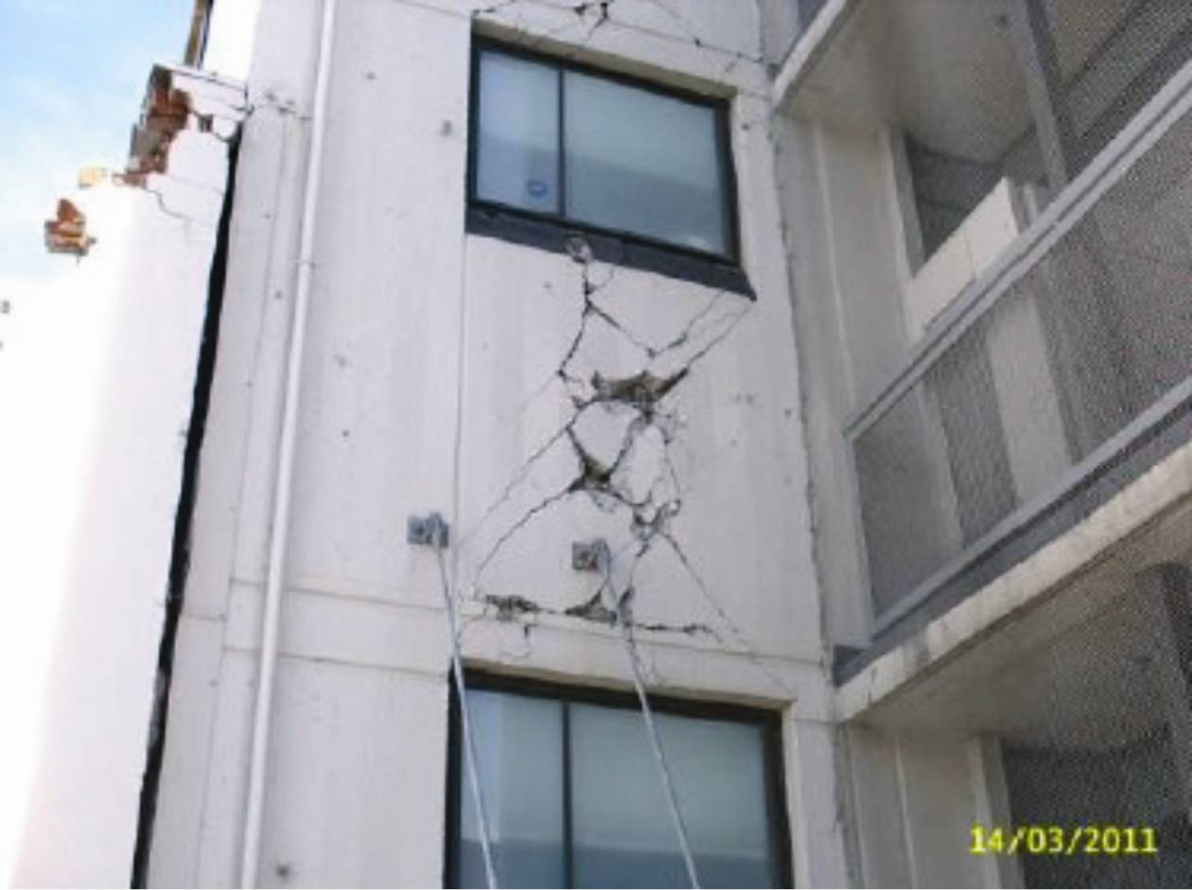
Figure 57: Conventional coupling beam failure, 180 Manchester Street (1964)
5.1.2.5 Structural masonry
Reinforced masonry buildings are made of solid grouted or cavity walls, which are known as structural masonry. Masonry is also commonly used as an infill in frames and it is considered to be non-structural. As discussed earlier, if this infill is not adequately isolated from the frame it can lead to stiffening effects and/or short-column failures.
In-plane diagonal shear failures are common in solid-grouted and cavity-type masonry walls as shown in Figure 58. Failures of masonry elements can also be attributed to construction deficiencies¹¹. In some cases the masonry block voids were only partially grouted, and under-reinforced.
Masonry shear cores around liftshafts and stairs are also common in buildings. These can become damaged with diagonal and/or sliding bed-joint shear cracking.
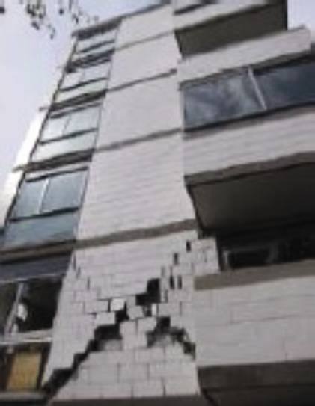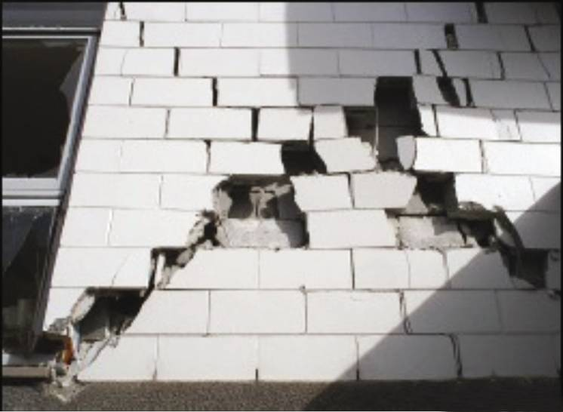
Figure 58: Structural masonry failure, 35 Cambridge Terrace (1964)
5.1.2.6 Punching shear
Buildings constructed using flat slabs supported directly on columns without beams are susceptible to punching shear cracking and failure (Figure 59). Demolition of these systems has shown them to be fragile with the potential of floor “pancaking”. Failure of slabs in punching shear can arise when inter-storey drift induces bending moments in the column, and these are then introduced into the floors. The shear stresses associated with the transfer of bending moments can greatly increase the stresses at the critical section and lead to a brittle failure.
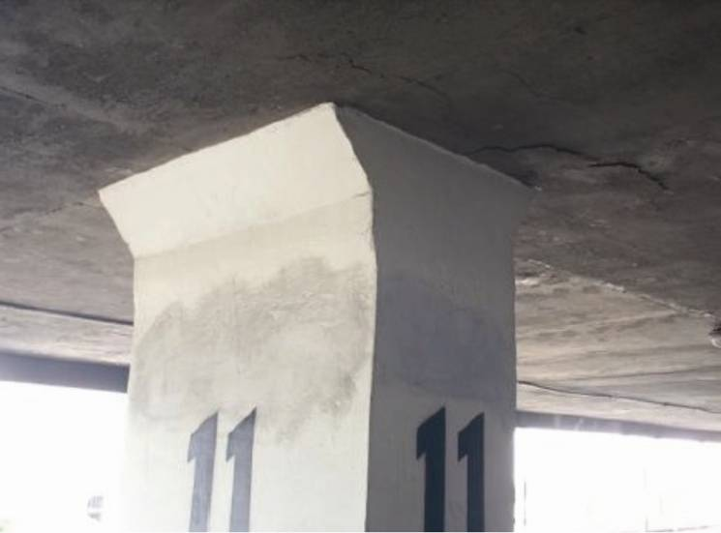
Figure 59: Punching shear cracking, 33 Lichfield Street

5.2 Building damage that is not part of the primary structure

5.2.1 Introduction
Analysis of individual buildings, and reports from other agencies, have highlighted that the safety of a building can be severely compromised by individual items and systems not complying with the structural requirements of the Building Code. We now discuss some examples of parts of buildings that failed in the earthquakes.

5.2.2 Compromised egress routes
5.2.2.1 Doors
There was evidence of doors jamming as a result of the permanent deformation of the Hotel Grand Chancellor, discussed in section 3 of this Volume of the Report. Maintenance workers needed to force doors open in order to evacuate the building.
5.2.2.2 Emergency lighting
In the Forsyth Barr building the emergency lighting failed, as discussed in section 4 of this Volume. The failure was likely to have been caused by the complete collapse of the stair. It is fortunate however that no one fell down the stairwell because of the lack of lighting. Emergency lighting systems are also often attached to suspended ceiling systems, which commonly failed.
5.2.2.3 Fire separations
The safety of buildings subsequent to the earthquakes was compromised by the failure of lightweight fire separations not detailed and installed to accommodate the flexibility of the main structure. This was demonstrated in the stairwells of the CCC Hereford Street offices (see section 6.12 of this Volume) and repairs were required to plasterboard firewalls after both the September and February earthquakes. The plasterboard is now reinforced with steel strapping to the outside, which will not prevent damage to the lining but will prevent it from falling on people and from blocking the escape route.
5.2.2.4 Shelving
The majority of buildings had shelving systems that did not remain standing during the major earthquakes. Even if the shelving did remain standing, the contents of the shelves often fell. This can be of particular significance where the primary escape route from the building is compromised.

5.2.3 Falling hazards
5.2.3.1 Ceilings
Failures of ceilings, in particular suspended tile ceilings, have been widely reported as a result of the earthquakes. This was discussed as having occurred in the Pyne Gould Corporation (PGC) building after the September earthquake (see section 2 of this Volume). The solution in that case was to replace the heavy ceiling tile system with a lighter system. Unfortunately, because the building collapsed on 22 February there is no way to determine how well the new tile system performed. However, there have also been reports of the failure, during the 23 December 2011 aftershock, of suspended tile ceilings that had only just been replaced as a result of the February earthquake. This occurred in the Christchurch Hospital Riverside Block.
The performance of ceilings in the February earthquake is considered in a report by Dhakal, MacRae and Hogg, published in the Bulletin of the New Zealand Society for Earthquake Engineering (NZSEE), Volume 44, Number 4, December 2011¹². That paper also includes conclusions and recommendations that are summarised below:
- Most damage occurred at the perimeter of ceilings and increased with the size of the ceiling.
- The observed damage primarily occurred in ceilings with heavier ceiling tiles. Wherever possible, heavier tiles should be avoided.
- Earthquake design for ceilings should be for life- safety rather than serviceability.
- Several ceiling failures were the result of the failure of services above the space, bulkheads and partition walls. Service installation requirements should be strictly complied with. Similarly, improved design guidelines for ceiling systems that take into account the interactions with partition walls are needed.
- Poor installation practices in the case of ceilings, services and partitions appear to have caused more failure than weakness in design. Quality control measures should be implemented to ensure compliance.
- Replacing ceilings quickly after an earthquake has been a priority in some cases. However, if not carried out correctly, further damage can occur in aftershocks and future earthquakes.
We agree with these observations.
5.2.3.2 Heating, ventilation, and air conditioning (HVAC) systems
The failure of the support of HVAC systems, in particular the way the failure affected ceilings, is considered in the Dhakal et al report. HVAC systems are commonly of metal construction and could be a significant danger if they fell on a person.
5.2.3.3 Lighting
Lighting systems, in particular those associated with suspended tile ceilings, but also longer channel lighting systems, have regularly failed and fallen into the room below. An example of the failure of a long channel system in the CCC Hereford Street offices in the September earthquake, and the solution to prevent a reoccurrence, is discussed in section 6.12 of this Volume.
5.2.3.4 Fire safety systems (excluding sprinklers)
No particular examples of the failure of fire safety systems have been bought to the attention of the Royal Commission. However, with many buildings having detector and alarm systems attached to the suspended tile systems, it follows that damage must have occurred. The major risk from falling objects in this case remains with the tile system itself rather than the attached fire safety systems.
5.2.3.5 Racking systems
The performance of racking systems in the Canterbury earthquakes has been considered in a report by Uma and Beattie¹³. The Royal Commission has not considered this matter further.
5.2.3.6 Non-structural partition walls
Although there have been many reports of damage to non-structural partition walls, the Royal Commission has seen no evidence that lightweight walls have failed in a manner that has created an immediate danger to people. The exception to this is lightweight walls that have impeded an exit route.

5.2.4 Risk of fire in buildings
We have seen little evidence of outbreaks of fires in buildings that remained standing after the earthquakes. One fire is known to have occurred as a result of the September earthquake but the specifics have not been investigated by us. There does, however, remain a significant risk if there is an outbreak of fire. The passive and active systems to protect the people occupying buildings and allow them to exit in safety should remain operative during and after an ultimate limit state event.

5.2.5 Discussion
Egress from a building during an emergency and the protection of the egress route should be considered as a life-safety issue, and consequently the means of egress should perform adequately in an ultimate limit state event. This also applies to building elements that could fall and injure people underneath.
Structural engineers focus on the primary structure, with the ancillary structures generally being managed by the designer responsible for the architectural elements. There is often no overall supervision of the structures within the building by a person with knowledge of how the building is expected to behave
in an earthquake.
There is a significant amount of work that can now be carried out without a building consent. Although there is an obligation for all work to comply with the Building Code, the restrictions in the Building Act on those who may carry out work only apply to residential buildings. Evidence discussed in the reports in the NZSEE Bulletin Volume 44, Number 4, December 2011^{9, 11, 12, 13} (referred to above) suggests that systems that may be of proprietary design and have adequate provision for seismic movement are not necessarily being installed in accordance with those designs, or with proper regard to the limitations of those designs.

5.2.6 Conclusions
We conclude that:
1. The principles of protecting life beyond ultimate limit state design should be applied to all elements of a building that may be a risk to life if they fail in an earthquake. This is already applied to stairs and the same factors of safety should apply to other critical non-structural building elements.
2. In the design of a building the overall structure, including the ancillary structures, should be considered by a person with an understanding of how that building is likely to behave in an earthquake.
3. Any element of a building that is considered to be a life-safety issue if it fails should only be installed by a suitably qualified and experienced person, or under the supervision of such a person. The regulatory framework necessary for this is discussed in Volume 7 of this Report.

References:
1. NZSS 95: 1936. New Zealand Standard Model Building By-Law. Standards Association of New Zealand. Available from Standards New Zealand
2. Ministry of Works. (1968). Code of Practice, Design of Public Buildings. Office of the Chief Structural Engineer.
3. ACI. (1971). Building Code Requirements for Reinforced Concrete (ACI 318-71). American Concrete Institute.
4. Park, R., and Paulay, T. (1975). Design of Reinforced Concrete Structures. Wiley Inter-Science, John Wiley and Sons Inc.
5. NZS 4203: 1976. Code of Practice for General Structural Design and Design Loadings for Buildings, Standards Association of New Zealand. Available from Standards New Zealand.
6. New Zealand Society for Earthquake Engineering Inc. (NZNSEE) Bulletins (1977, 1978). Volumes 10 and 11, New Zealand National Society for Earthquake Engineering.
7. NZS 3101:1982. Code of Practice for the Design of Concrete Structures. Standards Association of New Zealand. Available from Standards New Zealand.
8. Paulay, T., and Priestley, M. J. N. (1992). Seismic Design of Reinforced Concrete and Masonry Buildings. John Wiley and Sons Inc.
9. Kam, W. E., Pampanin, S. and Elwood, K. (2011). Seismic Performance of Reinforced Concrete Buildings in the 22 February Christchurch (Lyttelton) Earthquake. New Zealand Society for Earthquake Engineering Bulletin, 44(4).
10. Pampanin, S., Kam, W. E., Akguzel, U., Tasligedik, S. and Quintana-Gallo, P. (July 2011). Seismic Performance of Reinforced Concrete Buildings in the Christchurch CBD under the 22 February 2011 Earthquake – Part II Damage Observation. Report prepared for the Christchurch City Council.
11. Dizhur, D., Ingham, J., Moon, L., Griffith, M., Schultz, A., Senaldi, I., Magenes, G., Dickie, J., Lissel, S., Centeno, J., Ventura, C., Leite, J. and Lourenzo, P. (2011). Performance of Masonry Buildings and Churches in the 22 February 2011 Christchurch Earthquake. New Zealand Society for Earthquake Engineering Inc. Bulletin, 44(4).
12. Dhatzal, R. P., MacRae, G. A. and Hogg, K. (2011). Performance of Ceilings in the February 2011 Christchurch Earthquake. New Zealand Society for Earthquake Engineering Inc. Bulletin, 44(4).
13. Uma, S. R. and Beattie, G. (2011). Observed Performance of Industrial Pallet Rack Storage Systems in the Canterbury Earthquakes. New Zealand Society for Earthquake Engineering Inc. Bulletin, 44(4).

