3.2 Up until 4 September 2010
On 17 December 1992 a building consent application for the work necessary to change the use of the building from offices to a hotel and casino was submitted to the CCC (Council reference 9210270). This application was approved on 23 December 1992.
It is not clear from the CCC’s records whether it turned its mind to the requirements of section 46(2) of the Building Act 1991, under which a change of use required the CCC to be satisfied that, among other things, in its new use the building would comply with the provisions of the Building Code for structural behaviour. However, design loading requirements in late 1992 have been assessed by the Royal Commission as being lower than at the time of the original design, and in the circumstances it would have been reasonable for the CCC not to require a further structural assessment to justify the change in use.
Over the period from 1993 to 1995, applications for building consents (in five stages) were submitted for the hotel fit out. A casino licence was never granted. The work approved, however, included some strengthening of the floor of the podium at level 14 in order to enable this floor to be used as a conference facility. These alterations would not have altered the overall seismic characteristics of the building. A final code compliance certificate for this work was issued on 22 October 1998 (Council reference 93012531). The building owner at this time was Grand Central (NZ) Ltd.
Other building and resource consents were subsequently issued by the CCC, but since they were for work that had no relevance to the structural performance of the building they are not discussed.

3.3 The earthquakes
3.3.1 The September earthquake
The nature and intensity of the September earthquake are described in section 2 of Volume 1 of this Report. The HGC building was located similar distances from all four primary seismic measuring stations for the Christchurch CBD, as can be seen in Figure 26. The Dunning Thornton report prepared for DBH used an average of the measurements from these four stations. The Royal Commission accepts that the measurements used are acceptable for the purpose of analysis.
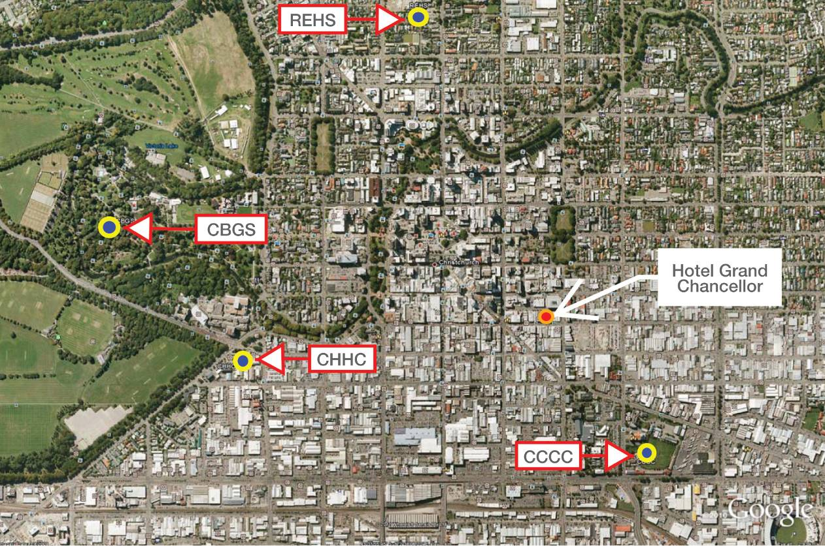
Figure 26: HGC building location in relation to the four seismic measuring stations
3.3.2 Between the September earthquakes and the Boxing Day aftershock
As discussed in a later volume of this Report, after the September earthquake a state of local emergency was declared and the CCC (under guidance from DBH) initiated a civil defence emergency management response. Starting on the day after the earthquake, teams were sent to all commercial areas of the CBD to undertake a Level 1 Rapid Assessment. These teams included at least one CCC officer, who was usually accompanied by a Chartered Professional Engineer (CPEng).
A Level 1 Rapid Assessment is an exterior inspection to look for obvious signs of damage that indicate immediate danger, or to identify that further investigations are required before use. A Level 2 Rapid Assessment is a more extensive visual inspection that includes the interior of the building.
On 5 September, both Level 1 and Level 2 assessments were carried out. Both resulted in a green “Inspected” placard, which placed no restriction on the occupancy or use, but encouraged owners to obtain a detailed structural assessment of the building.
The Level 2 assessment was carried out by Mr Gary Haverland, a senior structural engineer and director of Structex Ltd with over 24 years’ experience. His inspection was at the request of Mr Stephen Martin, the hotel’s general manager. Mr Haverland primarily identified cracked GIB plasterboard linings, tearing of floor coverings at the base of the stairs and flashing damage at the seismic joint between the HGC building and the neighbouring car park building. Some removal of linings was undertaken to inspect the stair support. All damage inspected was identified as superficial and not of structural concern.
Mr Martin employed Powell Fenwick Consultants Ltd to carry out a further structural inspection, which took place on 23 September 2010. This inspection was carried out by Mr Andrew Lind, a senior structural engineer with 18 years of experience. He was aware that buildings of this type (taller buildings with a longer initial period) have been subjected to higher than design loadings in the earthquake. Mr Lind was not able to see the key structural drawings and the critical nature of wall D5–6 was not obvious to him. As wall D5–6 was fully lined, the concrete could not be inspected for cracks. In evidence to the Royal Commission, he said he considered his inspection to have been more extensive than a Level 2 assessment, in that he observed beam column joints, and removed linings where they were damaged in order to investigate the underlying structure. He identified some hairline cracks, but otherwise the damage he observed was similar to that already noted by Mr Haverland. Mr Lind did not have any concern for the structural stability or strength of the building.
Mr Lind was, however, concerned about some of the stairs, having noted spalling at the landings from which some flights descended. He thought this was due to the stair units not sliding sufficiently at the base of the flight during the earthquake. At his direction the floor linings at every level were lifted to confirm the extent of the damage and a concrete patch repair was undertaken where necessary. The work was evidently carried out to his satisfaction.
The liftshaft was inspected at some point after this inspection but the actual date is not recorded.
A follow-up inspection of the beam-column joint in the conference room was undertaken by Mr Lind on 1 October 2010. There was no damage to the primary structure observed.
3.3.3 The Boxing Day aftershock
After the Boxing Day aftershock, Mr Lind carried out a further inspection at the request of Mr Martin, who was concerned about additional damage to the seismic joint between the hotel building and the adjoining car park building. There was also movement in the air conditioning and sprinkler pipes, with one of the sprinkler pipes bursting open. Fletcher Construction Ltd contractors were on site at the time carrying out repairs. They walked around with Mr Lind and removed linings where requested. In Mr Lind’s opinion, there was no additional structural damage to the building.
On 1 February 2011, Goleman Exterior Building Care (a division of Goleman Co. Ltd) presented a report on the exterior damage to the building after an inspection carried out by industrial abseilers. This was addressed to Fletcher Construction Ltd. It was unclear from the evidence given to the Royal Commission whether this report was considered by an engineer before the February earthquake.
3.3.4 The February earthquake
The nature and intensity of the February earthquake are described in section 2 of this Volume.
The principal direction of the shaking was east–west, with a significant vertical component. The earthquake was of a short duration but had high accelerations and displacements because its epicentre was close to the CBD.
When the earthquake struck the HGC building was evidently subjected to strong east–west accelerations, resulting in failure of the ground floor D5–6 shear wall and the collapse of many of the stair flights. The reasons for the failure and the likely sequence of events are addressed later in this Report.
The Royal Commission has been assisted in its understanding of the failure of the building by:
• the Dunning Thornton report1;
• the Expert Panel report2; and
• the review of both reports by Mr Holmes from Rutherford and Chekene prepared at the request
of the Royal Commission.
3.4. Investigations
3.4.1 Investigation by Dunning Thornton Consultants Ltd
The findings of the Dunning Thornton investigation were presented to the Royal Commission at the hearing on 17 January 2011 by Mr Adam Thornton, structural engineer and author of the Dunning Thornton report. The executive summary stated:
In the short but violent Lyttelton aftershock of 22 February 2011, the Christchurch Hotel Grand Chancellor building suffered major structural damage. The extent of damage suffered by the building was significantly increased by the collapse of a key supporting shear wall, which failed in a brittle manner.
The building survived the 4 September 2010 earthquake and the 26 December 2010 aftershock events without apparent significant structural damage and was fully in use when the February event occurred. During the approximate 12 seconds of intense shaking that occurred at 12:51pm on 22 February, the building suffered a major structural failure with the brittle rupture of a shear wall in the south-east corner of the building. This shear wall had supported vertically approximately one eighth of building’s mass and was also expected to carry a portion of lateral earthquake loads.
As a result of the wall failure, the south-east corner of the building dropped by approximately 800mm and deflected horizontally approximately 1300mm at the top of the building.
There was sufficient redundancy and resilience within the overall structure to redistribute the loads from the failing element and to halt the collapse.
This major movement induced other damage including: column failure at the underside of the podium, beam yielding, stair collapse and precast panel dislodgement. The collapse of the stairs, in particular, was dependent on the wall failure. Other more minor structural damage was consistent with what may have been expected in a well performing reinforced concrete structure in a seismic event of this nature.
The investigation found that, for the most part, the structural design appeared to be compliant with the codes of its day. However, for the failed wall, D5–6, it does appear that there were some items of non compliance that most likely contributed to the failure. The magnitude of possible axial loads was under-estimated and the wall lacked the confining reinforcing needed to provide the ductility required to withstand the extreme actions that resulted from the February 2011 aftershock. In addition the assessed response of the building to this shaking exceeded the actions stipulated by both the current and contemporary loadings codes for a building of this type, structural period (of vibration) and importance.

3.4.2 DBH Expert Panel review
The Expert Panel report concurred with the conclusions of the Dunning Thornton report.
The findings were presented to the Royal Commission at the hearing on 17 January 2012 by Associate Professor Dr Stefano Pampanin, one of the members
of the Panel.
The conclusions and recommendations of the Panel were set out in paragraphs 6.10 and 6.11 of the Expert Panel report, as follows.
6.10. Conclusions
Examination and analysis suggests that the building structure was generally well designed. Indeed, the overall robustness of the structure forestalled a more catastrophic collapse. However the shear wall D5–6 contained some critical vulnerabilities that resulted in a major, but local, failure. Other shear wall failures of similar appearance have been observed in other buildings following the 22 February 2011 aftershock, and this suggests that a review of both code provisions and design practice is warranted.
6.11. Recommendations
This section contains some recommendations arising from observations made during the investigation of the Hotel Grand Chancellor building and the meetings of the Panel. Some are quite specific to structural features that are contained within the Hotel Grand Chancellor and some are more generic, relating to design codes and practice generally.
The matters set out below are ones that the Department should give consideration to:
• Design rigour for irregularity
While current codes do penalise structures for irregularity, greater emphasis should be placed on detailed modelling, analysis and detailing. An increase in design rigour for irregularity is required.
• Design rigour for flexural shear walls
The behaviour of walls subject to flexural yielding, particularly those with variable and/or high axial loads, has perhaps not been well understood by design practitioners. An increase in design rigour for wall design generally, and in particular for confinement of walls that are subject to high axial loads, is required.
• Stair review
A review of existing stairs, particularly precast scissor stairs, should be promoted and retrofit undertaken where required.
• Stair seating requirement
The introduction of larger empirical stair seating requirements (potentially 4%) for both shortening and lengthening should be considered. This should be included in earthquake-prone building policies.
• Floor-depth walls
The consequences of connecting floor diaphragms with walls that are not intended to be shear walls requires particular consideration. A Design Advisory relating to walls/beams that are connected to more than one floor but which are not intended to act as shear walls, should be considered.
• Design rigour for displacement induced actions
Designers generally have tended to separate seismically resisting elements from ‘gravity-only’ frames and other elements of so-called secondary structure. However, not enough attention has always been paid to ensure that the secondary elements can adequately withstand the induced displacements that may occur during seismic actions. Non-modelled elements should perhaps be detailed to withstand 4% displacement. Modelled elements should be detailed to withstand a minimum of 2.5% displacement. An increase in design awareness relating to displacement induced actions should be promoted.
• Frames supported on cantilevers
Although this is not a common arrangement, caution needs to be taken when supporting a moment resisting frame on cantilever beams as effective ratcheting can lead to unexpected deflections. A Design Advisory relating to ratcheting action of cantilevered beams and frames should be considered.

During February 2012 DBH issued a final Expert Panel report. The only difference from the Stage 1 report was the renumbering of paragraphs 6.10 to 7.11, and 6.11 to 7.12.
3.4.3 William T. Holmes’ review
The Royal Commission retained Mr Holmes to review both the Dunning Thornton report and the Expert Panel report. His findings were presented to the Royal Commission at the hearing on 18 January 2012, and may be summarised under the following headings:
Overall comments
• general agreement on failure caused by a heavily loaded and lightly reinforced wall; and
• the content of the investigative report results in questions with answers not available or not on the record:
− the report relied on simplified analysis techniques apparently due to complexity of the building—particularly very strong vertical discontinuity (walls to frame);
− the derivation of drifts estimated from displacement spectra are not clear—certainly not the vertical distribution of drifts (section 5.1 of the Dunning Thornton report);
− the derivation of loading on the failed wall, D5-6, is not clear (Appendix F.1 of the Dunning Thornton report); and
− very high vertical accelerations are noted in the February event, but their relative contribution to the failure is not estimated. In fact, it is stated that the wall probably would have failed anyway.
September 2010 versus February 2011 shaking
• although the shaking intensity in the period range of the structure was more intense in September 2010 than in February 2011, the explanation of the lack of damage in September is not satisfying;
• ‘maximum possible displacements’ are estimated at 700mm in September and 1050mm in February using an average of four elastic spectra from recordings. Two of the four recordings in September would have also yielded 1000 or more millimetres and one of the records from February only yielded a maximum of 850mm;
• reference to paper by Associate Professor Pampanin and others as an explanation is unclear; and
• comparison of inelastic displacement spectra with estimated displacement in September do
not reconcile.
Possible explanations
• direction of strongest motion in September was north–south, which minimises interaction with global moment from cantilevers on east face (potential ratcheting). In February the strongest motion was east–west;
• damage in September in the frame superstructure was greater than reported; and
• inelastic spectra at base of upper moment frame were filtered by walled base structure in some way so that response was minimised. Brittle wall D5–6 did not go past its failure point (but did in February).
Lessons learned
• irregular structures, if allowed, must be carefully designed (peer review?);
• ‘late’ changes in design must be carefully considered (another example of bad things happening is the Kansas City walkway collapse);
• structures that incorporate major elements affected by shaking in two directions must be carefully considered (most structures designed for one direction at a time); and
• interaction of gravity framing with the lateral load system must be carefully considered (leaning columns, massive amounts of cantilevers, etc.) including the potential for ratcheting.
3.5 Discussion
3.5.1 Introduction
The Royal Commission agrees with many of the conclusions contained in the Dunning Thornton and the Expert Panel reports but has some reservations concerning aspects of the design of the building and its assessment in the reports, which we discuss below. In a number of cases the Royal Commission arrives at different conclusions from those given in the reports. These are briefly identified and are dealt with in greater depth later.

3.5.1.1 Design
The building was generally well-designed and detailed. However, there were two major errors made in the design analysis, which led to the partial failure of the building in the February 2011 earthquake. First, the axial load acting in wall D5–6 at ground level was underestimated, as clearly indicated in the Dunning Thornton report. This led to the wall being inadequately proportioned and detailed to sustain the structural actions imposed on it. Secondly, the modal response spectrum method of analysis was used in the design without allowance for the eccentric gravity loads acting on the structure. These actions gave the building a tendency to sway towards the east, which had a major influence on the seismic performance of the structure. This aspect was not considered in either the Dunning Thornton or the Expert Panel report.

3.5.1.2 Dunning Thornton report’s analysis
The Royal Commission notes the following points related to the Dunning Thornton report’s analysis of the building, which lead us to different conclusions:
1. The Dunning Thornton report indicates that the dependable base shear strength (in current design standards this is referred to as the design strength) for the frames at level 14 was 0.048W_{t} where W_{t} is the weight of the building above the structural walls (above level 14). This value appears to have come from information submitted to the CCC as part of the application for a building permit. The report further indicated that the actual strength was of the order of 0.08W_{t}. The Royal Commission does not accept this value, as the effective strength varies with the direction of lateral seismic forces owing to the eccentricity of the gravity loads. This has a major effect on the seismic performance of the building.
2. The Dunning Thornton report comes to the conclusion that the stairs would not have collapsed without the failure of wall D5–6 at the base of the building. The Royal Commission does not accept this conclusion, as the analysis fails to allow for a number of actions that were recognised in current design standards and have been shown to have a significant effect on inter-storey drift, a key feature (action) initialising failure of stairs.
3. The Dunning Thornton report indicates that if the critical wall in the building, D5–6, had been designed to the current Standard, NZS 1170.53, it would have collapsed. This conclusion was based on the observation that the minimum design base shear strength in the current Standard3 is lower than the corresponding value in the Loadings Code NZS 4203:19844 used for the design of the building. The Royal Commission has reservations about this conclusion.
4. The stability of any wall or column depends on three factors. The first is the strength for flexure and axial loads; the second is the detailing for confinement and shear strength; and the third is the magnitude of the displacement applied to the wall or column. The Dunning Thornton report discusses the first two points but does not give any indication of the displacement that the critical wall would have been subjected to from seismic actions.
3.5.2 Comments on aspects in the Dunning Thornton report

3.5.2.1 Fundamental period of vibration
In the September earthquake the predominant shaking for structures with fundamental periods of vibration in the range of 2.5–4 seconds was in the north–south direction, while the corresponding predominant shaking for the February earthquake was in the east–west direction5.
The Dunning Thornton report states that the HGC building had a calculated initial fundamental period of vibration (prior to the yield of the tower frames) of around 2.8 seconds. As a structure yields it softens and, as a consequence, the effective period was calculated to be about four seconds. The Royal Commission notes that this increase in period is an assumption inherent in the equal displacement concept, and is implicit in designs based on elastic methods of analysis such as the modal response spectrum method. With this method of analysis the change in stiffness as the earthquake progresses is, therefore, already built into the basic assumptions on which the approach is based. It is valid to allow for softening that may have occurred because of yielding in the September earthquake, and the effect this had on the fundamental period of the building in its condition at the start of the February earthquake, but it is not valid to allow softening due to the increase in period during the earthquake. Using a longer period for the analysis of the February earthquake could be justified, therefore, only on the basis of damage sustained during the September earthquake.
An examination of the response spectra for the September earthquake shows that any predicted yielding in structural elements resisting seismic shaking in the east–west direction would have been minor, as the shaking in this direction was much less than in the north–south direction for the period range of interest. The assessment in the Dunning Thornton report used a response spectrum found by averaging the measured response spectra from the four sets of horizontal records recorded in the CBD for the north–south and the east–west directions. The corresponding spectra for these records are given on pages 40 and 41 of the Carr report5 for both the elastic response and for ductile structures. From these spectra it can be seen that the response spectral lateral displacements in the east–west direction for the September earthquake are of the order of 210mm for a structure with a displacement ductility of 2 over the period range of 2.5–4.5 seconds. This level of ductility would induce little inelastic deformation in the structural members resisting east–west seismic actions and, consequently, any reduction in stiffness for this direction of loading would have been minor.

3.5.2.2 Response of buildings to the September earthquake
The Dunning Thornton report states on page 15 that the response of the structure did not match what was indicated by the response spectra. A number of possible explanations were advanced for this. However, one explanation that is likely to account for a major part of the apparent discrepancy is not mentioned. The two moment resisting frames orientated north–south, which resisted the seismic forces in that direction, comprised five bays in each case. Two of the bays had beams with clear spans of about 3.1m and the remaining three had clear span lengths of about 6.9m. Furthermore, precast pretensioned floor units spanned parallel to the beams and, in the longer spans, the critical sections of the potential plastic hinges were about 800mm from the support position of the precast floor units. When these frames were displaced in the north–south direction it is likely that:
• plastic hinges would have formed in the shorter spans at about 45 per cent of the lateral displacement required to initiate yielding in the longer spans; and
• the precast pretensioned units spanning past the plastic region would have contributed significantly to the flexural performance of the beam (see NZS 3101:20066, clause 9.4.1.6.26).
The first effect would result in the lateral displacement response being bi-linear in form, with the longer beam acting as a spring. This would have reduced the residual displacement of the frames after each significant inelastic excursion. The second effect relates to elongation associated with plastic hinges in the longer span, which would have been partially restrained by the precast pretensioned units. These would have increased the strength and acted as a partial spring to reduce deformation. These two effects could be expected to significantly reduce the peak north–south displacement sustained in the September earthquake.
The Dunning Thornton report indicates that for the February earthquake the response spectra used for the analysis give a maximum displacement at a period of three seconds of 1050mm at the dynamic centre of mass for the fundamental period. In the Dunning Thornton report’s analysis a value of 500mm was quoted for this displacement, but it is not clear how this reduction was justified. Carr, in his report5, shows that the corresponding displacement for structures with displacement ductility in the range of 2–4 is of the order of 400mm–500mm for the period range of 2.5–4 seconds. However, this explanation is not given in the Dunning Thornton report. For a building with a relatively long fundamental period in a short intense earthquake, the equal displacement concept overestimates the displacement. Consequently, the assumed displacement of 500mm for the dynamic centre of mass given in the Dunning Thornton report is appropriate, but not for the reasons that were given.

3.5.2.3 Calculation of axial load on critical wall
A number of questions arise, which are not explained in the Dunning Thornton report, about the way in which the axial load on the critical wall, D5–6, was calculated:
1. The report indicates that the axial load was calculated following the capacity design steps given in the Concrete Structures Standard. However, the report does not state which edition of the Standard was used and there are marked differences between the 1982 and the current design Standards (2006)6,7.
2. The capacity design steps in the Code for finding the maximum axial load levels in columns are based on the assumption that the lateral displacements of the building are well in excess of design levels for the ultimate limit state. The report predicts that the displacement ductility in the February earthquake was of the order of 3.3, which is well below the ultimate limit state design level of about 5 and far below the value of 7+ that should be sustained before collapse. Consequently, it is unlikely that the full capacity design axial loads would have been developed.
3. In the calculation of the peak axial loads in columns the flexural reinforcement in the beams was assumed to have its upper characteristic yield strength. This assumption gives a conservative basis for the purposes of design. However, in the assessment of a structure it is more rational to assume the reinforcement has average material properties. Using the upper characteristic strengths for the reinforcement would have led to a high estimate of the maximum axial load applied to the wall.
We conclude that the maximum axial load level given in the Dunning Thornton report is likely to have been overestimated by a few per cent. However, this discrepancy is small compared to the likely but unknown magnitude of the component of axial load induced by the vertical seismic ground motion.

3.5.2.4 Collapse of the stairs
The Royal Commission does not accept the Dunning Thornton report’s conclusion that the stairs would not have collapsed without the failure of wall D5–6. In the report’s analysis no allowance has been made for any of the following:
• the difference between the design and peak inter-storey drifts;
• P-delta actions;
• the difference in inter-storey deflections found using inelastic time history analyses and the elastic-based analyses modal response spectrum and equivalent static methods of analysis;
• the eccentricity of the gravity loads on the structure as illustrated in section 3.5.3 of this Volume, which arises from the cantilevering of the eastern-most bay of the building (see Figure 27). This causes the inter-storey drifts sustained during the earthquake to increase significantly in the eastward direction.
If allowance had been made for these actions the predicted inter-storey drifts would have been considerably greater than those quoted in the report. They would also have indicated that the stairs were likely to collapse even if the wall did not fail.
The Dunning Thornton report indicates that the drift the stairs must sustain is given by multiplying the inter- storey displacement between adjacent floors found from a response spectrum modal analysis by K/SM. In this term, K is 2.2 and S and M are both equal to 0.8, which results in the term having a value of 3.44. These values are given in the Loadings Code, NZS 4203:19844 for calculating the design inter-storey drift. However, this is a design displacement and not the peak value.
For stairs, it is essential to use the peak value and for this reason the Loadings Code, NZS 4203:19844 required the design drift to be doubled (see clause 3.8.4.2). It should be noted that the design lateral earthquake forces are calculated using a structural ductility factor of 4/SM, which is equal to 6.25. On the basis of the equal displacement concept, the peak displacement is 6.25 times the modal response spectrum drift, which is in close agreement with the value of 6.88 times the value specified in the Standard. We conclude that the calculated drift required for the design of stairs quoted in the Dunning Thornton report was incorrectly assessed. Comparative analyses of ductile structures based on inelastic time history analyses and modal response spectrum analyses have shown that P-delta actions can have a significant influence on inter-storey drift3,8,9. Allowance for P-delta actions in ductile moment resisting frames typically increases both the strength requirements and the inter-storey drifts by about 30–40 per cent.
Comparative analyses of ductile structures by inelastic time history and modal response spectrum analyses (the latter was used by Dunning Thornton) have shown that the latter method underestimates the maximum inter-storey drifts. This occurs as the deflected shape profile tends to change owing to the formation of higher modes of behaviour associated with the formation of plastic hinges in the structure. To allow for this effect, NZS 1170.5 requires the inter-storey drift derived from the drift envelope to be increased by the drift modification factor. For the HGC building the appropriate drift modification factor would be 1.5 (NZS 1170.5, clause 7.3.1.1)3.
The Royal Commission acknowledges that the influence of P-delta actions on deflections and the drift modification were not incorporated in design standards in the 1980s but, in assessing the building’s performance in 2011, it considers that allowance for all actions known to influence behaviour should be considered if the intent is to gain knowledge relevant to current design practice.

3.5.2.5 Would the building have collapsed in a NZS 1170.5 defined event?
The Dunning Thornton report (see page 30, section 10.4) contains the following statement:
The design basis earthquake as defined by NZS 1170.5 is similar to, but a little smaller than, an event defined in NZS 4203:1984, for a building having a period equivalent to that of the HGC building. Therefore, there is a likelihood of possible collapse during NZS 1170.5 defined actions. A relevant issue is that the D5–6 wall did not have sufficient robustness to cope with an event larger than that defined by the Standard. This was exposed on 22ndFebruary 2011.
We do not consider that this deals with the critical issue, which is whether the building would have performed adequately had it been designed to current New Zealand Standards (2011). This depends on the difference in the seismic design actions specified in the Loadings Standards in the 1980s4, the current Earthquake Actions Standard3 and the design requirements given in the corresponding Concrete Structures Standards, NZS 3101 of 1982 and 20066,7, compared with the details that were actually used.
The initial fundamental period of vibration of the building is given in the Dunning Thornton report as 2.6–2.8 seconds. Considering the earthquake actions as defined in the Standards, the lateral force coefficients for a fundamental period of 2.6 seconds in NZS 4203:19844 and NZS 1170.5:20043 for a ductile moment resisting frame are 0.048 and 0.031, respectively. However, allowing for the change in strength-reduction factors during this period (from 0.9 in 1980s to 0.85 in 1995)7,10 the corresponding ratio of strengths would be 1:0.69.
In NZS 4203:19824 there was no requirement for strength to be increased to counter P-delta actions. However, in our current Standard allowance must be made for P-delta actions and two methods are given for this purpose in NZS 1170.53. The simpler method increases the base shear strength by a factor of almost two, while the more detailed method changes the strength required by different proportions over the height of the building. A typical increase in strength with this approach would be of the order of 40 per cent. Using this value the ratio of equivalent strengths becomes 1:0.96 for the 1980s to the 2004 Standards respectively. On this basis, it can be seen that there was little difference in the strength requirements given by the 1984 and 2004 Standards4,3.
As noted previously, wall D5–6 did not satisfy the requirements of the Concrete Structures Standard in 19827. This was due to an error in assessing the axial load level. If the error had not been made, instead of a thickness of 400mm, the wall would have had a minimum thickness of 500mm, to satisfy the maximum slenderness ratio of 10:1 clear height for thickness. It would also have had more confinement reinforcement. If the wall had been designed to meet these requirements it is likely that it would have survived the February earthquake, although it is not possible to be certain of this unless the lateral displacement of the wall is known.
The stability requirements in the 2006 Concrete Structures Standard were based on the requirements given in NZS 3101:199510. These had been developed as a result of structural testing and analytical work, where it had been found that walls buckled after being subjected to high flexural tension strains. Unfortunately, the case of buckling caused by high compression loads was not considered. A consequence of this is that buckling of walls under low axial load conditions is covered in the current Standard, but cases such as that which occurred in wall D5–6 for high axial loads are not covered by the Standard. Consequently, it would be theoretically possible to proportion wall D5–6 to be even more slender than was the case in the 1980s.
We consider that the answer to the critical question of whether the building would have performed adequately had it been designed to 2011 Standards is that it very likely would not have.
This is due to a weakness in our current Concrete Structures Standard on the allowable slenderness of walls with high axial load ratios of (N/Ag fc’) (at or approaching 0.2A_{g} fc’), as identified above, rather than due to inadequacies of the design seismic actions defined in the Earthquake Actions Standard, NZS 1170.53. In our view, urgent revision of the design limits for stability in structural walls subjected to moderate or high axial load ratios in NZS 3101: 20066 is required.
As far as the structural seismic actions are concerned, there is relatively little difference in the required lateral strengths and deformation capacities for walls. The current Concrete Structures Standard, however, would require Wall D5–6 to sustain a higher axial load level than was the case in the 1980s Standard, owing to changes made in the way that over-strength actions are calculated in beams. Consideration also needs to be given to the influence of vertical seismic ground motion on the design axial loads induced in walls and columns.
3.5.3 Method of analysis used by the Royal Commission

3.5.3.1 Analytical model
A schematic representation of the HGC building’s structural system that resists lateral forces in the east–west direction is shown in Figure 27. Structural walls resist the lateral forces up to level 14 while, above this level, the forces are resisted by moment resisting frames. To maintain Tattersalls Lane at ground level the eastern-most bay of the building is cantilevered off the remainder of the structure.
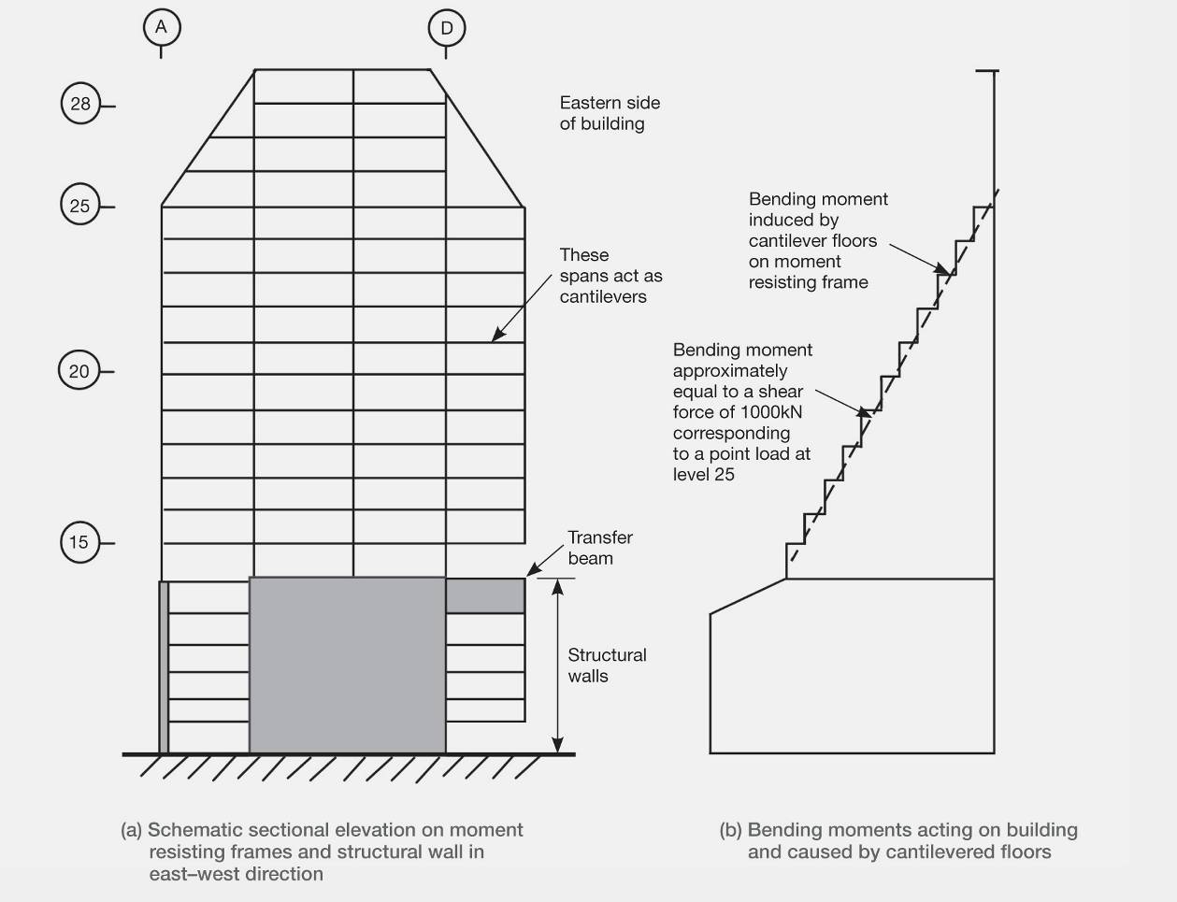
Figure 27: Action in HGC building from cantilever action of gravity load
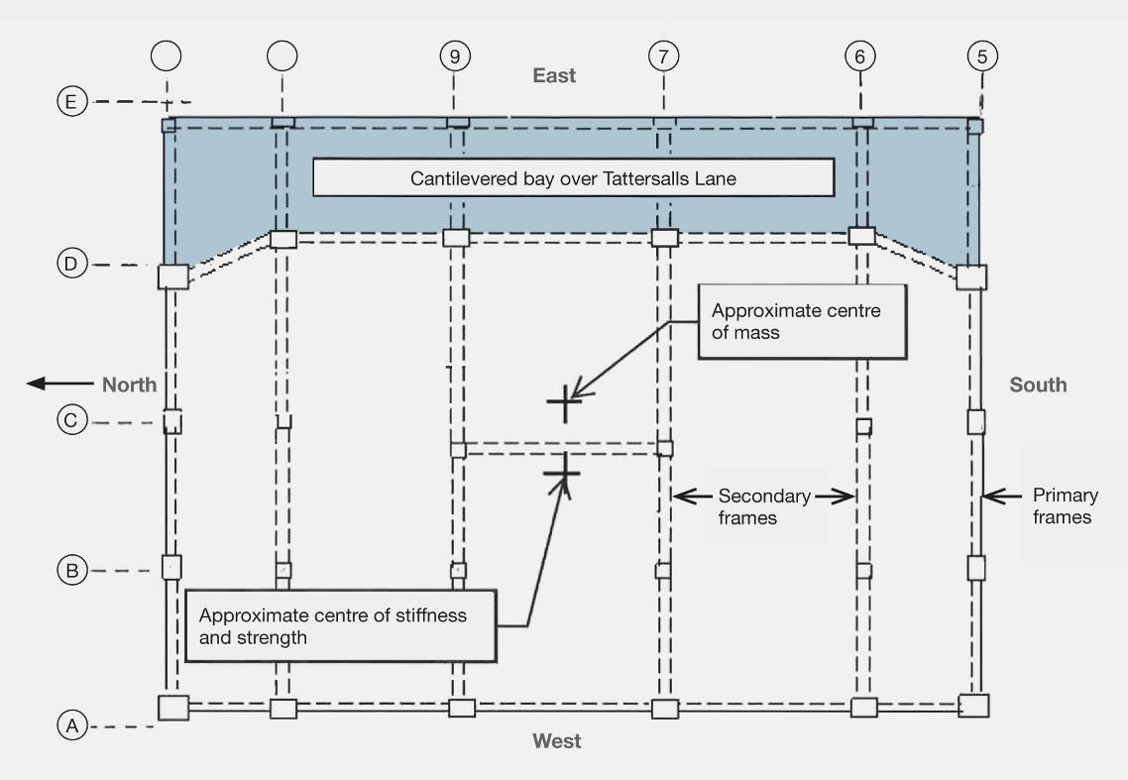
Figure 28: Plan of structural arrangement of tower above level 14
The dead and live loads acting on the cantilevered spans, as shown in Figures 27 and 28, induce bending moments as seen in Figure 27. These actions cause the building to deflect towards the east. The cantilever bending moments are approximately equivalent to the action of a single lateral force of 1000 kilonewtons (kN) acting at level 25.
Each floor in the levels above 14 contains frames that are intended to resist the lateral forces, and a set of lighter secondary frames that span in the east–west direction and resist the majority of the gravity loading. The lateral force resistant frames are located in grid lines A, D, 5 and 11, as shown in Figure 28. The gravity load frames are located between grid lines 6 and 10. The contribution of the gravity load frames to lateral resistance has not been included as they are relatively flexible compared to the lateral force resistant frames and they have been proportioned to reduce their lateral resistance by reducing their depths and/or longitudinal reinforcement at critical sections.
An analysis of the beams and columns in the building shows that the lateral force resistance provided by the frames in grid lines 5 and 11 in the east–west direction in the storeys above level 14 (the top of the structural walls) is about 7.8 per cent of the weight of the building above this level. This figure is based on nominal strength calculations (“ideal strengths” in terms of
NZS 3101:1984). In terms of an equivalent design base shear, these values need to be reduced to allow for building torsion and strength-reduction factors. This gives an equivalent design base shear of the order of 6.4 per cent of the seismic weight at the top of the structural walls at level 14.
As noted above, the eccentricity of the gravity loading is equivalent to a lateral force of 1000kN acting on the seismic resistance frames. Based on nominal strengths, this effectively reduces the ideal storey shear strength at the top of the structural walls to 6.4 per cent and 9.2 per cent, respectively, of the weight of the structure above level 14 for lateral seismic forces acting towards the east and west. However, as the reinforcement content in the beams is reduced over the height of the structure, the relative strength ratio for eastward–westward forces also reduces with increasing height.
The use of the modal response spectral analysis for ductile structures is based on the assumption that the lateral resistance is equal for both the forward and backward deformation. Hence, using this method of analysis for the HGC building violates one of the basic assumptions of the method. As the lateral force corresponding to inelastic deformation is lower for displacement to the east than to the west, it is to be expected that the structure would tend to progressively deflect towards the east during the period of strong ground motion. This behaviour has been referred to as “ratcheting”.
To investigate this effect we developed a simplified model of the HGC building. The model was restricted to assessing seismic displacements in the east–west direction. The structural walls up to level 14 were assumed to remain elastic and were represented by columns with a given shear stiffness.
The analytical model was developed in consultation with Professor Athol Carr, who subsequently made the analyses described in this Report. Further details of the model and the parameters assumed for the analyses and the details of the ground motion records are given in Appendix A on page 85.
The structure above level 14 was represented by three columns, 1, 2 and 3, as shown in Figure 29. The first column represents the storey shear strength based on the assumption that points of contra-flexure would develop at the mid-height of each storey, as seen in Figure 30. The shear resistance provided by this action is limited by the strength of the beams at the critical sections and this was found from an analysis of the beams on grid lines 5 and 11. These storey shear strengths were used to define the corresponding shear strengths in column 1 in the model. The corresponding shear stiffness was assessed from the strength and the associated inter-storey deflection at first yield of the beams. (Note that this represents a mathematical model of the HGC structure, not a physical model, and that the column numbers do not represent the grid lines in the building.)
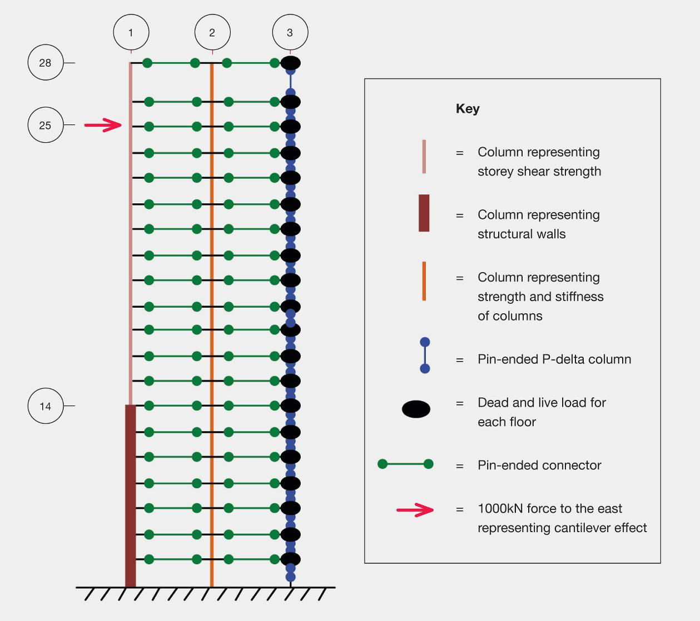
Figure 29: Schematic of the model for inelastic time history analysis
In any seismic loading situation the points of contra-flexure will move, provided the column strengths are adequate. Column 2 in the model, as shown in Figure 29, allows for this action. The flexural strengths of all the columns on grid lines 5 and 11, but excluding those on grid line E, were determined from the drawings, allowing for the gravity axial load that they resisted. The strengths at each storey of column 2 in the model are based on the sum of the calculated flexural strengths of these columns minus the corresponding column moments induced by the storey shear sway mechanism represented in column 1 in the model. The corresponding column stiffness values for the line 2 column in the model were calculated from the analysis of the columns at first yield but multiplied by 1.5 to allow for tension stiffening away from the potential plastic hinge region.
The third column, column 3 in the model, was added to allow actions arising from P-delta effects to be included, as indicated in NZS 1170.5 clause C6.5.1. This column was pinned at every level so it could resist axial loading alone but not contribute the lateral force resistance. The gravity loads at each floor were applied to column 3. As the first two columns in the model had their horizontal displacements slaved together and the P-delta column was tied to the other two columns by pin-ended struts, any P-delta actions induced by the gravity loads were transferred to the lateral force resisting elements of the building. The lateral stiffness of the shear elements was adjusted by changing the effective shear modulus until the fundamental period of the building was close to 2.8 seconds.
To allow for the cantilever portion of the frame, a single lateral force of 1000kN acting in the eastward direction was applied at level 25 (see Figures 27 and 29). This analytical model does not account for any reduction in strength as a result of torsional effects resulting from its irregular plan and the seismic actions in the north–south direction.
Using the model described above, inelastic time history analyses were made using the Ruaumoko analysis package11 for the four recorded ground motions in the CBD for the east–west or near east–west direction. Two further analyses were made. The first of these was a composite earthquake involving one long analysis of the Resthaven (REHS) ground motions for the September, Boxing Day and February earthquakes, but with a period of no ground shaking between each earthquake record to allow the model to settle. The second was for an earthquake representing an Alpine Fault event. This was based on a record of the Japanese earthquake of March 2011, which was recorded on ground similar to Christchurch and at a similar distance from the fault.
Further information on the analytical model, the analyses and the earthquake representing the
Alpine Fault event is given in Appendix A on page 85.
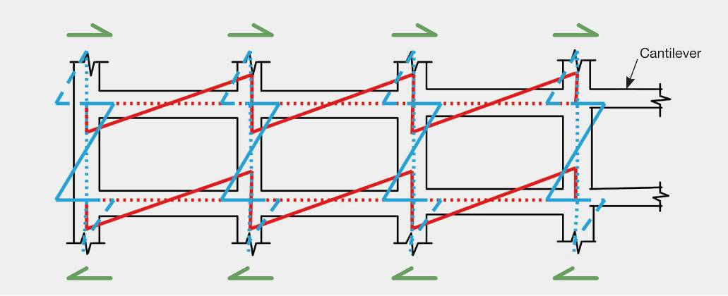
Figure 30: Storey shear strength (ignoring eccentric gravity loading)

3.5.3.2 Results of the analyses
After the inelastic time history analyses had been carried out, the displacement envelopes were calculated over the height of the building, together with peak inter-storey drifts and residual displacements. Results for the maximum storey displacements are given in Figure 31, below. The relatively stiff walls extended from ground level up to level 14, about 21m above the base. The predicted displacements of the top of the tower towards the east are three to five times greater than the corresponding maximum displacements to the west for the four CBD ground motion records.
The comparable Alpine Fault event, which had lower ground acceleration but a much longer duration, did not show the same degree of ratcheting in the eastern direction as the CBD ground motion records. The composite ground motion, involving one long earthquake in which the September event was followed by the Boxing Day and February earthquakes for the REHS station, showed a relatively small increase in ratcheting to the east when compared to the single REHS ground motion for the February earthquake.
To assess the significance of the eccentric gravity load acting on the structure, an analysis for the REHS ground motion was rerun assuming that there was no eccentric gravity loading. This was achieved by removing the lateral 1000kN force at level 25. The results of this analysis are shown in Figures 32 and 33 and can be compared with the corresponding values in Figures 31 and 34) where allowance was made for the eccentric gravity loading. It can be seen that without the eccentric gravity load the lateral displacement to the east is considerably reduced and the corresponding peak displacement to the west is of comparable magnitude.
Figures 34–37 show how the displacement at the top of the building varied with time for ground motions in the east–west direction measured in the CBD during the February earthquake (at the CBGS, CHHC, REHS and CCCC seismic measuring stations, as shown in the Dunning Thornton report, on page 13, and more completely defined by Carr5). Part (a) of each of these figures gives a plot of the recorded ground accelerations as a proportion of the acceleration due to gravity, while part (b) shows the corresponding displacement where the displacements to the east are given in negative values. In all cases, the analyses indicate that the building displaces progressively towards the east during the period of strong ground motion.
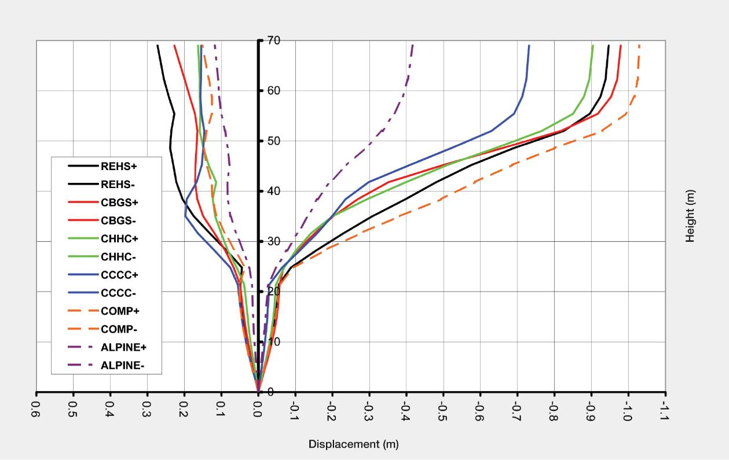
Figure 31: Maximum displacement envelopes for inelastic time history analyses
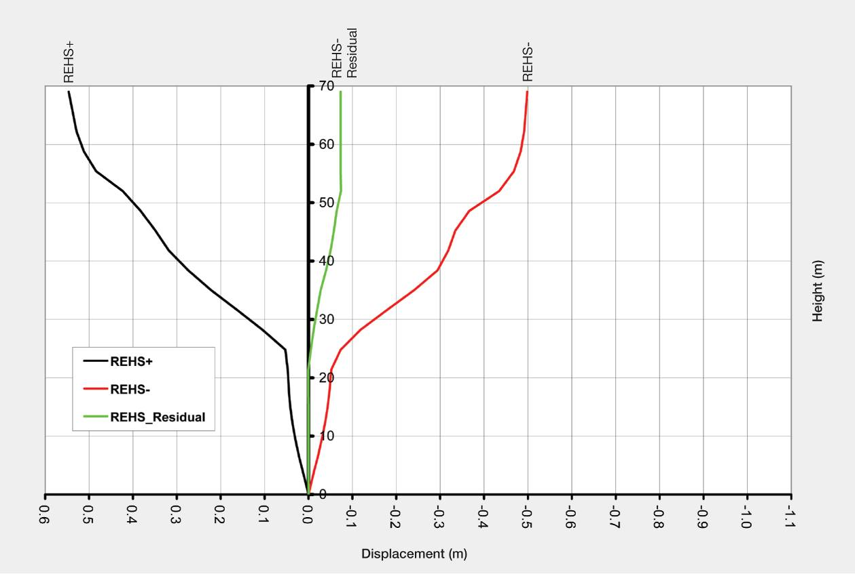
Figure 32: Maximum displacement envelope and residual displacement with no cantilever action
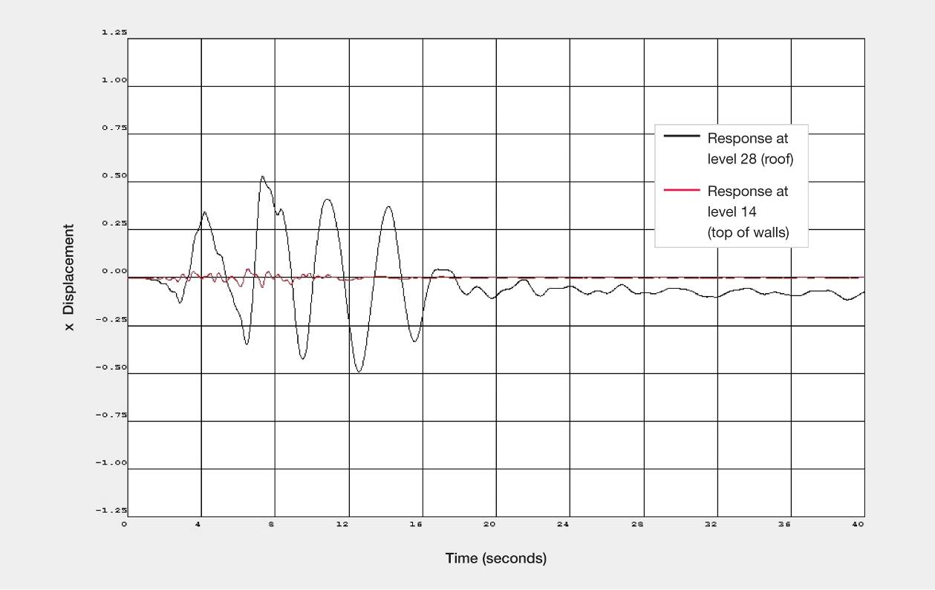
Figure 33: Displacement inelastic time history with no cantilever action (source: Athol Carr)
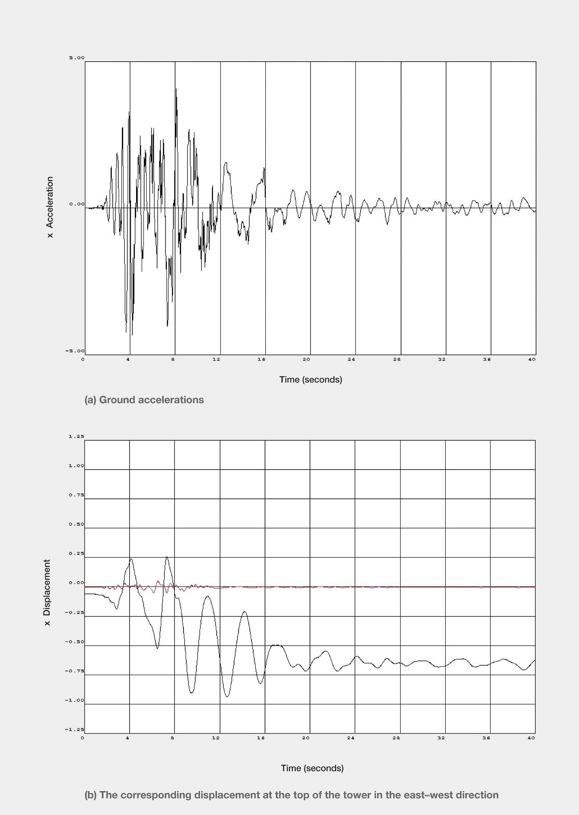
Figure 34: REHS earthquake record (source: Athol Carr)
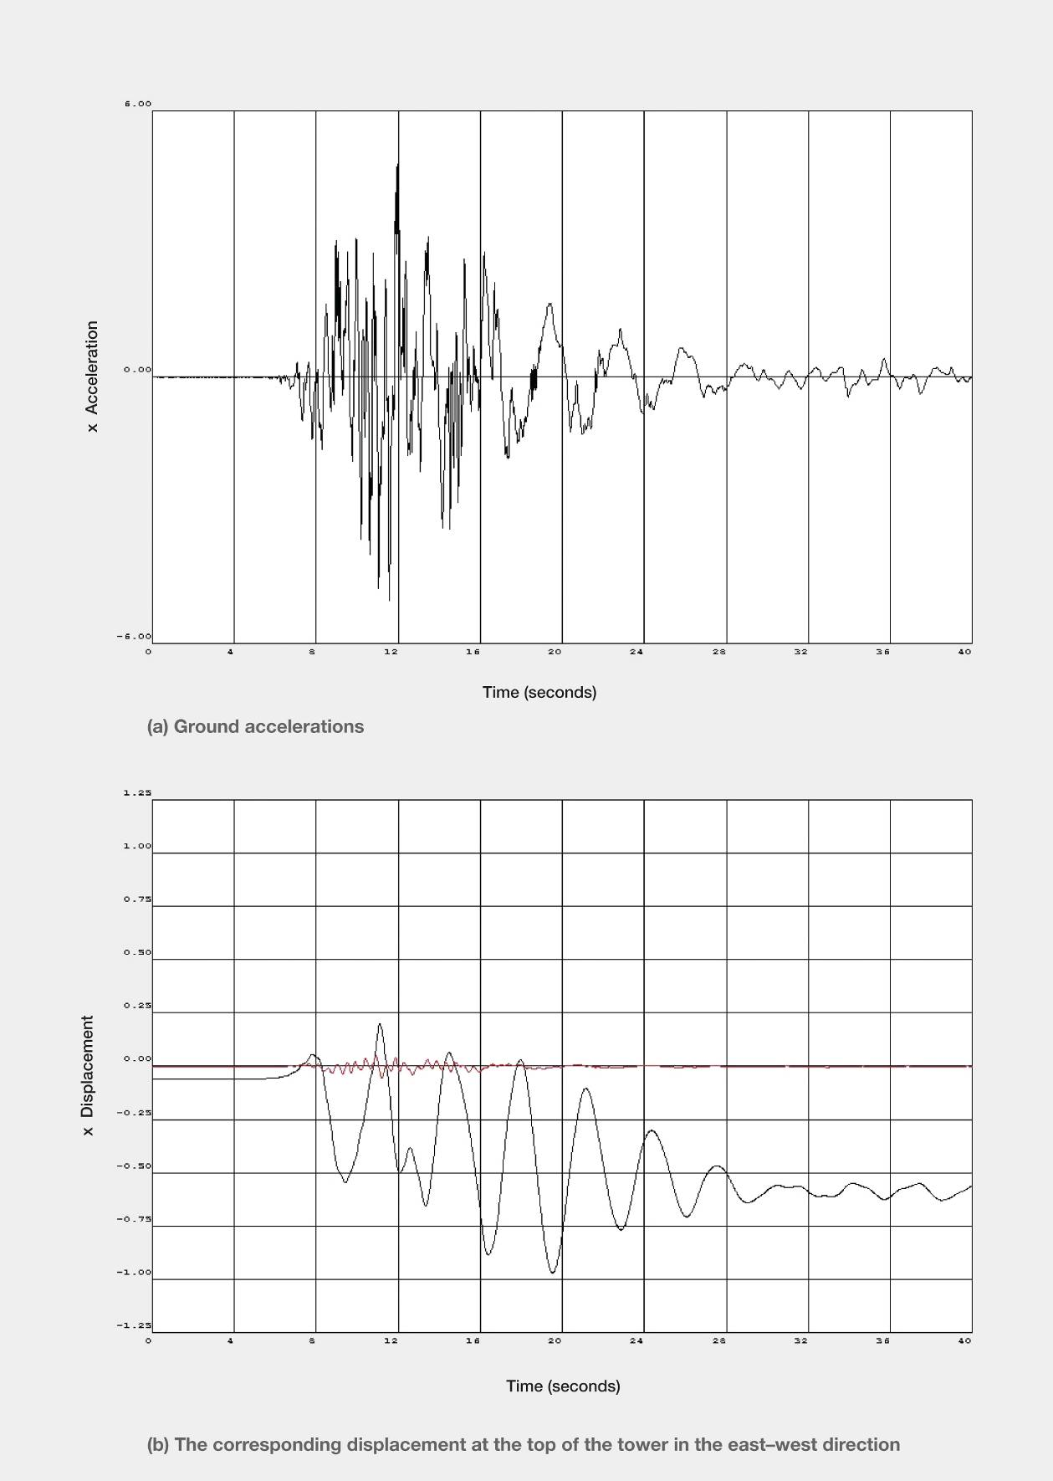
Figure 35: CBGS earthquake record (source: Athol Carr)
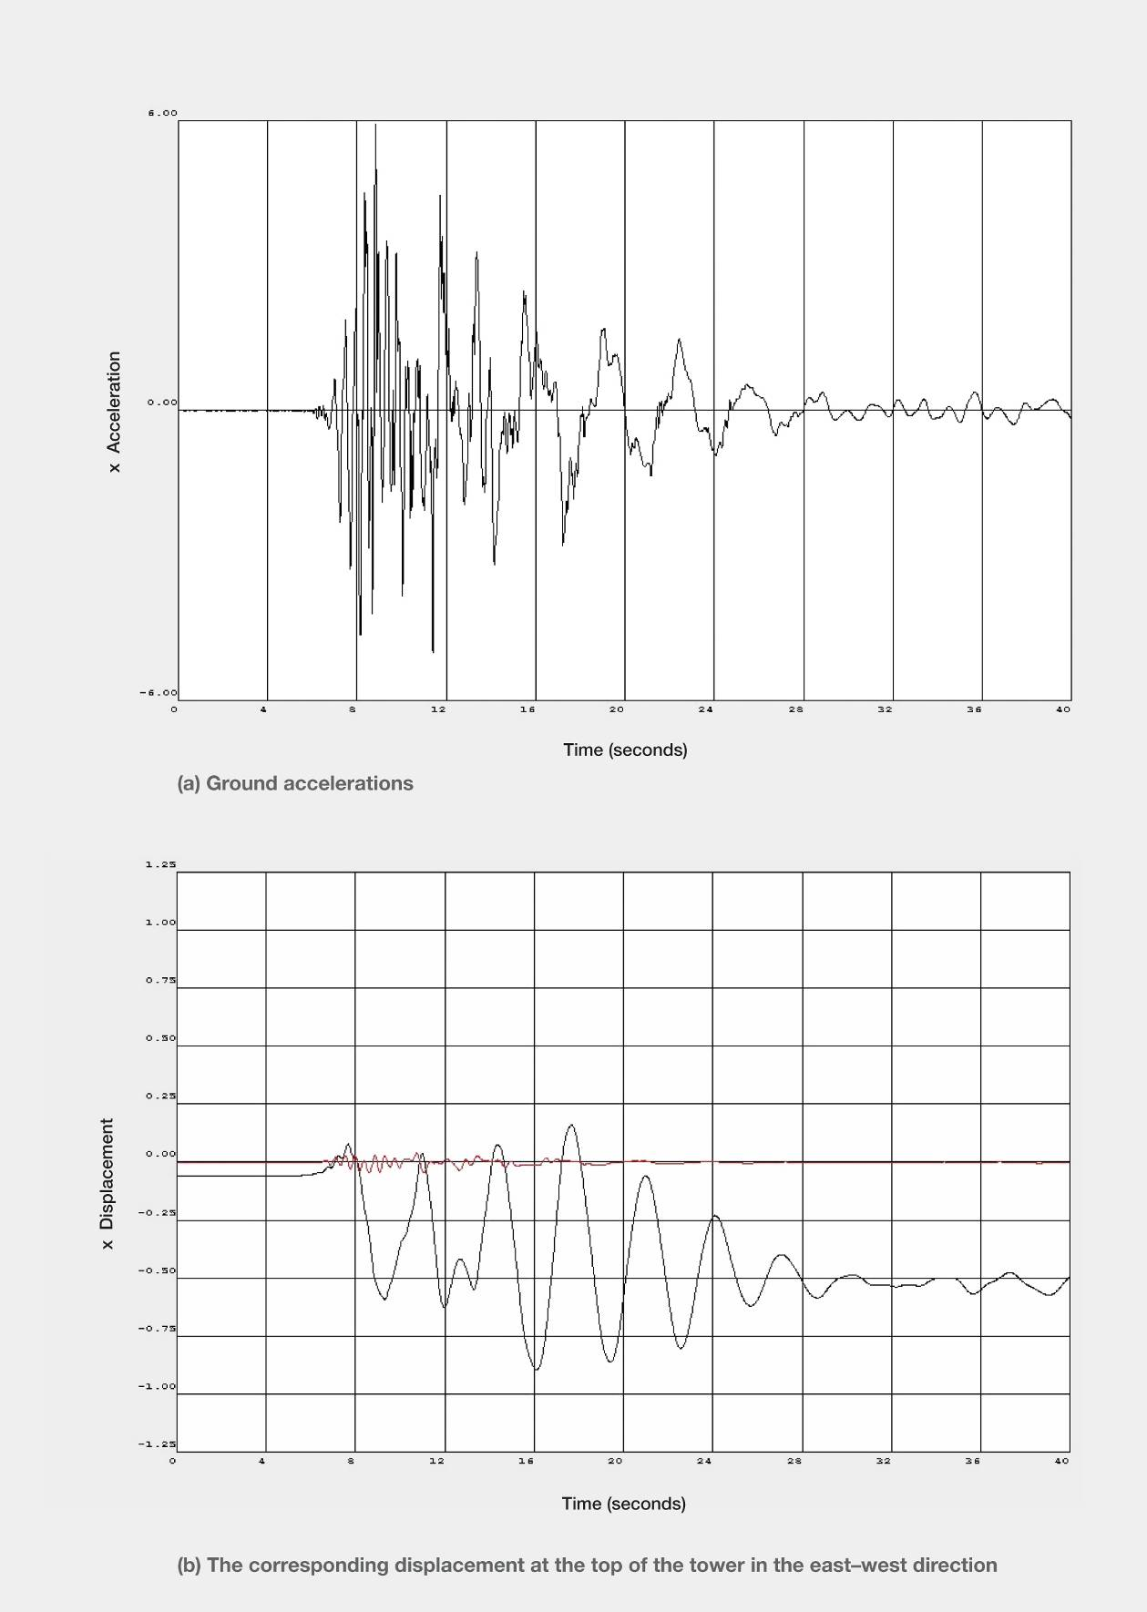
Figure 36: CHHC earthquake record (source: Athol Carr)
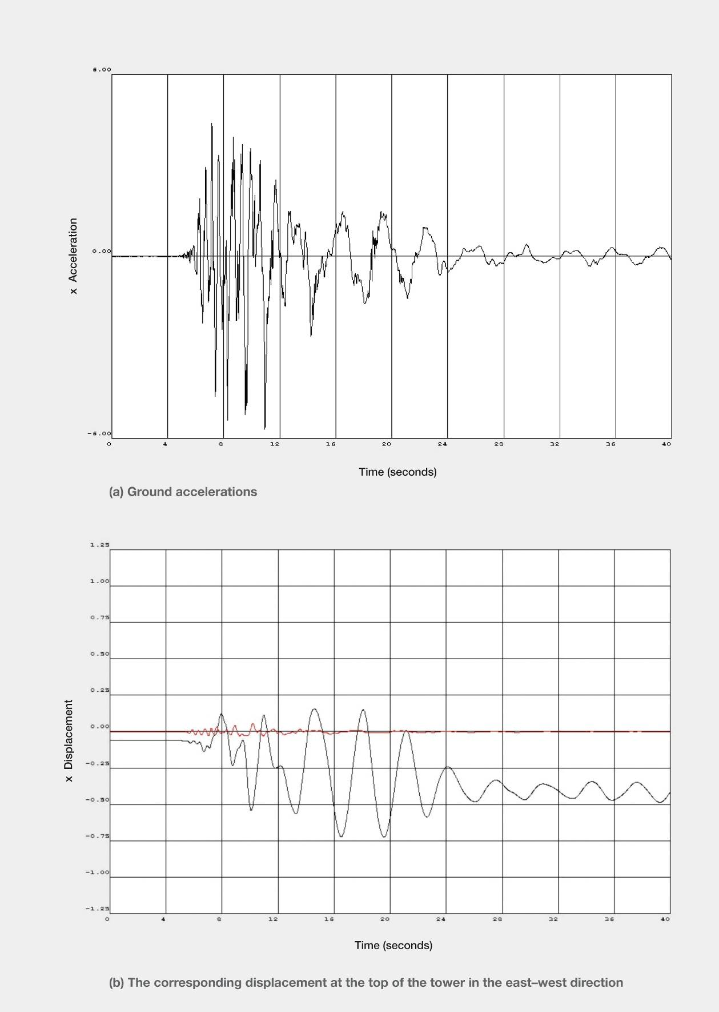
Figure 37: CCCC earthquake record (source: Athol Carr)
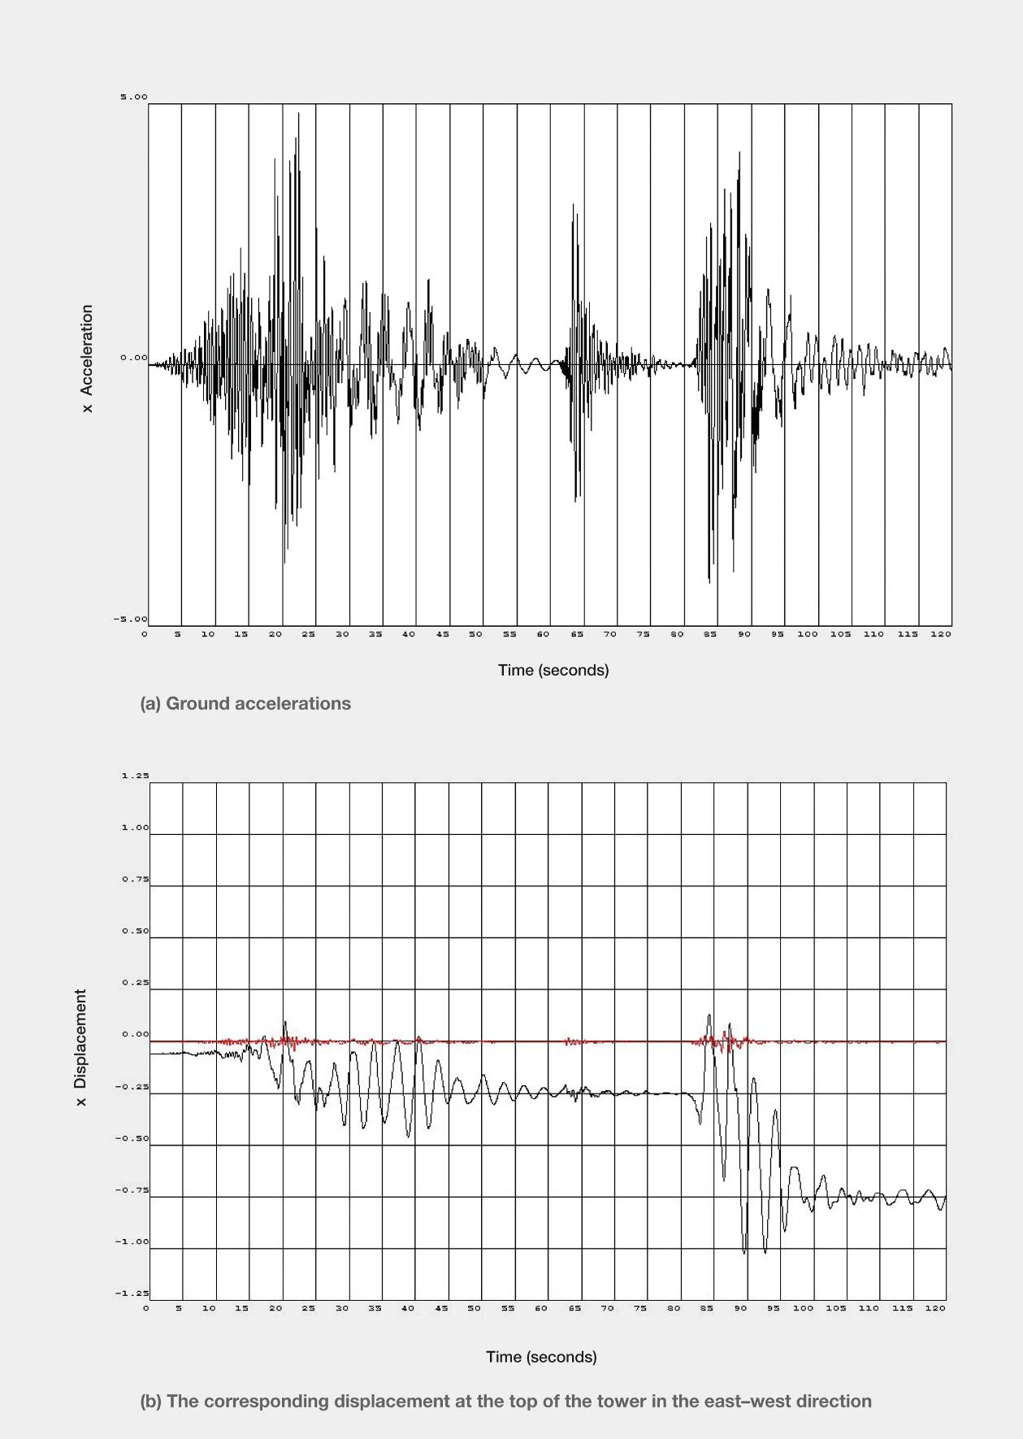
Figure 38: Composite REHS earthquake record (source: Athol Carr)
Figure 39: Ground motion representing an Alpine Fault earthquake (source: Athol Carr)
Figure 38 shows the corresponding ground accelerations and displacement at the top of the tower for a composite earthquake comprising the September, Boxing Day and February earthquakes. It can be seen that the September earthquake had only a relatively small impact on the building in the east–west direction. This was due to the relatively small excitation in the east–west direction compared with that in the north–south direction5. The Boxing Day event had virtually no effect because the high frequency of ground motion did not excite a structure with a relatively long natural period of vibration. By far the greatest displacements were in the February earthquake, which as previously noted had a strong east–west component in the ground motion.
Figure 39 shows the corresponding ground motion acceleration record and displacement at the top of the building for an earthquake record that has been chosen to represent a potential Alpine Fault earthquake. It can be seen that the predicted behaviour is similar to that seen with the CBD earthquakes although the displacements are not as great. Owing to the distance of Christchurch from the Alpine Fault, the ground motion in an Alpine Fault earthquake is expected to be much less intense than that in the Christchurch earthquake sequence but of much longer duration. Clearly, a building with a lower lateral strength could have been much more seriously affected than in this analysis. This aspect needs to be considered given the very considerable reduction in design base shear strengths permitted in current and previous design Standards (NZS 1170.5:20043 and NZS 4203:199212)compared with the corresponding values given in the 1976 and 1984 editions of NZS 420313,14.
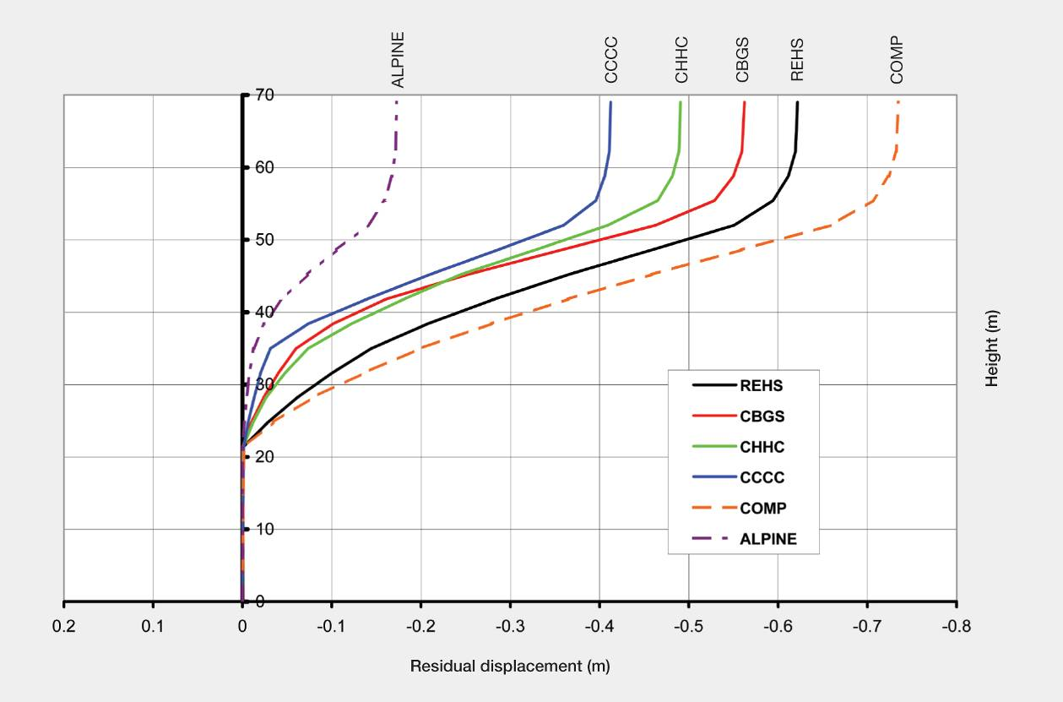
Figure 40: Residual displacement following earthquake ground motion
Figure 40 shows the residual predicted displacements over the height of the building after all motion has ceased for all the earthquake ground motion records. It can be seen that for the four CBD records the residual displacements were between 420 and 620mm.
Figure 41 shows the predicted peak inter-storey drifts for the different earthquake records. The four CBD earthquakes gave peak inter-storey drifts towards the east of the order of four per cent of the storey height for levels between 20 and 23. This would have been more than sufficient to cause the stairs in the HGC building to lose their support and consequently fail. The corresponding predicted peak drifts to the west were appreciably smaller and the stairs descending from the west to the east may have been damaged by being subjected to compression.
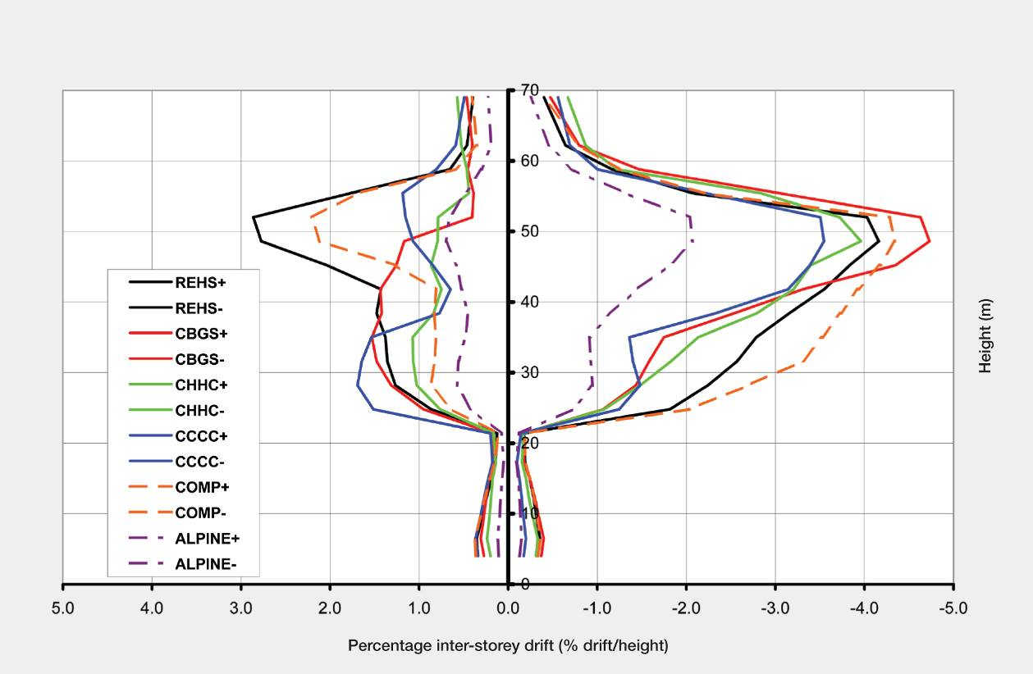
Figure 41: Residual displacement following earthquake ground motion
3.5.4 Failure of wall D5–6
The actions that determine the survival of a wall or column are the axial load level, the detailing for confinement and shear, and the displacements imposed on the wall. The Dunning Thornton report did not quantify the lateral displacements applied to the walls. The only lateral displacements recorded in their report are in the table on page 16 and in Figure 7. These values are not relevant to wall D5–6, which was located well away from the centre line of stiffness and lateral strength. Consequently, any torsional displacements induced on the wall were not reflected in the table or the figure.
Inspection of Figures B6 and B7 in the Dunning Thornton report (in Appendix B) shows that the centre of stiffness and strength near ground level is on the northern side of the major structural wall on grid line 8. It is likely to be close to the intersection of grid lines C and 9. The critical wall, D5–6, is about 14m from the centre of stiffness. Consequently, any torsional rotation of the building is likely to have imposed significant lateral displacements on the wall D5–6 (see Figure 42).
The building is likely to have a high torsional response near ground level for two reasons:
1. In the tower above the structural walls the centre of mass is appreciably eccentric to the centre of stiffness and strength and consequently any north–south motion will induce significant torsion in the building (see Figure 28).
2. The podium to the building effectively had a height of six floors, rising to level 14 (see Figure 17). The podium, measuring about 12m by 16m, is located on the southern side of the building between the approximate centre line in the north–south direction and the western edge of the tower (see Figure 42). The podium is supported by columns, which are laterally flexible compared to the walls. Consequently, a large part of the lateral resistance to earthquake forces from the podium would have been transmitted to the structural walls in the main part of the building, and that would have induced significant torsion in the structure. The resultant twist would have induced out-of-plane displacement in wall D5–6, which could be expected to play a significant part in the structural failure of the wall.
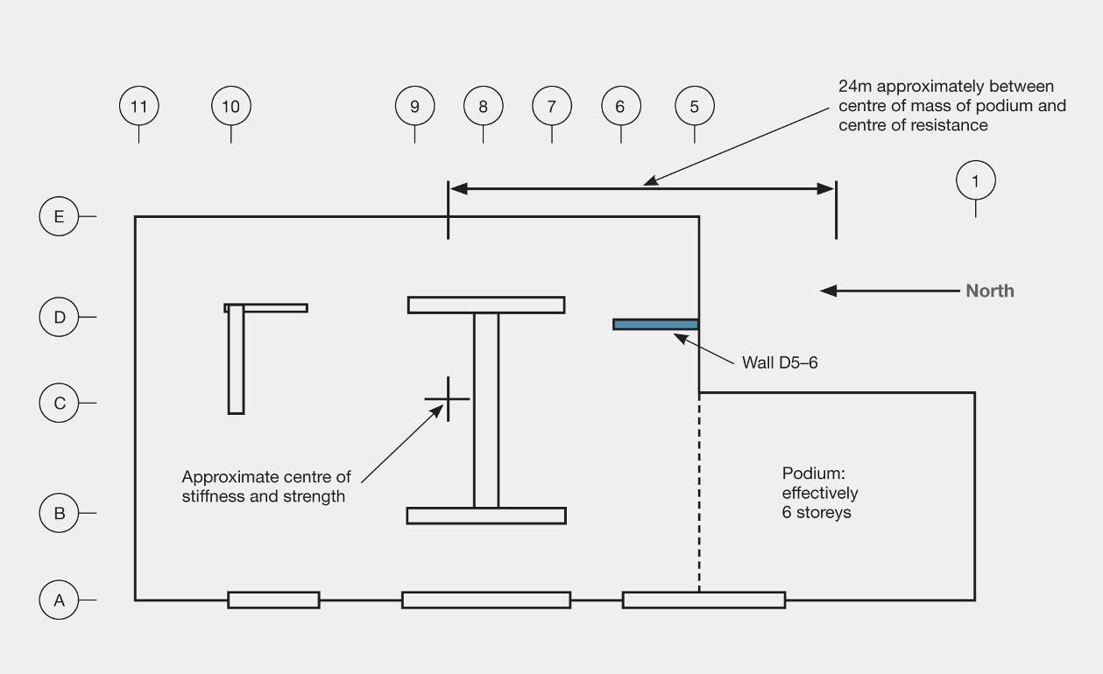
Figure 42: Location of podium to main structural walls at ground level
3.5.5 Transfer beams
Transfer beams located immediately below level 14 (see Figure 25) supported the gravity loads from the cantilevered portion of the building below level 14, which is the top of the structural walls that extended from the foundations to level 14. On grid line 8, the cover concrete in the transfer beam spalled close to where the gravity load was transferred to the transfer beam, exposing the stirrups at the mid-depth of the beam. In this location the stirrups consisted of 20mm U- shaped bars at a spacing of 200mm, which lapped at the mid-height of the beam (see Figure 27). When wall D5–6 collapsed the shock loading on the transfer beam would have been high and it must have caused the stirrups to be highly stressed. The splitting forces associated with bond in the lap length would have caused the cover concrete to spall (see the Figure in Appendix B, page 14, in the Dunning Thornton report). It is fortunate that complete collapse did not occur as this spalling would have greatly reduced the bond resistance of the stirrups and their capacity to resist shear in the transfer beam.
The beam was 600mm wide with a depth of close to 3600mm. The current Concrete Structures Standard, NZS 3101:20066 does not permit the use of lapped stirrups to resist shear in potential plastic hinge zones or where the shear stress exceeds 0.5 √f´_{c} (clause 8.7.2.8). However, neither of these limits would have been critical in the design of the beam. The current Standard has limits in the spacing of stirrups across a beam section in the case where the beam is wide compared to its depth (clause 9.3.9.4.12). However, the criterion, as written, would not apply to the transfer beam situation.
To prevent the potential mode of failure observed in the transfer beam, it is necessary to prevent high bond stresses developing in closely spaced stirrup legs where U-shaped stirrups are lapped in cover concrete. It is recommended that where U-shaped stirrups are used only a proportion of them should be permitted to be lapped in the cover concrete, with the remainder lapped in the core concrete (see Figure 43). Alternatively, the stirrups could be lapped with hooked ends, where the hooks are bent into the concrete core in the beam. We recommend that the Standard be amended to require lapped U-shaped stirrups to comply with these proposals.
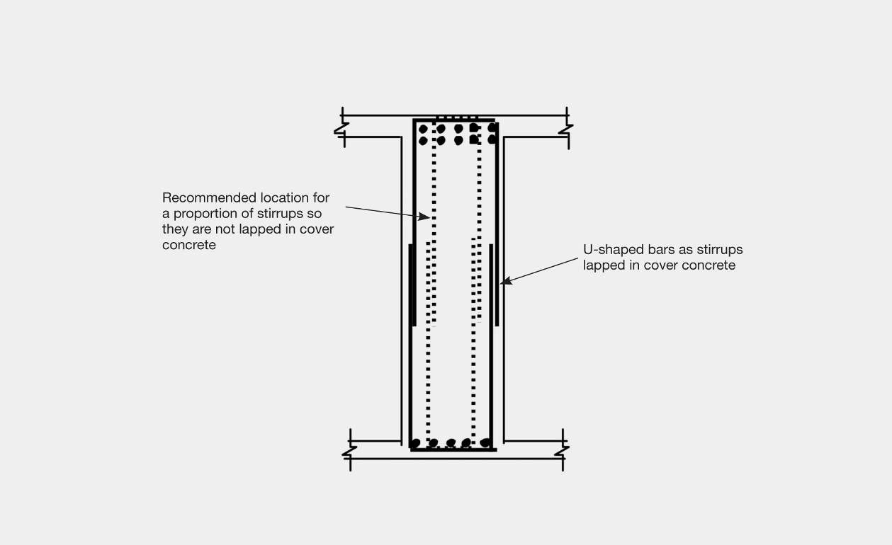
Figure 43: Location of U-shaped stirrups to avoid all being lapped in cover concrete
3.6 Discussion
The Royal Commission accepts the recommendations made by the Expert Panel. These are listed in section 6.11 of the Expert Panel report and in section 4.2, Volume 1 of this Report. However, we consider some further conclusions and recommendations are justified, as discussed below:
1. The HGC building was highly irregular in several ways. Two aspects of this irregularity were not identified in the Dunning Thornton report and at least one of these was not identified in the original design of the building. To identify these two aspects it is essential to have a clear understanding of the basic concepts of the dynamic behaviour of structures.
(a) The first aspect arises from the eastern bay of the building being cantilevered off the structure to avoid closing Tattersalls Lane. As identified in section 3.5, this gives the building a tendency to sway to the east by reducing the lateral force resistance in this direction and increasing the lateral force resistance for displacement towards the west. The modal response spectrum and the equivalent static method of analysis are based on the assumption that the strength and stiffness of a structure are equal for both forward and backward displacement. The cantilevering action in the HGC building violates this fundamental assumption so the analytical results based on elastic methods of analysis are incorrect. The fact that this fundamental problem was not identified in the reports received by the Royal Commission highlights the need for structural engineers to have a clear understanding of the basic assumptions involved in seismic design. It is noted that the problem could have been avoided simply by changing the distribution of reinforcement in the beams to give the structure equal strength against lateral displacement in the eastern and western directions.
(b) The critical design actions on walls consist of the axial loads, the bending moments and the lateral displacements imposed on the walls. It is necessary to have an assessment of all these actions to be able to design a wall or assess a wall’s seismic performance. The torsional response of the HGC building is of particular concern in assessing the lateral displacements that were imposed on the critical wall. Much of this displacement is likely to have come from the seismic forces rising from the mass of the podium inducing torsion in the building. Where the modal response spectrum method of analysis is used in design, the practice is to sum the mass of each mode for the direction of shaking until the sum reaches 90 per cent of the mass of the building. The contributions from the remaining modes are discarded. It is possible in this case that the displacement contribution from the torsional mode associated with the podium was not included, leading to an under-estimate of the lateral displacement applied to the wall. A further complication, which has been drawn to the Royal Commission’s attention by Professor Carr, is that where there are torsional modes, the sum of all the effective masses in all the modes may exceed the total mass of
the building.
2. The axial load in a wall in a multi-storey structure cannot be accurately determined. The HGC building was highly indeterminate in all three dimensions. Bending moments in a wall, unless it is under a very high axial load, cause it to elongate, and this displacement can be restrained by surrounding structural elements, potentially significantly increasing the axial load on the wall. This behaviour has been observed in a large-scale test and found to have a dramatic influence on the seismic performance of the test building14.
3. There is an urgent need to revise the provision in NZS 3101:2006 that deals with the stability of walls subjected to high axial loads. Until this revision is made it is recommended that rectangular walls subjected to calculated axial loads greater than 0.1 Agf´c be proportioned so that the ratio of clear height between lateral supports divided by thickness does not exceed 10.
4. The provisions for shear reinforcement in beams in NZS 3101:2006 should be revised to limit the proportion of shear reinforcement that is in the form of lapped U-bars that can be lapped in
cover concrete.
5. It is evident from the reports received by the Royal Commission on this building that there is significant misunderstanding by structural engineers of the relationship between design inter-storey drift and peak inter-storey drift. In addition, there is a lack of understanding as to why inter-storey drift values calculated from elastic-based methods of analysis need to be adjusted to allow for the change in form of the deflected shape profile caused by inelastic behaviour. This aspect should be more clearly identified in NZS 1170.5, where this effect is allowed for by the drift modification factor in clause 7.3 of the Standard.

Appendix A: Simplified model assumptions

Assumed properties
Property | Symbol | Value | Units
Concrete strength | f´_{c} | 30 | MPa
Concrete ultimate strain | _{c} | 0.003
H-section steel yield strength | fyh | 380 | MPa
All other steel yield strength | fyd | 275 | MPa
Concrete elastic modulus | E | 25000 | MPa

Loading | Symbol | Value | Units
Gravity floor load | DL + YLL | 8 | kPa
Columns line on  grid lines 5 & 11 tributary area | TA | 110 | m²
Equivalent external column width | W | 7000 | mm
Equivalent external column depth | D | 1000 | mm

Analysis assumptions for column strength and inter-storey shear
Refer to section 3.1, analytical model and Figure 29.
1. Nominal strengths have been calculated, for example no strength reduction factors have been applied for beams and columns.
2. As described in section 3.1, column 1 in the analytical model is given a shear strength in each storey, determined as described below.
3. The flexural strengths of the beams at each level were determined at the critical sections of the potential plastic hinges using standard flexural theory. These bending moments were extrapolated to the centre line of the columns. The sum of these column moments divided by the inter-storey height gives the storey shear strength based on the assumption that points of inflection occur at the mid-height of each storey.
4. As points of inflection may vary it is necessary to allow for any additional lateral strength that may arise at a level because of surplus strength in the column and the movement of the points
of inflection.
5. The columns on grid lines 5 and 11, but excluding the columns on grid line E (see Figure 28, page 69) contribute to the lateral load resistance. In the analytical model these columns are represented by a single compound column, which is labelled as 2 in Figure 29, page 70.
6. The axial load assumed to act on the compound column, column 2, in the analytical model is based on the total tributary area supported by the columns represented by the compound column noted above at the level being considered and an assumed gravity load of 8kN/m².
7. Column 2 in the analytical model is given a flexural strength equal to the value calculated for the compound column minus the corresponding bending moment associated with the storey shear actions in column 1. This is the surplus strength referred to above.
8. The critical moment in the compound column at each level is assumed to be at the mid-height between the face of the beam and the beam centre line.
9. The stiffness of the compound column was based on the section stiffness found from an elastic-based analysis at first yield of longitudinal reinforcement and in which the concrete was assumed to have no tensile strength. This stiffness was multiplied by 1.5 to allow for tension stiffening in the mid-storey region.

Analysis programme
The analyses were carried out using the two-dimensional version of Ruaumoko11,15. This programme was developed in the 1970s in the Department of Civil Engineering, University of Canterbury, for the analysis of inelastic buildings and bridges subject to earthquake and other dynamic excitation. Since 1990 it has been used by over 130 universities, building research institutes, highway authorities and consulting practices around the world for research, teaching and design. It has a very wide range of member models and inelastic and hysteretic representations to model numerous structural engineering systems. Further details may be found on the Ruaumoko website www.ruaumoko.co.nz

Damping model
The programme has a wide variety of damping models ranging from the simple but problematic Rayleigh damping found in most other programmes, to a variety of non-linear member damping models16,17,18. The model used for these analyses is that proposed by Wilson and Penzien19, which allows the damping to be specified over all natural frequencies of free vibration in the structure. In the model used, the damping was specified at five per cent of critical damping at all frequencies of the structure.

Hysteretic models used for the inelastic structural members
The most commonly-used hysteretic model for reinforced concrete members is the Takeda hysteretic model11,20. This allows for degradation of the member stiffness as the member undergoes inelastic deformation. It was used for the shear members and column members in the structural model.
The first column in the model, representing most of the shear stiffness of the building, used a shear spring that was initially elastic for the lower levels and could yield using the Takeda hysteretic model for the post-yield behaviour.
The second, the flexural column members, used a Giberson beam member model15 where plastic hinges using the Takeda hysteretic model were able to form at the ends of the column members.
The third, the P-delta column, used pin-ended struts that were tied to the other columns by stiff pin-ended links so that the P-delta actions on the structure would be readily available. If the P-delta column had been connected to the other columns by the computationally more efficient displacement slaving, then the P-delta actions could only be obtained by inference from the longitudinal forces in the P-delta columns and the inter-storey drifts of the P-delta columns.

Testing the HGC for an Alpine Fault event
Finding a ground acceleration record that could be used to represent what might be expected at a soft ground site in Christchurch for a magnitude 8 earthquake on the Alpine Fault is not easy. The best suggestion was to use a record from the magnitude 9 earthquake in Japan in March 2011, recorded on soft ground near Tokyo21. The magnitude of this earthquake is much greater than that for the Alpine Fault event, but the recording was made at a much greater distance from the epicentre than Christchurch in an Alpine Fault event. It was felt that these effects would, to an extent, cancel out.
The other point to note is that the 300-second duration of the record would also be longer than that expected from an Alpine Fault earthquake. In terms of the analyses, this final aspect did not matter as the analyses took only in the order of five minutes for the 300-second acceleration record. The magnitude of the accelerations is much less than recorded in the 22 February 2011 earthquake, but the longer duration of shaking could be important for structures whose strength and stiffness might degrade with increasing numbers of cycles of inelastic deformation. The 2011 Christchurch earthquake shaking was, fortunately, of very short duration.

References:
1. Dunning Thornton Consultants Ltd. (2011). Report on the Structural Performance of the Hotel Grand Chancellor in the Earthquake of 22 February 2011.
http://www.dbh.govt.nz/userfiles/File/Reports/quake-structural-performance-hotel-grand-chancellor.pdf
2. Department of Building and Housing Expert Panel. (2011). Structural Performance of Christchurch CBD Buildings in the 22 February 2011 Aftershock – Stage 1 Expert Panel Report. Williams, S., Priestley, N. Anderson, H., Cook, M., Fehl, P., Hyland, C., Jury, R., Millar, P., Pampanin, S., Skimming, G. and Thornton, A.
http://www.dbh.govt.nz/UserFiles/File/Reports/quake-stage1-expert-panel-report.pdf.
3. NZS 1170.5:2004 Structural Design Actions, Part 5: Earthquake actions – New Zealand. Standards New Zealand.
4. NZS 4203:1984 Code of Practice for General Structural Design and Design Loadings for Buildings. Standards Association of New Zealand. Available from Standards New Zealand.
5. Carr, A. J. (September 2011). Inelastic Response Spectra for the Christchurch Earthquake Records. Report to Canterbury Earthquakes Royal Commission (ENG.CAR.0001).
6. NZS 3101:Part 1:2006. Concrete Structures Standard, Part 1 – The Design of Concrete Structures. Standards New Zealand.
7. NZS 3101:Part 1:1982. Code of Practice for the design of concrete structures. Standards Association of New Zealand. Available from Standards New Zealand.
8. Ruiz, J. A. F. (2006). Performance of Reinforced Concrete Moment Resisting Frames Subjected to Earthquake Actions. University of Canterbury, Civil Engineering report No. 2006/1.
9. Fenwick, R. C., Davidson, B. J. and Chung, B. T. (1992). P-delta Actions in Seismic Resistant Structures. New Zealand Society for Earthquake Engineering Bulletin 25(1), 56–89.
10. NZS 3101:Part 1:1995, Concrete Structures Standard, Part 1 – The Design of Concrete Structures. Standards New Zealand.
11. Carr, A. J. (2008). Ruaumoko User Manual, Volume 5-Appendices (Strength and Stiffness degradation models). Department of Civil Engineering, University of Canterbury.
12. NZS 4203:1992. Code of Practice for General Structural Design and Design Loadings for Buildings. Standards New Zealand.
13. NZS 4203:1976. Code of Practice for General Structural Design and Design Loadings for Buildings. Standards Association of New Zealand. Available from Standards New Zealand.
14. Wight, J. K. (ed). (1985). Earthquake effects on reinforced concrete structures. American Concrete Institute, Special Publication, SP84.
15. Carr, A. J. (2007). Ruaumoko User Manual, Volume 1-Theory. Department of Civil Engineering, University of Canterbury.
16. Crisp, D. J. (1980). Damping Models for Inelastic Structures. M.E. Report, Department of Civil Engineering, University of Canterbury.
17. Carr, A. J. (1997). Damping Models for Inelastic Analyses. Proc. Asia-Pacific Vibration Conference ’97, Kyongju, Korea. November 1997: 42–8.
18. Carr, A. J. (2005). Damping Models for Time-history Structural Analyses. Proc. 11th Asia-Pacific Vibration Conference APVC-05, Langkawi, Malaysia, November 25-27, 2005, 287-293.
19. Wilson, E. L. and Penzien, J. (1972). Evaluation of Orthogonal Damping Matrices, Int. J. Numerical Methods in Eng., Vol. 4, 5–10.
20. Otani, S. (1980). Non-linear Dynamic Analysis of Reinforced Concrete Building Structures. Canadian J. Civil Engineering, Vol. 7, No. 2, 1980, 333–344.
21. Bradley, B.A. (2012). Ground Motion Comparison of the 2011 Tohoku Japan and the 2010-2011 Canterbury Earthquakes: Implications for large events in New Zealand. Paper presented at the New Zealand Society for Earthquake Engineering Inc. (NZSEE) Conference April 2012, Christchurch.

