3.1 Original construction of the HGC building
The building was originally designed as a car park building with an office tower above. There were 12 levels of car park decks (each being a half-floor) with 15 office floors above that. In effect it was a 21-storey building. To the front of the tower facing Cashel Street was a podium that consisted of parking up to level 12, with a conference room on top of that. There was no level 13, which meant that when the evacuees exited the tower from level 15 they were on the roof of the conference room.
The plan dimension of the tower was about 33m by 24m, with the podium being about 17m by 12m.
Foundations consisted of large pile caps and rafts supported on multiple driven bulb (Franki) piles. The depths of the piles varied from 5m to 13m. Above- ground structural elements were of reinforced concrete.
The ground floor to level 14 consisted of cast-in-situ flat slab concrete floors, with cast-in-situ reinforced concrete cantilever shear walls. The shear walls were not coupled and were arranged irregularly in the plan, accentuated by a right of way set back to accommodate right of access along Tattersalls Lane on the eastern side of the building. The wall that failed was at the ground level on grid line D, between grid lines 5 and 6 (wall D5–6). The failed wall can be seen in Figure 20, the view from Cashel Street when the HGC building was being constructed, and in Figure 21, the ground floor plan view showing the location.
The eastern bay (see elevation and photograph in Figure 22) was supported by an unusual structural arrangement consisting of deep transfer beams (see Figures 23–25), cantilevered over the right of way between levels 12 and 14 to support a series of tension hangers. The tension hangers can also be seen in Figure 24. The hangers, in turn, supported a long deep transfer beam along the eastern boundary above the first floor. Interspaced with the hangers were column struts supported by the long beam which, together with the hangers, supported the perimeter beams on the eastern boundary side of the tower (grid line E).
Of note are the deep cantilever transfer beams that lay on grid lines 5 and 6. These beams, which were part of the eastern bay hanging system, were both supported at the fulcrum of their cantilevers by the critical wall D5–6. The transfer beams were each a full floor in height and were tied into the concrete floor diaphragms at levels 12 and 14.
At level 14 a vertical irregularity occurred as the shear walls stopped and, from levels 14 to 28, seismic resistance was provided by ductile moment resisting frames on the perimeter to the north, west and south and offset by one grid on the eastern side. These upper floors were constructed using a proprietary precast prestressed rib and timber infill system with in situ topping. This flooring was supported on the seismic frames and on additional frames (beams and columns) not specifically designed as primary seismic-resisting elements.
In the upper structure, the eastern-most bay between grid lines D and E was cantilevered off the rest of the structure over Tattersalls Lane at each floor level. This cantilever can be seen in Figure 25.
There was a vertical separation at level 14 along the eastern boundary line (grid line E). This meant that the vertical loads accumulating along grid line E were not transferred directly down on to the system that existed in the lower structure along that grid line. However, the loads from the eastern bay, between grid lines D and E, did find a load path to wall D5–6 via the upper columns on grid line D. In particular, the columns at grid lines D5 and D6 were supported directly on wall D5–6.
The seismic frame lay on grid lines A, D, 5 and 11 (see Figure 28 on page 69). The internal columns of seismic frames do not typically carry additional axial (vertical) loads induced by seismic actions, but the end columns of seismic frames can attract large seismic axial loads in addition to their normal gravity loads. Column D5 was an end column for the frames on both grid lines D and 5, which meant that it could attract seismic-induced axial load from both axes. These loads fed directly onto the critical wall, D5–6.
Overall, the structure of the building was complex, with irregularities both horizontally and vertically.
The original building was approved by the issue of a series of building permits, all of which were issued to Don Forbes Construction Ltd. The architects were Architecture Warren and Mahoney Ltd, and the owner of the building was Cashel St Parking Building Ltd. The original engineering design was carried out by Holmes Wood Poole & Johnstone Ltd. Holmes Consulting Group was responsible for the later parts of the design.
The engineering design work occurred over an extended period, from 1985 to 1987, during which time there were several design changes relating to land and site usage. During the early construction of the building the original design had to be amended to remove structure from Tattersalls Lane. The developer had attempted to secure title, or rights, over the use of Tattersalls Lane but was prevented by legal action after the original design was completed and construction was under way. Consequently, the engineers were required to redesign parts of the structure in order to relocate the wall that was initially at E5–6 to the west of Tattersalls Lane so that it was at D5–6. This required additional structure, including transfer beams to cantilever the eastern bay between grid lines D and E over Tattersalls Lane.
The approval process can be traced through the building permits (the dates given are the dates of applications for the permits):
Approved under Christchurch City Council Building By-Law 105 (1979) (this bylaw applied
until 30 November 1985):
• 10 September 1985 – Piles for car park building – Council reference 85/2412; and
• 29 October 1985 – Pile caps – Council reference 85/3043.
Approved under Bylaw 105 (1985) (this bylaw applied from 1 December 1985):
• 25 July 1986 – Piles for a multi-storey building – Council reference 86/1765;
• 20 August 1986 – Erect a retail and car parking development – Council reference 86/3690; and
• 28 August 1986 – Car park building foundation – Council reference 86/2284.
At this point the design was changed to accommodate the cantilever over Tattersalls Lane:
• 21 January 1987 – Stage 8, extend car park over ROW - Council reference 86/3689; and
• 20 July 1987 – Stage 8 additions including structural cantilever – Council reference 87/1323.
The name of the engineering firm changed to Holmes Consulting Group from here on:
• 23 December 1987 – Erect office tower – Council reference 87/1727; and
• 24 August 1988 – Construction Stage II (Architect finish and structure details) – Council reference 88/3328.
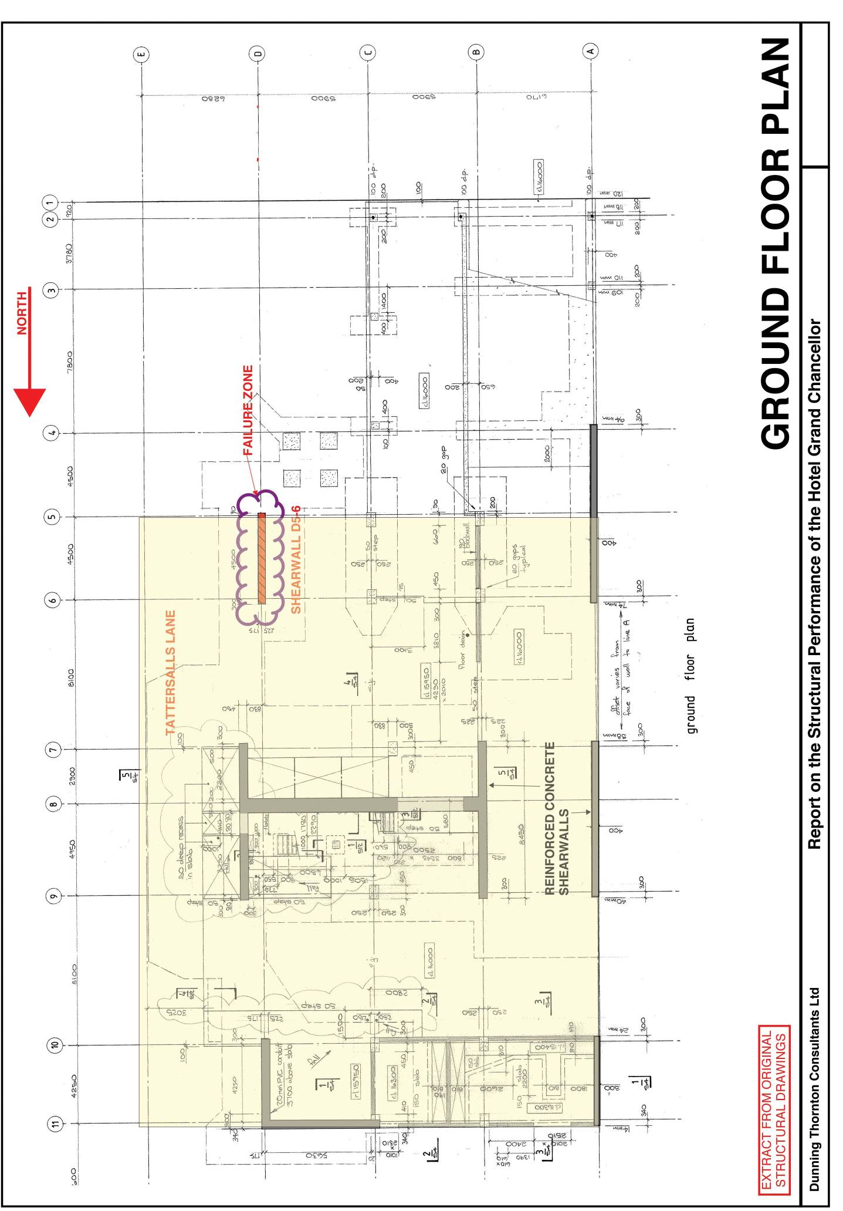
Figure 21: Ground floor plan (source: Dunning Thornton report)
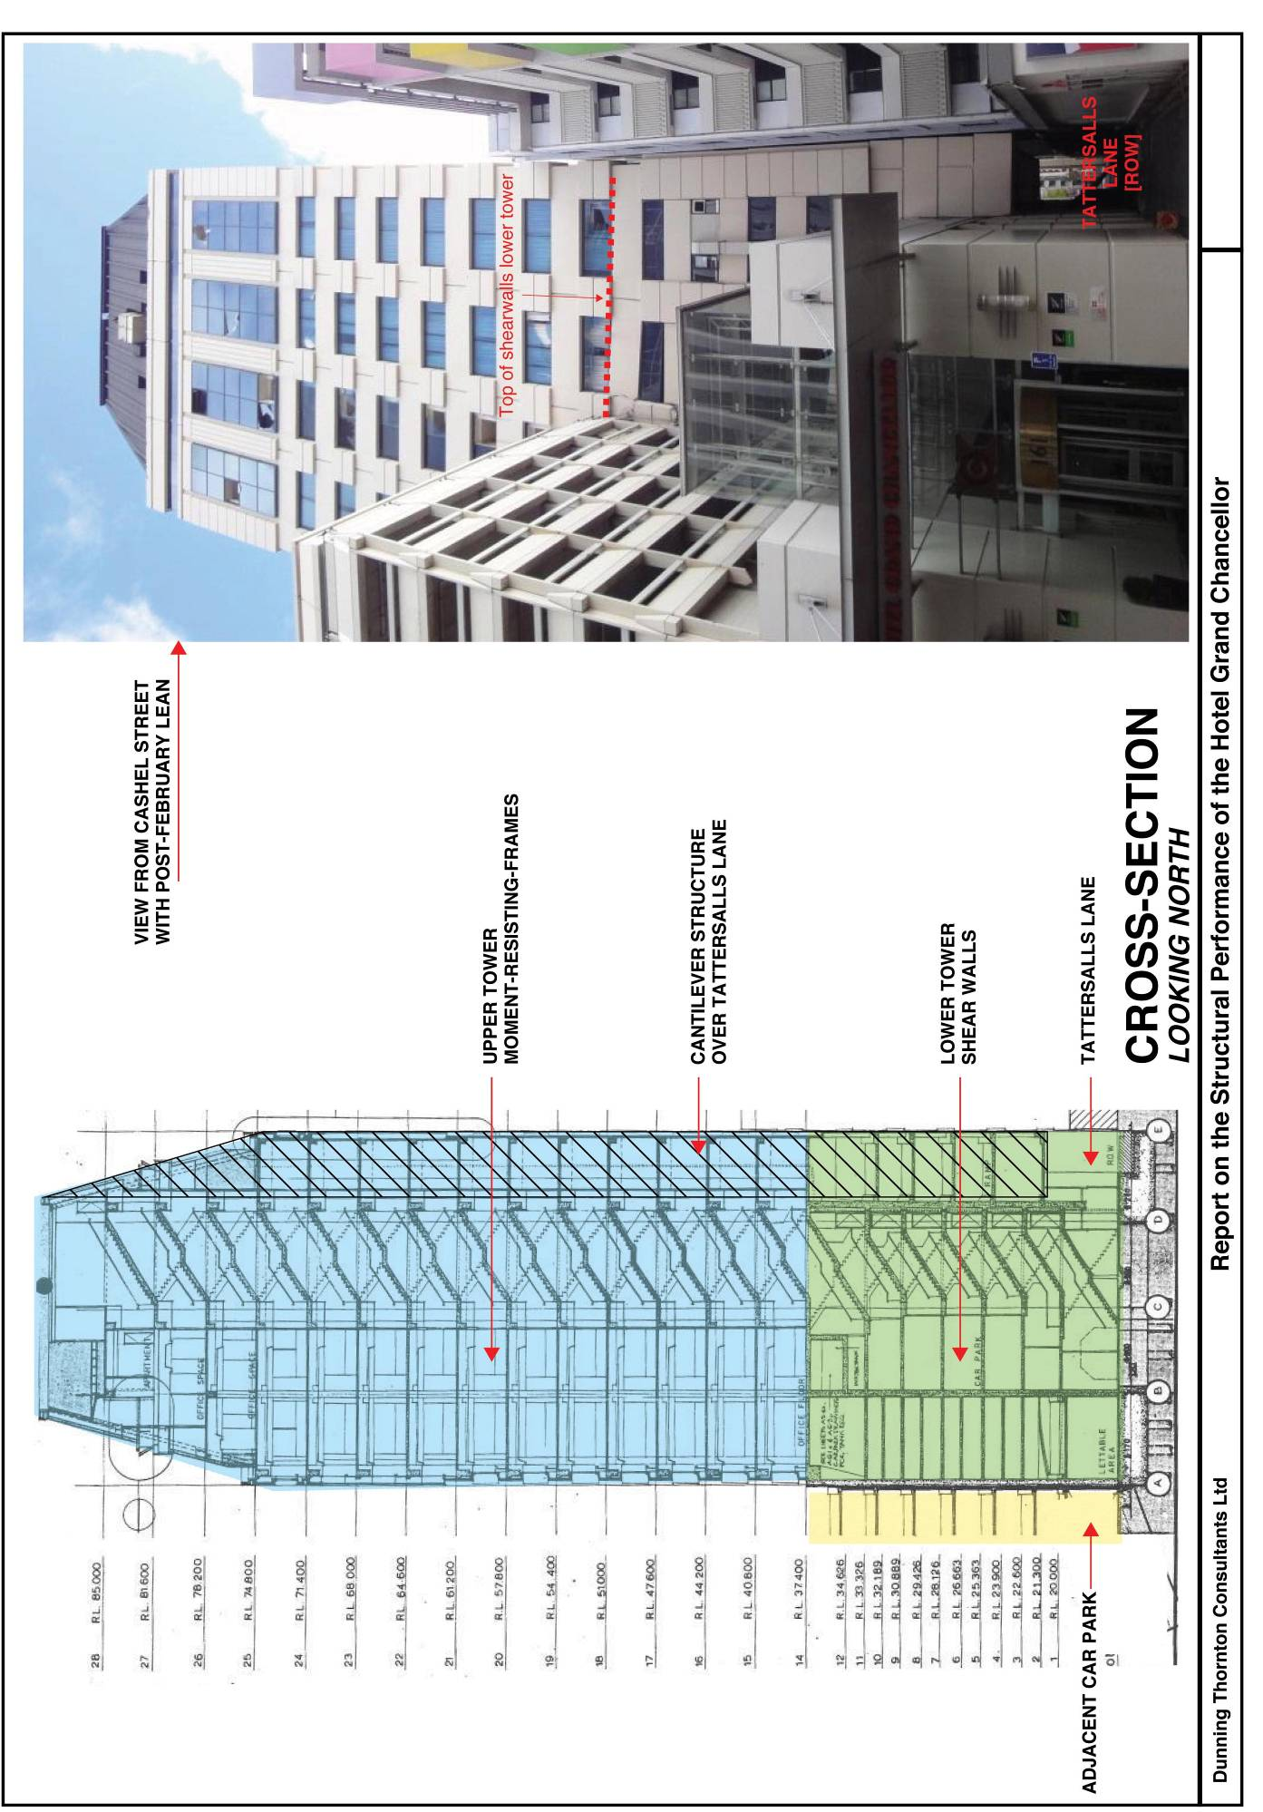
Figure 22: Cross-section looking north and view from Cashel Street (source: Dunning Thornton report)

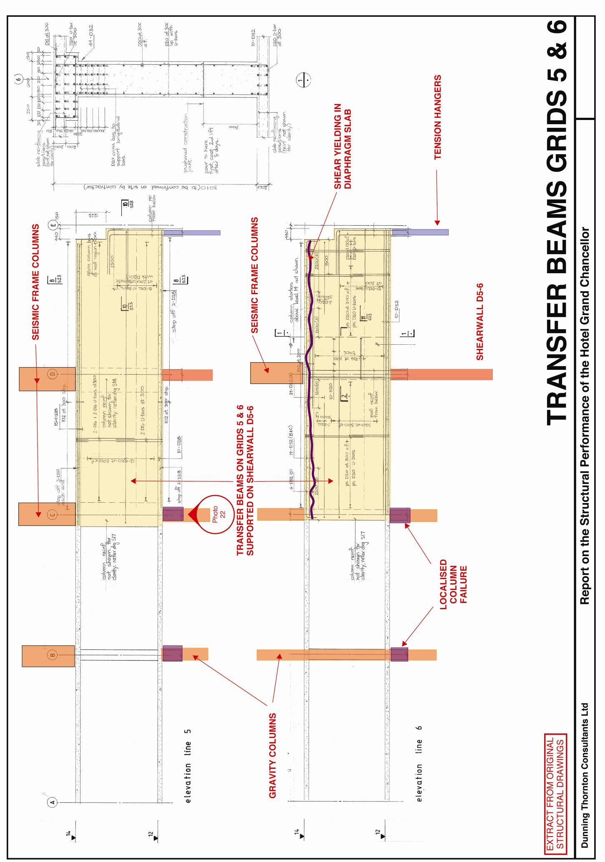Figure 23: Transfer beams grid lines 5 and 6 (source: Dunning Thornton report)
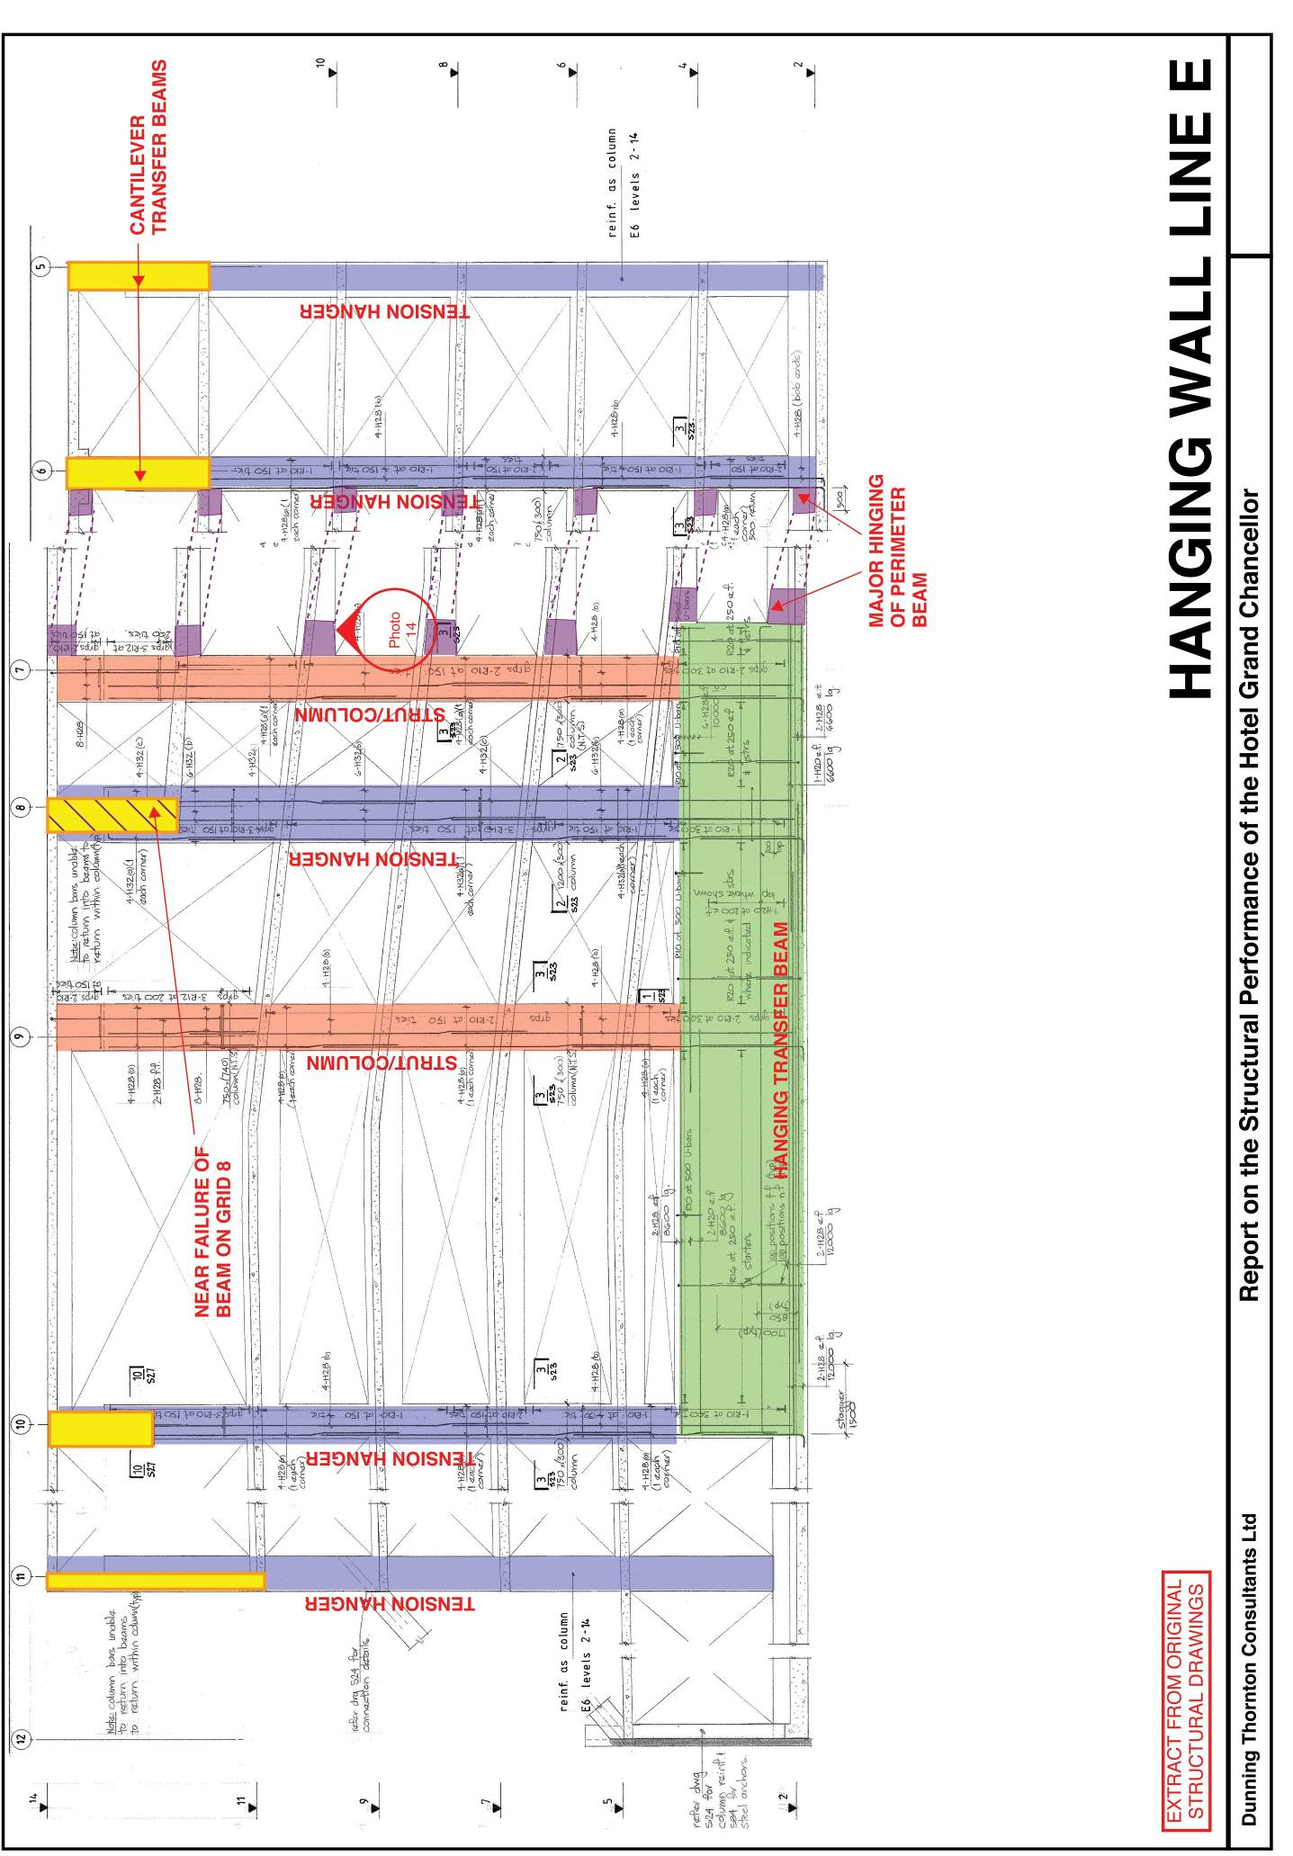Figure 24: Hanging wall grid line E (source: Dunning Thornton report)
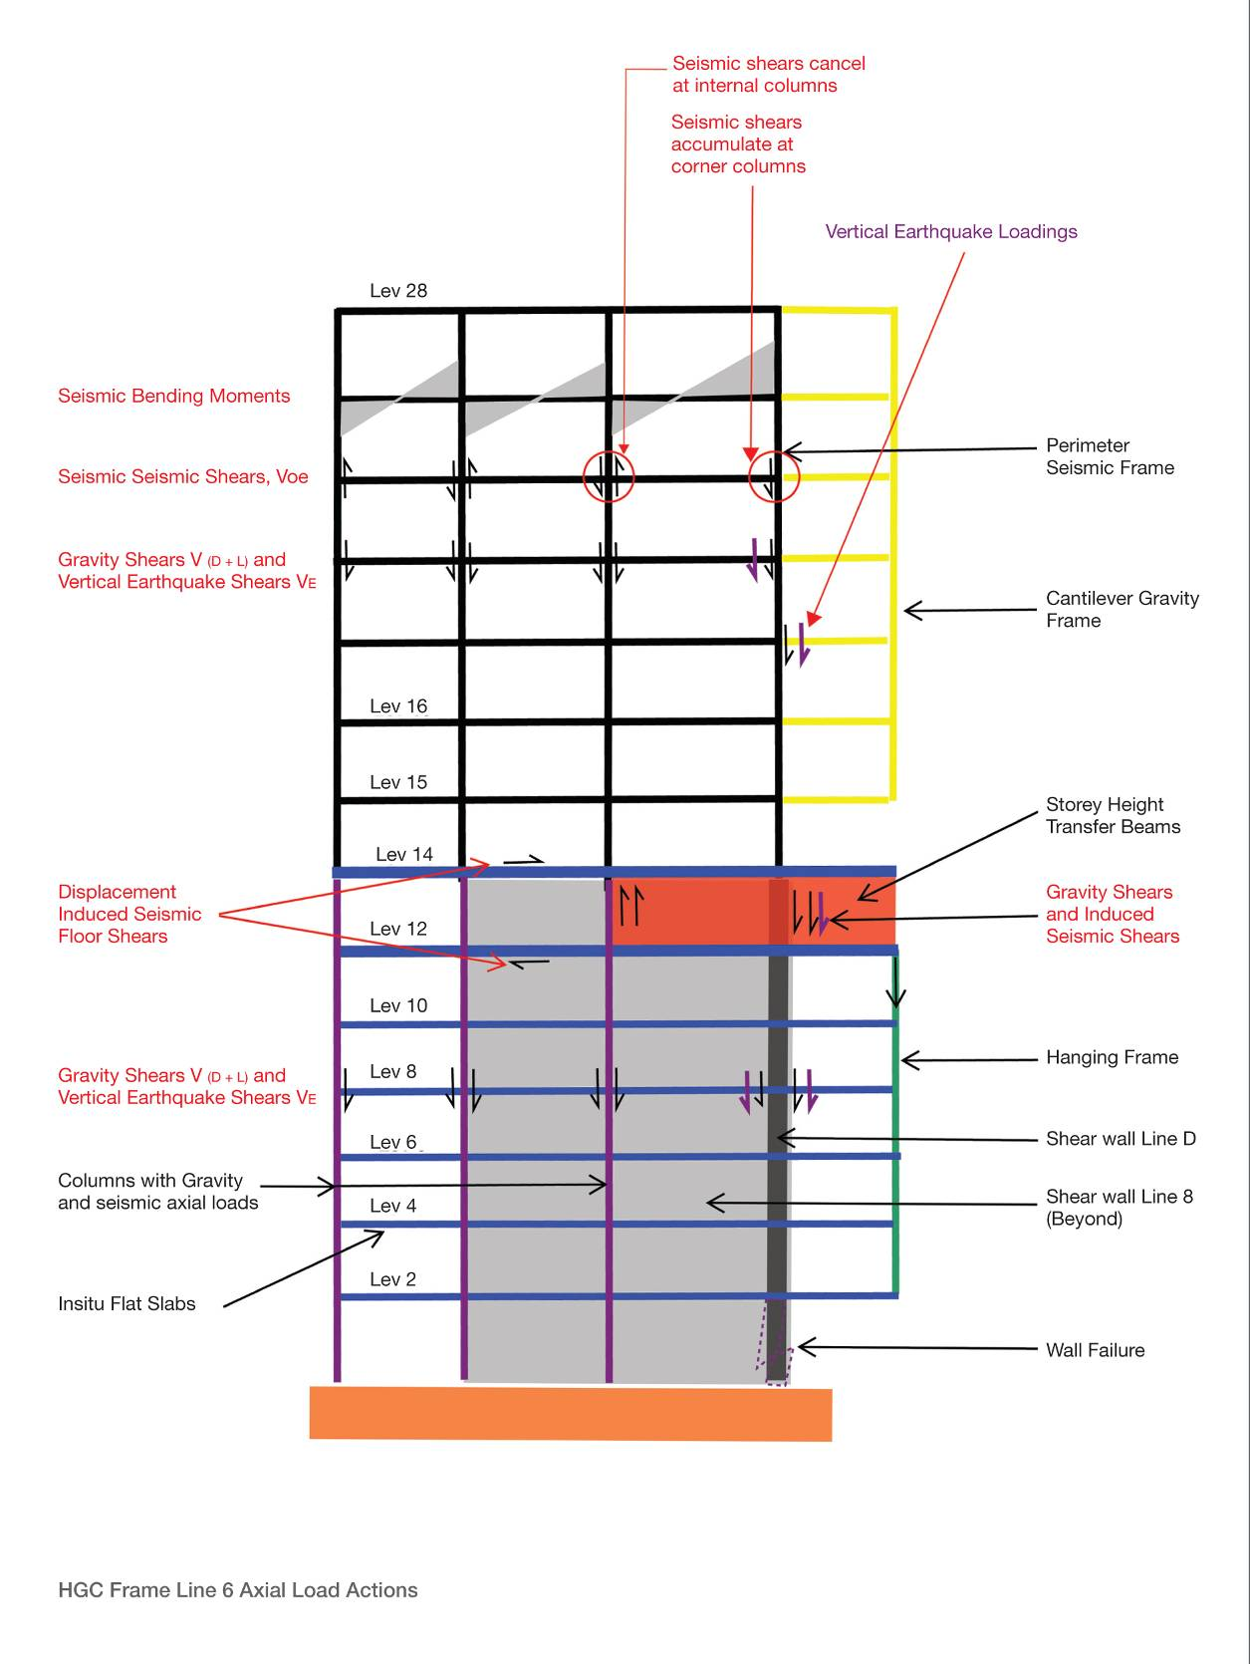
Figure 25: Dunning Thornton interpretation of axial load actions (source: Dunning Thornton report)
(Note that the Royal Commission does not necessarily agree with this interpretation)

