

A. The main auditorium of the Christchurch Town Hall (source: Marshall Day Acoustics)

B. The intersection of High, Manchester and Lichfield Streets in the Christchurch Central Business District after the 22 February 2011 earthquake (source: Photosouth)

C. People escaping from the 17-storey Forsyth Barr Building on 22 February 2011   
(source: Fairfax Media/*The Press*)

D. The five-storey Pyne Gould Corporation Building collapsed as a result of the 22 February 2011 earthquake (source: ex eye witness)

ISBN: 978-0-478-39562-4

(Final Report Microsoft Word)

ISBN: 978-0-478-39564-8

(Volume 2 Microsoft Word)

Canterbury Earthquakes  
Royal Commission

PO Box 14053   
Christchurch Mail Centre 8544   
Christchurch   
New Zealand

0800 337 468

+64 3 741 3000

canterbury@royalcommission.govt.nz

Contents

**Section 1: Approach to the representative sample of buildings 2**

**Section 2: Pyne Gould Corporation building**

**Section 3: Hotel Grand Chancellor**

**Section 4: Forsyth Barr building**

**Section 5: General observations of damage**

5.1 Damage to the primary structure

5.2 Building damage that is not part of the primary structure

**Section 6: Individual buildings not causing death**

6.1 Buildings designed prior to the introduction of Loadings   
 Code NZS 4203:1976

6.1.1 48 Hereford Street: Christchurch Central Police Station

6.1.2 53 Hereford Street: Christchurch City Council Civic Offices

6.1.3 100 Kilmore Street: Christchurch Town Hall

6.2 1976 to 1984: Buildings designed to Loadings Code NZS 4203:1976

6.2.1 166 Cashel Street: Canterbury Centre/Westpac Tower building

6.3 1984 to 1992: Buildings designed to Loadings Code NZS 4203:1984

6.3.1 90 Armagh Street: Craigs Investment House building

6.3.2 20 Bedford Row: Bedford Row Public Car park building

6.3.3 79 Cambridge Terrace: Bradley Nuttall House building

6.3.4 151 Worcester Street building

6.3.5 78 Worcester Street: Clarendon Tower building

6.4 1992 to 2008: Buildings designed to Loadings Standard NZS 4203:1992

6.4.1 100 Armagh Street: Victoria Square apartment building

6.5 2004 to 2011: Buildings designed to Earthquake Actions Standard NZS 1170.5:2004

6.5.1 62 Gloucester Street: Gallery Apartments building

6.5.2 2 Riccarton Avenue: Christchurch Women’s Hospital building

6.5.3 224 Cashel Street: IRD building

6.5.4 166 Gloucester Street: Pacific Tower building

6.5.5 52 Cathedral Square: Novotel Hotel building

**Section 7: Cost implications of changing the seismic hazard factor**

**Section 8: Discussion of representative sample issues  
Section 9: Conclusions and recommendations**

Section 1:   
Approach to the representative sample of buildings

The Royal Commission’s Terms of Reference require that a reasonably representative sample of buildings be considered to analyse the performance of buildings in the Christchurch Central Business District (CBD) in the Canterbury earthquakes. The Commission is tasked with investigating why some buildings failed severely, why the failure of some buildings caused extensive injury and death, why buildings differed in the extent to which they failed and their failure caused injury and death, and whether there were particular features of buildings (such as age, location and design) that contributed to their failure.

## 1.1 Determining which buildings to include in the sample

The Christchurch CBD includes buildings with a wide range of ages, construction methods and sizes. Four buildings were required to be included by specific direction in the Terms of Reference:

1. The Pyne Gould Corporation (PGC) Building at 233 Cambridge Terrace. This was a five-storey, 1960s building that collapsed catastrophically killing 18 people (see section 2 of this Volume).
2. The Hotel Grand Chancellor at 161 Cashel Street. This was a 27-storey (12 of which were half-storeys) 1980s building in which a wall failed on the ground floor, leading to a near-collapse that would have caused loss of life both within the building and in the vicinity. Stairs also collapsed in this building, trapping people in the upper levels (section 3).
3. The Forsyth Barr Building at 764 Colombo Street (the corner of Armagh and Colombo Streets). This is an 18-storey 1980s building in which the stairs collapsed, trapping people in the upperlevels (section 4).
4. The CTV building at 245 Madras Street. This was a six-storey 1980s building that collapsed catastrophically killing 115 people. The report on this building has been delayed so that it may be completed after the relevant hearings have been held.

It was left to the Royal Commission to decide what other buildings should be included in the representative sample. At an early stage the Commission decided that it would be appropriate to include all buildings that caused a fatality as a result of their failure. Five of these were outside the CBD, but were included in recognition of the effects of the failures on people’s lives. All these buildings are dealt with in Volume 4 of this Report.

We considered that the objectives of this study should be to:

* determine what changes should be made to current design standards to improve the seismic performance of new buildings;
* determine changes that should occur in the approach that structural engineers take to the design of new buildings and/or the seismic assessment of existing buildings; and
* identify critical features in existing buildings that have led to poor performance in the Christchurch earthquakes so that attention can be drawn to these for the retrofit of existing buildings, both in Christchurch and elsewhere in the country.

To ensure that the buildings to be studied were truly a representative range, we considered many factors, including:

* age, particularly in relation to design standards that applied at the time of design;
* size;
* predominant construction materials;
* seismic resistance system;
* any seismic upgrades that had been carried out;
* the level of damage to the building from the earthquakes;
* the level of damage to the building due to land damage caused by the earthquakes; and
* the public interest in some buildings.

This led to a list of about 160 buildings that were of potential interest to the Commission. Information on these buildings was sought from a range of people and organisations, including the Canterbury Earthquake Recovery Authority (CERA), building owners and consulting engineers.

We express our appreciation to the Christchurch City Council (CCC) for its efforts in locating and providing detailed information on these buildings.

For a large number of buildings there was inadequate information available for the Royal Commission to consider them further. In many cases engineers’ reports had been commissioned by the building owners in order to determine the level of damage, and once it had been established that repair was not economic, the assessment did not proceed to a detailed engineering evaluation. The Royal Commission is required to consider how and why a building failed. Once a building is demolished and the site cleared it is difficult to establish the reasons for the way it performed if full evaluations are not available.

## 1.2 Reports available

We commissioned a number of reports to assist us in our investigation. They should be of some assistance to structural engineers engaged in assessing the seismic performance of buildings. The reports are briefly described below.

Bull, D. K. (2011). *Report to the Royal Commission – Stairs and Access Ramps between Floors in Multi Storey Buildings*1. This report details the level of inter-storey drift required in the design of stairs and methods of assessing the drift required in existing buildings.

Carr, A. J. (2011). *Inelastic Response Spectra for the Christchurch Earthquake Records, Report to Royal Commission, Sept. 2011*2. This report gives details of the response spectra that can be used to assess the likely magnitudes of forces and displacements imposed on buildings during the Christchurch earthquakes.

MacRae, G., Clifton, C., and Megget, L. (2011). *Review of New Zealand Building Codes of Practice, Report submitted to Royal Commission*3 August 2011. This report details changes that have occurred in standards for reinforced concrete buildings, structural steel buildings, and loadings over the last six decades as they apply to seismic loading on buildings and design standards.

Smith, P. C., and Devine, J. W. (2011). *Historical Review of Masonry Standards in New Zealand*, Report submitted to Royal Commission, 20114. Describes changes that have occurred in masonry standards since 1948.

In the aftermath of the earthquakes, reports were also being independently prepared by other organisations and people. Those made available to us have been considered, and have assisted us in our understanding of the performance of many building types. These include:

Clifton, C., Bruneau, M., Fussell, A., Leon, R., MacRae, G., (2011). *Steel Building Damage from the Christchurch Earthquake Series of 2010 and 2011*. November 20115.

Dhakal, R., MacRae, G., Hogg, K., (2011). *Performance of Ceilings in the February 2011 Christchurch Earthquake*, report published in the Bulletin of the New Zealand Society for Earthquake Engineering (NZSEE), Volume 44, Number 4, December 20116.

Pampanin, S., Kam, Y. K., Akguzel, U., Tasligedik, S., and Quintana-Gallo, P. (2011). *Seismic Performance of Reinforced Concrete Buildings in the Christchurch CBD under the 22nd February Earthquake*, Report prepared for Christchurch City Council and University of Canterbury, Civil and Natural Resources Engineering, November 20117. Some of the damage patterns observed in this report are summarised in section 5 of this Report.

Uma, S., Beattie, G., (2011). *Observed Performance of Industrial Pallet Rack Storage Systems in the Canterbury Earthquakes*, Bulletin of the NZSEE, Volume 44, Number 4, December 20118.

Structural Engineering Society New Zealand Inc. (SESOC) (2010), *Interim Design Guidance, Design of Conventional Structural Systems Following the Canterbury Earthquakes*, Draft version 6, 18 April 20129. This document is intended to provide guidance to structural and geotechnical engineers and territorial authorities in the design of structures during the interim period between the Canterbury earthquakes and possible changes to the New Zealand Building Code. This document has no legal status but it is hoped that the issues raised will be considered. The document reflects the views of SESOC. The Royal Commission believes the development of the guide is very positive and we encourage engineers involved in the rebuild of Christchurch to consider the recommendations closely.

A range of details used in buildings is considered from the point of view of current requirements in design Standards but with additional recommendations, which are based on observed performance in the Canterbury earthquakes. In many cases the recommendations are aimed at increasing buildings’ performance for the serviceability limit state. In some cases following the recommendations will involve extra cost and it will be necessary to weigh the added cost against the potential improvement in seismic performance. For example, in a number of situations it is recommended that walls be increased in thickness compared to the minimum thickness values used in current practice. While this change is likely to make only a small difference to the cost of the wall, the carry-over effects may in some cases be significant and this needs to be considered carefully. The carry-over effects may arise from   
the increased mass of the structure and the increased ultimate strength of the walls, which   
may apply increased forces to the foundations with a consequent increase in cost of the   
foundation structure.

## 1.3 Discussion

After considering all information available we were of the opinion that reinforced concrete buildings constructed within (about) the last 50 years would be the major group that would require independent analysis. Our main reasons are:

1. From the late 1960s to the early 1980s there were major changes in structural design for earthquakes. The MacRae et al report charts the change in approach by describing the change in design Standards that occurred during this time. This was the period when design for ductility and capacity design were being developed. From the late 1960s to the late 1970s different structural engineers followed widely different practices. The Ministry of Works led the way in the application of the new approach to design. The poor performance of many buildings built prior to the introduction of ductility and capacity design is well known and is only briefly discussed in this Report. The report by Pampanin et al gives some idea of the extent of the problem with these structures, most of which were built between 1935 and the mid-1970s.

2. Few buildings were constructed between 1935 (when unreinforced masonry (URM) building construction ceased), and the late 1960s, when more modern design methods became prevalent. This was largely due to the Second World War and the tighter financial times both before and after it. In addition, these buildings generally do not assist the understanding of the design of new buildings. Lessons learned from buildings in the representative sample designed and constructed prior to 1976 (especially the PGC building) will apply equally to buildings that are older than those chosen where critical structural weaknesses need to be identified. However, an overall impression of the performance of this group of buildings was also obtained from the Pampanin et al report, with a summary of typical damage patterns provided in section 5 of this Volume of this Report.

3. Steel frame buildings are not particularly numerous in the Christchurch CBD, and information available shows that they performed well as they were designed and constructed to modern standards. The Clifton et al report has assisted the Royal Commission with a general understanding of the performance of these buildings. We have investigated one building as a representative of this style, and comment on the findings of the Clifton et al report in section 8   
of this Volume of the Report.

4. Small buildings such as houses and commercial buildings constructed using similar techniques are being extensively analysed by other agencies, primarily under the umbrella of the Engineering Advisory Group (EAG). The EAG is set up as a committee appointed by the Department of Building and Housing’s Chief Executive, and comprises a small group of leading engineers and remediation specialists, including representatives from DBH,   
The Earthquake Commission, BRANZ, GNS Science, Structural Engineering Society New Zealand Inc. (SESOC), New Zealand Society for Earthquake Engineering and New Zealand Geotechnical Society.

This work has been considered by the Royal Commission, and we have decided that it is not necessary for us to replicate it in regard to small buildings.

5. Owing to the economic boom of the 1980s, a significant number of the examples of larger buildings are from this era.

## 1.4 The representative sample

In addition to the buildings specified in the terms of reference and those that are included in Volume 4 of this Report, the following buildings were the subject of detailed consideration by the Royal Commission. The references are the location within this Report.

**Pre 1976 – Buildings designed prior to the introduction of Loadings Code NZS 4203:197610   
(see section 6.1)**

6.1.1 48 Hereford Street: Christchurch Central Police Station

6.1.2 53 Hereford Street: Christchurch City Council Civic Offices

6.1.3 100 Kilmore Street: Christchurch Town Hall.

**1976 to 1984 – Buildings designed to Loadings Code NZS 4203:197610 (see section 6.2)**

6.2.1 166 Cashel Street: Westpac/Canterbury Centre building.

**1984 to 1992 – Buildings designed to Loadings Code NZS 4203:198411 (see section 6.3)**

6.3.1 90 Armagh Street: Craigs Investment House

6.3.2 20 Bedford Row: Bedford Row Car Park

6.3.3 79 Cambridge Terrace: Bradley Nuttall House

6.3.4 151 Worcester Street

6.3.5 78 Worcester Street: Clarendon Tower.

**1992 to 2008 – Buildings designed to Loadings Standard NZS 4203:199212 (see section 6.4)**

6.4.1 100 Armagh Street: Victoria Square apartment building.

**2004 to 2011 – Buildings designed to Earthquake Actions Standard NZS 1170.5:200413 (see section 6.5)**

6.5.1 62 Gloucester Street: Gallery Apartments

6.5.2 2 Riccarton Avenue: The Christchurch Women’s Hospital

6.5.3 224 Cashel Street: IRD building

6.5.4 166 Gloucester Street: Pacific Tower

6.5.5 52 Cathedral Square: Novotel Hotel.

The study of sample buildings included analyses to reveal likely actions that have caused the observed damage. To assist in the inquiry the consulting engineers Spencer Holmes Limited, Compusoft Engineering Limited, and Rutherford and Chekene (California) were employed by the Royal Commission to assess the performance of a number of the buildings. We have recorded our opinions on the behaviour of structures that has resulted in the damage observed.

Given the time constraints, the number of buildings that were fully assessed was limited. We are, however, satisfied that we have considered a sufficiently representative sample of buildings in the course of the inquiry. Currently CERA is requiring owners to obtain detailed engineering assessment of a wide range of buildings. As these become available the information gained should add to the available knowledge about building performance in the earthquakes. In addition, the EAG is investigating a full range of buildings and the findings of that group are expected to be complementary to the Royal Commission findings.

## 1.5 Summary of buildings analysed (not URM)

This table sets out the buildings considered, grouping them in accordance with their age, structural type and other relevant considerations.

|  |  |  |  |  |  |
| --- | --- | --- | --- | --- | --- |
|  | **1935 – 1976** | **NZS 4203:197610** | **NZS 4203:198411** | **NZS 4203:199212** | **NZS 1170.5: 200413** |
| **Address  of building** | 233 Cambridge Tce  48 Hereford St  53 Hereford St  100 Kilmore St | 166 Cashel St | 90 Armagh St  20 Bedford Row  161 Cashel St  79 Cambridge Tce  764 Colombo St  70 Kilmore St  151 Worcester St | 100 Armagh St | 224 Cashel St  52 Cathedral Square  62 Gloucester St |
| **Moment resisting frame** | 53 Hereford St |  | 764 Colombo St  151 Worcester St |  | 224 Cashel St |
| **Structural walls** | 233 Cambridge Tce  100 Kilmore St | 166 Cashel St | 20 Bedford Row  161 Cashel St  79 Cambridge Tce  70 Kilmore St | 100 Armagh St | 224 Cashel St  52 Cathedral Square  62 Gloucester St |
| **Precast floors** | 100 Kilmore St |  | 20 Bedford Row  161 Cashel St  79 Cambridge Tce  764 Colombo St  151 Worcester St | 100 Armagh St | 224 Cashel St  62 Gloucester St |
| **Precast beams or columns or walls** |  |  | 20 Bedford Row  79 Cambridge Tce  764 Colombo St  151 Worcester St | 100 Armagh St | 224 Cashel St  62 Gloucester St |
| **Minor land damage** | 233 Cambridge Tce  53 Hereford St |  | 20 Bedford Row  79 Cambridge Tce |  | 224 Cashel St |
| **Significant land damage** | 100 Kilmore St |  | 90 Armagh St  70 Kilmore St | 100 Armagh St |  |
| **Minor to moderate building damage** | 48 Hereford St  53 Hereford St |  | 764 Colombo St | 100 Armagh St | 224 Cashel St  52 Cathedral Square |
| **Significant building damage** | 233 Cambridge Tce  100 Kilmore St | 166 Cashel St | 90 Armagh St  161 Cashel St  79 Cambridge Tce  151 Worcester St  70 Kilmore St |  | 62 Gloucester St |
| **Regular structural form** |  | 166 Cashel St | 90 Armagh St  20 Bedford Row  764 Colombo St  151 Worcester St | 100 Armagh St | 224 Cashel St |
| **Irregular structural form** | 233 Cambridge Tce  100 Kilmore St |  | 161 Cashel St  79 Cambridge Tce  70 Kilmore St |  | 224 Cashel St  62 Gloucester St |
| **Shallow foundations** | 233 Cambridge Tce  48 Hereford St  53 Hereford St  100 Kilmore St | 166 Cashel St | 90 Armagh St  79 Cambridge Tce | 100 Armagh St |  |
| **Deep foundations** |  |  | 90 Armagh St  20 Bedford Row  161 Cashel St  79 Cambridge Tce  764 Colombo St  151 Worcester St | 100 Armagh St |  |

## 1.6 The Christchurch earthquakes

In assessing the seismic performance of buildings in Christchurch it is important to be able to relate their performance to the characteristics of the earthquakes. These characteristics are described in detail in the seismicity section in Volume 1 of this Report. Details of the ground motion and acceleration and displacement response spectra are given in the Carr report2. For convenient reference in this section of this Report the displacement spectra obtained by averaging the recorded ground motion at the four principal CBD seismic measuring sites (locations shown in Figure 1) are reproduced in Figures 2–5.

The averaged spectral displacements at the four sites are shown for the September earthquake in Figures 2 and 3 for the east–west and north–south directions respectively. Corresponding spectra for the February earthquake are shown in Figures 4 and 5. The design displacement spectrum for the 500-year return earthquake is shown on the figures.

The sites are:

• Resthaven Retirement Home (REHS) site near Peacock Street in the north-west.

• Christchurch Catholic Cathedral College (CCCC) site near Barbadoes Street in the south-east.

• Christchurch Botanic Gardens (CBGS) site near the rose garden in the west.

• Christchurch Hospital (CHHC) site near Antigua Street in the south-west.

Spectral values have been obtained assuming five per cent equivalent viscous damping for elastic response, and for structures with displacement ductility values of 2, 4 and 6, for the September and February earthquakes (see the Carr report2).

We note that spectral displacements in the period range of 2.5–4 seconds were particularly high relative to the spectral values in the north–south direction in the September earthquake and in the east–west direction in the February earthquake. These high values would have generated particularly severe conditions for the Hotel Grand Chancellor, Forsyth Barr, Clarendon Tower and Gallery Apartments buildings.

The Canterbury earthquakes have tested CBD buildings in excess of their ultimate limit state.

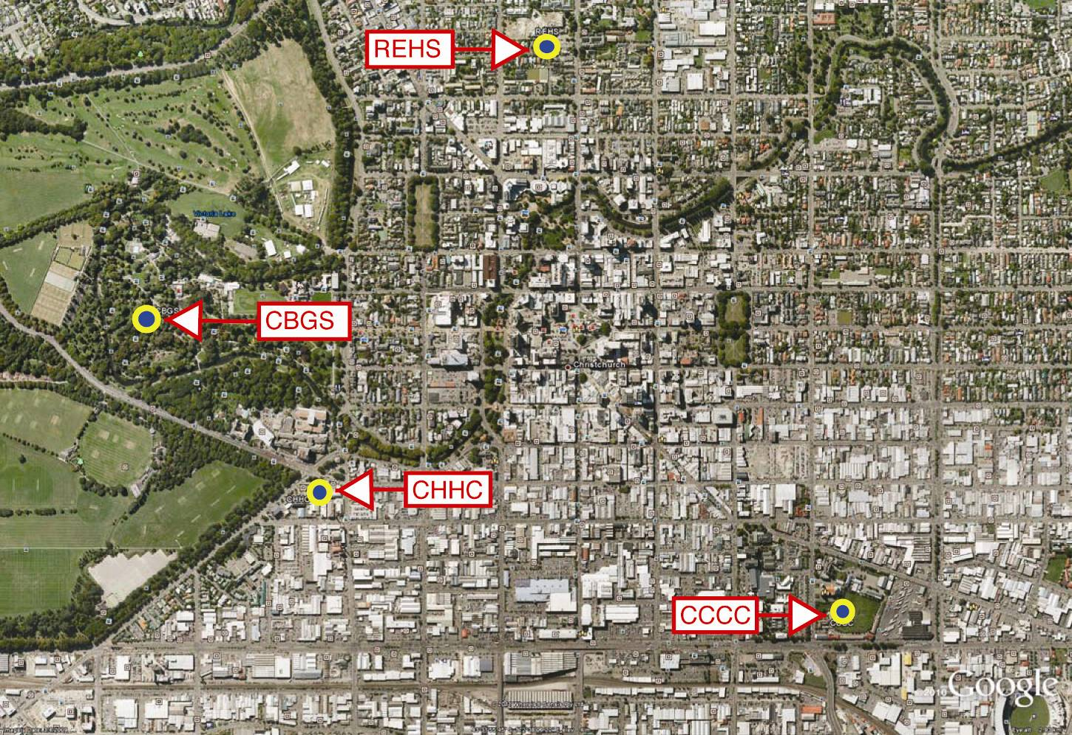

Figure 1: Location of seismic measuring stations

### Displacement spectra averaged from ground records obtained at stations CHHC, CBGS, CCCC and REHS (Carr report2)

Note that the Code displacements for periods greater than 0.7 seconds are the same for all ductility levels.

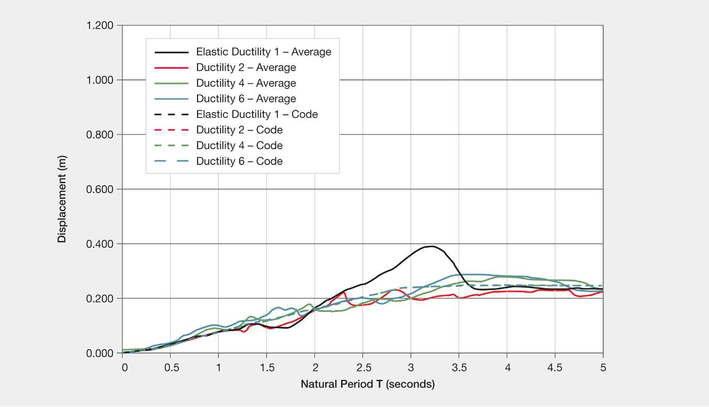

Figure 2: Average displacement spectra from four stations in the Christchurch CDB – September east–west direction (source: Carr report)  
  
Figure 3: Average displacement spectra from four stations in the Christchurch CDB – September north–south direction (source: Carr report)

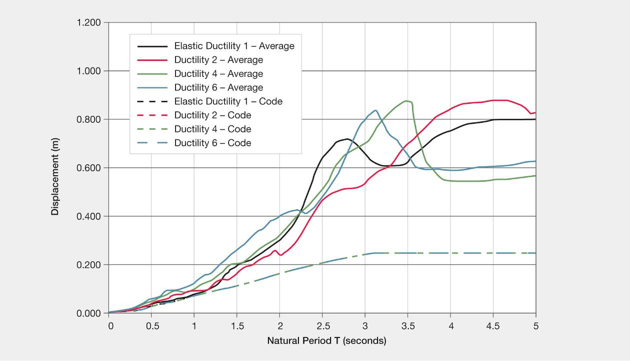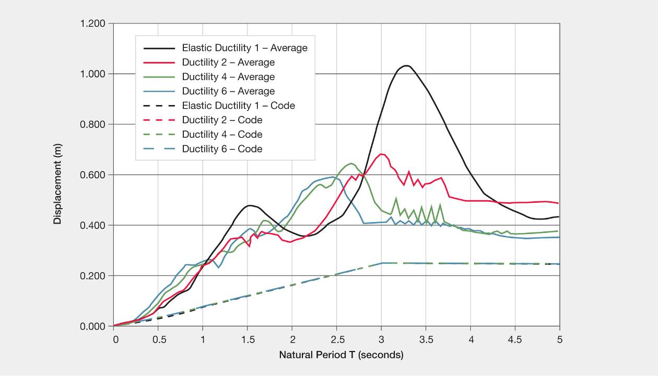

Figure 4: Average displacement spectra from four stations in the Christchurch CDB – February east–west direction (source: Carr report)

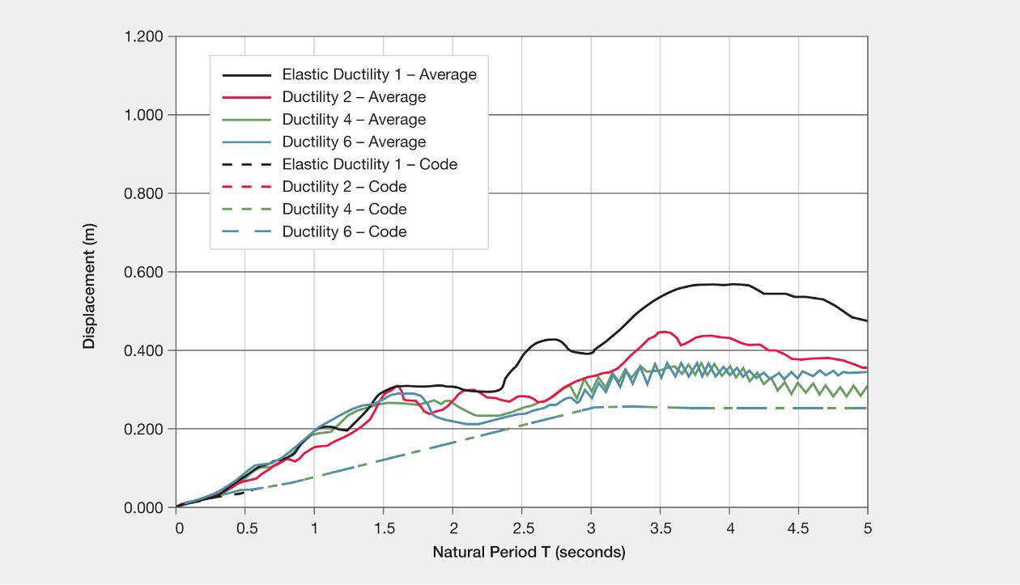

Figure 5: Average displacement spectra from four stations in the Christchurch CDB – February north–south direction (source: Carr report)

## References:

1. Bull, D. K. (2011). *Stairs and Access Ramps between Floors in Multi Storey Buildings*. Report to the Royal Commission. Christchurch, New Zealand: Canterbury Earthquakes Royal Commission.
2. Carr, A. J. (2011). *Inelastic Response Spectra for the Christchurch Earthquake Records*. Report to the Royal Commission, September 2011. Christchurch, New Zealand: Canterbury Earthquakes Royal Commission.
3. MacRae, G., Clifton, C. and Megget, L. (2011). *Review New Zealand Building Codes of Practice*. Report to the Royal Commission. Christchurch, New Zealand: Canterbury Earthquakes Royal Commission.
4. Smith, P. C., and Devine, J. W. (2011). *Historical Review of Masonry Standards in New Zealand*. Report to the Royal Commission, 2011. Christchurch, New Zealand: Canterbury Earthquakes Royal Commission.
5. Clifton, C., Bruneau, M., MacRae, G., Leon, R. and Fussell, A. (2011). *Steel Building Damage from the Christchurch Earthquake Series of 2010 and 2011*. November 2011.
6. Dhakal, R., MacRae, G. and Hogg, K. (2011). Performance of Ceilings in the February 2011 Christchurch Earthquake. Report published in the *Bulletin of the New Zealand Society for Earthquake Engineering Inc. (NZSEE),* 44(4).
7. Pampanin, S., Kam, W., Akguzel, U., Tasligedik, S. and Quintana-Gallo, P. (2011). Seismic Performance of *Reinforced Concrete Buildings in the Christchurch CBD under the 22nd February Earthquake.* Report prepared for Christchurch City Council and University of Canterbury, Civil and Natural Resources Engineering, November 2011.
8. Uma, S. and Beattie, G. (2011). Observed Performance of Industrial Pallet Rack Storage Systems in the Canterbury Earthquakes, *Bulletin of the New Zealand Society for Earthquake Engineering Inc. (NZSEE)* 44(4).
9. Structural Engineering Society New Zealand Inc. (SESOC) (2010). *Interim Design Guidance, Design of Conventional Structural Systems Following the Canterbury Earthquakes*. Draft version 6, 18th April, 2012.
10. NZS 4203:1976. *Code of practice for General Structural Design and Design Loadings for Buildings*. Standards Association of New Zealand. Available from Standards New Zealand.
11. NZS 4203:1984. *Loadings Code, Code of practice for General Structural Design and Design Loadings for Buildings*. Standards Association of New Zealand. Available from Standards New Zealand.
12. NZS 4203:1992. *Loadings Standard, Code of practice for General Structural Design and Design Loadings for Buildings*. Standards New Zealand.
13. NZS 1170.5:2004. *Structural Design Actions, Part 5: Earthquake actions – New Zealand.* Standards New Zealand.