Section 3:
Introduction to the seismic design of buildings

3.1. Structural actions
When a structural member such as a beam, column or wall is subjected to forces that are normal (i.e., at right angles) to the span of the member, bending moments and shear forces are induced.
These actions are internal to the member and are most simply envisaged by considering the forces at an imaginary cut through the member. The portion of the structure separated by the cut is known as a free body, see Figure 1(a) and (b).The forces acting at this section are required to satisfy equilibrium, which stops the free body from rotating or moving.

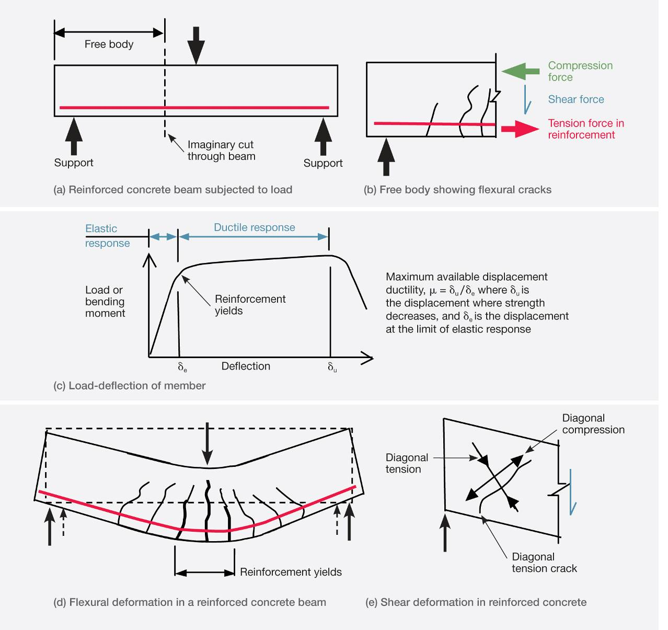
Figure 1: Structural actions in a reinforced concrete beam
Loads applied in a direction normal to the axis of a structural member cause it to bend. The internal action associated with this deformation is known as a bending moment, which induces tension on one side of the member and compression on the other side, as illustrated in Figure 1(b). Owing to the low tensile strength of concrete, cracks form in the regions subjected to tension. When these cracks are initiated the tension force previously resisted by the concrete is transferred to the reinforcement, as shown in Figure 1(b). If the load is increased, a stage is reached when the tension force in the reinforcement causes it to yield. This results in the cracks opening further and the deflection increasing. Once yielding of the reinforcement occurs the member can only take a small additional increase in force, as shown in Figure 1(c). Figure 1(d) shows a beam subject to a load that causes the reinforcement to yield. The ability of the member to deform without losing strength above the point where the reinforcement yields is referred to as ductile behaviour. The zone containing the yielding reinforcement is known as a plastic hinge or plastic region. The tensile strains in the reinforcement are greater than the compression strains in the concrete (on the other side of the member) and consequently the member as a whole increases in length. This is known as elongation, which can become significant when extensive plastic hinging occurs.
Shear forces in a member prevent the free body from sliding at the imagined cut. This force induces diagonal tensile and diagonal compression stresses in the member, which cause the member to deform, as shown in Figure 1(e). Owing to the low tensile strength of concrete the diagonal tensile stresses can cause diagonal cracks to form in the concrete. These are often referred to as shear cracks. These cracks limit the shear strength that can be carried by the concrete. To prevent this type of failure, stirrups are used to tie together portions of the member on each side of the diagonal crack.
The load deflection characteristics of structural steel members are in many respects similar to those of a reinforced concrete element. The yielding of the steel in the flanges in tension and/or compression gives the member a ductile performance similar to that shown in Figure 1(d). Shear forces induce diagonal tension and compression forces in the web. If the diagonal compression stresses are of sufficient magnitude and the web is not adequately restrained by the addition of web stiffeners, buckling of the web can occur.
Composite steel concrete beams are often used in buildings and bridges. Often they take the form of a concrete floor slab cast onto the top flange of a steel beam. Studs are welded onto the steel beam to anchor the concrete to the top flange so the slab acts compositely with the beam. This has the advantage of increasing the strength and stiffness of the beam while the slab helps restrain it against buckling. Elongation can occur in bending, but very much less than with reinforced concrete.

3.2 Seismic design of buildings

3.2.1 Introduction
The discussion below gives a brief outline of the concepts involved in seismic design of buildings.
Current New Zealand practice is to design buildings to satisfy two sets of design criteria, namely the serviceability limit state (SLS) and ultimate limit state (ULS).
The earthquake design actions for the two limit states are based on the predicted earthquake magnitudes that on average are expected to occur once in the given return periods. As noted later, the length of the return period used for the design limit states varies, depending on the importance of the building to the community.
The SLS involves designing the building so it remains fit for use in the event of an earthquake with a magnitude of shaking that may be expected to occur once or twice during the design life of the building. If damaged in such an event it should be repairable at low cost. Structures required for essential services after a major earthquake or other major emergencies are designed to sustain a higher level of seismic actions in the SLS.
For the ULS the design criteria have been developed to ensure that life is protected in the event of a major earthquake. This is achieved by requiring the building to have suitable levels of strength, stiffness and ductility to survive a major earthquake without collapsing as a result of structural failure. For commercial buildings of normal importance this major earthquake is assumed to have a return period of 500 years. Post-disaster structures, structures that are designed to contain significant numbers of people, and school buildings used for teaching are designed for earthquake actions with return periods of 2500 and 1000 years respectively (assuming a building design life of 50 years). Satisfying the design criteria for the ULS should enable building to be repaired after earthquakes that are more intense than those envisaged for the SLS. However, the ULS design criteria do not imply that repairs are possible after an ULS earthquake.
Protection against collapse in most modern buildings is provided by ensuring that in the event of a major earthquake the structures will behave in a ductile manner. This involves cracking of concrete and yielding of reinforcement in reinforced concrete buildings and yielding of structural steel members in steel buildings. This causes damage to structural elements as well as damage to non-structural elements such as the linings in the building. A consequence of this is that protection against collapse and protection of life may be at the expense of the building, which may have to be demolished after the earthquake. Ensuring buildings have adequate ductility to satisfy the ULS is achieved through a process called capacity design, which is explained later in this section.
Design seismic actions, consisting of forces and displacements that a building must be able to sustain, are determined from analyses carried out to criteria specified in the Structural Design Actions Standard, AS/NZS 1170.0¹ and Earthquake Actions Standard, NZS 1170.5.² Design actions depend on the predicted dynamic characteristics of the structure, the seismicity of the region, and the type of soils on which the building is founded. In Christchurch the soils consist of deep alluvial deposits of sand, silt and shingle. The deep relatively soft alluvial soils increase the magnitude of the long-period vibrations in the ground motion compared with stiff soil or rock sites.
The way in which a building behaves in an earthquake depends to an appreciable extent on its dynamic characteristics. When the natural period of vibration of a structure is similar to that of the ground motion, resonance can occur, vigorously shaking the structure. Thus houses with one or two storeys, which have a high natural frequency (or low period) of vibration, are shaken more vigorously on the Port Hills, where there are shallow stiff soils, compared to the adjacent plains, where there are deep alluvial soils. In the same way multi-storey buildings, which have a relatively long natural period of vibration, when built on the deep alluvial soils in Christchurch are subjected to greater forces and displacements in an earthquake than equivalent tall buildings on the Port Hills.

3.2.2 Response spectra
Response spectra form the basis of design for seismic actions. They are used to gauge how buildings with different dynamic and ductile characteristics will respond to earthquake motion under given ground conditions. Design response spectra have been developed from a large number of recorded ground motions. As every earthquake ground motion is unique, the design response spectra are based on averaged recorded motions from a large number of earthquakes.
A response spectrum of an earthquake is obtained by applying the measured ground motion to a simple structure that has a single mode of deformation, known as a Single Degree of Freedom (SDOF) structure. The response of such a structure depends on its natural period of oscillation, which is a function of its mass and stiffness. To derive a response spectrum for a single earthquake, SDOF structures are analysed under the measured ground motion, and the maximum response in terms of the peak acceleration and/or the peak displacement of the mass relative to the ground is recorded. The analysis is repeated for SDOF structures with different periods of vibration and the recorded values are graphed (Figure 2). The result is a response spectrum for accelerations or displacements, which can be used as a basis for assessing forces and/or displacements in buildings.
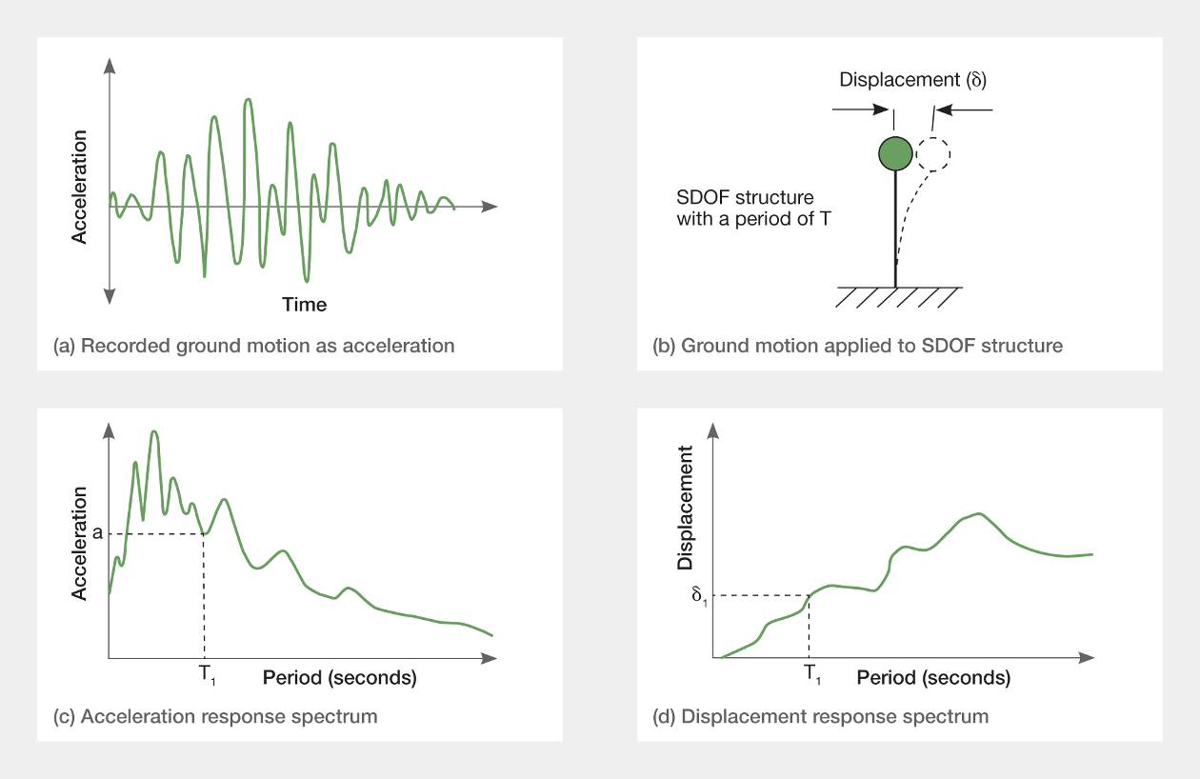
Figure 2: Response spectra for an earthquake
Structural design codes generally contain design response spectra for elastically-responding SDOF structures, assuming that the energy dissipation that occurs is represented by five per cent equivalent viscous damping, as shown in Figure 3(b). These curves are derived by considering the response spectra calculated for a large number of earthquakes, which in NZS 1170.5 are scaled to represent actions associated with the magnitude of an earthquake that on average is expected to occur once in a period of 500 years. As there is a large amount of scatter in the shape of response spectra the design curves are smoothed shapes, which represent the general trends and magnitudes observed in actual earthquakes.
The five per cent equivalent viscous damping represents energy dissipation that occurs in structures because of friction in the building, interaction between the supporting soil and foundations, and other effects that are not easily quantified. Damping limits the extent of structural response.
Acceleration spectra are particularly useful for design as the lateral force induced by a mass in a structure is equal to the mass multiplied by its acceleration. To simplify calculations of the maximum forces, acceleration response spectra are given in terms of the recorded acceleration divided by g, the acceleration due to gravity (9.81m/s²). With this simplification, the maximum inertial force induced on a mass is equal to its weight multiplied by the appropriate acceleration response spectrum coefficient for the period of the SDOF structure.
A basic assumption with the use of response spectra is that the structure has the same stiffness and strength for both the forwards and backwards displacement. If this condition is not satisfied, allowance needs to be made for the tendency of the structure to displace further in the weaker or more flexible direction than in the other direction.
Ground conditions have a major influence on the shape of response spectra. In design codes of practice this is covered by defining a number of response spectra to cover the range of different soil conditions. As noted previously, soft soils increase the response in the longer period range, while with stiff soils, such as rock, the response is higher in the short period range and lower in the long period range. This is shown in Figure 3(a), which shows response spectra for two sites in Lyttelton, which are close together but on very different soils.
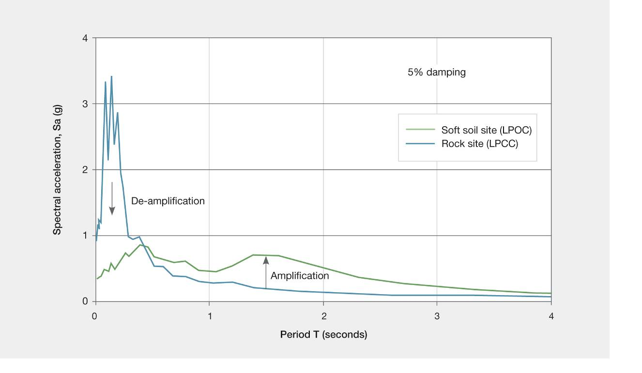
Figure 3(a): Acceleration response spectra for the February 2011 earthquake measured at a rock site and a soft soil site that are close to each other in Lyttelton³
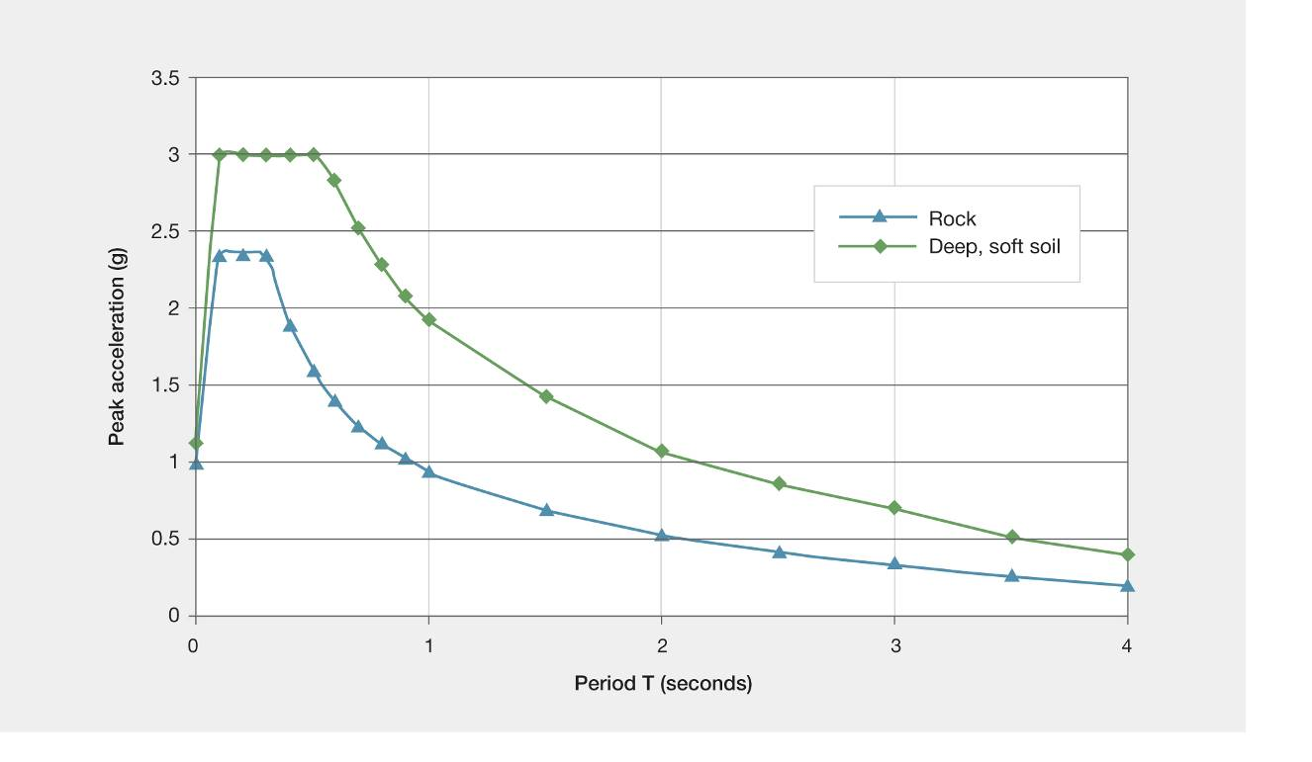
Figure 3(b): Design response spectra for alluvial soil (type D) and a rock site (type B) in NZS 1170.5
Figure 3(b) shows the corresponding rock (type B) and soft soil (type D) contained in NZS 1170.5. The distance of an earthquake from the site being considered also has a major effect on the frequency content of the ground shaking. The high-frequency vibrations in the ground decrease (attenuate) more rapidly with distance than the long-period vibrations. A consequence of this is that the response spectra for a distant earthquake, such as an Alpine Fault earthquake felt in Christchurch, will be very different from the corresponding spectra for the recent Christchurch earthquake series. NZS 1170.5 recognises the influence of soil type on response by giving four different spectra shapes: for rock, shallow soil sites, deep or soft soils and very soft soils. For the Christchurch Central Business District (CBD) the appropriate soil types are deep soils and in some cases very soft soils (types D and E in NZS 1170.5).
Figure 3(b) shows that for buildings with a natural period of two seconds the design peak ground accelerations on deep alluvial soils are about twice as high as on a rock site.

3.2.3 Ductile behaviour
As previously noted, the majority of modern multi-storey buildings are designed to respond in a ductile manner in the event of a major earthquake. The level of ductility, or more accurately displacement ductility, is measured by the structural ductility factor, µ. This value is taken as the ratio of the peak displacement that can be reliably sustained without significant strength loss to the displacement where significant inelastic deformation starts to occur, as shown in Figure 1(c).
Analysis of a large number of SDOF structures indicates that the peak displacement achieved by ductile structures is generally of a similar magnitude to that sustained by an elastically responding structure with the same initial period of vibration. This “equal displacement concept” is extensively used in structural design codes. It does not apply to structures with short periods of vibration. In NZS 1170.5 the equal displacement concept is assumed to apply for structures with fundamental periods of 0.7 seconds or more for all soil types, except type E (very soft) soils, where the corresponding limit is 1.0 second. For structures with fundamental periods less than these values the lateral displacements exceed the corresponding deflections sustained by the elastically responding structure. NZS 1170.5 defines the relationship that can be used for design between the elastic displacement and ductile displacement for structures where the period is less than these limits.
As shown in Figure 4, allowing the structure to behave in a ductile manner in a major earthquake has a number of major advantages, namely:
1. Lower strengths are required, reducing in construction cost.
2. There is more freedom in the architecture of the building, enabling greater clear floor spans to be used with smaller beams, increased spacing of columns, etc.
3. A ductile building is tough in an earthquake and can generally withstand earthquakes considerably greater than design level (ULS) without collapse.
4. A ductile structure generally gives warning well before collapse occurs by opening up wide cracks in reinforced concrete structures and sustaining high displacements in steel and concrete members.
5. Non-ductile buildings give no warning of collapse and generally have less reserve capacity to sustain earthquakes greater than design level without collapse.
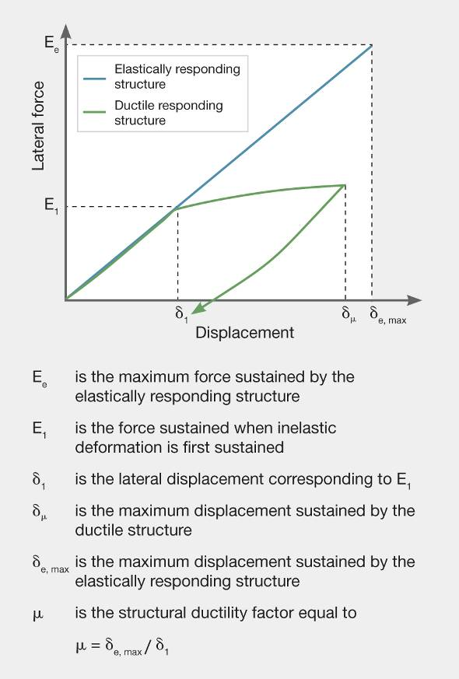
Figure 4: Structural ductility factor

3.2.4 Multi-degrees of freedom
Most structures can vibrate in a number of different mode shapes, as shown in Figure 5. The main, or fundamental mode, accounts for the majority of displacement. However, higher modes can have a significant influence on structural actions in parts of the structure and on the magnitude of inter-storey deflections.
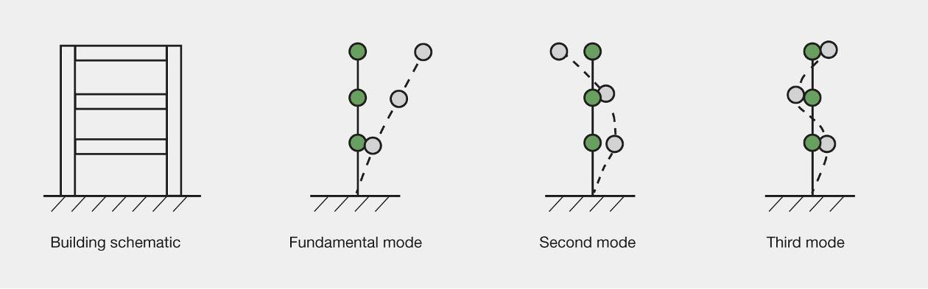
Figure 5: Higher mode shapes of deformation
Where the mass is eccentric from the centre of lateral stiffness and/or force resistance, a torsional response can occur giving rise to torsional modes of deformation. This arises predominantly in buildings that are irregular in plan. NZS 1170.5 requires allowance to be made for torsional response in all structures. This can arise from small differences in the stiffness and strength of members, non-uniform disposition of live and dead loads in the building or a component of torsional rotation in the ground motion. Ideally, buildings should be designed to minimise torsional response in earthquakes as this can cause rotation to occur about the centre of lateral resistance, which has the effect of increasing the displacements applied to structural elements located at a distance from the centre of rotation. It is the magnitude of the imposed displacement that is the principal cause of failure of structural elements. Consequently, one of the aims in seismic design is to minimise rotation of buildings caused by torsion, as this greatly improves the building’s seismic performance.

3.2.5 P-delta actions
When gravity loads are displaced laterally, additional bending moments (referred to as P-delta actions) are induced, causing the deflection to increase further. When a structure exceeds its yield strength, P-delta actions cause the displacement to increase predominantly in one direction, with subsequent inelastic load cycles. It follows that P-delta actions tend to be more critical in major earthquakes that have a long duration of shaking and in structures that have been designed with a high level of ductility.
One way to envisage P-delta actions is to separate the two basic requirements of a structure. The first is to support the gravity loads and the second is to provide lateral resistance. In general both of these functions are resisted to a greater or lesser extent by the same structural elements.
Figure 6 shows a simple structure where the two functions of supporting gravity loads and providing lateral resistance are separated. At each level in the building, pin-ended columns support the gravity load while a second cantilever column, which may be representing a frame or wall, resists the lateral forces.
Figure 6 shows that when lateral displacements arise in the structure the pin-ended columns supporting the gravity loads are displaced. To restrain the pin- ended column in its deflected shape, lateral forces are transmitted from it to the lateral-force-resisting structural component. This increases the bending moments and shear forces in the lateral-force-resisting structure and consequently there is a further increase in displacement associated with P-delta actions. If the lateral-force-resisting system develops plastic hinges in an earthquake the lateral stiffness is temporarily reduced. This can result in a significant increase in displacement, the magnitude of which depends on the duration of the lateral seismic force acting in that particular direction. As the inelastic displacement is not necessarily recovered when the lateral force reduces or changes direction, subsequent inelastic cycles can cause the structure to progressively deflect in the same direction. For this reason P-delta actions tend to be more critical in earthquakes where the ratio of the duration of strong ground motion divided by the fundamental period of the building is high. NZS 1170.5 has design rules to counter P-delta actions, which require additional strength to be added and allowance made for additional deformation caused by these actions.
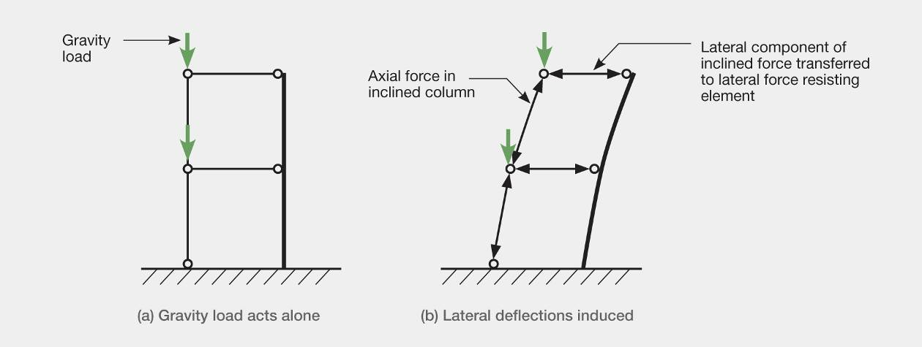
Figure 6: P-delta actions

3.2.6 Capacity design
A building that can sustain its strength well beyond the stage where yielding and structural damage is initiated (i.e., a ductile building) has major advantages over a brittle building, which loses its strength suddenly and is in danger of collapsing at a displacement close to that where the damage was initiated.
Capacity design is a process that has been developed to ensure that in the event of a major earthquake ductile behaviour can occur and brittle failure modes are suppressed. This is achieved by designing the structure so that inelastic deformation is confined to selected locations, known as potential plastic hinges. To achieve this objective, all the structural elements outside the potential plastic hinges are designed to have a strength that is greater than the structural actions (bending moments, shear forces, etc.) that can be transferred to them by the plastic hinges. The plastic hinges limit the magnitude of the seismic forces in the structure and ensure that ductile behaviour is maintained.
The steps involved in capacity design are as follows:
1. Identify the location of potential plastic hinges required to give the building a potential ductile performance. This step is illustrated in Figure 7(a). In moment resisting frame structures potential plastic hinges are generally located at the base of the columns and in the beams. This enables the structure to deform by what is referred to as a beam sway mechanism, as shown in Figure 7(b), spreading the inelastic deformation over the height of the building. The column sway mechanism shown in Figure 7(c) concentrates the inelastic deformation in one storey. In multi-storey buildings, where a column sway mechanism develops, high rotations are induced in the columns in order to sustain the necessary displacement. As the rotational capacity of plastic hinges is limited, these high rotations can cause premature failure and hence non-ductile behaviour. In structural walls the potential plastic hinges are generally designed to form at the base of the walls.
2. Structural analyses are carried out to determine the minimum design strengths required in the potential plastic hinge regions to satisfy the serviceability and ultimate limit state requirements. The design strengths are taken as the nominal strengths multiplied by a strength-reduction factor. As noted below, the nominal strength is a conservative estimate of the likely strength.
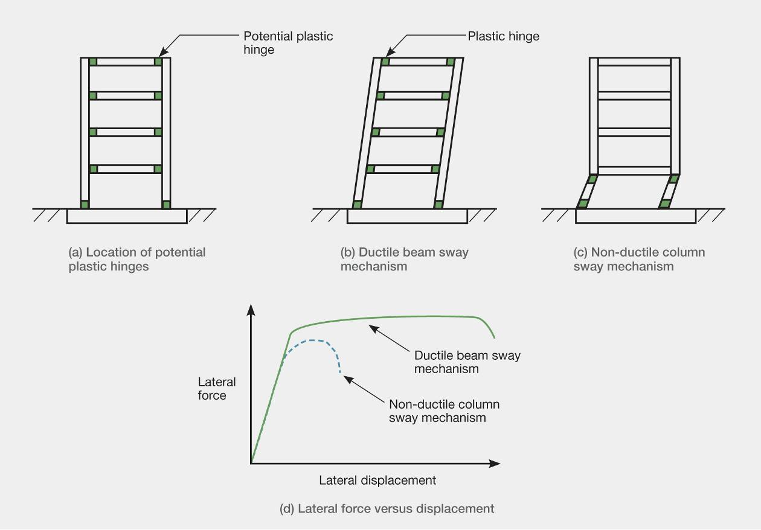
Figure 7: Ductile and non-ductile sway
3. Potential plastic hinge zones are detailed to provide the required design strength. After this the over-strength of each potential plastic hinge region is calculated, based on the structural details actually used in the plastic hinge and on the basis that the materials have their upper characteristic strength values. This over-strength is the maximum likely strength of the plastic hinge region. For reinforcement or structural steel members the upper characteristic strength is such that on average 95 per cent of the material will have a yield strength less than this value. The assumed maximum stress in the reinforcement or structural steel member is further increased to allow for strain hardening. In some cases where high axial load levels act it is necessary to allow concrete strengths greater than those assumed in design and for a further increase in strength where the concrete is confined.
4. The combination of structural actions that give the most critical actions that may need to be resisted by each plastic hinge is assessed and these values are used to determine the maximum structural actions that can be induced into the regions of the structure outside the potential plastic hinges.
5. The remainder of the structure (outside the potential plastic hinge zones) is designed to have a nominal strength greater than the maximum structural actions that can be induced in it by the plastic hinges.
The nominal strengths in flexure, axial load, shear and torsion are calculated assuming the materials have their lower characteristic strengths, which are based on the calculation that only five per cent of the material (steel, concrete, etc.) will on average have strengths lower than the assumed value. For the ULS the strength-reduction factor is always less than 1. For reinforced concrete the ratio of average strength to nominal strength is generally in excess of 1.15 and the strength- reduction factor for flexure is 0.85. Consequently the average strength at or close to first yield of the reinforcement is achieved with a high level of certainty. If allowance is made for increase in strength caused by strain hardening of reinforcement the average peak strength increases to about 1.5 times the design strength. This process ensures that the design strength is achieved with a high level of certainty. This, together with other conservative assumptions regarding inelastic deformation limits, gives protection against collapse for earthquakes considerably in excess of design levels corresponding to the ultimate limit state design actions.
Proper application of capacity design principles should ensure that the structure will behave in a predictable ductile way in the event of a major earthquake.

3.3 Analysis of seismic actions

3.3.1 Introduction
There are three different types of analysis that can be made to assess seismic design actions for new buildings or to assess the likely performance of existing structures: force-based design, displacement-based design and time history analysis.
Force-based design methods have been extensively used for many decades and are well established and accepted in many structural design codes of practice. Displacement-based design methods are more recent. The initial steps in this approach were made about 30 years ago, but it is only in the last decade and a half that displacement-based approaches have been established and used in practice. At present, displacement-based methods are not as widely accepted as force-based methods.
Both methods have advantages and disadvantages. Force-based design is familiar, widely accepted and there is plenty of software available. Displacement-based design has the advantage of concentrating at the outset on limiting seismic-induced displacements to an acceptable level. The magnitude of inelastic deformation associated with ductile behaviour is a major cause of damage. Consequently a design method using this approach starts by considering the level of damage that is acceptable in a given situation. This can help a designer select more rational structural arrangements and strength distributions in some situations.
Both force and displacement-based methods of analysis rely on response spectra (see section 3.2.2). In NZS 1170.5, the design response spectrum for a building is specified in terms of:
1. A specified spectral shape factor, C_{h}(T), which depends on the soil type. For the Christchurch CBD this is deep alluvial soils, type D in NZS 1170.5.
2. The seismic hazard factor for the region, which for Christchurch is currently 0.3.
3. The return period, R, which relates the magnitude of the design actions to the earthquake considered at the design limit state. As noted earlier, the ULS for normal commercial buildings has a value of 1 and corresponds to a return period of 500 years.
4. A near fault factor that allows for increased seismic actions for buildings located close to a major fault. These major faults are listed in Table 3.6 of NZS 1170.5. As none of these are close to Christchurch this coefficient is neutral and it has a value of 1.
The application of these factors gives the design response spectrum for the Christchurch CBD for type D soil conditions shown in Figure 8.
In the following sections the basic concepts of force-based and displacement-based design are described. In the interests of brevity, many of the details have been omitted.

3.3.2 Design spectra
Figure 8(a) shows a response spectrum for a Christchurch site for normal commercial buildings on soil type D for the ultimate limit state. The peak design lateral force on an elastic SDOF structure is equal to the weight of the structure multiplied by the lateral force coefficient, C(T), corresponding to the fundamental period, T, of the structure (see section 3.2.2).
With reference to Figure 8(a), the design lateral force for a SDOF structure with a fundamental period of 1.5 seconds is 0.43 multiplied by its weight. Figure 8(b) shows the corresponding displacement for the SDOF structure as 0.25m. In Figure 8(c) the relationship between the lateral force coefficient and displacement is shown. The first two spectra are used in force-based design of new buildings. In displacement-based design the values are adjusted to allow for different damping levels.
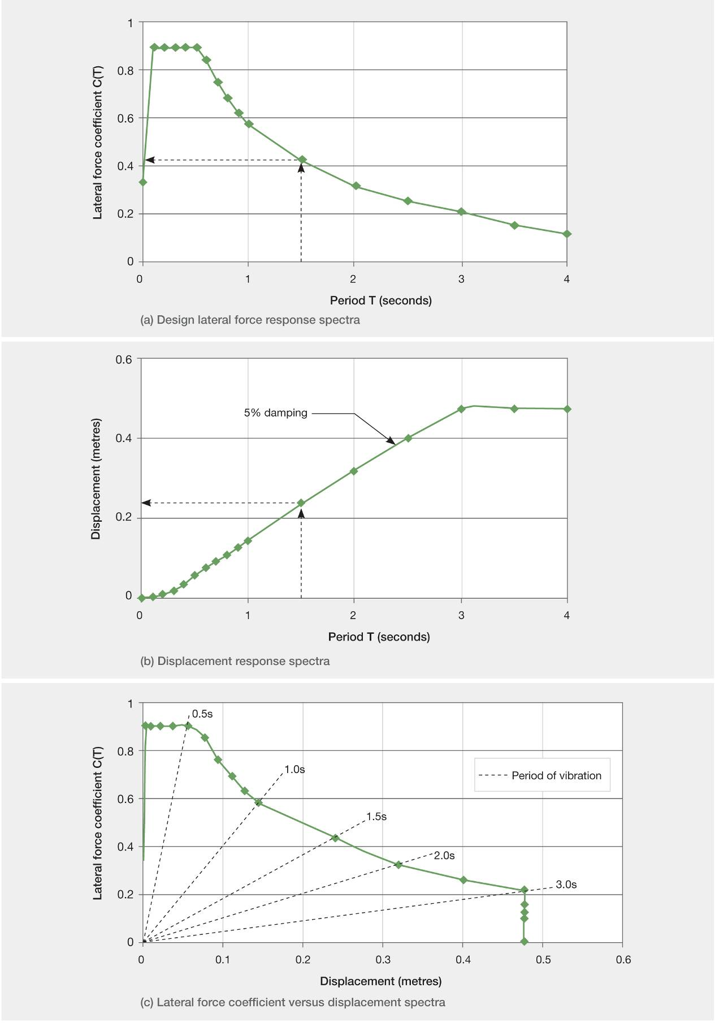
Figure 8: Elastic design response spectra for normal commercial buildings in Christchurch

3.3.3 Force-based design
There are two different force-based methods of design in NZS 1170.5, namely equivalent static and response spectrum.

3.3.3.1 Equivalent static method
The equivalent static method is the simpler of the two. It can be used on low-rise structures and on reasonably regular multi-storey buildings provided their fundamental period does not exceed two seconds. It is based on the assumption that the building will behave predominantly in its first mode. Much of the analysis necessary for this approach can be carried out by hand.
The approach relies heavily on the equal displacement concept, in which a ductile structure sustains either a peak displacement equal to that sustained by an equivalent elastic structure if the period exceeds the critical value or where the period is less than the critical value, the peak displacement is taken as the product of a coefficient and the elastic displacement. The coefficient varies with period and values are given in design codes.
In practice, the ductile inelastic deformation dissipates energy (effectively increasing the level of damping) but at the same time it increases the effective period of vibration. There are two effects here. First, if the change in effective period is ignored, the damping reduces both the lateral seismic forces and the displacement demand. However, allowing for the change in effective period increases the displacement demand. These two effects generally tend to cancel each other out, as indicated by the general validity of the equal displacement concept. In displacement-based design the effect of an increase in effective period and damping are individually assessed.
The steps involved in analysing a building with force-based design can be outlined as follows:
1. Developing an analytical model of the building in which the structural elements are all represented by stiffness values that correspond to the response of the structure just prior to the stage where inelastic deformation is induced.
2. Analysing this structure to find its fundamental period of vibration.
3. Finding the lateral forces that would act on the SDOF structure that has the same fundamental period. With reference to Figure 8(a), if the fundamental period of the building was 1.5 seconds the equivalent force would be 0.43 W_{t}, where W_{t} is the weight of the structure.
4. If the structure is ductile, the design base shear is taken as the value noted above but divided by a coefficient, k_{u}, where for a building with a period greater than 0.7 seconds k_{u} is taken as equal to the structural ductility factor, μ. This reduction in design force is based on the equal displacement concept. The value is further reduced by the structural performance factor, S_{p}, which was introduced to allow for a number of factors that are not easily quantified and are not directly accounted for in the design process. Hence for a building with a fundamental period of 1.5 seconds, which has been designed assuming a structural ductility factor of 4.0 and the corresponding S_{p} factor of 0.7, the design base shear force, V, is equal to 0.0753Wt.
5. The design base shear is equal to the sum of the design lateral forces.
6. The lateral force coefficient acting at each level is theoretically equal to the acceleration at that level relative to the ground. For simplicity, it is generally assumed that the acceleration at any height is proportional to the height above the ground. Hence the design lateral forces are found by multiplying the weight at each level by the lateral force coefficient, which has a linear variation proportional to height. However, one modification is made whereby eight per cent of the base shear force is added to the lateral force at the highest level, with the remaining 92 per cent being distributed on the basis of the lateral force for each height. This modification is made to allow for actions associated with the second and higher modes of deformation.
The equation for the lateral forces is given by:
F_{i} = 0.92V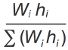+ F_{t}
where F_{i} is the lateral design force at level i, V is the base shear force, W_{i} is the weight and h_{i} is the height at the level, i, being considered. ∑ (W_{i} h_{i} ) is the sum of the product of the weight and the height for all levels and F_{t} is equal to zero for all levels except the highest where it is equal to 0.08V.
The set of forces defined above is applied to the analytical model. This gives a set of bending moments, shear forces and axial loads acting in the structural members together with the lateral deflection at each level. These sets of values are scaled to allow for torsional actions that may be introduced into the building. These torsional actions can arise as a result of non-uniform ground motion, irregularities in the distribution of load and the eccentricity of the centre of lateral force resistance from the centre of mass and hence seismic force. The displacements are increased to allow for the associated inelastic deformation. If the inter-storey drift limits are within the acceptable range a further analysis is carried out for P-delta actions and the inter-storey drifts re-checked. If the deflections exceed permitted limits the member sizes and associated stiffness values are modified and the process is repeated.
Once the design actions have been calculated, capacity design is undertaken to ensure the buildings will behave in a ductile manner in a major earthquake. To complete the design, the design forces that need to be accommodated to ensure that the different structural elements are tied together, are calculated from criteria given in the design standards.

3.3.3.2 Modal response spectrum method
The modal response spectrum method is a computer-based approach. As with the equivalent static method, an analytical model of the building is developed. The computer programme determines the different modes of vibration of the structure, finding the period and deformed shape of each mode together with the effective mass of each mode. On the basis of the response spectrum the lateral force coefficient for each mode is found and the associated structural actions are determined.
Once the structural actions in each mode have been assessed, the next task is to combine the actions. Because the modes all sustain their peak displacements and structural actions at different times, the values cannot be simply added. There is a variety of techniques available for deriving appropriate values for design purposes. The simplest of these is to take the square root of the sum of the squares of each structural action at the point being considered. There are other more comprehensive techniques available.
Response spectrum analysis is a more advanced approach than the equivalent static method in that it handles torsional actions more realistically and makes a more rational allowance for higher mode effects. For this reason, this approach is used where the equivalent static method is not appropriate because of irregularities in the structure or because higher mode effects are expected to play an important role in the structural behaviour of the building.
There are some basic problems with the modal response spectrum method of analysis. If torsional modes of response are ignored, the sum of all the masses associated with displacement in one direction equals the total mass of the structure. However, many of the very short period modes contribute little to the total mass. Consequently many of the higher mode contributions can be ignored. To find the number of modes that need to be included in an analysis, starting at the fundamental mode the effective masses in each mode are added until the total is equal to or greater than 90 per cent of the total mass of the structure. The 90 per cent limit is widely accepted in design codes of practice. With torsional response the sum of the effective masses in each mode no longer add up to 100 per cent of the mass of the structure. This can be important where torsional response is a major feature of the building, in that the torsional contribution can in some situations be omitted.
A further major problem arises out of the combination of the modal actions. By taking the sum of the squares, or any of the other methods of combination, the sign of the action (that is, positive or negative bending moments, shears or displacements) is lost. A consequence of this is that the bending moments are no longer consistent with the shear forces or deflections and hence it is not possible to use the results of a response spectrum modal analysis to track loads. Where this is required it is necessary to use the results of an analysis for a single mode.
The modal response spectrum analysis assumes elastic behaviour. In design it is necessary to modify the predicted values to allow for inelastic behaviour and for P-delta actions in a similar way to that used with the equivalent static method.
Once the analysis has been completed and the structure is detailed to satisfy strength and stiffness requirements, capacity design is carried out to ensure that the building will behave in a ductile manner in the event of a major earthquake. It is essential to realise that buildings do not respond to major earthquakes elastically and any elastic analysis only gives a guide to performance. For this reason it is essential that capacity design is carried out if any appreciable ductility has been assumed in the design.
As with the equivalent static method, the design forces required to tie the structural components together are not given by the analysis and it is necessary to follow criteria given in the design standards to assess these actions.

3.3.4 Displacement-based design
As noted previously, the initial steps in the development of displacement-based design were made three decades ago. However, it is only in the last decade that the method has been used to any appreciable extent. Here only one version of this approach, namely Direct Displacement-Based Design (DDBD) will be described. The objective of the method is to base the design on the displacement that can be safely sustained for the limit state being considered. This has the advantage of focusing on displacement, which is the principal, though not sole, cause of structural damage. Focusing on displacements at the start of an analysis can in certain cases be advantageous in helping to identify how the strength to resist lateral seismic forces can best be distributed. The ability to allow directly for the influence of damping and period shift on strength and displacement demands can also be a major advantage when designing buildings using new technologies such as Precast Seismic Structural Systems (PRESSS), where the structure does not sustain structural damage and energy is dissipated by specifically designed structural elements.
The philosophy of DDBD is based on the fundamental inelastic mode of response and can be divided into four components, as shown in Figure 9. For a multi-storey building it begins by idealising the structure as a SDOF system, which has a characteristic force-displacement response into the inelastic range. The effective mass and height of the equivalent SDOF simulation can be simply calculated using weighted formulae.
The design displacement limit can be calculated at the start of design without needing to know the strength or initial stiffness. For the ultimate limit state the maximum displacement is defined by the displacement associated with the permissible material strain limits for structural elements or the limiting permitted inter-storey drift.
The level of displacement ductility varies with different limit states. There are relationships between the displacement ductility and equivalent viscous damping that can be found in the literature: Priestley et al⁴ give suitable equivalent viscous damping ratios for the various structural forms and displacement ductility levels, as shown in Figure 9(c). NZS 1170.5 contains design spectra based on five per cent equivalent viscous damping for different soil types. In displacement-based design the designer requires response spectra with equivalent viscous damping levels associated with the limit state being considered and assumed ductility level. The required spectra for defined equivalent viscous damping levels can be obtained by multiplying the five per cent damped spectrum by an appropriate factor, F. A number of different factors have been proposed but one recommended for sites that are not close to major fault lines is:
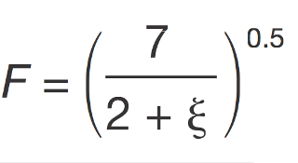
In this equation is the equivalent viscous damping level.
The design process is illustrated in Figure 9. It follows six basic steps:
1. An equivalent static SDOF structure is derived from the proposed building, as shown in Figure 9(a).
2. A limiting displacement, ∆_{u}, is selected based on limiting material strains or inter-storey drift.
3. Based on the properties of the proposed building, the displacement at first yield of the SDOF structure ∆_{y} is assessed. The ratio of ∆_{u}/∆_{y} gives the ductility. From an assumed strength, F_{n}, and an appropriate strain hardening stiffness ratio, , the secant stiffness, K_{e}, can be found as shown in Figure 9(b).
4. From the displacement ductility the equivalent of viscous damping can be found as shown in Figure 9(c).
5. The fundamental period and the equivalent viscous damping allows the peak displacement to be found as shown in Figure 9(d). This value can now be compared to the initial displacement.
6. The process is repeated by changing the assumed strength, F_{n}, until convergence is obtained.
As with the equivalent static method, the base shear is used to determine the distribution of strength over the height of the structure. Further adjustments are made to allow for P-delta actions and this is followed by capacity design to provide protection against higher mode actions.
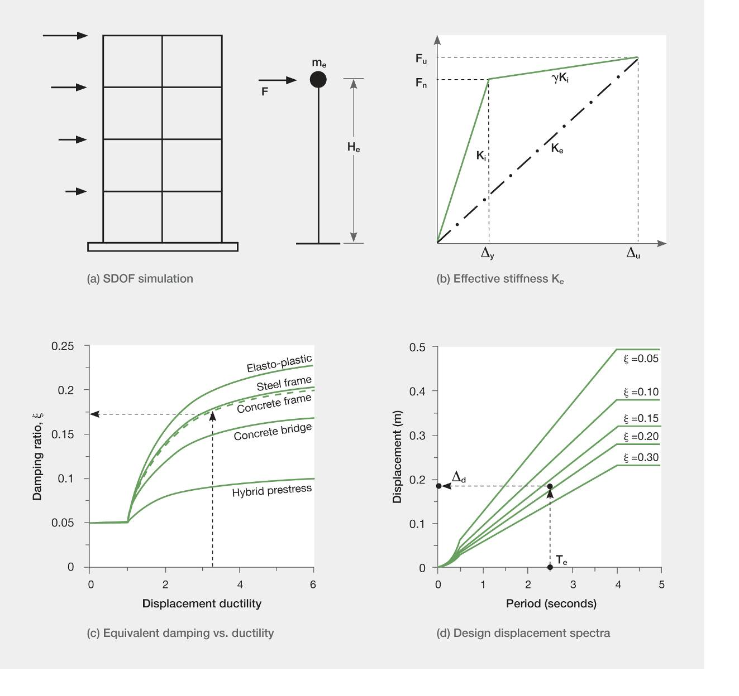
Figure 9: Fundamentals of direct displacement-based design(adapted from Priestley⁴)
As with force-based principles, the DDBD method is based on a range of assumptions, which are simplifications of a structure’s behaviour and dynamic characteristics. In DDBD there are concerns relating to the level of equivalent viscous damping and the secant stiffness of the SDOF system, as well as the idealisation of a truly Multi Degree of Freedom (MDOF) structure as a SDOF and the implicit assumptions that are made in the deflected shape profile of the structure.
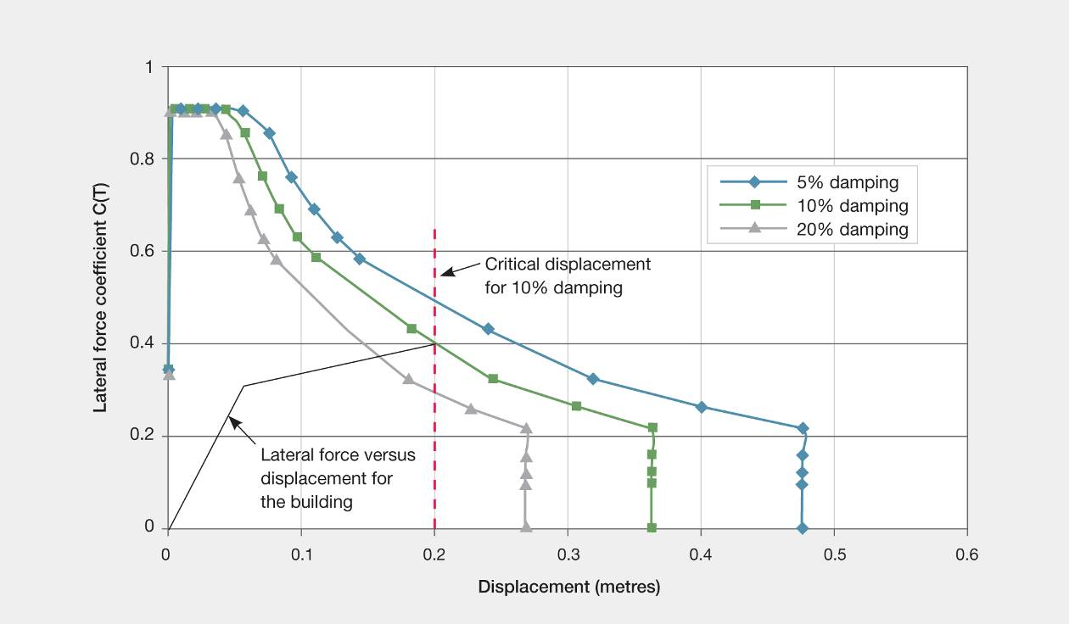
Figure 10: Seismic performance of existing structures with displacement-based assessment
The relationship between the lateral force coefficient and displacement shown in Figure 10 can be used to assess the seismic performance of existing structures. For an existing structure it is possible to assess the yield strength and the strain hardening ratio together with the displacement at first yield. With this information it is possible to plot the relationship between lateral force and displacement. The point at which at which this curve intersects the curve for a given damping defines the magnitude of the displacement that the structure must be able to sustain (Figure 10). In making this assessment it is essential to make allowance for either increased displacements or reduced lateral strength caused by P-delta actions.

3.3.5 Time history analysis
An analytical elastic model of the structure is developed. This is then analysed by subjecting the structure to a number of notional earthquake ground motions. Rules are given in NZS 1170.5, which identify the earthquake characteristics that must be used and how they are to be scaled so that they are consistent with the design response spectrum.
The elastic time history analysis approach has the advantage that it avoids the problem inherent in the modal response spectrum method of combining the modal actions. However, there are several inherent problems with this elastic time history analysis when it is used for ductile structures. The analysis does not allow for the influence of inelastic actions on the deflected shape profile or on P-delta actions. Consequently, separate allowance needs to be made for these effects. In addition, care is required in selecting the appropriate level of damping and the way in which it is included in the analysis, as this can have a significant influence on the predicted actions. Having obtained the structural actions from the analyses, there remains the problem of how these elastic values can be reduced to values appropriate for ductile structures. The elastic time history method is appropriate for assessing serviceability limit state conditions and in structures where inelastic deformation is not anticipated in the design limit state being considered. It may also be used as a method of assessing the likely required strengths for a model used for an inelastic time history analysis.
Inelastic time history analyses involve modelling the elastic and inelastic response of the building elements. As with elastic time history analyses, a series of earthquake ground motions, suitably scaled so that they are consistent with the design response spectrum, is applied to the analytical model. This method of analysis is appropriate for use in the design of special structures and for assessing the likely seismic performance of existing structures. The use of this method of analysis involves specialist knowledge and a considerable time commitment.

3.4 Different structural forms in buildings

3.4.1 General
There are a number of common structural forms used to provide resistance to lateral forces from wind or earthquakes. They include structural walls, moment resisting frames, eccentrically braced frames and concentrically braced frames. All may be referred to as lateral-force-resisting elements. In all cases the floors and sometimes the roofs are designed to hold the building together and transmit inertial induced forces to the lateral force resisting elements. To sustain these actions the floors act as diaphragms. For this reason floors are often referred to as diaphragms.
Different structural elements that are widely used to provide lateral force resistance are described in the following paragraphs. A number of advanced structural forms or structural components that may potentially be used to improve the seismic performance of new buildings, or in some cases existing structures, are described in Volume 3 of this Report.

3.4.2 Moment resisting frames
Moment resisting frames are made up of beams and columns in an arrangement such as that shown in Figure 11. These are designed to resist lateral forces caused by earthquakes. Potential plastic hinges are located in the beams adjacent to the columns and at the base of the columns. This form of construction is used with both reinforced concrete and structural steel. Often moment resisting frames are located around the perimeter of the building, where greater beam and column sizes can be accommodated without increasing storey heights. More slender beams and smaller columns may be used in the interior of the building to support the floors and transmit most of the gravity loads to the foundations.

3.4.3 Eccentrically braced frames
Eccentrically braced frames are constructed from structural steel members. They are generally located in perimeter frames or in the structural elements surrounding stairs and lift shafts.
The beams are braced with diagonal members, as shown in Figure 12.
When critical lateral forces are applied to the frame, high shear forces are induced in the active link of the beam, causing the link to yield in shear. This arrangement has been found to be capable of sustaining repeated inelastic deformation provided the active link is adequately reinforced with web stiffeners to prevent premature buckling failure. It has been found to be a reliable method of providing ductility in buildings.
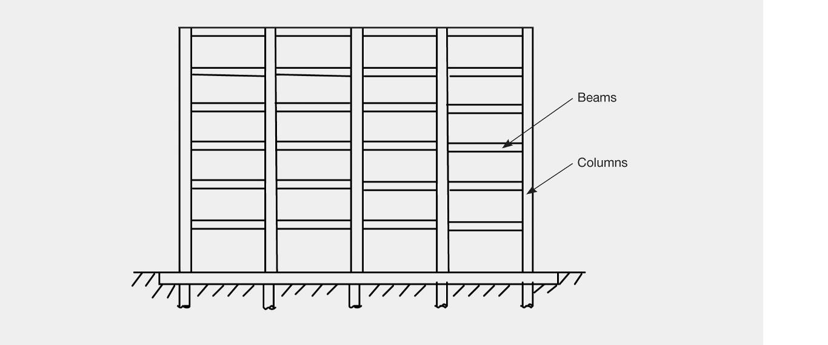
Figure 11: Moment resisting frame
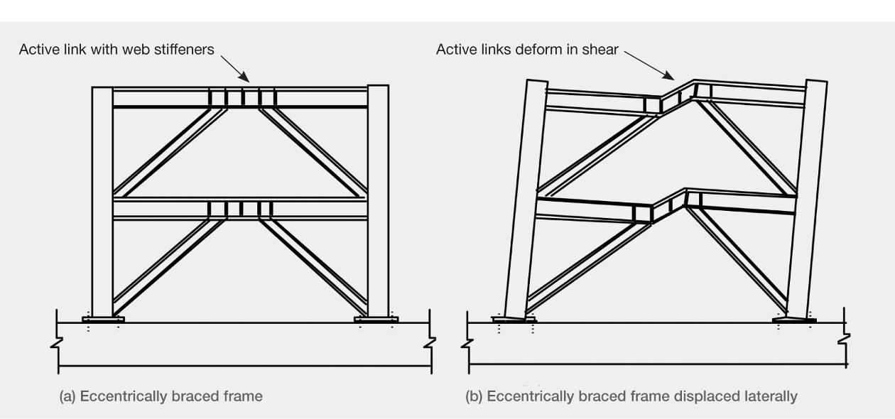
Figure 12: Eccentrically braced frame
Generally only one or two bays in each perimeter frame are eccentrically braced, which leaves room for windows and doorways in bays that are not braced.

3.4.4 Structural walls
Structural walls, often referred as shear walls, are extensively used to provide lateral resistance for wind and earthquake actions. For seismic resistance, structural walls are generally designed with potential plastic hinges located at their base. This limits the region where special detailing of reinforcement is required. The detailing enables the plastic hinge to sustain the inelastic deformation associated with rotation in this region. The plastic hinge also limits the structural actions that can be induced into the higher regions of the wall.
Coupled shear walls are used extensively (Figure 13). The basic concept is to proportion the wall and coupling beams so that in a major earthquake plastic hinges form first in the coupling beams and then at the base of the walls. It has been found that coupling beams designed with diagonal reinforcement can sustain extensive repeated inelastic displacements, so they provide good ductile behaviour. The coupling beams, when reinforced with diagonal reinforcement, deform in a shear-like mode. This form of structure limits the damage zone to regions that can be relatively easily repaired after a major earthquake.
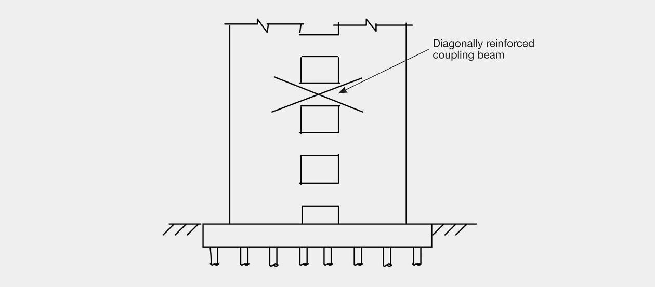
Figure 13: Coupled structural wall

3.4.5 Concentrically braced frames
Concentrically braced frames are used extensively in low-rise steel industrial buildings. Diagonal bracing spanning between adjacent columns transfers forces in the structure to the foundations.
Where a high lateral stiffness is required, for example in the retrofit of some masonry buildings, K braced frames (Figure 14) may be used.
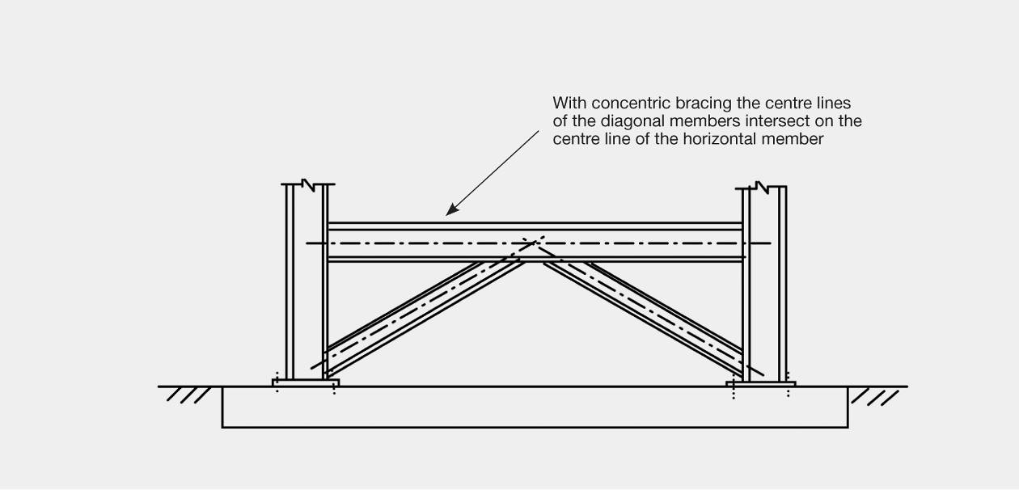
Figure 14: Concentrically braced frame

3.4.6 General building forms
Many buildings contain a mixture of the structural elements described above. A common form is to have a core of structural walls around the stairwells and liftshafts. These provide a high proportion of the lateral seismic resistance. Surrounding these walls are arrangements of columns and beams, which generally provide the resistance to gravity loads. They can also contribute as moment resisting frames to resist a portion of the lateral forces, particularly the resistance to torsional rotation. The beams and columns may be of reinforced concrete or structural steel.
Another very common arrangement is to use walls to resist seismic forces in one direction and moment resisting frames at right angles.

References
1. AS/NZS 1170.0:2002. Structural Design Actions Part 0: General Principles. Standards Australia/Standards New Zealand.
2. NZS 1170.5:2004. Structural Design Actions Part 5: Earthquake Actions – New Zealand. Standards New Zealand.
3. Cubrinovski, M. and McCahon, I. (2011 August). Foundations on Deep Alluvial Soils. Report to the Royal Commission of Inquiry into Building Failure Caused by the Canterbury Earthquakes.
4. Priestley M.J.N., Calvi G.M. and Kowalsky M.J. (2007). Displacement-based Seismic Design of Structures. Pavia: IUSS Press.

