Section 2:
Seismicity

The Canterbury earthquake sequence that began on 4 September 2010 was unusual in two respects. First, the intensity of shaking was unusually high and it occurred in a low-to-moderate zone of seismic activity. Second, the faults that ruptured were located close to and, in one case, passed through an urban area that contained an extensive array of instruments for measuring ground shaking.

2.1 Introduction
The earthquakes, which had tragic consequences, have yielded many valuable lessons for seismologists and geotechnical and structural engineers around the world. The detailed records of ground shaking are enabling seismologists to gain a unique insight into the mechanics of the types of earthquakes that occurred.
In Christchurch, there is a wide range of building types, from unreinforced masonry buildings to the most modern structures. The buildings are constructed predominantly on deep alluvial soils, but some are founded on rock. Recording and analysing this damage will give major insights into how these structures have performed and how we can improve the earthquake performance of buildings in New Zealand, but the lessons will be relevant worldwide.
These unusual features help to explain the widespread interest in the Canterbury earthquakes.

2.2 The Royal Commission’s approach
The Terms of Reference defining the scope of the first part of the Inquiry (into the representative sample of buildings) require the Royal Commission to investigate the various aspects of building failure, “having regard … to the nature and severity of the Canterbury earthquakes”. Accordingly, it was necessary for the Royal Commission to develop an understanding of the Canterbury earthquakes and the characteristics of the ground motions they caused.
The Terms of Reference for the second part of the Inquiry require the Royal Commission to consider the adequacy of the current legal and best practice requirements for the design, construction and maintenance of buildings in CBDs in New Zealand, to address the known risk of earthquakes. That specifically includes the extent to which the knowledge and measurement of seismic events have been used in setting legal and best practice requirements for earthquake risk management in respect to building design, construction and maintenance. These terms require the Royal Commission to understand the nature of the earthquake risk affecting cities throughout New Zealand and the means by which that risk is assessed and accounted for in building design. Further, we are required to make recommendations as to any measures necessary or desirable to prevent or minimise the failure of buildings in New Zealand and to make recommendations on matters that will inform early decision making on rebuilding and repair work that forms part of the recovery from the Canterbury earthquakes.
Taken together, these provisions in the Terms of Reference meant that it was necessary for us to obtain information about the forces that give rise to earthquakes in New Zealand, the faults on which they occur and the predicted frequency of recurrence. It was also necessary to understand the activity rates of faults that ruptured to cause the Canterbury earthquakes and how they contributed to the ongoing risk of earthquakes in the region.
To this end, we sought advice from GNS Science, New Zealand’s leading research organisation in the field of seismic hazards. They provided the report “The Canterbury Earthquake Sequence and Implications for Seismic Design Levels” (the GNS Science report), dated July 2011, in collaboration with Professor Jarg Pettinga of the University of Canterbury.¹ The report was published on the Royal Commission’s website in August 2011. It formed the basis of the Royal Commission’s understanding of the seismicity of New Zealand in general and Canterbury in particular. The hearing about these issues was held in October 2011, when four of the authors of the report gave evidence that further informed our understanding.²
Given the significance of seismicity to the Inquiry, and to ensure that the advice obtained reflected international understanding and best practice, the Royal Commission instructed two peer reviewers to consider the GNS Science report and advise the Royal Commission of their opinions on it. The reviewers were:
a) Ralph J Archuleta, Professor of Seismology, Department of Earth Science, University of California (Santa Barbara), and
b) Norman Abrahamson, Adjunct Professor of Civil Engineering, University of California (Berkeley).
Both provided written reviews that were published on the Royal Commission’s website and Professor Abrahamson also gave evidence at the hearing. In addition, eight submissions were received and considered by the Royal Commission.
Subsequent to the hearing, we sought further advice in relation to the nature of the Canterbury earthquakes from Dr. Brendon Bradley of the University of Canterbury. GNS Science provided additional advice by summarising the ongoing work and responding to the significant aftershocks that took place on 23 December 2011.
The Royal Commission’s understanding, based on the advice and evidence referred to above, is set out in the following discussion.

2.3 New Zealand’s tectonic setting
The earthquake and volcanic activity experienced in New Zealand results from the interaction between two tectonic plates known as the Pacific Plate and the Australian Plate. The tectonic plates are segments of the earth’s crust. The upper brittle part of the crust that hosts most of the earthquakes varies in thickness from 10–50km. The tectonic plates are in a state of continual movement relative to each other. At their edges they pull apart (in “rift” areas), slide past each other laterally (at a “strike-slip” plate boundary) or converge (“subduction” or “collision” areas).³
Most of the world’s earthquake and volcanic activity occurs along the boundaries of tectonic plates. The Pacific Plate is the largest and fastest-moving major tectonic plate. Its boundary, the Pacific Rim (sometimes referred to as the “ring of fire”), is characterised by both earthquake and volcanic activity.
New Zealand straddles the boundary zone between the Australian and Pacific Plates that are moving in relation to each other at 35–45mm per year. Figure 1 illustrates the tectonic plate setting of New Zealand.
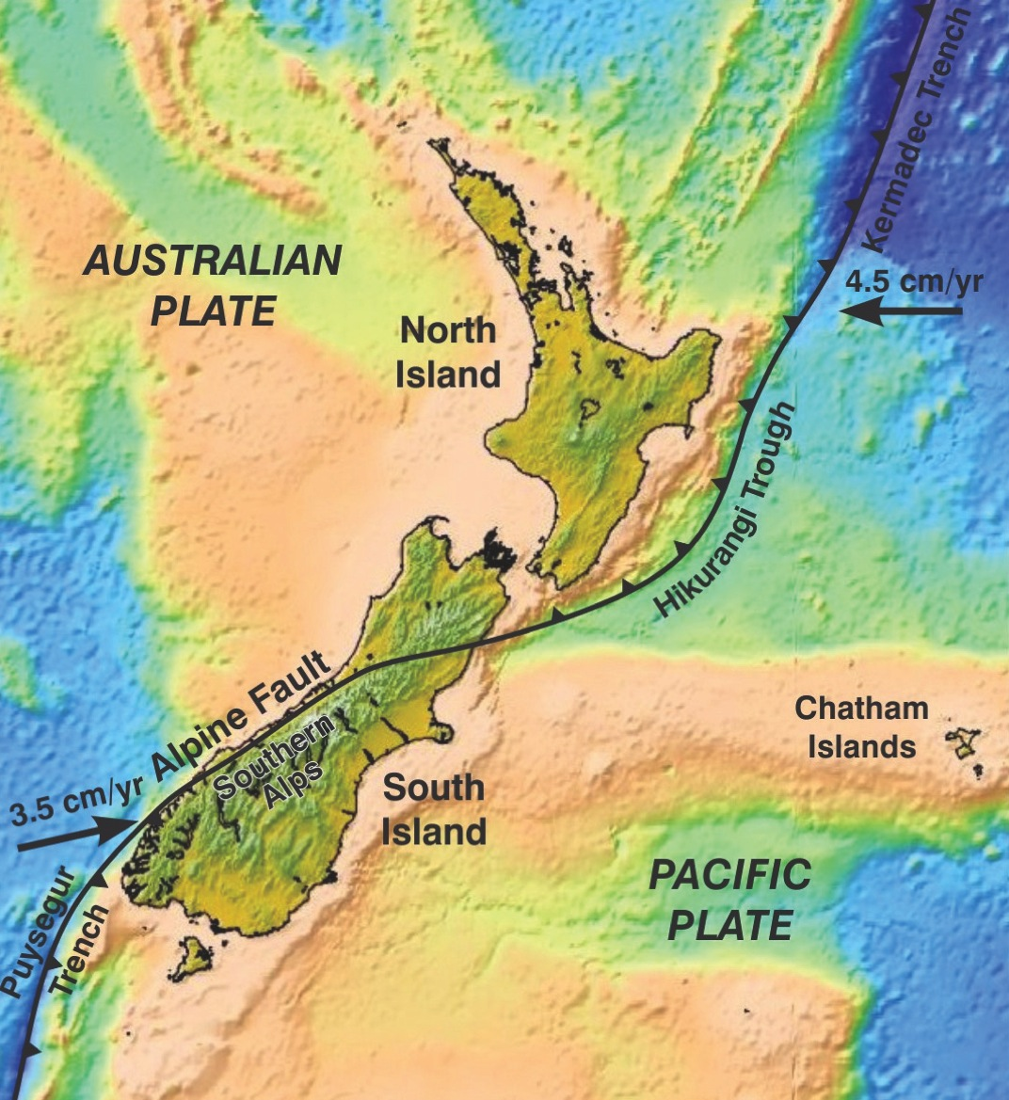
Figure 1: Plate tectonic setting of New Zealand (source: GNS Science report 2011/183, July 2011)
The west-pointing arrow in the upper right corner shows the movement of the Pacific Plate towards the Australian Plate in northern New Zealand, while the arrow pointing north-east in the lower left corner shows the movement of the Australian Plate relative to the Pacific Plate in southern New Zealand.
The plates are in collision in the North Island where the edge of the Pacific Plate “subducts” in a westerly direction under the North Island, offshore of the East Coast along the Hikurangi Trough. Subduction is also occurring off the coast of Fiordland, along the offshore Puysegur Trench where the Australian Plate subducts beneath the Pacific Plate.
In the central and northern parts of the South Island the crusts of the Pacific and Australian Plates are thick. This means that one plate cannot be driven under the other. The plates meet in what GNS Science calls a “glancing collision” and the plate boundary accommodates the movement of rock in the plates in two ways. One is by a sideways slip along the boundary; the other by an upward movement of the edge of the Pacific Plate. As a result of this phenomenon, the west coast of the South Island is moving in a north-easterly direction relative to the rest of the island, at a rate of about 30mm per year. The forced upward movement of the edge of the Pacific Plate has produced the Southern Alps in a process that has lasted millions of years. GPS measurements have been made from the 1990s to the present day; they show that most of the South Island is being continually contorted as it is forced south-west into the Australian Plate.
In the central South Island, about 75 per cent of the motion between the Australian and Pacific Plates occurs during major earthquakes along the Alpine Fault. However, to the east of the Alpine Fault the land is broken into a complex web of active geological faults. It is here that the remaining 25 per cent of plate motion occurs, through occasional earthquakes on these faults. It has been estimated that faults along the eastern foothills of the Southern Alps and within the Southern Alps themselves may accommodate up to 20 per cent of the plate boundary deformation.⁴ Similarly, it is estimated that about five per cent of the overall Pacific/Australian Plate motion is accommodated by the fault lines lying beneath the Canterbury plains. The average total movement of these faults is about 1–2mm per year.⁵
GNS Science advises that “it is inevitable that this steady build-up of ground deformation across the Canterbury plains will occasionally be released as earthquakes”.⁶
Satellite surveying over the last 15 years has enabled direct measurement of the deformation (or strain) occurring in New Zealand. This is illustrated in Figure 2, where the dark to red areas have the highest rates of deformation and the orange to yellow shaded areas have the lowest rates.
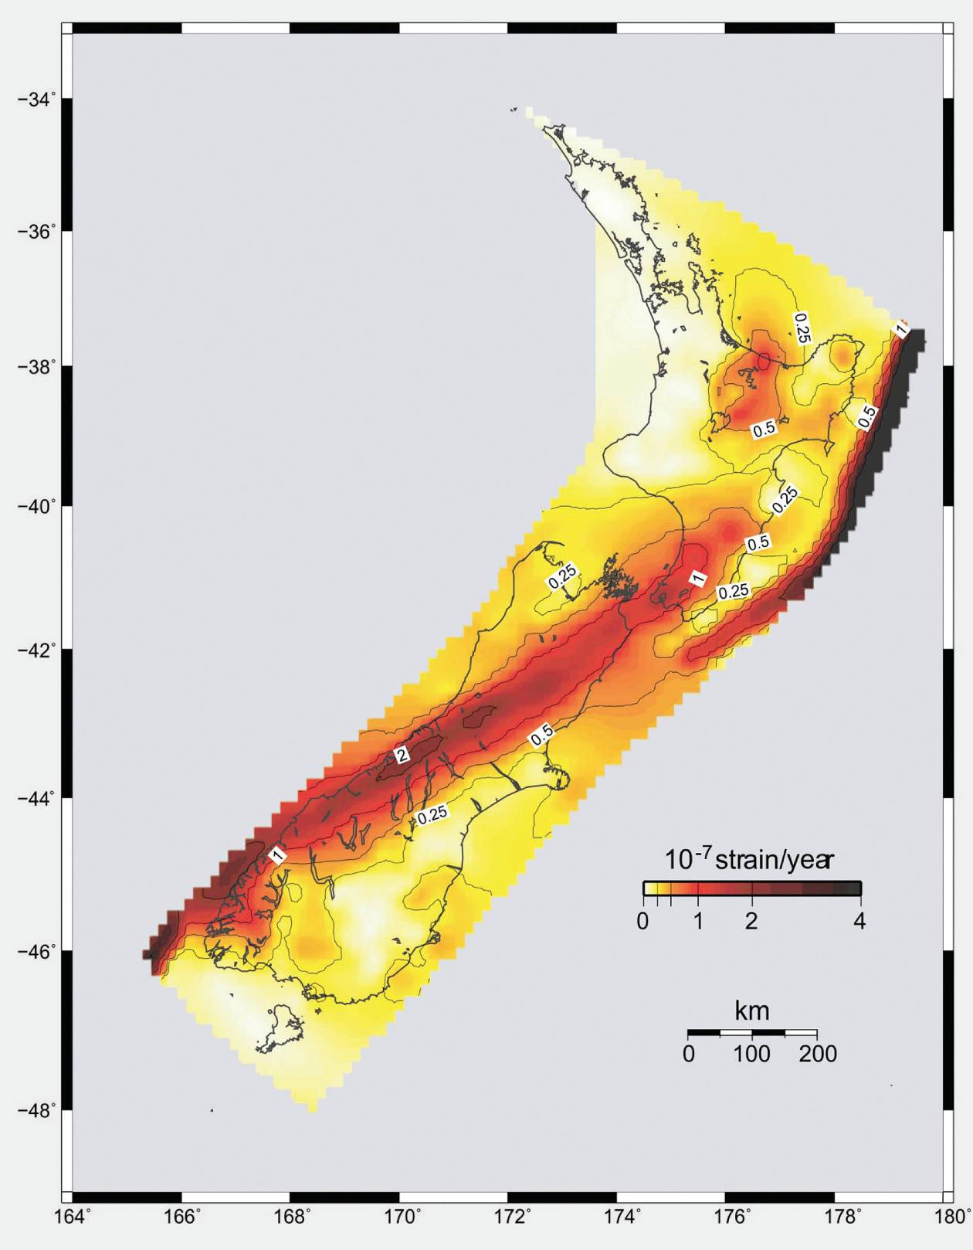
Figure 2: Deformation (strain) occurring in New Zealand (source: GNS Science report 2011/183, July 2011)

Over the last 15 years it has become possible to measure the deformation (strain) occurring in New Zealand directly by satellite surveying using GPS. The dark to red areas have the highest rates of deformation, while the land in the yellow to orange areas is deforming at relatively lower rates. Accumulation of strain in the New Zealand crust will eventually result in earthquakes, so areas with a high strain rate tend to have more earthquakes. Major faults such as the Alpine Fault have extremely high strain rates.
GNS Science observed in its report that the accumulation of strain in the New Zealand crust must eventually result in earthquakes, and those areas sustaining greater strain tend to have more earthquakes. There are extremely high strain rates at the location of major faults such as the Alpine Fault.

2.4 Faults
Faults are fractures in rock that result from compression, tension or shearing forces. They are associated with significant movement of the rock on one side of the fault relative to the other, and may be classified based on their orientation and relative movement or slip across the fault plane. Appendix 1 (Definition and Classification of Faults) in the GNS Science report defines and classifies faults on this basis and illustrates the different kinds of fault diagrammatically. This is reproduced as Figure 3 below.
Definition and classification of faults
Faults are rock fractures across which there has been significant movement of the block on one side relative to the other. Faults represent the response of the rock formations to compression, tension or shearing forces. They can be classified on the basis of their orientation and the relative movement or slip across the fault plane (Figure 3).
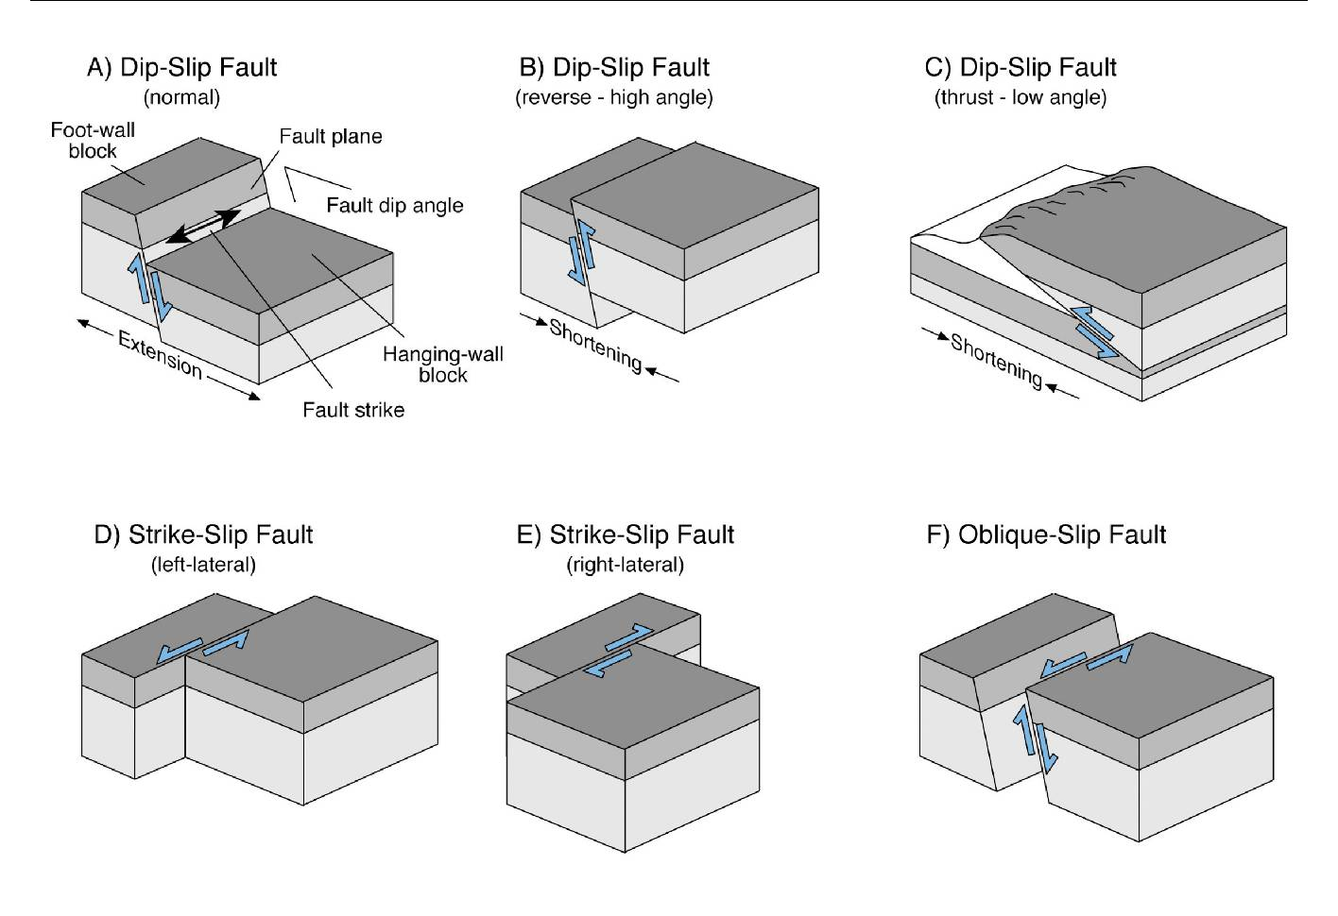

Figure 3: Fault classification and terminology: (a) to (c) dip-slip faulting; (d) and (e) horizontal or strike-slip faults; and (f) oblique-slip faulting. Other fault terminology is shown on block diagram (a). Figure modified from Pettinga et al. (2001)⁷
Dip-slip faults are those in which the relative movement of one side to the other is parallel to the direction of the inclination (the dip) of the fault (Figures 3A, 3B, 3C). If the upper block (hanging wall) above the fault plane has moved down the fault plane then the fault is called a normal fault, and if the upper block has moved up the fault plane it is called a reverse fault. When a fault plane has a shallow angle of slip (less than 45º) and the upper block has moved up the fault plane, it is called a thrust fault. Normal faults form in areas where the crust is being pulled apart, while reverse and thrust faults form in areas that are being compressed.
Strike-slip or lateral faults are defined by horizontal movement parallel to the line of the fault plane (Figure 3D). Strike-slip faults are often vertical, and movement is described as right-lateral or left- lateral, based on the relative direction of movement of the ground on one side of the fault to the other. Oblique-slip faults occur where relative movement across the fault includes both horizontal and vertical slip (Figure 3F).
A fault trace is the line where a fault intersects the ground surface and may be recognised by a displacement of ground surface. If one side of the fault rises above the level of the other side, it may form a step-like linear fault scarp. Visible fault traces and fault scarps indicate that movement along the fault has been geographically recent.
A fault strand is an individual fault of a set of closely spaced, sub-parallel faults, while a fault splay is a subsidiary fault that diverges from a more prominent fault. Fault splays are common near the ends of major faults.
The term slip rate is used to refer to the average rate of displacement at a point along a fault. The slip rate is determined from offset geologic features whose age can be estimated. It is measured parallel to the dominant slip direction or estimated from the surveyed vertical or horizontal separation of geological markers in the field.⁸

2.4.1 Other terms used to characterise faults
The terms “shallow”, “deep” and “blind” are also used to characterise faults. The first two are reasonably self-explanatory and simply refer to the depth of the fault beneath the surface. The depth of the rupturing fault will be one of the factors that contribute to the felt magnitude of the earthquake. Depending on the nature of the subsurface ground, a rupture that occurs near the surface will be felt more strongly than a rupture having an equivalent energy release and other characteristics seated deeper beneath the surface.
A blind fault is one that has no surface expression and its presence is therefore difficult to identify.

2.5 Active faults in the Canterbury region
There are four major types of rock formation in the Canterbury region. The deepest and oldest layer, which underlies the others, is made of hardened sandstones and mudstones, commonly referred to as “greywacke”. Originally the New Zealand land mass was a part of the super continent of Gondwana, from which it split about 85 million years ago. The greywacke had been deposited and deformed before the split occurred. As New Zealand moved away from Gondwana, the land eroded and subsided. In the period 80–25 million years ago, terrestrial and marine sediments were deposited on the eroded surface of the greywacke basement rocks. Subsequently, more marine sediments were deposited and volcanic eruptions resulted in the formation of Banks Peninsula in the period of 11–6 million years ago. During the last two million years, as ice age glaciers advanced and receded on numerous occasions, rivers flowing from the rising Southern Alps buried the underlying rocks of the Canterbury plains under alluvial gravels typically ranging in thickness from 200–600m.
As New Zealand parted from Gondwana its basement rocks were pulled apart. They developed a system of faults that extended through the basement greywacke and into the layers above. They remain beneath both the Canterbury plains and Banks Peninsula today.
There is a summary description of the tectonic structure of the Canterbury region in Appendix 2 of the GNS Science report, which we have reproduced as Annex 1. The summary description of the tectonic structure of the Canterbury region describes eight structural domains shown in Figure 22.
The Alpine Fault runs down the western side of the Southern Alps and is about 650km in length. At the hearing, Professor Pettinga illustrated its location and those of other active faults¹⁰ in the South Island by referring to Figure 4.

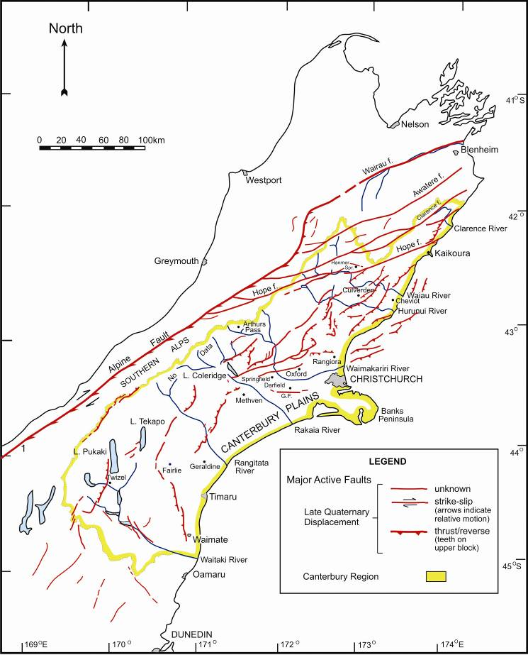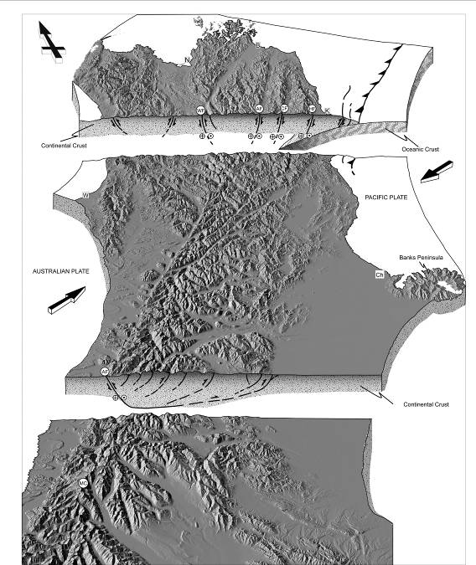
Canterbury has many active faults that contribute to the earthquake hazard.
Figure 4: Faulting and the earthquake-driven landscape (source: Evidence to the Royal Commission by Professor Pettinga, University of Canterbury, October 2011)

This figure was prepared in 1998 as part of a regional study for the Canterbury Regional Council and reflected work carried out by the University of Canterbury and others (including GNS Science) in the period since 1987. The study established that there were more than 100 active faults in the Canterbury region capable of generating large earthquakes. Before this, only eight active faults had been documented in the region.
Those faults include the Hope Fault, which is about 220km long and extends from Kaikoura through Hanmer Springs to the West Coast, where it links into the Alpine Fault at a point south-east of Greymouth. It is divided into a series of individual segments, each of which is capable of generating large earthquakes. Another significant fault is in the 40km long (as exposed in the surface) Porter’s Pass-Amberley Fault Zone, which has ruptured at least five times at comparatively regular intervals over the last 10,000 years. In his evidence, Professor Pettinga referred to estimates that the fault is capable of generating earthquakes of up to magnitude 7.5. The GNS Science report and Professor Pettinga also referred to other faults located to the east and south-east of the Porter’s Pass-Amberley Fault Zone, including the Ashley Fault north of Rangiora, the Hororata Fault and the Springbank Fault, all roughly to the north-west of Christchurch.
In his evidence, Professor Pettinga emphasised that:
• the plate boundary zone in the South Island is between 150–200km wide, resulting in earthquake activity in much of the island;
• the nature of the collision of the continental plate crusts in the central part of the Island results in relatively shallow earthquakes, which are typically the most damaging kind; and
• the thickness of the layer of alluvial gravels beneath the surface of the Canterbury Plains means that there are faults whose existence is masked and it is very difficult to ascertain whether or not they are active.
The 4 September and 26 December 2010 (Boxing Day) and 22 February, 13 June and 23 December 2011 earthquakes all occurred on faults that had not previously been known to exist. The GNS Science report commented that because the gravels remained largely undisturbed until the September earthquake,
…it can be inferred that movements along the inherited faults under the Canterbury Plains causing large earthquakes are generally rare and separated in time by long periods of quiescence extending over thousands of years.¹¹
The September, Boxing Day and February earthquakes highlighted the fact that there remain significant gaps in the knowledge of the subsurface geology of the region. Professor Pettinga explained the particular challenges that existed in Canterbury because of the thickness of the Canterbury plains’ gravel layer and its potential to mask fault activity, leading to a lack of evidence about whether or not the faults were active. In an attempt to increase the extent of knowledge about seismic reflection, several surveys were undertaken in areas that have been associated with very extensive aftershock activity. They included the eastern side of Lyttelton Harbour to the north (encompassing much of the Pegasus Bay area), the area between the Christchurch Central Business District (CBD) and New Brighton Beach, and in the area between the eastern end of the Greendale Fault (that ruptured on 4 September 2010) and the Port Hills Fault (that ruptured on 22 February 2011). A specially designed vehicle under contract from the University of Calgary in Canada was used to carry out the land-based survey work. The survey involved transmitting vibrations into the ground through the different geologic strata and recording the reflected signal by a series of geophone lines (sensors) laid out on and connected to the ground. This information was then captured in a recording system to be analysed later. The surveys targeted the top two kilometres of the subsurface because displacements of strata extending up towards the ground might indicate that there had previously been significant and relatively recent earthquake events. Equipment deployed on a marine survey vessel was used by the National Institute of Water and Atmospheric Research (NIWA) to survey in Pegasus Bay. The vessel towed a long PVC tube containing hydrophones and sent a sound signal down over the stern of the ship. The hydrophones collected the reflected signals coming up from beneath the floor of the sea.
In addition to the seismic reflection surveys, data gathered locating the hypocentres (the hypocentre is the point of origin of the rupture beneath the surface. The epicentre is the point on the surface above the hypocentre) of aftershocks have also contributed to the knowledge about the location and extent of the active faults. The location of part of the Greendale Fault is now visible on the surface. The onshore and offshore investigations carried out since the earthquake sequence began have revealed a number of hidden active faults, based on aftershock patterns and seismic reflection surveys. It is important that such survey work be carried out to increase understanding of the number, location and extent of the active faults. It must be accepted, however, that it is unlikely that currently available investigative techniques would be able to build up a complete picture, as the subsurface conditions militate against that.
Professor Pettinga illustrated the location of known active faults at the time of the hearing in the following figures. The first, Figure 5, shows the known active faults in and near Christchurch as at October 2011. The second, Figure 6, shows the known active faults in Pegasus Bay.
Professor Pettinga concluded that there does not appear to be a single fault extending through the ground beneath Christchurch. Rather, it is now known that there are a number of active faults under and near the city, including the Greendale Fault, the Port Hills Fault and the faults that ruptured on Boxing Day 2010 and 13 June 2011. Since the hearing, there has also been the significant earthquake that occurred on 23 December 2011, with its epicentre about six kilometres off the coast of New Brighton.
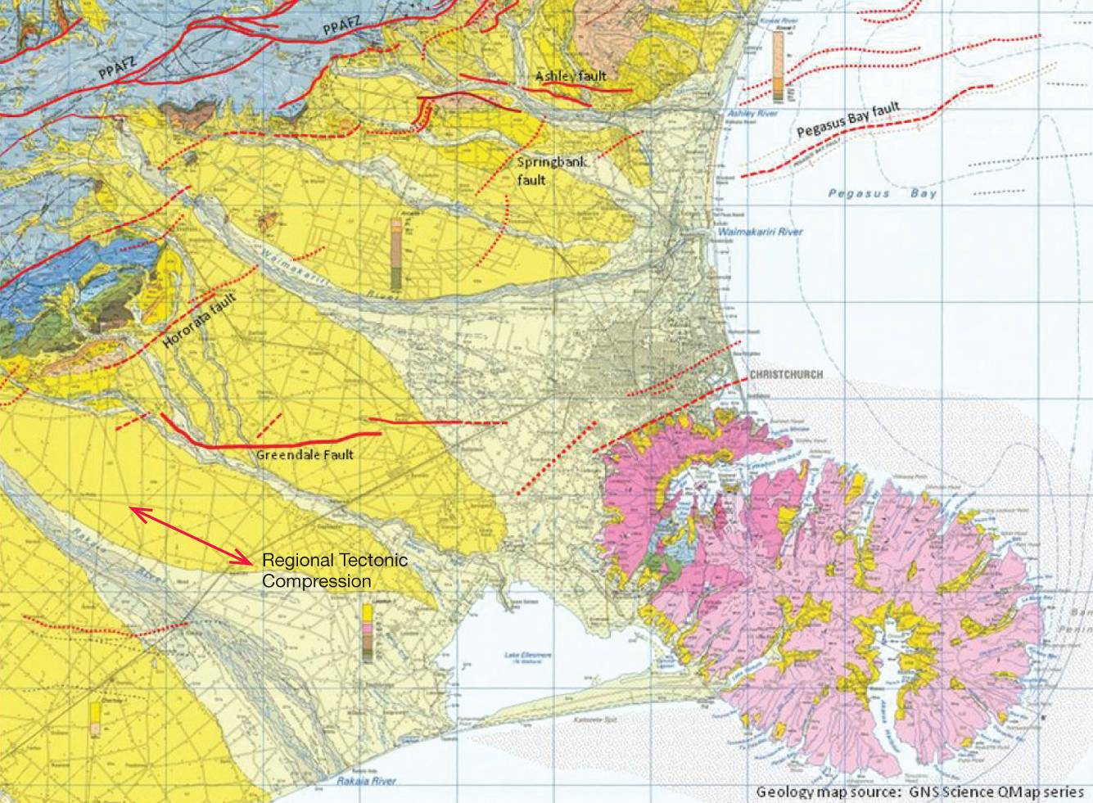
Figure 5: Known active faults in and near Christchurch, as at October 2011 (source: Evidence to the Royal Commission by Professor Pettinga, University of Canterbury, October 2011)
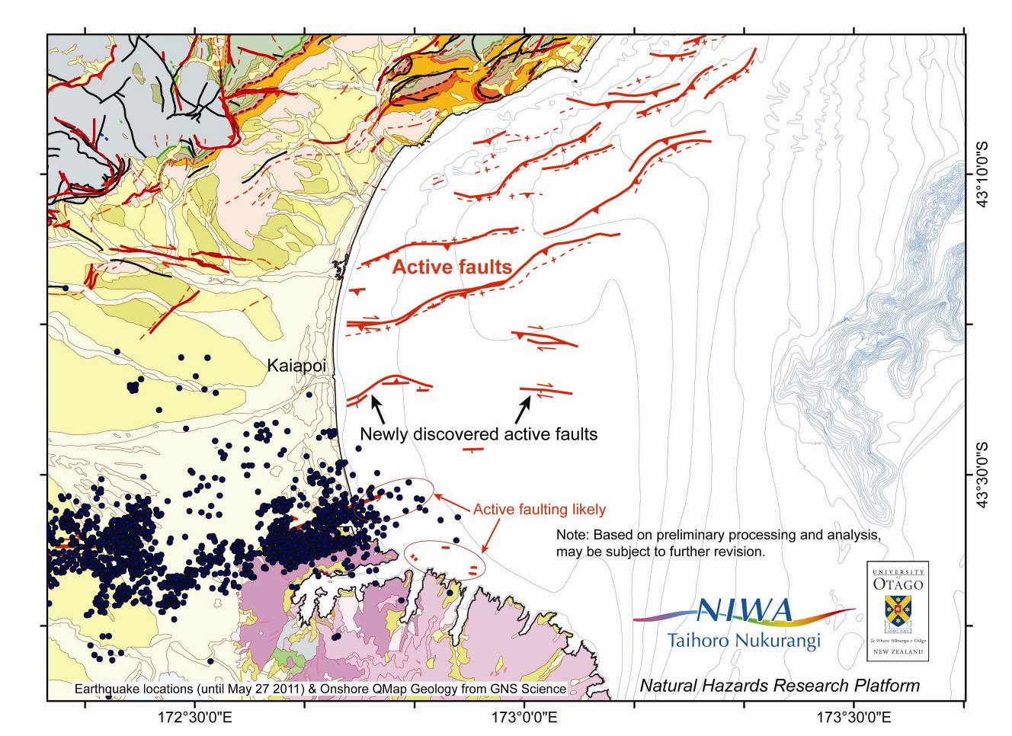
Figure 6: Known active faults in Pegasus Bay (source: Evidence to the Royal Commission by Professor Pettinga, University of Canterbury, October 2011, data courtesy of P. Barnes, NIWA)

