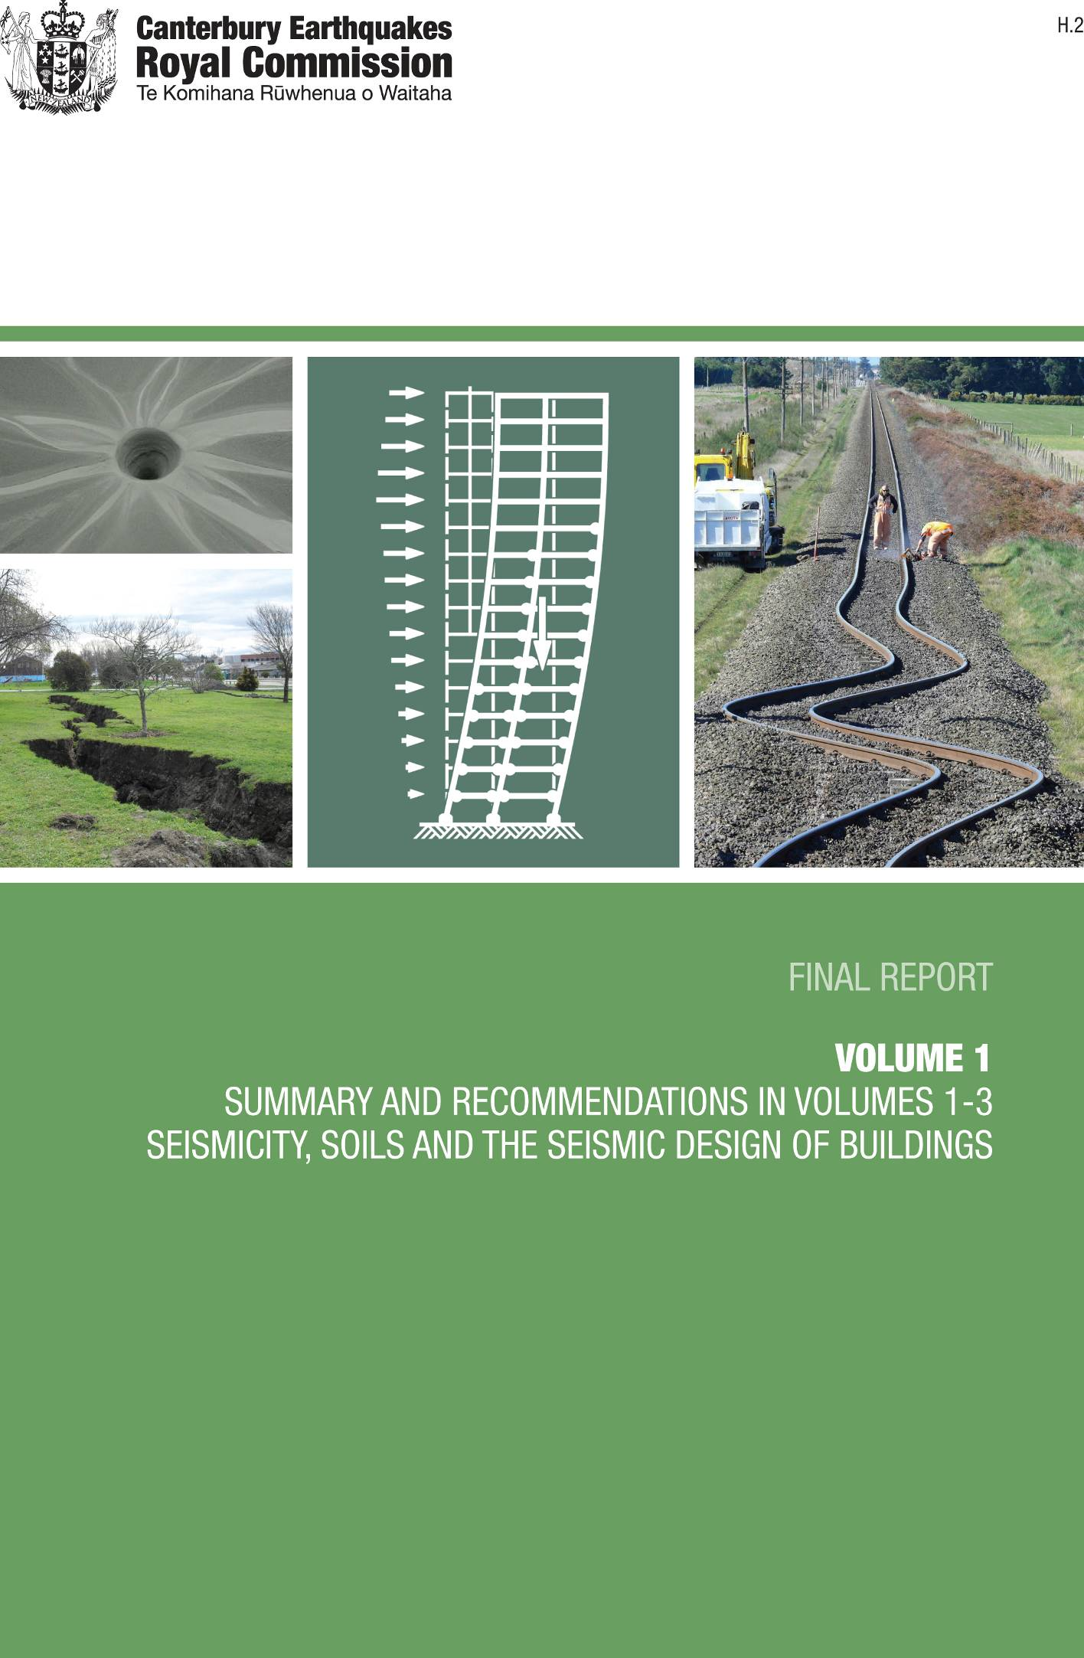
A. Silt crater resulting from liquefaction after the 22 February 2011 earthquake (source: George Kuek)
B. Rupture in a Christchurch park as the result of the 4 September 2010 earthquake (source: Ministry of Civil Defence & Emergency Management)
C. Past experiences and research into the response of structures during severe earthquakes has led to significant advances in guidance for the analysis and design of buildings. This image is sourced from the text ‘Seismic Design of Reinforced Concrete and Masonry Buildings’, which is a publication by leading New Zealand earthquake engineers Thomas Paulay and Nigel Priestley
D. Earthquake shockwaves preserved in rail tracks (source: Ministry of Civil Defence & Emergency Management)

ISBN: 978-0-478-39562-4
(Final Report in Word)
ISBN: 978-0-478-39563-1
(Volume 1 in Word)

Canterbury Earthquakes

Royal Commission

PO Box 14053
Christchurch Mail Centre 8544
Christchurch
New Zealand
0800 337 468
+64 3 741 3000
canterbury@royalcommission.govt.nz

Letter of Transmittal

To His Excellency, Lieutenant General The Right Honourable Sir Jerry Mateparae GNZM, QSO Governor-General of New Zealand

Your Excellency

Pursuant to the Orders in Council dated 11 April 2011 and 7 February 2012 appointing us to be a Royal Commission of Inquiry into Building Failure caused by the Canterbury Earthquakes and to provide a Final Report not later than 12 November 2012, with a first part delivered by 29 June 2012, we now humbly submit the first part of our Final Report for Your Excellency’s consideration.
We have the honour to be

Your Excellency’s most obedient servants

Hon Justice Mark Cooper (Chairperson)

Sir Ronald Carter

Adjunct Associate Professor Richard Fenwick

Dated at Wellington this 29th day of June 2012.

Contents

Letter of transmittal
Introduction
Section 1: Summary and recommendations – Volumes 1–3
Section 2: Seismicity
2.1 Introduction
2.2 The Royal Commission’s approach
2.3 New Zealand’s tectonic setting
2.4 Faults
2.5 Active faults in the Canterbury region
2.6 Earthquakes
2.7 The Canterbury earthquakes
2.8 The New Zealand National Seismic Hazard Model
2.9 Conclusions
Annex 1: Tectonic structure of the Canterbury region
Section 3: Introduction to the seismic design of buildings
3.1 Structural actions
3.2 Seismic design of buildings
3.3 Analysis of seismic actions
3.4 Different structural forms in buildings
Section 4: Soils and foundations
4.1 Introduction
4.2 Expert advice
4.3 Canterbury soils
4.4 Soils in the Christchurch CBD
4.5 Role of soils in an earthquake
4.6 Soil liquefaction and lateral spreading
4.7 Damage to structures
4.8 Impact of Alpine Fault rupture
4.9 Canterbury earthquakes: performance of foundations
4.10 Seismic design and construction of building foundations
in CBDs of New Zealand cities
Appendix 1: Terms of Reference

Appendix 2: Expert advisers

Appendix 3: Submitters and witnesses

Appendix 4: Glossary of terms

Introduction

On 4 September 2010, at 4:35am, an earthquake of magnitude 7.1 struck Christchurch and the surrounding Canterbury region. The earthquake had an epicentre near Darfield, a small town about 40km west of the Christchurch Central Business District. An aftershock sequence began, which at the time of writing is ongoing. All of the earthquakes were the result of ruptures on faults not known to be active prior to the September event.
The early morning timing of the September earthquake and the rural location of its epicentre no doubt prevented fatalities. However, many unreinforced masonry buildings were damaged and there was extensive damage to infrastructure. The eastern suburbs of Christchurch and Kaiapoi were seriously affected by liquefaction and lateral spreading of the ground.
The September earthquake was followed by four other major earthquakes occurring on Boxing Day 2010, and 22 February, 13 June and 23 December 2011. Of these, the event on 22 February was by far the most serious, resulting in 185 deaths. It led to the establishment on 11 April 2011 of this Royal Commission of Inquiry into Building Failure Caused by the Canterbury Earthquakes.

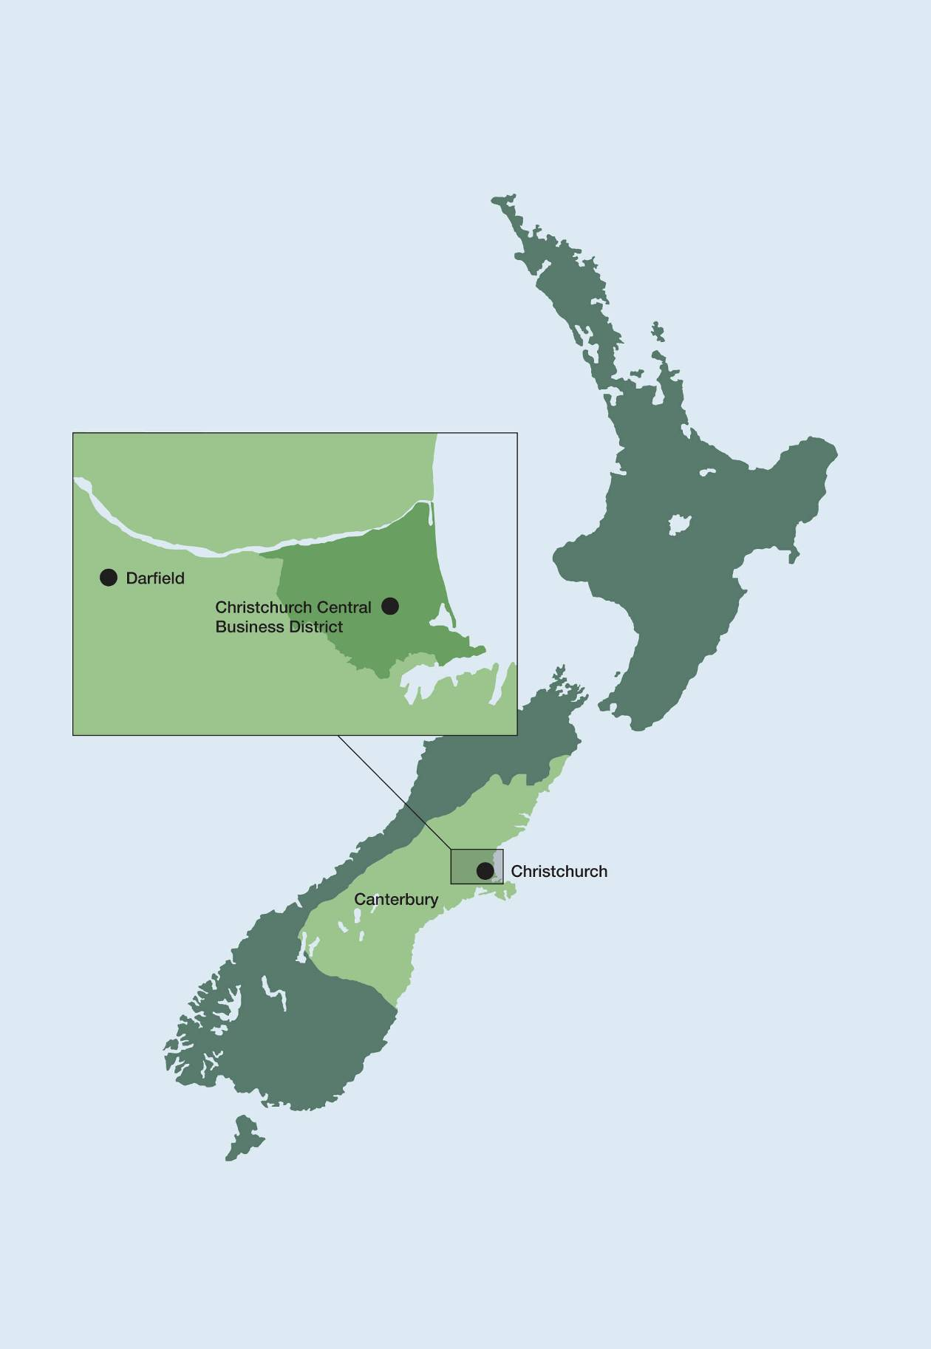

Map of New Zealand showing Canterbury region
The February earthquake struck on a Tuesday, at 12:51pm. The centre of Christchurch was full of people going about their business in New Zealand’s second largest city and there were many tourists. The earthquake had a magnitude of 6.2. The fault that ruptured was at a shallow depth and had an epicentre in the Port Hills, just to the south of Christchurch. The earthquake had devastating consequences. Two buildings collapsed catastrophically, the Canterbury Television (CTV) and Pyne Gould Corporation (PGC) buildings, where respectively 115 and 18 people lost their lives and others were seriously injured. Failure of other buildings caused the deaths of 42 people and again resulted in many injuries. Ten people lost their lives for reasons not related to building failure, including rock falls. Of those killed, 77 were foreign nationals.
As a result of the earthquakes, the CBD was also altered irrevocably. At the time of writing, in May 2012, the Canterbury Earthquake Recovery Authority (CERA) estimated that there had been 655 building demolitions in the CBD, with a further 100 under way. It was projected that the total number of demolitions would be about 1100. This has had a huge economic impact, but there has also been a great social and cultural cost in terms of the loss of historic buildings and cultural facilities.
The Royal Commission’s Terms of Reference are set out in Appendix 1. They mandate an inquiry in two broad parts. The first concerns the performance in the earthquakes of a representative sample of buildings in the Christchurch CBD, bound by Bealey, Fitzgerald, Moorhouse, Deans and Harper Avenues. The second is about the adequacy of the current legal and best-practice requirements for design, construction and maintenance of buildings in central business districts in New Zealand to address the known risk of earthquakes. The Terms of Reference provide that the Royal Commission must make recommendations upon or for:
(a) any measures necessary or desirable to prevent or minimise the failure of buildings in New Zealand due to earthquakes likely to occur during the lifetime of those buildings; and
(b) the cost of those measures; and
(c) the adequacy of legal and best-practice requirements for building design, construction, and maintenance insofar as those requirements apply to managing risks of building failure caused by earthquakes.
Some matters were specifically excluded from the inquiry. They included the role and response of those acting under the Civil Defence Emergency Management Act 2002 or providing any emergency or recovery services or other response, after the February earthquake. Also excluded were matters that are the responsibility of other agencies or bodies, “such as the design, planning, or options for rebuilding in the Christchurch CBD”.
As required by the Terms of Reference, the Royal Commission provided an Interim Report to the Governor-General in October 2011. In accordance with the Terms, the Interim Report included recommendations intended to inform early decision making and repair work that would form part of the recovery from the earthquakes.
We were unable, however, to comply with the instruction in the Terms of Reference that the Final Report be provided not later than 11 April 2012, and in February 2012 the Terms were modified to instruct us to report and make final recommendations:
(a) not later than 29 June 2012, on matters that will inform early decision making on rebuilding and repair work that forms part of the recovery from the earthquakes; and
(b) at any time before 12 November 2012 on any other matter, if we are able to do so; and
(c) not later than 12 November 2012, on all matters on which we have not otherwise reported.
The Modifications to the Terms of Reference are set out in Appendix 1.
This change meant that we are able to provide our Final Report in stages, and to make recommendations on matters particularly relevant to the redevelopment of the Christchurch CBD at an earlier stage than would otherwise have been the case.
This first part of the Royal Commission’s Final Report is in three Volumes. They are:
Volume 1: which gathers together the recommendations made in all three Volumes, and also includes discussion of seismicity, the seismic design of buildings, soils and geotechnical considerations.
Volume 2: which covers the representative sample of buildings, excluding the CTV building and earthquake-prone buildings.
Volume 3: which discusses engineering technologies available to reduce earthquake damage to buildings.
The content of these volumes focuses on some matters that are relevant to the inquiry as a whole (seismicity and the seismic design of buildings) as well as issues particularly relevant to the rebuild of Christchurch (the geotechnical issues discussed in Volume 1, the conclusions and recommendations in Volume 2 and the discussion of low-damage technologies in Volume 3). Volume 2 contains our findings on the representative sample of buildings, with the exception of the CTV building and earthquake-prone buildings. Those subjects will be addressed in subsequent volumes, as will the other issues on which we are required to report.
It is appropriate to make here some general observations that we consider justified by the detailed discussion set out in these volumes. First, the September and February earthquakes were events likely to have long recurrence intervals, in each case greater than 8000 years. Second, the February earthquake tested the resilience of normal commercial buildings to an extent beyond the levels of shaking used for the purposes of design in current New Zealand Standards.
As noted in our Interim Report, and repeated in Volume 2 of this Report, there is an urgent need to reconsider the design of stairs in multi-storey buildings so as to avoid a repeat of the collapses that occurred in the Forsyth Barr, Hotel Grand Chancellor and other buildings. Those collapses could have had tragic consequences, and it is very fortunate that they did not lead to loss of life. They point to the need to ensure to the extent possible that means of egress from buildings remain available for use after an earthquake. We are aware that the Department of Building and Housing (DBH) has already taken action on this subject. Otherwise, with the exception of the CTV and PGC buildings, modern commercial buildings generally performed in accordance with the key objective of life- safety set by the Building Code.
We have concluded that confidence is justified in the current processes by which earthquake risk in New Zealand is assessed and translated into the provisions of the relevant Standards used for the purposes of building design. We are satisfied that there is no need to change the existing process for setting the “z” value that plays a crucial role in the design of buildings for earthquake resistance. For reasons addressed in Volume 2, we conclude that the construction costs do not appear to increase significantly with increases in the seismic design factor of the magnitude that has occurred (or may be contemplated) in Christchurch. Further, it would not be sensible, in our opinion, to conclude that the performance of buildings in the February earthquake demonstrates a need for wholesale change.
There are nevertheless aspects of current design practices and Standards that can and should be enhanced, and these are the subject of particular recommendations that we make. We have not been able to specifically verify the cost increment resulting from the recommendations we make because the costs will depend to a significant degree on the design of individual buildings and the soil conditions of the site. However, we consider they are necessary to address or mitigate what we have observed from the earthquakes. We have also identified a need for further research into some of the problems that we discuss. But we consider that the objective should be incremental improvement, rather than a change of direction, and the necessary improvements can be incorporated within the framework of the present rules.
There is no doubt that the economic, social and cultural consequences of the earthquakes have been very severe. There is also no doubt that design approaches to mitigate damage should be adopted where it is economically feasible to do so. It is for that reason that we have dealt with the low-damage technologies discussed in Volume 3. However, once the objective of life-safety is achieved, the question of the extent to which buildings should be designed to avoid damage is a social and economic one, and the answer depends on choices that society as a whole must make.
The Terms of Reference require the consideration of “best-practice requirements for the design, construction and maintenance of buildings”, and do not embrace broader societal issues and the decisions that will need to be made in rebuilding the Christchurch CBD. In the circumstances, our concept of “best practice” is one that reflects the existing objective of life-safety, and looks to ensure that building damage is minimised within the limits established by the existing knowledge about earthquake risk and our understanding of the cost implications of more onerous requirements. Any other approach would be a radical change that we do not consider would be justified by the experience of the Canterbury earthquakes.

Section 1:
Summary and recommendations – Volumes 1–3

Volume 1: Seismicity, soils and the seismic design of buildings

Section 2: Seismicity
In this section the Royal Commission discusses the forces giving rise to earthquakes in New Zealand generally, and the active faults in the Canterbury region. We refer to earthquakes that have occurred historically and describe the nature and characteristics of the Canterbury earthquakes. We describe the New Zealand National Seismic Hazard Model and alterations that have been made to the model, noting in particular the way in which GNS Science has responded to the implications of the Canterbury earthquakes.
The Royal Commission considers that confidence is justified in the knowledge and expertise of GNS Science with respect to the seismicity of New Zealand. The way in which the knowledge of earthquake risk is reflected in the ongoing development of building standards is appropriate.

Recommendations
We recommend that:
1. Research continues into the location of active faults near Christchurch and other population centres in New Zealand, to build as complete a picture as possible for cities and major towns.
2. The provisions of the Earthquake Actions Standard, NZS 1170.5, relating to vertical accelerations be reviewed. (See also recommendations 33 and 34 below.)

Section 3: Introduction to the seismic design of buildings
This section outlines the concepts, theory and methods of practice used to design buildings that can withstand earthquakes.
There are no recommendations associated with this section.

Section 4: Soils and foundations
The soils in the Christchurch CBD, being highly variable both horizontally and vertically across short distances, pose challenges for the design of structures and their foundations to withstand the potential impact of future large earthquakes. The Royal Commission considers that there must be greater focus on geotechnical investigations to reduce the risk of unsatisfactory foundation performance.
Tonkin and Taylor, for the Christchurch City Council (CCC), evaluated the nature and variability of subsurface conditions in the Christchurch CBD and adjacent commercial areas to the south and north-east. This will be held in a database available to the public. This information will be of assistance in assessing the potential need for land improvement, in the selection of appropriate foundation types, and in the planning of detailed investigation of foundation soils.
We make detailed recommendations in respect of site investigations, ground improvement and foundations design. Some recommendations are of particular relevance in the Christchurch CBD but many are of wider application.

Recommendations
We recommend that:
Geotechnical considerations
3. A thorough and detailed geotechnical investigation of each building site, leading to development of a full site model, should be recognised as a key requirement for achieving good foundation performance.
4. There should be greater focus on geotechnical investigations to reduce the risk of unsatisfactory foundation performance. The Department of Building and Housing should lead the development of guidelines to ensure a more uniform standard for future investigations and as an aid to engineers and owners.
5. Geotechnical site reports and foundation design details should be kept on each property file by the territorial authority and made available for neighbouring site assessments by geotechnical engineers.
6. The Christchurch City Council should develop and maintain a publicly available database of information about the subsurface conditions in the Christchurch CBD, building on the information provided in the Tonkin and Taylor report. Other territorial authorities should consider developing and maintaining similar databases of their own.
7. Greater use should be made of in situ testing of soil properties by the cone penetrometer test (CPT), standard penetration test (SPT) or other appropriate methods.
8. The Department of Building and Housing should work with the New Zealand Geotechnical Society to update the existing guidelines for assessing liquefaction hazard to include new information and draw on experience from the Christchurch earthquakes.
9. Further research should be conducted into the performance of building foundations in the Christchurch CBD, including subsurface investigations as necessary, to better inform future practice.
Foundation loadings and design philosophy
Serviceability limit state (SLS)
10. Where liquefaction or significant softening may occur at a site for the SLS earthquake, buildings should be founded on well-engineered deep piles or on shallow foundations after well-engineered ground improvement is carried out.
11. Conservative assumptions should be made for soil parameters when assessing settlements for the SLS.
Ultimate limit state (ULS)
12. Foundation deformations should be assessed for the ULS load cases and overstrength actions, not just foundation strength (capacity). Deformations should not add unduly to the ductility demand of the structure or prevent the intended structural response.
13. Guidelines for acceptable levels of foundation deformation for the ULS and overstrength load cases should be developed. The Department of Building and Housing should lead this process.
Strength-reduction factors
14. The concessional strength-reduction factors in B1/VM4 for load cases involving earthquake load combinations and overstrength actions (_{g} = 0.8–0.9) should be reassessed.
15. The strength-reduction factors in B1/VM4 should be revised to reflect international best practice including considerations of risk and reliability.
16. For shallow foundations, soil yielding should be avoided under lateral loading by applying appropriate strength-reduction factors.
17. For deep pile foundations, soil yielding should be permitted under lateral loading, provided that the piles have sufficient flexibility and ductility to accommodate the resulting displacements. In such cases, strength- reduction factors need not be applied.
Shallow foundation design
18. The Department of Building and Housing should lead the development of detailed guidelines to address the design and use of shallow foundations.
19. The Department of Building and Housing should lead the development of more detailed guidance for designers regarding acceptable foundation deformations for the ultimate limit state (ULS).
20. Shallow foundations should be designed to resist the maximum design base shear of the building, so as to prevent sliding. Strength- reduction factors should be used.
Ground improvement
21. The performance of ground improvement in Christchurch should be the subject of further research to better understand the reasons for observed variability in performance.
22. Ground improvement, where used, should be considered as part of the foundation system of a building and reliability factors included in the design procedures.
23. Ground-improvement techniques used as part of the foundation system for a multi-storey building should have a proven performance in earthquake case studies.
24. The Department of Building and Housing should consider the desirability of preparing national guidelines specifying design procedures for ground improvement, to provide more uniformity in approach and outcomes.
Deep foundation design
25. Detailed guidelines for deep foundation design should be prepared to assist engineers and to provide more uniformity in practice. The Department of Building and Housing should lead this process.
Driven piles
26. Because driven piles have significant advantages over other pile types for reducing settlements in earthquake-resistant design, building consent authorities should allow driven piles to be used in urban settings where practical.
Kinematic effects
27. Where there is a risk of significant liquefaction, deep piles should be designed to accommodate an appropriate level of lateral movement of the surface crust even when they are far from any watercourse.
Lateral loading
28. Base friction should not be included as a mechanism for lateral load transfer between the ground and the building when it is supported on deep piles.
29. If reliance is to be placed on passive resistance of downstand beams and other vertical building faces, a realistic appraisal of the relative stiffness of the load-displacement response of the passive resistance compared to the pile resistance should be made.
30. For buildings on deep piles, it is not essential that the calculated lateral capacity of the foundations should exceed the design base shear at the ULS, provided that the piles have sufficient flexibility and ductility to accommodate the resulting yield displacement and kinematic displacements.
31. There are major problems in the use of inclined piles where significant ground lateral movements may occur. Where the use of inclined piles is considered, the kinematic effects that may generate very large axial loads that could overload the pile and damage other parts of the structure connected to the pile should be considered.

Volume 2: The performance of Christchurch CBD buildings
In this Volume we address the representative sample of buildings and lessons that can be learned from the performance of those buildings in the Canterbury earthquakes. We recommend that a number of changes be made to design practices and Standards to enhance the ability of buildings to resist earthquakes. In some cases, we have identified the need for further research. The rationale behind these recommendations is in section 9 of Volume 2.

Recommendations
We recommend that:
Recommendations related to the Earthquake Actions Standard, NZS 1170.5
32. The response spectral shape factor, C(T), for deep alluvial soils under Christchurch, should be revised. The likely change in spectral shape with earthquakes on more distant faults also needs to be considered.
33. The shape of response spectra for vertical ground motion should be revised.
34. The implications of vertical ground motion for seismic design actions should be considered and locations identified where high vertical accelerations may be expected in earthquakes.
35. The requirements for regularity in buildings, and for torsion due to the distance between the centre of mass and the centres of stiffness and strength, should be revised to recognise the implications of these parameters on observed behaviour.
36. Design actions for floors acting as diaphragms need to be more clearly identified in the Standard. This includes actions that arise from:
• the weight of the floor and its associated gravity loading and the acceleration of the floor;
• shear transfer between the lateral-force-resisting elements;
• self-strain forces induced by elongation and bending of beams; and
• local forces induced by structural elements such as T-shaped walls that have differing strengths for displacement in the forward and backward directions.
37. A more rational theoretical basis should be developed for ‘magnitude weighting’, which is used in the development of the design response spectra for structures.
38. Explanation should be added to the commentary to the Standard to explain:
• the difference between design inter-storey, and peak inter-storey drifts; and
• the influence of ductile behaviour on the shape profile of a multi-storey building.
39. The Standard should be amended to require that the supports of stairs and access ramps be designed to be capable of sustaining 1.5 times the peak inter-storey drift associated with the ultimate limit state, together with an appropriate allowance for construction tolerance and any potential elongation effects.
Recommendations related to the Concrete Structures Standard, NZS 3101:2006
40. A comprehensive study of the existing literature on the influence of the rate of loading on seismic performance of reinforced concrete structures should be undertaken to address the inconsistencies in the published opinions, and to make appropriate recommendations for design.
41. Research into the influence of the sequence of loading cycles on yield penetration of reinforcement into beam-column joints and the development zones of reinforcement is desirable.
42. Changes should be made to the Standard to ensure that yielding of reinforcement can extend beyond the immediate vicinity of a single primary crack, and that further research be carried out to refine design requirements related to crack control in structural walls.
43. The Standard should be modified to include requirements related to confinement of ductile walls.
For the ductile detailing length of ductile walls, transverse reinforcement shall be provided over the full length of the wall as follows:
• confinement of boundary regions shall be provided in accordance with NZS 3101:2006, clause 11.4.6, modified to provide confinement over the full length of the compression zone; and
• transverse reinforcement in the central portion of the wall shall satisfy the anti-buckling requirements of NZS 3101:2006, clause 11.4.6.3.
We note that earlier this year the Structural Engineering Society New Zealand Inc. (SESOC) published a draft recommendation to this effect.
44. As a short-term measure, where there is a ductile detailing length in the wall and the axial load ratio, ^{N}/_{Ag}f’_{c} , equals or exceeds a value of 0.10, the ratio of the clear height between locations where the wall is laterally restrained to the wall thickness should not exceed the smaller of 10, or the value given by clause 11.4.2 in the Standard.
Research should also be carried out to establish more rational expressions for limiting the ratio of clear height to thickness, allowing for both the loading and the imposed deformations on walls.
45. Research should be carried out into stiffness degradation due to yielding in the structure and elongation of the plastic hinges, as this could be of considerable value in establishing acceptable design criteria.
46. Guidance should be given in the Standard on the expected magnitude of elongation that occurs with different magnitudes of material strain and structural designers should be required to account for this deformation in their designs.
47. Structural designers develop a greater aware-ness of the interactions between elements due to elongation so that allowance for adverse effects can be mitigated in the design; and guidance on these matters should be given in the commentary to the Standard.
48. The Standard should be revised to provide guidance on elongation of plastic hinges in beams. This should include:
• the width and location of cracks that may be induced in floor slabs at the junction of the floor and supporting beams and the disruption that these cracks may cause to membrane forces that transfer seismic forces to the lateral-force-resisting elements; and
• details of reinforcement required to ensure that the bars do not fail in tension at the cracks.
49. In the Commentary to the Standard attention should be drawn to the significant axial compression force that may be induced in beams by the restraint of floor slabs.
50. Low-friction bearing strips should be used to support double-Tee precast units to isolate the precast units and the supporting structure from friction forces
51. Where clause 8.7.2.8 in the Standard permits the use of stirrups in the form of overlapping U-shaped bars, the proportion of these bars lapped in cover concrete should not exceed 0.5.

Issues related to the Structural Steel Standard, NZS 3404:2009
The Standard does not require redundancy in a building that relies on eccentrically braced frames (EBFs) for seismic resistance, to ensure that collapse cannot occur in the event of one or two active links failing. We consider there should be a requirement for redundancy in such buildings. This requirement might be satisfied by providing columns with sufficient strength and stiffness so that they could provide an alternative load path for a portion of the lateral force resisted by the EBFs in each frame.

Recommendations
We recommend that:
52. The Standard should be amended to require a level of redundancy to be built into structures where eccentrically braced frames are used to provide seismic resistance.

General issues related to structural design
These recommendations are directed to design engineers, and should be considered by the Structural Engineering Society New Zealand Inc., the New Zealand Geotechnical Society, the New Zealand Society for Earthquake Engineering Inc., the Institution of Professional Engineers New Zealand, and other interested bodies. They should also be addressed in continuing education courses. In some cases, information may appropriately be added to the commentary to NZS 1170.5.

Recommendations
We recommend that:
53. There should be greater cooperation and dialogue between geotechnical and structural engineers.
54. Designers should define load paths to ensure that the details have sufficient strength and ductility to enable them to perform as required.
55. Structural engineers should assess the validity of basic assumptions made in their analyses.
56. Appropriate allowance should be made for ratcheting where this action may occur.
57. Structural engineers should be aware that current widely used methods of analysis do not predict elongation associated with flexural cracking and the formation of plastic hinges.
58. In designing details, compatibility in deformations is maintained between individual structural components.
59. Structural engineers should be aware of the relevance of the tensile strength of concrete and how it can influence structural behaviour.

Particular issues relating to assessment of existing buildings
These recommendations are directed to design engineers, and should be considered by the Structural Engineering Society New Zealand Inc., the New Zealand Society for Earthquake Engineering Inc., the Institution of Professional Engineers New Zealand, and other interested bodies. They should also be addressed in continuing education courses.

Recommendations
We recommend that:
60. Training or guidance should be provided so that structural engineers are aware of the following issues when assessing existing buildings:
a In a number of reinforced concrete buildings designed using Standards published prior to 1995, the columns that were provided primarily to support gravity loading had inadequate confinement reinforcement to enable them to sustain the inter-storey drifts associated with the ultimate limit state. There are a number of reasons for this:
• first, it was not until 1995 that a requirement was introduced for all columns to have confinement reinforcement;
• second, design inter-storey drifts calculated using Standards in use prior to 1995 gave smaller inter-storey drifts than the corresponding values found using current Standards. The difference arises from the use of stiffer section properties, the lack of a requirement for drifts associated with P-delta actions to be included, and the practice of taking the design inter-storey drift as 50 per cent of the peak value (²/_{SM}) while the ductility was calculated on the basis of (⁴/_{SM}) .
b There are a number of structural weaknesses in existing buildings due to aspects of design not being adequately considered in earlier design Standards. The report by MacRae et al identifies many of these aspects.
c In assessing the potential seismic performance, particular attention should be paid to ensuring that seismic gaps for isolating stairs or separating buildings, or parts of buildings, have been kept clear.
61. Where mesh has been used to transfer diaphragm forces that are critical for the stability of a building in a major earthquake, retrofit should be undertaken to ensure there is adequate ductility to sustain the load path.

Issues raised in our Interim Report related to structural design: means of egress
A number of recommendations were made in the Royal Commission’s Interim Report. All these have been addressed in greater detail in this report except the following.
It was proposed that a maximum considered earthquake limit state be introduced into the Earthquake Actions Standard, NZS 1170.5:2004. The intention was that this limit state be considered for the design of stairs, ramps and egress routes from buildings to ensure that these remained useable following a major earthquake. Having given further consideration to this issue, we now consider that the same objective can be achieved by a different approach that might better fit the existing framework of NZS 1170.5.

Recommendations
We recommend that:
62. Critical elements such as stairs, ramps and egress routes from buildings should be designed to sustain the peak for inter-storey drifts equal to 1.5 times the inter-storey drift in the ultimate limit state. In calculating this inter-storey drift, appropriate allowance should be made for elongation in plastic hinges or rocking joints with an appropriate allowance for construction tolerance. NZS 1170.5:2004 and the relevant materials Standards should be modified to provide for this requirement.
Building elements that are not part of the primary structure
63. The principles of protecting life beyond ultimate limit state design should be applied to all elements of a building that may be a risk to life if they fail in an earthquake.
64. In designing a building, the overall structure, including the ancillary structures, should be considered by a person with an understanding of how that building is likely to behave in an earthquake.
65. Building elements considered to pose a life- safety issue if they fail should only be installed by a suitably qualified and experienced person, or under the supervision of such a person. The Department of Building and Housing should give consideration to the necessary regulatory framework for this.

Volume 3: Low-damage building technologies
There are building systems emerging that have the ability to reduce the extent of damage sustained by buildings in earthquakes. The general objective of these low-damage technologies is to provide new forms of lateral load resisting structures, where damage is either suppressed or limited to readily replaceable elements.
This Volume describes the evolving forms of low- damage technologies and how they can give a better seismic performance in major earthquakes, along with some limitations and matters of concern. Practical examples of these structural solutions built from concrete, steel and timber have been presented along with the associated benefits, challenges and costs. The Volume also discusses the performance objectives that underpin New Zealand’s current building regulatory regime and how it allows for innovation.
We consider that there is a place for the use of new building techniques in the rebuild of Christchurch and in developments elsewhere. There will be many cases where their use is justified because of better structural performance notwithstanding any increased costs that result.

Recommendations
We recommend that:
66. Research should continue into the development of low-damage technologies.
67. The Department of Building and Housing should work with researchers, engineering design specialists and industry product providers to ensure evidence-based information is easily available to designers and building consent authorities to enable low-damage technologies to proceed more readily through the building consent process as alternative solutions.
68. The Department of Building and Housing should work with researchers, engineering design specialists and industry product providers to progress, over time, the more developed low-damage technologies through to citation in the Building Code as acceptable solutions or verification methods. This may involve further development of existing cited Standards for materials, devices and methods of analysis.
69. The Department of Building and Housing should foster greater communication and knowledge of the development of these low- damage technologies among building owners, designers, building consent authorities, and the public.
70. To prevent or limit the amount of secondary damage, engineers and architects should collaborate to minimise the potential distortion applied to non-structural elements. Particular attention must be paid to prevent the failure of non-structural elements blocking egress routes.

